Julia Vineyard

Worked with: Jessica Bonin, Juliana Berube

Models 1 Individual Assignment

1. Chart, histogram

   Description automatically generated
2. p-value= 0.04097

shapiro.test(catrate$cat.rate)

1. The null hypothesis is that the data were sampled from a normally distributed population.
2. Yes, because the p-value is less than 0.05 we can reject the null hypothesis and say that there is strong evidence that the sample came from a non-normally distributed population.

5. t.test(catrate$cat.rate, mu=2/7)

6. The null hypothesis states that the true mean is equal to 2/7.

7. This is a two-tailed test.

8. The p-value is 0.005966. If the null hypothesis were true, only about 0.6% of the time we would find that the average catastrophic rate is equal to or greater than 0.539.

9. The confidence interval is 0.3526250 0.7261295 so it does not include 0.

10. Yes, we have a p-value of 0.01193 so we have strong evidence to reject the null hypothesis that the true mean is equal to 2/7. Additionally, we can test this by checking the mean which gives a result of 0.5393773.

11. wilcox.test(catrate$cat.rate, mu=2/7, alternative="g", exact=FALSE)

12. The p-value of the t.test is 0.005966 and the p-value of the wilcox.test is 0.003137. They are different, but both are less than 0.05 suggesting a strong relationship.

13. Yes, there is strong evidence to reject the null because the p-value is less than 0.05 (0.003137).

14. Both allow you to reject the null hypothesis that the true mean of catastrophic rates is equal to 2/7.

15. The histogram revealed that the data is not normally distributed so the Wilcoxon rank sum test is more appropriate.

16. dat_adelie=subset(penguin_dat, species=="Adelie")

dat_chin=subset(penguin_dat, species=="Chinstrap")

shapiro.test(dat_adelie$flipper_length_mm)

shapiro.test(dat_chin$flipper_length_mm)

17. Yes, the flipper lengths for each species are both normally-distributed according to the p-values. Both p-values are greater than 0.05 (Adelie=0.72, Chinstrap=0.8106) so there is no evidence to reject the null hypothesis that the data were sampled from a normally distributed population.

18.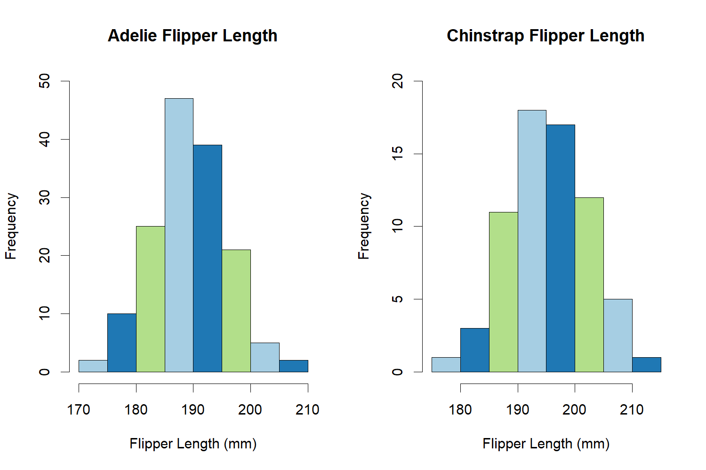

19. The alternative hypothesis states that the difference in the average flipper length of the Adelie penguins and Chinstrap penguins is not equal to 0. So, the average flipper lengths of the species are not the same.

20. t.test(flipper_length_mm ~ species, data=penguin_dat)