**How to install the plugin**

# Install the nuget package

dotnet add package Silktide.Umbraco.Plugin

Go to the administration panel in “Settings” > “Silktide”. Enter your API key and click “Save”

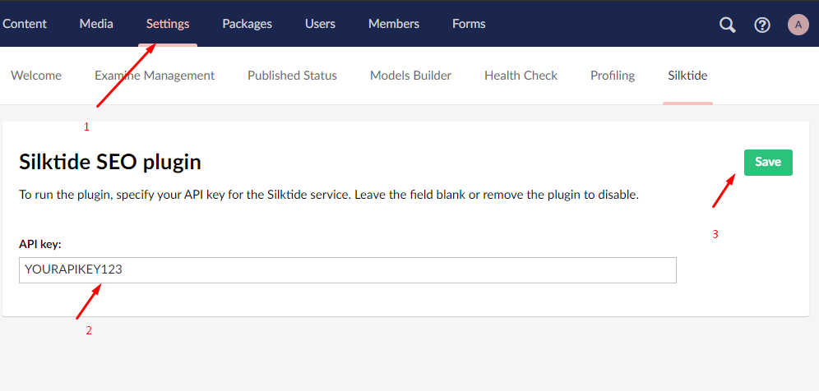

# How to setup

In the .cshtml page template specify the following line in the header

@inject IHttpContextAccessor httpContextAccessor;

<meta name="silktide-cms" content="@Html.Raw(httpContextAccessor.HttpContext.Items["SILKTIDE.CMS"])">

# How to remove the plugin

dotnet remove package Silktide.Umbraco.Plugin

# How to test

The plugin implements 2 things:

## Case A:

Calling a remote API and passing a key and a list of updated site URLs to it.

* Register a temporary address on <https://webhook.site>
* Install the plugin in Umbraco
* Replace in ~/App_Plugins/Silktide/silktideConfig.json the ‘host’ parameter. You should get something like this:

{

"host": "https://webhook.site/292aa852-b406-4a2c-a429-7a2c1b73b611",

"apikey": "112233"

}

* After replacing the address, save the setting again to update the cache

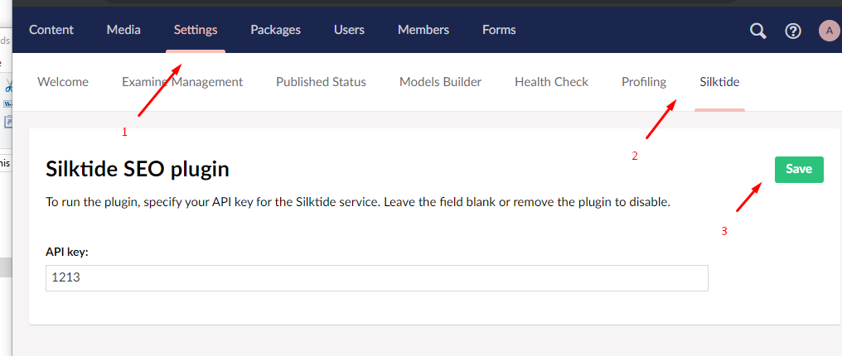

* Test saving content in a variety of ways (with and without additional languages)

**Expected result:**

When publishing content in case of data changes the remote API should receive data as a POST request like this

{

  "apiKey": "123456798",

  "urls": [ "http://url1.local", "http://url2.local" ]

}

## Case B:

Rendering the path to the admin panel in JSON format in base64 encoding

* Install the plugin in Umbraco
* In the umbraco view in .cshtml file specify the following line:

@inject IHttpContextAccessor httpContextAccessor;

@Html.Raw(httpContextAccessor.HttpContext.Items["SILKTIDE.CMS"])

Make sure when you visit the page on which you inserted this code that you see something like this

*eyJlZGl0b3JVcmwiOiJodHRwOi8vc2lsa3RpZGUtZW4ubG9jYWwvdW1icmFjbyMvY29udGVudC9jb250ZW50L2VkaXQvMTA2Nj9tY3VsdHVyZT1lbi1VUyJ9*

* Decode string using BASE64 decoder. You should get something like this:

{

  "editorUrl": "http://silktide-en.local/umbraco#/content/content/edit/1066?mculture=en-US"

}

* Make sure that the current page is available at the parameter specified in the ‘*editorUrl’*

**Expected result:**

After inserting the code you should get a BASE64 format string which is a link to this page for editing in the admin panel

# Test environment

**Login**: admin@admin.com

**Password**: [admin@admin.com](mailto:admin@admin.com)

**Dashboard path**: ~/umbraco