CS3026 Operating Systems – Assignment 2  
File Allocation Table  
Julia Wiktoria Zięba (ID: 51768280)

REPORT

# CSG_D3_D1

Preparing first block

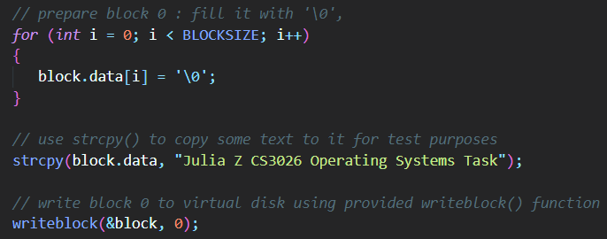

Preparing the fat table

Prepare root

Copy fat

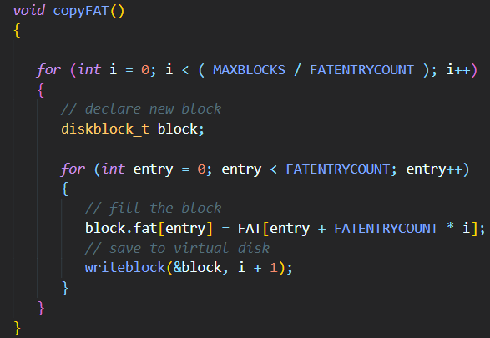

Shell for d

# CSG_C3_C1

# CSG_B3_B1

# CSG_A5_A1