Julie Burke

December 11, 2017

Final Project Report

1. Your goals

My goal was to retrieve data using the Instagram and Facebook API and visualize it.

I also want to cache all the data I acquire and add relevant data to a SQL database.

From Facebook, I wanted to get the day of each of my posts. Then, I planned to visualize it using Plotly in a bar graph that showed the frequency of my posting on each day of the week.

From Instagram, I wanted to get the location of my 20 most recent posts. Then, I planned to plot these locations on a map of the world using Google maps.

1. Which goals you achieved

I achieved all of my goals (stated above) for this project. Additionally, I got extra data from Facebook, locations of posts, and visualized alongside the Instagram data and color coded the points on the map to differentiate where the data came from.

1. What problems you faced

I was only able to get 20 posts from Instagram due to regulations placed on developers by Instagram.

Additionally, for Facebook, because some of my recent posts were private I did not get 100 posts when I set the limit to 100. The number of posts returned will depend on how many of the users 100 most recent posts are public (Colleen said it was okay if less than 100 are returned).

1. Your social media “report”

My social media report is my SQL database (approved by Colleen). Here is a screenshot of part of the Tables for Instagram and Facebook.

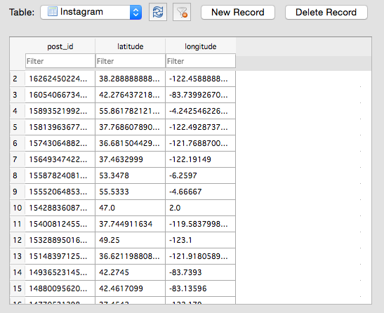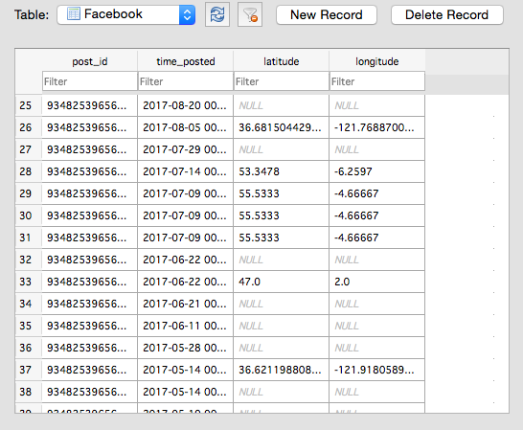

1. Instructions for running your code.

Before running my code, add the following into the private_tokens.py file:

* Facebook access token
* Instagram access token
* Plotly username
* Plotly API key

If you do not add these keys/tokens into the file, you will be prompted for them in terminal at runtime.

Once that is done, you can run my code from terminal. Simply navigate to the folder where the file is (must also include the private_tokens.py file and run the file (python project.py).

Upon doing so the following files will be created:

* JSON cache file with all the data collected
* SQL database with two tables (Facebook and Instagram)
* An html file that displays the Google map visualization

Additionally, you can check your Plotly account to see the bar chart visualization of the Facebook day of week data.

Print statements have been included to let the user know what tasks have been completed.

1. Documentation for each function you wrote (Code must be fully formatted and you must include ALL resources used.)

See comments in code

1. Resources

|  |  |  |  |
| --- | --- | --- | --- |
| **Date** | **Issue Description** | **Location of Resource** | **Result**  **(did it solve the issue?** |
| 9/25 | Facebook API request, what is the fieldname for location and what does it return? | https://developers.facebook.com/docs/graph-api/reference/location/ | Yes |
| 9/25 | Facebook API – get access token | https://developers.facebook.com/tools/explorer?method=GET&path=me%3Ffields%3Did%2Cname&version=v2.11 | Yes |
| 9/28 | Instagram API request, basics to get started + access token | https://www.instagram.com/developer/ | Yes |
| 9/29 | Instagram returning 20 values when count = 100 | https://www.instagram.com/developer/limits/ | Yes, but cannot get more than 20 |
| 9/30 | How to turn Facebook time 🡪 datetime 🡪 day of week | https://www.mathworks.com/help/matlab/ref/datenum.html | Yes |
| 12/4 | How to plot lat, long values on a map of the world | https://pypi.python.org/pypi/gmplot/1.0.5 | Yes |
| 12/4 | How to change color of markers on map visualization | https://github.com/vgm64/gmplot | Yes |
| 12/5 | Plotly Bar Chart basics | https://plot.ly/python/bar-charts/ | Yes |
| 12/5 | How to add labels to Plotly visualization | https://plot.ly/python/figure-labels/ | Yes |