Julia Diliberto

CST 370

Lab 6

February 15, 2016

This screenshot shows each of the assigned search methods applied to a value that is in the array.

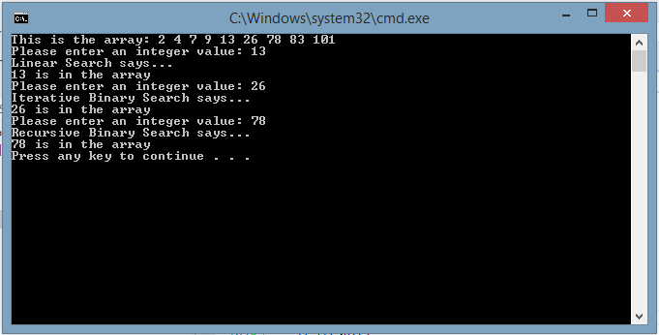

This screenshot shows each of the assigned search methods applied to a value that is not in the array.

