Julia Diliberto

CST 370

Programming Assignment 7

February 20, 2016

This screen shot shows the operation of the recursive search function with items found and not found, inorder(), preorder() and nodeCount() when the tree is not empty.

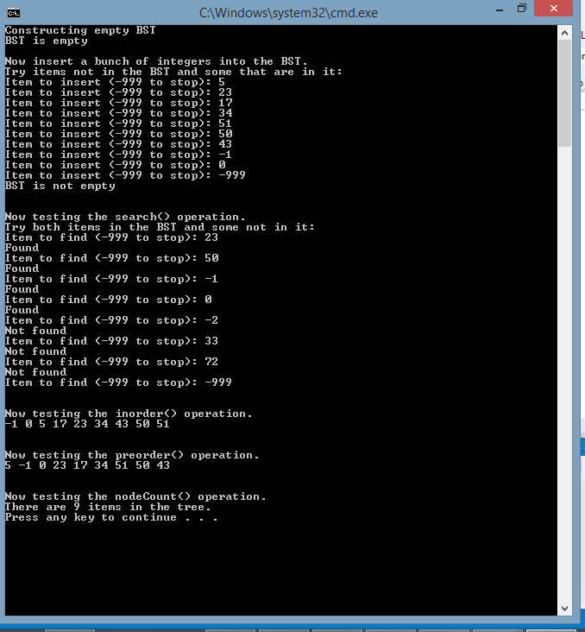

This screen shot shows the operation of the recursive search function with items not found, inorder(), preorder() and nodeCount() when the tree is empty.

