# Literature Review

## Overview

Many genetic and functional disorders are characterised by disordered craniofacial growth. In general, in research and in clinical practice, disordered growth is operationalised as dysmorphology, relative to some age and sex appropriate control population. Dysmorphology can be defined in various ways (see section 1.4 ), but in general refers to the degree of deviation from “normal”. The most common and traditional method is to compare particular measurements on a patient to established normative values. The collection of measurements, both for population norms and for individual patients is time consuming and requires a skilled operator. Advances in 3D photography has facilitated instantaneous 3D image capture. Advances in image processing, developed for morphometric analysis, also allow for automatic landmarking of 3D images. This has not yet been widely implemented due to the lack of comparable population norms collected under this protocol. Part of the work of this thesis is acquiring these required norms and provide a user friendly graphical user interface for clinicians to apply this automated landmarking protocol. Section 1.2. Surveys extant methods of landmark acquisition and describes an automatic method of landmark acquisition.

Techniques from morphometrics –the statistical analysis of shape – allow one to extend the description of a normal population (and thus the description of dysmorphology) from specified interlandmark measurements, which are difficult to interpret holistically, to representations that describe the entire 3D surface of the face. Section 1.3 describes these advances.

Disordered growth may also comprise elements other than dysmorphology relative to an age-appropriate normal population, such as abnormal growth rate and growth direction. Morphometrics allows these normal growth properties to be modelled as a multivariate growth vector or growth curve, and allows the assessment of deviation therefrom. An interesting by-product of such a model is the ability to “grow” a face parallel this vector/curve, potentially providing a patient-specific prediction of growth. Section 1.5. discusses some of the statistical problems associated with determining an appropriate trajectory; namely sexual dimorphism, non-linearity of growth and the independence (modularity) of growth of different regions of the craniofacial complex. Section 1.6, describes previous attempts at modelling growth and untested, but theoretically applicable statistical models in the context of the problem of non-linearity.

## Anatomical Landmark Acquisition for population norms and patient assessment

Landmarks are traditionally defined as precise locations on biological forms that hold some developmental, functional, structural or evolutionary significance ([Richtsmeier et al., 2002](#_ENREF_116)) that are unambiguously defined and reliably locatable ([Richtsmeier et al., 1995](#_ENREF_117)). Commonly used landmarks to quantify the human face include inner and outer commissures of the eye (endo- and exo-canthi, respectively) and the tip of the nose (the pronasale) ([Farkas, 1994c](#_ENREF_47)).

Landmarks are often used in clinical assessment. Generally some particular measurement or measurements of interest are compared to normative values, derived from some appropriate control population. Measurements are often collected directly on the patient. Most frequently in clinic this is done by a clinician with calipers or rulers ([Farkas, 1994c](#_ENREF_47)) However some researchers. According to one method, the landmark is indicated on the subject by positioning a stylus, attached to an electromechanical system for determining the position of the stylus in space ([Ferrario et al., 2004](#_ENREF_54)). According to another, all the landmarks are indicated by positioning a reflective marker at the landmark location on the subject, and a stereo-camera digitises the location of the points ([Ferrario et al., 1998a](#_ENREF_55), [Ferrario et al., 2004](#_ENREF_54)).

Landmark indication and inter-landmark measurements can also be taken, indirectly, on an image. Imaging modalities include X-ray CT, MRI, 3D laser-scanning, 2D and 3D photography. 3D photographs capture a full 3D representation of the outer surface of the soft-tissue. Direct methods present practical drawbacks, particularly for large-scale studies. They are time-consuming, they require the presence of both the clinician and a cooperative patient for the entirety of the acquisition ([Farkas, 1996](#_ENREF_48), [Farkas and Deutsch, 1996](#_ENREF_49), [Hurwitz et al., 1999](#_ENREF_76), [Weinberg et al., 2004](#_ENREF_135), [Aynechi et al., 2011](#_ENREF_13)), which presents particular problems in studies involving infants or young children, and those with a developmental disability ([Aldridge et al., 2005](#_ENREF_6)). Additionally some measurements may be distorted due to manual compression of the soft tissue by the measuring instrument ([Farkas, 1994b](#_ENREF_45), [Farkas, 1996](#_ENREF_48), [Weinberg et al., 2006](#_ENREF_133)).

Indirect image-based methods are limited by the information in the image itself. 2D photography, captures a 2D perspective projection of the surface, distorting measurements. 3D laser scanners, 2D and 3D photography, for example, only capture the outer surface of the soft-tissue. The identification of certain landmarks, particularly those defined by the underlying bone-structure and/or requiring palpation, such as the gonion (the point of the mandibular angle), will be difficult ([Weinberg et al., 2004](#_ENREF_135), [Aldridge et al., 2005](#_ENREF_6), [Weinberg and Kolar, 2005](#_ENREF_132), [Farkas and Deutsch, 1996](#_ENREF_49)). The converse problem applies to identifying soft-tissue landmarks from X-ray, CT and MRI.

Both direct and indirect manual landmarking suffer from the problem of standardisation. As both require manual indication by an operator, both suffer from intra and inter-operator error ([Fagertun et al., 2014](#_ENREF_43), [Toma et al., 2009](#_ENREF_127), [Weinberg et al., 2004](#_ENREF_135)). Consistency in data collection is essential for valid comparison of normative and patient measurements ([Farkas and Deutsch, 1996](#_ENREF_49), [Weinberg and Kolar, 2005](#_ENREF_132)), making a fully automated landmarking procedure that could be implemented, at both stages valuable for both research and clinical practice.

One approach to automatic landmarking, and the related issue of automatic image segmentation, is to define ad hoc heuristics or “rules of thumb” for identifying certain landmarks that exploit a priori knowledge about the landmark/region or the relationship between the landmark and other image elements. This knowledge guides the algorithm in the form of heuristics for finding the particular region/landmark, Much work has been done in this area, primarily for identifying landmarks, or regions of interest on cephalograms ([Parthasarathy et al., 1989](#_ENREF_113), [Levy-Mandel et al., 1986](#_ENREF_92), [Forsyth and Davis, 1996](#_ENREF_58), [Tong et al., 1989](#_ENREF_128), [Ren et al., 1998](#_ENREF_115)) and on 2D images of faces: for example, algorithms for locating pupil centre ([Zhu et al., 1999](#_ENREF_142)), outer-lip contour ([Yokogawa et al., 2007](#_ENREF_138)), the palpebral fissure ([Souza et al., 2000](#_ENREF_125)) and the outer contour of the eyes ([Douglas et al., 2003](#_ENREF_37)). The algorithms themselves are multifarious, and their details are not particularly relevant. They all share the common problem that for each landmark a set of rules for finding it needs to be defined, which is laborious and likely error-prone. An exception is the “spatial spectroscopy” approach, ([Rudolph et al., 1997](#_ENREF_121), [Rudolph et al., 1998](#_ENREF_120)) however this relies on 2D pixel intensity in cephalograms and is not applicable to 3D images which is the concern of this thesis. Add new paper in “reliability”, also Liang 2013, Sukno 2012

Full 3D image-registration or *quasi-landmark mapping* provides a solution to the problem of automatic landmarking that does not rely on ad hoc heuristics and is applicable to 3D images. A 3D image is derived from several three-dimensional photographs taken simultaneously. Each camera, positioned around the subject projects identical arrays of black and white speckles onto the facial surface. From the positional differences in corresponding speckles in the separate 2D images, it is possible to reconstruct the three-dimensional location of each point as it lands on the subject. This is similar to the way in which the brain can construct a perception of depth from two images, taken from different angles in a three-dimensional movie. These points comprise a three-dimensional point-cloud. That is each point has an x, y and z co-ordinate (i.e. a position in three-dimensional space). Simple triangulation of the points is then performed to join the points closest to each other. This defines a representation of the three-dimensional surface as an irregular polygon with triangular facets, referred to as a “mesh” (see Figure 2.3). The points are referred to as “nodes” or “vertices”. Each vertex has a number associated with it in the image file, but these do not bear any reliable relationship to the anatomy of the surface. E.g. vertex 400 could be the tip of the nose in one image and somewhere on the cheek in another.

Image registration defines a mapping of the vertices from one (template) image onto their corresponding locations on another. This is equivalent to warping the template into the shape of the face being mapped. There exist several algorithms for so doing (e.g. [Andresen and Nielsen, 2001](#_ENREF_12), [Snyders et al., 2014](#_ENREF_124), [Claes et al., 2012b](#_ENREF_31), [Hutton et al., 2003a](#_ENREF_78)). The locations of the vertices are then the locations of the corresponding points on the mapped image. The result is an image of the same shape as the original image but its vertex indices and connectivity structure are in correspondence with the template (see Figure 2.4). These mapped points are called quasi-landmarks because any given point may or may not have a well-defined biological meaning. The exact properties of the template image are not important, but in general an average face of some population is used, with regularly spaced points.

Once this full correspondence is established for any (anatomical) landmark subsequently indicated on the template, the corresponding location on the mapped image is also defined. If the indicated landmark is on a vertex then the corresponding location on the mapped image is the equivalent vertex. If it is not, the correspondence is still defined by finding the corresponding triangular facet on which the indicated landmark lies and its corresponding position within that triangle, relative to its three vertices.

[Illustration]

This approach has been used in some studies ([Claes et al., 2014](#_ENREF_30), [Wei et al., 2011](#_ENREF_131)), but its full potential has not yet been exploited. Although it provides the potential for a fully consistent automatic landmarking protocol that can be applied, both to the collection of measurement norms and to subsequent patient assessments, no such norms exist and the protocol is not available in a user-friendly format.

## anthropometry and morphometrics

The twin fields of morphometrics and anthropometry concern the quantification of anatomy. Although, strictly speaking “anthropometry” can refer to the collection of other human bio-information ([e.g. weight and height; de Onis et al., 2004](#_ENREF_35)), we use the term here to refer more particularly to the craniofacial anthropometry exemplified by the work of Leslie Farkas ([Farkas, 1994a](#_ENREF_44), [Farkas and Deutsch, 1996](#_ENREF_49)). The terms are occasionally treated as though they were interchangeable ([e.g. Farkas et al., 1992](#_ENREF_52)). However in their most frequent usage, the fields differ primarily in the sophistication of the analyses used, which is a product of their different origins and aims.

Craniofacial anthropometry uses as its primary units, linear distances or angles between anatomical landmarks or relative proportions thereof. Much of the work of anthropometry has been the standardisation of measurement protocol and the construction of large normative databases of these measurements in normal ([Farkas et al., 2003](#_ENREF_50), [Farkas, 1994c](#_ENREF_47)) and disordered populations ([Farkas et al., 2001](#_ENREF_51), [Farkas et al., 1985](#_ENREF_46)). In anthrpometry the description of shape is limited to distances and angles. Statistical methods applied in anthropometry are almost always univariate, e.g. z-scores and t-tests.

Morphometrics refers to a broad range of techniques, which were developed to answer questions about shape. It has found widespread use in biology (particularly evolutionary biology) where it has been applied to studies of anatomy. Its descriptions of form are diverse and differs primarily in that it treats shape as multivariate and employs multivariate statistical methods. Relevant methods are discussed further in sections 1.4.2 and 1.6.

### Morphometric representations of shape

*Morphometrics* represents a single shape as a composite of measured traits. These traits can be linear measurements/angles, as in anthropometry. The use of this kind of description defines the “traditional” approach to morphometrics ([Blackith and Reyment, 1971](#_ENREF_18), [Marcus, 1990](#_ENREF_98)). However, morphometrics underwent a revolution in the 1990s ([Rohlf and Marcus, 1993](#_ENREF_119), [Adams et al., 2004](#_ENREF_5)). This was the development of techniques for representing and analysing the entire spatial arrangement of a configuration of landmarks, thus encoding the geometry of the surface in question. For this reason modern morphometrics is often referred to as geometric morphometrics.

One method is to represent the configuration of landmarks as the matrix of all interlandmark distances ([Lele, 1993](#_ENREF_91)), e.g for five landmarks:

C =

Another approaches represents a shape as the coefficients of thin-plate spline function, this represents the configuration as the deformation of a thin metal plate into the configuration of landmarks ([Bookstein, 1989](#_ENREF_20)). Additionally, the outline of a shape such as the lateral profile can be considered to be an irregular wave and be represented as a Fourier series.

The representation that this thesis is primarily concerned with is the representation of the form as the landmark co-ordinates themselves

### Procrustes methods for the analysis of landmark configurations

#### Procrustes methods for comparing two landmark configurations.

A configuration of landmarks, is simply a set of points in a three-dimensional space. Procrustes Analysis determines the rotation, translation (shift in the centre of the configuration) and uniform scaling to apply to optimally align two configurations.

The residual differences between the locations of each landmarks indicates the differences between the two shapes. This is often visualised as a distance map, where each point is colour-indexed to the difference between the two configurations.

Standard Procrustes Analysis is widely used. It uses a least-squares criterion to estimate the required transformations. That is “optimal” alignment is that which minimises the sum of squared distances between corresponding landmark configurations. It is well established that outliers bias least-squares estimates, because large deviations exert a disproportionate influence on any calculations. In shape analysis this gives rise to the Pinocchio effect ([Zelditch et al., 2004](#_ENREF_141)), whereby large localised shape differences, bias the superimposition. Standard Procrustes Analysis is therefore not suitable for the study of dysmorphology – such as those resulting from abnormal growth processes – where it is precisely the large, localised differences that are of interest.

The relatively new field of *dysmorphometrics* ([Claes et al., 2012a](#_ENREF_29)) was developed to deal with this issue. Among the techniques developed within this new field is a weighted “robust” Procrustes superimposition where the Procrustes alignment and whether a particular landmark is an outlier or inlier are iteratively estimated. The result is a weighted least-squares estimate, where the contribution of each landmark to the estimated transformation is related inversely to the probability that it is an outlier.

Figure 2.5 illustrates Procrustes superimposition and the Pinnochio effect. Here there are two versions of the same face. These are identical except in one (“Pinnochio lying”) the nose is abnormally extended. The middle row shows the standard and robust Procrustes alignments of the two images. In the standard case, the alignment is not accurate in that the identical regions are not perfectly aligned. In the robust cases the alignment of the identical regions is much better. The bottom row illustrates how the abnormality (the large nose) might be characterised in “distance map”. Here each point on the “Lying Pinnochio” is colour indexed to the distance between its corresponding point on the “Truthful Pinnochio”.

[Insert Figure 2.5 about here]

#### Procrustes methods for determining shape-space

An important concept in the analysis of groups of shapes is a shape-space ([Dryden and Mardia, 1998](#_ENREF_39)). Where each point is an instance of a shape and each axis is some variable that contains information about the shape (e.g. inter-landmark measurement or landmark co-ordinates). In order to define a shape space where landmark co-ordinates are the axes, Generalised Procrustes Analysis (GPA) is used.

Generalised Procrustes Analysis ([Gower, 1975](#_ENREF_66)) is an iterative process that estimates the mean configuration of a population of shapes, and brings each example shape into a common frame of reference (i.e. relative to the mean). First, some example configuration is selected as a proxy for the mean. The selection is not crucial, although it is often useful to select one where the co-ordinate x, y, and z axes are aligned to anatomical axes. All faces are scaled to a standard size and superimposed on this mean. The mean of all (now co-aligned) landmark co-ordinates, is then taken as an updated estimate of the mean configuration and the process is repeated, and usually converges in three iterations. The landmarks are mean-centred (the co-ordinates of the mean configuration are subtracted from each configuration), these mean-centred landmark co-ordinates are called Procrustes residuals and reflect each configuration’s deviation from the mean.

The population of shapes can now be represented as a matrix:

where the rows correspond to j shapes and the columns contain the x, y and z Procrustes residuals for *k* landmarks (e.g. refers the x co-ordinate of the kth landmark on the first shape). The geometrical interpretation of this matrix is as a point-cloud in *k* x 3 dimensional space. Each row (shape) can be thought of as a point within that space. Figure 2.6 illustrates a distribution of shapes on the first two Procrustes residuals (columns) in P.

[Insert Figure 2.6 about here]

After GPA the matrix of Procrustes residuals constitute k x3 mean-centred variables that represent the shape of each face in a common frame of reference (e.g. relative to the Procrustes mean).

It is convenient, both conceptually and mathematically, to “rotate” the data onto new axes called Principal Components (also illustrated in Figure 1.4.). Geometrically, these are orthogonal directions through the point-cloud that successively capture less and less variability in the data. The first PC is the direction along which the point-cloud is most stretched (there is most variability). Each PC represents a particular way in which the sample of shapes vary. They do not have any particular biological meaning, but provide an intuitive way to summarise the variation present in the sample and possess convenient mathematical properties. Rotated data is generally referred to as a *point-distribution model* ([Hutton et al., 2001](#_ENREF_77), [Lorenz and Krahnstöver, 2000](#_ENREF_94))or *face space* ([Wei et al., 2011](#_ENREF_131)).

## description of normal and abnormal morphology

### Anthropometric description

In general a face is only considered normal with reference to some “normal” population (however, see Enlow ([1969](#_ENREF_41)) for a method of determining facial dys-equilibrium without reference to a normal population). The description of the normal population determines the manner in which abnormality can be determined. For statistical purposes, a population of observations on a single variable is characterised by its centre (e.g. mean) and the normal variability is characterised by some index of the spread of the distribution (e.g. standard deviation). One way to describe a population of shapes is as a set of norms means and standard deviations. As described in section 1.3, much of the work of anthropometry has been to collect large normative databases to describe normal and abnormal populations. How abnormal a face is on any particular measurement can be described as a z-score.

which reflects how much the observation x differs from the mean µ, standardised to units of the typical variability around the mean σ. A collection of z-scores (for a host of different measurements) can characterise the pattern of dysmorphology (which measurements are abnormal, which are not) in a particular individual, referred to as the pattern-profile ([Garn et al., 1984](#_ENREF_62)). The mean of these pattern profiles (over a homogenous sample of dysmorphic individuals) have been used to characterise the pattern of abnormality associated with numerous disorders ([Allanson et al., 1997](#_ENREF_10), [Allanson and Hennekam, 1997](#_ENREF_9), [Allanson and Cole, 1996](#_ENREF_8), [Allanson et al., 1993](#_ENREF_7), [Guyot et al., 2001](#_ENREF_67), [Hunter, 1996](#_ENREF_75)). A commonly used adjunct to the pattern profile is the “pattern variability index” ([PVI; Garn et al., 1985](#_ENREF_61)), also called the “craniofacial variability index” ([CVI; Ward et al., 1998](#_ENREF_130)). This is the standard deviation of the set of z-scores. In essence it reflects the degree of variability in the degree of dysmorphism. I.e. a face that is uniformly dysmorphic (i.e. has large and similar z-scores on all measurements has a low PVI. A face that varies in the degree or direction of dysmorphology in different measurements will have a high PVI. This is considered a crude measure of overall facial harmony. Given norms (and sample sizes) for two populations, they can be compared at the level of individual measurements by a t-test ([e.g. Tanikawa et al., 2015](#_ENREF_126)).

### Morphometric descriptions

A criticism of the anthropometric approach is that such measurements tend to oversimplify morphology when used in isolation and can be very difficult to interpret collectively ([Marcus et al., 2009](#_ENREF_97)). For this reason techniques from morphometrics have been applied to the description of normality and abnormality holistically. These begin with a sample of faces, each face defined by the co-ordinates of a set of landmarks. These can be either sparsely indicated anatomical landmarks or spatially-dense quasi-landmarks, which define the entire surface of the face. The visualisations below are all derived from the latter case, enabling visualisation along an apparently smooth (due to the density of the landmarks) facial surface.

* + - 1. *Population archetypes/templates.*

Homogenous populations can be summarised as facial archetypes or templates ([Kau et al., 2006a](#_ENREF_80), [Shaweesh et al., 2006](#_ENREF_122)). These are the average of a sample of faces. The average is simply the arithmetic mean of the co-ordinates after all faces are co-aligned. These are used to typify a particular ethnic ([Kau et al., 2010](#_ENREF_82)), age ([Kau et al., 2006b](#_ENREF_83)) or syndromic group ([Bughaigis et al., 2014](#_ENREF_24), [Hammond et al., 2004](#_ENREF_70), [Cox-Brinkman et al., 2007](#_ENREF_34), [Hammond et al., 2012a](#_ENREF_69), [Bhuiyan et al., 2006](#_ENREF_16), [Marcus et al., 2009](#_ENREF_97)). Latterly these have been created by averaging full 3D facial images, deriving an average representation of the entire facial surface. However these techniques are descended from earlier attempts which used sparse configurations of anatomical landmarks to define the average surface, referred to as *mesh diagrams* ([Moorrees and Lebret, 1962](#_ENREF_107), [Moorrees et al., 1976](#_ENREF_108), [Ferrario et al., 1998b](#_ENREF_56), [Evanko et al., 1997](#_ENREF_42)). Sometimes the variability within the population is also represented by creating an archetype that represents the typical deviation from the mean (e.g. +/- 1SD) ([Shaweesh et al., 2006](#_ENREF_122), [Moorrees and Lebret, 1962](#_ENREF_107), [Kau et al., 2010](#_ENREF_82)).

An individual face, or the mean face of a dysmorphic population, can be superimposed onto the template. The regions that differ and the amount in which they differ can be visualised as a distance map. A distance map is where regions of a face are coloured according to the error of the superimposition (the distance between the two configurations), which varies, dependent on the local difference between the faces ([Hammond, 2007](#_ENREF_68), [Cox-Brinkman et al., 2007](#_ENREF_34), [Hammond and Suttie, 2012](#_ENREF_71), [Kau et al., 2006b](#_ENREF_83), [Koudelová et al., 2015](#_ENREF_90), [Kau et al., 2006a](#_ENREF_80), [Kau et al., 2010](#_ENREF_82), [Kau et al., 2007](#_ENREF_81), [Shaweesh et al., 2006](#_ENREF_122)). The overall degree of dysmorphology can be summarised as the mean error of the superimposition (i.e. the mean, difference between the faces). In general these studies do not take into account the typical variability around the mean, leading to conclusions that are based on the raw anatomical difference between the two faces (see Figure 2.8, “Distance”)

An approach that takes into account the typical variability around the mean is Peter Hammond’s facial signature ([Hammond et al., 2012b](#_ENREF_72), [Hammond and Suttie, 2012](#_ENREF_71), [Hammond et al., 2012a](#_ENREF_69)). This a method of characterising where on the face, and to what degree a given face is dysmorphic relative to a population. First all faces are co-aligned to the mean configuration by GPA. The surface normal (direction perpendicular to the surface) is computed for each point on the mean face. The displacement for each point on each face, along the corresponding surface normal, is computed, defining, a distribution of displacements for each point. The deviation of any point on any face, not included in the reference population, can be expressed as a z-score within the appropriate distribution of displacements. The signature of any face, not included in this reference population, can be visualised as its standardised displacement (see Figure 2.8, “Projected Distance Normed”)

The “signature weight” is a derived summary metric of dysmorphology:

where ***zi***  represents the displacement of the ith landmark along the surface normal of the average face, represented as a z-score.

#### Point-distribution models

The construction of a point-distribution model, or face space was described in section 1.3.2.2. Essentially this represents the entire covariance structure of the population. Specifically each dimension is direction of covariance in the data. These are mutually orthogonal (uncorrelated), meaning that each dimension accounts for different variability in the data. along each dimension, the limits of normal variability are defined as (e.g. 1.96 standard deviations). Any location in the space corresponds to an actual face. In fact using a point-distribution model it is possible to generate any number of synthetic faces just by specifying the co-ordinates in face-space ([Blanz and Vetter, 1999](#_ENREF_19)). So long as the co-ordinates are within the bounds of normal variability this face is usually anatomically plausible. To help illustrate this above point the first 8 PCs from a subsample of our normative data are illustrated in Figure 2.9. The illustration includes “morphs” (i.e. faces constructed corresponding to particular locations in face-space) constructed at =/-1.96 standard deviations along each PC.

A problem with comparing a face to the mean of a population is that visualisations of dysmorphology, such as a distance map, and any summary measures based on these will code for any difference from the mean, even the difference from the mean which is perfectly normal (i.e. the idiosyncracies of the person that are not dysmorphic). A relatively new approach is to characterise dysmorphology in terms of difference from a “normal equivalent” of that person ([Claes et al., 2013](#_ENREF_32), [Claes et al., 2012a](#_ENREF_29)). This estimates where the faces would be in face-space were it not for the dysmorphology, and produces the face at that location. Characterising dysmorphology relative to this normal equivalent seriously reduces the amount of idiosyncratic, but normal, deviation included in the assessment of dysmorphology ([Claes et al., 2013](#_ENREF_32)). For example Figure 2.10 shows a patient with hemi-mandibular hypertrophy. The right side of her mandible is affected. *e* and *f* compare the actual face to a normalised equivalent and the mean of the reference population, respectively, highlighting the regions that are “dysmorphic”. Comparison with the mean incorrectly highlights regions on both sides of the face of the mandible, whereas comparison with the normal equivalent localises the dysmorphology much better to the right side of her mandible.

Within a point-distribution model all faces are represented within a common co-ordinate system. This makes the computation of distance between faces meaningful, as capturing “difference” between them. A face can be considered dysmorphic, relative to the reference population, if its distance from the origin (mean) exceeds some threshold. That is, if it is an outlier in a multivariate sense, The familiar notion of distance between two points *a* and *b* (of which one may be the origin) in three-dimensions, the Euclidean distance:

extends simply to a space with any (*d*) dimensionality:

where ***ai***and ***bi*** represent the co-ordinate of point a and b on the ith dimension.

Another measure of distance in a point-distribution model with a straightforward interpretation is the Mahalanobis distance (D; [Mahalanobis, 1936](#_ENREF_96), [Brereton, 2015b](#_ENREF_23)). ***D*** generalises the concept of a z-score to multiple dimensions:

where ***ai*** and ***bi*** are the co-ordinates of ***a*** and ***b*** on the on the ith Principal Component,  ***σi*** is the standard deviation of scores along this PC. If the probability of observing a given value of ***D*** exceeds some threshold one can conclude that it is unlikely to have come from the population in question and is, therefore, dysmorphic relative to that population. Assuming multivariate normality, the distribution of ***D2*** follows a chi-squared probability distribution with *d* degrees of freedom ([Brereton, 2015a](#_ENREF_22)) so the probability of a given value of ***D*** is easily determined.

[Illustration of distributions]

The Mahalanobis distance has been used as part of a classification system for determining individuals expressing subclinical manifestation of the cleft-lip and palate phenotype. They were considered at risk of carrying the latent genotype in part if their Mahalanobis distance from a control group mean was greater than a cut-off ([Weinberg et al., 2008](#_ENREF_134)). It was also used for determining whether an unearthed skull was dysmorphic, relative to a control population, identifying a case of cranial synostosis ([Harris and Ross, 2008](#_ENREF_73)). D can also be used to assess the significance of differences in the mean-location of different sub-groups in the point-distribution model, such as the difference in facial morphology in different strains of mice ([Young et al., 2007](#_ENREF_139)).

## modelling craniofacial growth – problems

Disordered growth may also comprise elements other than dysmorphology relative to an age-appropriate normal population, such as abnormal growth rate and growth direction. Morphometrics allows these normal growth properties to be modelled as a multivariate growth vector or growth curve, and allows the assessment of deviation therefrom. An interesting by-product of such a model is the ability to “grow” a face parallel this vector/curve, potentially providing a patient-specific prediction of growth.

[Illustration]

The general problem is that of establishing an appropriate line or curve through shape space that captures the change that occurs in the face over time. This could take the form of establishing a typical ontogenetic trajectory for a particular population, based on cross-sectional data or establishing the trajectory of an individual over time. Our focus is on methods applicable to cross-sectional data although some are applicable to both. The difference between these two cases is illustrated in Figure 2.11. The effect of time may be represented by age, although most of the work from which the following discussion arises from evolutionary biology where age of an (e.g. fossil) specimen is unknown and authors have used proxies for age. These proxies have included classification into developmental stages based on evidence of the occurrence or non-occurence of a particular developmental milestone, e.g. adult tooth eruption ([Smith, 2001](#_ENREF_123), [Drake, 2011](#_ENREF_38), [Lieberman et al., 2007](#_ENREF_93)). Authors have also used measures of, or measures that are assumed to correlate with, the global size of the organism or region of interest in the organism ([Mitteroecker et al., 2004b](#_ENREF_104), [Frost et al., 2003](#_ENREF_60), [Zelditch and Fink, 1995](#_ENREF_140), [Vignon, 2012](#_ENREF_129)).

### Parallelism

The basic assumption underpinning craniofacial growth in such a way is that all individual growth trajectories in shape-space are parallel ([Morris et al., 2000](#_ENREF_109)). That is to say all faces grow the same way, only their individual displacements differ. This is obviously a simplification. Investigating how great this assumption is would require longitudinal data collected over the entire period of growth and is not feasible within this thesis.

### Sexual dimorphism, non-linearity, modularity and integration

Within morphometrics the concepts of “integration” and “modularity”are both related to the statistical dependence, of traits (e.g. meausrements, landmark co-ordinates) comprising an organism. The concepts and their operationalisation within morphometrics are discussed here as they present major statistical challenges to modelling growth.

Structures within an organism can be integrated due to their shared developmental, functional and/or genetic origins ([Klingenberg, 2008](#_ENREF_86), [Olson and Miller, 1958](#_ENREF_112)). E.g. the mandible and maxilla share the common function, among others, of mastication. This common function necessitates a structural cohesion between the two elements. Thus, for any given mandible shape there will be a limited range of corresponding maxilla shapes that will be functional. Almost every person has a functional combination of the two, that is the shape of the two elements do not vary independently of each other but can be expected to co-vary within a population. Another example is that the width of the basicranium determines the limits of the facial perimeter and is related to retrognathia and, inversely, to vertical and anteroposterior facial length ([Enlow and Hans, 1996 pg 11](#_ENREF_40)). The concept of integration is similar to Enlow’s notion of “architectural equivalents”, i.e. that there are dimensions within the craniofacial complex that must correspond to maintain harmony ([Enlow et al., 1969](#_ENREF_41)).

Morphometrics operationalises integration as the statistical association between measured traits (e.g. measurements, landmark co-ordinates) ([Klingenberg, 2008](#_ENREF_86)). Other definitions also require that the landmarks be displaced jointly and in the same or a similar direction ([Goswami, 2006](#_ENREF_64), [Goswami, 2007](#_ENREF_65)) or be spatially contiguous ([Klingenberg, 2009](#_ENREF_87)). Integration within a structure that is defined by multiple traits is determined by Principal Components Analysis of the so-called “phenotypic covariance matrix” where each element in the matrix corresponds to the covariance between a pair of traits ([Goswami, 2006](#_ENREF_64), [Goswami, 2007](#_ENREF_65), [Ackermann and Cheverud, 2004](#_ENREF_3), [Ackermann and Cheverud, 2000](#_ENREF_2), [Cheverud, 1996](#_ENREF_27), [Cheverud, 1989](#_ENREF_26), [Marroig and Cheverud, 2001](#_ENREF_99), [Mitteroecker and Bookstein, 2009](#_ENREF_101), [Klingenberg et al., 1996](#_ENREF_88), [Klingenberg and Zimmermann, 1992](#_ENREF_89)). Recall that PCA extracts a series of dimensions that account for gradually less and less variability in the data. Were all traits perfectly correlated all variability would be captured by a single (the first) PC. In the converse case all PCs would account for the same small amount of variability. Therefore authors have suggested, as a measure of integration, the variance of the eigenvalues (variance explained by each PC).

Modularity refers to the relative independence of regions that are tightly integrated internally. Furthermore, anatomical modules are those which can evolve, and most importantly for our purposes, grow independently without disturbing the overall functional and structural equilibrium (ref). The key issue is differential growth rate of different regions of the craniofacial complex. For example, it is well known that the neurocranium expands rapidly until approximately when to accommodate the rapidly expanding brain, following the neural growth curve, reaching full size prior to the onset of puberty ([Feik and Glover, 1998](#_ENREF_53), [Baer, 1973](#_ENREF_14), [Moss and Young, 1960](#_ENREF_110)). In contrast the growth of the face tends to follow the somatic growth curve, growing rapidly in the first four years, plateauing before another period of rapid development at puberty (ref).

Most frequently, studies of modularity are aimed at testing a priori hypotheses and the modules based on prior knowledge ([Monteiro et al., 2005](#_ENREF_106), [Bastir and Rosas, 2005](#_ENREF_15)). There have also been attempts to define anatomical modules based on clustering of the covariance structure. Olson and Miller ([1958](#_ENREF_112)) define the ρ-groups method. This method essentially defines groups of traits (e.g. measurements, Procrustes residuals) that are highly correlated internally. Some threshold value is set and a set of groups is determined such that all correlations between all pairs of measurements within the group are above a certain threshold. Craemer (ref) also attempted to define modules by clustering of a set of quasi-landmarks defining the face, based entirely on their spatial arrangement. That is, nearby landmarks were clustered together. Such methods do not take into account the covariance structure at all and defined modules do not necessarily fit the standard statistical definition of modules.

The second major problem in modelling craniofacial growth is non-linearity. This must be broken down into parts, otherwise the problems that different modelling procedures are addressing will not be clear. The first type of non-linearity is non-linearity of growth direction. That, is the nature of the change that is occurring over time varies with time. Say, for the first years of life the cranial vault expands laterally, and later expands anteroposteriorly. The “direction” of growth has changed over time. Modelling this kind of change necessitates a curve, or an approximation of one, through multivariate shape-space. The second type of non-linearity is non-linearity of growth-rate. Say, for instance the expansion of the cranial vault is always in one direction but the rate of change waxes and wanes throughout ontogeny. This kind of non-linearity can be approximated by a single direction through shape-space, where an individual’s position along it is a nonlinear function of age/ontogenetic stage. That is an individual can progress along the path at a rate that is dependent upon their age.

The third problem is that of sexual dimorphism. It is well established that craniofacial features are very different between adult males and females ([Tanikawa et al., 2015](#_ENREF_126), [Claes et al., 2011](#_ENREF_33), [Claes et al., 2014](#_ENREF_30), [Hennessy et al., 2005](#_ENREF_74)). and adolescents ([Koudelová et al., 2015](#_ENREF_90), [Ferrario et al., 2003](#_ENREF_57), [Bulygina et al., 2006](#_ENREF_25)). There is also a growing body of evidence suggesting differences as young as one year old, although the exact nature of this difference is uncertain (compare [Bulygina et al., 2006](#_ENREF_25), [Matthews et al., under review](#_ENREF_100)). Given such radically different terminating points (the male and female adult morphology) it is fair to assume that they will not be well characterised by the same growth trajectory.

## Mathematical Models of craniofacial growth

### Linear Models

As discussed in the previous section, growth may be non-linear in two aspects – rate and direction. Most previous work from morphometrics in determining trajectories have assumed linear models and these will be discussed.

#### Principal Component Axis

Where a sample is of mixed age/ontogenetic stage, it is sometimes assumed that the first Principal component approximates the developmental trajectory of the population. The “population” in question may be a population of images of different individuals sampled at a range of ages or developmental stages ([Hammond et al., 2012a](#_ENREF_69), [Lieberman et al., 2007](#_ENREF_93), [Bhullar et al., 2012](#_ENREF_17), [Bookstein et al., 2003](#_ENREF_21)); or the population of images from the same individual, sampled at different time-points. In the latter case the PC of a temporally connected sequence of images is taken to describe an individuals’ shape change over time. This latter strategy has been applied to modelling growth ([Andresen et al., 2000](#_ENREF_11)) and, as part of the so-called “Motion Procrustes” analysis, to modelling biological motion, such as that of the heart through the cardiac cycle ([Adams and Cerney, 2007](#_ENREF_4), [Piras et al., 2014](#_ENREF_114)).

[Insert illustration of difference]

This approach is reasonable, to a point. The first PC, which captures the most variability in shape will probably bear a relationship to the main biological driver of that variability. In a sample of heterogenous ontogenetic stage, then this will likely correspond somewhat to the growth process. This approach also makes no assumptions about the rate of change along the axis, allowing for non-linearity in growth rate. However, it is fundamentally an over-interpretation of a PC. PCs are statistical constructions that account for maximum variability in the data and do not necessarily correspond to any biological process ([Mitteroecker et al., 2005](#_ENREF_103), [Mitteroecker et al., 2004a](#_ENREF_102)). The issue is that although it is probably associated with growth it is not necessarily. At the very least, it can be said this sub-optimal.

#### Linear regression based approaches

##### Modelling growth as a regression problem.

Here we are assuming cross-sectional data.

The linear regression of a single variable, representing age onto a multivariate outcome y is to fit the model:

or condensed as:

where the effect of ***age*** on the *p* outcomes in Y is modelled as a set of coefficients (m1 to mp ). If the matrix Y is the matrix of Procrustes residuals, each coefficient *m* represents the amount of change in each landmark co-ordinate per unit of age (e.g. per year). It thus defines a growth vector through shape-space. It is useful conceptually to expand this expression further to:

This splits the vector into two elements: its length, or magnitude which is a single (scalar) value *b*;and its direction , which is a *unit vector* of length 1. *b* represents the overall magnitude of change along the growth vector per-year and thus measures growth-rate. A similar index was used by Hammond et al ([2012a](#_ENREF_69)) to assess rate of change in position along PC1, serving as a proxy for the growth direction, as discussed above.

It will become useful later if it is also clear that constitutes a function relating age to the normal position on the growth vector at that age. It may be useful to think of the linear model as a special case of a general growth model:

where is some function (or transformation e.g. BRIM) relating age to the normal position along the growth vector at that age. In general the first derivative of this function at a particular age, models growth-rate at that age. In the linear case the first derivative equals *b* for all *age*, thus the modelled growth rate is monotonic. The first section below discusses methods of fitting the linear model. These have been used previously in morphomometrics. We also discuss extensions of these models that, in theory, allow for non-monotonic growth-rate. We then discuss methods of approximating a multidimensional growth curve using these techniques.

##### Methods of fitting linear models

One method of fitting a linear model of the form above is least-squares multivariate regression ([Monteiro, 1999](#_ENREF_105)). This method minimises the difference between the actual and predicted values (error) of the outcome variable. This approach is convenient and has been used extensively ([Dean et al., 2000](#_ENREF_36)) as well as extensions of this basic model, such as MANCOVA, which includes a categorical predictor variable ([Vignon, 2012](#_ENREF_129)).

As discussed previously, the face is highly integrated and growth affects the face in an integrated way. Statistically this means that landmark locations/measurements will co-vary within a single time point and change over time in a co-ordinated manner. In short, they are correlated. It is well-known that high degrees of collinearity between variables in ordinary least-squares models causes instability in the parameter estimates. Additionally if the shape is defined by many landmarks, e.g. any analysis using spatially-dense quasi-landmarks, the number of variables exceeds the number of observations, meaning that the least squares solution is not defined.

A general method of dealing with multiple, co-linear variables is to reduce the dimensionality and covariance in the data by re-representing it as one or multiple (but fewer) uncorrelated *latent variables*. A latent variable is a one-dimensional recoding of multiple variables. Geometrically they are projections onto some direction in a variable space (e.g shape/face-space). These latent variables are determined so as to represent some “important” dimension of the covariance structure. What qualifies as interesting or appropriate for a given context depends on the purpose.

With the dimensionality so reduced and the covariance broken, the problem is simplified to an ordinary least squares regression of latent variables. Projections onto PCs are one example of latent variables. They are “interesting” in that they always capture the maximum residual (after accounting for all previous PCs) variability. One general approach that might be applied to establishing ontogenetic trajectories is Principal Components Regression (PCR). Where the multivariate outcome variables are now projections onto a limited number (*p*) of principal components.

A more optimal method of determining latent variables is *partial least-squares regression* (PLSR) or *partial least-squares projection to latent structures*. The interested reader may see Appendix or elsewhere ([e.g. Geladi and Kowalski, 1986](#_ENREF_63)), for a general description of PLSR. For clarity here we will limit ourselves to the specific case of regressing shape onto the single predictor (age). In PLSR the growth vector , is determined so that the linear relationship between positions (projections) onto , and age is maximised. In the usual parlance of PLSR these projections () is the latent variable. Simple linear regression of u onto age, estimates *b,* establishing the relationship between age and position on the growth vector:

*.* And Y (shape) can be predicted using the model established in section 1.6.1.2.1.

### Modelling non-linear growth rate along a single growth vector

As explained in the previous section

relates a person’s age to their position along the growth vector via a linear function, modelled as the single coefficient *b*. One can consider, this a special case of a general class of models:

. relates age to the normal position along the growth vector *q* at that age. A way to model nonlinear growth rate (along a single direction) is to make . non-linear.

There are many classes of non-linear functions used to model nonlinear relationships. Such as polynomial e.g. quadratic (n=2) or cubic (n=3) see Figure 2.13:

A very versatile approach is a spline function. The flexibility of a spline function is in that it allows different functions to specify the relationship between for different values of x (e.g. age). E.g. between age 1 and age 2 may be one function and between age 2 and 3 another. The simplest case is a piecewise-linear spline where the function is always linear (Figure 2.14).

[Insert *Figure 2.13* about here]

[Insert Figure 2.14 about here]

Such non-linear relations have been incorporated into the PLS regression model. To the best of our knowledge these have never been applied to modelling growth. Appendix 2.1 discusses these methods in more general terms, but as per the linear model we will present the model as appropriate to this context. Whereas in linear PLS the vector is determined so as to maximise the linear relationship between age and projections onto the growth vector . In non-linear PLS they are determined so as to maximise the non-linear (e.g. quadratic) relationship (see Figure 2.15). The function relating age to is non-linear. That is, the first derivative that is not the same for all values of age, thus modelling variations in growth-rate.

In general can be any nonlinear function that is continuous and differentiable ([Wold et al., 1989](#_ENREF_137)). Wold ([1989](#_ENREF_137)) used the quadratic inner relationship. Frank ([1990](#_ENREF_59)) used a model equivalent to a linear spline. Wold ([1992](#_ENREF_136)) used a spline with quadratic and cubic polynomial sections. Some have also used updating neural networks to model this relationship (Refs).

### Piecewise approximations of a multidimensional growth curve.

As discussed previously growth is non-linear in two aspects, growth rate and direction. Assuming an appropriate function can be defined non-linear PLS can model non-linearities in growth-rate. However, except over a limited domain, growth direction is unlikely to be accurately modelled by a single growth vector. It is more accurately thought of as a multidimensional growth curve. Some authors have attempted to, on very sparse configurations of two-dimensional landmarks, model changes in the growth vector across time by some non-linear function ([Morris et al., 2000](#_ENREF_109), [Kent et al., 2001](#_ENREF_85), [Kent et al., 2000](#_ENREF_84)). This is not tractable using thousands of spatially-dense quasi-landmarks to define the surface, as is the current aim. And we must pursue some piecewise solution. A piecewise solution means that the properties of the curve are approximated over a limited domain (piece) and the entirety of the curve is a sequence of these approximations.

One such solution is what we shall call piecewise PLSR ([Rob, 2013](#_ENREF_118)). This partitions the sample into domains based on their age, (e.g one domain may be age 0-1). For each domain a separate PLS model is fit. Rob used linear PLS:

where for each domain (aged between min and max) growth rate is modelled by b and growth direction by q, however both are free to vary between domains. A non-linear PLS model could also be used for each domain or a combination of linear and non-linear models could be used

A disadvantage of this piecewise approximation is that it is not continuous; there is no guarantee that qi andqi+1 will intersect at the border of their domains. Meaning that there will be a “jump” in the predicted value of the face at each domain edge. This is implausible anatomically, as facial growth is smooth and continuous.

A further approach, which we will call a *continuous mean* approximation is to approximate the curve as a sequence of points, where each point is the mean face of some “kernel” of ages ([Hutton et al., 2003b](#_ENREF_79)), e.g. the predicted face at age 0.5 would be the mean face of all faces aged from 0 to 1. This model is continuous. However neither growth rate nor direction at defined for any point. These could (although Hutton did not) be approximated by a local PLSR for all faces in the kernel. In this case it is essentially the same as piecewise PLSR except that the domains are not defined a priori. This model may be too flexible and ultimately model noise. However Hutton suggested that with appropriate kernel size the mean estimate is stable. Owing to their extremely small sample size for each age they had to use an absurd kernel size of (+/-10 years). Shaweesh ([2006 their Figure 10](#_ENREF_122)) suggests that for adult populations the mean stabilises using a sample of approximately 13 or 14 faces (if scaled to a common size). Together, this suggests that with an adequate sample size this approach may be stable with a small enough kernel to adequately capture the nuanced changes in craniofacial growth throughout ontogeny.

## applications and limitations of growth models

### “Growing” a face.

Any of the regression based models defined above or a continuous mean can be used to “grow” a face. That is to take an image at time 1 and make a prediction regarding how the face should look at time 2. If a person’s face is within the bounds of normal facial variability at time 1, this is essentially another way of creating a normal equivalent (see section 1.4.2.2) of the person at time 2. If an image of the individual is available, such as one would have when assessing surgical outcomes then the normal equivalent is likely to be more accurate (I think). However the growing of a face in 3D may have forensic applications in the identification of missing persons (who have previously had 3D images taken!!!!)

Assuming that the nature of their deviation from normal does not change through their ontogeny i.e. assuming parallelism (see section 1.5.1.). The first step is to determine how the face deviates from the norm at time 1.

where is the vector of differences between the co-ordinates of the face at time 1 and the predicted “normal” face at the age the face at that time .

In any regression based model is given by:

where is the growth vector and is age. Using a continuous mean approximation is simply the mean face over the kernel around .

The “grown” face is then determined by adding the displacement vector to the “normal” face predicted by the model for the age at time 2. In terms of shape-space geometry this is equivalent to “moving” the face parallel to the vector/curve, modelling individual differences from the norm as a vector orthogonal to the growth vector/curve.

Two factors determine the accuracy of the prediction. Firstly, the accuracy of the assumption that the nature of an individual’s deviation from normal does not change throughout ontogeny. To assess the validity of this assumption one would need to chart the growth of numerous individuals throughout childhood and adolescence. This is not feasible within this thesis.

The second factor is the plausibility of the “normal” face to which the individual is added. The term plausibility is preferable to accuracy because the normal face only exists as a statistical construct and accuracy has no real meaning in this context. The plausibility of the normal face must be inferred from 1) the *a priori* appropriateness and 2) stability of the model. If the model is inappropriate (e.g. linear over a domain where growth is non-linear) then the normal face is also inappropriate. If the model is unstable (even if the model has an appropriate form) then the normal face is being affected by the idiosyncrasies of the sample, and is a noisy approximation.

All regression based approaches impose some assumptions about the nature of growth (e.g. linear; some manner of non-linear growth-rate, but linear growth direction). These assumptions cannot be 100% accurate and therefore any regression based model will be inappropriate to a degree. A continuous mean approach is clearly the most *a priori* appropriate of the models as it makes no assumption about the nature of growth. Whether it also wins in terms of stability (and accuracy of prediction if we get sufficient longitudinal data) is an empirical question. Yay!

### Assessing abnormal growth rate and growth direction

#### Abnormal growth direction

It is common to attempt to plot multidimensional growth trajectories and compare them visually. This requires visualising them as projected onto some limited number of axes either 2 ([Dean et al., 2000](#_ENREF_36), [Loy et al., 2001](#_ENREF_95)), or 3 ([Bulygina et al., 2006](#_ENREF_25), [Neubauer et al., 2009](#_ENREF_111)). To ensure that these axes represent a large amount of the actual variability these are, usually the first few Principal Components. While such a representation is appealing because such plots are intuitive to interpret, a 2D or 3D window into face-space does not capture all of the variability. Trajectories that may appear to be identical or parallel in the particular dimensions visualised, may diverge in other dimensions. Such representations are, therefore potentially misleading ([see Mitteroecker et al., 2005 their Figure 5 for a neat illustration of this](#_ENREF_103)). There is also no particular reason that the dimensions represented by PCs are what is interesting or relevant, in terms of a study.

The degree of divergence between two growth vectors can be summarised by the angle between them. What an angle in a multidimensional space is may not be immediately intuitively understood. But consider in three dimensions, any two lines (vectors) define a unique plane on which they both lie. The 3D angle is simply the 2D angle on that plane. This extends to further dimensions. The general formula for the angle *θ* between two vectors and of any dimensionality is:

For comparing the trajectory of one group to normal, the vector typifying that group can be determined by an appropriate regression model. If comparing the growth trajectory of an individual between time 1 and time 2 the vector can be the change in their locations between time-points.

#### Abnormal growth-rate

Growth models of the form:

define the growth rate at as the first derivative of the function (see section 1.6.1.2.1). If is linear this first derivative is constant for all and constitutes an obvious test statistic to compare between groups. If it is not linear . . . maybe use area between two curves for each fit model to define degree of difference in growth rate as a test statistic and test against the null hypothesis of zero area.

The closest point on the growth curve or vector, to an individual in shape-space is , essentially, how far advanced they are along the “normal” growth process and provides a measure of developmental age. This can be compared to their actual age to determine developmental lag/acceleration, at the level of an individual. This does not require the computation of a growth function explicitly. In a continuous mean approximation this could be determined as the closest mean face in the sequence of mean faces ([Rob, 2013](#_ENREF_118)).

### Applicability over limited domains

At a minimum, the comparison of growth vectors and the determination of the growth-rate of a group require the fitting of an appropriate regression based model. This may also be required to successfully grow a face, but this is an empirical question. Any single regression-based model models only one growth vector, along which the rate of growth can be linear or non-linear dependent upon the model. However, owing the non-linearity of growth direction, and that this may be nested differently in different “modules” any single regression model will only be appropriate over a limited domain. Here “domain” refers quite broadly to an age-range, or a particular module, or most likely a particular age range within a particular module.

## summary, thesis aims and plan

The methods of geometric morphometrics provide powerful tools for the study of normal craniofacial growth and deviations therefrom. Abnormal growth is often operationalised in clinic as dysmorphology relative to an age or sex matched control population. Traditionally these have been quantified as measurements/angles between anatomical landmarks.

Surface registration algorithms allow for the fully automated indication of anatomical landmarks onto 3D images (see section 1.2). Derived measurements can be used to typify normal populations and to assess individual patients (see section 1.4.1). The automatic landmarking essentially removes inter and intra operator error. It is likely that this vastly improves reliability, however no data on the reliability of the automatic mapping is available. The roll-out of such a method into routine clinical assessment is hampered by the unavailability of requisite population norms.

**Paper 1** (see Appendix 2.2.1 for a more fleshed out description) provides these norms and a GUI for clinical use.

Morphometrics provides methods, based on multivariate regression techniques, for assessing deviation from “normal” growth rate and direction. Any single regression model is only applicable over a limited domain, owing to the non-linearities in growth direction. No information is available on the applicability of different classes of models to various domains **Paper 2** (see Appendix 2.2.2) explores the properties of the continuous multidimensional growth curve to determine the appropriate domains over which certain models are applicable.

An interesting by-product of an appropriate model is the ability to “grow” a face in three dimensions (section 1.7.1). The most appropriate model for such a purpose may simply be a continuous mean approximation, of the multidimensional growth curve which imposes no assumptions of linearity of either growth rate or growth direction (section 1.6.3), however such a model may be unstable. **Paper 3** uses the results of Paper 2 to construct an approproate piecewise PLSR approximation of the multidimensional growth-curve 1.6.3) and compare to a sequential mean approximation, in terms of stability. If we get sufficient longitudinal scans we can also assess accuracy of prediction of facial growth at the level of an individual (which is different to accuracy of the “norm” discussed in section 1.7.1). If there are any tractable solutions to the modularity problem this is the place for them.

# Appendices

## general presentation of partial least-squares regression

In general PLSR is a method of relating multiple correlated predictor variables (X) to multiple correlated response variables (Y). Essentially it extracts successive “latent variables” that account for the most residual (after the covariance accounted for by the previous latent variables is removed). These latent variables are one-dimensional compressions of the multivariate spaces that each observation occupies. That is to say each observation can be thought of as a location in a space were the axes are the predictor variables, and also a location in a space where the axes are the response variables. If the matrix of response variables (Y) is the matrix of Procrustes residuals then the space of Y variables is a shape-space.

To determine the first set of latent variables, using the notation of Galedi and Kowalski ([1986](#_ENREF_63)). Two vectors and are determined through the space of the X and Y variables respectively. Observations are projected onto and to determine latent variables t and u ( Figure 2.12 A and B). and constitute one-dimensional representations of the X and Y variables, respectively. and are determined so that the covariance (linear relationship) between and is maximised. Therefore these are more optimal latent variables for a regression than PCs because they are determined to explicitly capture the covariance between the two blocks. The regression is then an ordinary least-squares regression of onto (Figure 2.12 C) This model, relating to is termed the “inner relationship” as it models the relationship between the latent variables:

the Y-block is then predicted, by the “mixed relationship”, because it models acual outcome variables as a function of the inner relationship, not directly as a function of X :

or contracted as:

To summarise: an observation’s projection onto q(u) is predicted by the OLS model. The vector q is scaled according to u, to determine the predicted values on all *p* variables in Y, for that observation. A nonlinear function relating to has been incorporated into PLSR models. Essentially the vectors and are determined so as to maximise the nonlinear relationship between projections to . Thus a more general form of the “mixed relationship” is:

where , the “inner relation” is a linear or non-linear function relating to .

In general, subsequent latent variables can be extracted by repeating the process above using residual X and Y matrices, with the covariance accounted for by the previous latent variables removed and theY is predicted as the sum of these mixed relationships:

for all c latent variables.

This cam also be represented directly as a function of the original X variables ([Abdi, 2010](#_ENREF_1)):

which is termed the “outer relationship”.

In the case of a growth model where there is a single predictor (e.g. age), it is only possible to extract one latent variable. Furthermore, no compression of the X matrix can be performed, therefore is equal to . Thus the entirety of the model can be expressed, as it is in the main text, as the single mixed relationship:

This is a convenient expression, because the elements of the equation have a well-defined meaning in terms of growth. Namely that is the growth vector and describes the rate of change along this vector as a function of age. Its first derivative at a given age describes the growth-rate at that age.

C:\Users\harry.matthews\Documents\Thesis\Ch 1\Figures\Projection_to_latent_structures(Linear).tiff

Figure . Partial least-squares regression. Blue points are actual variable values, red points are their projections, green points are their values predicted by the regression model. The vectors w and q are determined through the predictor (A) and response (B) space respectively. Projections onto these vectors (t and u) constitute a one-dimensional recoding of the X and Y variables. The vectors are determined so that the covariance between t and u is maximised. t is regressed on u (C) by oridinary least-squares regression (C). The predicted Y values are plotted in D.

*C:\Users\harry.matthews\Documents\Thesis\Ch 1\Figures\Projection_to_latent_structures(quadratic).tiff*

*Figure 2.2 Partial least-squares regression with a quadratic inner relation. Compare to* Figure 2.12*. Blue points are actual variable values, red points are their projections, green points are their values predicted by the regression model. The vectors w and q are determined through the predictor (A) and response (B) space respectively. Projections onto these vectors (t and u) constitute a one-dimensional recoding of the X and Y variables. The vectors are determined so that the quadratic relationship between t and u is maximised. In this case the quadratic relationship is not a very good fit and these are very similar to those extracted in the linear model (*Figure 2.12*) t is regressed on u (C) by non-linear least-squares regression (C) to. The predicted Y values are plotted in D. The predicted Y values will always lie along a single vector.*

## more detailed study plan

### Paper One - Craniofacial norms with automatic landmarking protocol.

**Brief rationale:**

Manual anthropometry, either directly on a patient , or on an image of the patient is time consuming and prone to inter and intra-operator error. A fully automatic and standardised protocol would alleviate this. Such a protocol exists in the form of a full surface registration (mapping) between some template and other faces. The locations of any landmarks indicated on the template are also defined on any mapped face (see section **Error! Reference source not found.**). This protocol is limited in its utility as no appropriate craniofacial norms, collected under this protocol exist. It is also not widely used as the implementation of this protocol currently requires considerable specific expertise.

This paper describes the automatic landmarking protocol and craniofacial norms and some reliability analyses. Two GUIs, one for performing the surface registration (not mine), and one for processing the scans and computing measurements (mine) are also made available.

**Analysis**

reliability of mapping of anatomical landmarks determined entirely by reliability of quasi-landmark mapping.

resistance to dysmorphology – extend vector in face-space – do registration again, determine degree of disagreement between extended vertex locations and after re-mapping.

assess reliability of quasi-landmark mapping for different initial alignments, cleaning images (we have some duplicate images)

compare error of mapping to our own and previous studies intra/inter-operator error

### Paper Two - A modularised study of the multivariate craniofacial growth curve (or “taking it all to bits”)

**Bruef rationale:**

Appropriate regression-based ontogenetic trajectories through shape-space, in general provide a means of establishing abnormal growth rate and growth direction The applicability of a model and assessments based on that model may be limited to a particular domain (domain here refers to a particular age/range and/or module).

PLS is a powerful regression method, applicable to establishing ontogenetic trajectories in shape-space. Growth is non-linear in two aspects – growth-rate and growth-direction (see section **Error! Reference source not found.**.), it is also modular in that the nature of these non-linearities may differ for different regions of the face.

The standard linear PLS model is linear in both aspects. Over a limited domain a linear PLS may be adequate to characterise growth. The domain may be extended by using PLS with a non-linear inner relation which can model non-linearities in growth rate along a single growth vector.

Here we use PLS to establish a continuous approximation of growth-rate and of changes in growth direction. throughout ontogeny, for different modules of the face. The purpose is to identify the domains over which different classes of PLS models are appropriate.

**Analysis**

The point here is to identify abrupt changes in growth-rate and growth direction. It is really a pattern finding exercise more than an experiment.

**Continuous approximation of growth-rate**

Using a kernel of some age-range around a given age (+/- 1 year), estimate growth-rate for that point as the coefficient *b* of the inner relation of a linear PLS. This is an estimate of the slope of the tangent to the multidimensional growth-curve at that point. This will define a continuous bivariate curve (*b* v age) in which abrupt changes should be evident

**Continuous approximation of change in growth direction**

Using two kernels around an age (one above, one below) fit linear PLS for both kernels and the angle (θ) between the growth vectors *q*. Plot curve (θ v age). we are looking for spikes that indicate abrupt changes in direction.

For 1 and 2 experiment with kernel sizes.

Compare with known information (check we aren’t doing anything really stupid).

**How you might interpret such information**

Domains over which linear PLS is appropriate display:

1. constant *b* over the domain
2. θ close to zero over the domain

Domains over which spline PLS is appropriate display:

1. θ close to zero over the domain.

Modules may be considered non-modular over the domain (i.e their growth may modelled together )if both display:

1. θ close to zero over the domain.
2. both show similar fluctuations (or lack thereof) in *b*. That is the curves of ( *b v age*) need to be similar shape, magnitude of b is irrelevant to this criteria.

The applicable domains may be extended by some solution to the modularity problem. I have no idea of what it might be.

### Paper 3 – Piecewise approximations of the multidimensional growth curve throughout ontogeny (or “putting it back together”).

Growth is non-linear in two aspects, growth rate and growth direction. A “normal” growth trajectory can be approximated in a piecewise manner, either as a continuous mean or as a collection of regression models, each which is applicable over a limited domain (of ages or modules).

The stability and (if sufficient longitudinal data is available) accuracy of prediction can be compared between a continuous mean approximation and peicewise PLS models over appropriate (based on Paper 2 results).

### Tying it all together

I am a bit concerned that, at first face, paper 1 does not fit with paper 2 and paper 3 as a coherent body of work. Since this is the thing that people are most likely to actually use, it obviously needs to be here.

Some (slightly hacky) ways of tying it all together as a thesis might be:

1. Frame paper 1 as methods development and replicate some the analyses in Paper 2 and Paper 3 on sparse configurations of landmarks acquired using the automatic landmarking protocol. This may be a good idea anyway to compare regression models with iunderstood changes in interlandmark measurements over growth.
2. I have not thought through exactly how, but it should be possible to frame paper 2 at least as a normative study of growth.
3. Or it is possible that they all loosely fit together anyway under the topic of “Morphomeytric methods for the assessment of normal and abnormal growth”.

**Figures**

**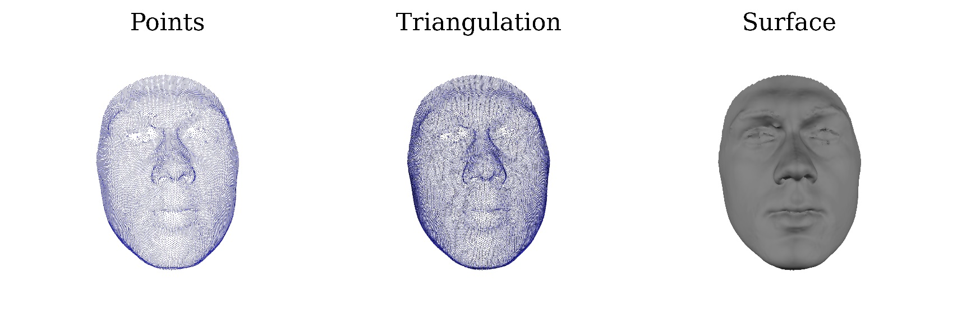**

*Figure 2.3. In a 3D image the surface is defined by a set of points. These points are triangulated to form a representation of the surface as an irregular polygon or “mesh”.*

*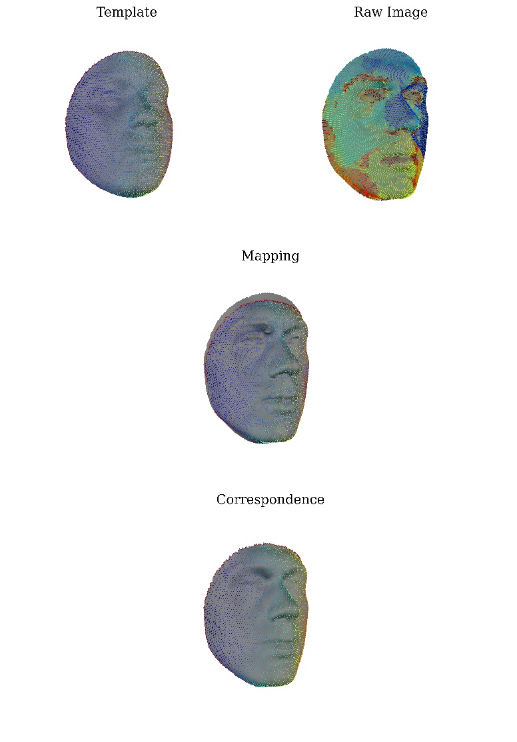*

*Figure 2.4 The top row illustrates a generic facial template (top left) and an example 3D image (top-right). The vertices of each mesh are coloured according to their index (e.g. the deepest blue vertex has an index of one). The vertices of the template are what we refer to as “quasi-landmarks”. The vertices in a raw 3D image bear no reliable relationship to the anatomy of the face. The template face is warped, or “mapped” by some algorithm (in this case the non-rigid registration developed in Claes (*[*2007*](#_ENREF_28)*)) onto the surface of the image. This establishes the correspondence between the vertices of the template and the surface of the raw image. Thus the quasi-landmarks are indicated on the raw image automatically.*

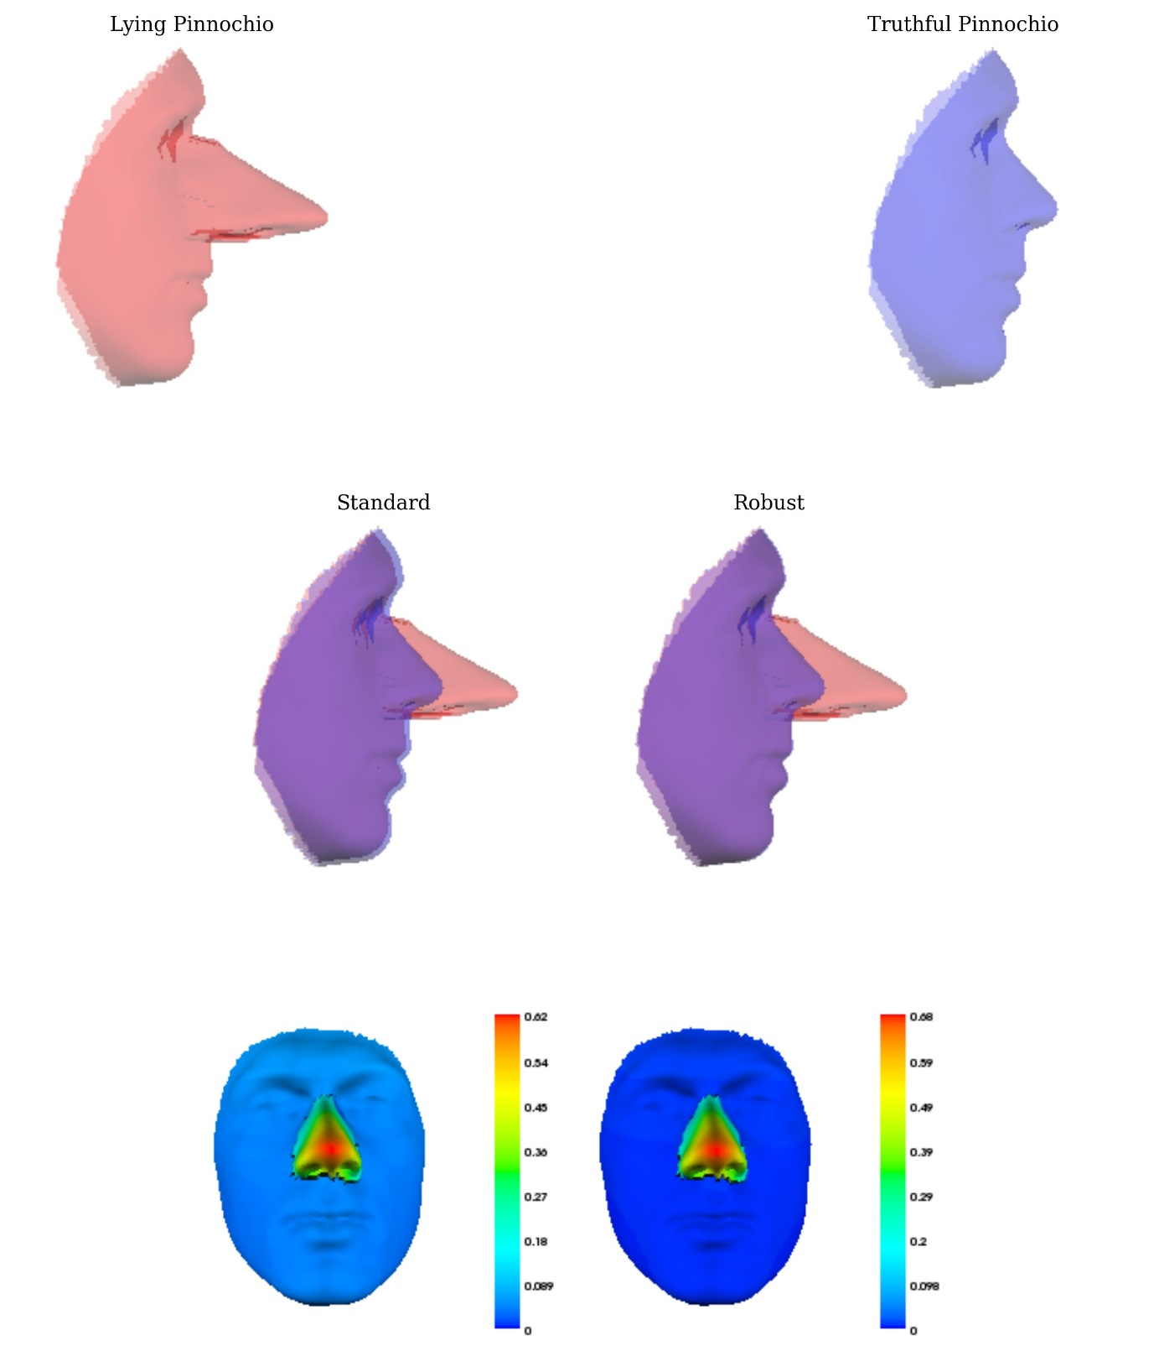

Figure . illustrates Procrustes superimposition and the Pinnochio effect. Here there are two versions of the same face. These are identical except in one (“Pinnochio lying”) the nose is abnormally extended. The middle row shows the standard and robust Procrustes alignments of the two images. In the standard case, the alignment is not accurate in that the identical regions are not perfectly aligned. In the robust cases the alignment of the identical regions is much better. The bottom row illustrates how the abnormality (the large nose) might be characterised in “distance map”. Here each point on the “Lying Pinnochio” is colour indexed to the distance between its corresponding point on the “Truthful Pinnochio”.

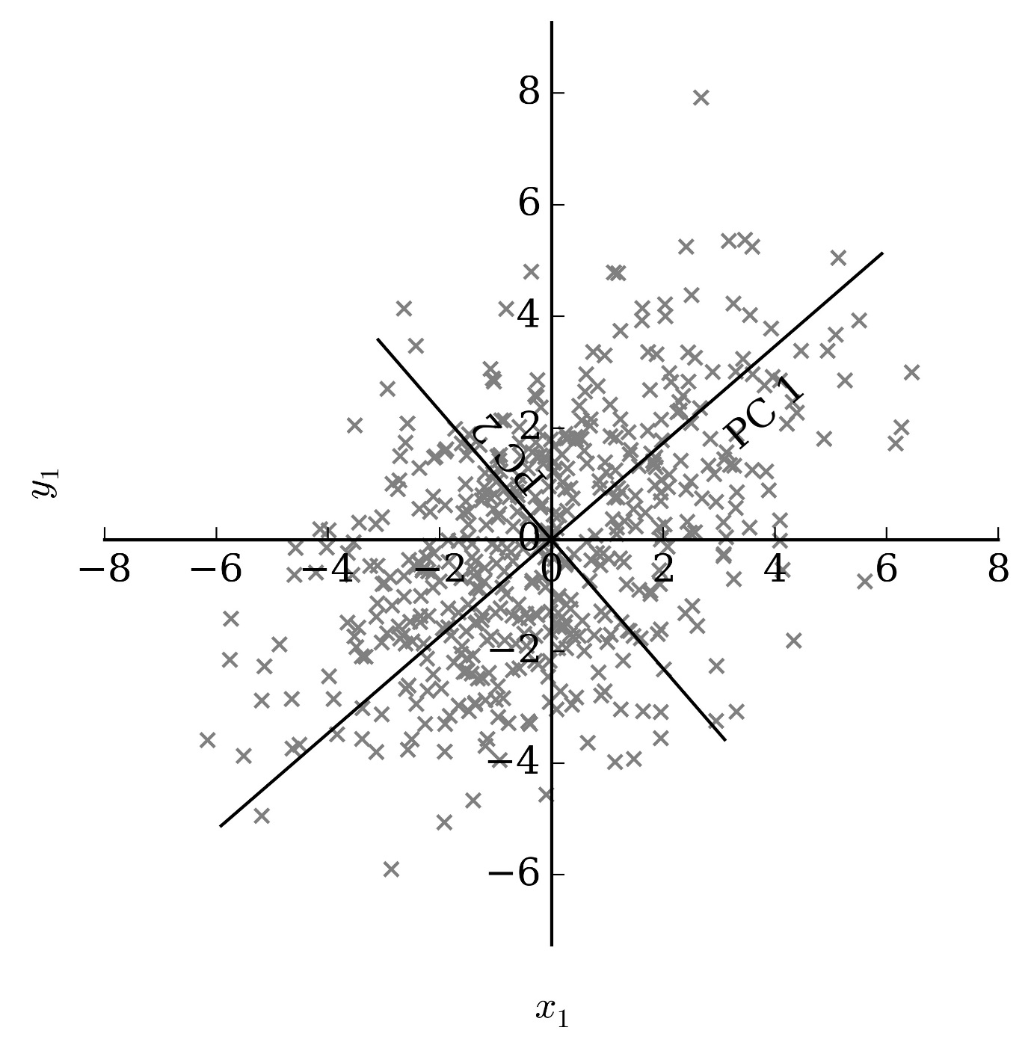

Figure . A population of shapes after Generalised Procrustes Analysis can be interpreted as a point-cloud in a multidimensional space, where each axis corresponds to a Procrustes residual. This figure shows a simulated population distributed on two axes: one corresponding to the x co-ordinate of vertex 1, the second corresponding to the y co-ordinate of vertex 1. Principal Components are mutually orthogonal directions through the point-cloud. The first PC is the direction along which the point-cloud is most stretched. The second is the direction along which the point cloud is most stretched, constrained to be orthogonal to the first.

*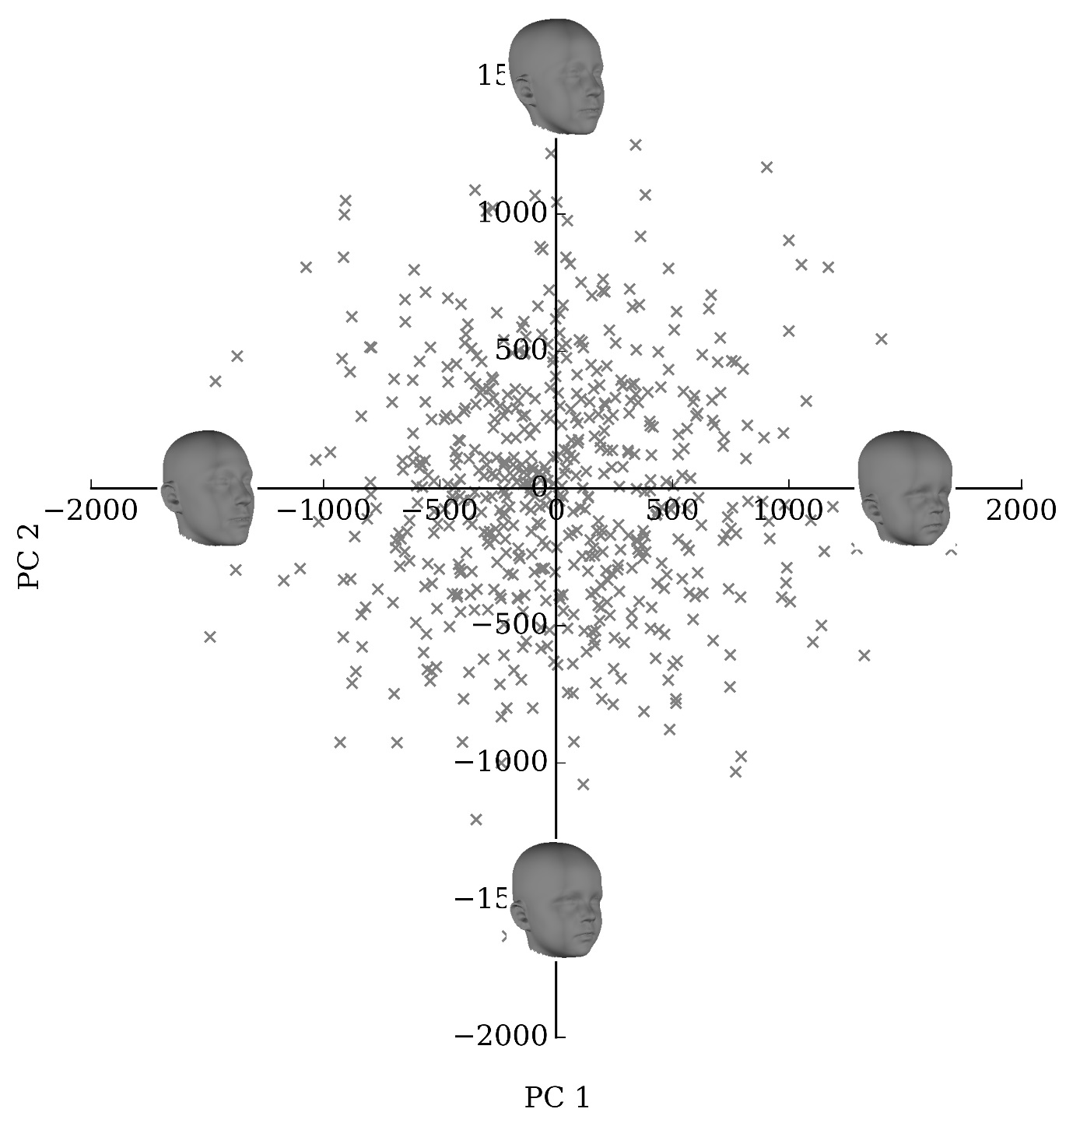*

Figure . Shows the distribution of a subsample of the normative database of the first 2 axes of the point-distribution model.

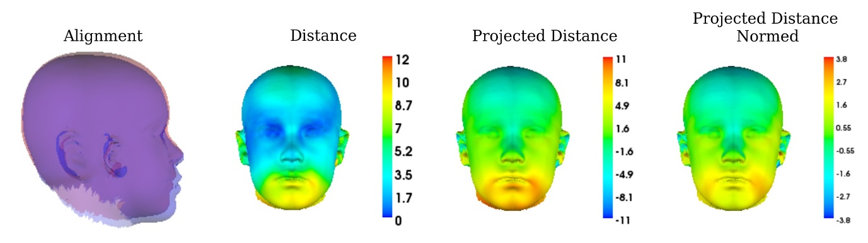

Figure . “Alignment” shows the Procrustes alignment of a face (blue) onto the sample mean (red). The sample mean can be considered a “facial archetype” of the population in question. . “Distance” shows the face, with each point colour-indexed to the distance between the two faces (colourbar units are mm). In “Projected Distance”, each point is colour indexed to the distance between the faces along the “normal” at that point on the average face (colourbar units are mm). In “Projected Distance Normed”, the projected distance is normed according to the standard deviation of distances along that normal. This is an example of Peter Hammond’s “facial signature”

*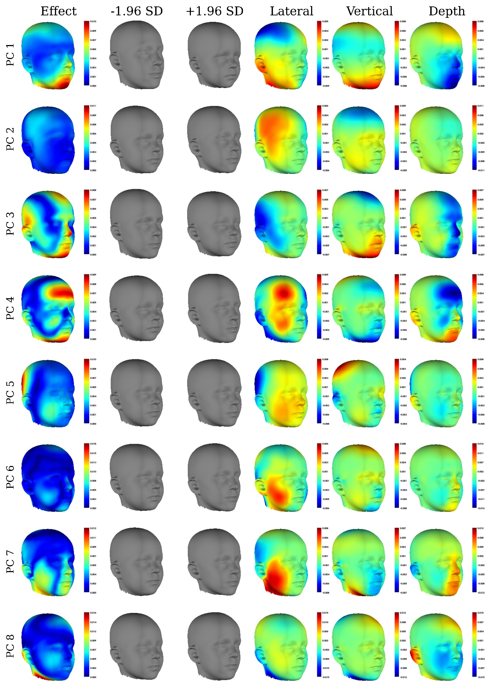*

*Figure 2.9 Illustrates the first 8 PCs based on a subsample of our normative database. The limits of normal variability are shown by the grey “morphs” consytructed at +/- 1.96 SDs. The heat-maps illustrate the regions that change the most between the morphs. These illustrate the change either in terms of the total distance (“Effect”) or the distance in the “Lateral, “Vertical” or “Depth” direction.*

*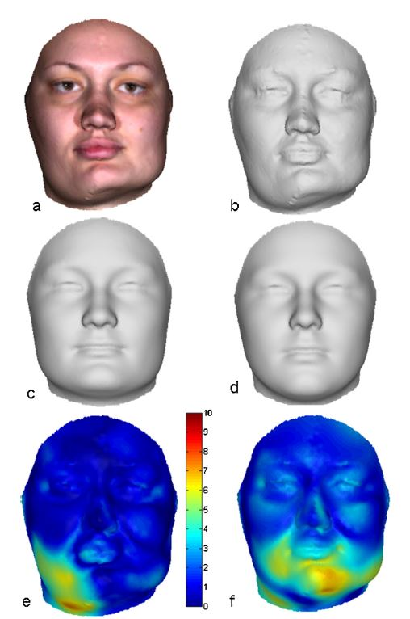*

*Figure 2.10 Borrowed temporarily from Claes et al (*[*2013*](#_ENREF_32)*). Shows a patient with hemifacial hypertrophy (a,b). A “normal equivalent” of the patient (c), the average of the normal population (d). e and f are distance maps highlighting the difference between the actual face and the normal equivalent (e) or the population average (f).*

*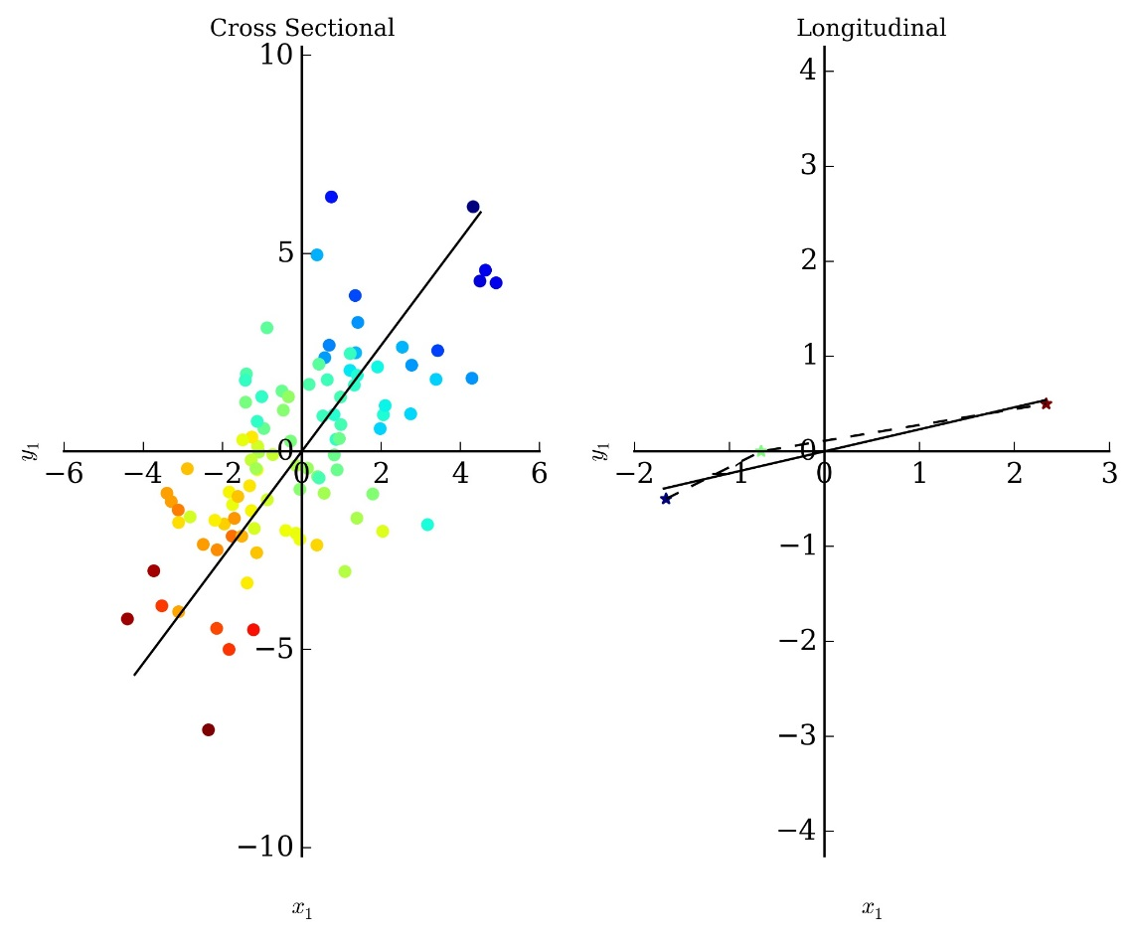*

*Figure 2.11 Determining growth trajectories from cross-sectional (left) and longitudinal (right) data. Each point represents an observation (face) in shape-space. The colour represents their age. On the left hand side each point corresponds to a different person, on the right each point is the samer person at a different age. Solid lines indicate a linear approximation of the growth trajectory estimated from the data.*

C:\Users\harry.matthews\Documents\Thesis\Ch 1\Figures\Projection_to_latent_structures(Linear).tiff

Figure . Partial least-squares regression. Blue points are actual variable values, red points are their projections, green points are their values predicted by the regression model. The vectors w and q are determined through the predictor (A) and response (B) space respectively. Projections onto these vectors (t and u) constitute a one-dimensional recoding of the X and Y variables. The vectors are determined so that the covariance between t and u is maximised. t is regressed on u (C) by oridinary least-squares regression (C). The predicted Y values are plotted in D.

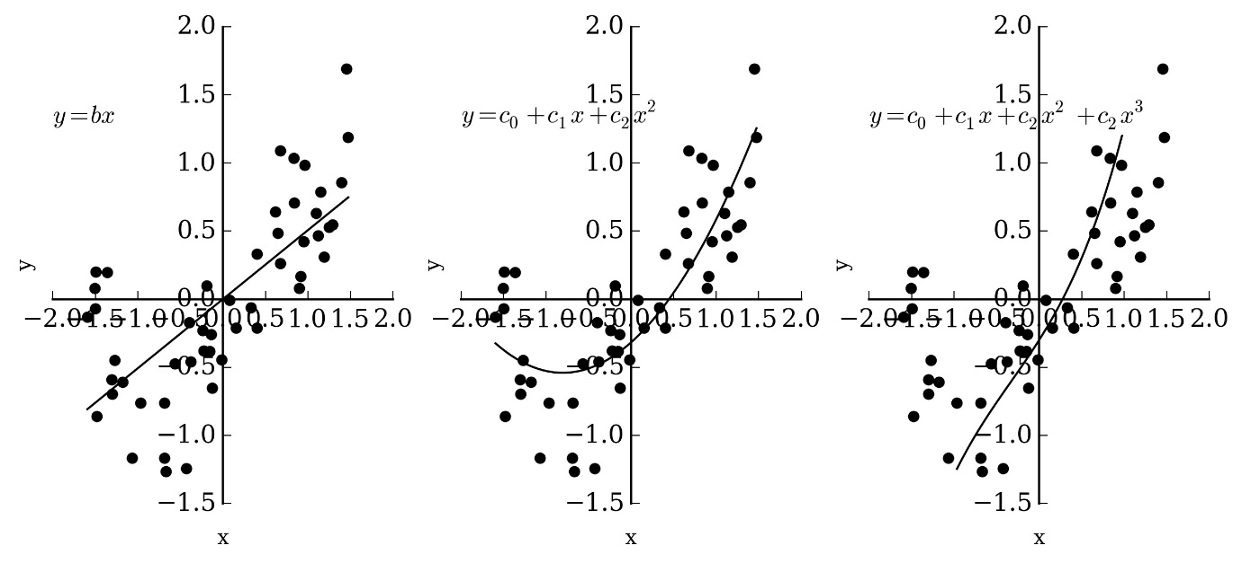

*Figure 2.13 Types of non-linear relationships. Shows a linear (left), quadratic (middle) and cubic (right) function fit to the same data.*

*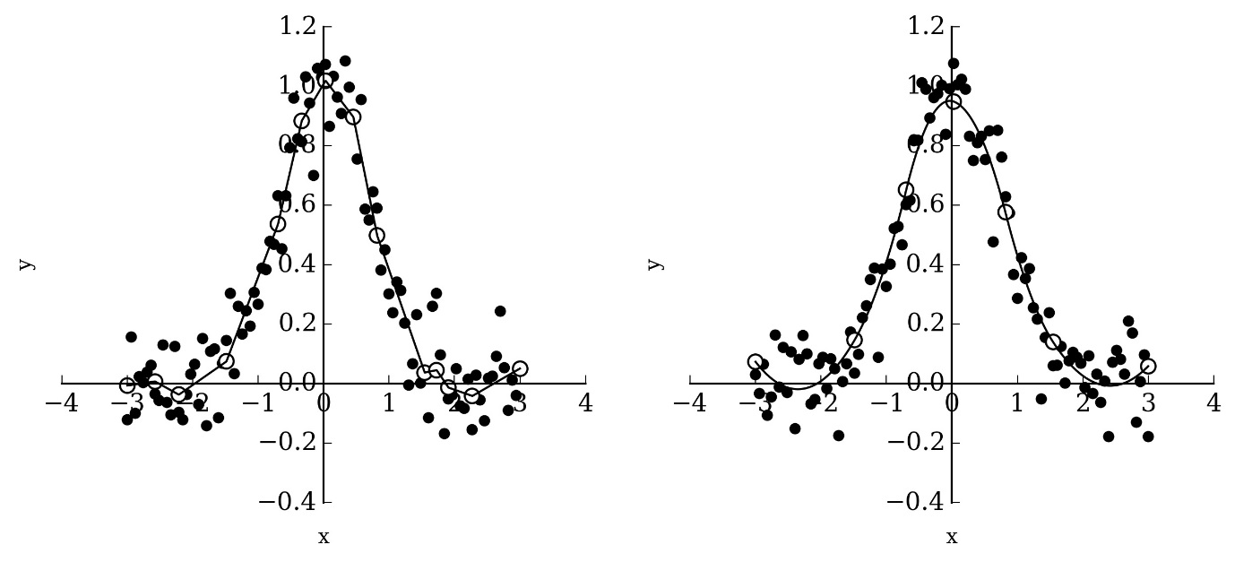*

Figure . Illustrates two spline approximations of noisy data, sampling a Gaussian relationship between x and y. Data points are black circles. Know positions are white circles. Left the relationship is approximated by multiple linear segments, right is approximated by multiple quadratic segments.

*C:\Users\harry.matthews\Documents\Thesis\Ch 1\Figures\Projection_to_latent_structures(quadratic).tiff*

*Figure 2.15 Partial least-squares regression with a quadratic inner relation. Compare to* Figure 2.12*. Blue points are actual variable values, red points are their projections, green points are their values predicted by the regression model. The vectors w and q are determined through the predictor (A) and response (B) space respectively. Projections onto these vectors (t and u) constitute a one-dimensional recoding of the X and Y variables. The vectors are determined so that the quadratic relationship between t and u is maximised. In this case the quadratic relationship is not a very good fit and these are very similar to those extracted in the linear model (*Figure 2.12*) t is regressed on u (C) by non-linear least-squares regression (C) to. The predicted Y values are plotted in D. The predicted Y values will always lie along a single vector.*

ABDI, H. 2010. Partial least squares regression and projection on latent structure regression (PLS Regression). *Wiley Interdisciplinary Reviews: Computational Statistics,* 2**,** 97-106.

ACKERMANN, R. R. & CHEVERUD, J. M. 2000. Phenotypic covariance structure in tamarins(genus Saguinus): a comparison of variation patterns using matrix correlation and common principal component analysis. *American Journal of Physical Anthropology,* 111**,** 489.

ACKERMANN, R. R. & CHEVERUD, J. M. 2004. Morphological integration in primate evolution. *In:* PIGILIUCCI, M. & PRESTON, K. (eds.) *Phenotypic Integration: Studying the Ecology and Evolution of Complex Phenotypes.* New York: Oxford University Press.

ADAMS, D. C. & CERNEY, M. M. 2007. Quantifying biomechanical motion using Procrustes motion analysis. *Journal of biomechanics,* 40**,** 437-444.

ADAMS, D. C., ROHLF, F. J. & SLICE, D. E. 2004. Geometric morphometrics: Ten years of progress following the ‘revolution’. *Italian Journal of Zoology,* 71**,** 5-16.

ALDRIDGE, K., BOYADJIEV, S., CAPONE, G., DELEON, V. & RICHTSMEIER, J. 2005. Precision and error of three-dimensional phenotypic measures acquired from 3dMD photgrammetric images. *American Journal of Medical Genetics Part A,* 138A**,** 247-253.

ALLANSON, J., O'HARA, P., FARKAS, L. & NAIR, R. 1993. Anthropometric craniofacial pattern profiles in Down syndrome. *American journal of medical genetics,* 47**,** 748-752.

ALLANSON, J. E. & COLE, T. R. 1996. Sotos syndrome: evolution of facial phenotype subjective and objective assessment. *American journal of medical genetics,* 65**,** 13-20.

ALLANSON, J. E. & HENNEKAM, R. 1997. Rubinstein‐Taybi syndrome: Objective evaluation of craniofacial structure. *American journal of medical genetics,* 71**,** 414-419.

ALLANSON, J. E., HENNEKAM, R. & IRELAND, M. 1997. De Lange syndrome: subjective and objective comparison of the classical and mild phenotypes. *Journal of medical genetics,* 34**,** 645-650.

ANDRESEN, P. R., BOOKSTEIN, F. L., COURADSEN, K., ERSBOLL, B. K., MARSH, J. L. & KREIBORG, S. 2000. Surface-bounded growth modeling applied to human mandibles. *IEEE Transactions on Medical Imaging,* 19**,** 1053-1063.

ANDRESEN, P. R. & NIELSEN, M. 2001. Non-rigid registration by geometry-constrained diffusion. *Medical Image Analysis,* 5**,** 81-88.

AYNECHI, N., LARSON, B. E., LEON-SALAZAR, V. & BEIRAGHI, S. 2011. Accuracy and precision of a 3D anthropometric facial analysis with and without landmark labeling before image acquisition. *Angle Orthod,* 81**,** 245-52.

BAER, M. J. 1973. *Growth and Maturation. An Introduction to Physical Development,* Cambidge, MA, Howard A Doyle.

BASTIR, M. & ROSAS, A. 2005. Hierarchical nature of morphological integration and modularity in the human posterior face. *Am J Phys Anthropol,* 128**,** 26-34.

BHUIYAN, Z. A., KLEIN, M., HAMMOND, P., VAN HAERINGEN, A., MANNENS, M. M., VAN BERCKELAER-ONNES, I. & HENNEKAM, R. C. 2006. Genotype-phenotype correlations of 39 patients with Cornelia De Lange syndrome: the Dutch experience. *Journal of Medical Genetics,* 43**,** 568-575.

BHULLAR, B.-A. S., MARUGÁN-LOBÓN, J., RACIMO, F., BEVER, G. S., ROWE, T. B., NORELL, M. A. & ABZHANOV, A. 2012. Birds have paedomorphic dinosaur skulls. *Nature,* 487**,** 223-226.

BLACKITH, R. E. & REYMENT, R. A. 1971. *Multivariate morphometrics,* New York, Academic Press.

BLANZ, V. & VETTER, T. A morphable model for the synthesis of 3D faces. Proceedings of the 26th annual conference on Computer graphics and interactive techniques, 1999. ACM Press/Addison-Wesley Publishing Co., 187-194.

BOOKSTEIN, F. L. 1989. Principal warps: Thin-plate splines and the decomposition of deformations. *IEEE Transactions on Pattern Analysis & Machine Intelligence***,** 567-585.

BOOKSTEIN, F. L., GUNZ, P., MITTERŒCKER, P., PROSSINGER, H., SCHÆFER, K. & SEIDLER, H. 2003. Cranial integration in Homo: singular warps analysis of the midsagittal plane in ontogeny and evolution. *Journal of Human Evolution,* 44**,** 167-187.

BRERETON, R. G. 2015a. The chi squared and multinormal distributions. *Journal of Chemometrics,* 29**,** 9-12.

BRERETON, R. G. 2015b. The Mahalanobis distance and its relationship to principal component scores. *Journal of Chemometrics,* 29**,** 143-145.

BUGHAIGIS, L., MATTICK, C., ORTH, F., TIDDEMAN, B. & HOBSON, R. 2014. 3D Facial Morphometry in Children with Oral Clefts. *The Cleft Palate-Craniofacial Journal,* 51**,** 452-461.

BULYGINA, E., MITTEROECKER, P. & AIELLO, L. 2006. Ontogeny of facial dimorphism and patterns of individual development within one human population. *American Journal of Physical Anthropology,* 131**,** 432-443.

CHEVERUD, J. M. 1989. A comparative analysis of morphological variation patterns in the papionins. *Evolution***,** 1737-1747.

CHEVERUD, J. M. 1996. Developmental integration and the evolution of pleiotropy. *American Zoologist,* 36**,** 44-50.

CLAES, P. 2007. *A robust statistical surface registration framework using implicit function representations: Application in craniofacial reconstruction.* Doctor of Philosophy, KU, Leuven.

CLAES, P., DANIELS, K., WALTERS, M., CLEMENT, J., VANDERMUELEN, D. & SUETENS, P. 2012a. Dysmorphometrics: The modelling of morphological abnormality. *Theoretical Biology and Medical Modelling,* 9.

CLAES, P., LIBERTON, D., DANIELS, K., ROSANA, K., QUILLEN, E., PEARSON, L., MCEVOY, B., BAUCHER, M., ZAIDI, A., YAO, W., TANG, H., BARSH, G., ABSHER, D., PUTS, D., ROCHA, J., BELEZA, S., PEREIRA, R., BAYNAM, G., SUETENS, P., VANDERMEULEN, D., WAGNER, J., BOSTER, J. & SHRIVER, M. 2014. Modelling 3D facial shape from DNA. *PLOS Genetics,* 10.

CLAES, P., WALTERS, M. & CLEMENT, J. 2012b. Improved facial outcome assessment using a 3D anthropometric mask. *International Journal of Oral and Maxillofacial Surgery,* 41**,** 324-330.

CLAES, P., WALTERS, M., GILLETT, D., VANDERMEULEN, D., CLEMENT, J. & SUETENS, P. 2013. The normal-equivalent: a patient-specific assessment of facial harmony. *International Journal of Oral and Maxillofacial Surgery,* 42**,** 1150-1158.

CLAES, P., WALTERS, M., VANDERMEULEN, D. & CLEMENT, J. 2011. Spatially-dense 3D facial asymmetry assessment for both typical and disordered growth. *Journal of Anatomy,* 219**,** 444-455.

COX-BRINKMAN, J., VEDDER, A., HOLLAK, C., RICHFIELD, L., MEHTA, A., ORTEU, K., WIJBURG, F. & HAMMOND, P. 2007. Three-dimensional face shape in Fabry disease. *European Journal of Human Genetics,* 15**,** 535-542.

DE ONIS, M., ONYANGO, A. W., VAN DEN BROECK, J., CHUMLEA, W. C. & MARTORELL, R. 2004. Measurement and standardization protocols for anthropometry used in the construction of a new international growth reference. *Food and Nutrition Bulletin,* 25**,** S27-36.

DEAN, D., HANS, M. G., BOOKSTEIN, F. L. & SUBRAMANYAN, K. 2000. Three-Dimensional Bolton–Brush Growth Study Landmark Data: Ontogeny and Sexual Dimorphism of the Bolton Standards Cohort. *The Cleft Palate-Craniofacial Journal,* 37**,** 145-156.

DOUGLAS, T. S., MARTINEZ, F., MEINTJES, E. M., VAUGHAN, C. L. & VILJOEN, D. L. 2003. Eye feature extraction for diagnosing the facial phenotype associated with fetal alcohol syndrome. *Medical and Biological Engineering and Computation,* 41**,** 101-6.

DRAKE, A. G. 2011. Dispelling dog dogma: an investigation of heterochrony in dogs using 3D geometric morphometric analysis of skull shape. *Evolution & development,* 13**,** 204-213.

DRYDEN, I. L. & MARDIA, K. V. 1998. *Statistical shape analysis*, Wiley Chichester.

ENLOW, D. H. & HANS, M. G. 1996. *Essentials of facial growth,* Philadelphia, WB Saunders Company.

ENLOW, D. H., MOYERS, R. E., HUNTER, W. S. & MCNAMARA, J. A., JR. 1969. A procedure for the analysis of intrinsic facial form and growth. An equivalent-balance concept. *American Journal of Orthodontics,* 56**,** 6-23.

EVANKO, A. M., FREEMAN, K. & CISNEROS, G. J. 1997. Mesh diagram analysis: developing a norm for Puerto Rican Americans. *The Angle Orthodontist,* 67**,** 381-388.

FAGERTUN, J., HARDER, S., ROSENGREN, A., MOELLER, C., WERGE, T., PAULSEN, R. R. & HANSEN, T. F. 2014. 3D facial landmarks: Inter-operator variability of manual annotation. *BMC medical imaging,* 14**,** 35.

FARKAS, L. 1994a. Examination. *In:* FARKAS, L. (ed.) *Anthropometry of the Head and Face.* 2nd ed. New York: Raven Press.

FARKAS, L. 1994b. Sources of error in anthropometry and anthroposcopy. *In:* FARKAS, L. (ed.) *Anthropometry of the Head and Face.* 2nd ed. New York: Raven Press.

FARKAS, L., MUNRO, I. & KOLAR, J. 1985. Abnormal measurements and disproportions in the face of Down's syndrome patients: preliminary report of an anthropometric study. *Plastic and reconstructive surgery,* 75**,** 159-167.

FARKAS, L. G. 1994c. *Anthropometry of the Head and Face*, Raven Press.

FARKAS, L. G. 1996. Accuracy of anthropometric measurements: past, present, and future. *The Cleft palate-craniofacial journal,* 33**,** 10-22.

FARKAS, L. G. & DEUTSCH, C. K. 1996. Anthropometric determination of craniofacial morphology. *American Journal of Medical Genetics,* 65**,** 1-4.

FARKAS, L. G., HRECZKO, T. M., KATIC, M. J. & FORREST, C. R. 2003. Proportion indices in the craniofacial regions of 284 healthy North American white children between 1 and 5 years of age. *J ournal of Craniofacial Surgery,* 14**,** 13-28.

FARKAS, L. G., KATIC, M. J., FORREST, C. R. & LITSAS, L. 2001. Surface anatomy of the face in Down's syndrome: linear and angular measurements in the craniofacial regions. *Journal of Craniofacial Surgery,* 12**,** 373-379.

FARKAS, L. G., POSNICK, J. C., HRECZKO, T. M. & PRON, G. E. 1992. Growth patterns of the nasolabial region: a morphometric study. *The Cleft Palate-Craniofacial Journal,* 29**,** 318-324.

FEIK, S. A. & GLOVER, J. E. 1998. Growth of children's faces. *In:* CLEMENT, J. G. & RANSON, D. L. (eds.) *Craniofacial Identification in Forensic Medicine.* London : Arnold ; New York : Oxford University Press, 1998.

FERRARIO, V. F., DELLAVIA, C., ZANOTTI, G. & SFORZA, C. 2004. Soft tissue facial anthropometry in Down syndrome subjects. *Journal of Craniofacial Surgery,* 15**,** 528-532.

FERRARIO, V. F., SFORZA, C., POGGIO, C. E., COVA, M. & TARTAGLIA, G. 1998a. Preliminary evaluation of an electromagnetic three-dimensional digitizer in facial anthropometry. *The Cleft Palate-Craniofacial Journal,* 35**,** 9-15.

FERRARIO, V. F., SFORZA, C., SCHMITZ, J. H., MIANI, A. & SERRAO, G. 1998b. A three-dimensional computerized mesh diagram analysis and its application in soft tissue facial morphometry. *American journal of orthodontics and dentofacial orthopedics,* 114**,** 404-413.

FERRARIO, V. F., SFORZA, C., SERRAO, G., CIUSA, V. & DELLAVIA, C. 2003. Growth and aging of facial soft tissues: A computerized three‐dimensional mesh diagram analysis. *Clinical Anatomy,* 16**,** 420-433.

FORSYTH, D. B. & DAVIS, D. N. 1996. Assessment of an automated cephalometric analysis system. *European Journal of Orthodontics,* 18**,** 471-8.

FRANK, I. E. 1990. A nonlinear PLS model. *Chemometrics and intelligent laboratory systems,* 8**,** 109-119.

FROST, S. R., MARCUS, L. F., BOOKSTEIN, F. L., REDDY, D. P. & DELSON, E. 2003. Cranial allometry, phylogeography, and systematics of large‐bodied papionins (primates: Cercopithecinae) inferred from geometric morphometric analysis of landmark data. *The Anatomical Record Part A: Discoveries in Molecular, Cellular, and Evolutionary Biology,* 275**,** 1048-1072.

GARN, S. M., LAVELLE, M. & SMITH, B. H. 1985. Quantification of dysmorphogenesis: pattern variability index, sigma z. *American journal of roentgenology,* 144**,** 365-369.

GARN, S. M., SMITH, B. H. & LAVELLE, M. 1984. Applications of pattern profile analysis to malformations of the head and face. *Radiology,* 150**,** 683-90.

GELADI, P. & KOWALSKI, B. R. 1986. Partial least-squares regression: a tutorial. *Analytica chimica acta,* 185**,** 1-17.

GOSWAMI, A. 2006. Cranial modularity shifts during mammalian evolution. *The American Naturalist,* 168**,** 270-80.

GOSWAMI, A. 2007. Phylogeny, diet, and cranial integration in australodelphian marsupials. *PLoS One,* 2**,** e995.

GOWER, J. C. 1975. Generalized Procrustes analysis. *Psychometrika,* 40**,** 33-51.

GUYOT, L., DUBUC, M., PUJOL, J., DUTOUR, O. & PHILIP, N. 2001. Craniofacial anthropometric analysis in patients with 22q11 microdeletion. *American journal of medical genetics,* 100**,** 1-8.

HAMMOND, P. 2007. The use of 3D face shape modelling in dysmorphology. *Archives of Disease in Childhood,* 92**,** 1120-1126.

HAMMOND, P., HANNES, F., SUTTIE, M., DEVRIENDT, K., VERMEESCH, J. R., FARAVELLI, F., FORZANO, F., PAREKH, S., WILLIAMS, S. & MCMULLAN, D. 2012a. Fine-grained facial phenotype–genotype analysis in Wolf–Hirschhorn syndrome. *European Journal of Human Genetics,* 20**,** 33-40.

HAMMOND, P., HUTTON, T. J., ALLANSON, J. E., CAMPBELL, L. E., HENNEKAM, R., HOLDEN, S., PATTON, M. A., SHAW, A., TEMPLE, I. K. & TROTTER, M. 2004. 3D analysis of facial morphology. *American Journal of Medical Genetics Part A,* 126**,** 339-348.

HAMMOND, P. & SUTTIE, M. 2012. Large‐scale objective phenotyping of 3D facial morphology. *Human mutation,* 33**,** 817-825.

HAMMOND, P., SUTTIE, M., HENNEKAM, R. C., ALLANSON, J., SHORE, E. M. & KAPLAN, F. S. 2012b. The face signature of fibrodysplasia ossificans progressiva. *American Journal of Medical Genetics Part A,* 158**,** 1368-1380.

HARRIS, S. M. & ROSS, A. H. 2008. Detecting an undiagnosed case of nonsyndromic facial dysmorphism using geometric morphometrics. *Journal of forensic sciences,* 53**,** 1308-1312.

HENNESSY, R. J., MCLEARIE, S., KINSELLA, A. & WADDINGTON, J. L. 2005. Facial surface analysis by 3D laser scanning and geometric morphometrics in relation to sexual dimorphism in cerebral–craniofacial morphogenesis and cognitive function. *Journal of Anatomy,* 207**,** 283-295.

HUNTER, A. G. 1996. Craniofacial anthropometric analysis in several types of chondrodysplasia. *American journal of medical genetics,* 65**,** 5-12.

HURWITZ, D. J., ASHBY, E. R., LLULL, R., PASQUAL, J., TABOR, C., GARRISON, L., GILLEN, J. & WEYANT, R. 1999. Computer-assisted anthropometry for outcome assessment of cleft lip. *Plastic and Reconstructive Surgery,* 103**,** 1608-1623.

HUTTON, T. J., BUXTON, B. F. & HAMMOND, P. Dense surface point distribution models of the human face. IEEE International Conference on Computer Vision and Pattern Recognition, 2001 Kauai, Hawaii. IEEE, 153-160.

HUTTON, T. J., BUXTON, B. F. & HAMMOND, P. Automated Registration of 3D Faces using Dense Surface Models. BMVC, 2003a. Citeseer, 1-10.

HUTTON, T. J., BUXTON, B. F., HAMMOND, P. & POTTS, H. W. 2003b. Estimating average growth trajectories in shape-space using kernel smoothing. *IEEE Transactions on Medical Imaging,* 22**,** 747-753.

KAU, C., ZHUROV, A., RICHMOND, S., CRONIN, A., SAVIO, C. & MALLORIE, C. 2006a. Facial templates: A new perspective in three dimensions. *Orthodontics and Craniofacial Research,* 9**,** 10-17.

KAU, C. H., RICHMOND, S., INCRAPERA, A., ENGLISH, J. & XIA, J. J. 2007. Three‐dimensional surface acquisition systems for the study of facial morphology and their application to maxillofacial surgery. *The International Journal of Medical Robotics and Computer Assisted Surgery,* 3**,** 97-110.

KAU, C. H., RICHMOND, S., ZHUROV, A., OVSENIK, M., TAWFIK, W., BORBELY, P. & ENGLISH, J. D. 2010. Use of 3-dimensional surface acquisition to study facial morphology in 5 populations. *American Journal of Orthodontics and Dentofacial Orthopedics,* 137**,** S56. e1-S56. e9.

KAU, C. H., ZHUROV, A., RICHMOND, S., BIBB, R., SUGAR, A., KNOX, J. & HARTLES, F. 2006b. The 3-dimensional construction of the average 11-year-old child face: a clinical evaluation and application. *Journal of oral and maxillofacial surgery,* 64**,** 1086-1092.

KENT, J. T., MARDIA, K. V., MORRIS, R. J. & AYKROYD, R. G. Procrustes growth models for shape. Proceedings of the First Joint Statistical Meeting New Delhi, India, 2000. 236-238.

KENT, J. T., MARDIA, K. V., MORRIS, R. J. & AYKROYD, R. G. 2001. Functional models of growth for landmark data. *Proceedings in Functional and Spatial Data Analysis***,** 109-115.

KLINGENBERG, C. P. 2008. Morphological integration and developmental modularity. *Annual review of ecology, evolution, and systematics***,** 115-132.

KLINGENBERG, C. P. 2009. Morphometric integration and modularity in configurations of landmarks: tools for evaluating a priori hypotheses. *Evolution & Development,* 11**,** 405-421.

KLINGENBERG, C. P., NEUENSCHWANDER, B. E. & FLURY, B. D. 1996. Ontogeny and individual variation: analysis of patterned covariance matrices with common principal components. *Systematic Biology,* 45**,** 135-150.

KLINGENBERG, C. P. & ZIMMERMANN, M. 1992. Static, ontogenetic, and evolutionary allometry: a multivariate comparison in nine species of water striders. *American Naturalist***,** 601-620.

KOUDELOVÁ, J., BRŮŽEK, J., CAGÁŇOVÁ, V., KRAJÍČEK, V. & VELEMÍNSKÁ, J. 2015. Development of facial sexual dimorphism in children aged between 12 and 15 years: A three‐dimensional longitudinal study. *Orthodontics & Craniofacial Research,* 18**,** 175-184.

LELE, S. 1993. Euclidean distance matrix analysis (EDMA): estimation of mean form and mean form difference. *Mathematical Geology,* 25**,** 573-602.

LEVY-MANDEL, A., VENETSANOPOULOS, A. & TSOTSOS, J. 1986. Knowledge-based landmarking of cephalograms. *Computers and Biomedical Research,* 19**,** 282-309.

LIEBERMAN, D. E., CARLO, J., DE LEÓN, M. P. & ZOLLIKOFER, C. P. 2007. A geometric morphometric analysis of heterochrony in the cranium of chimpanzees and bonobos. *Journal of Human Evolution,* 52**,** 647-662.

LORENZ, C. & KRAHNSTÖVER, N. 2000. Generation of Point-Based 3D Statistical Shape Models for Anatomical Objects. *Computer Vision and Image Understanding,* 77**,** 175-191.

LOY, A., BERTELLETTI, M., COSTA, C., FERLIN, L. & CATAUDELLA, S. 2001. Shape changes and growth trajectories in the early stages of three species of the genus Diplodus (Perciformes, Sparidae). *Journal of Morphology,* 250**,** 24-33.

MAHALANOBIS, P. C. 1936. On the generalized distance in statistics. *Proceedings of the National Institute of Sciences (Calcutta),* 2**,** 49-55.

MARCUS, J. R., DOMESHEK, L. F., LOYD, A. M., SCHOENLEBER, J. M., DAS, R. R., NIGHTINGALE, R. W. & MUKUNDAN JR, S. 2009. Use of a three-dimensional, normative database of pediatric craniofacial morphology for modern anthropometric analysis. *Plastic and Reconstructive Surgery,* 124**,** 2076-2084.

MARCUS, L. F. Traditional morphometrics. Proceedings of the Michigan morphometrics workshop, 1990. Special Publication, 77ą122.

MARROIG, G. & CHEVERUD, J. M. 2001. A comparison of phenotypic variation and covariation patterns and the role of phylogeny, ecology, and ontogeny during cranial evolution of New World monkeys. *Evolution,* 55**,** 2576-2600.

MATTHEWS, H., PENINGTON, T., SAEY, I., HALLIDAY, J., MUGGLI, E. & CLAES, P. under review. Spatially dense morphometrics of craniofacial sexual dimorphism in one year-olds. *Journal of Anatomy*.

MITTEROECKER, P. & BOOKSTEIN, F. 2009. The ontogenetic trajectory of the phenotypic covariance matrix, with examples from craniofacial shape in rats and humans. *Evolution,* 63**,** 727-737.

MITTEROECKER, P., GUNZ, P., BERNHARD, M., SCHAEFER, K. & BOOKSTEIN, F. L. 2004a. Comparison of cranial ontogenetic trajectories among great apes and humans. *Journal of Human Evolution,* 46**,** 679-698.

MITTEROECKER, P., GUNZ, P. & BOOKSTEIN, F. L. 2005. Heterochrony and geometric morphometrics: a comparison of cranial growth in Pan paniscus versus Pan troglodytes. *Evolution & development,* 7**,** 244-258.

MITTEROECKER, P., GUNZ, P., WEBER, G. & BOOKSTEIN, F. 2004b. Regional dissociated heterochrony in multivariate analysis. *Annals of Anatomy-Anatomischer Anzeiger,* 186**,** 463-470.

MONTEIRO, L. R. 1999. Multivariate regression models and geometric morphometrics: the search for causal factors in the analysis of shape. *Systematic Biology***,** 192-199.

MONTEIRO, L. R., BONATO, V. & DOS REIS, S. F. 2005. Evolutionary integration and morphological diversification in complex morphological structures: mandible shape divergence in spiny rats (Rodentia, Echimyidae). *Evolution and Development,* 7**,** 429-39.

MOORREES, C. F. & LEBRET, L. 1962. The mesh diagram and cephalometrics. *The Angle Orthodontist,* 32**,** 214-231.

MOORREES, C. F., VAN VENROOIJ, M. E., LEBRET, L. M., GLATKY, C. B., KENT, R. L. & REED, R. B. 1976. New norms for the mesh diagram analysis. *American journal of orthodontics,* 69**,** 57-71.

MORRIS, R., KENT, J., MARDIA, K. & AYKROYD, R. 2000. A parallel growth model for shape. *Proceedings Medical Imaging Understanding and Analysis 2000***,** 171-174.

MOSS, M. L. & YOUNG, R. W. 1960. A functional approach to craniology. *American Journal of Physical Anthropology,* 18**,** 281-92.

NEUBAUER, S., GUNZ, P. & HUBLIN, J. J. 2009. The pattern of endocranial ontogenetic shape changes in humans. *Journal of Anatomy,* 215**,** 240-255.

OLSON, E. C. & MILLER, R. L. 1958. *Morphological Integration,* Chicago, University of Chicago Press.

PARTHASARATHY, S., NUGENT, S. T., GREGSON, P. G. & FAY, D. F. 1989. Automatic landmarking of cephalograms. *Computers and, Biomedical Research,* 22**,** 248-69.

PIRAS, P., EVANGELISTA, A., GABRIELE, S., NARDINOCCHI, P., TERESI, L., TORROMEO, C., SCHIARITI, M., VARANO, V. & PUDDU, P. E. 2014. 4D-analysis of left ventricular heart cycle using Procrustes motion analysis. *PLoS One,* 9.

REN, J., LIU, D., FENG, D., SHAO, J., ZHAO, R., LIAO, Y. & LIN, Z. A knowledge-based automatic cephalometric analysis method. Proceedings of the 20th Annual International Conference of the IEEE Engineering in Medicine and Biology Society, 1998. IEEE, 723-727.

RICHTSMEIER, J. T., BURKE DELEON, V. & LELE, S. R. 2002. The promise of geometric morphometrics. *American Journal of Physical Anthropology,* 119**,** 63-91.

RICHTSMEIER, J. T., PAIK, C. H., ELFERT, P. C., COLE III, T. M. & DAHLMAN, H. R. 1995. Precision, repeatability, and validation of the localization of cranial landmarks using computed tomography scans. *The Cleft Palate-Craniofacial Journal,* 32**,** 217-227.

ROB, L. 2013. *Non-linear models for studying facial growth.* Master of Science in Biomedical engineering, KU Leuven.

ROHLF, F. J. & MARCUS, L. F. 1993. A revolution in morphometrics. *Trends in Ecology & Evolution,* 8**,** 129-132.

RUDOLPH, D., SINCLAIR, P. & COGGINS, J. 1998. Automatic computerized radiographic identification of cephalometric landmarks. *American Journal of Orthodontics and Dentofacial Orthopedics,* 113**,** 173-179.

RUDOLPH, D. J., COGGINS, J. M. & MOON, H. 1997. Investigation of filter sets for supervised pixel classification of cephalometric landmarks by spatial spectroscopy. *International Journal of Medical Informatics,* 47**,** 183-91.

SHAWEESH, A., CLEMENT, J., THOMAS, C. & BANKIER, A. 2006. Construction and use of facial archetypes in anthropology and syndrome diagnosis. *Forensic science international,* 159**,** S175-S185.

SMITH, K. K. 2001. Heterochrony revisited: the evolution of developmental sequences. *Biological Journal of the Linnean Society,* 73**,** 169-186.

SNYDERS, J., CLAES, P., VANDERMEULEN, D. & SUETENS, P. 2014. Development and comparison of non-rigid surface registration and extensions.

SOUZA, A. D. A., RUIZ, E. E. S. & CRUZ, A. A. V. 2000. Palpebral fissure morphology segmentation measurement using image processing. *Engineering in Medicine and Biology Magazine, IEEE,* 19**,** 114-119.

TANIKAWA, C., ZERE, E. & TAKADA, K. 2015. Sexual dimorphism in the facial morphology of adult humans: A three-dimensional analysis. *HOMO-Journal of Comparative Human Biology*.

TOMA, A. M., ZHUROV, A., PLAYLE, R., ONG, E. & RICHMOND, S. 2009. Reproducibility of facial soft tissue landmarks on 3D laser‐scanned facial images. *Orthodontics & craniofacial research,* 12**,** 33-42.

TONG, W., NUGENT, S., JENSEN, G. & FAY, D. An algorithm for locating landmarks on dental X-rays. Images of the Twenty-First Century. Proceedings of the Annual International Conference of the IEEE Engineering in Medicine and Biology Society, 1989 Seattle WA. IEEE, 552-554.

VIGNON, M. 2012. Ontogenetic trajectories of otolith shape during shift in habitat use: Interaction between otolith growth and environment. *Journal of Experimental Marine Biology and Ecology,* 420**,** 26-32.

WARD, R. E., JAMISON, P. L. & FARKAS, L. G. 1998. Craniofacial variability index: a simple measure of normal and abnormal variation in the head and face. *American Journal of Medical Genetics,* 80**,** 232-240.

WEI, R., CLAES, P., WALTERS, M., WHOLLEY, C. & CLEMENT, J. 2011. Augmentation of linear facial anthropometrics through modern morphometrics: a facial convexity example. *Australian dental journal,* 56**,** 141-147.

WEINBERG, S. M. & KOLAR, J. C. 2005. Three-dimensional surface imaging: limitations and considerations from the anthropometric perspective. *Journal of Craniofacial Surgery,* 16**,** 847-851.

WEINBERG, S. M., NAIDOO, S., GOVIER, D. P., MARTIN, R. A., KANE, A. A. & MARAZITA, M. L. 2006. Anthropometric precision and accuracy of digital three-dimensional photogrammetry: comparing the Genex and 3dMD imaging systems with one another and with direct anthropometry. *Journal of Craniofacial Surgery,* 17**,** 477-483.

WEINBERG, S. M., NEISWANGER, K., RICHTSMEIER, J. T., MAHER, B. S., MOONEY, M. P., SIEGEL, M. I. & MARAZITA, M. L. 2008. Three-dimensional morphometric analysis of craniofacial shape in the unaffected relatives of individuals with nonsyndromic orofacial clefts: a possible marker for genetic susceptibility. *American Journal of Medical Genetics,* 146A**,** 409-20.

WEINBERG, S. M., SCOTT, N. M., NEISWANGER, K., BRANDON, C. A. & MARAZITA, M. L. 2004. Digital three-dimensional photogrammetry: evaluation of anthropometric precision and accuracy using a Genex 3D camera system. *The Cleft Palate-Craniofacial Journal,* 41**,** 507-518.

WOLD, S. 1992. Nonlinear partial least squares modelling II. Spline inner relation. *Chemometrics and Intelligent Laboratory Systems,* 14**,** 71-84.

WOLD, S., KETTANEH-WOLD, N. & SKAGERBERG, B. 1989. Nonlinear PLS modeling. *Chemometrics and Intelligent Laboratory Systems,* 7**,** 53-65.

YOKOGAWA, Y., FUNABIKI, N., HIGASHINO, T., ODA, M. & MORI, Y. 2007. A proposal of improved lip contour extraction method using deformable template matching and its application to dental treatment. *Systems and Computers in Japan,* 38**,** 80-89.

YOUNG, N. M., WAT, S., DIEWERT, V. M., BROWDER, L. W. & HALLGRIMSSON, B. 2007. Comparative morphometrics of embryonic facial morphogenesis: Implications for cleft‐lip etiology. *The Anatomical Record,* 290**,** 123-139.

ZELDITCH, M. L. & FINK, W. L. 1995. Allometry and developmental integration of body growth in a piranha, Pygocentrus nattereri (Teleostei: Ostariophysi). *Journal of Morphology,* 223**,** 341-355.

ZELDITCH, M. L., SWIDERSKI, D. L. & SHEETS, H. D. 2004. *Geometric Morphometrics for Biologists: A Primer,* New York, Academic Press.

ZHU, D., MOORE, S. T. & RAPHAN, T. 1999. Robust pupil center detection using a curvature algorithm. *Computer methods and programs in biomedicine,* 59**,** 145-157.