*Figures and Tables*

MeshMonk: open-source large-scale intensive 3D phenotyping

Julie D. White1*, Alejandra Ortega-Castrillón2,3, Harold Matthews4,5,6, Arslan A. Zaidi1,7, Omid Ekrami8, Jonatan Snyders9, Yi Fan4,5,10, Tony Penington4,5,6, Stefan Van Dongen8, Mark D. Shriver1, Peter Claes2,3*

**\* Correspondence:**jdw345@psu.edu; peter.claes@kuleuven.be

**1 Figures**

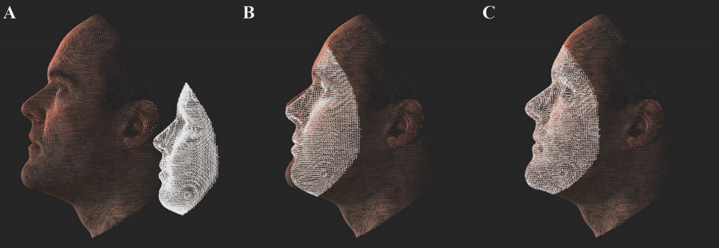

**Figure 1. Depiction of MeshMonk registration process.** **(A)** The target face and anthropometric mask are separated and not necessarily aligned in space or scale. **(B)** The anthropometric mask is scaled to fit the target face and is matched with the target face using a rigid registration algorithm. **(C)** The anthropometric mask is further modified to fit the target face using a nonrigid registration that allows for fine adjustment.

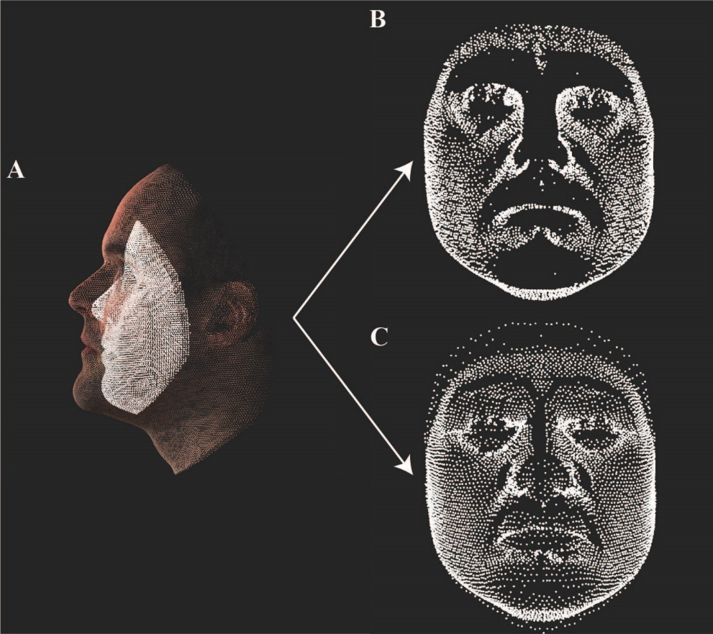

**Figure 2. Nonsymmetric vs. Symmetric alignment.** **(A)** The registration of the anthropometric mask to the target face, stopped prior to the completion of the rigid registration step. **(B)** Illustration of registration using a nonsymmetric alignment. **(C)** Illustration of registration using a symmetric alignment. Dark areas in **(B)** and **(C)** represent parts of the target face that have no correspondence on the anthropometric mask.

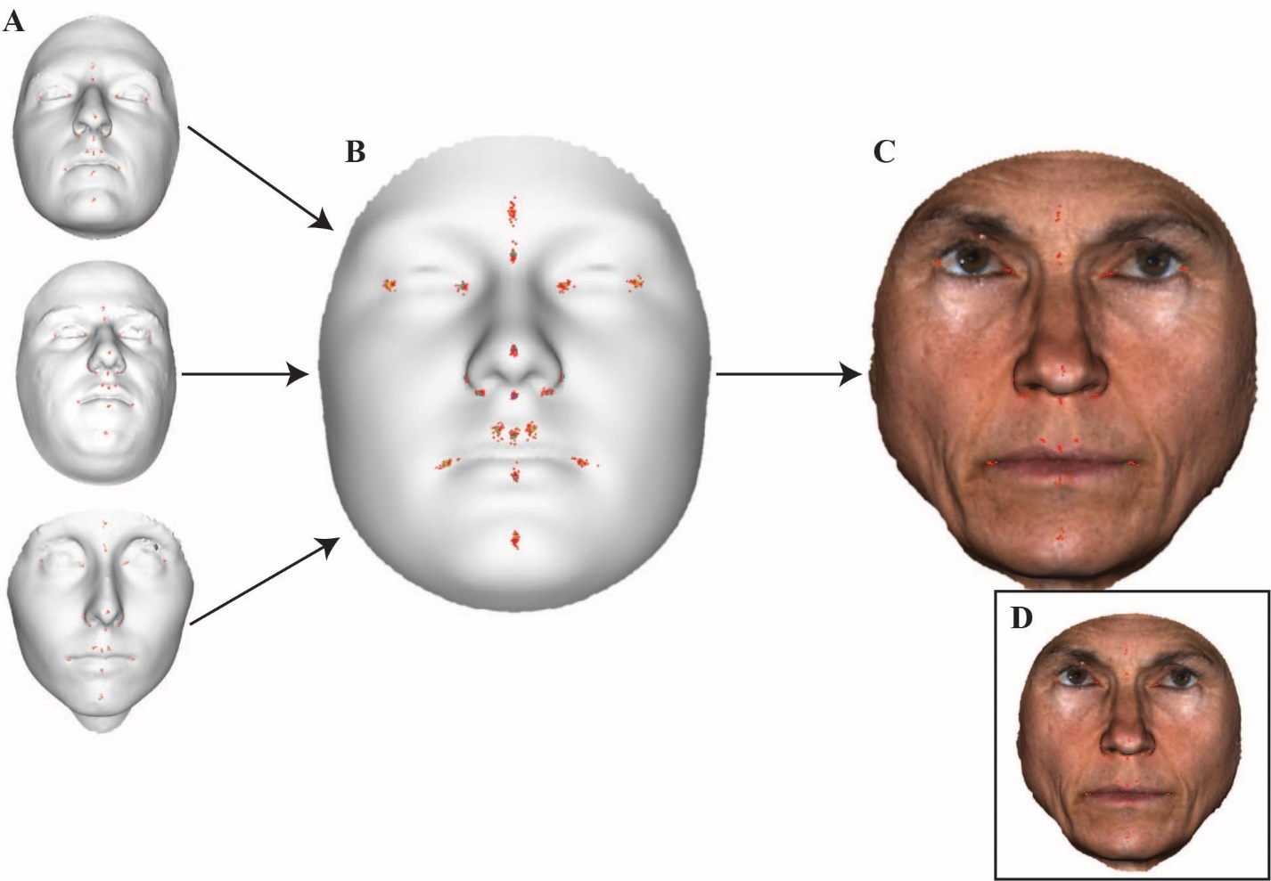

**Figure 3. Depiction of automatic landmark indication. (A)** Each facial scan was manually landmarked six times, three times each by two observers. These iterations were then averaged together and are placed on the anthropometric mask, except the landmark indications corresponding to the test face. **(B)** Placement of N=40 manual landmark indications on the anthropometric mask, leaving out the test face. The average of all 40 placements is shown as a colored point, which is colored based on the level of dispersion between the average and the manually placed indications for that landmark. **(C)** The average of all 40 placements of manual landmarks is indicated on the test face, serving as the automatic landmark indication. **(D)** The manual landmark indications for the shown example face, for comparison to the automatic indication in **(C)**.

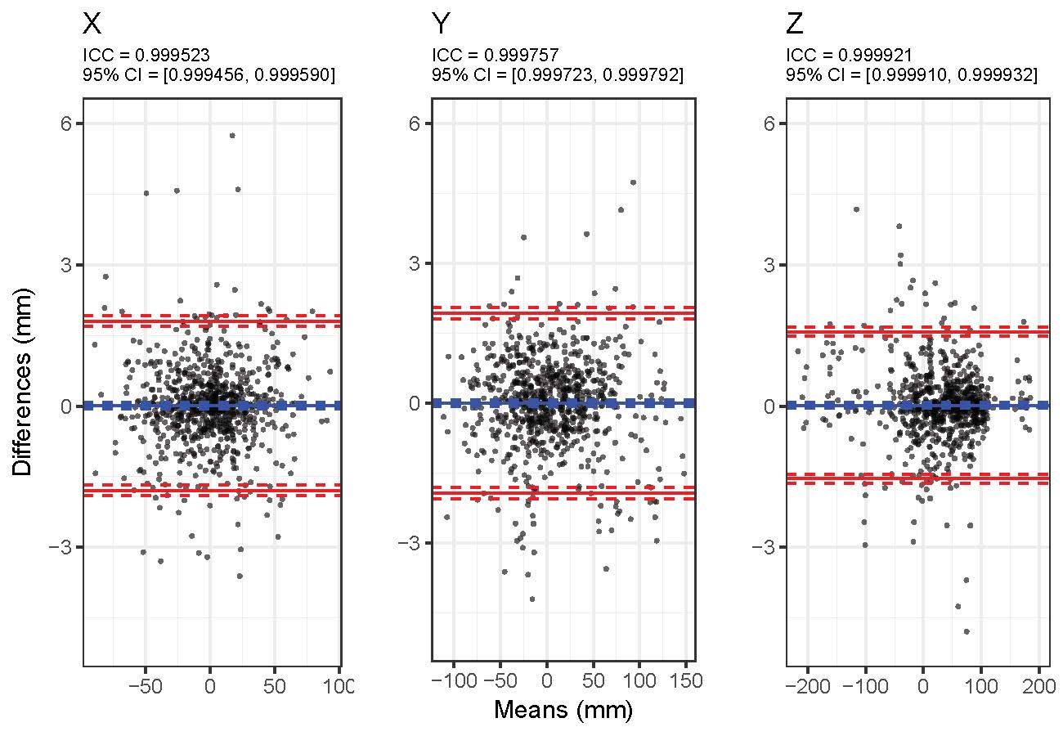

**Figure 4. Bland-Altman plot for similarity between manual and automatic landmark placements.** For *x*, *y*, and *z*, Bland-Altman plot showing the differences between the manual and automatic landmark indications, using the global average of all manual landmarks, against the averages of the two techniques. Blue lines represent the mean difference value and red lines represent the upper and lower 95% confidence limits. Also given are the intra-class correlation coefficient with ICC 95% confidence interval.

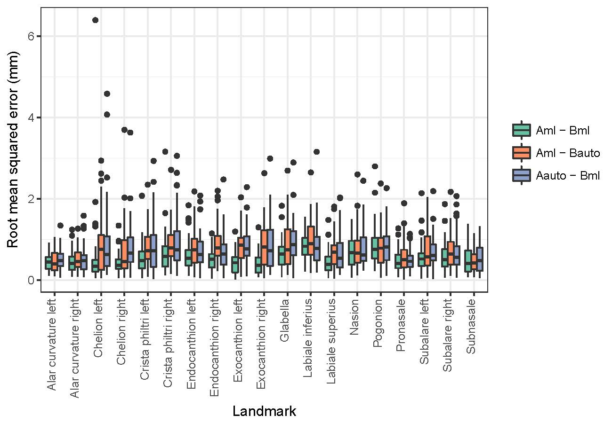

**Figure 5. Comparison of inter-observer errors.** RMSE values calculated using both manual landmarks, and after replacing each observer’s set with their automatic landmarks.

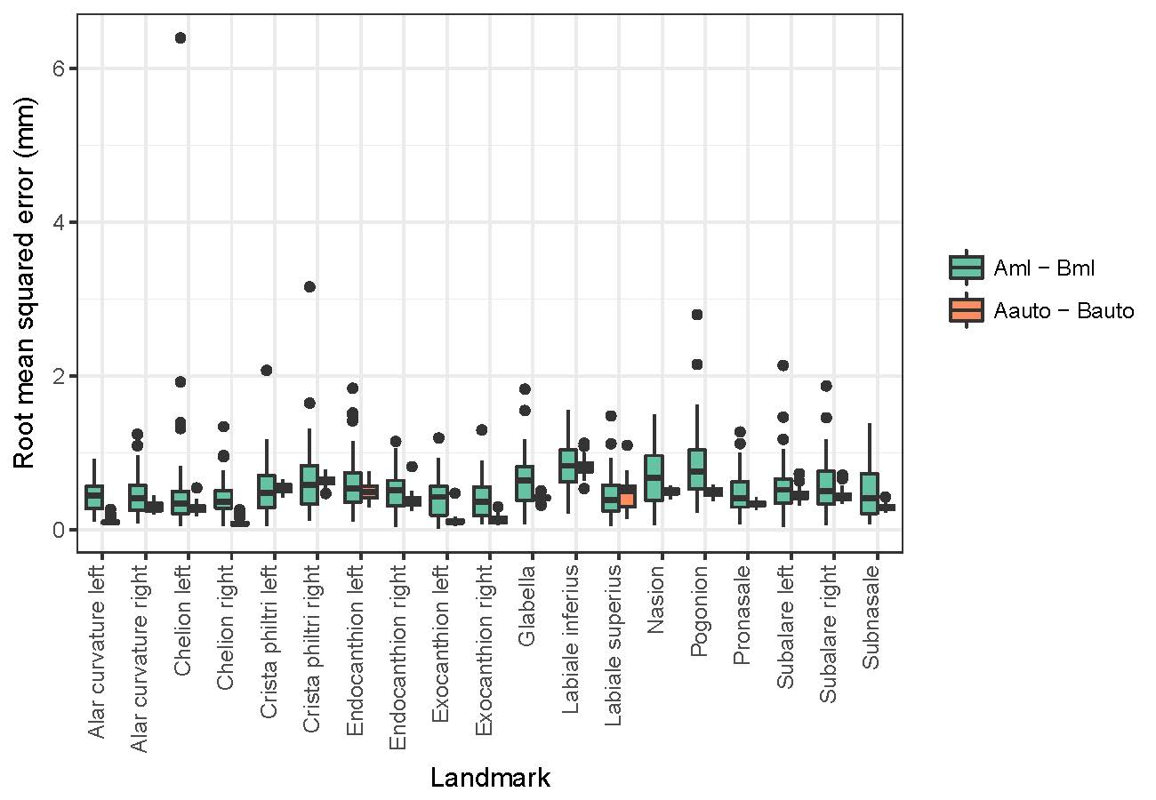

**Figure 6. Comparison of inter-observer error variance with variance of RMSE values calculated by comparing both automatic landmark indications.** All but the labiale superius landmark had significantly smaller variances in the automatic landmark indication comparison.

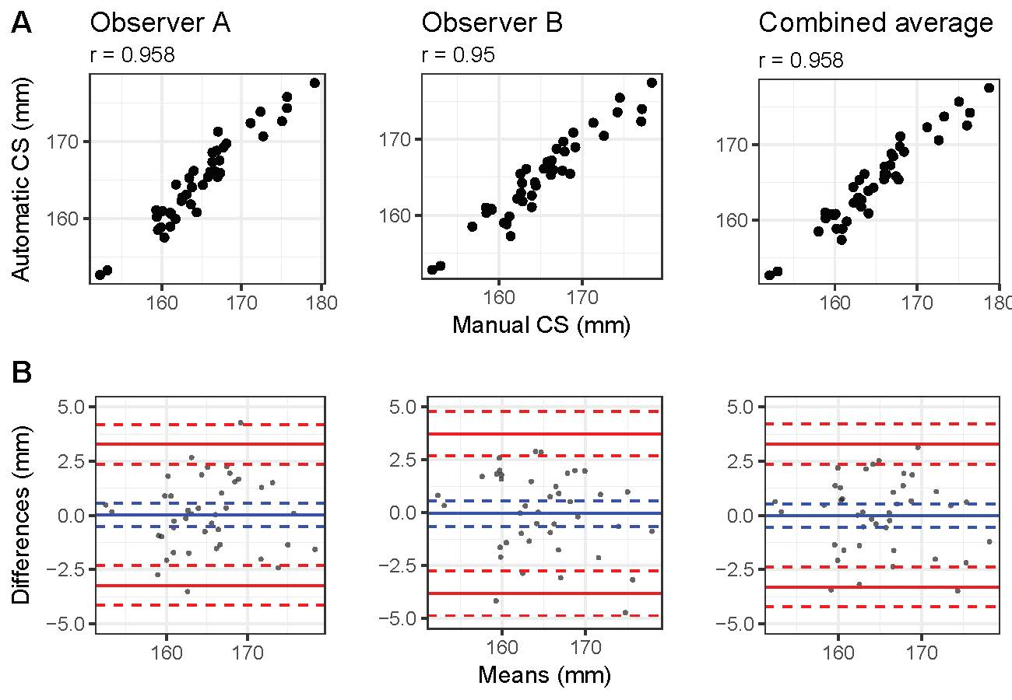

**Figure 7. Comparison of centroid sizes.** (A) Point plots for comparison of centroid sizes using automatic and manual landmarking methods, separated by observer. (B) Bland-Altman plot showing the differences between centroid sizes produced using the manual and automatic methods against the averages of the two techniques. Blue lines represent the mean difference value and red lines represent the upper and lower 95% confidence limits.

**2 Tables**

**Table 1. Description of landmarks used in validation.** Landmark descriptions are those reported on the the Richtsmeier Lab website (http://www.getahead.la.psu.edu/).

|  |  |  |  |
| --- | --- | --- | --- |
| Landmark | Abbr. | Location | Definition |
| Glabella | g | Midline | The most prominent midline point between the eyebrows. |
| Nasion | n | Midline | The point in the midline of both the nasal root and the nasofrontal suture. This point is always above the line that connects the two inner canthi. |
| Pronasale | prn | Midline | The most protruded point of the apex nasi. |
| Subnasale | sn | Midline | The midpoint of the angle at the columella base where the lower border of the nasal septum and the surface of the upper lip meet. |
| Labiale superius | ls | Midline | The midpoint of the upper vermillion line. |
| Labiale inferius | li | Midline | The midpoint of the lower vermillion line. |
| Pogonion | SPg | Midline | The most anterior point of the chin. |
| Endocanthion | en | Bilateral | The point at the inner commissure of the eye fissure. |
| Exocanthion | ex | Bilateral | The point at the outer commissure of the eye fissure. |
| Alar curvature | ac | Bilateral | The most lateral point in the curved base of each ala. Indicating the facial insertion of the nasal wingbase. |
| Subalare | sbal | Bilateral | The point at the lower limit of each alar base, where the alar base disappears into the skin of the upper lip. The landmarks indicate the labial insertion of the alar base |
| Crista philtri | cph | Bilateral | The lower point on each elevated margin of the philtrum just above the vermillion line. |
| Chelion | ch | Bilateral | Point located at each labial commissure at the most lateral intersection of upper and lower lip. |

**Table 2.** **Intra- and inter-observer error of manual landmarks.** Values have been averaged across each participant as well as *x*, *y*, and *z* axes to give an estimate of the error per landmark. Supplemental Table X reports error per *x*, *y*, and *z* axis.

|  |  |  |  |
| --- | --- | --- | --- |
| *Landmark* | *Standard deviation (mm)* | | *RMSE (mm)* |
| *Observer A* | *Observer B* | *Inter-observer* |
| *Alar curvature left* | 0.6020 | 0.4339 | 0.4337 |
| *Alar curvature right* | 0.6304 | 0.3773 | 0.4648 |
| *Chelion left* | 0.6080 | 0.4472 | 0.5914 |
| *Chelion right* | 0.6002 | 0.4934 | 0.4220 |
| *Crista philtri left* | 0.5016 | 0.3041 | 0.5488 |
| *Crista philtri right* | 0.5358 | 0.2949 | 0.6699 |
| *Endocanthion left* | 0.7447 | 0.4372 | 0.6168 |
| *Endocanthion right* | 0.7697 | 0.4462 | 0.5102 |
| *Exocanthion left* | 0.5863 | 0.4380 | 0.4166 |
| *Exocanthion right* | 0.6543 | 0.3579 | 0.4038 |
| *Glabella* | 0.5761 | 0.6881 | 0.6423 |
| *Labiale inferius* | 0.5032 | 0.3175 | 0.8283 |
| *Labiale superius* | 0.4254 | 0.2666 | 0.4504 |
| *Nasion* | 0.5365 | 0.5402 | 0.6983 |
| *Pogonion* | 0.8208 | 0.7593 | 0.8466 |
| *Pronasale* | 0.4593 | 0.3157 | 0.4700 |
| *Subalare left* | 0.5018 | 0.4262 | 0.5664 |
| *Subalare right* | 0.4883 | 0.4848 | 0.6057 |
| *Subnasale* | 0.4504 | 0.4695 | 0.4921 |
| ***Mean*** | ***0.5787*** | ***0.4367*** | ***0.5620*** |

**Table 3.** **MANOVA on all manual landmark indications to assess manual landmarking error.** Manova was performed on the six GPA-aligned manual landmark indications, with individual, observer, individual x observer, and the nested interaction of observer x iteration as predictors.

|  |  |  |  |  |  |  |  |
| --- | --- | --- | --- | --- | --- | --- | --- |
| Variable | DF | SS | MS | R2 | F | Z | Pr(>F) |
| Individual | 40 | 1.1803 | 0.0295 | 0.8491 | 40.7135 | 26.620 | 0.001 |
| Observer | 1 | 0.0244 | 0.0244 | 0.0176 | 33.6563 | 14.568 | 0.001 |
| Individual x Observer | 40 | 0.0492 | 0.0012 | 0.0354 | 1.6963 | 26.292 | 0.001 |
| Observer x Iteration | 4 | 0.0203 | 0.0051 | 0.0146 | 6.9974 | 19.485 | 0.001 |
| Residuals | 160 | 0.1160 | 0.0007 | 0.0834 |  |  |  |
| Total | 245 | 1.3901 |  |  |  |  |  |

**Table 4. Root mean squared error between manual and automatic landmarks**. Root mean squared error values between the average of all manual landmark indications (CML) and the automatic indications trained using this combined average (CAuto). Values are presented for each axis, averaged across all faces, as well as averaged across the axes (mean).

|  |  |  |  |  |
| --- | --- | --- | --- | --- |
| *Landmark* | *Root mean squared error (mm)* | | | |
| *X* | *Y* | *Z* | *Mean* |
| *Alar curvature left* | 0.1605 | 0.5233 | 0.6085 | **0.4308** |
| *Alar curvature right* | 0.1653 | 0.5221 | 0.5661 | **0.4178** |
| *Chelion left* | 1.1061 | 0.7131 | 0.6077 | **0.8089** |
| *Chelion right* | 0.9822 | 0.6600 | 0.5539 | **0.7320** |
| *Crista philtri left* | 0.7537 | 0.8927 | 0.4515 | **0.6993** |
| *Crista philtri right* | 0.7556 | 1.0005 | 0.4395 | **0.7319** |
| *Endocanthion left* | 0.7751 | 0.5437 | 0.4002 | **0.5730** |
| *Endocanthion right* | 1.0360 | 0.6517 | 0.5024 | **0.7300** |
| *Exocanthion left* | 0.9081 | 0.7362 | 0.8761 | **0.8401** |
| *Exocanthion right* | 0.9421 | 0.6537 | 0.9457 | **0.8472** |
| *Glabella* | 0.4806 | 1.3053 | 0.5583 | **0.7814** |
| *Labiale inferius* | 0.4560 | 0.7216 | 0.4756 | **0.5511** |
| *Labiale superius* | 0.5887 | 0.8055 | 0.3319 | **0.5754** |
| *Nasion* | 0.3543 | 0.9732 | 0.4748 | **0.6008** |
| *Pogonion* | 0.4313 | 1.0009 | 0.3791 | **0.6038** |
| *Pronasale* | 0.3987 | 0.5606 | 0.2827 | **0.4140** |
| *Subalare left* | 0.7271 | 0.4349 | 0.5570 | **0.5730** |
| *Subalare right* | 0.6526 | 0.4329 | 0.6008 | **0.5621** |
| *Subnasale* | 0.3239 | 0.4752 | 0.2620 | **0.3537** |
| *Mean* | **0.6315** | **0.7162** | **0.5197** | **0.6224** |

**Table 5. Comparison of inter-observer errors.** Root mean squared error for only manual landmarks and using manual and automatic indications. Based on a paired T-test, comparisons that are significantly different using an alpha of 0.05 are in bold.

|  |  |  |  |  |  |  |  |
| --- | --- | --- | --- | --- | --- | --- | --- |
|  | *AML-BML* | *AML – BAuto* | | | *AAuto - BML* | | |
| *Landmark* | *Mean RMSE (mm)* | *Mean RMSE (mm)* | *T*  *statistic* | *P value* | *Mean RMSE (mm)* | *T statistic* | *P value* |
| *Alar curvature left* | 0.43 | 0.44 | -0.10 | 0.9197 | 0.52 | -2.14 | **0.0382** |
| *Alar curvature right* | 0.46 | 0.52 | -0.99 | 0.3275 | 0.53 | -1.23 | 0.2266 |
| *Chelion left* | 0.59 | 0.89 | -1.89 | 0.0665 | 0.91 | -2.40 | **0.0212** |
| *Chelion right* | 0.42 | 0.72 | -2.59 | **0.0132** | 0.8 | -3.78 | **5.20 x 10-4** |
| *Crista philtri left* | 0.55 | 0.85 | -2.87 | **0.0066** | 0.83 | -3.11 | **0.0034** |
| *Crista philtri right* | 0.67 | 0.88 | -1.89 | 0.0661 | 0.95 | -3.53 | **0.0010** |
| *Endocanthion left* | 0.62 | 0.78 | -2.50 | **0.0167** | 0.74 | -1.46 | 0.1527 |
| *Endocanthion right* | 0.51 | 0.90 | -5.49 | **2.50 x 10-6** | 0.73 | -2.84 | **0.0071** |
| *Exocanthion left* | 0.42 | 0.88 | -6.14 | **3.00 x 10-7** | 0.87 | -5.80 | **8.93 x 10-7** |
| *Exocanthion right* | 0.40 | 0.85 | -5.54 | **2.09 x 10-6** | 0.88 | -5.65 | **1.49 x 10-6** |
| *Glabella* | 0.64 | 0.90 | -2.63 | **0.0121** | 0.93 | -3.12 | **0.0033** |
| *Labiale inferius* | 0.83 | 0.98 | -2.14 | **0.0381** | 0.88 | -0.54 | 0.5895 |
| *Labiale superius* | 0.45 | 0.70 | -3.05 | **0.0040** | 0.69 | -3.21 | **0.0026** |
| *Nasion* | 0.70 | 0.78 | -0.93 | 0.3556 | 0.81 | -1.25 | 0.2188 |
| *Pogonion* | 0.85 | 0.83 | 0.15 | 0.8835 | 0.86 | -0.22 | 0.8245 |
| *Pronasale* | 0.47 | 0.58 | -2.16 | **0.0366** | 0.51 | -0.65 | 0.5169 |
| *Subalare left* | 0.57 | 0.67 | -1.35 | 0.1842 | 0.72 | -2.24 | **0.0308** |
| *Subalare right* | 0.61 | 0.74 | -1.63 | 0.1114 | 0.67 | -0.84 | 0.4083 |
| *Subnasale* | 0.49 | 0.45 | 0.69 | 0.4939 | 0.51 | -0.26 | 0.7930 |
| *Mean* | 0.56 | 0.75 |  |  | 0.75 |  |  |

**Table 6. Comparison of inter-observer error variance.** The root mean squared error of average landmark configurations for the manual and automatic landmarks averaged across scans as well as the F value and P value from performing a Levene’s test per landmark.

|  |  |  |  |  |
| --- | --- | --- | --- | --- |
| *Landmark* | *Manual (mm)* | *Auto (mm)* | *F value* | *P value* |
| *Alar curvature left* | 0.4337 | 0.1030 | 59.6244 | **2.83 x 10-11** |
| *Alar curvature right* | 0.4648 | 0.3017 | 22.2346 | **1.01 x 10-5** |
| *Chelion left* | 0.5914 | 0.2826 | 4.6453 | **0.0341** |
| *Chelion right* | 0.4220 | 0.0901 | 24.5101 | **4.03 x 10-6** |
| *Crista philtri left* | 0.5488 | 0.5390 | 29.1832 | **6.60 x 10-7** |
| *Crista philtri right* | 0.6699 | 0.6324 | 18.1685 | **5.49 x 10-5** |
| *Endocanthion left* | 0.6168 | 0.4955 | 14.2000 | **3.13 x 10-4** |
| *Endocanthion right* | 0.5102 | 0.3774 | 28.4103 | **8.85 x 10-7** |
| *Exocanthion left* | 0.4166 | 0.1142 | 47.7334 | **1.06 x 10-9** |
| *Exocanthion right* | 0.4038 | 0.1359 | 28.0100 | **1.03 x 10-6** |
| *Glabella* | 0.6423 | 0.4155 | 41.5866 | **7.95 x 10-9** |
| *Labiale inferius* | 0.8283 | 0.8164 | 26.3847 | **1.93 x 10-6** |
| *Labiale superius* | 0.4504 | 0.4651 | 2.4213 | 0.1236 |
| *Nasion* | 0.6983 | 0.4966 | 87.7550 | **1.67 x 10-14** |
| *Pogonion* | 0.8466 | 0.4919 | 23.9927 | **4.95 x 10-6** |
| *Pronasale* | 0.4700 | 0.3360 | 38.2428 | **2.49 x 10-8** |
| *Subalare left* | 0.5664 | 0.4580 | 16.4805 | **1.14 x 10-4** |
| *Subalare right* | 0.6057 | 0.4402 | 25.6819 | **2.54 x 10-6** |
| *Subnasale* | 0.4921 | 0.2930 | 42.6476 | **5.57 x 10-9** |
| *Mean* | 0.5620 | 0.3834 |  |  |

**Table 7. MANOVAs on average manual landmark configurations and automatic landmark configurations, separately.** Results of two separate MANOVAs, one using the average manual landmark configurations from each observer as the response, and the other using the automatic landmark configurations as the response. In both cases, individual and observer were included as predictors. The interaction effect between individual and observer was not included because the residual degrees of freedom became zero when it was included.

|  |  |  |  |  |  |  |  |  |
| --- | --- | --- | --- | --- | --- | --- | --- | --- |
| Variable | | DF | SS | MS | R2 | F | Z | Pr(>F) |
| Individual | *ML* | 40 | 0.3937 | 0.0098 | 0.9413 | 23.987 | 22.515 | 0.001 |
| *Auto* | 40 | 0.3152 | 0.0079 | 0.9714 | 435.70 | 27.609 | 0.001 |
| Observer | *ML* | 1 | 0.0082 | 0.0081 | 0.0195 | 19.853 | 11.563 | 0.001 |
| *Auto* | 1 | 0.0085 | 0.0085 | 0.0264 | 472.98 | 8.1969 | 0.001 |
| Residuals | *ML* | 40 | 0.0164 | 0.0004 | 0.0392 |  |  |  |
| *Auto* | 40 | 0.0007 | 1.81 x 10-5 | 0.0022 |  |  |  |
| Total | *ML* | 81 | 0.4182 |  |  |  |  |  |
| *Auto* | 81 | 0.3245 |  |  |  |  |  |

**Table 8. MANOVA on manual and automatic landmarks, together.** Results from a single MANOVA using the average manual landmark indications from each observer (AML and BML) and the automatic landmark indications using the observer level averages (AAuto and BAuto).

|  |  |  |  |  |  |  |  |
| --- | --- | --- | --- | --- | --- | --- | --- |
| Variable | DF | SS | MS | R2 | F | Z | Pr(>F) |
| Method | 1 | 0.0003 | 0.0003 | 0.0004 | 0.3463 | -2.2135 | 0.987 |
| Individual | 40 | 0.6522 | 0.0163 | 0.8778 | 20.2019 | 23.3507 | 0.001 |
| Observer | 1 | 0.0167 | 0.0167 | 0.0224 | 20.6396 | 11.4067 | 0.001 |
| Individual x Observer | 40 | 0.0085 | 0.0002 | 0.0114 | 0.2623 | 13.7253 | 0.001 |
| Residuals | 81 | 0.0654 | 0.0008 | 0.0880 |  |  |  |
| Total | 163 | 0.7430 |  |  |  |  |  |

**Table 9. ANOVA of centroid sizes.** Results from an ANOVA with centroid size as the response variable and individual, observer, method and individual x observer as predictors.

|  |  |  |  |  |  |
| --- | --- | --- | --- | --- | --- |
| Variable | Df | Sum Sq | Mean Sq | F value | Pr(>F) |
| Individual | 40 | 7936 | 198.39 | 130.407 | <2 x 10-16 |
| Observer | 2 | 0 | 0.23 | 0.154 | 0.857 |
| Method | 1 | 0 | 0 | 0.002 | 0.962 |
| Individual x Observer | 80 | 12 | 0.15 | 0.101 | 1.000 |
| Residuals | 122 | 186 | 1.52 |  |  |