Analysis Project Features List

|  |  |  |  |  |
| --- | --- | --- | --- | --- |
| **Analysis Features** | **Category** | **Possible Points** | **Points** | **Comments** |
| **Documentation (15 total points)** | | | | |
| Executive Summary (up to 1 page) | Core | 2 |  |  |
| Feature List | Core | 2 |  |  |
| List of Web and AI sources used | Core | 3 |  |  |
| Summary Report (up to 15 pages) | Core | 8 |  |  |
|  | | | | |
| **Analysis: Customers by Region (10 total points)** | | | | |
| Overview of approach with assumptions | Done | 3 |  |  |
| Predicted sales for 2023+2024 for each province and at least two charts or visualizations | Done | 4 |  |  |
| Recommendation/summary paragraph for management | Done | 3 |  |  |
|  | | | | |
| **Analysis: Best and Worst Products (10 points)** | | | | |
| Overview of approach with assumptions | Done | 3 |  |  |
| Predicted sales for 2023+2024 for top 5 and bottom 5 products with at least two charts or visualizations | Done | 4 |  |  |
| Recommendation/summary paragraph for management | Done | 3 |  |  |
|  | | | | |
| **Analysis: Payment Methods (up to 5 total points)** | | | | |
| Overview of approach with assumptions | Done | 1 |  |  |
| Visualization of payment methods used in 2022 | Done | 2 |  |  |
| Visualization/prediction of payment methods for 2024 | Done | 2 |  |  |
|  | | | | |
| **Analysis: Inventory Management (up to 10 total points)** | | | | |
| Overview of approach with assumptions | Done | 3 |  |  |
| Perform analysis with at least two charts or visualizations | Done | 4 |  |  |
| Recommendation paragraph to management | Done | 3 |  |  |
|  | | | | |
| **Analysis: Your Choice (up to 10 total points)** | | | | |
| Overview of approach with assumptions | Done | 3 |  |  |
| Perform analysis with at least two charts or visualizations | Done | 4 |  |  |
| Recommendation paragraph to management | Done | 3 |  |  |
|  | | | | |
| **Analysis: Your Choice (up to 10 total points)** | | | | |
| Overview of approach with assumptions | Done | 3 |  |  |
| Perform analysis with at least two charts or visualizations | Done | 4 |  |  |
| Recommendation paragraph to management | Done | 3 |  |  |
|  |  |  |  |  |
| **General and Open Category (up to 20 total points)** |  |  |  |  |
| Suggest database improvements | Done | 3 |  |  |
| *Other (your suggestions including using tools besides Excel)* | Done | Up to 20 |  |  |
| **Total: (out of 50 with max of 10 bonus. i.e. 60 is max.)** |  |  |  |  |

**Group members:** Komal Singh [ksingh0925@gmail.com](mailto:ksingh0925@gmail.com)

Julie Flament [juliemeflament@gmail.com](mailto:juliemeflament@gmail.com)

Vanshika Singla vanshikasingla2002@gmail.com

# Executive Summary Report for ACME Company CEO

This executive summary encapsulates key insights from the recent analysis of ACME Company's products, customers, and warehouse inventory. The analysis was conducted using predictive modeling and visualizations to derive recommendations. Here's a brief overview of the findings:

Problem Statement:

ACME Company, despite maintaining a comprehensive database of product sales over the years, has yet to leverage this valuable data for strategic decision-making. The absence of insights into key customer behaviors, item sales volume, and pricing dynamics represents a missed opportunity for optimizing business strategies. This executive summary aims to outline the significance of data-driven decision-making and the potential impact on ACME's overall business performance.

Recommended Solution and Project Objectives:

To address this challenge, the proposed solution involves implementing a robust data analysis strategy that focuses on key customer insights, item sales volume, and pricing dynamics. The primary project objectives include:

* Establishing a systematic analysis framework for customer behavior.
* Identifying high-performing and underperforming products based on sales volume.
* Analyzing pricing strategies and recommending adjustments for market competitiveness.
* This initiative will enable ACME to make informed decisions, enhance customer satisfaction, and optimize product distribution strategies.

Solution's Value:

The implementation of a data-driven approach is anticipated to yield substantial benefits. By understanding customer behavior and identifying top-selling products, ACME can tailor marketing efforts, streamline inventory management, and enhance overall customer satisfaction. Financially, this initiative has the potential to increase revenue by strategically modifying pricing strategies and focusing on high-demand products.

Alignment with company goals includes contributing to the expansion objective for the fiscal year, with a projected increase in market share by leveraging data-driven insights. Early feedback indicates minimal impact on the perceived value or prestige of the brand, ensuring a smooth transition toward a more data-centric business model.

Conclusion and Importance of the Work:

In conclusion, the incorporation of data analytics into ACME's business strategy is not just an operational enhancement but a transformative step toward achieving long-term success. The insights derived from analyzing key customer data, sales volume, and pricing dynamics will empower ACME to make informed decisions, foster growth, and remain competitive in the market. This strategic shift positions ACME for increased market share, improved customer satisfaction, and sustainable profitability.

# List of Web/AI Sources used:

* https://asana.com/resources/executive-summary-examples
* https://chat.openai.com/c/8985619a-56dd-4dd3-9498-8060e9f998e6
* <https://support.microsoft.com/en-us/office/create-a-map-chart-in-excel-f2cfed55-d622-42cd-8ec9-ec8a358b593b>
* <https://support.microsoft.com/en-us/office/forecast-and-forecast-linear-functions-50ca49c9-7b40-4892-94e4-7ad38bbeda99>
* https://blog.saleslayer.com/why-is-database-normalization-so-important

# Summary Report

Analysis: Customers by Region

**Overview of approach with assumptions**: We ran the SQL query to get the total number of customers per each province. Based on these results I chose a map visualization to see which provinces had the highest number of customers. Alberta is the top province with most customer sales whereas Quebec has the least. Assumptions made were that the data in the customer table is accurate and free from inconsistencies. Another assumption made was that “customer ID” is a unique key and represents each customer uniquely.

**Predictions for 2023+2024:** To make these predictions, we used =Forecast. Linear formula and used previous queries to isolate the customer count by year. Based on these predictions we were able to make a bar graph and a map visualization. The predictions state that the state of Alberta is going to increase to about 89 customers and Quebec is going to see massive decreases in customer count in 2024 going to 5 customers for the year.

**Recommendation:** The company should make targeted marketing efforts in high-growth provinces of Alberta and Prince Edward Island as well as take relevant strategic measures for provinces showing decline which include Quebec and New Brunswick.

Analysis: Best and Worst Products

**Overview:** To find the best 5 and worst 5 products, I checked how much money each product made by combining information about products and their sales. I added up how many items were sold and how much money they made altogether for each product. I only looked at products that were sold at least 60 times. Then, I arranged these products from the most money made to the least. I assumed that the data I used was correct, the prices were in the same money type, and the names of the products were consistent in all the places they were mentioned. Assumptions: My study only shows what I asked for in my question and may not include changes happening in the market right now and I assume that all the products were introduced in the market at the same time. So, if I don't see any sales for that year, it means there were no sales for that year.

**Top products**

|  |  |  |
| --- | --- | --- |
| **productId** | **productName** | **totalRevenue** |
| 81 | Aerodynamic Copper Bag | 32684.89 |
| 70 | Heavy Duty Plastic Knife | 29536.23 |
| 72 | Ergonomic Iron Lamp | 25879.65 |
| 160 | Practical Cotton Wallet | 25731.17 |
| 150 | Incredible Wool Plate | 23343.69 |

**Worst products**

|  |  |  |
| --- | --- | --- |
| **productId** | **productName** | **totalRevenue** |
| 174 | Sleek Bronze Keyboard | 2404.3 |
| 48 | Lightweight Aluminum Gloves | 3502.07 |
| 162 | Enormous Wool Wallet | 4156.69 |
| 61 | Synergistic Iron Car | 4290.21 |
| 40 | Fantastic Silk Knife | 4515.65 |

**Predictions and Suggestions** – By performing the sales prediction on the basis for every year for the best product- AERODYNAMIC COOPER BAG- To do so, we used another query that helped me count the total sales for each year and then used the forecasting over the timeline of those years.

|  |  |  |  |  |
| --- | --- | --- | --- | --- |
| **Timeline** | **Values** | **Forecast** | **Lower Confidence Bound** | **Upper Confidence Bound** |
| 2019 | 1464.6 |  |  |  |
| 2020 | 4201.65 |  |  |  |
| 2021 | 3782.78 |  |  |  |
| 2022 | 2929.96 | 2929.96 | 2929.96 | 2929.96 |
| 2023 |  | 3596.2225 | 1008.23 | 6184.22 |
| 2024 |  | 3942.5578 | 1274.29 | 6610.83 |

For Worst product – We filtered out all my candidates for worst products and checked if some of the products are seasonal only and only sold for partial years. We figured that the Sleek Bronze Keyboard was only sold for 2 years.

|  |  |  |
| --- | --- | --- |
| **productName** | **totalRevenue** | **orderYear** |
| Lightweight Aluminum Gloves | 1782.68 | 2021 |
| Lightweight Aluminum Gloves | 924.4 | 2023 |
| Lightweight Aluminum Gloves | 794.99 | 2020 |

|  |  |  |
| --- | --- | --- |
| Sleek Bronze Keyboard | 1334.95 | 2021 |
| Sleek Bronze Keyboard | 1069.35 | 2022 |

So, applying the forecast on Sleek Bronze Keyboard. We see these predictions and the trendline.

|  |  |  |  |
| --- | --- | --- | --- |
| **Timeline** | **Values** | **Forecast** | **Confidence Interval** |
| 2021 | 1334.95 |  |  |
| 2022 | 1069.35 |  |  |
| 2023 |  | 803.75 | 1.29926E-12 |
| 2024 |  | 538.15 | 1.32474E-12 |

**Suggestions for management-** We can use our extracted data to find out the trends and the products that are doing good. We are generating a lot from the Aerodynamic Copper bag and heavy-Duty plastic Knife. So, it would be a good idea to increase the advertisement for these products. Whereas Sleek Bronze keyboard is not producing a lot of revenue and we figured how this was only sold for 2021 and 2022 only, based on our assumptions (check overview) and will continue to decrease its sales.

Note- This might not be the best way to make predictions as revenue generated will also depend on the price of each product. However, assuming that we are more interested in the profits. Revenues will still be better than any other measure.

Your Choice - Overall revenue generation/ Profits and the Predictions for the next 3 years.

**Overview**: We checked the orders made each year and how much money they totaled. We added up the total sales for each year and arranged them in order, starting from the earliest year. However, we are aware that fluctuations really happen because of some reasons. Since, the data for 2023 is not fully included as we are currently in the year, and it only contains months up to October. Also, 2019 data is incomplete. So, we first make the predictions for all the data then use only full data sets.

**Assumptions:** This study only shows what was asked for in my question and may not include changes happening in the market right now and we assumed that all the products were introduced in the market at the same time.

Predictions and Suggestions:

Initial Data for all the sales-

|  |  |
| --- | --- |
| **year** | **totalSales** |
| 2019 | 97845.91 |
| 2020 | 617639.61 |
| 2021 | 705774.5 |
| 2022 | 676308.99 |
| 2023 | 573330.71 |

Forecast and predictions –

|  |  |  |  |
| --- | --- | --- | --- |
| **year** | **totalSales** | **Forecast(totalSales)** | **Confidence Interval(totalSales)** |
| 2019 | 97845.91 |  |  |
| 2020 | 617639.61 |  |  |
| 2021 | 705774.5 |  |  |
| 2022 | 676308.99 |  |  |
| 2023 | 573330.71 |  |  |
| 2024 |  | 762127.9784 | 456305.7993 |
| 2025 |  | 851584.0928 | 510369.6222 |

Updated sales (BETTER PREDICTIONS) and revenue generated- By removing the parts were incomplete.

New Forecast for updated data

|  |  |
| --- | --- |
| **Timeline** | **Values** |
| 2020 | 617639.6 |
| 2021 | 705774.5 |
| 2022 | 676309 |
| 2023 | 687996.9 |

|  |  |  |  |  |
| --- | --- | --- | --- | --- |
| **Timeline** | **Values** | **Forecast** | **Lower Confidence Bound** | **Upper Confidence Bound** |
| 2020 | 617639.6 |  |  |  |
| 2021 | 705774.5 |  |  |  |
| 2022 | 676309 |  |  |  |
| 2023 | 687996.9 | 687996.85 | 687996.85 | 687996.85 |
| 2024 |  | 717172.9 | 646990.58 | 787355.23 |
| 2025 |  | 742044.58 | 670486.09 | 813603.06 |

**More Suggestions for management -**

As clearly shown by our two predictions, management needs to recognize that market fluctuations and seasonal trends might significantly impact sales. Adapt strategies to mitigate or capitalize on these fluctuations to maintain consistent growth.

Also, this analysis can be helpful to mitigate any risks. Utilize confidence interval data to assess potential risks. Develop contingency plans accounting for both upper and lower confidence bounds to manage uncertain scenarios.

Further I would suggest considering leveraging the forecasted growth for 2023, 2024 and 2025 to develop long-term strategies. Identify areas where increased revenue might stem from and allocate resources accordingly.

Analysis: Payment Methods

Overview: I found all of the payment methods used in the year 2022 when purchasing a product. I used their payment expiry date to see when the transaction was made to ensure it was in 2022. Furthermore, I counted the value of the orders from each payment method that was used to see which was most popular. To predict the payment methods used in 2024, I found the value of the orders from each payment method used in 2023 and used linear regression. This gave me the prediction of payment methods used in 2024 based on the two previous years (2022 and 2023).

Visualization:

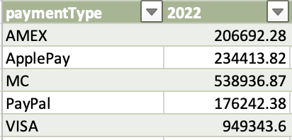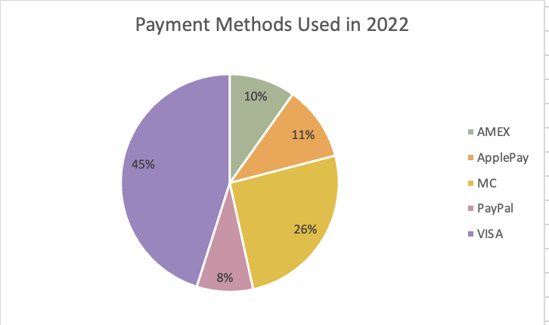

Prediction Visualization:

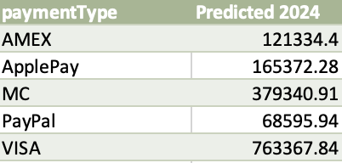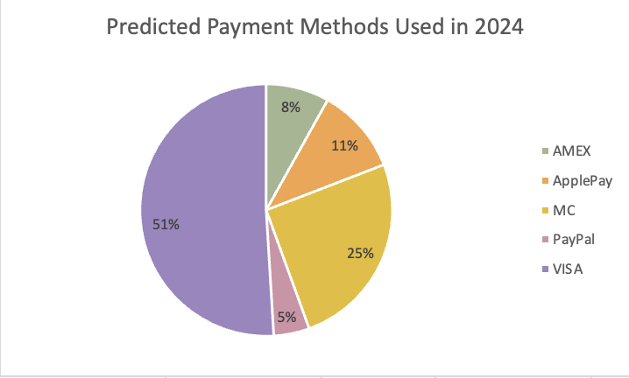

Analysis: Inventory Management

**Overview:** The first visualization explores the total inventory that each warehouse has had over the years. Furthermore, it explores how much each of those products is worth, hence the total value. By summing up the value per product, we find the total value of products held in each warehouse. The second visualization explores the highest-selling products based on what was held in the warehouses. The numbers above each bar in the bar chart represent the product ID of the highest-selling products.

First Visualization:

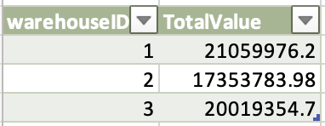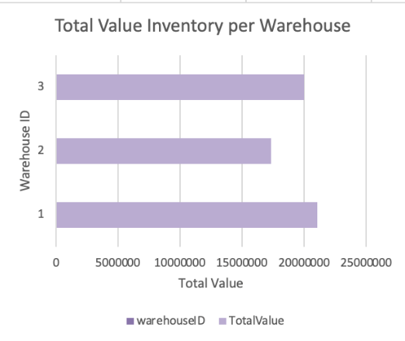

Second Visualization:

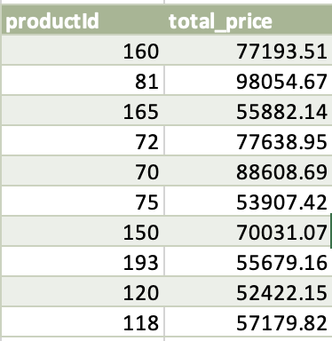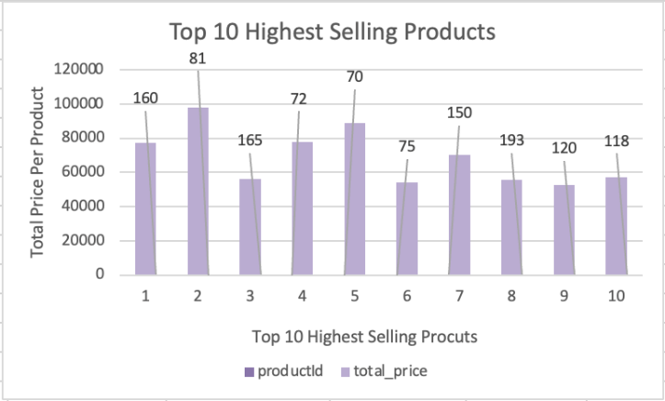

**Recommendation to Management**

Using these two graphs, we especially recommend that the warehouses that hold products with the least amount of value should start holding more of the higher-selling products shown in the second visualization. By prioritizing higher-selling products in these warehouses, there's a chance to increase revenue. It's crucial to ensure a balanced inventory mix and consider factors like demand fluctuations, and storage capacity when making such adjustments. By reallocating space or adjusting inventory levels to accommodate these in-demand products, those warehouses could potentially improve efficiency and profitability.

Analysis of Choice #1: Top products by category

Overview: In this analysis, my focus was to explore the categories that seemed to resonate most with customers. To begin, I first looked at how many products had been sold in each category to provide some insight into customers' primary interests in purchases. In my second visualization, I then chose to explore which products were the highest-rated products and associated them with their respective categories. This would provide some insight into which categories held the highest satisfaction among customers, providing valuable insights into their preferences and satisfaction levels.

First Visualization:

Second Visualization:

Third Visualization:

**Recommendation to Management:**

I recommend that management prioritizes products from the appliances category. These products were the 4th most sold products among all the categories, but they were the best-rated products as well. For starters, considering their position as top sellers, further investing in these products could significantly increase sales and revenue. Additionally, the fact that they're highly rated indicates satisfied customers, which often leads to repeat purchases potentially attracting new customers. However, an increased focus on appliances might mean less attention to other product categories, potentially affecting their performance. Emphasizing appliances because of their impressive sales and positive reception seems like a promising approach but ensuring that it aligns with the broader company objectives is essential.

# Database improvements

Based on the information provided in the article by sales layer and with the help of ChatGPT, here are some steps we would recommend the ACME company can take to improve the database using normalization in the following ways:

**Optimize Storage Space:**

Normalization helps optimize storage space by organizing data more efficiently. Ensure that unnecessary redundancy is eliminated, and data is stored in a concise and logical manner.

**Consider Different Normalization Levels:**

Evaluate the specific needs of ACME and consider applying different normalization levels based on the complexity of the data. This might include reaching at least the Third Normal Form (3NF) to eliminate columns that do not depend on the main key value.

**Enhance Security:**

Improved security is a direct benefit of normalization. It ensures that data is accurately located, reducing the risk of unauthorized access or data breaches.

**Prepare for Growth:**

Normalizing the database prepares it for future growth. As we have seen in the predictions, the ACME company will be expecting an increase customer base, therefore, an organized and normalized database is better equipped to handle increased data volumes.

# Suggestions

We believe that Tableau would be a great tool to analyze the data given in this database. This is because since there is a large dataset, forming relationships and joins in Tableau is an easier process to help organize the data to work with. Also, since the database contains multiple tables, the functionality to be able to write queries and make various types of visualizations is much more advanced in Tableau. Tableau also provides a much easier user interface and experience than Excel. Working in a group, was a little harder on Excel due to it’s lack of features available in MacOS, however, Tableau would be able to overcome this obstacle for us.