Reimagining Space: How Activity Space Explains Human Behavior in Buildings

David Kirsh
Cognitive Science
UCSD, La Jolla,
CA 92093-0515, USA

Corresponding Author:

David Kirsh
Cognitive Science
UCSD, La Jolla,
CA 92093-0515, USA
+1 760 271-0030
dkirsh@gmail.com

Reimagining Space: How Activity Space Explains Human Behavior in Buildings

David Kirsh
Cognitive Science, UCSD
La Jolla, CA 92093-0515

Abstract: Humans rarely engage an architectural space without having some task or activity in mind – even when just walking or talking. Tasks shape how a person perceives and conceives of their environment. They influence how someone ‘enactively’ encounters their surroundings, suggesting the world a person represents and acts in is not solely a geometric space. Drawing from the cognitive science of problem solving and task execution, I explore three levels from which to understand activity in buildings: logical, physical and cognitive. In architecture, we need a concept of an ‘activity space’ as something richer than both space and material layout to improve requirements gathering, to better appreciate design tradeoffs, and to build AI agents that can simulate how diverse humans engage space and furniture. In the social, cognitive and neuro sciences we need it to better explain the microstructure of action and cognition.
Keywords: Action, activity, activity space, space, enactive bubble, cognitively active, architectural requirements, cognitively congenial, architecture, design, interior design.

Architectural space is more than bounded geometric space. It is a playground for human activity and experience – a system of overlapping subject-specific and group-specific ‘enactive envelopes’ – a collection of perceived and conceptualized platforms or stages where activities are played out. Change your task or your social group and you will change your experience, your causal encounter, your memory and your conception of the space you are in.
My thesis is that human activity is best understood when analyzed at three levels: the logical, physical and cognitive. Each level provides a distinct window onto the constraints, affordances, needs and opportunities for meaningful engagement that people face during an activity. These perspectives illuminate unique facets of human–building interaction that architects and interior designers may find useful. I will outline each viewpoint, explore how they interconnect, and relate them to broader concepts that enrich our understanding of how people are immersed in the built environment.

Some background: The enactive perspective
People are goal-oriented creatures. Rarely are we not engaged in a task, activity, or social encounter. Our task-positive network (Cole et al, 2014), with its salience determining functions, is typically on whenever we are not asleep or daydreaming. Moment-by-moment we have task-related concerns that filter and drive our selective attention to things, continuously coloring how we experience the physical place we are in. Two people deep in a heated discussion will enter Hagia Sophia differently than one person whose life’s ambition is to immerse himself in the space. Who they are, their interests, ambitions, reason for being there, as well as the task they are busy with as they enter, all matter to experience. Imagine two children who see the same space as an opportunity for hide and seek? Their encounter will be utterly different.
This raises an obvious question: what do people really ‘pick up’ and react to when in an environment? Architects need an accurate model of occupants to articulate requirements. This is problematic. Different people may be expected to detect, attend and react to different things. Worse, what is potentially cognitively active for any given agent at one moment may be different at another moment when they are engaged in a different activity. All these differences in what is cognitively active may not easily be reduced to differences in physical elements. They may be more about what a human projects onto a scene or onto a space to make the mental side of task performance easier.
If this is correct, the environment we respond to is not objective geometric space, but a structured field of interpreted relevance—shaped by our expectations, intentions, and action possibilities. Architects and scientists need methods to identify and analyze what is cognitively active in this enacted world.
The idea of enactive cognition is increasingly influential in cognitive science, especially in embodied and situated approaches, where it offers a dynamic, interaction-based account of how people perceive, engage and appropriate their environments rather than adopting a more static account of a world out there ready to be apprehended. It is currently our best starting point for thinking about what is cognitively active in an agent’s local environment. The latest versions of enactive cognition are predictive and constructive theories that claim that what people attend to in an environment is a tiny fraction of what is there to be perceptually detected; and moreover, it is strongly dependent on their interests, perceptual expertise, concepts, physical skills, and of course, the activities they are engaged in. This is just what we need to understand the context of action. It has strong relations to prior work on affordances first introduced by J.J Gibson. The theory also supports the idea that, in some sense, humans ‘co-create’ the environment they live in. They partly invent the place they are in.
The idea of co-creation has two sides: physical and epistemic. Physically, during dinner preparation, when we move from washing or peeling potatoes to cutting them into slices, we shift physical position, shift tool use, shift what we focus on, and shift our conception of where we are in our overall activity. We create a changed physical environment as we act – a new worldline in 4-dimensional spacetime. To see this as co-creating requires taking a dynamical system point of view. Even though we are the ones primarily driving our planning and action, the tighter we are connected causally to the physical environment the more we constitute a coupled system. It is the distributed cognitive system of us with our local environment that creates a changed physical world. This is a type of co-creation.
There is a different idea of co-creation. Perhaps more interesting. It is that personal activity constantly reshapes how we interpret space, creating what might be thought of as a personal epistemic bubble of what is relevant in the space around us. This bubble, though tied to things outside, is driven by neuro-cognitive projections of what is and is not doable and predictions of what is and is not likely to be present in the environment. Seeing what we expect (though not necessarily there) is commonplace. We respond to the environment as interpreted rather than to some neutral stimulus description.
On this view, there is a tight causal connection between our epistemic bubble and our environment of activity. When we shift from washing to cutting potatoes our bubble shifts. We shift position, focus, interests. This changes our environment of activity. We are still occupied with potatoes, but with a different aspect of potatoes and we interact differently. Our bubble changes much more radically when we change from preparing dinner to eating. We enter a new cognitive environment shaped by very different concerns and action possibilities. If we have not yet moved to the table, our physical environment may not have changed much. The tangible difference between food ready-to-be-plated and food already-plated is not great. But the conceptual difference is huge. Conceptually, we are moving from ‘preparing’ to ‘getting ready to eat’. We are still in the same kitchen, even at the same counter. But when we change our activity, our concerns change radically and the features of the outer world that matter suddenly shift. It would be natural to begin thinking about how to adjust lighting, soundscape, social organization for eating – things that were far from mind before, and which require a complete reframing of focus. Our experienced world is now very different despite our being in the same physical space.
If it seems implausible that our experience can undergo abrupt shifts despite gradual changes in the external world, consider the findings on inattentional blindness. In Simons and Chabris (1999), participants asked to count basketball passes failed to notice a person in a gorilla suit walking directly through the scene—an event fully visible yet cognitively absent for 70% of viewers. Their perception was constrained by a narrow epistemic window, shaped entirely by the demands of their counting task. What lay outside this window simply did not register. This phenomenon underscores how perception is gated by relevance, and how tightly our experience can be confined within an epistemic bubble. We see less than is there. Yet the same mechanisms that filter out visible but improbable things also allow us to perceive things that are not literally there—such as projected cues, inferred intentions, or communicative signals that are only loosely grounded in the sensory stream. In the gorilla experiment, we might notice shared eye contact and interpret it as a communicative signal indicating who will be passed the basketball next. We think we see the ‘intent’ when in fact it is not there. Our interpretational framing propelled by task expectations drives us to see more than is there.
We experience these shifts of attention and epistemic bubbles all the time. Imagine you are in Paddington train station in London. It is large. As you approach what should be your gate a digital notice flashes that your train is badly delayed. After a quick but unsuccessful look for a comfortable seat on the platform you decide to find a café.
What happened? You left one ‘enactive space’ – the space related to finding your way to the gate, the right train, and then your seat – and entered another, the enactive space where you want to find a good place to hang out that is not on the platform. With your new goal comes different values, interests and the need to hunt for different attributes and opportunities. Things you were blind to earlier, when rushing on your way to the train, are now very much the center of your attention. Your navigational goals and strategies have changed, hence where you look and what you take in will change, and so will your memory of what is where.
How an enactive space is constructed also depends importantly on non-task factors, most notably physical and neural differences between agents. Personal idiosyncrasies related to body size and strength, skills, cognitive talents and capacities, affective biases and so on, each can impact the enactive space that is co-created. ‘Neurodiverse’ people, when engaged in the same task as ‘neurotypicals,’ likely attend to and engage space, structure, and local qualitative properties quite differently. So would people who have physical disadvantages, or who are emotionally aroused at the time of action, or people who are deeply familiar with the space, or are expert at the activities performed there. Everyone’s concerns are different, their strategies of attention are different, their execution is different; hence their understanding of situational possibilities will be different.
It is not yet obvious how architects should respond to this more accurate (and complicated) way of understanding how people perceive and engage the built environment. But somehow, they should.
To explore the idea of three levels – three perspectives on an activity – I will begin with chess, an atypically precise and narrow activity, but one where the three levels are easy to appreciate.

Example One: Chess
Although chess has exact deterministic rules, making it a formal game, it still shares with all activities the possibility of physical and psychological levels of analysis. For one thing, the board, pieces and transitions are surprisingly open in how they may be physically implemented. So, the same chess game can look completely different if implemented in wildly different pieces and boards. See figure 1 where we explain through images how two perfectly valid, but idiosyncratic board shapes and sizes can be created by ‘wrapping’ a chess board over different 3D shapes. From figure 1 is obvious that there are indefinitely many ways of designing a chess board and environment beyond conventional ways.
The reason? Legal game transitions define a topology – system of connectivity. They constrain but do not prescribe the other levels: ‘metric space’ – that is, the physical level, and ‘cognitive space’, the psychological level.
Activity analysts who study chess start with a design of topological graphs where the connectivity between legal moves is fixed. But the scale, shape – even dimensionality of physical or digital boards – is left as an open parameter.
Architects and chess craftsmen, by contrast, design 3D shapes. They know they have to support the connectivity of moves in chess, but that hardly tells them how to design the board and pieces. The design opportunity of physical chess design is that there are infinitely many ways of realizing topological connectivity in the metric world of spatial dimensions. The objective of this paper is to explain the nature of these formal and physical levels and then relate them with the cognitive level, which itself raises another set of questions.
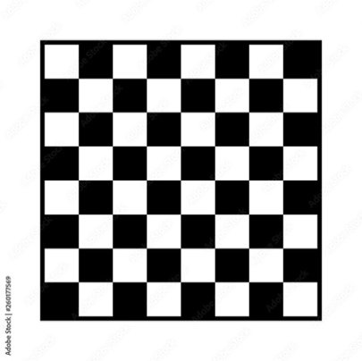 | 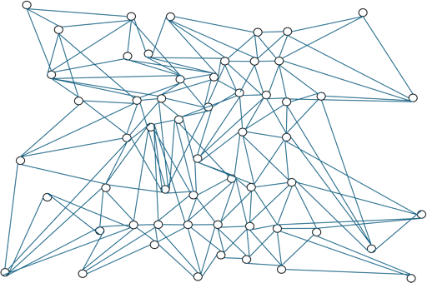 | 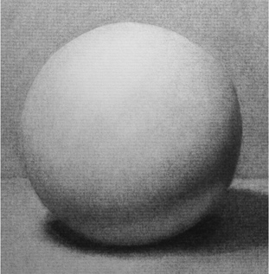 | 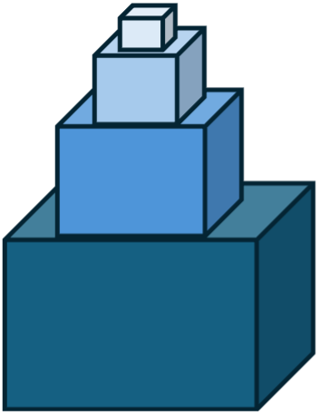
1a | 1b | 1c | 1d
Figure 1. Shown here are 4 topologically identical chess implementations. In fig 1a, a standard 2-dimensional chess board is displayed. It is a flat 2D surface with 64 cells in an 8x8 matrix. In fig 1b, a connected graph with 64 nodes is represented in a node and link format that shows all the one-step connections (neighboring cells) of the board. You can imagine the board of 1a as a set of numbered cells and in 1b those numbered cells are represented as connected (numbered) nodes. If connectivity is preserved, and the links in 1b do not carry any other meaning than reachable in one step, we are free to distort the appearance and length of the links in graph 1b in any way we like. Hence the graph representation of 1b could have a regular square appearance on analogy with 1a with dots for squares and links for shared sides. Or it might be arbitrarily distorted, as it is in 1b. Assume now that the nodes in 1b are appropriately colored black and white or odd and even appropriately. Now, imagine wrapping or warping the connected graph of 1b around the sphere in 1c. The 2D ‘chess board’ projected onto the skin of the sphere in 1c is topologically identical to 1a and 1b. In principle, any game you can play on 1a you can play on the projection in 1c. Fig 1d offers a further non-standard implementation of a chess board. Three boxes are stacked on top of a large bottom box. Call the outer rim of squares of a normal chess board a ‘square ring’. Imagine these 28 cells are mapped onto the protruding part of the bottom box. The next square ring contains 20 squares. This ring is mapped onto the protruding surface of the next cube, and so on. Figs 1a, 1b and the projections in 1c and 1d are all formally legal physical implementations of a chess board. Obviously, some of these will make playing chess much harder. Designing the physical arena of activity can be non-trivial. It’s analysis even harder. The implications of this diversity will be discussed in the section on the physical perspective.

The Logical Perspective
In chess, the highest goal is to win. This overarching aim clarifies what it means to succeed and, by extension, indicates when a player is performing well. Every activity has success conditions: whether the activity is cooking, having an intimate conversation, walking to an exit, or writing an essay on a computer. These top-level goals serve as an organizing principle, helping us understand the various parts and phases of the activity. By analyzing the goal structure implicit in these parts and phases we can analyze how top-level goals spawn sub-goals, and how these in turn, spawn additional sub-goals recursively. Any AI system is bound to start with this logical or topological search approach to understanding an activity.
The topology of goals and sub-goals can be complex and is often represented as a hierarchy. In many human activities the graph structure of activity is more complex than a simple hierarchy and might be represented as AND-OR trees where the path to reaching the next node sometimes requires executing more than one distinct action simultaneously. For our purposes, this is a detail. The essential point is that for participants to understand where they are in an activity, and to plan where they might go next, they must grasp an essential part of the abstract goal structure of that activity. This is nicely represented in graph theory and represents the formal perspective.
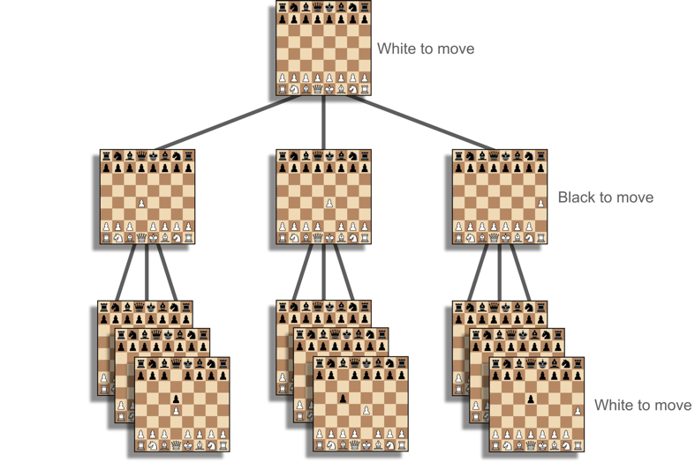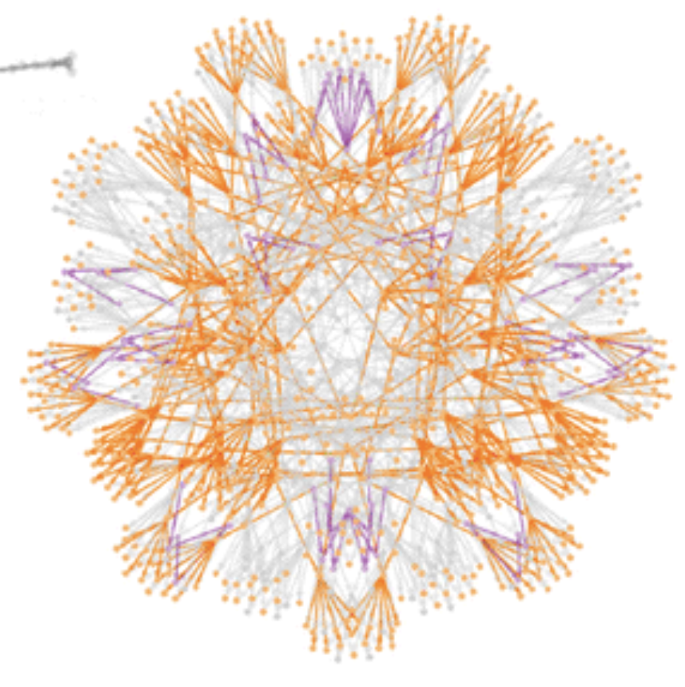
Figure 2. In Fig 2a a tiny fraction of the states involved in chess turn-taking is shown. It defines a massive hierarchy of possible states and transitions. In fig 2b the boards are represented as nodes and links as legal actions. Because of the many moves possible at each board state, it is helpful to represent the graphical state space in a more circular fashion. But all these visual representations are just aids for people to understand the structure of the task space of chess.
We assume that people who know how to perform an activity must at least have an implicit grasp of its formal structure, perhaps the way Chomsky argued that people have an implicit grasp of a language grammar. It is also possible that their implicit understanding is built into their predictive processing system which assigns an implicit probability distribution over the next possible moves, given their goals and their ‘grasp’ of the world state. In such models, the probabilities of executing anything but a ‘legal’ move – a move circumscribed by the rules of the game or the norms of an activity – are very small. In chess, this means that players can be expected to confine their predictions of next moves to legal moves starting from the current game state. If someone is unable to understand where they are in the game, or how turn taking works, or what might make one move better than another, we assume that they cannot understand what is really going on when a game is played. Hence, they cannot play it. They have no grasp of the logic of the game. Generalizing beyond games: they cannot really participate in this activity.
The goal structure of chess, therefore, serves as an organizing principle for the activity. It sets constraints on what is and is not part of the activity. It defines the chess action repertoire for each agent. And it is required knowledge for someone to make sense of the game or activity. Thus, anyone who can play chess knows that scratching one’s head, if done during play, is something that happens in the time and space of chess playing, but head scratching is not part of the formal game itself. It is not part of the game because there is no game situation where it can ever take one closer or farther from any goal.
Newell and Simon would call this formal level the ‘task level’ of analysis and the abstracted environment in which actions are undertaken they called a ‘task environment’. Because there are complications in using this terminology let us call this level of analysis the formal level. Activity at the formal level completely abstracts over the specific physical properties of how states and moves are instantiated physically. It also abstracts over how agents cognitively determine their next action.
On now to the physical level, where topology meets implementation in metric space.

The Physical Perspective
We have all seen countless kitchens that are badly designed. The fault might lie in bad requirements gathering, i.e. failing to understand what people want to do in their kitchen. Or it might lie in uncertainty about the trade-off’s occupants are willing to make between the ease of performing different activities, perhaps biasing high frequency recipes or tasks. The need to handle such trade-offs makes designing at the physical level – the level of material architecture – quintessentially challenging.
Formal knowledge is only a fraction of what a designer must know. All architects know there are factors that constitute preconditions for human activity in general: things like lighting, fresh air and thermal comfort, tolerable acoustics and perhaps lines of sight. Whatever the activity, these requirements must be met. They are general preconditions that lie outside the formal model of legal moves but bear on things to consider when designing for humans.
The reason such preconditions lie outside of formal models is that formal models specify tasks and activities. Two implementations of task can look very different or have very different physical properties but still count as the same task. This was shown in figure 1 where two formally identical activities were implemented in massively different physical and spatial ways. To push the idea further, in one implementation, chess pieces might weigh hundreds of pounds, be burning hot, and the board spread out over acres of land. In another it might be pocket sized with pieces less than a cm in height. All such differences are well defined and recognized as having no effect on the legal actions, rules or norms of a game or activity. Air quality and other human preconditions (like temperature) are never defined at the logical level if the same game or task or activity can be undertaken (or played) by machines. If we agree that computers or robots can play chess, then temperature or air quality is not a part of chess states. It is correct to leave it out at the logical level. Obviously, failure to design for these universal human preconditions would have an enormous effect on how humans play the game.
Other factors not specified at the formal level can also influence an activity. If the board is enormous, most players will be unable to survey the board state of the game. Psychologically the game will be different. Equally we can ask whether the game is being played in a digital, or notational form or using physical pieces and physical board. Are the cognitive processes players use similar when chess is played using algebraic notation rather than standard geometric layout? All these factors lie outside the formal model. All are relevant to how one must move, what one sees, how to motor prepare to execute a move and also how to cognize and think about the physical activity of playing. So, a designer must take these into account when considering how to design the physical space, environment, and arena of chess.
The story does not end here. Architects and designers must consider another set of contextual concerns. Circulation and accessibility. How well-connected is the space? When designing a kitchen do bulky supplies have to be stored nearby or in shelves in the space? What sort of spatial flow do we expect? What about ease of movement? Are machines needed to bring things in? Each of these factors lies outside the formal analysis of chess or the formal analysis of cooking. Yet user-needs include access and use of special tools, large equipment like fridges, stoves, and so on. Obviously they must be added to the design requirements. All these things matter to how people behave and think in a kitchen and hence to kitchen design.
A common method to simplify this problem is to describe complex activities— such as cooking, office work and even socializing – using a two-step approach. Step One starts by abstracting the overall activity into a network of sub-activities. These are nodes in a formal graph and the transitions or dependencies between them links or edges. In a kitchen context, these nodes would represent whole sub-tasks (e.g., chopping, mixing, heating) while the edges capture the order in which these sub-activities occur and their interdependencies. This is officially part of the formal level. Step Two involves expanding a sub-activity into simpler actions that ultimately act on simple environmental states. Whether at high level (step one) or the level of simple actions (step two) the graphical representation of actions remains purely topological. Step Two means we know how to describe the simple environmental states that matter to goal progress. But nothing is said in material terms about what those states look like, where they are in a space, how big they are, what material they rely on, and so on.
Currently there are standard – though coarse – methods in architecture for dealing with inferring gross spatial layout from a specification in Step One. An adjacency matrix and a bubble diagram are used during architectural requirements gathering and planning. They are typically a representation of the main functional parts of a floor or small building at the level of rooms, along with a crude representation of how much space those rooms might need and some initial guess at which rooms need to be near each other to function efficiently. See fig 3. To construct these representations data must be collected on the frequency and importance of sub-activities and the transitions between them. We then can assign a weight to the nodes and edges in a bubble diagram and assign a word or number to the importance of spatial connections in the adjacency matrix. Frequent tasks and transitions might be given higher importance. The challenge then becomes one of mapping the abstract, topological graph of step one – say the bubble diagram – onto a physical, metric layout – an architectural plan – in a way that minimizes costs (e.g., time, effort, or physical strain) associated with movement. In essence, one must reconcile the idealized “flow” of activities as indicated by the bubble diagram with the concrete spatial and other cost constraints of the building being planned.
The relation between formal analyses and design level analyses is, as mentioned above, primarily a mapping between topological space and metric space. The effect of making the activity space easy to cognize rather than just easy to physically act in, is something we will discuss next. In principle, the process of building constraints on physical layout can be run recursively by decomposing each bubble into a smaller bubble diagram that serves as a coarse representation of regions or surfaces within a room where different activities are to be performed. In this manner, one might imagine the functional parts of a kitchen laid out spatially. Because of different activities and especially frequencies, professional kitchens would be laid out one way, household kitchens another. Differences in process, such as that between McDonalds and a Michelin star kitchen would also be reflected in different stations and layout, all originally captured in adjacency matrices and bubble diagrams (or something similar but more precise).
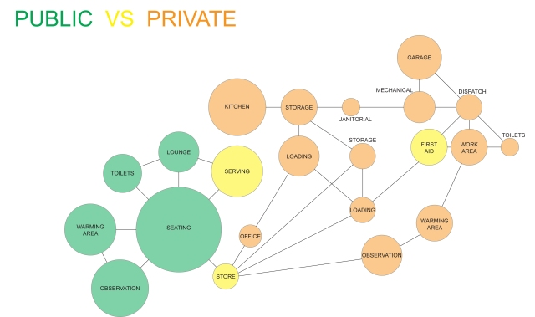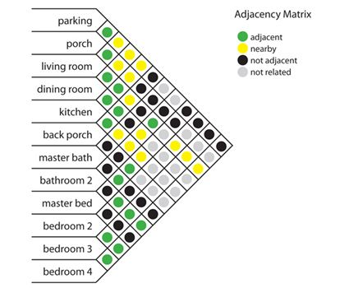
Figure 3. An adjacency diagram and a bubble diagram are both coarse topologies of regions where different activities are to be performed. In the simplest account, each bubble represents a separate room and a separate activity. To spatialize activities to minimize resources, such as walking distance, time, or energy needed to move resources, transit time and so on, an adjacency matrix is used. It provides a cross-product matrix of each region with every other that can be used to encode an estimate of the weighting of the connection between each. The matrix is a triangle because all connections are assumed to be symmetric, so if the connection between the living room and the kitchen is important it remains just as important regardless of which direction you are going. Ideally, the line distance between bubbles reflects the weight of the connection. As with any formal model it constrains physical realizations but it still leaves much open and underspecified.
Although the story is easy to tell, the jump from a detailed bubble diagram to a physical layout in an architectural plan is a big one, with many stages of reconceptualizing and reevaluating value and cost. There are materials to be considered too. The problem is essentially an optimization problem where the function to be optimized has variables for the topology plus background considerations such as HVAC, light, materials, etc. Unlike spatial optimization problems in other design fields, however, this one remains under constrained.
Compare the architectural layout problem with chip design. In chip design, functional parts are specified at many levels of granularity before being specified at a logic gate level which then is handed off to silicon layout optimizing programs. This optimizing problem, though massive, is easier than in architecture because it has no exogenous or non-local factors that must be considered. Architecture, by contrast, has many other types of constraint beyond space, connectivity and shape. In addition to those just mentioned i.e. HVAC … there is the need to integrate with other building requirements such as circulation, daylight, views, safety, building codes .... Some of these are holistic concerns, linking the current layout concern with more global building concerns. In architecture, shape and volume are not just pragmatic factors. There is an overall design aesthetic to be considered. It constitutes another holistic concern. Then there is furniture and equipment that can change the requirements for layout or the efficiency of a space. Finally, there is the need to support adaptability to accommodate shifting patterns of action. This does not imply there are no computational programs to help. But to date, none suffice. The architectural problem of moving from topological accounts to physical accounts, remains woefully underdetermined.

The cognitive perspective
Despite the current distance between topological and metric/physical specifications, 21st century architecture is pushing for computational solutions. See footnote 16 again. But when we look at designs from a cognitive perspective, we know that spatial or physical optimization is not all that matters. The cognitive efficiency or intuitiveness of a design matters too.
To explain what I mean by a cognitive perspective, let’s start with some history. Newell and Simon's in their celebrated work on planning and problem solving, introduced the concept of problem space – a simplified version of what we are calling the cognitive perspective on activity. They saw this initially as a ‘mind’ internal, computational zone where symbolic representations of states, goals, operators, and heuristics were manipulated through algorithmic search, evaluation, and planning processes. Later, Larkin and Simon (1987) extended the problem space to include elements of the outside world where operations on physical structures could replace mental operations on internal representations. This latter view is a step closer to our current view. Nonetheless, whether mental space is conceived in a purely internalist way or understood to be partially distributed across and internal and external representations, mental space is different in kind from the logical space defined by formal analyses of activities and tasks. The task or formal environment analysis is different from a problem space analysis because mental processes are defined over symbolic representations that are computationally manipulated, whereas the formal specification of a task is really defined over mathematical entities and can be variably represented in the form of graphs, rules, algebras and so on. Formally, the semantics of all those task representations is the same. Thus, from a formal perspective it doesn’t matter what representational formalism is used to specify a problem or task as long as it is expressively adequate to refer to all possible states. This contrasts with the cognitive perspective where a key objective is to discover the way people actually represent problems.
These differences are well known in computer science where the study of data structures and algorithmics focuses on how different data structures (symbolic representations) make some problem easier to solve in a computational sense. For instance, to solve multiplication problems it is much easier and faster to use Arabic numerals (1,2,3, …) than to use Roman numerals (I, II, III, IV ..). Arabic numerals are more generative and support use of more efficient algorithms. In Roman notation, multiplication and division (by humans) cannot be done without the aid of an abacus – a very different representation than roman notation. If we were to study the behavior of Romans and Moderns, we would find differences in their bookkeeping behavior, tax collection procedures and methods of running stores all owing to their different representations of numbers. Representational design, and by analogy the design of activity space has outsize consequences for the ways people perform functionally similar activity.
Back to chess. Playing chess on standard chessboards will be cognitively much easier than playing chess using algebraic notation because of the ease of seeing spatial relations. But even two implementations of a 2D board can have different consequences. For instance, playing chess on a sphere will be harder than playing chess on a flat surface small enough to be easily surveyed because on a sphere it is hard to see the entire game state at once. Even when board and sphere players use identical internal representations of chess, we know there will be significant performance differences. Because at least half the cells on the surface of a sphere are always occluded a player cannot visually compare all cells at once. Many cells will have to be remembered from last sighting. Players who cannot easily hold in mind the state of an entire board will find this seriously impacting their play.
Cooking offers a second and less formal example of how design of the cooking activity space, both informationally and physically matters.
Complex recipes are always easier to follow if there are timers to help keep track of the time left of sub-processes. All well-equipped kitchens have timers to add precision and save memory. Yet using a timer is not part of the formal problem of cooking. How do we accommodate timers in a formal analysis? We do not. Clearly, modifying the difficulty of a problem is not just about how we represent things inside our heads. It also matters how things, such as time, are externally represented, manipulated, stored and transformed outside.
Researchers interested in how humans actually solve problems, both from an embodied and a situated cognition perspective typically talk about offloading computation or using the work to hold state as a type of external memory. Whether these terms are ideal or not they do encourage us to think about the many ways we can improve our activity space that depend on how we physically engage environments.
A fine example comes from French cooking. Mise-en-place means “everything in its place”. It is the practice of preparing, organizing, and arranging ingredients and tools before cooking begins. It, and other ways of preparing a kitchen, can significantly alter the success of a chef even though it is not part of the formal state space of cooking.
Here's why mise-en-place is so helpful. By thoughtfully positioning pre-chopped vegetables, measured spices, and utensils soon to be used, a chef can encode in the environment critical information such as the sequence of steps and timing cues. This spatial layout minimizes cognitive load by reducing the need for real-time decisions or consulting the recipe repeatedly and so also lowers the risk of mistakes. It reduces the demands on internal prospective memory. Moreover, a well-organized workspace supports efficient resumption after interruptions, ensuring that the cook can quickly locate items and maintain the workflow seamlessly. If only we could find architectural layouts that provide cognitive benefits like reducing the need for real-time decisions and minimizing cognitive load in such activities as wayfinding!
In the search for metrics it is convenient that cognitive benefits can often be measured in purely behavioral terms. By using standard ergonomic techniques like speed-accuracy profiles (Figure 4), time to recover from interruption, and the cost of worst error, we can say fairly precisely how Env₁ is better than Env₂. Better designed interfaces enable fewer errors, faster decision making and are more robust to interruption. Since architects are in the business of designing 3D interfaces the lesson applies equally to architecture.
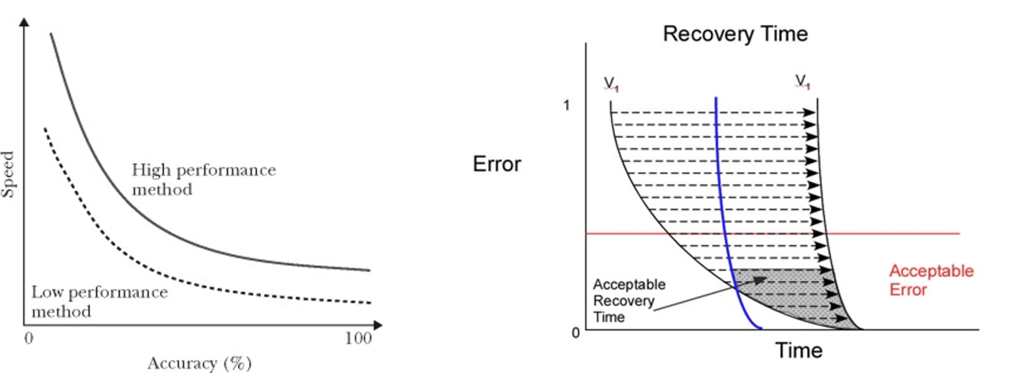
Figure 4. Fig 4a: Speed accuracy curves show the tradeoff between performing a task or activity faster and making errors at that speed. The faster one goes the more probable an error. Another way of thinking of error is that it is a measure of quality. The faster one goes the more likely one is to produce a lower quality product. Fig 4b: In some environments it is easier to recover the state you were in before an interruption. Imagine dropping a coffee cup at Starbucks. It is easy to restart because the order was written. In older Italian cafes, where orders are remembered and not written it is easy to forget a drink if many orders have been placed since. Even worse, if the barista is burned all memorized orders will likely be lost.
Let us call the cognitive helpfulness of an environmental its cognitive congeniality. Mise-en-place is a behavioral technique that is designed to improve the congeniality of an environment and so make us cognitively more effective. Many of these same ideas can be built into the design of the environment. With AI, the range of these cognitive aids skyrockets. These cognitive additives are all cognitive level features of a physical space. They increase cognitive congeniality, making our environments easier to work in, easier to monitor how well we are doing, to keep track of what must be done, and to see what next steps might be good. In a well-designed activity space, the environment cooperates by making the state of activity ‘visible’ – even when states are not superficial – like time left (via the chess clock). Good lighting and acoustics help too since well-designed lighting and acoustics can increase the probability that we detect visible and audible cues better. The most important principle of congenial space, though, is that the tools, parts, and elements of an activity are conveniently placed, and the task state is structured to make it obvious what are the next tools to use, the next actions to perform and in the best case, what are the benefits of different choices.
Summary So Far: The process of architectural and interior design may be improved by thinking of activity at three levels: formal, material, cognitive. We need to think of activity at the formal level to understand the essential structure of an activity – the “sub-goal states” of the world that have to be reached before the final goal of an activity can be achieved. We need to think about activity at the physical level because the formal level is agnostic about shapes, distances, and time. It tells us nothing about where and how actions should be performed and how to lay out space or the elements in space. The formal level is also mute about the biological needs that living humans have – needs that are universal preconditions for controlled performance, breathing, room to maneuver, etc.. At the physical level, we lock these down, ensuring that people have the light, air, circulation, lines of sight and so on that they need to thrive while working or playing in a building. We cannot see in the dark, or around corners.
At the cognitive level, we focus on the representations, algorithms, heuristics and biases people bring to a situation. Because we humans have limited memories, attention span, imperfect ability to predict the future and so on, we cannot divine the path to our goals in advance. We need to search and compute; we need to calculate; we may need to explore or work with cognitive tools like calculators or computers. Often, we learn tricks and techniques to help us perform better. We add things to the environment; we speak or ask others; we learn conceptual tricks; we acquire special skills that let some of us do things others cannot. Our success depends on cognitive overlays, our cognitive skills, and insight. It is not enough, therefore, for architects to find efficient mappings of formal theories of action onto metric theories of designed space. They must also understand the third perspective: how to enhance the cognitive congeniality of those environments to make activity cognition more effective. This requires deeper familiarity with the way occupants solve their ‘everyday’ problems. We can be certain that the cognitive level will be of increasing importance in an age where AI can support our activities in countless ways.

Activity Space
Owing to the importance of cognitive overlays and personal cognitive bubbles, both driven by a person’s strong activity focus, it often happens that what one person ‘sees’ in a physical space is quite different than what they or another person sees when engaged in a different activity. The enactive bubbles of each are different, so their perceptions and their identification of the context of activity are different. To refer to these different half-mental half-physical ‘spaces’ I propose introducing the term “activity space”. It is a physical (or digital) space where an activity takes place; and it can always be analyzed at our three levels of logical, physical, and cognitive.
In this last section, I will discuss an example of a restaurant area in a famous Florentine market to show how a single physical space can support multiple activity spaces. See figure 5. In this one space – an open floor with tables and chairs – we find guests being escorted to their table; orders placed and taken by a waiter; plates brought and removed, and non-participants walking through or near the tables enroute to somewhere else. A whole system of activities is superimposed on the furniture, floor, humans and moveable artifacts. Everyone is working or acting simultaneously in the same physical space. Many of them must choreograph their movement to prevent collisions. The staff, further, must time their use of surfaces, such as where and when servers pick up ready-to-serve dishes; the moment when bussers visit a customer’s table to remove trash and dirty dishes; and how they use floor space and openings to move around. All this simultaneous, closely located role play is precisely why we need a notion of activity space. Each role player – server, busser, customer, cleaner – sees the part of the local environment they care about, interpreting it through the lens of their own activity. They each live and act in their enactive bubbles. What is cognitively active for each is different. This is our everyday world.

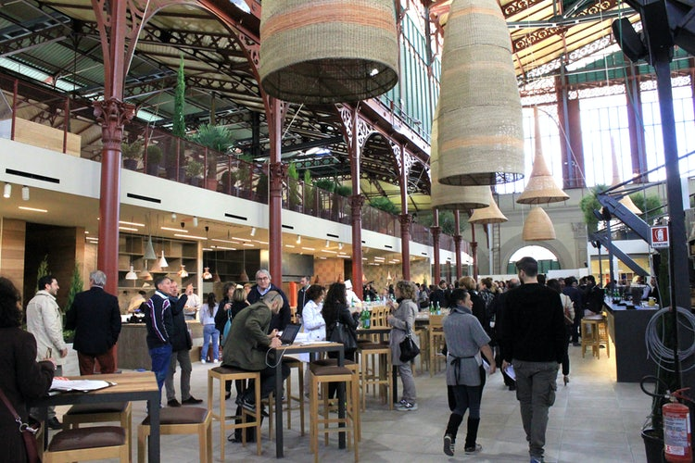
Figure 5. In this picture of the San Lorenzo market in Florence we see a snapshot of the complex ecosystem that is a working restaurant. Bussing and waiting staff follow different paths through the space to the same tables, though at different times. Waiting staff collect plates from a service counter and lay them down on dining tables while bussing staff take plates from vacated tables to the dishwashing station. How should an architect design the location of stations to optimize for these and other roles? How should the pickup bar be shaped and designed?
These different concerns and perceptions play out more precisely in how the space is used by each. Consider the job of bussing staff. Their main task is clearing plates from recently vacated tables. As they move table to table, they fill a hand-carried tray before heading to the dishwashing area to drop things off. Tray size limits how many tables they can clear in one round. To overcome that limitation, it is common to add bussing stations strategically placed so that the buss staff can bus more tables before returning to the kitchen with the big container from their bussing station. Because of the addition of stations to whole space the route bussers follow through the space will change as they detour to their bussing station to unload. This may seem like extra steps. But these small detours will save them several drop-offs to ‘dishwashing’ far away. Upshot: a small change in the furniture of the space will have a large change in the route and workflow of bussers. And in their efficiency.
Is it an architect’s job to worry about such changes? I think it is. The Florentine restaurant scene is a standard case of multi-use space: physical spaces where many activities can take place. There are a few architectural approaches to multi-use. Space can be zoned by using movable partitions. This would not be helpful in the market in Florence. Signage can be introduced or staff can be taught soft constraints via rules detailing which occupants have rights to one vs another region. This is partially useful here since clearly role players must know the traffic rules and who has priority. But in larger or more complex environments it might be too demanding cognitively. Another approach might be to design modular areas that can be reconfigured as needed. This might work here and might in fact be the best description of what actually happens in an environment with a highly variable traffic landscape. Regardless of the answer, though, bussers, servers and cleaners will view the space relative to their own interests. Each will consider paths differently depending on the clearance requirements they believe they need when carrying large loads. This means that ultimately, we need to model the ways individuals will adapt to the conditions of the shared space.
Given the direction of technology today, it is likely that most of these architectural or interior design techniques are soon to be superseded by a more adaptive architecture, as reversible design and robotic reconfiguration becomes a standard part of building design. Bussing stations will become robots that move to the tables needing to be cleaned. Adaptive lighting will likely direct customers to their preferred seating or address other concerns. Space, lighting, signage all will become more intelligent. In this scenario the types of analytical tools that will be needed are exactly those that come from deepening the account of activity space.
One important reason is that adaptive architecture will have to rely on AI-based activity identification to know what is happening in a space. Action identification is known to be highly contextualized, each action framed by the larger activity it is a part of. Activity space is just such a framing construct. That is the thesis of this paper: we must conceptualize people as agents engaged in activities framed by an activity space. When they shift goals, they may enter a new activity space, or a different part of the same one. All of this can be analyzed and understood by distinguishing three levels of analysis and using those levels to better identify and predict what they do.

Conclusion
My goal has been to encourage architectural practice to broaden its requirement gathering to include analysis of occupant activity at three distinct levels: logical, physical and cognitive. This is a structured approach that requires analytical techniques not currently taught in typical approaches to requirement gathering.
Looking ahead, in an increasingly AI penetrated world, the big data and computational analyses needed to properly understand activities is soon going to be available. Analyses of how people customarily work, simulations of how they might work if small changes are made to a plan, or if digital elements were to be added to a space, are all things we can expect to be available in the very near future. Plugins will be offered for parametric modeling and simulation of occupant behavior. I have been arguing that the concept of activity space and the three levels of activity analysis that come with it will provide both scientists, technologists and architects with the conceptual apparatus they need for deeper insight into how humans interact and might interact with building elements and features.
An activity space is an enactive bubble that biases how people perceive, think and act when immersed in an activity. It is the part of the environment that becomes cognitively active when they act or plan. We are biased by our interests, our competences, cognitive styles. Many of our perceptual categories are tied to our activities and are invisible to others when not so involved. We change what we perceive as we move further along in our tasks. This variance in how people perceive and engage their surroundings is even greater when we consider the prevalence of neurodiversity among humans. All this suggests that how people engage environments is not what common sense would have us believe.
In this new world of design, big data, and AI the concept of an activity space has a bright future.

Data Sharing: Data sharing is not applicable to this article as no new data were created or analyzed in this study.
Acknowledgements: I wish to thank … for their thoughtful comments.

References
Cadena, C., Carlone, L., Carrillo, H., Latif, Y., Scaramuzza, D., Neira, J., Reid, I., & Leonard, J. J. (2016). Past, present, and future of simultaneous localization and mapping: Toward the robust‐perception age. IEEE Transactions on Robotics, 32(6), 1309–1332.
Chandrasekharan, S. (2005). Epistemic structure: An inquiry into how agents change the world for cognitive congeniality (Doctoral dissertation, Carleton University)
Clark, A. (2013). Whatever next? Predictive brains, situated agents, and the future of cognitive science. Behavioral and Brain Sciences, 36(3), 181–204.
Cole, M., Bassett, D., Power, J., Braver, T., & Petersen, S. (2014). Intrinsic and Task-Evoked Network Architectures of the Human Brain. Neuron, 83, 238-251.
Danna, R. (2021). Figuring out: The spread of hindu-arabic numerals in the european tradition of practical mathematics (13th–16th centuries). Nuncius, 36(1), 5-48.
Fox, M. D., Snyder, A. Z., Vincent, J. L., Corbetta, M., Van Essen, D. C., & Raichle, M. E. (2005). The human brain is intrinsically organized into dynamic, anticorrelated functional networks. Proceedings of the National Academy of Sciences, 102(27), 9673-9678.
Friston, K. (2010). The free-energy principle: A unified brain theory? Nature Reviews Neuroscience, 11(2), 127–138.
Gibson, J.J. (1966). The senses considered as perceptual systems. Houghton Mifflin.
Gibson, J. J. (1979). The ecological approach to visual perception. Boston, MA: Houghton Mifflin
Kirsh, D. (1995). The intelligent use of space. Artificial intelligence, 73(1-2), 31-68.
Kirsh, D. (1996). Adapting the environment instead of oneself. Adaptive Behavior, 4(3-4), 415-452.
Kirsh, D. (2008). Kirsh, D. Problem Solving and Situated Cognition. In Robbins, P. and Aydede, M.(eds.) The Cambridge Handbook of Situated Cognition. New York: Cambridge University Press. Pp 264-306. 2008.
Kirsh, D. (2010). Thinking with external representations. AI & society, 25, 441-454.
Kirsh, D. (2019). Do architects and designers think about interactivity differently?. ACM Transactions on Computer-Human Interaction (TOCHI), 26(2), 1-43.
Kirsh, D. (2023). Atmosphere, mood, and scientific explanation. Frontiers in Computer Science, 5, 1154737.
Kirsh, D., & Maglio, P. (1994). On distinguishing epistemic from pragmatic action. Cognitive science, 18(4), 513-549.
Larkin, J. H., & Simon, H. A. (1987). Why a diagram is (sometimes) worth ten thousand words. Cognitive Science, 11(1).
Marchette, S. A., Vass, L. K., Ryan, J., & Epstein, R. A. (2011). Cognitive mapping in humans: Spatial navigation, landmark salience, and cognitive strategies. Annals of the New York Academy of Sciences, 1224(1), 144–161.
Newell, A., & Simon, H. A. (1972). Human problem solving (Vol. 104, No. 9). Englewood Cliffs, NJ: Prentice-hall.
Noë, A. (2004). Action in perception. MIT press
Parr, T., & Friston, K. J. (2017). Working memory, attention, and salience in active inference. Frontiers in Psychology, 8, 110.
Pezzulo, G., Rigoli, F., & Friston, K. (2018). Hierarchical active inference: A theory of motivated control. Trends in Cognitive Sciences, 22(4), 294–306
Raichle, M. E., MacLeod, A. M., Snyder, A. Z., Powers, W. J., Gusnard, D. A., & Shulman, G. L. (2001). A default mode of brain function. Proceedings of the National Academy of Sciences, 98(2), 676-682.
Robbins, P. and Aydede, M.(eds.) The Cambridge Handbook of Situated Cognition. New York: Cambridge University Press. Pp 264-306. 2008.
Rensink, R. A., O’Regan, J. K., & Clark, J. J. (1997). To see or not to see: The need for attention to perceive changes in scenes. Cognitive Science, 8(5), 368–373.
Simons, D. J., & Chabris, C. F. (1999). Gorillas in our midst: Sustained inattentional blindness for dynamic events. See also Perception, 28(9), 1059–1074.
Seth, A. K., & Friston, K. (2016). Active interoceptive inference and the emotional brain. Philosophical Transactions of the Royal Society B: Biological Sciences, 371(1708), 20160007.
Thrun, S., Burgard, W., & Fox, D. (2005). Probabilistic Robotics. MIT Press.
Uncapher, M. R., Hutchinson, J. B., & Wagner, A. D. (2011). Dissociable effects of top-down and bottom-up attention during episodic encoding. The Journal of Neuroscience, 31(10), 3939–3947
Vallacher, R. R., & Wegner, D. M. (1987). What do people think they're doing? Action identification and human behavior. Psychological review, 94(1), 3.
Varela, F. J., Thompson, E., & Rosch, E. (1992). The embodied mind: Cognitive science and human experience. MIT press.
Wu, Z., Pan, S., Chen, F., Long, G., Zhang, C., & Yu, P. S. (2020). A comprehensive survey on graph neural networks. IEEE Transactions on Neural Networks and Learning Systems, 32(1), 4–24.

Figures

 |  |  | 
1a | 1b | 1c | 1d
Figure 1. Shown here are 4 topologically identical chess implementations. In fig 1a, a standard 2-dimensional chess board is displayed. This is a 2D surface with 64 cells in an 8x8 matrix. In fig 1b, a connected graph with 64 nodes is represented in a node and link format that shows all the one-step connections (neighboring cells). If connectivity is preserved, and the links do not carry any other meaning than reachable in one step, we are free to distort the appearance and length of the links in this graph in any way we like. Hence 1b could have a regular appearance on analogy with 1a, or it might be arbitrarily distorted, as it is in 1b. Assume that the nodes in 1b are appropriately colored black and white. Now, imagine wrapping or warping the connected graph of 1b around the sphere in 1c. The 2D ‘chess board’ projected onto the skin of the sphere in 1c is topologically identical to 1a and 1b. In principle, any game you can play on 1a you can play on the projection in 1c. Fig 1d offers a further non-standard implementation of a chess board. Three boxes are stacked on top of a large bottom box. Call the outer rim of squares of a normal chess board a ‘square ring’. Imagine these 28 cells are mapped onto the protruding part of the bottom box. The next square ring contains 20 squares. This ring is mapped onto the protruding surface of the next cube, and so on. Figs 1a, 1b and the projections in 1c and 1d are all formally legal physical implementations of a chess board. Obviously, some of these will make playing chess much harder. Designing the physical arena of activity can be non-trivial. It’s analysis even harder. The implications of this diversity will be discussed in the section on the physical perspective.
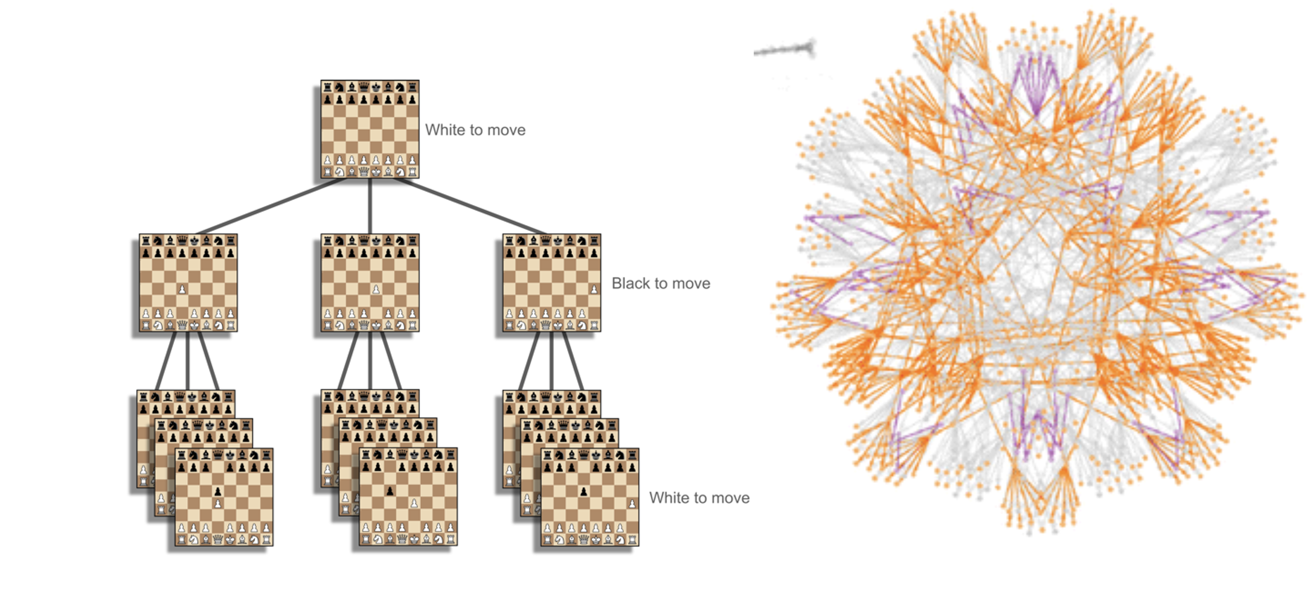
Figure 2. In Fig 2a a tiny fraction of the states involved in chess turn-taking is shown. It defines a massive hierarchy of possible states and transitions. In fig 2b the boards are represented as nodes and links as legal actions. Because of the many moves possible at each board state, it is helpful to represent the graphical state space in a more circular fashion.

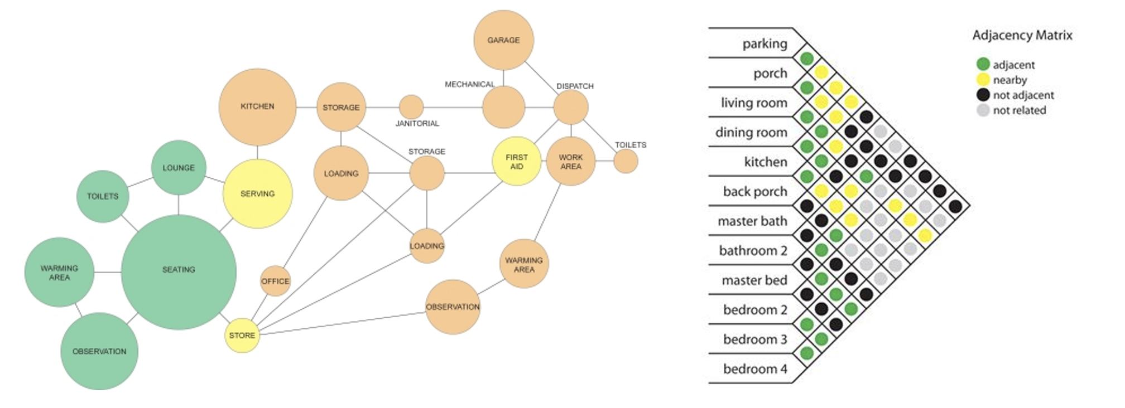

Figure 3. An adjacency diagram and a bubble diagram are both coarse topologies of regions where different activities are to be performed. In the simplest account, each bubble represents a separate room and a separate activity. To spatialize activities so as to minimize resources, such as walking distance, time or energy needed to move resources, transit time and so on, an adjacency matrix is used. It provides a cross-product matrix of each region with every other that can be used to encode an estimate of the weighting of the connection between each. The matrix is a triangle because all connections are assumed to be symmetric, so if the connection between the living room and the kitchen is important it remains just as important regardless of which direction you are going. Ideally, the line distance between bubbles reflects the weight of the connection. As with any formal model it constrains physical realizations, but leaves much open and much underspecified.


Figure 4. Fig 5a: Speed accuracy curves show the tradeoff between performing a task or activity faster and making errors at that speed. The faster one goes the more probable an error. Another way of thinking of error is that it is a measure of quality. The faster one goes the more likely one is to produce a lower quality product. Fig 5b: In some environments it is easier to recover the state you were in before an interruption. Imagine dropping a coffee cup at Starbucks. It is easy to restart because the order was written. In older Italian cafes, where orders are remembered and not written it is easy to forget a drink if many orders have been placed since. Even worse, if the barista is burned all memorized orders will likely be lost.


Figure 5. In this picture of the San Lorenzo market in Florence we see a snapshot of the complex ecosystem that is a working restaurant. Bussing and waiting staff follow different paths through the space to the same tables, though at different times. Waiting staff collect plates from a service counter and lay them down on dining tables while bussing staff take plates from those tables to the dishwashing station. How should an architect design the location of stations to optimize for these and other roles? How should the pickup bar be shaped and designed?

The concept of enaction in cognitive science is that the environment of a person, or any other biological creature, “does not exist ‘out there’ … [like] a landing pad for organisms that somehow drop or parachute into the world. Instead, living beings and their environments stand in relation to each other through mutual specification or codetermination." Francisco J Varela; Evan Thompson; Eleanor Rosch (1992). The embodied mind: Cognitive science and human experience. MIT Press.
The task-positive network activates during goal-directed, externally focused tasks, engaging attention and control regions, while the default mode network is active during rest and internal reflection. They exhibit anticorrelated activity, supporting complementary processes in cognition. Classic studies include Raichle et al. (2001) and Fox et al. (2005).
Kirsh, D. (2023). Atmosphere, mood, and scientific explanation. Frontiers in Computer Science, 5.
Kirsh, D., & Maglio, P. (1994). On distinguishing epistemic from pragmatic action. Cognitive science, 18(4), 513-549.
Predictive processing theories propose that perception is largely a brain-driven process that actively constructs reality through predictions and error corrections. Predictive processing is often extended into the domain of active inference, where motor actions are seen as a way to minimize prediction errors. This means that exploratory behaviors—like eye movements and even hand or arm movement – can be employed to seek out information that either confirms or challenges the brain's predictions. See Friston, K. (2010). The free-energy principle: A unified brain theory? Nature Reviews Neuroscience, 11(2), 127–138. Pezzulo, G., Rigoli, F., & Friston, K. (2018). Hierarchical active inference: A theory of motivated control. Trends in Cognitive Sciences, 22(4), 294–306. Parr, T., & Friston, K. J. (2017). Working memory, attention, and salience in active inference. Frontiers in Psychology, 8, 110.
Affordances are relational properties, emerging from the interaction between an organism and its surroundings. They are not simply features but actionable possibilities that inform behavior, perception, and decision-making. This view emphasizes the natural, embodied coupling between organism and environment, where perception inherently guides action by directly recognizing what the environment offers in everyday human contexts. The affordances a person notices are only a subset of all affordances—specifically, those relevant to that person’s goals and interests. See Norman, D. (2013). The design of everyday things: Revised and expanded edition. Basic books.
This epistemic bubble can be conceived as a personal bubble of situational awareness. The environmental features one is aware of in such a bubble go beyond what can be explicitly articulated and may include non-conceptual elements, such as knowing where a sound is coming from. This is what I mean by cognitively active. See Kirsh, D. (2019). Do architects and designers think about interactivity differently? ACM Transactions on Computer-Human Interaction (TOCHI), 26(2), 1-43.
A simple example is the way expectations can affect the patterns we see in a collection of dots. There may be no right answer to the question “what pattern is really there”. But historical and contextual factors can bias the way dots are gestalted into a pattern. Similarly, if someone sees a 3x3 matrix and thinks it represents a tic tac toe board onto which they then project imaginary X’s and O’s, are they seeing what is really there? If it be said that the board could be so gestalted, shall we also say that seeing – really projecting – future states of a possible tic tac toe game, not currently being played is also a reasonable pattern to be perceived? See Kirsh, D. (2010). Thinking with external representations. AI & society, 25, 441-454.
Seth, A. K., & Friston, K. (2016). Active interoceptive inference and the emotional brain. Philosophical Transactions of the Royal Society B: Biological Sciences, 371(1708), 20160007.
Uncapher, M. R., Hutchinson, J. B., & Wagner, A. D. (2011). Dissociable effects of top-down and bottom-up attention during episodic encoding. The Journal of Neuroscience, 31(10), 3939–3947. This study investigates how both top-down (goal-driven) and bottom-up (stimulus-driven) attentional processes influence memory encoding. Their neuroimaging findings help explain how our current interests and tasks direct what we encode and later recall. A more navigation specific article is the review piece by Marchette, S. A., Vass, L. K., Ryan, J., & Epstein, R. A. (2011). Cognitive mapping in humans: Spatial navigation, landmark salience, and cognitive strategies. Annals of the New York Academy of Sciences, 1224(1), 144–161. This article discusses how navigational tasks and the inherent interest in certain environmental features (e.g., prominent landmarks) affect spatial memory. The authors describe neural evidence indicating that task goals modulate which spatial elements are encoded during navigation.
A recent popular view is that neural divergence is a politically charged expression. Instead of two categories of typical and atypical, there are many differences between the brains of all people. If people are to be classified by their brain functioning or structure, the purpose of the classification should be made explicit since different principles will lead to different groupings.
If the term success seems too strong, we can stipulate that different achievement states such as satisfactory, adequate, appropriate are included in what we mean by success. We can even allow that some activities, such as conversations, might have quite different ‘success’ conditions than we currently think. As social neuroscience evolves, we may discover conversation has different goals and conversational success a different meaning then we think today. It might mean achieving social bonding, closeness, happiness conditions. Or, a given person might have their own success conditions, such as convincing a hearer to vote in a certain way, or to marry them. In both philosophical and scientific contexts to say an activity has success conditions does not prejudge what those conditions are.
As with most things formal it is often possible to find an alternative formal representation that is expressive enough to capture all the relations, states and constraints represented, which in this case is represented as a directed acyclic graph (DAG). For example, one can construct a set of inference or rewrite rules that capture the dependency relationships encoded in a DAG. Whatever the formalism, however, its purpose at the formal level is to specify the goal sub-goal structure of the activity and the actions that will step a participant through the states of the activity.
Newell, A., & Simon, H. A. (1972). Human problem solving (Vol. 104, No. 9). Englewood Cliffs, NJ: Prentice-hall.
See Kirsh, D. (2009). Problem Solving and Situated Cognition. In Robbins, P. and Aydede, M.(eds.) The Cambridge Handbook of Situated Cognition. New York: Cambridge University Press. Pp 264-306. 2008. Cambridge: Cambridge University Press, 2009.
Three methods in particular have been gaining adherents. Graph Neural Network based inference leverages graph‐structured learning to predict metric layouts directly from connectivity graphs. See Wu, Z., Pan, S., Chen, F., Long, G., Zhang, C., & Yu, P. S. (2020). A comprehensive survey on graph neural networks. IEEE Transactions on Neural Networks and Learning Systems, 32(1), 4–24. Pose-Graph SLAM uses classical nonlinear optimization to align a topological graph with metric constraints. See Thrun, S., Burgard, W., & Fox, D. (2005). Probabilistic Robotics. MIT Press. Earlier work on topometric fusion anchored local metric submaps to a global topology for coherent floor-plan reconstruction. See Cadena, C., Carlone, L., Carrillo, H., Latif, Y., Scaramuzza, D., Neira, J., Reid, I., & Leonard, J. J. (2016). Past, present, and future of simultaneous localization and mapping: Toward the robust‐perception age. IEEE Transactions on Robotics, 32(6), 1309–1332.
Newell and Simon, op cit.
Larkin and Simon (1987) show that when a problem is laid out in the world—whether as a diagram or the pieces on a chessboard—the arrangement itself becomes part of the problem-space. Because the spatial layout embodies constraints that would otherwise have to be laboriously retrieved from symbolic notation, many “search” steps are replaced by direct perceptual inspection. This offloading lowers cognitive cost and reshapes the very path the solver takes through the problem.
For Newell and Simon, the activity they studied was problem solving activity – puzzles, math problems, chess, etc. Their interest extended to the problem of planning. They assumed that there is always some amount of planning when people decide what to do and how to do it. Decision making and planning were central to their work.
Danna, R. (2021). Figuring out: The spread of hindu-arabic numerals in the european tradition of practical mathematics (13th–16th centuries). Nuncius, 36(1), 5-48.
Except for those players that can visualize algebraic notation in board like format.
Mise-en-place is not part of the formal state space of cooking because a subject is no closer or farther from the goal of food transformation by performing these extra steps of moving food around. This situation has an analogy in card games where human subjects often move the cards in their hands before playing. These card movements are not part of the state space of the game. After re-ordering, nothing about the game state has changed. Yet, playing the game or following complex recipes are cognitively easier because of it. See Kirsh, D. (1995).
For an analysis of architecture as designing 3D interfaces that support more complex forms of interaction than human computer interaction see Kirsh, D. (2019). Do architects and designers think about interactivity differently? ACM Transactions on Computer-Human Interaction (TOCHI), 26(2), 1-43.
Kirsh, D. (1996). Adapting the environment instead of oneself. Adaptive Behavior, 4(3-4), 415-452. The concept of cognitive congeniality was introduced to explain how adapting one’s environment could reduce mental effort while leaving the underlying task structure (the formal state space) the same. Instead of reshaping the physical steps required to reach a goal (e.g., adding shortcuts or removing choice points), it is often possible to cognitively redesign the physical environment to make the environment easier to think in. See also Chandrasekharan, S. (2005). Epistemic structure: An inquiry into how agents change the world for cognitive congeniality (Doctoral dissertation, Carleton University) for a thesis length exploration of this idea.
Game clocks make explicit how much time each player has left to make their moves. This adds information that can improve planning since extra time to consider end games is strategically desirable.
Vallacher, R. R., & Wegner, D. M. (1987). What do people think they're doing? Action identification and human behavior. Psychological review, 94(1), 3.

