How to Use Chatbot Data Website

Last updated: November 7, 2019

Table of Contents

URL 3

Manage Users 3

Add GBC User 3

Documentation 3

Transcripts 3

Intent Monitoring 4

Main Stats 4

Categories 4

Popular Intents 4

Total Conversations 4

Escalation 5

Browse by Date 5

Browse by Popular 5

See Intent Data 6

See Escalation Data 6

Manage Intent Category 7

Search 7

Errors and Escalation 8

Processing Errors 8

Unrecognized Errors 8

Mismatch Errors 8

Escalation 8

Percentage of Escalation 8

# URL

Chatbot data website can be accessed through the following URL: <https://dmzmsa01.georgebrown.ca/ChatbotService/>

# Manage Users

## Add GBC User

If you wish to add a new admin user for this management website, simply put their GBC ID and click “Add GBC User” Button. After they are added, click “Edit” to give them permissions to manage the website.

# Documentation

This tab contains example functions in the backend service; most of the user-specific questions will be listed here. When you click on the URL, it will display sample answers for each question.

# Transcripts

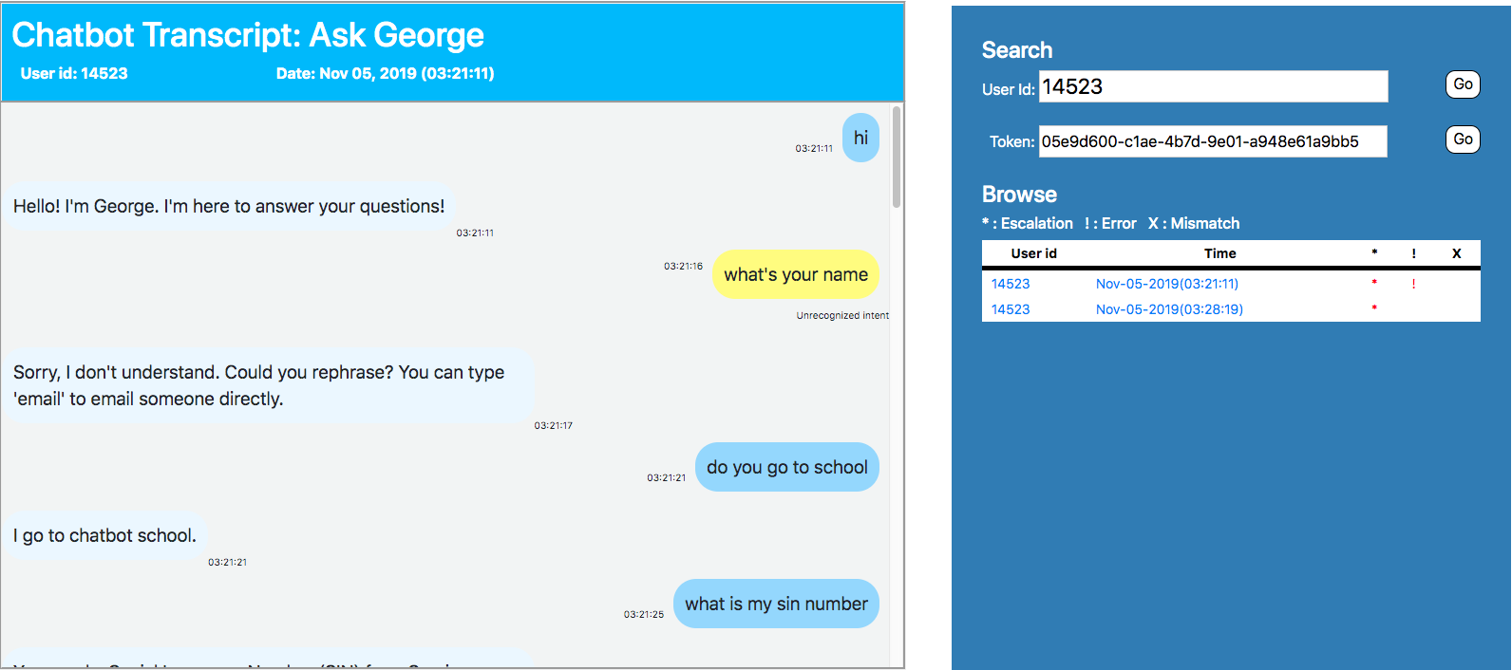

Figure 1. Transcripts

As shown in Figure 1, if you click on the “User id” or “Time”, it will direct you to the conversation related to the specific chat token. Also, if you click on the “User id”, the Browse tab will only show the conversation from that specific user. Similarly, you can type the user id and chat token on the Search tab.

*, !, and X each expresses whether the conversation contains escalation, server error, and intent mismatch, respectively.

Having an escalation means that the user was not satisfied with the conversation. It is marked whenever user invokes specific intent, including insult, break, or unrecognized.

Server error happens when something goes wrong in the backend service. The chatbot will automatically display “Sorry, I was unable to process your message. Try again later,” and the chat bubble color would be red.

Intent mismatch is the situation when the chatbot invoked the wrong intent. It will be figured out manually by the admin user, and they can set the correct intent for that specific utterance.   
Note that marking it as resolved in **Errors and Escalation** tab does not change anything on the actual chatbot, so it is recommended to fix it on the AWS Lex console first, and then mark it as Resolved.

# Intent Monitoring

## Main Stats

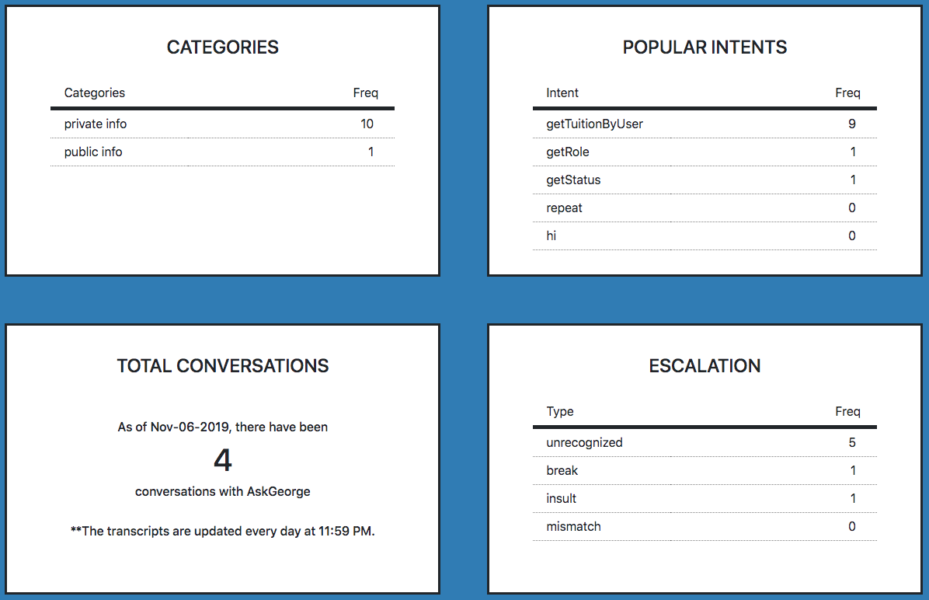

Figure 2. Main Stats-Intent Monitoring

### Categories

This box lists the top 5 intent category by its frequency.

### Popular Intents

This box lists the top 5 intent by its frequency.

### Total Conversations

This box displays the number of conversations happened until the update.

### Escalation

This box lists the top 5 escalation by its frequency.

## Browse by Date

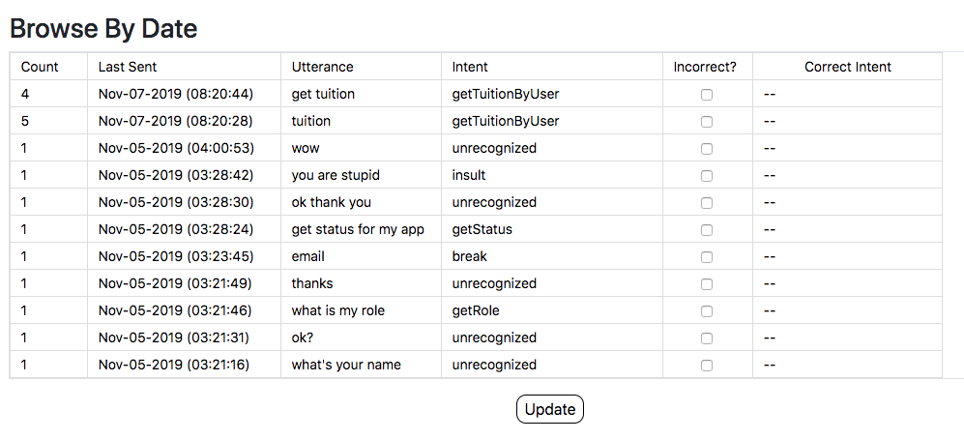

Figure 3. Browse by Date-Intent Monitoring

This tab contains information about all of the intent utterances, listed by the date it was sent. If the utterance does not match with the correct intent that should have been invoked, you can check “incorrect?” box and choose the correct intent.

The checked intent will now appear in **Mismatch Errors** box under Errors and Escalation tab, and after it is fixed in AWS Lex Console, it can now be marked as “Resolved.”

## Browse by Popular

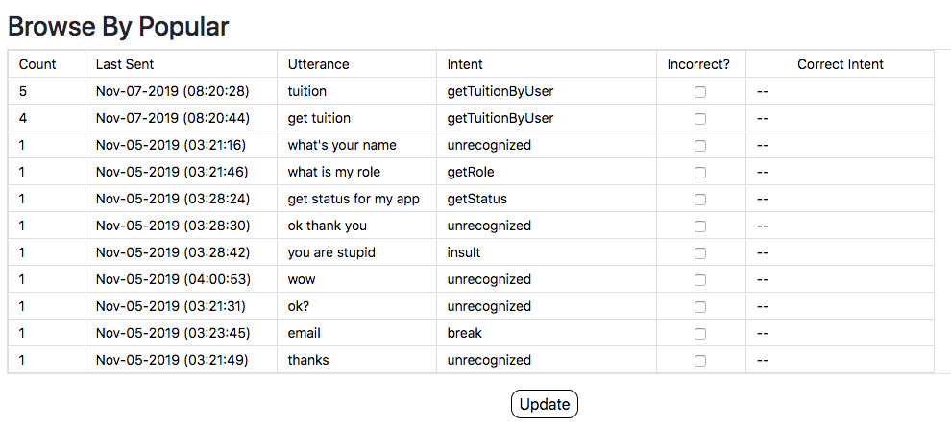

Figure 4. Browse by Popular-Intent Monitoring

This tab contains the same information as **Browse by Date** tab, but it is listed by the frequency of each utterances instead of the date it was sent.

## See Intent Data

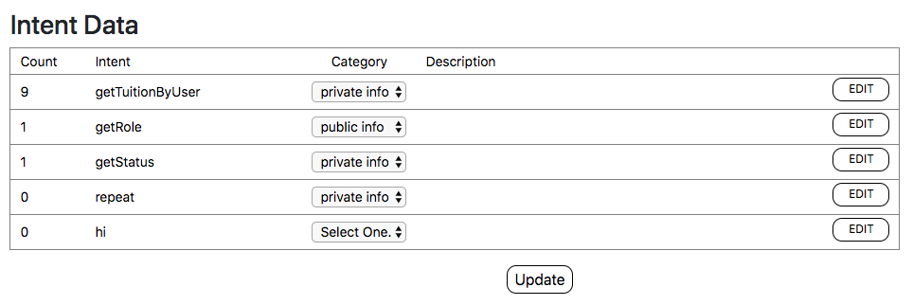

Figure 5. See Intent Data-Intent Monitoring

In this tab, you can manage the intent’s category and description. Note that you cannot add nor delete an intent, since it will be automatically updated when the transcript gets updated (every day at 11:59 PM). With that said, if you add a new intent on AWS Lex console, it will not be added until the user actually invokes that intent.

## See Escalation Data

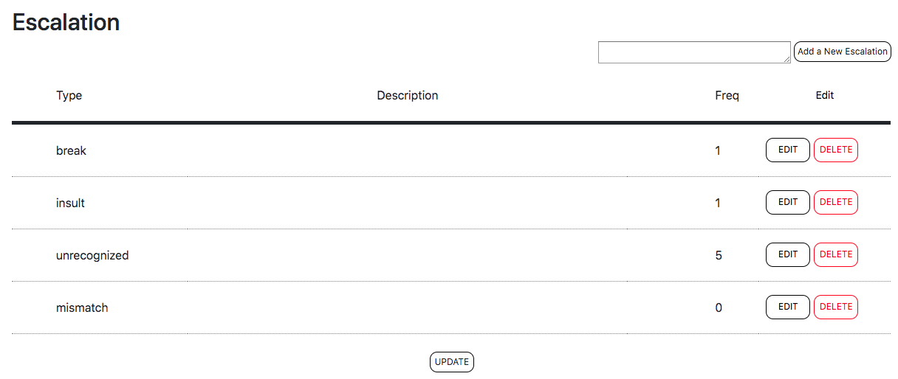

Figure 6. See Escalation Data-Intent Monitoring

This tab is used to manage the escalation data. Each escalation is an intent, so if you think specific intent should be considered as an escalation, you can type the intent name in the “Add a New Escalation” text box. For example, in Figure 5, the intent “repeat” should be under escalation category, so you can add it by typing “repeat,” and it will be added to the Escalation table.

## Manage Intent Category

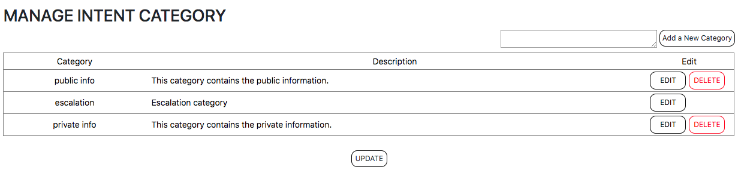

Figure 7. Manage Intent Category-Intent Monitoring

This tab contains the information about each intent category; you can add, delete, and modify description on the categories. Note that you cannot delete escalation category as it is mandatorily used in many fields.

## Search

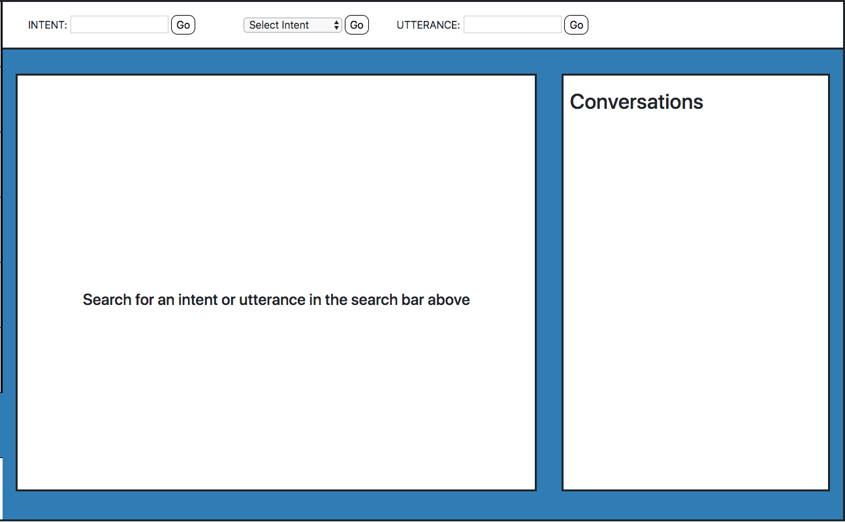

Figure 8. Search-Intent Monitoring

In this tab, you can search the conversation by specific utterance or intent. After you search, the relevant conversations will appear in the “Conversations” tab, and it will direct you to the related transcript.

# Errors and Escalation

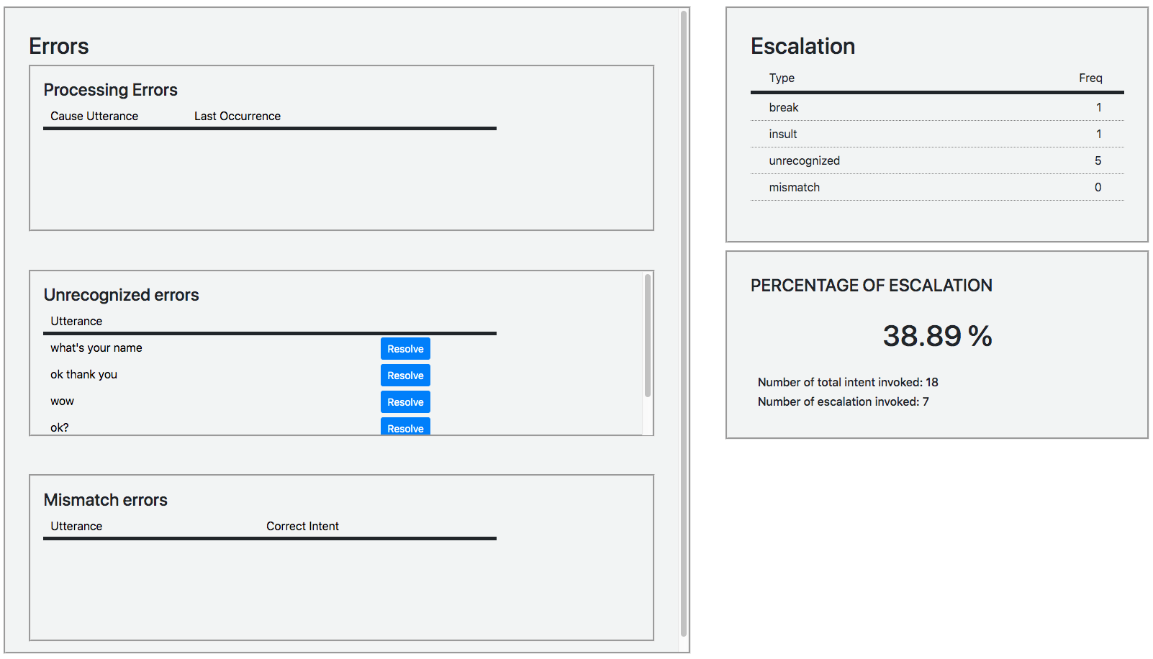

Figure 9. Errors and Escalation

## Processing Errors

As briefly mentioned in **Transcripts** section, processing errors (server errors) includes the error happening in backend service. You can mark it as “Resolved” once the error is fixed.

## Unrecognized Errors

Unrecognized error appears when the user invokes “Unrecognized” intent, which happens when the user’s utterance does not match with any of the currently existing intents. You can fix this issue by simply adding a new intent, or by adding a new utterance to the existing intent in AWS Lex Console.

## Mismatch Errors

Mismatch errors only appears when the admin user manually mark the intent utterance as “Incorrect,” and assign a new correct intent for that utterance. It can be fixed by adding a specific utterance to another intent in AWS Lex Console.

## Escalation

This box contains information about the frequency of each escalation.

## Percentage of Escalation

This box contains information about the percentage of escalation over the total intent invoked. It gives you an idea on how much success we are having with the chatbot in general. Note that it does not necessarily determine whether we succeeded or not, since the user might just want to contact the admissions officer, and it would still be considered as an escalation.