**Using Wearable Technology and Machine Learning**

**to Garner New Insight into**

**Postural Orthostatic Tachycardia Syndrome**

**MSDS 5143: Practicum I Final Paper**

Julie Fisher1 and Brandon Harden1

1College of Computing and Technology, Lipscomb University Nashville, TN, 37204

***Abstract*—**

**Wearable sensors can continuously measure body functions over time, including heart rate and physical activity. This paper investigates the ability of wearable sensors to monitor physiological changes in a person with postural orthostatic tachycardia syndrome (POTS). The overall goal is to use this in conjunction with machine learning to find relationships, associations, and patterns between symptoms of POTS and environmental factors. POTS is a form of dysautonomia that occurs in an estimated 0.2% of the population (Sheldon et al., 2015) and where the underlying pathophysiology isn’t completely understood (Bagai, 2013). POTS does however have a distinct and detectable increase in heart rate upon standing, making it an ideal candidate for symptom detection and correlation with external factors.**

**This paper contains the results of a single patient observational study which suggest that current wearable technology can be used in conjunction with machine learning to find relationships between symptoms of POTS and environmental factors. The preliminary results from the first stage exploratory analysis showed that quantity of sleep is negatively correlated with an increase in average heart rate. Based on this initial analysis, we expect to find additional correlations within the data.**

***Keywords* — dysautonomia, orthostatic intolerance, orthostatic tachycardia, postural orthostatic tachycardia syndrome, postural tachycardia, wearable technology, machine learning, data science**

1. **INTRODUCTION**

**A. Background**

Smart people who have earned their MDs and PhDs in medicine say that the quality of life for a patient with postural orthostatic tachycardia syndrome (POTS) is comparable to patients with the more recognizable conditions of congestive heart failure and chronic obstructive pulmonary disease (Garland et al., 2016). They also report that for POTS patients “even activities of daily living such as bathing or doing housework may greatly exacerbate symptoms […and…] can pose significant limitations on functional capacity” (Raj, 2013) In layman terms, it sucks.

Having lived with POTS for over 7 years, Julie likens it to living with and managing diabetes - without the tools that make such a feat possible, like a glucometer and education on nutritional factors such as limiting carbohydrates. This lack of resources is due in part to the syndrome’s heterogenous nature involving multiple underlying pathophysiologies, as well as its complicated and poorly understood pathophysiology (Khan et al., 2016). In other words, it’s not just patients that are flying blind, doctors are too.

**B. Postural Orthostatic Tachycardia: definition and symptoms**

So what is POTS? The official definition from an international panel of experts states “POTS is a clinical syndrome usually characterized by (1) frequent symptoms that occur with standing; (2) an increase in heart rate of ≥30 beats per minute (bpm) when moving from a recumbent to a standing position (or ≥40 bpm in individuals 12 to 19 years of age); and (3) the absence of orthostatic hypotension (>20 mm Hg drop in systolic blood pressure)” (Sheldon et al., 2015). It’s a rare condition estimated to affect about 0.2% of the general population (Sheldon et al., 2015). However, since that represents an estimated 500,000 people in the United States alone (Robertson, 1999), the term rare seems a little less appropriate.

The actual number of POTS patients is difficult to determine due to underrecognition and misdiagnosis (Crnosija et al. 2015). Eighty-five percent of POTS patients report being told their symptoms are “all in their head” or given similar psychiatric labels before being correctly diagnosed (Dysautonomia International Report, publication pending). Due to these confounding factors, the average time to diagnosis is just under 6 years (Dysautonomia International Report, publication pending).

As a non-lethal condition with symptoms that are difficult to quantify like rapid heart rate, palpitation, exercise intolerance, lightheadedness, extreme fatigue, headache, and mental clouding (Raj and Robertson, 2007), POTS is easy to treat as an unserious condition. However, symptoms are often disabling to the point that 25% of POTS patients are unable to work (Garland et al., 2015). This creates undue hardship not only on the individual, but also requires society to help support that individual.

That leaves POTS patients in the uncomfortable position of managing their symptoms on their own, mainly through trial and error. Lacking an instrument to measure her state of wellbeing, Julie went in search of something that could at least provide a little guidance to improve her situation.

**C. Pre-study investigation**

The search for a wearable sensor started with an inexpensive Wal-Mart watch. Having given up on trying to support herself while barely able to stand let alone engage in normal activities such as shopping for groceries, cleaning the apartment, walking the dog, showering, or many other daily activities, Julie couldn’t afford anything much fancier. Even if she could, the cognitive difficulties were seriously hampering her higher-level thinking and reasoning skills. So, a simple watch to start. It told the time, yes, but more importantly it calculated heart rate with the push of a button. No more compressing a pulse point and counting for 15 seconds, then trying to calculate the beats per minute. At the push of a button, she could have her heart rate in 5 seconds or less.

From these rudimentary, real-time only measurements Julie made 3 discoveries over the course of several years: 1) heart rates in the 90s meant she needed to sit down and rest or more serious symptoms were imminent, 2) heart rates in the 100s correlated with chest discomfort that turned to pain and she needed to lie down ASAP, and 3) heart palpitations and chest discomfort weren’t always associated with high heart rates, they occasionally occurred at lower pulse rates. Due to severe exercise intolerance that didn’t even allow for static exercise like stretching and calisthenics, these heart rates were all observed either at rest, or at low levels of activity, such as standing. The first two observations gave her a guide for activities and when to call it quits. The third made her suspect that factors, other than just heart rate, were influencing her symptoms. Perhaps blood pressure or circulatory issues were involved.

There were other issues she observed during that time as well. For example, there was an obvious relationship between sleep and symptoms. A lack of adequate sleep or poor sleep quality caused a deterioration of symptoms. Knowing herself, she knew she couldn’t be counted on to keep a sleep diary recording duration of sleep with any consistency. She also knew that the act of tracking sleep would alter how and when she went to sleep. Thus, she couldn’t quantify the amount of sleep necessary to avoid exacerbating symptoms. Two other potential factors she observed were weather and food. These were harder to track due to inconsistent or delayed influence.

Julie noticed marked exacerbation in symptoms during some weather events, but no effect on symptoms during others. At first, she suspected this was due to air pressure, but a short stint tracking barometric pressure revealed no relation. There were also obvious correlations with food, sometimes improving and sometimes worsening symptoms. However, the variety of food and drink consumed and the delayed onset obscured the nature of the relationship. Several simple experiments in removing and adding back different types of food failed to produce pronounced results. Clearly, it was time for a more comprehensive tracking system.

1. **MATERIALS AND METHODS**

**A. Data criteria and device selection**

In addition to real-time monitoring, Julie wanted to be able to record data for later analysis. As POTS is, at heart, a syndrome of high heart rate, she needed something that could track heart rate continuously, not sporadically or only during exercise. The only commercially available fitness tracker she could find at the time was the Fitbit Charge HR. Fitbit recorded and stored the data, allowing customers to see charts of their data. It also counted steps, tracked sleep, and provided access to Fitbit’s nutrition logging and calorie counter. Paired with publicly available historic data on weather, it seemed well-designed to provide all the necessary information for the next stage of data collection other than blood pressure.

**B. Description of the Data Set**

This study focuses on an intense analysis of a single individual’s recorded vitals. The detailed analysis of that individual’s data allows the assessment of potential trends in symptom shifts and triggers over a longer period and may identify lifestyle modifications to improve quality of life. The data from the single individual came from the Fitbit Charge HR and the Fitbit Charge 2. A change was made in March 2017 due to wearing out of the original device.

Data available through Fitbit and the Charge HR include heart rate, sleep information, sporadic nutrition data, occasional weight and BMI measurements, daily step counts, and activity levels. One challenge in this dataset is that water consumption was not recorded and it has been established that water consumption helps improve POTS symptoms (Raj, 2013). Two other variables that would help complete the inputs for symptom prediction are blood pressure and respiratory rate. Currently, there are no commercially available devices that reliably record blood pressure in a moving subject during normal daily activity.

All information obtained for analysis was downloaded through the Fitbit API. Heart rate data is available at an interval of one measurement every tenth of a second. Sleep and step data are both stored at one minute intervals. Nutrition data is sporadic and still being reviewed for compatibility with analysis.

1. **RESULTS**

**A. Preliminary Analysis**

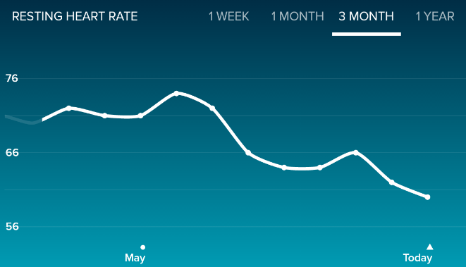Cursory review of the data provided by the Charge HR has provided important new insights. For example, during periods in which resting heart rate is decreasing, Julie feels better. During periods of increasing resting heart rate, symptoms become more prevalent. These shifts in resting heart rate range from the mid-70s down to a recent low of 59 as shown in Figure 1 and Figure 2. While it’s well-known and confirmed through experimentation that more athletic individuals have lower resting heart rates (Li et al., 2017), additional literature review is required to determine variability within the results of a single individual.

Figure 1 - Resting heart rate over 3 months

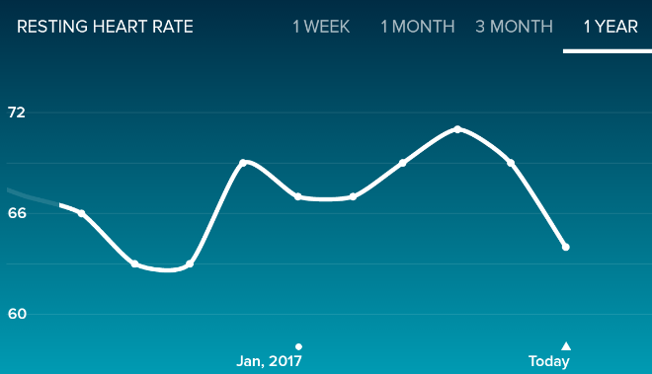

Figure 2 - Resting heart rate over 1 year

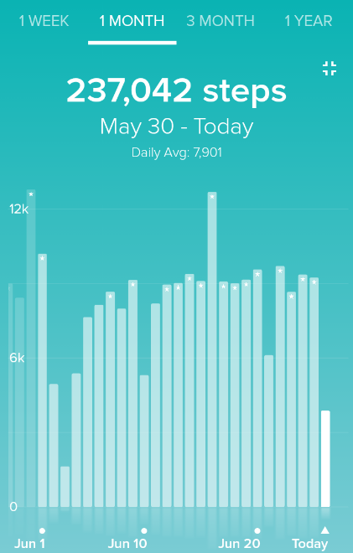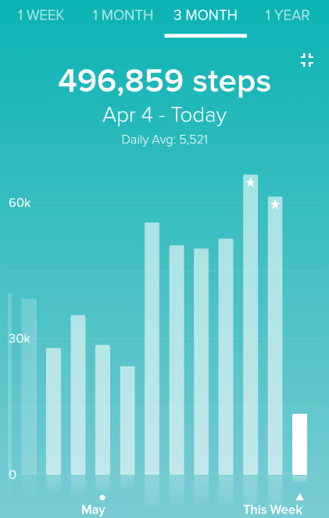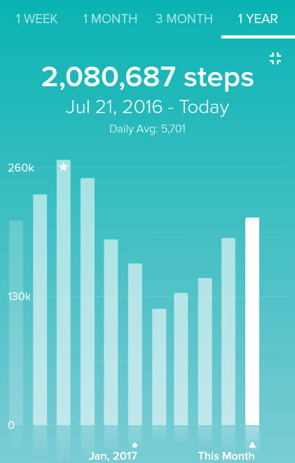We attempted to compare steps, as shown in Figure 3 to the resting heart rate over 1 month, 3 month, and 1 year time periods. The three-month graphs most clearly show a potential negative relationship between steps and average resting heart rate, but is difficult to quantify due to low resolution and the varying time scale binning provided by the Fitbit graphs. The next steps in evaluating this data is covered in Section B – Planned future analysis.

Figure 3 - step activity over 1 month, 3 month, and 1 year time periods

The other insight was into sleep. The average amount of sleep necessary to prevent increased symptoms seems to be between 6.5 and 7 hours. The granularity of this observation is limited by the Fitbit visualizations as seen in Figure 4. The standard graphs are very basic, with low resolution of data and no customization. To address this limitation, the data will need to be analyzed with other tools, such as R, Python, or Tableau.

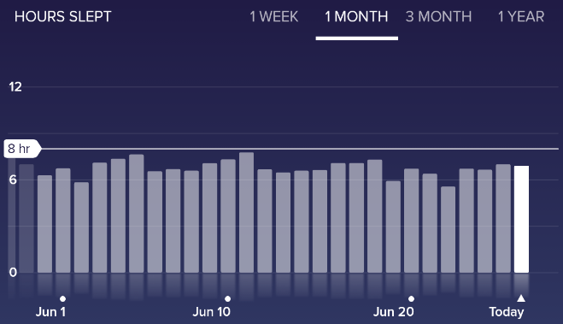

Figure 4 - Hours slept over 1 month

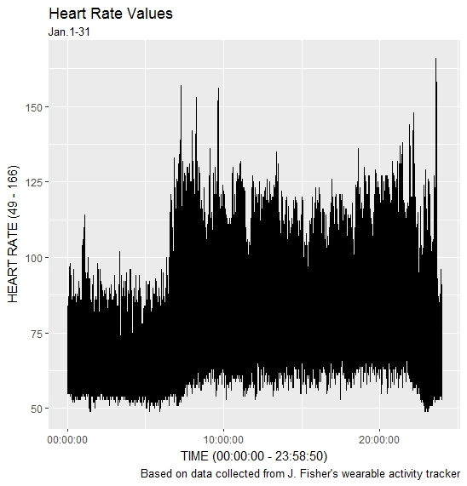Our initial analysis of the detailed heart rate data started with the values for January 2017. In the detailed download via the Fitbit API heart rate is available at intervals of every tenth of a second. Initial observations are shown in Figure 5. This graph shows all recorded heart rates by time of day. As expected, heart rate values are observed to be lower overnight and higher during the day. The peak for the month was 166 bpm.

Figure 5 - heart rate for January 2017 by time of day

**B. Planned future analysis**

While the raw data from the sensors, such as the accelerometer, are unavailable, there is high resolution pre-processed data available. This data includes heart rate measurements of several times per second, sleep data at a minute by minute interval, step counts at 1 second intervals, and sporadic food logs.

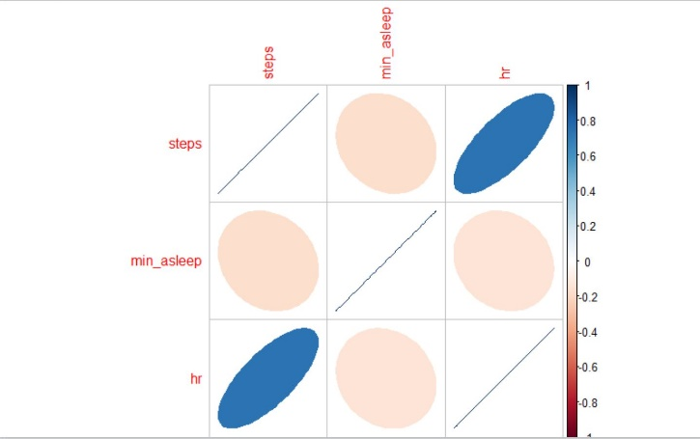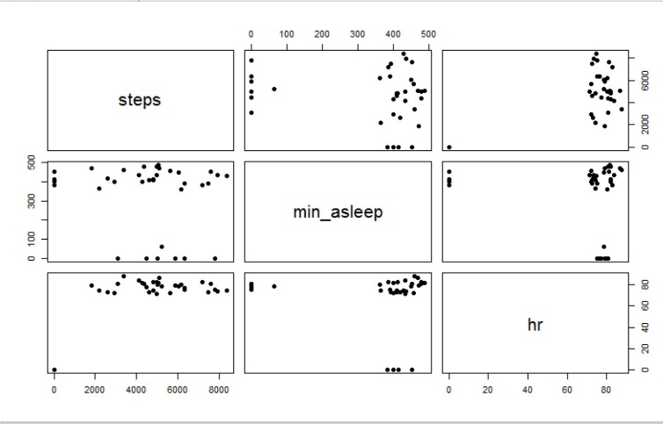Preliminary analysis shows expected relationships between average heart rate and steps as shown in Figure 6 and Figure 7. It also shows a weak relationship between average heart rate and sleep. The average heart rate is the overall average and doesn’t currently account for resting heart rate versus active heart rate.

Figure 6 - Correlation plot of avg HR, steps, and sleep

Figure 7 - Pairs correlation plot of HR, steps, and sleep

We are currently researching accepted values to qualify ‘at rest.’ The study using two years of Michael Snyder’s personal data, along with data from a cohort of 43 participants, calculated resting heart rate by using recordings with step measurements of 0 for at least 10 minutes prior (Li et al, 2017). Once this important baseline has been established, we can look for associations between it and activity levels and sleep parameters. We will also be able to search for changes in heart rate over 30 bpm, the hallmark indication of POTS. The frequency of such a large change can then be compared to the external factors to look for relationships.

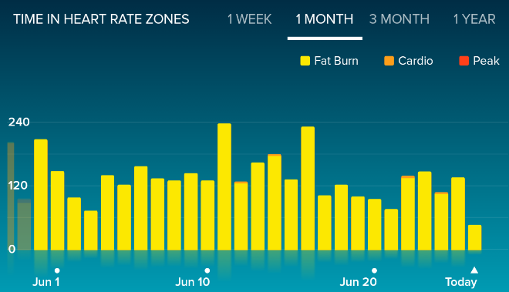Once we have determined the extent of these basic associates, we can begin to explore further relationships. One promising area is heart rate at various levels of activity. As seen in Figure 8, Fitbit provides a graph showing number of minutes in each exercise zone. This appears to be based solely on heart rate, with no correlation to identified activity. Due to the unique profile of POTS, this definition of activity zone loses much of its analytical impact. By creating zones based on activity level instead of heart rate, we should be able to garner better insight into the elevated heart rates experienced by a POTS patient.

Figure 8 - heart rate by activity zone

With the goal of understanding a deviation from normal patterns (i.e.- change of baseline), we will analyze our data for systematic normal patterns such as circadian rhythms (Li et al., 2017). Physiological data and physical activity information can be compared to explain fluctuations in circadian data. For example, spikes in heart rate at certain times of the morning or evening could be related to dog walking.

Symptom state will be quantified as changes in heart rate over 30 bpm. We will need to determine the best way to detect this change as well as how to separate increased heart rate due to POTS from expected rises in heart rate due to activity. We anticipate being able to distinguish these features by relating heart rate with number of steps for the same time frame. The degree of changes in addition to the frequency of heart rate changes over 30 bpm is anticipated to provide a baseline for symptom severity.

We also plan on correlating the data from the Charge HR with NOAA weather data. This will allow us to determine if there are any relationships between daily temperature, temperature change throughout the day, barometric pressure, humidity, or precipitation with increased POTS symptoms. As discussed previously, preliminary analysis was unable to detect associations with barometric pressure or precipitation with symptoms. However, that analysis was unable to account for the other factors listed above, as well as changes in barometric pressure.

In addition to traditional statistical analysis, we intend to use machine learning techniques to evaluate whether there are patterns in the data. These techniques will be applied using R and Python to investigate if and how data provided by the Charge HR can be used to predict environmental factors that trigger symptoms. Classification algorithms can assist in identifying which, if any, variables led to increased symptomatology and autoencoder algorithms can be used with our combined Fitbit and external data sets to reduce features. The simplified data set can then be run through a classification algorithm to investigate if symptoms occur or not.

Once proof of concept for analyzing data for a POTS patient has been established, this study would like to expand to include other POTS patients and voluntary health control subjects. This would allow us to determine if the relationships observed in this data set can be generalized to the wider POTS population or a subgroup within that population. The healthy controls will help establish a baseline for normal functioning and rule out normal fluctuations for regular physiologic processes.

**C. Challenges**

While the information from the Charge HR is much better than the real-time only measurements of the Wal-Mart watch, it still presents challenges. These include: (1) accuracy, (2) a limited scope, and (3) a high signal to noise and are described in more detail below.

**1. Accuracy**

The main concern in using a commercial device is accuracy. There has been much debate about the viability of commercial devices for use in medical conditions (Stahl et al., 2016; Li et al., 2017). However, based on the type of analysis we will be conducting and the properties of POTS, we believe this won’t present a major problem.

There is an overall consensus that wrist worn devices using optically based heart rate monitors are reasonably accurate at rest and moderate activity levels, but struggle at higher levels of exertion (Want et al., 2017 and Prospero, Mike 2016). Due to symptoms of exercise intolerance, most POTS patients, and Julie specifically, don’t often exceed low, let alone moderate, activity levels. Indeed, much of Julie’s time is spent at rest. In addition, the change of heart rate is the target under examination and that change must meet a high threshold of over 30 bpm. A study on accuracy of wrist-based heart rate monitors, including the Charge HR deemed them to be accurate enough for the recreational athlete and research purposes (Stahl et al., 2017).

The use of wearable technology to conduct individualized research isn’t new either. This trend has been helped along by their increased prevalence in recent years. The number of devices shipped increased from 29 million units in 2015 to 33.9 million in 2016 (Lampkin, 2017). The data collected by these devices is commonly used to evaluate sports performance, increase overall fitness by targeting minimum number of steps and nutrition goals, and address general health with the tracking of sleep quantity and quality (Stahl et al., 2016). The study involving Michael Snyder, professor and chair of genetics at Stanford University School of Medicine, used the Basis Peak wearable device. They were able to detect when he contracted Lyme disease using the data from this device. The study followed 43 participants and collected over 250,000 measurements a day (Li, 2017).

**2. Limited scope**

Single patient, or n-of-1, studies aren’t as common as their random clinical trial counterparts, but are seen as a viable alternative when random clinical trials are not appropriate, whether due to limited cases as in rare or unusual diseases or for new, novel treatments (Larson, 1990). Personalized medicine is one of the more well-known areas that account for individualized variables involving both genetic and environmental factors that influence response to therapy (Jain, Kewal, 2014). Oncology is the most advanced in using personalized medicine (Hayden, Erika, 2009) and has only begun to realize the benefits and challenges of tailoring the treatment to a specific patient profile.

Treatments targeting specific mutant genes have been available for certain cancers since 2001 (Hayden, Erika, 2009). Prior to this, treatment was based on the origin of the cancer. But the variation in individual response to a particular therapy for the same type of cancer produced unsatisfactory results; some patients showed no response, whereas others showed a dramatic response (Jain, Kewal 2014). Targeting specific genes has improved outcomes. This type of targeted, individualized approach could easily be expanded to areas outside cancer and genetics to realize similar benefits.

**3. Noise**

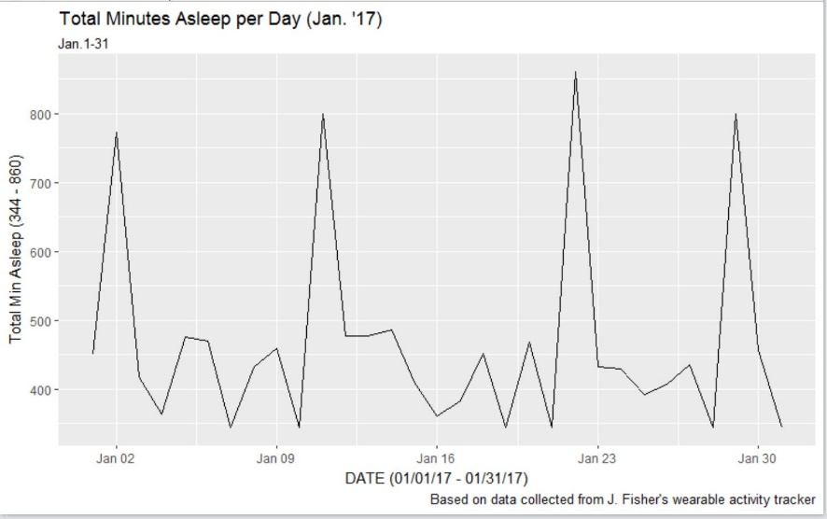The Charge HR data includes outlier readings that may or may not be accurate, as well as missing values. As the device was used in a real-world setting and not a laboratory we will need to account for the device’s misinterpretation of sensor readings. The data was also processed by Fitbit prior to use and we will need to account for the assumptions made by Fitbit when completing that processing.

Figure 9 - minutes asleep recorded by the Fitbit Charge HR for January 2017 showing spikes of around 800 minutes asleep for multiple days

To help control for these factors, information from the Charge HR was confirmed or supplemented by smartphone tracking and personal calendars where possible. Due to the lack of GPS tracking on the Charge HR, all location data had to be supplemented from external sources.

1. **DISCUSSION**

The current healthcare model doesn’t allow for sufficient data collection on individuals to make the kind of targeted treatment that is available in oncology. As such, individuals are often compared to the average measurements of a population. However, physiological parameters vary, not only among individuals depending on gender, life stage, and physical training, but also for the specific individual over the course of a day and depending on ambient environment, daily activities, and general health (Li et al., 2017). The expansion of mobile technology and advances in mobile medical equipment to the commercial wearable device market opens a potential source to fill this gap.

Rare conditions and chronic illnesses like POTS are particularly well suited for the economical solutions that wearable devices present. Advancements in and widespread adoption of wearable technology presents an opportunity to supplement research into these areas. This is important because chronic diseases are a growing financial burden on the healthcare system and rare conditions have trouble funding research to solve debilitating symptoms. For example, POTS hasn’t even been able to fund any long-term studies addressing the use of medication, which has resulted in 100% off label use (Raj, 2013).

The preliminary analysis of the data has already produced new insights into Julie’s symptoms. We confirmed that sleep is associated with higher average heart rate. We expect this result to become more pronounced once we account for activity by limiting the heart rate to average resting heart rate. We were also able to discover that during periods of increased resting heart rate Julie has worse symptoms and during periods of decreasing heart rate her symptoms tend to abate.

Should we be able to identify environmental factors that affect POTS symptoms, this technique could be expanded to include other illnesses and syndromes. Any identified factors for POTS or other conditions could help focus future studies and expand medical knowledge of systems such as the autonomic nervous system and sympathetic nervous system.

**REFERENCES**

Abdulla, Aza, and Thirumagal Rajeevan. “Reversible postural orthostatic tachycardia syndrome.” World Journal of Clinical Cases: WJCC 3.7 (2015): 655.

de Arriba-Pérez, Francisco, Manuel Caeiro-Rodríguez, and Juan M. Santos-Gago. "Collection and processing of data from wrist wearable devices in heterogeneous and multiple-user scenarios." Sensors 16.9 (2016): 1538.

Bagai, Kanika, et al. “Estimation of sleep disturbances using wrist actigraphy in patients with postural tachycardia syndrome.” Autonomic Neuroscience 177.2 (2013): 260-265.

Bagai, Kanika, et al. “Objective Sleep Assessments in Patients with Postural Tachycardia Syndrome using Overnight Polysomnograms.” Journal of clinical sleep medicine: JCSM: official publication of the American Academy of Sleep Medicine 12.5 (2016): 727.

Baylor College Of Medicine. "Study Finds Common Knee Surgery No Better Than Placebo." ScienceDaily. ScienceDaily, 12 July 2002. < www.sciencedaily.com/releases/2002/07/020712075415.htm >

Dusheck, Jennie. "Wearable Biosensors May Help Detect Illness Prior to Symptoms." Medical Product Outsourcing. N.p., n.d. Web. 03 January 2017.

Dysautonomia International Report: Physician Patient Interaction in Postural Orthostatic Tachycardia Syndrome; publication pending.

Hayden, Erika Check. "Personalized cancer therapy gets closer." (2009): 131-132.

Jain, Kewal K. "Personalized Cancer Therapy." Applications of Biotechnology in Oncology. Springer New York, 2014. 671-824.

Lamkin, Paul. "Fitbit's Dominance Diminishes But Wearable Tech Market Bigger Than Ever." Forbes. Forbes Magazine, 19 Apr. 2017. Web. 03 June 2017.

Garland, Emily M., Jorge E. Celedonio, and Satish R. Raj. “Postural tachycardia syndrome: beyond orthostatic intolerance.” Current neurology and neuroscience reports 15.9 (2015): 1-11.

Niizeki, Kyuichi, and Tadashi Saitoh. "Analysis of cardiorespiratory phase coupling and cardiovascular autonomic responses during food ingestion." Physiology & behavior 159 (2016): 1-13.

Ostchega Y, Porter KS, Hughes J, Dillon CF, Nwankwo T. Resting pulse rate reference data for children, adolescents, and adults: United States, 1999–2008. Natl Health Stat Report. 2011;(41):1–16. pmid:21905522

Prospero, Mike. "Who Has The Most Accurate Heart Rate Monitor?" Tom's Guide. Tom's Guide, 01 June 2016. Web. 26 June 2017.

Raj, Satish R. “Postural tachycardia syndrome (POTS).” Circulation 127.23 (2013): 2336-2342.

Raj, Satish R., and David Robertson. "Blood volume perturbations in the postural tachycardia syndrome." American Journal of the Medical Sciences 334.1 (2007): 57.

Sheldon, Robert S., et al. "2015 Heart Rhythm Society expert consensus statement on the diagnosis and treatment of postural tachycardia syndrome, inappropriate sinus tachycardia, and vasovagal syncope." *Heart rhythm* 12.6 (2015): e41.

Stahl, Sarah E., et al. "How accurate are the wrist-based heart rate monitors during walking and running activities? Are they accurate enough?" *BMJ open sport & exercise medicine* 2.1 (2016): e000106.

Wang, Robert, et al. "Accuracy of wrist-worn heart rate monitors." Jama cardiology 2.1 (2017): 104-106.