**Using Wearable Technology and Machine Learning**

**to Garner New Insight into**

**Postural Orthostatic Tachycardia Syndrome**

**MSDS 5143: Practicum I Final Paper**

Julie Fisher1 and Brandon Harden1

1College of Computing and Technology, Lipscomb University Nashville, TN, 37204

***Abstract*—**

**Our goal is to use data science and machine learning to analyze data from wearable technology to determine if there are external factors such as weather or sleep that trigger symptoms in Postural Orthostatic Tachycardia Syndrome (POTS). POTS is a poorly understood medical condition affecting mainly women (80% - 85%) of childbearing age (13 - 50 years old) (Raj, 2013). POTS is a rare disease where all medication used to treat it are off label due to a lack of clinical trials (Raj, 2013). In the absence of funding for long-term research, alternate approaches can be explored including the use of wearable technology.**

***Keywords* — dysautonomia, orthostatic intolerance, orthostatic tachycardia, postural orthostatic tachycardia syndrome, postural tachycardia, wearable technology, machine learning, data science, single patient research, n-or-1 research**

1. **INTRODUCTION**

Smart people who have earned their MDs and PhDs in medicine say that quality of life for a patient with postural orthostatic tachycardia syndrome (POTS) is comparable to patients with the more recognizable conditions of congestive heart failure and chronic obstructive pulmonary disease (Garland et al., 2016). In layman terms, it sucks.

Having lived with POTS for over 7 years now, I tend to liken it to living with and managing diabetes - without the tools that make such a feat possible, like a glucometer and education on nutrition, specifically carbohydrates. This lack of resources is due in part to the heterogenous nature involving multiple underlying pathophysiologies, as well as the complicated and poorly understood pathophysiology of POTS (Khan et al., 2016) and the autonomic nervous system. It’s not just patients that are flying blind, doctors are too.

So what is POTS? The official definition as stated by a panel of experts is “POTS is a clinical syndrome usually characterized by (1) frequent symptoms that occur with standing; (2) an increase in heart rate of ≥30 beats per minute (bpm) when moving from a recumbent to a standing position (or ≥40 bpm in individuals 12 to 19 years of age); and (3) the absence of orthostatic hypotension (>20 mm Hg drop in systolic blood pressure)” (Sheldon et al., 2015). It’s a rare condition estimated to affect about 0.2% of the general population (Sheldon et al., 2015). However, when that number is associated with an estimated 500,000 people in the United States alone (Robertson, 1999), the word rare seems a little less appropriate. The actual number of POTS patients is difficult to determine due to the common misdiagnosis of POTS as anxiety, depression, and panic attack (reference). This causes delayed reporting and averages out to 6 years before correct diagnosis (reference).

As a non-lethal syndrome with difficult to quantify symptoms like rapid palpitation, exercise intolerance, lightheadedness, extreme fatigue, headache, and mental clouding (Raj and Robertson, 2007), it’s easy to dismiss POTS as trivial. However, symptoms are often disabling to the point that 25% of POTS patients are disabled to the point they are unable to work (reference). This creates undue hardship not only on the individual, but also on society to support that individual.

Where does that leave POTS patients? In the uncomfortable position of managing their symptoms as best they can, mainly through trial and error. With the lack of an instrument like a glucometer to measure the current state of well being, I went in search of something that could at least provide a little guidance.

My search started with a cheap Wal-Mart watch. Having given up on trying to support myself while barely able to stand let alone shop for groceries, clean my apartment, walk the dog, shower, or many of those other necessary tasks of living, I couldn’t afford anything much fancier. Even if I could, the cognitive symptoms were seriously hampering my higher-level thinking and reasoning skills. So, a simple watch to start. It told the time, yes, but more importantly it calculated my heart rate with the push of a button. No more compressing a pulse point and counting for 15 seconds, then trying to do math. At the push of a button, I could have my heart rate in 5 seconds or less.

From these rudimentary, real-time only measurements I made 3 discoveries over the course of several years: 1) heart rates in the 90s meant I needed to sit down and rest or more serious symptoms were imminent, 2) heart rates in the 100s was where chest discomfort turned to pain and I needed to lie down ASAP, and 3) heart palpitations and chest discomfort weren’t always associated with heart rates over 90. Due to exercise intolerance, these heart rates were all observed either at rest, or at low levels of activity, such as standing. The first two observations gave me a guide for activities and when to call it quits. The third makes me think there are other factors at play than just heart rate, like maybe blood pressure or circulation.

There were other potential trends I noticed over that time as well. For example, there was an obvious relationship between sleep and symptoms. When I didn’t sleep enough, either due to time constraints or quality, my POTS symptoms would be noticeably worse. Knowing myself, I knew I couldn’t be counted on to keep a sleep diary recording duration with any consistency and that the act of tracking sleep would alter how and when I went to sleep. Thus I couldn’t quantify the amount of sleep necessary to avoid exacerbating symptoms. Two other potential areas of correlation were weather and food.

I noticed marked exacerbation in symptoms during some weather events, but a lack of symptoms during others. At first I suspected this was due to air pressure, but a short stint tracking barometric pressure revealed no relation. There were also obvious correlations with food, both to improve and worsen symptoms. However, the varied of food and drink consumed muddied the relationships. Several simple experiments in removing and adding back in several types of food failed to produce pronounced results. Clearly, it was time for a more comprehensive tracking system.

In addition to real-time monitoring, I wanted to be able to record data for later analysis. As POTS is, at heart, a syndrome of high heart rate, I needed something that could track heart rate continuously. The only commercially available fitness tracker that fit the bill at that time was the Fitbit Charge HR. Fitbit recorded and stored the data, allowing customers to see charts of their data. It also counted steps, tracked sleep, and provided access to Fitbit’s nutrition logging and calorie counter. Pared with publicly available historic data on weather, it should fit the bill for the next stage of data collection for analysis.

Cursory review of the data provided by the Charge HR provided new insights. For example, during periods in which resting heart rate is decreasing, I feel better. During periods of increasing resting heart rate, symptoms become more prevalent. These shifts in resting heart rate range from the mid-70s down to a recent low of 59. While it’s well documented that more athletic individuals have lower resting heart rates (reference), I will need to do additional literature review to determine variability within the results of a single individual.

The other insight was into sleep. The average amount of sleep necessary to prevent increased symptoms seems to be between 6.5 and 7 hours. The granularity of this observation is limited by the Fitbit visualizations. The standard graphs are very basic with low resolution of data and no customization. To address this limitation, the data will need to be analyzed with other tools, such as R, Python, or Tableau.

While the raw data from the sensors, such as the accelerometer, are unavailable, there is high resolution pre-processed data that should fit the bill for the next stage of analysis. This data includes heart rate measurements of several times per second, sleep data at a minute by minute interval, step counts at 1 second intervals, and all logged food. While this information is much better than the real-time only measurements of the Wal-mart watch, it still presents some challenges.

The main concern in using a commercial device is accuracy. There has been much debate about the viability of commercial devices for use in medical conditions (references). However, based on the type of analysis we will be conducting and the properties of POTS, I believe this won’t present a major hindrance.

There is an overall consensus that wrist worn devices using optically based heart rate (HR) monitors are reasonably accurate at rest and moderate activity levels, but struggle at higher levels of exertion (Want et al., 2017 and Prospero, Mike 2016). Due to symptoms of exercise intolerance, the majority of POTS patients, and I in particular, don’t often exceed low, let alone moderate, activity levels. Indeed, much of my time is spent at rest. In addition, the change of heart rate is the target under examination and that change must meet a high threshold of over 30 bpm. A study on accuracy of wrist-based heart rate monitors, including the Charge HR deemed them to be accurate enough for the recreational athlete and research purposes (Stahl et al., 2017).

The use of wearable technology to conduct individualized research isn’t new either. This trend has been helped along by their increased prevalence in recent years. The number of devices shipped increased from 29 million units in 2015 to 33.9 million in 2016 (Lampkin, 2017). The data collected by these devices is commonly used to evaluate sports performance, to increase overall fitness by targeting minimum number of steps and nutrition goals, and to address general health with the tracking of sleep quantity and quality (references). Michael Snyder, professor and chair of genetics at Stanford University School of Medicine, was part of a study using the Basis Peak wearable device wherein they were able to detect when he contracted Lyme disease. The study followed 43 participants and collected over 250,000 measurements a day (Dusheck, 2017).

Neither is the study of a single individual to garner information and personalized treatment new. Personalized medicine is defined as the prescription of specific treatment and therapeutics best suited for an individual taking into consideration both genetic and environmental factors that influence response to therapy (Jain, Kewal, 2014). Oncology is the most advanced in personalized medicine (Hayden, Erika, 2009) and has only begun to realize the benefits and challenges of tailoring the treatment to the specific patient.

Treatments that target specific mutant genes have been available for certain cancers since 2001 (Hayden, Erika, 2009). Prior to this, treatment was based on the origin of the cancer. But the variation in individual response to a particular therapy for the same type of cancer produced unsatisfactory results; some patients show no response, whereas others show a dramatic response (Jain, Kewal 2014). Targeting specific genes has improved outcomes. This type of targeted, individualized approach could be expanded to other areas, which have the potential of realizing similar benefits.

The current healthcare model doesn’t allow for sufficient data collection on individuals to allow for the kind of targeted treatment available in oncology. As such, individuals are often compared to the average measurements of a population. However, physiological parameters vary, not only among individuals depending on gender, life stage, and physical training, but also for the specific individual over the course of a day and depending on ambient environment, daily activities, and general health (Li et al, 2017). The expansion of mobile technology and advances in mobile medical equipment to the commercial wearable device market opens a potential source to fill this gap.

Rare conditions and chronic illnesses like POTS are particularly well suited for the economical solutions that wearable devices present. Advancements in and widespread adoption of wearable technology presents an opportunity to supplement research into these areas. This is important because chronic diseases are a growing financial burden on the healthcare system and rare conditions have trouble funding research to solve debilitating symptoms. For example, postural orthostatic tachycardia syndrome (POTS) hasn’t even been able to fund any long term studies addressing the use of medication, which has resulted in 100% off label use (Raj, 2013).

The syndrome is poorly understood as are the underlying mechanisms that cause it, factors that trigger it, and long term effects of medication. Tachycardia and resting heart rate are easy to track using heart rate monitoring devices such as the Fitbit Charge HR.

Should we be able to identify factors that affect POTS symptoms, this technique could be expanded to include other illnesses and syndromes. Any identified factors for POTS or other conditions could help focus future studies and expand medical knowledge of systems such as the autonomic nervous system and sympathetic nervous system.

1. **Materials and Methods**

**A. Description of Data Set**

This study focuses on an intense analysis of a single individual, which will then be expanded out to include additional volunteers. The detailed analysis of a single individual will allow us to assess potential trends and triggers over a longer period and then focus our analysis of a larger study of shorter duration. The data from the single individual came from the Charge HR 1 and the Charge HR 2. A change was made in March 2017 due to wearing out of the original device.

We chose the Fitbit Charge HR as the wearable device due to the continuous heart rate tracking. This allows for pinpoint assessments of change in heart rate, which is the hallmark symptom of POTS. Fitbit also holds the largest portion of market share as of 2015 (Arriba-Perez et al 2016) expanding the pool of candidates likely to already own a device as participants will have to provide their own wearable.

Data available through Fitbit and the Charge HR include heart rate, sleep information, sporadic nutrition data, occasional weight and BMI measurements, daily step counts, and activity levels. One challenge in this dataset is that no water intake was recorded and it is known that water consumption helps improve symptoms. Two other variables that would help complete the inputs for symptom prediction are blood pressure and respiratory rate. There are no current commercially available devices that reliability record blood pressure in a moving subject during normal daily activity.

The information collected by the Fitbit was then correlated with other sources such as smartphone tracking, personal calendars, and NOAA weather data. The Charge HR doesn’t have GPS tracking, so this had to be supplemented with the smartphone tracking and personal calendars.

Machine learning methods were then applied using R and Python to investigate if and how data provided by the Charge HR could be used to predict variables that trigger symptoms in POTS patients. Classification algorithms assisted in identifying which, if any, variables led to increased symptomatology. Autoencoder algorithms were used with our combined Fitbit and external data sets to reduce features. Our simplified data set was then run through a classification algorithm to investigate if symptoms occur or not.

1. **Wearable Device Selection & Data Capturing**

The numerous manufacturers and devices available in the wearables market each output data in a unique way. Currently, there is no standard on how data is to be collected and stored. Our research currently involves using and analyzing the data from only one wearable device named Charge HR. The metrics recorded and stored by (___) are listed below.

· HR: BPM

· Steps: Algorithmically derived by manufacturer

· Activity: Categories are algorithmically derived by manufacturer- running, walking, transport.

We are to look into using additional wearable devices in our research in order to 1) expand our collection of data variables for analyzing 2) assist in reproducibility and 3) show how multiple wearable manufacturers have the potential to assist in health care monitoring and detection of factors that lead to POTS symptoms. Variables that would be of interest to us that these additional wearables could collect are: Accelerometer, Skin Temperature, Oxygen Saturation (SpO2). For validation purposes the wearables user(s) will be tasked with maintaining a comprehensive personal log/ calendar. This log will be used to indicate various activities and physiological statuses such as- bike ride, “tired”, or “alert”. The physiological status of “tired” and “alert” will be measured using a psychomotor vigilance test (Canadian tiredness test)[1].

Assessing the Validity and Accuracy of Wearable Measurements

To assess the validity of the wearable device’s measurements used in or research, we will test the correlation of measurements between the wearable devices used in our research to that of a medical grade biosensor device. The Bland-Altman method and Pearson correlation will be used to analyze the relationship between the wearables and the clinical grade devices[2]. We are currently anticipating being able to partner with Lipscomb University and Vanderbilt University in order to use their medical grade devices for validity assessment.

Creating a Base -Line & Analyzing Deviations

With the goal of understanding a deviation from normal patterns (ie- change of base-line) we will first analyze our data for systematic normal patterns such as circadian rhythms[3]. Physiological data and physical activity information (Activity variable or Personal log) can be compared in order to explain fluctuations in circadian data (ie- Fluctuations in HR in the a.m. can be supported by a logged morning bike ride).

Assessing Personalized Physiological and Activity Profiles

To help with creating physiological parameters for the participants in our study, we plan to study their changes in resting HR and resting skin temperature with changes in activity. This could help with supporting claims such as women tend to have a higher BPM than men[4]. Since studies show that levels of exercise effects the symptoms experienced by POTS patients, and increased activity patterns are associated with overall fitness levels, we are to examine the relationship between resting HR, activity, and weight loss.

1. **Results**

Heart rate data was obtained for May 15, 2016 - June 15, 2017. Heart rate is recorded every tenth of a second. Initial observations for January 2017 are below, shown by time in hours. Heart rate values are lower overnight and show peaks of up to 166 bpm for the month.

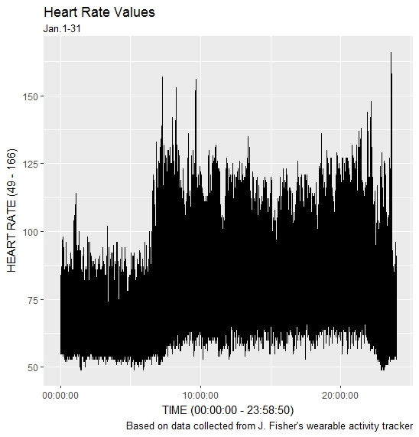

Macronutrients, gathered from nutrition tracking data, are below for a 1 week period and a 1 month period. As shown, these values are similar across time.

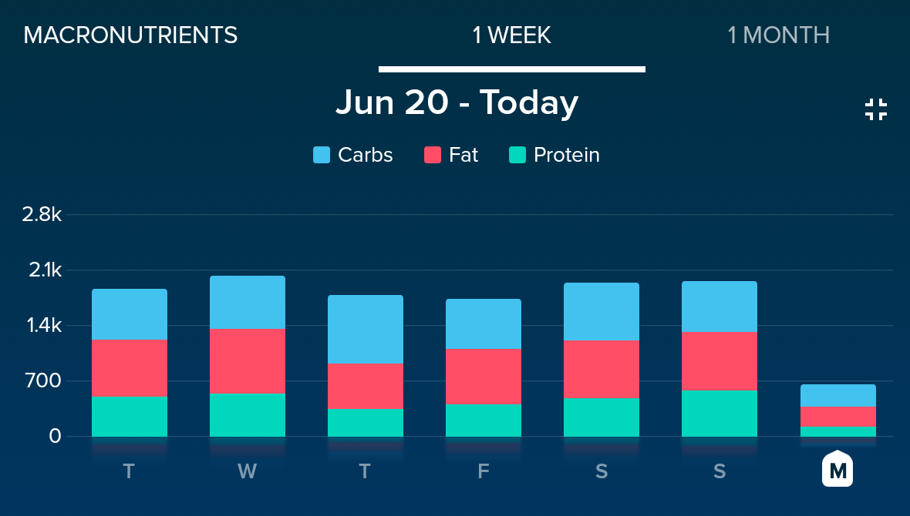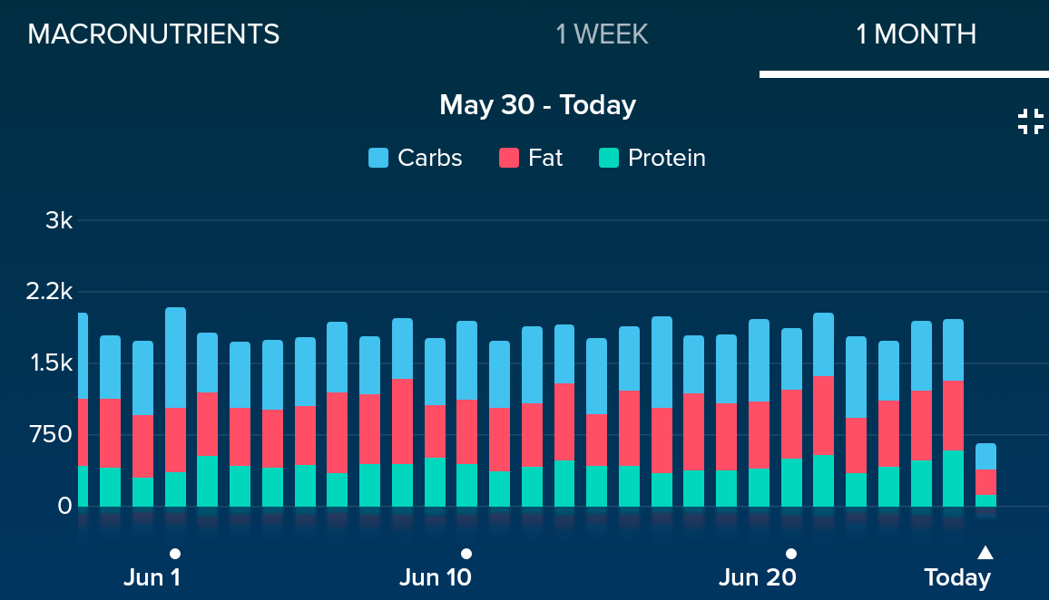

Step counts are shown below over a 1 month period, 3 month period, and 1 year period. As shown, there are periods of lower step count in the January/February time period than the surrounding months.

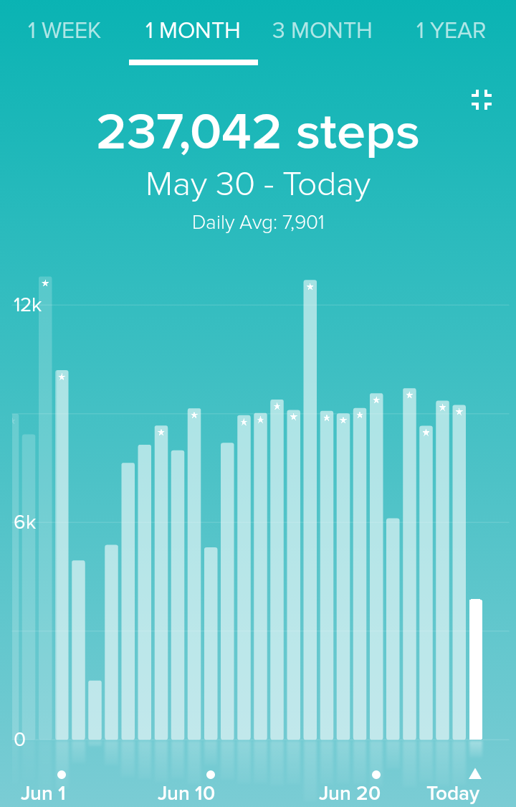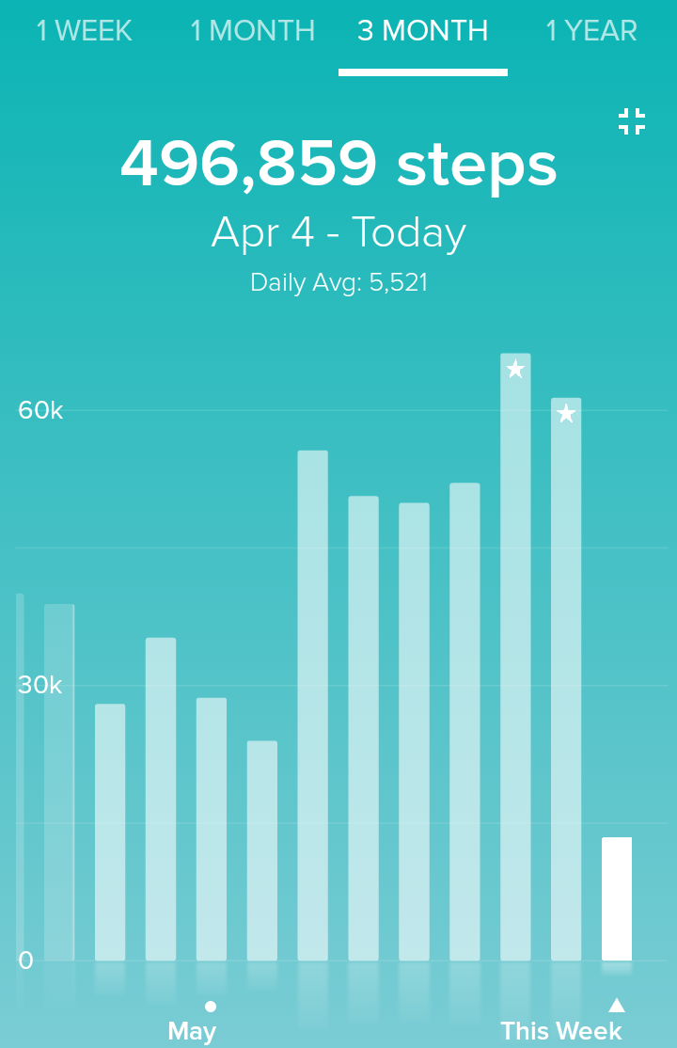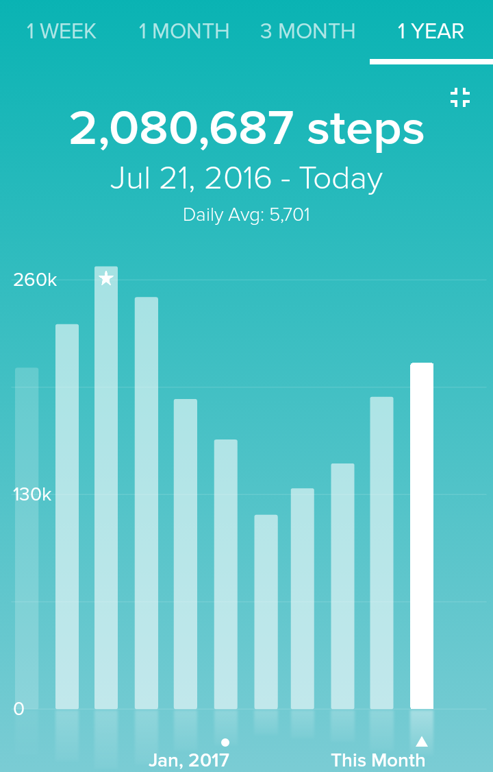

Below are shown average resting heart rate over a 1 year period and a 3 month period. As shown, there is a wide variance in heart rate over time.

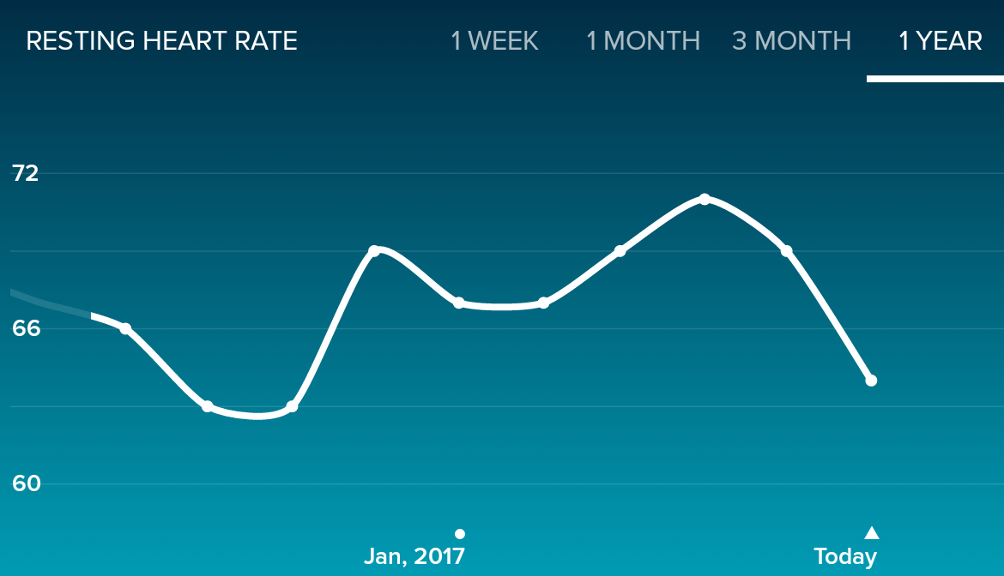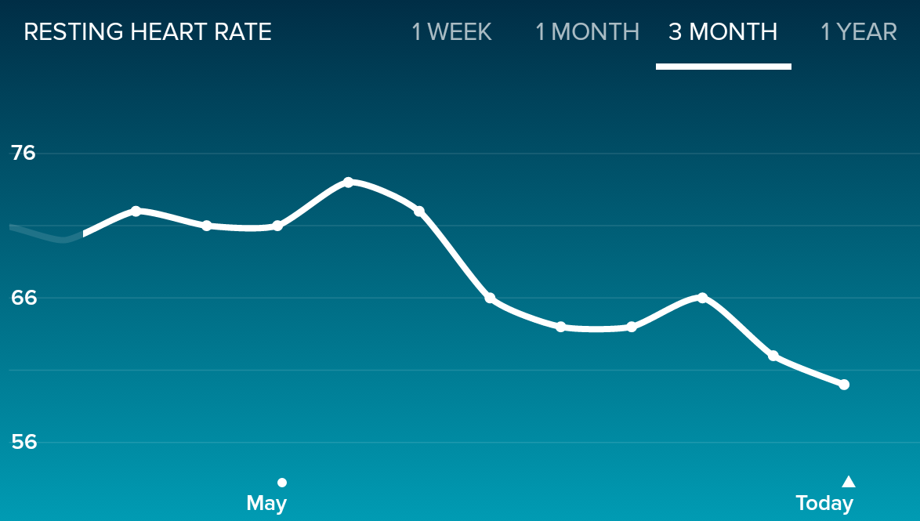

Below is a graph of the time in various heart rate exercise zones. The third and fourth graphs show similar information. This information will be correlated to separate out high heart rate due to actual activity from high heart rate due to POTS. The second graph shows sleep quantity over the course of a month. As shown, the time asleep is relatively consistent.

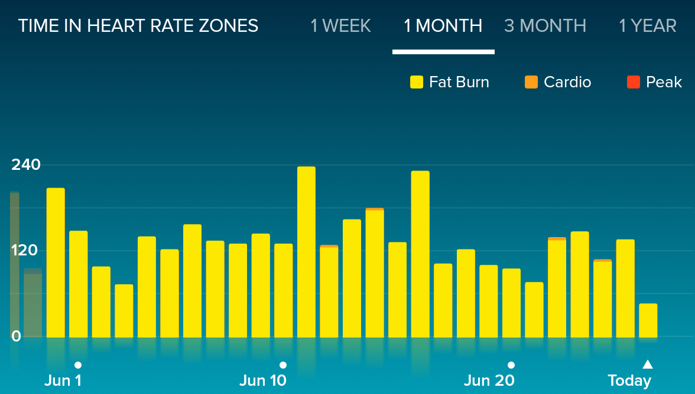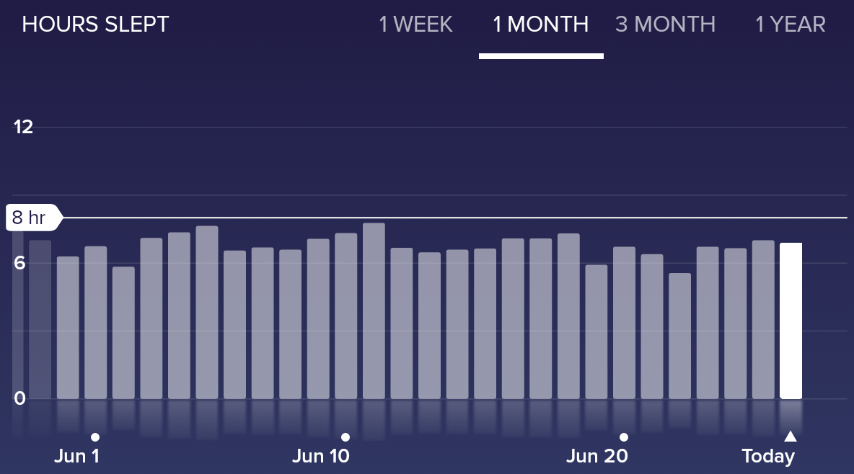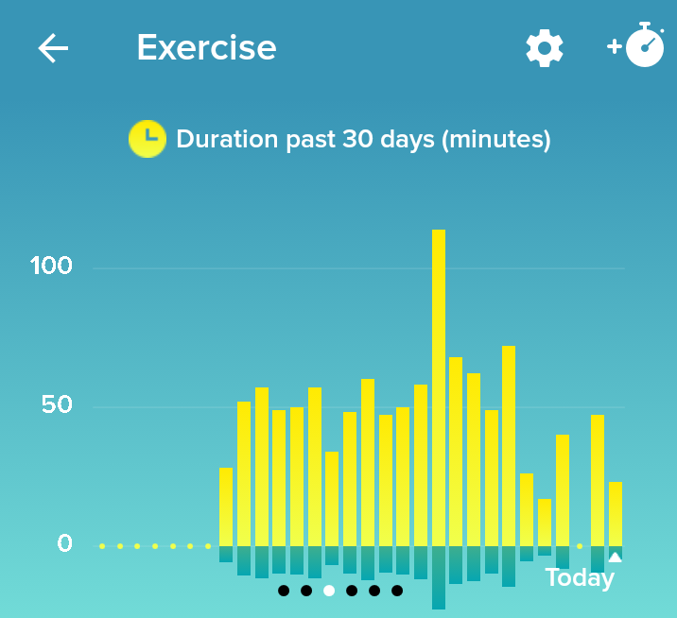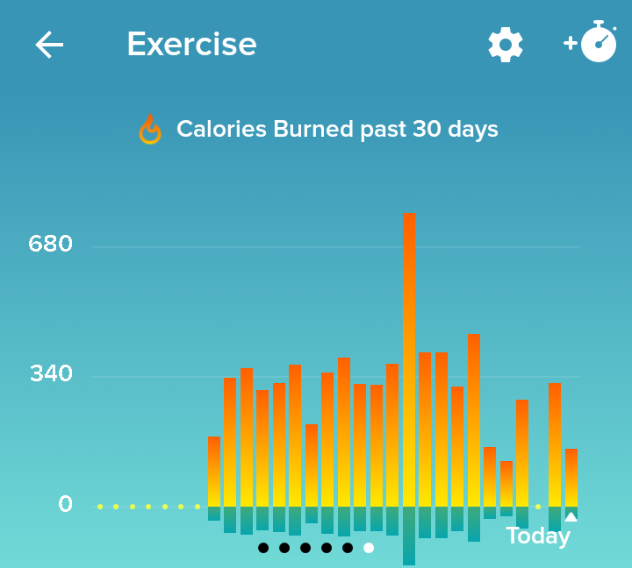

1. **Discussion**

To be completed once analysis has been run.

**REFERENCES**

Abdulla, Aza, and Thirumagal Rajeevan. “Reversible postural orthostatic tachycardia syndrome.” World Journal of Clinical Cases: WJCC 3.7 (2015): 655.

de Arriba-Pérez, Francisco, Manuel Caeiro-Rodríguez, and Juan M. Santos-Gago. "Collection and processing of data from wrist wearable devices in heterogeneous and multiple-user scenarios." Sensors 16.9 (2016): 1538.

Bagai, Kanika, et al. “Estimation of sleep disturbances using wrist actigraphy in patients with postural tachycardia syndrome.” Autonomic Neuroscience 177.2 (2013): 260-265.

Bagai, Kanika, et al. “Objective Sleep Assessments in Patients with Postural Tachycardia Syndrome using Overnight Polysomnograms.” Journal of clinical sleep medicine: JCSM: official publication of the American Academy of Sleep Medicine 12.5 (2016): 727.

Baylor College Of Medicine. "Study Finds Common Knee Surgery No Better Than Placebo." ScienceDaily. ScienceDaily, 12 July 2002. < www.sciencedaily.com/releases/2002/07/020712075415.htm >

Dusheck, Jennie. "Wearable Biosensors May Help Detect Illness Prior to Symptoms." Medical Product Outsourcing. N.p., n.d. Web. 03 January 2017.

Hayden, Erika Check. "Personalized cancer therapy gets closer." (2009): 131-132.

Jain, Kewal K. "Personalized Cancer Therapy." Applications of Biotechnology in Oncology. Springer New York, 2014. 671-824.

Lamkin, Paul. "Fitbit's Dominance Diminishes But Wearable Tech Market Bigger Than Ever." Forbes. Forbes Magazine, 19 Apr. 2017. Web. 03 June 2017.

Garland, Emily M., Jorge E. Celedonio, and Satish R. Raj. “Postural tachycardia syndrome: beyond orthostatic intolerance.” Current neurology and neuroscience reports 15.9 (2015): 1-11.

Niizeki, Kyuichi, and Tadashi Saitoh. "Analysis of cardiorespiratory phase coupling and cardiovascular autonomic responses during food ingestion." Physiology & behavior 159 (2016): 1-13.

Prospero, Mike. "Who Has The Most Accurate Heart Rate Monitor?" Tom's Guide. Tom's Guide, 01 June 2016. Web. 26 June 2017.

Raj, Satish R. “Postural tachycardia syndrome (POTS).” Circulation 127.23 (2013): 2336-2342.

Raj, Satish R., and David Robertson. "Blood volume perturbations in the postural tachycardia syndrome." American Journal of the Medical Sciences 334.1 (2007): 57.

Sheldon, Robert S., et al. "2015 Heart Rhythm Society expert consensus statement on the diagnosis and treatment of postural tachycardia syndrome, inappropriate sinus tachycardia, and vasovagal syncope." *Heart rhythm* 12.6 (2015): e41.

Stahl, Sarah E., et al. "How accurate are the wrist-based heart rate monitors during walking and running activities? Are they accurate enough?." *BMJ open sport & exercise medicine* 2.1 (2016): e000106.

Wang, Robert, et al. "Accuracy of wrist-worn heart rate monitors." Jama cardiology 2.1 (2017): 104-106.

1. http://www.painfreesleep.ca/tiredness-test?&cid=semeOyQHbZq
2. Altman DG, Bland JM. Measurement in Medicine: The Analysis of Method Comparison Studies. Journal of the Royal Statistical Society Series D (The Statistician). 1983;32(3):307–17.
3. Li X, Dunn J, Salins D, et al. Digital Health: Tracking Physiomes and Activity Using Wearable Biosensors Reveals Useful Health-Related Information. PLoS Biology. 2017 Jan.
4. Ostchega Y, Porter KS, Hughes J, Dillon CF, Nwankwo T. Resting pulse rate reference data for children, adolescents, and adults: United States, 1999–2008. Natl Health Stat Report. 2011;(41):1–16. pmid:21905522