Julie-Maude Viel

Dahomée Forgues

Computer Science

Draft

**Final Project**

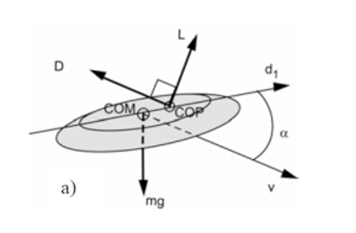Frisbees are flying objects used to entertain people. As it does not require a lot of abilities to throw them, the concept behind them might seems very simple. In contrary to this assumption, they are complex since they operate under two physical concepts, aerodynamic lift and gyroscopic stability[1]. Looking at Bernoulli’s principle and the lift force which causes an object to stay in the air, the Frisbee could be compared to a wing. Gyroscopic stability is responsible to keep the Frisbee straight. Other forces implied with the stability such as the angular momentum are exerted, and they all play a role in preventing it from flipping over during its flight period. In this project, our focus will be on what is the angle of attack to throw a Frisbee in order to reach a maximum distance. Using some different methods and equations, all the variables will be optimized to get the best possible answer.  
 Since there is a lot of variables to consider, we will have to use many different equations. An equation for the drag force will be used $Fd=- \frac{1}{2 }CdρAv^{2}$ and we will need to calculate a drag coefficient first $Cd={Cd}_{0 }+{Cd}_{α }{(α-α_{0 })}^{2}$. Same thing with the lift force $Fl= \frac{1}{2 }ClρAv^{2}$, a lift coefficient needs to be calculated first $Cl={Cl}_{0 }+{Cl}_{α }α.$ The Frisbee’s area, the air pressure, the density of the fluid which in this case will be air, the acceleration of gravity and the height of the fluid will have to be considered in these formulas too. The velocities and pressures are linked together, and they act inversely to each other. The average velocity of a Frisbee throw we will use is approximatively 14 m/s, the standard air density we will use in this case will be 1.23 kg/m3, the Frisbee’s area will be 0.0531m2 and as we might need it, the viscosity of air used will be 1.73x10-5N s/m2. Finally, to make sure we get the most accurate answer, we will create a Golden Search method that will optimize our result to find the angle of attack. Since we know the maximum (90o) and minimum (0o) angles at which we can throw a Frisbee, this method will be helpful to narrow down the possible angles to find the best one. The Golden Search will also be used in this case because it is a unimodal function, meaning there is a single highest value.

1. Morrison, V.R. “The Physics of Frisbees”. *Electronic Journal of Classical Mechanics and Relativity.*Http://scripts.mit.edu/~womens-ult/frisbee_physics.pdf.