Retail Profitability Calculator 1.0 04/16/2018

Github branch – master: <https://github.com/juliemoore/RetailProfitCalculator>

Github commit: 3da9c9deffd74be53b6f9a6c7827ec3ba54ddc7e

Developer: Julie Moore

GENERAL USAGE NOTES

There has been significant improvement and some fun additions to the app since the time of the last submission.

The Main Activity has a new Image Button where the user can view a list of formula names and thumbnail images of the formula equations. When the user selects a formula on the list, a custom dialog appears with a larger image of the formula equations. In addition, the Formula List Activity has a floating action button. When clicked, the user is taken to a fully functioning calculator. The app is also sporting a new logo that is more meaningful.

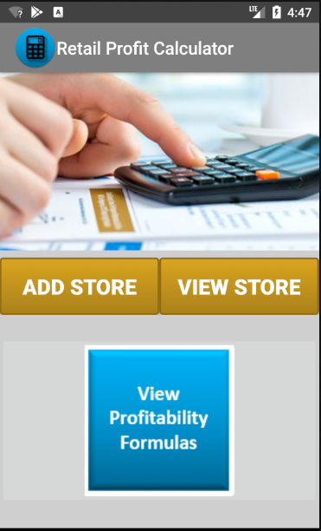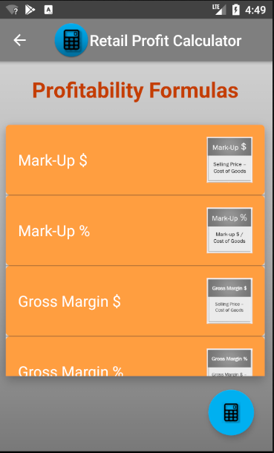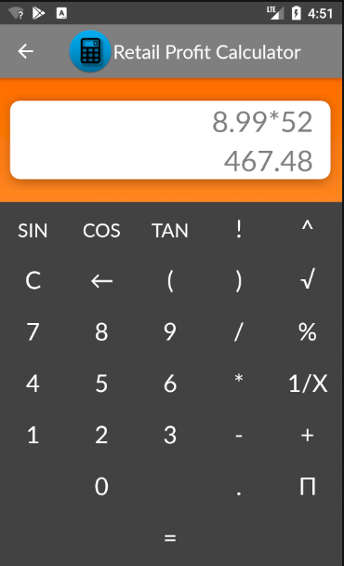

FAB

button

Image

button

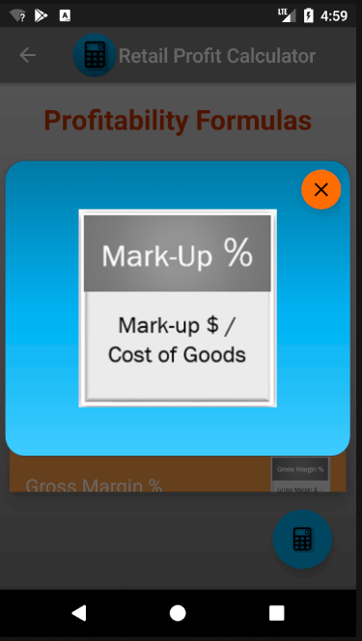

The Add Store Activity Edit Text components have been changed to the TextInputLayout components to handle user data input on orientation state changes.

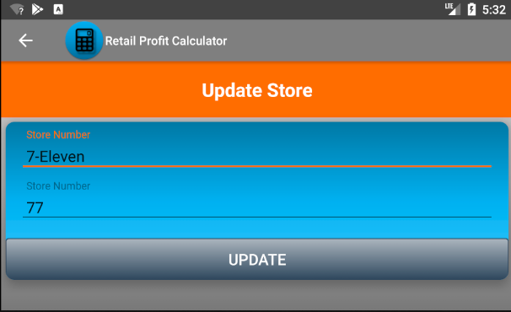

The product section of the app is improved. The user can now add more than one product to a store and can update the products. The Product List Activity’s “Add Store” is now a floating action button.

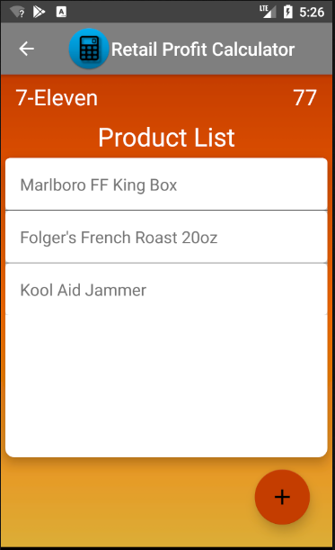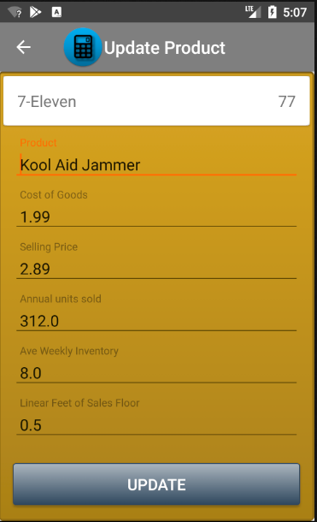

FAB

button

The Summary Activity’s formulas calculate correctly and the “Share” button has an inner-app communication feature that will write the profitability summary to an email. This feature also allows the user to choose an email app.

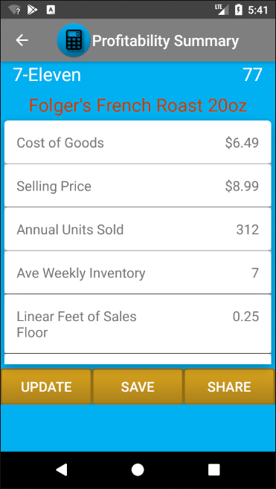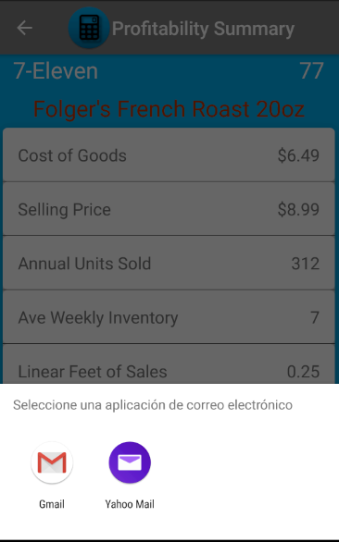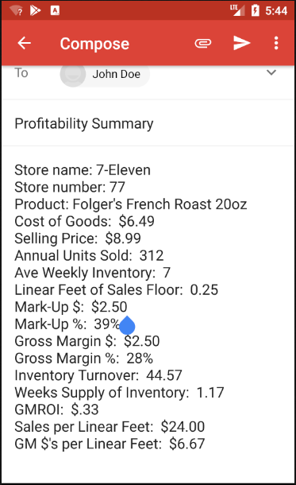

The app also display text in Spanish

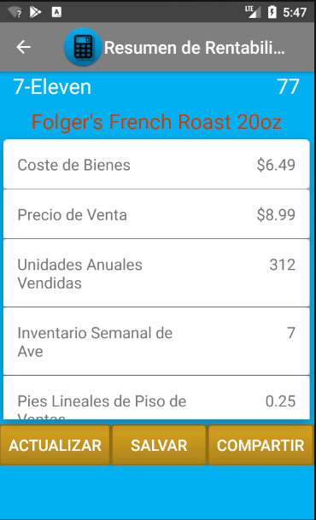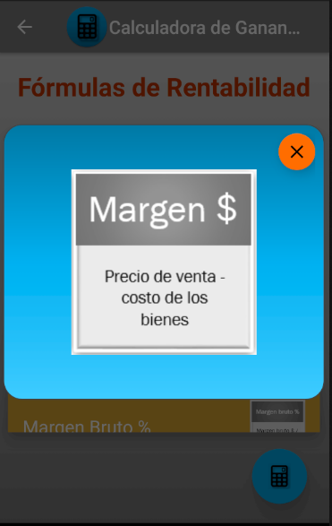

Contact Information:

Email: [julie749779@cccneb.edu](mailto:julie749779@cccneb.edu)

Phone: 402-303-9919

The program is free to copy and distribute for educational purposes. The images may be copyrighted and should not be used for professional use.