Lesson 4. Where is the golden ratio?

Objective: The golden ratio = 1.61803398… is a strange number. It is the only number that if you subtract one from it −1 = 0.61803398…, you end up with its own reciprocal = 0.61803398… The golden rectangle with side ratio of 1: is thought to be the most visually pleasing proportion. From a large golden rectangle we first cut off the largest square. The leftover piece is again a golden rectangle. We again cut off the largest square from the leftover rectangle, and so on. In this way, we cut up the original golden rectangle into ever-decreasing squares. Since the squares get smaller by scaling factor , they are self-similar golden squares.

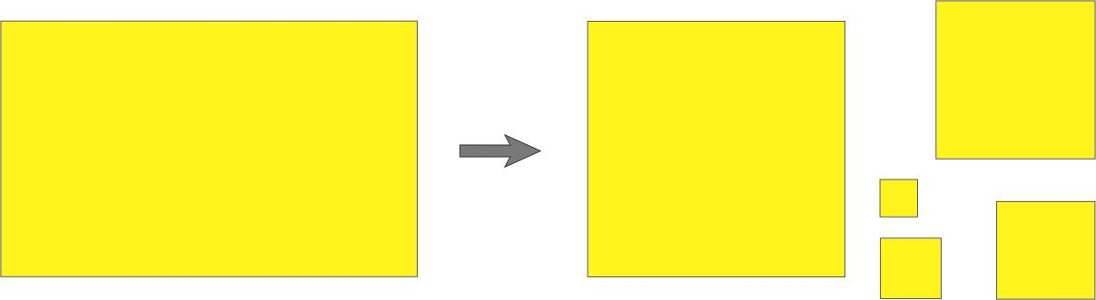

We now draw a quarter circle on each square and bring all the squares back to where they were in the original rectangle. There then emerges a winding (logarithmic) spiral that you often find emblazoned on a pinwheel. By spinning the pinwheel in clockwise or counterclockwise direction, the spiral pattern implodes into the pole or expands outwardly. Finally the Fibonacci numbers are introduced to count the rabbit pairs in an ideal growing environment. Curiously, such a rabbit population growth is related to the golden ratio.

Scary words: Golden ratio, golden rectangle, self-similar golden squares, Logarithmic spiral, continued fractions, Fibonacci numbers.

Last update: 23 Dec 2002

Lesson

Golden ratio

The golden ratio denoted here by is also called the golden mean or section. It has the value, 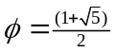 = 1.61803398… We show how this comes about in two ways. One is by an algebraic relation. Suppose that a line segment is cut into two pieces of length a and b, and we have shown here a is longer than b. Clearly, the length of the original line segment is a+b.

a b

We now form two ratios 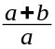 and . The first is ratio of the whole length to longer piece a, and the second ratio is longer piece a to shorter piece b. We now ask, when are the two ratios equal? This is an algebra question that can be solved by equating the two ratios

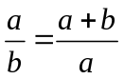. (1)

First of all, by dividing each and every term of equation (1) by a, we get 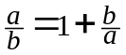. So, denoting the ratio by 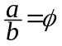, we end up with
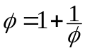. (2)
On the other hand, dividing each and every term of equation (1) by b gives 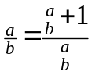, which by writing becomes a little more complicated expression
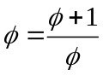. (3)
But you know that equations (2) and (3) are the same, just written differently.

Now, by multiplying both sides of equation (3) by , we get a quadratic equation

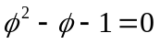. (4)

Using the quadratic root formula, we find two roots of equation (4); the first root is 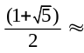1.618 and the second root is 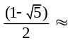−0.618. The first root is the ratio that we are looking for, and we ignore the second root because it is a negative number. We can easily check to see if 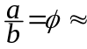1.618 is the right answer. With 1.618 b, the two ratios 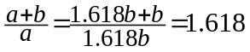 and 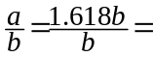 1.618 are indeed the same. (Project a – The decimal digits of by continued fractions) Now, by subtracting 1 from both sides of equation (2) we get

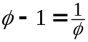. (5)
This means that 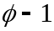= 0.61803… is same as its own reciprocal = 0.61803… In other words, and have the same decimal digits. For instance, try for 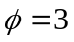 in (5). Then the left-hand side 3 −1 = 2 and the right-hand side 1/3 = 0.333… are not certainly equal.

The second way to define the golden ratio is by a geometric relation. Consider the square A-B-C-D in figure 1, which has the side of length 1 in whatever the unit you choose. For instance, it may be 1 meter or 1 yard. We denote by E the midpoint of side A-D. Draw a circular arc with radius E-C and denote by F where the arc intersects the extended line segment of A-D, as shown in figure 1. Then, the line segment A-F will have length 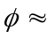1.618. (Project b – Show the length A-F is )

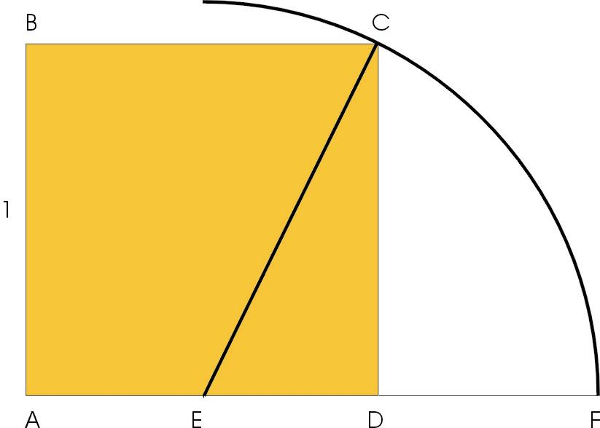
Figure 1. Geometric construction of golden ratio

Golden rectangle

A rectangle with side ratio 1: is called the golden rectangle. It was thought to be the most visually pleasing proportion and, hence, often used in the classic paintings and architecture. Figure 2 presents the front view of the ancient temple Parthenon in Athens (fifth century BC). The top frame has the golden ratio 1: , as it was originally constructed. The middle frame of figure 2 has the side ratio 1:, which corresponds to the 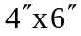color print format. Lastly, the bottom frame of figure 2 has the side ratio 1: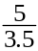 (1.43). This is the nominal 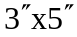 color print format, which actually measures 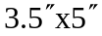. Note that the color print formats are taller than the golden rectangle in figure 2. We leave it to the readers to compare the aesthetic virtues of side ratio, also called aspect ratio.

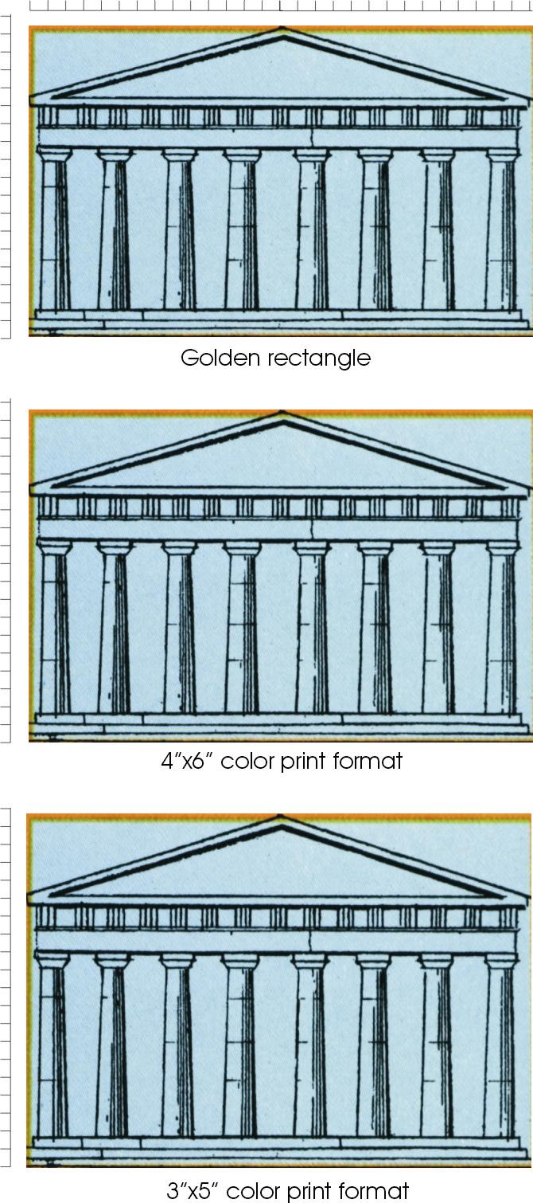
Figure 2. Ancient temple Parthenon at Athens

Golden square paper-cutouts

Let us begin with a large golden rectangle of construction paper with long side A-B of 16.2cm and short side A-D of 10cm, as shown in figure 3(I). Here, the side ratio 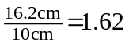 is roughly the golden ratio. We first cut off square A-E-F-D and place it in figure 4(I). The remaining E-B-C-F of figure 3(II) is supposed to be a golden rectangle, although the ratio 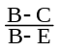 is only 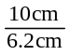1.61 in the present project. To be exact, B-E is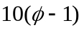cm, so that we should have had

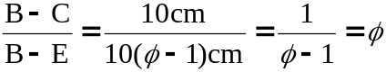,

in view of relation (5). This shows that after cutting off the largest square from a golden rectangle, the leftover is again a golden rectangle.
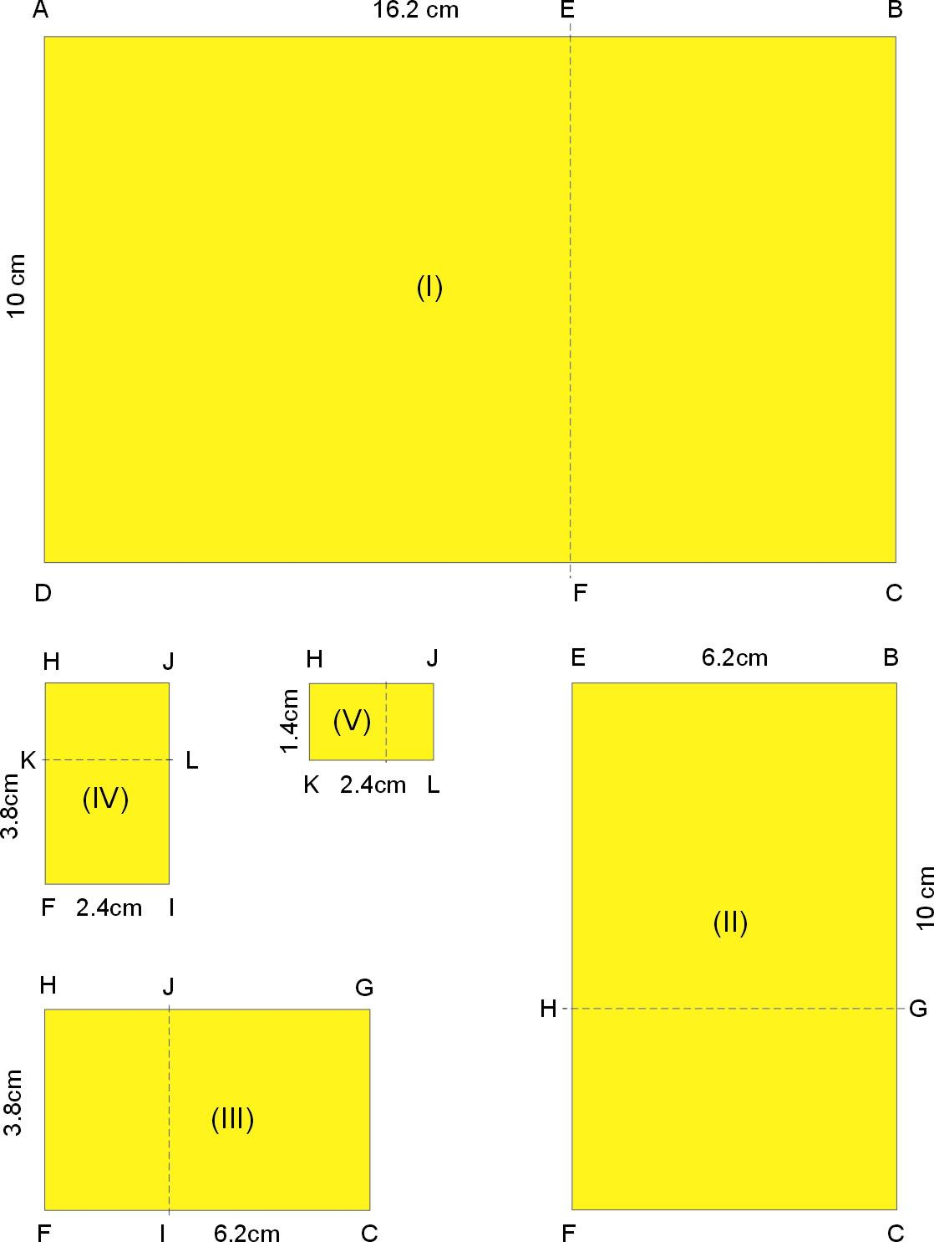

Figure 3. Golden rectangles

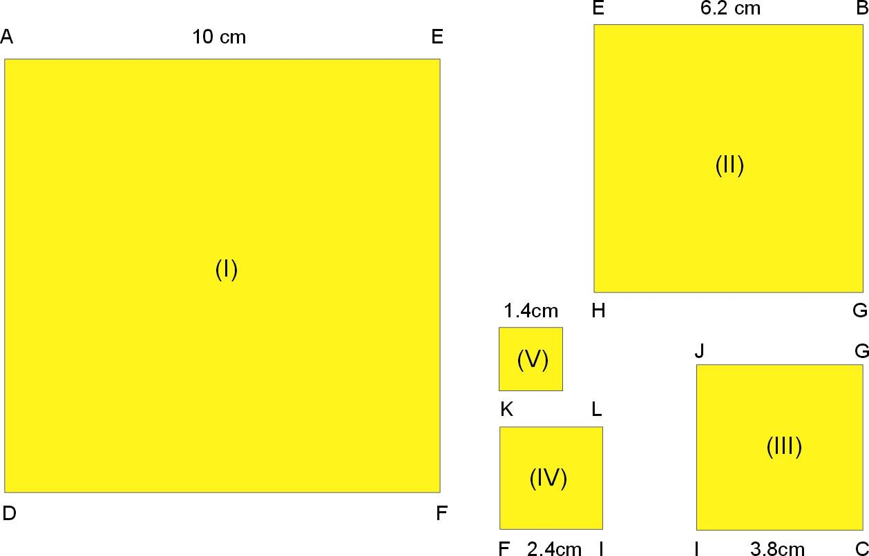

Figure 4. Self-similar golden squares

Next we cut off square E-B-G-H and move it to figure 4(II). The leftover H-G-C-F of figure 3(III) is again a golden rectangle, although in actuality we only have 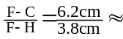1.63. In this fashion, we cut off the largest squares from figure 3(III) − 3(V), and place them in figure 4(III) − 4(V). Listed in the second column of table 1 are the side lengths of five squares (I−V) of figure 4, and the scaling factors of two neighboring squares are shown in the third column. Note that the ratios are considerably different from . You may record the actual side lengths of your paper cutout squares in the last column of table 1, and compute the scaling factors to compare with the golden ratio.

Table 1. Golden squares from rectangle of 10cm 16.2cm

Label | Side of the square (cm) | Scaling factor (large to small square) | Side of your paper square (cm)
I | 10 | 10/6.21.61
II | 6.2 | 6.2/3.81.63
III | 3.8 | 3.8/2.41.58
IV | 2.4 | 1.4/1/41.71
V | 1.4

Logarithmic spiral

A fascinating thing about self-similar golden squares is a logarithmic spiral that emerges quite naturally. To see this, let us go back to the five golden squares of figure 4 and draw a full quarter circle in each square as shown in figure 5. When the squares are drawn in together there appears a spiral of one and a quarter turn in figure 6. What is missing here is a leftover piece from rectangle H-J-L-K of figure 3(V) that we have previously discarded. Had we continued cutting out an ever smaller golden square from the leftover piece, the spiral would have wound down to a point, called the pole of spiral. You may continue to fill in at least a half turn of spiral toward the pole in figure 6.

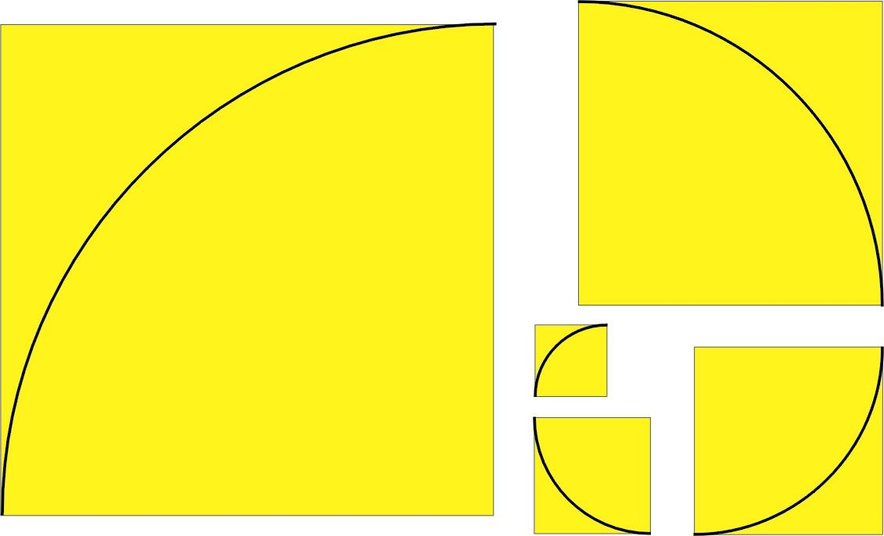
Figure 5. Golden squares with a quarter circle

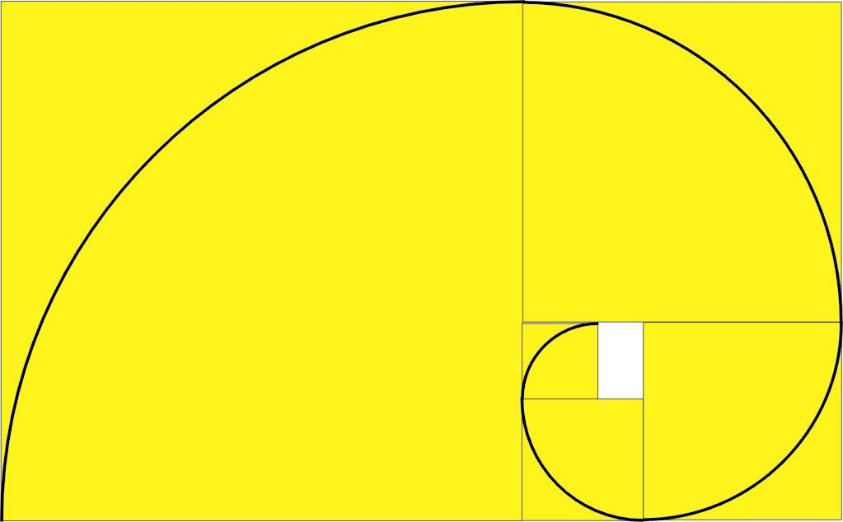
Figure 6. Logarithmic spiral

Perhaps you have seen a pinwheel with a logarithmic spiral painted on it in flower garden. (Project c − Make a logarithmic spiral pinwheel) By spinning the pinwheel clockwise, you see the spiral fanning out due to the radial expansion. On the other hand, when it spins counterclockwise the spiral gets sucked into the pole by the radial contraction. Mathematically, the radial expansion and contraction are governed by the logarithmic function of increasing and decreasing rotation angle. This is why it is called a logarithmic spiral. A cutaway view of a chambered nautilus shell shown in figure 7 is a familiar example of logarithmic spirals found in nature. Here, self-similarity allows some shell animals such as the mollusk to have a home of same shape but larger size as the shell expands along the logarithmic spirals.

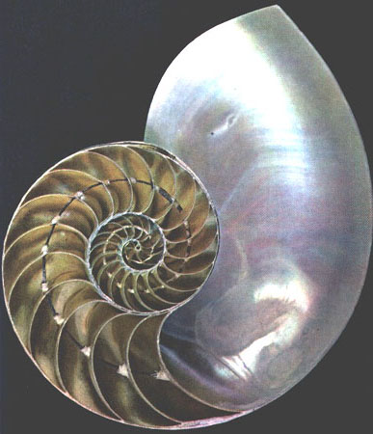
Figure 7. The cutaway of a chambered nautilus shell

The Fibonacci numbers

A simple model for the population growth of rabbits is based on the following rules.

(a) The rabbits are always in pairs for reproduction.
(b) A rabbit pair must grow one generation to maturity and then begets one baby pair at every generation thereafter.
(c) No rabbit pairs die off.

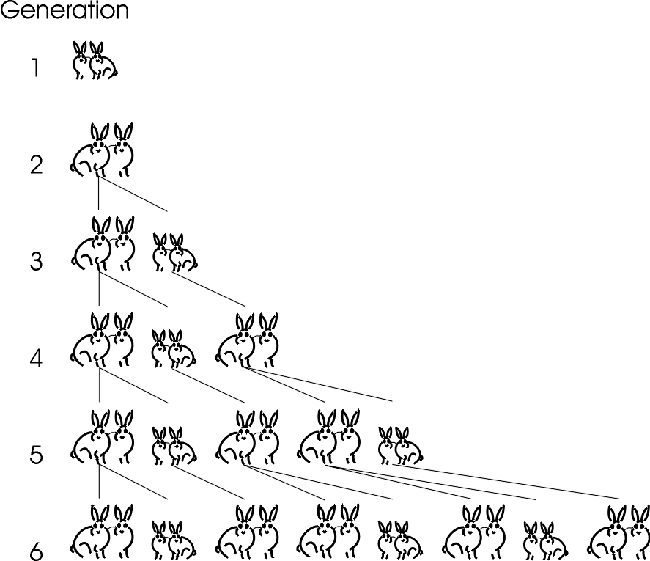
Figure 8. Rabbit population growth by the Fibonacci numbers

Under these rules, we follow in figure 8 the rabbit population beginning from a baby pair of the 1st generation. Since it takes one generation to maturity, there is an adult pair for the 2nd generation, which is ready for reproduction. So, there are two rabbit pairs, the parent and baby pairs, of the 3rd generation. Next, the adult pair begets a baby pair but the baby pair simply matures, so a family of three rabbit pairs for the 4th generation, and so on. The numbers of total rabbit pairs at each generation are known as the Fibonacci numbers, named after Leonardo Fibonacci, a twelfth-century Italian mathematician who advocated the adoption of Arabic numbers. Denoting by 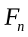 the Fibonacci number of 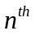generation, we summarize the set of Fibonacci numbers {} as

{}= {1, 1, 2, 3, 5, 8, 13, 21, 34, 55, 89, 144, …}.

As in figure 8, in particular, 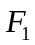=1, 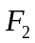=1, 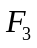=2, 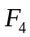=3, and so on. It is interesting to point out that the Fibonacci numbers obey the following relationship

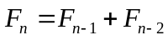.

That is, is given by sum of the two previous Fibonacci numbers 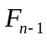 and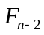. For this relationship to work correctly, we require the index n be 3 or greater. For examples, 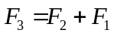= 1 + 1= 2, 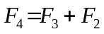= 2 + 1= 3, and 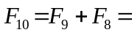 34 + 21= 55. Lastly, we observe Fibonacci numbers in the petals of some common flowers. For instance, the lilies and irises have 3 petals, primroses and buttercups have 5 petals, corn marigolds have 13 petals, and daisies can have 34, 55 and 89 petals.



We show in Project d that the ratio of two adjacent Fibonacci numbers approaches the golden ratio after many generations; that is,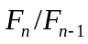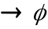 as n becomes large. This is indeed a mystery. What does the golden ratio have to do with a rabbit population model in figure 8?

Project a – The decimal digits of 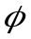 by continued fractions

We find the decimal digits of =1.61803398… by iterating the function

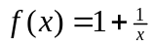. (1)
First, we insert for x and obtain 2-layer fraction of the 1st iteration.

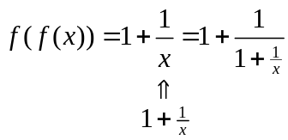 (2)

Then, inserting for x in the 1st iteration, we get 3-layer fraction of the 2nd iteration.

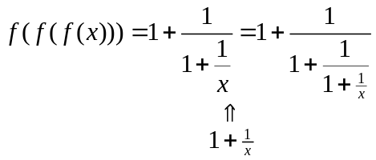 (3)
Similarly, 4-layer fraction of the 3rd iteration is

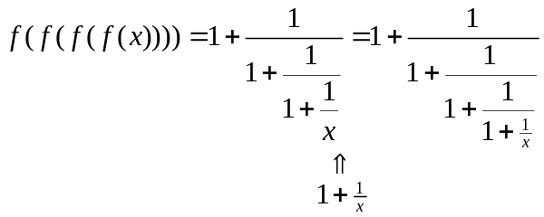 (4)

Hence, by repeated iterations we build up the multi-layer fraction as shown

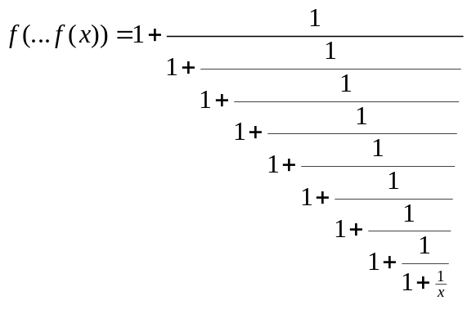 (5)
This is called a continued fraction.

We now evaluate the decimal digits of from the continued fractions. Dropping the term from function (1) we get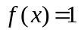, which appears in the second column of the table below. Now, by dropping from fraction (2) we obtain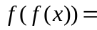 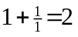, and similarly 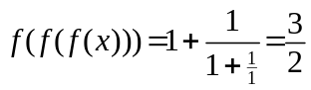 and 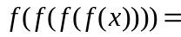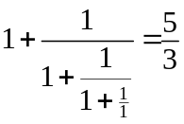. These function values are also listed in table A. You may evaluate the remaining function values in the table. At the 9th iteration we have 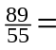 1.61818181… from fraction (5), agreeing with the golden ratio 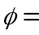1.61803398… up to the three decimal places. Then, by carrying out continued fraction beyond (5), we can evaluate as many decimal digits of as required.

Table A: Finding golden ratio by continued fractions

No. of iterations | Function value
0 | 1
1 | 2
2 | 3/2=1.5
3 | 5/3=1.66666…
4
5
6
7
8
9 | 89/55=1.61818…

Return to main text

Project b – Show the length A-F is 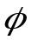

Show this by applying the Pythagoras theorem to the right triangle C-D-E in figure 1. (Note that C-E = 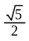)

Return to main text

Project c – Make a logarithmic spiral pinwheel

Cut out the dotted circle with a spiral pattern and mount it on the eraser end of a pencil with a thumbtack.

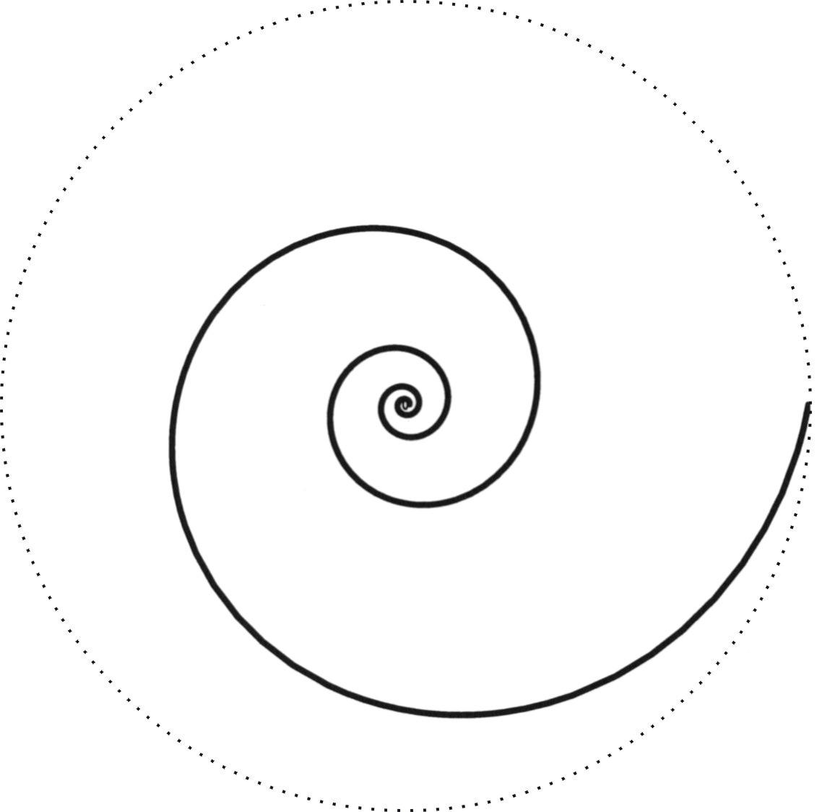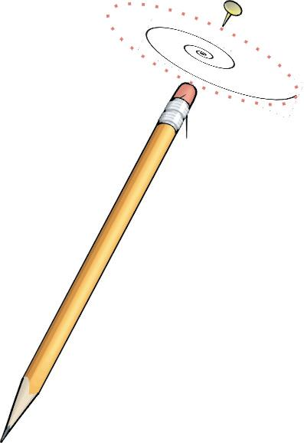

Return to main text

Project d – The ratio of two adjacent Fibonacci numbers

The Fibonacci numbers =1, =1, =2, …, 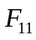=89 are listed in the second column of table D, and you can complete the third column by computing the ratio 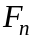/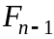 of two neighboring Fibonacci numbers. Can you identify / as n increases? Interestingly, the / are identical to the function values of continued fractions listed in the table of Project a.

Table D: The ratio of two neighboring Fibonacci numbers

n |  | /
2 | 1 | 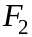/=1/1
3 | 2 | /=2/1
4 | 3 | 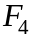/=3/2
5 | 5 | 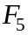/=
6 | 8 | 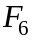/=
7 | 13 | 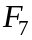/=
8 | 21 | /=
9 | 34 | 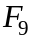/=
10 | 55 | 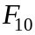/=
11 | 89 | 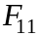/=

Return to main text

