**Potential for Climate Change to Increase Double Cropping in Washington State and Implications for Total Consumptive Water Use**

Michael Brady

School of Economic Sciences

Washington State University

The potential for climate change to increase water use for agriculture even in the absence of any new water rights is important to evaluate in forecasting future changes in water use in Eastern Washington.  Climate change projections for Washington State predict a warming spring that extends the growing season. In addition, total precipitation is predicted to increase, although more is likely to fall as rain than snow, as is reported in the 2016 Long-Term Water Supply and Demand Forecast report. This is expected to increase drought risk for junior water rights holders. However, for irrigators in places like the Columbia Basin Project they may take advantage of the extended growing season by planting two crops. They have almost no risk of curtailment. In addition, they are permitted to use more water per acre in comparison to irrigation districts in the Yakima Basin. Double cropping options include two primary crops that are both harvested in the same year, or a primary crop and a late season cover crop that is not harvested.

There is some evidence beyond anecdote that double cropping is increasing in Washington. Consider an old enterprise budget for sweet corn and peas from WSU Extension published in 2002. Hinman et al. (2002) provides cost of production and revenue assumptions for a dry beans, sweet corn, and green peas rotation under center pivot in the Columbia Basin. Sweet corn and peas is commonly mentioned as the most likely double cropping option in the region. Nowhere in the budget is there a mention that sweet corn and green peas could be grown in the same calendar year. The planting and harvest time assumptions make clear one is grown per year. Ten years later an article in the Tri-City Herald by Ty Beaver (“Washington ranked No. 1 in U.S. sweet corn production”, Sept. 18, 2012) profiles a 28-year-old farmer in Pasco that has hit on the idea of double cropping sweet corn and peas. The general impression of the article is that this was a somewhat novel and innovative change in management that was paying off. While this is only two pieces of information, it is enough to form a tentative hypothesis that farmers in Washington are starting to adapt to a longer growing season with double cropping.

As is discussed in the literature review in this report, the potential for multi-cropping to mitigate the negative impacts of climate change has caught on in just the last five or ten years. Most studies generally find that a longer growing season is a benefit in terms of food production, although it does not always outweigh the negative effects of climate change. However, there is a noticeable gap in the literature. No paper has looked in any detail at the irrigated western U.S. Therefore, there has not been an adequate consideration of the extent to which water rights limit an increase in multi-cropping. Also missing is spatial interactions between irrigators in a basin with in-stream flow rules that determine curtailment.

The rest of the report is as follows. First, historical and projected changes in the length of the growing season is discussed. Second, a simple accounting exercise is performed to determine whether a realistic increase in double cropping would actually represent a significant amount of water in the region relative to the total water used for out-of-stream uses. Third, a review of the existing literature on multi-cropping is provided. Fourth, an empirical analysis is provided to evaluate the extent of multi-cropping in the western U.S. It is beyond the scope of this article to predict changes in double cropping in Washington with simulations to demonstrate downstream effects on other irrigators. That level of analysis would require many months to design and carry out based on expertise from engineering and economics. However, the empirical analysis in this report provides a less costly but very informative consideration of whether a more involved project would be informative.

**“Back of the Envelope” Estimate of Whether Double Cropping is Hydrologically Significant**

There are about 1.8 million irrigated acres in Washington State according to both the USDA and WSDA.  Due to limitations on water rights it is not feasible to double crop on much of this land. To be somewhat conservative we only consider irrigated land in the Columbia Basin Project and in WRIA 32. WRIA 32 contains Horse Heaven Hills and Patterson. To arrive at an eligible number of acres based on their water right we add together the Columbia Basin Project acreage of 671,000 acres with the irrigated acreage in WRIA 31 (160,737). This gives a total of 831,737 acres.

In these two regions three crop groups each make up about a quarter of the total irrigated acreage. These are vegetables, hay/silage, and cereal grains. Many of the vegetable crops can be double cropped. The same is true for the primary cereal grains wheat and corn. An important exception is potatoes which account for about 13% of the total. Hay crops can be double cropped in the last year for a stand. Assuming that a typical alfalfa and Timothy hay planting lasts three years only 1/3 of the hay crop is considered. These adjustments leave just under half of the acreage remaining for double cropping consideration, or about 400,000 acres.

The assumptions required to further refine the acreage number from here become more tenuous. One approach is to also work from the bottom up to arrive at a lower bound that only includes the crops that are known to be frequently double cropped. This includes the combinations sweet corn/peas and field corn/winter wheat. Wheat is not broken out into winter and spring in the WSDA layer, so the assumption is made that half is winter wheat. Summing together these four crops accounts for ¼ of the 831,737 acres, or 207,934 acres.

The two values of 207,000 and 400,000 acres provide upper and lower estimates of acreage that could be double cropped. There is no expectation that all of it would be double cropped. The most difficult assumption to make without any additional biophysical modeling is the increase in double cropping on this eligible acreage. Are assumption is that as a result of climate change double cropping will occur on 10% of this eligible land where it did not before. In other words, double cropping expands onto 20,000 to 40,000 acres.

Assuming an average consumptive use of 3 acre-feet/acre this would represent an increase in water use of 60,000 to 120,000 acre-feet.

**Historical and Projected Changes in Growing Season Length and Intensity**

Interest in “multi-cropping” has increased recently in the academic literature. It has been considered both an outcome of climate change, and a potential adaptation strategy to mitigate other negative impacts of climate change on agricultural systems. Kunkel et al. (2004) can perhaps be credited with kicking-off this line of research by showing the increase in frost-free days in the U.S. By 2000, the national average growing season had increased about 1-week since 1980 and about 2-weeks since 1900. This understates changes in the western U.S. where the expansion in the growing season was 19 days over the 20th Century compared to 3 days in the eastern U.S. This is shown in Figure 1, which updates the Kunkel et al. (2004) data set to 2016. Most of the change is due to an earlier end to frost in the spring as opposed to a later first frost in the fall.

WSU’s Ag Climate Tools projects shows projections in the change in the growing season at a high spatial resolution for Washington (aglimatetools.cahnrs.wsu.edu/cbcct/). A screen shot of a location in the Columbia Basin Project is shown in Figure 2. A comparison of the historical length to project future is provided in the very bottom panel. The projection is for the rate of expansion to be faster than it has in the past 30 years.

**State of the Literature on Double Cropping**

A majority of the academic publications examining drivers and consequences of multi-cropping have been published since 2010. This is likely motivated by Kunkel et al. and other climate science papers quantifying historical changes in growing season and predictions about future changes that have been published since the mid 2000’s. These papers develop a number of related concepts. A summary of them is provided below to help clarify major concepts and the degree to which they are different. As mentioned in the beginning of this report, to my knowledge no studies have focused on the irrigated western United States.

* **Cropping Frequency Gap** = Potential cropping frequency – Actual cropping frequency
* **Multiple Cropping Index (MCI)** = Average number of crops harvested per area
* **Crop Harvesting Frequency (CHF)** 
  + CHF = Harvested Area/Standing Cropland
  + Citation: Ray and Foley (2013)
  + Maximum Potential CHF
  + Harvest Gap = Potential CHF – Actual CHF
* **Cropping Intensity (CI)** = Average Annual Number of Crop Harvested on Total Cropland
  + Citation: Siebert, Portmann, and Doll (2010)
  + CI = (Total harvested crop area per year)/(Cropland Extent)
  + CI can be adjusted to include or exclude temporarily fallowed land (e.g. land in Conservation Reserve Program).
* **USDA Categories of Multi-Cropping** 
  + Citation: Borchers et al. (2014)
  + Double Cropping = Harvesting two crops or commodities in a calendar year.
  + Cover Cropping = Planting two crops but harvesting only one.
  + Dual Purpose Crops = Livestock grazing of crops before or after harvest
  + **NOT DOUBLE CROPPING** = Crops that are sown once and harvested multiple times (e.g. alfalfa).

There has been a substantial increase in **CHF** globally in the last 50 years. Ray and Foley (2013) report that the global value for **CHF** was 89.2% in 2011, which is 11% higher than in 1961 (78%). Globally, annually harvested cropland is still less than total standing cropland area, but the two are converging. Tropical and sub-tropical lands, where double and triple-cropping are common, contains about 10% of global standing cropland. Countries with CHF values much greater than 1 include Bangladesh (1.67), China (1.29), Egypt (1.75), and Vietnam (1.39). Not all countries with a high CHF are in the tropics. Germany and Belgium’s values are 1.66 and 1.20, respectively. There are also relatively rich and tropical countries like Costa Rica (0.99) that do not have a CHF greater than 1. This just means there are a complex set of factors that determine the amount of double and triple cropping. The United States has a CHF of 0.71. Countries like China, India, and Australia have been increasing their CHF by around 1% per year since 2000. The U.S. is part of the group of countries along with Brazil, Chile, and others in the Americas that have significantly increased CHF rates since 2000. Most relevant to this report is the estimate of the potential to increase harvest frequency, which is based on their measure of **maximum potential CHF**. They estimate the maximum potential CHF for the U.S. as a whole to be 1. Ray and Foley develop a number of very useful metrics, and their global perspective is valuable for developing a sense of what is actually achieved across countries. However, as is the case with larger scale studies, they lack critical details related to irrigated areas.

Meza, Silva, and Vigil (2008) published one of the more highly cited papers on double cropping in the well-respected journal *Agricultural Systems* (vol 98, issue 1). While their analysis was focused on Chile, they characterize the study as relevant to Mediterranean-type climates. A Mediterranean-type climate is one with between 12 and 45 inches of rain concentrated in the winter months and high temperatures between 75 and 95 degrees F, which characterizes much of the Pacific Northwest. As the author note, local differences are significant and preclude applying predictions in one location to another. That said some of their findings are instructive of potential changes. In particular, they find that double cropping has many advantages over other adaptation strategies at the farm level, but does increase total consumptive water use. Mo et al., (Agriculture, Ecosystems & Environment, 2009) analyze a major agricultural region in China. Seifert and Lobell (2015) predict more double cropping due to climate change in the Eastern United States. Liu et al. (2013) developed the concept of an MCI.

The multi-cropping categories from USDA (Borchers et al.) are useful for limiting the scope of this study and conforming it to existing definitions of double cropping. I will focus on double and cover cropping. Dual-purpose crops are not included because the connection to irrigated water use is less. Borchers et al. relied primarily on data from the June Agricultural Survey (JAS), which focuses on the major program crops. Results are shown in Figure 3. Therefore, it does not address irrigated agriculture for the most part. However, some of the spatial differences across regions and changes over time provide a baseline measure of double cropping frequency. The highest share of cropland that is double cropped is in the Northeast (9.58%) while the lowest is the Pacific Northwest (0.52%). See The Southeast leads in terms of total cropland area that is double cropped. From 1999 to 2012, there was no clear upward trend in double cropping for most regions. The one exception is the Pacific Northwest, although this is only a very modest increase from nearly zero to roughly 200,000 acres. They do show that double cropping of corn, wheat, and soybeans increases when prices of these commodities increase.

An alternative to projecting changing growing conditions for a specific location is to comparing double cropping rates across the Western United States now. It is possible that parts of California provide a window into Washington’s future. If there is extensive double cropping in California where water availability allows then it is reasonable to expect more double cropping in Washington as the climate warms. UC Davis produced an enterprise budget for double-cropped corn silage production in the southern San Joaquin Valley. The budget assumes that planting can be completed by early April and harvest is in August.

**Data and Analysis**

The objective of this empirical analysis is to see if there is an increasing trend in double cropping in Washington over time, and whether double cropping is more common in parts of the western U.S. that have longer growing seasons. In other words, it combines a spatial and temporal analysis to identify if there is a discernable relationship between growing season length and double cropping frequency. It is also important to consider water rights limitations on double cropping. To do this I use differences in Yakima County and Grant County as a type of natural experiment. Grant County almost entirely consists of the Columbia Basin Project where water is less limiting. In Yakima County, it is thought that even the more senior irrigation districts (e.g. SVID, Yakima-Tieton) are limited by the amount of water they can divert to the degree that double cropping is not feasible. To use terminology from the crop sciences literature, Grant County is “phenologically limited”, or at least has been in the past, whereas Yakima County is “hydrologically limited”. As growing season lengthens, the phenological limits are slackened but hydrological limits are not. While there is uncertainty over how much longer the growing season will be in Washington in the future, we can use another location right now as an experiment in extending the growing season. San Joaquin County in California is used for this purpose because it was the location of the enterprise budget reported earlier assumes double cropping. Morrow County, Oregon is also included as a comparison because it has similar climatic conditions to Washington but is under the purview of Oregon state water law.

There are three sources of cropping pattern data. None is perfect but they complement each other. The WSDA GIS Cropland Layer provides field level crop planting information for the past decade. It is updated approximately every three years. The main deficiency of WSDA data is that it provides planted rather than harvested acres. It only records one crop per year for any given field. USDA NASS annual survey data provides information on harvested and planted acres for some crops at the county level. It does not separate acreage by irrigated and non-irrigated, however. In addition, many of the crops that are relevant for this analysis are only reported at the state level. The Census of Agriculture provides better coverage across crops at the county level, but only reports every five years.

My approach is to use all three data sets in a complementary fashion to see whether there are is an upward trend in three metrics:

* Cropping Intensity – Ratio of harvested irrigated cropland to total irrigated cropland
* Cropping Patterns in Yakima and Grant County
  + Sweet corn and peas – commonly double cropped
  + Increase in field corn – longer growing season is allowing planting corn after the first cutting of an alfalfa stand in its third year.

**Cropping Intensity**

Values for cropping intensity were calculated for Grant and Yakima County for 1997 and 2012, and for San Joaquin and Morrow County for 2012. The cropping intensity is the number of harvested acres of crops to the total irrigated cropland in the county. All values are from the Census of Agriculture for those years. The harvested cropland totals requires adding up individual crop values for acres harvested. Total irrigated cropland is calculated as total irrigated cropland minus irrigated pasture on cropland. Results are reported in Table 1. There is no clear trend showing that a longer growing season leads to more double-cropping. CI is higher for Grant County than Yakima. This is consistent with our hypothesis that farmers in Grant County are not hydrologically constrained so they can double crop. However, CI is lower for Grant County in 2012 than in 1997. In contrast, CI for Yakima increased from 1997 to 2012. Also, CI in San Joaquin is not higher than in Grant County even though it is a much warmer climate with a far longer growing season.

These results put some doubt into the idea that a longer growing season will necessarily increase double cropping in Washington where water rights are not limiting in terms of diversion quantities. There are a few factors to consider. First, there may be something about California water rights that are limiting double cropping. Also, economic drivers may mean that it is actually not that financially advantageous to double crop compared to alternatives. These factors will be important to incorporate into any modeling exercise to predict double cropping in Washington. Another very significant caveat is that a more formal engagement USDA NASS in the Olympia, WA office should be initiated to ensure that all interpretations of cropping data is consistent with their interpretation of the data.

**Cropping Patterns in Yakima and Grant County**

*Sweet Corn and Peas Acreage*

According to the Census of Agriculture, Grant County harvested a total of 25,856 acres of sweet corn in 2012. This was a decrease from 30,364 in 2007. Yakima County showed a similar trend where sweet corn decreased from 3,589 in 2007 to 1,061 acres in 2012. These findings are more consistent with market price effects than taking advantage of a longer growing season. Yakima County does not have a reportable amount of green pea acreage. Grant County showed a decrease in green peas from 2007 to 2012.

*Field Corn*

While the USDA does not consider more cuttings of hay as a form of double crop, a longer growing season could motivate farmers to plant corn after the first cutting of alfalfa in the third year of a stand. Therefore, it is worth looking at whether field corn and silage acreage is increasing more in Grant than Yakima County. As shown in Figure 5, corn acreage has increased in both Grant and Yakima, but their trends are largely consistent with market driven price increases that led to a growth in corn planting across the country. Unfortunately, USDA NASS data at the county level has become more limited in the last ten years due to budget cuts. The WSDA GIS data does help fill in the post-2008 data gap. Changes in the major crop groups for Grant County are compared to a combination of Yakima and Benton Counties in Figure 4. These data were limited to irrigated fields. What is surprising is that a larger increase in grains is shown in Yakima and Benton compared to Grant. In summary, there is no clear result pointing to an increase in double cropping in Grant County to date. Future analysis may require analysis of remote sensing data at different times of the growing season.

**Conclusions**

A review of the existing scientific literature on the effect of climate change on double, or multi-, cropping clearly shows that it could have a significant impact on food production globally. Climate change projections show this is particularly the case in the western U.S., however no studies to date have adequately considered the nature of water rights. The greater potential to double crop is almost universally cast as a positive in terms of food production in places like China, Chile, and the eastern U.S. where studies have been conducted. In Washington, it has the potential to increase total consumptive water use where water rights are not limiting. This could harm downstream water users that have water rights that are more restrictive. This study was only an initial assessment of this potential. The primary finding was that there is no clear indication that double cropping has increased in Washington in the last ten to twenty years. That said, it could be something that is just catching on now. An additional point of caution is that cropping intensity is not particularly high in San Joaquin County in California, which has a much longer growing season than eastern Washington. This motivates caution in simply extrapolating a longer growing season to more double-cropping. A careful consideration of the economic motive to double crop is critical along with an accurate representation of incentives and restrictions imposed by water rights.

**References**

Borchers, A., E. Truex-Powell, S. Wallander, and C. Nickerson. 2014. Multi-Cropping practices: recent trends in double-cropping. Economic Information Bulletin No. (EIB-125).

Hinman, H., G. Pelter, E. Soreson, L.A. Fickle. 2002. 2002 Cost of producing dry beans, sweet corn, and green peas under center pivot irrigation in the Columbia Basin of Washington State. Farm Business Reports, EB1941E. WSU Extension.

Kunkel, K. E., Easterling, D. R., Hubbard, K., & Redmond, K. (2004). Temporal variations in frost‐free season in the United States: 1895–2000. *Geophysical Research Letters*, *31*(3).

Liu, L., Xu, X., Zhuang, D., Chen, X., & Li, S. (2013). Changes in the potential multiple cropping system in response to climate change in China from 1960–2010. *PloS one*, *8*(12), e80990.

Meza, F. J., Silva, D., & Vigil, H. (2008). Climate change impacts on irrigated maize in Mediterranean climates: evaluation of double cropping as an emerging adaptation alternative. *Agricultural systems*, *98*(1), 21-30.

Ray, D. K., & Foley, J. A. (2013). Increasing global crop harvest frequency: recent trends and future directions. *Environmental Research Letters*, *8*(4), 044041.

Siebert, S., Portmann, F. T., & Döll, P. (2010). Global patterns of cropland use intensity. *Remote Sensing*, *2*(7), 1625-1643.

Seifert, C. A., & Lobell, D. B. (2015). Response of double cropping suitability to climate change in the United States. *Environmental Research Letters*, *10*(2), 024002.

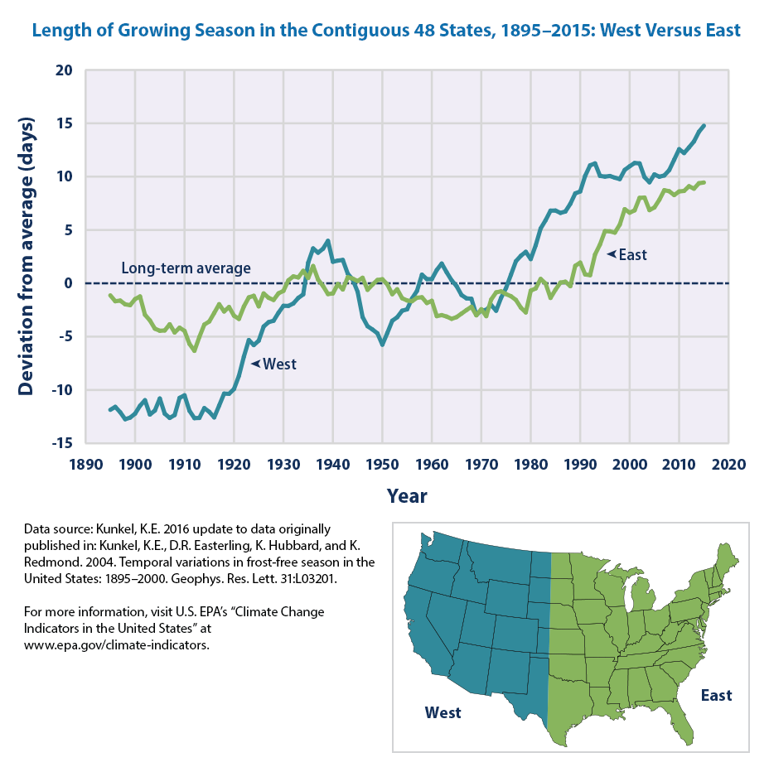

Figure 1. Change in length of growing season in the U.S. from Kunkel et al. (2004).

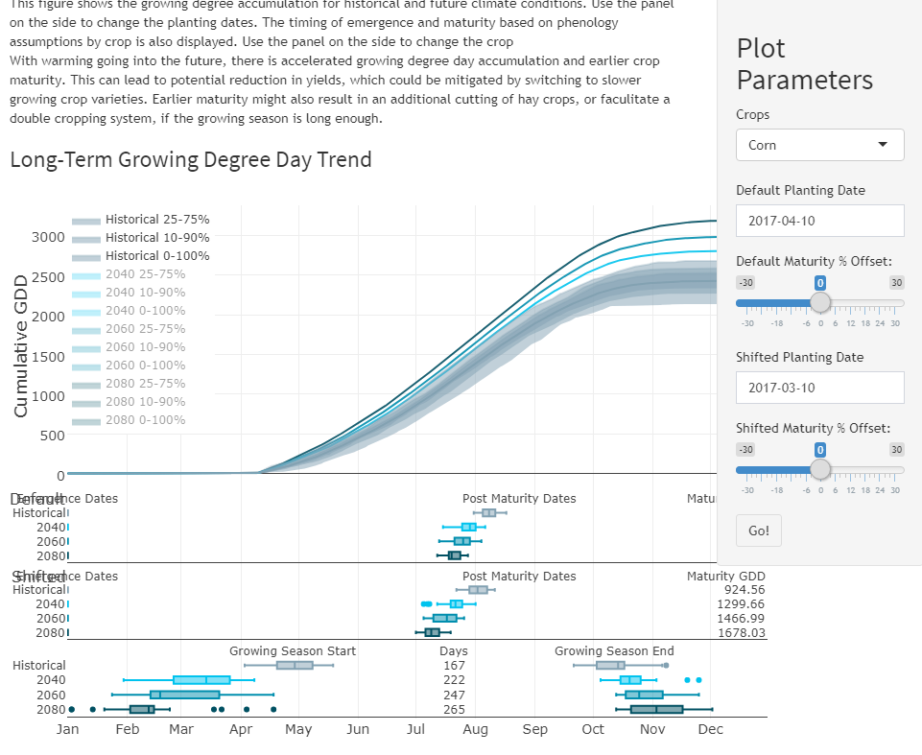

Figure 2. Example of projected change in the growing season for corn in the Columbia River Basin from the Center for Sustaining Agriculture and Natural Resources Ag Climate tools (agclimatetools.cahnrs.wsu.edu/cbcct/).

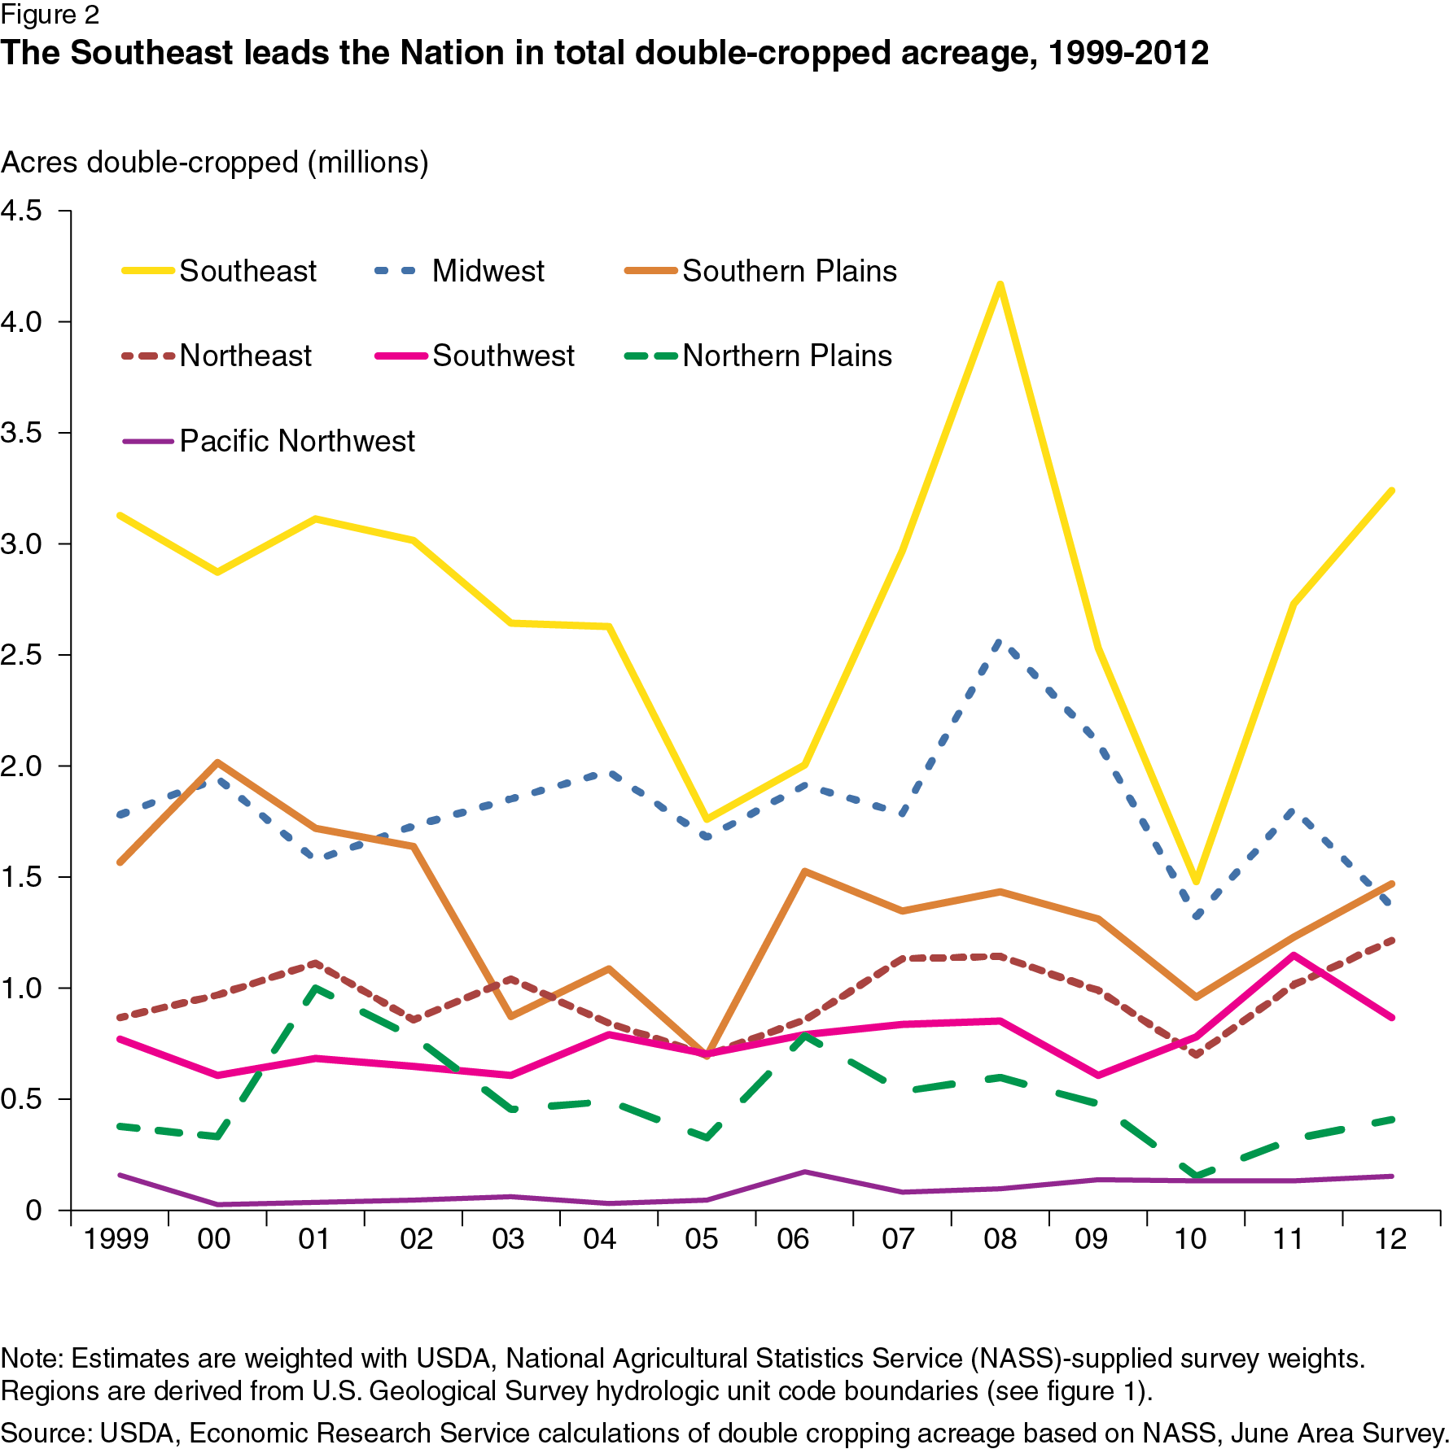

Figure 3. Borchers et al. (USDA ERS) showing regional trends in double cropping acreage.

Figure . Changes in crop group acreage for Yakima, Benton, and Grant Counties.

Figure 5. Field corn planted and harvested acres trends in Grant and Yakima County.

Table 1. Cropping Intensity by County and Year.

|  |  |  |  |  |
| --- | --- | --- | --- | --- |
| County | Year | Harvested Acres | Irrigated Cropland | Cropping Intensity |
| Grant | 1997 | 494,460 | 420,759 | 1.175 |
| Grant | 2012 | 461,533 | 415,595 | 1.111 |
| Yakima | 1997 | 174,696 | 225,715 | 0.774 |
| Yakima | 2012 | 184,067 | 210,313 | 0.875 |
| Morrow (OR) | 2012 | 72,844 | 62,437 | 1.167 |
| San Joaquin (CA) | 2012 | 504,917 | 460,727 | 1.096 |

**Appendix**

Definitions from USDA Census Documentation

“**Irrigated land.** This category includes all land watered by any artificial or controlled means, such as sprinklers, flooding, furrows or ditches, subirrigation, and spreader dikes. Included are

supplemental, partial, and preplant irrigation. Each acre was counted only once regardless of the number of times it was irrigated or harvested. If an operation reported less than one acre irrigated, the irrigated land for the operation was rounded to one acre. Livestock lagoon waste water distributed by sprinkler or flood systems was also included.”

**“Acres and quantity harvested.** Crops were reported in whole acres, except for the following crops that were reported in tenths of acres: tobacco, nursery and greenhouse crops in the open, vegetables including potatoes and sweet potatoes, fruit and nut crops including land in orchards, and berries; and in Hawaii, coffee. Totals for crops reported in tenths of acres were rounded to whole acres at the aggregate level during the tabulation process. Nursery and greenhouse crops grown under glass or other protection were reported in square feet and are published in square feet. If two or more crops were harvested from the same land during the year (double cropping), the acres were counted for each crop. Therefore, the total acres of all crops harvested could exceed the acres of cropland harvested. An exception to this procedure was hay. When more than one cutting of hay was taken from the same acres, the acres were counted only once. If there were multiple cuttings of one type of hay production, e.g. two cuttings of alfalfa for dry hay, acreage was reported once but the quantity harvested includes all cuttings. Acreage cut and tons harvested for both dry hay and haylage, silage, or greenchop was reported for each crop. For interplanted crops or ‘‘skip-row’’ crops, acres were reported according to the portion of the field occupied, whether by a crop or whether it was idle land. If a crop was interplanted in an orchard or vineyard and harvested, then the entire orchard or vineyard acreage was reported under the appropriate fruit crop and the interplanted estimated crop acreage was reported under the appropriate crop. If a crop was planted but not harvested, the acres were not reported as harvested. These acres were reported in the ‘‘land’’ section on the report form under the appropriate cropland items – cropland on which all crops failed or were abandoned, cropland in cultivated summer fallow, cropland idle or used for cover crops or soil-improvement but not harvested and not pastured or grazed, or other pasture and grazing land that could have been used for crops without additional improvements. This does not include fruit and nut orchards, vineyards, berries, acres in production for cut Christmas trees, and acres in production for short rotation woody crops that were not harvested. Acreage in these commodities were included in cropland harvested whether the crop was harvested or not. Abandoned orchards were reported as cropland idle, not as harvested cropland, and the individual abandoned orchard crop acres were not reported. Crops that were only hogged or grazed were reported as “Other pasture and grazing land that could have been used for crops without additional improvements.” Crop residue left in fields after the 2012 harvest and later hogged or grazed was reported as cropland harvested and not as other pasture and grazing land that could have been used for crops. Quantity harvested was not obtained for crops such as fruits and nuts, berries, vegetables and melons, and nursery and greenhouse crops.”