# WeRateDogs – Insights into the @dog_rates Twitter page

Did you ever hear about the twitter account WeRateDogs? People in the internet went crazy about this Twitter Account. I want to show you today why.

Today WeRateDogs has over 8,8M followers. The key concept is to have a lovely picture of the doggos, floofer, pupper or puppos (this is how they define the stage of the dogs) with a cool caption and a rating with denominator of 10 but a numerator, which could be anything.

Ein Bild, das Screenshot enthält.

WeRateDogs has right now over 12,5K tweets. I was able to analyze 1902. First question is, what is the most common dog type? Interesting to see from the around 300 different dog types included in this data set. 11 types had more than 25 tweets. By far the most posted dog is the Golden Retriever.

Ein Bild, das Screenshot enthält.

If you compare the different dog stages, it is interesting to see that doggo stage has some huge outliers. There it would be necessary to have a deeper investigation. Besides that, floofers have on average the most retweets followed by puppo.

Ein Bild, das groß, fliegend, Gruppe enthält.

Is there a correlation between the ratings and the retweets? According to this graph below, ratings between 12 and 14 have the highest amount of retweets, up to 80000. Everything below 10 has less than 10000 retweets. In future analysis this would be a good objective to invest more time.

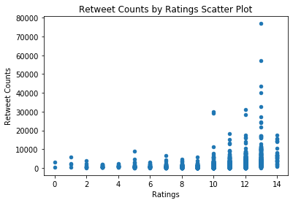

Has seen in the graph below, the interaction per post increased over the time. It slowly grew and some of the tweets had an outstanding amount of favorites.

Ein Bild, das Tisch, groß, fliegend, Regen enthält.
