Exercices sur les base de données - Locafly – Julien Chénel – 7 mars 2018

MCD original
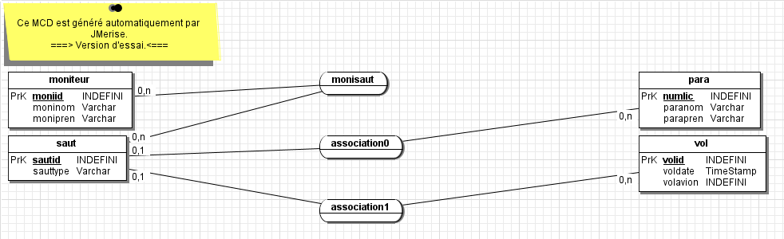

Dictionnaire des données

Nouveau MCD
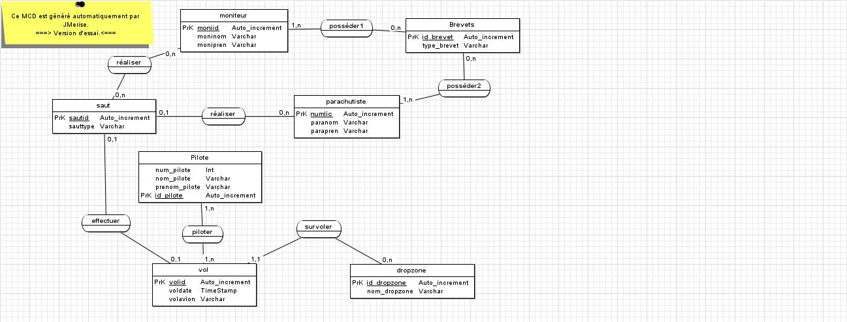

Nouveau MLD
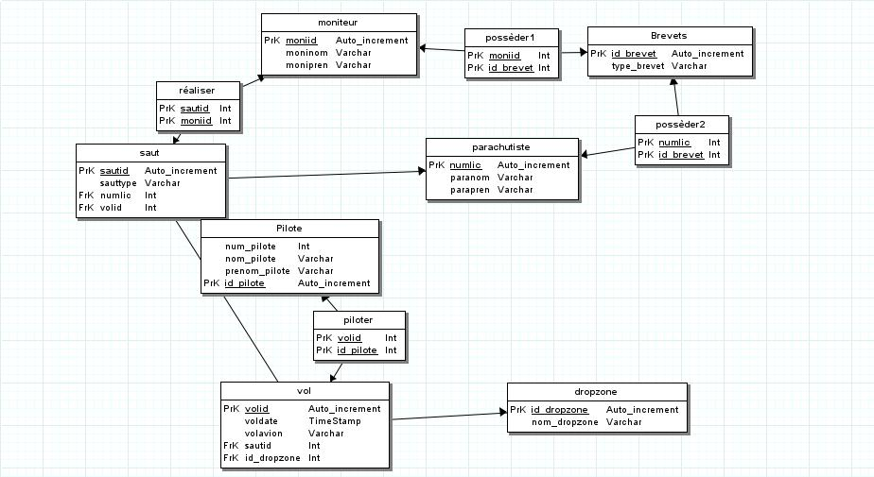

Modèle physique - MPD

#------------------------------------------------------------
# Script MySQL.
#------------------------------------------------------------

#------------------------------------------------------------
# Table: moniteur
#------------------------------------------------------------

CREATE TABLE moniteur(
moniid int (11) Auto_increment NOT NULL ,
moninom Varchar (40) ,
monipren Varchar (40) ,
PRIMARY KEY (moniid )
)ENGINE=InnoDB;

#------------------------------------------------------------
# Table: parachutiste
#------------------------------------------------------------

CREATE TABLE parachutiste(
numlic int (11) Auto_increment NOT NULL ,
paranom Varchar (40) ,
parapren Varchar (40) ,
PRIMARY KEY (numlic )
)ENGINE=InnoDB;

#------------------------------------------------------------
# Table: saut
#------------------------------------------------------------

CREATE TABLE saut(
sautid int (11) Auto_increment NOT NULL ,
sauttype Varchar (25) ,
numlic Int NOT NULL ,
volid Int NOT NULL ,
PRIMARY KEY (sautid )
)ENGINE=InnoDB;

#------------------------------------------------------------
# Table: vol
#------------------------------------------------------------

CREATE TABLE vol(
volid int (11) Auto_increment NOT NULL ,
voldate TimeStamp ,
volavion Varchar (10) ,
sautid Int NOT NULL ,
id_dropzone Int ,
PRIMARY KEY (volid )
)ENGINE=InnoDB;

#------------------------------------------------------------
# Table: Brevets
#------------------------------------------------------------

CREATE TABLE Brevets(
id_brevet int (11) Auto_increment NOT NULL ,
type_brevet Varchar (100) ,
PRIMARY KEY (id_brevet )
)ENGINE=InnoDB;

#------------------------------------------------------------
# Table: dropzone
#------------------------------------------------------------

CREATE TABLE dropzone(
id_dropzone int (11) Auto_increment NOT NULL ,
nom_dropzone Varchar (100) ,
PRIMARY KEY (id_dropzone )
)ENGINE=InnoDB;

#------------------------------------------------------------
# Table: Pilote
#------------------------------------------------------------

CREATE TABLE Pilote(
num_pilote Int ,
nom_pilote Varchar (100) NOT NULL ,
prenom_pilote Varchar (100) NOT NULL ,
id_pilote int (11) Auto_increment NOT NULL ,
PRIMARY KEY (id_pilote )
)ENGINE=InnoDB;

#------------------------------------------------------------
# Table: réaliser
#------------------------------------------------------------

CREATE TABLE realiser(
sautid Int NOT NULL ,
moniid Int NOT NULL ,
PRIMARY KEY (sautid ,moniid )
)ENGINE=InnoDB;

#------------------------------------------------------------
# Table: possèder1
#------------------------------------------------------------

CREATE TABLE posseder1(
moniid Int NOT NULL ,
id_brevet Int NOT NULL ,
PRIMARY KEY (moniid ,id_brevet )
)ENGINE=InnoDB;

#------------------------------------------------------------
# Table: piloter
#------------------------------------------------------------

CREATE TABLE piloter(
volid Int NOT NULL ,
id_pilote Int NOT NULL ,
PRIMARY KEY (volid ,id_pilote )
)ENGINE=InnoDB;

#------------------------------------------------------------
# Table: possèder2
#------------------------------------------------------------

CREATE TABLE posseder2(
numlic Int NOT NULL ,
id_brevet Int NOT NULL ,
PRIMARY KEY (numlic ,id_brevet )
)ENGINE=InnoDB;

ALTER TABLE saut ADD CONSTRAINT FK_saut_numlic FOREIGN KEY (numlic) REFERENCES parachutiste(numlic);
ALTER TABLE saut ADD CONSTRAINT FK_saut_volid FOREIGN KEY (volid) REFERENCES vol(volid);
ALTER TABLE vol ADD CONSTRAINT FK_vol_sautid FOREIGN KEY (sautid) REFERENCES saut(sautid);
ALTER TABLE vol ADD CONSTRAINT FK_vol_id_dropzone FOREIGN KEY (id_dropzone) REFERENCES dropzone(id_dropzone);
ALTER TABLE realiser ADD CONSTRAINT FK_realiser_sautid FOREIGN KEY (sautid) REFERENCES saut(sautid);
ALTER TABLE realiser ADD CONSTRAINT FK_realiser_moniid FOREIGN KEY (moniid) REFERENCES moniteur(moniid);
ALTER TABLE posseder1 ADD CONSTRAINT FK_posseder1_moniid FOREIGN KEY (moniid) REFERENCES moniteur(moniid);
ALTER TABLE posseder1 ADD CONSTRAINT FK_posseder1_id_brevet FOREIGN KEY (id_brevet) REFERENCES Brevets(id_brevet);
ALTER TABLE piloter ADD CONSTRAINT FK_piloter_volid FOREIGN KEY (volid) REFERENCES vol(volid);
ALTER TABLE piloter ADD CONSTRAINT FK_piloter_id_pilote FOREIGN KEY (id_pilote) REFERENCES Pilote(id_pilote);
ALTER TABLE posseder2 ADD CONSTRAINT FK_posseder2_numlic FOREIGN KEY (numlic) REFERENCES parachutiste(numlic);
ALTER TABLE posseder2 ADD CONSTRAINT FK_posseder2_id_brevet FOREIGN KEY (id_brevet) REFERENCES Brevets(id_brevet);

