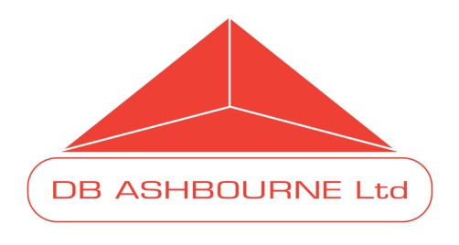

**Medical Information Enquiry Form**

|  |  |  |  |
| --- | --- | --- | --- |
| Date: |  | Enquiry Received by: |  |
| Time: |  | Enquiry reference number: |  |

|  |  |  |  |  |
| --- | --- | --- | --- | --- |
| Type of Enquiry:  (Highlight as necesssary) | General | Medical | Product Complaint | Adverse Event |

ENQUIRER DETAILS*

Name:

Status:

Hospital/Pharmacy/Surgery/Consumer/Relative/Other

Address:

Telephone:

Fax:

Email:

PRODUCT DETAILS*

|  |  |  |  |  |  |
| --- | --- | --- | --- | --- | --- |
| Name: |  | Strength: |  | Batch Number: |  |

Patient Identifier* – Initials/Age/Sex (if an adverse event):

|  |  |  |  |
| --- | --- | --- | --- |
| **Pregnancy/breast feeding enquiries:**  Has the patient taken the product? |  | **Off Label Use enquiries:**  Has the patient taken the product? |  |

SUMMARY OF ENQUIRY/COMPLAINT/ADVERSE EVENT*:

*Minimum information required if enquiry concerns a possible adverse event

RESPONSE SUMMARY:

|  |  |  |
| --- | --- | --- |
| METHOD OF RESPONSE (Highlight as necessary): | | |
| Telephone | Email | Letter/Fax |
| Other (please specify) |  | |

|  |  |  |  |
| --- | --- | --- | --- |
| Enquiry answered by: |  | Answer date and time: |  |
| Signature: |  | | |

|  |  |
| --- | --- |
| HAS QPPV (JACKIE AKHURST) BEEN NOTIFIED (IN CASES INVOLVING A POSSIBLE ADVERSE EVENT?) | |
| YES | NO |

***The QPPV must be notified immediately for enquiries involving a possible adverse event, pregnancy exposure, use during breast feeding, off label use, misuse/abuse, lack of effect, medication error, occupational exposure and overdose***

ADR Reference Number: