ILLAWARRA WOODWORKERS GROUP INCORPORATED

www.illawarrawoodworkers.org.au



Illawarra Woodworkers Group

JULY 2024 NEWSLETTER

Committee 2024/25
President | Jason Hedley
Vice -president | Aron Lavings
Secretary | Pat Keefe
Treasurer & Public Officer | Julien Leveugle
Assistant Treasurer | William Perry
Coordinator (Organising) | Horacio Rodrigues
Coordinator (Workshop Maintenance) | Mark Beaver
Club sales Coordinator | Darinka Radinovic
Librarian | Darinka Radinovic
Newsletter Editor | Virginie Schmelitschek / Julien Leveugle

Hello Fellow Woodies
A big thank you to Julien for designing our new logo, which you can see above. We had 3 to choose from, and this is the one with the most votes.
In the depths of winter our members continue to produce beautiful items. Have a look at the photos further in our newsletter I took over the last few months. Cooler weather means that the mosquitoes at least stay away!
I have also included the promised information about Bill Boddy, whom the annual trophy is named after.

Member news:
We have a few new (prospective) members in the Club, so please say hello when you see someone you have not met before.

Stalls and Events
On 17th August the Club is holding a stall at the Family Heritage Fair from 10 am to 4pm. We need helpers on the Friday (16 July) to help set up and also a few on the Saturday. Please put your name on the roster on the board in the club. Contact Darinka if you have any questions.

Workshop Safety – a monthly message from the Workshop Coordinator
(we cannot be reminded of this often enough!)
- IMPORTANT: Work shop safety must always be at the top of our list of priorities. Wear suitable clothes and enclosed shoes.
- Always ensure the dust collector gates are open when you use the equipment in the shed. ASK someone, if you are not sure what to do.
- Get help with the correct procedure for the sawdust bag.
- Clean up a machine and the floor after use, if significant mess. DO NOT ASSUME SOMEONE ELSE will use it after you. Do it as you go.
- Put the hose in to the vacuum cleaner the right way! If it is not sucking up the mess, empty it!
- The drum sander cannot have painted or varnished timber going through it as it will clog up the sandpaper.
- The table saw is NOT a storage space
    - NOT a work bench
    - Put NOTHING on the extension
- Use eye, ear, head and feet protection too, no loose clothes, and, keep an eye on people around you.
- Sometimes it’s just the simple things we all forget, like if you have medium/long hair, tie it up if working close to moving machinery.
- NEVER be complacent – blades bite!
(the last 3 dot points were copied from “Ingrained” the Knox newsletter)

LIBRARY
Our club library is available to all members with copies of Australian Wood Worker, Fine Woodworking, etc. available to get some ideas on your next project. Just remember to sign out and back in anything that you need.

Bill Boddy trophy explained
In an earlier newsletter I mentioned the Bill Boddy trophy, which is awarded once a year to a club member who has been an outstanding member to the club, and I promised to find out who he was.
“Bill was a driving force behind our club and President for well over 10 years. He was the instigator of getting our clubhouse for a ‘peppercorn lease’ from the Department of Education and he worked to provide the club with good machine and hand tools. Though his official work was not in carpentry and joinery, he became an expert at numerous forms of woodwork, end never stinted at passing on his knowledge and experience to others. He attended Master classes in turning and other woodskills and soon passed these skills onto others. His determination for woodwork and the club, soon propelled him into the Club Executive, where his ideas and thrust dominated. He was not a natural teacher, but he became multi-skilled and was glad to share his skills and ideas.
He liked driving big vehicles, and to a large extent he was the driving force behind the Club. His demands and standards were usually higher than most of us could match, but he was a great man, and will be greatly missed”.
(thank you, Bill, for providing this info, part of an article from a 2007 Newsletter)

FROM THE SHED:
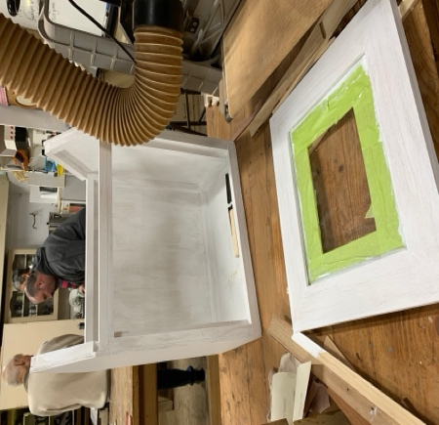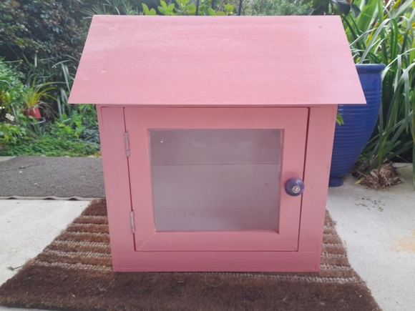
The club was requested to put this street library together for one of our members.

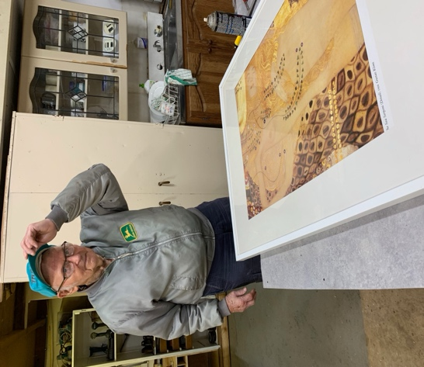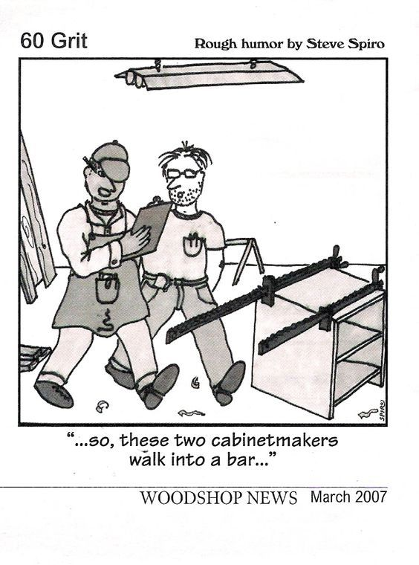
Another job for the club: fixing the frame around the print – Peter did a great job.
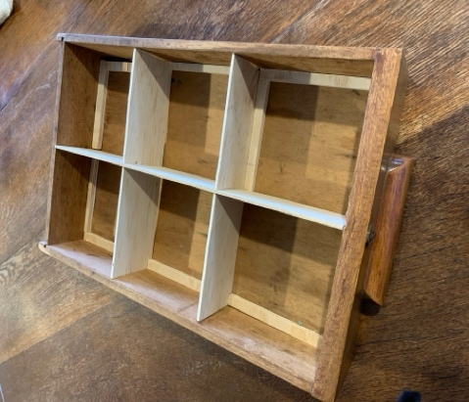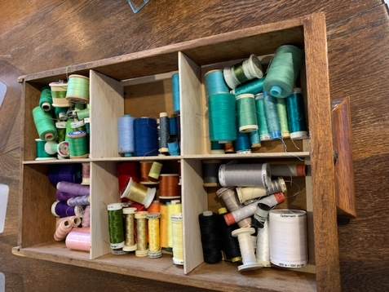
I made these partitions for a drawer in my sewing desk. So much better than loose!
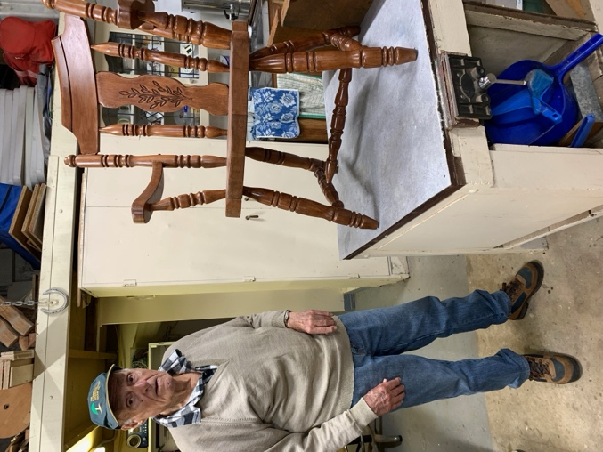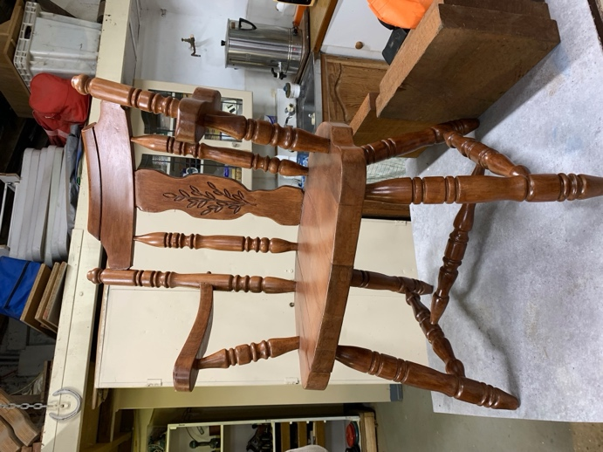
Rick found this old 1950’s chair by the roadside and restored it beautifully. For sale!

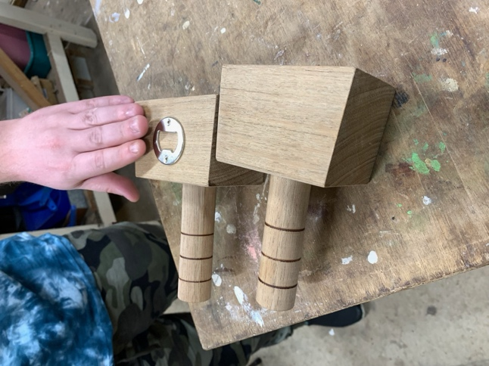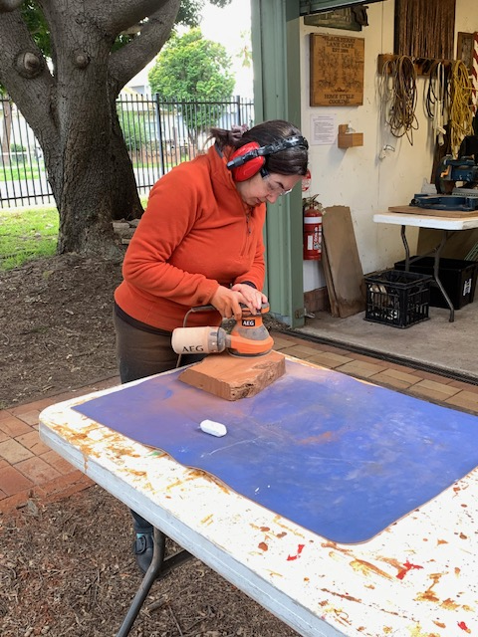
Aron showing his bottle opener mallets and (prospective) new member Masi’s first sanding attempt.
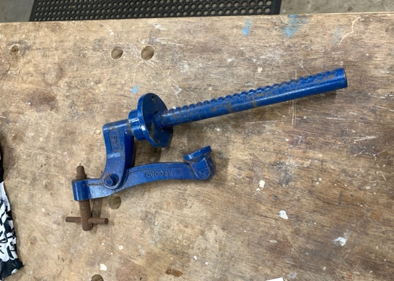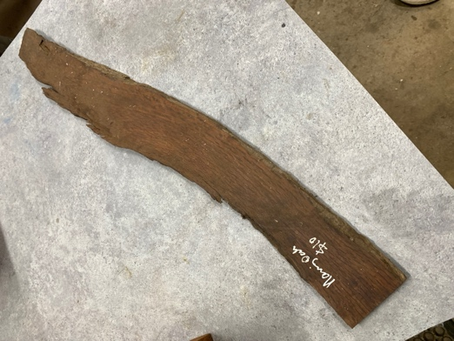
Pat picked up some items, timber and machines from a deceased estate.
The above two he handed out as “Lucky Door” prizes.
Left: a bench hold down vice. Right: A small hairy oak plank
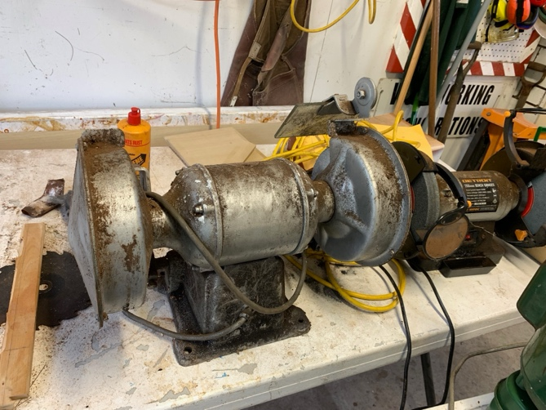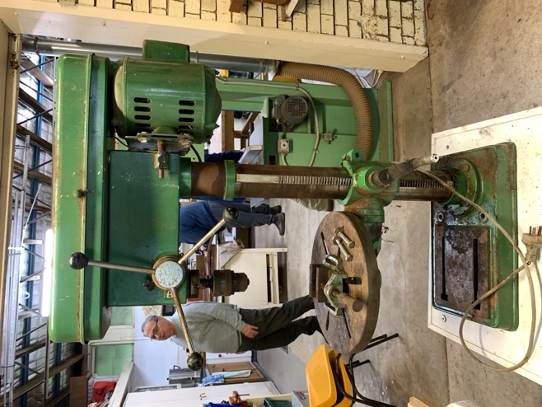
These 2 also came from the deceased estate. The drill press (r) was snapped up and the bench grinder (l) is for sale for $50 to a member.

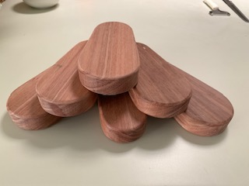 These beauties are quilters ‘clappers’ for use by quilters to get very flat seams. They are $15 ea and a good earner for our club. So far 10 have been sold!

Other Woodworking groups
If you are interested in what other Woodworker Groups are doing, Pat kindly supplies me with the links to the Knox and District Woodworkers Club (Vic) NEWSLETTER
Their LATEST KDWC edition of the "Ingrained" newsletter is now at https://www.knoxwoodies.org.au/current
You can also see previous editions at: https://www.knoxwoodies.org.au/archives
see the Club on FACEBOOK at: https://www.facebook.com/groups/knoxwoodies

Also: Woodworking NSW has an interesting site: https://www.woodworkersnsw.org.au
And if you are looking for courses: https://blog.handkrafted.com/woodwork-courses-australia/

Time for some fun:

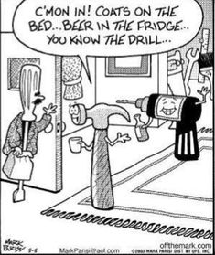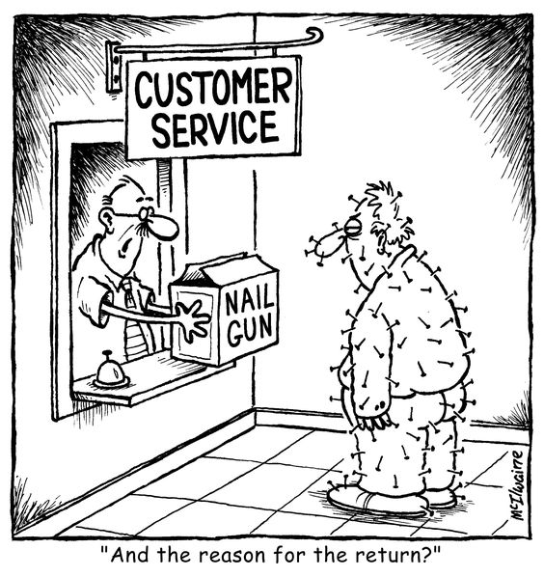

The last laugh
Q: Why are carpenters such good witnesses?


This is your lot for this newsletter.
Please send in anything you think may be useful/fun for our members.

Cheers

Virginie Schmelitschek
(Editor)

A: because they saw everything!

