ILLAWARRA WOODWORKERS GROUP INCORPORATED

www.illawarrawoodworkers.org.au



Illawarra Woodworkers Group

September 2024 NEWSLETTER

Committee 2024/25
President | Jason Hedley
Vice -president | Aron Lavings
Secretary | Pat Keefe
Treasurer & Public Officer | Julien Leveugle
Assistant Treasurer | William Perry
Coordinator (Organising) | Horacio Rodrigues
Coordinator (Workshop Maintenance) | Mark Beaver
Club sales Coordinator | Darinka Radinovic
Librarian | Darinka Radinovic
Newsletter Editor | Virginie Schmelitschek / Julien Leveugle

Hello Fellow Woodies
It is September, and I am due to get you another newsletter. It has been a sparse few months, so this will be short and sweet!

Member news:
Pat sent me his Turn Up 2024 Report:
Turn Up 2024 was held at the Lake Keepit Sport & Rec, Lake Keepit, which is 1/2 hr east of Gunnadah.
The aim is for a group of Wood Turners to Turn up and Turn. There are no formal classes or lectures. Learners are welcome and there was 1 novice turner in this year's group.
Informally, I saw a demonstration of some custom-made tools and some hands-on training in cutting beads.
There were 18 participants, some with partners. 14 turners, with scroll saw, carvers and miscellaneous wood crafters making up the numbers.
It is held in the main hall, in air conditioned luxury, and we were accommodated in bunk rooms, 2 or 3 people per room. The weekend goes from Friday to Monday morning, and it has a social atmosphere, where collaboration was the theme.
Cost of the weekend is $350, including accommodation and meals, and I did not go hungry.
Was it worth it? Yes. Will I do it again? Yes.
And if anyone is interested in going next year, I'll share my lathe.
Pat Keefe
Photos of Pat’s weekend:
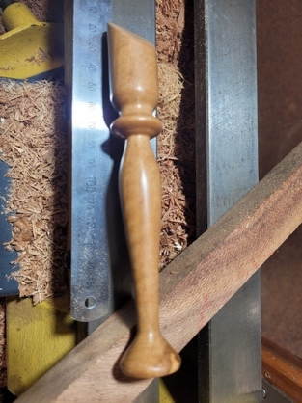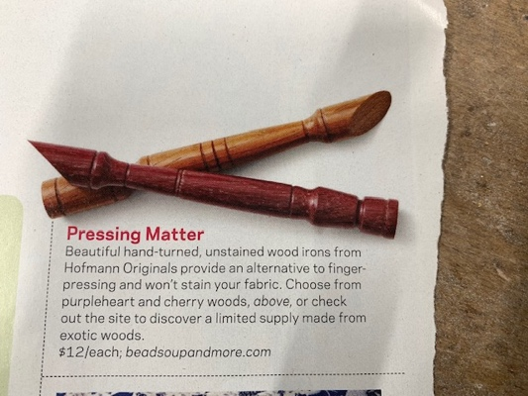
Pat turned this wood iron (for sewers and quilters) there, after the above example from a magazine.
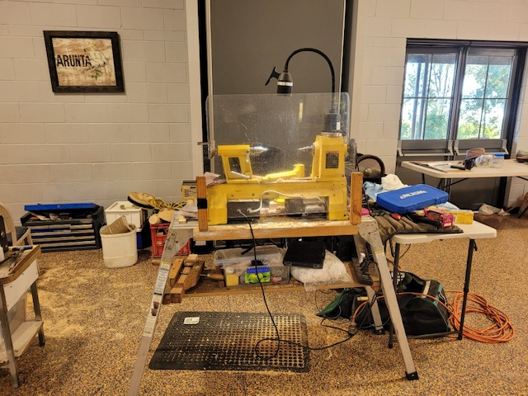
Pat’s set up at Turn Up.

Work from our members
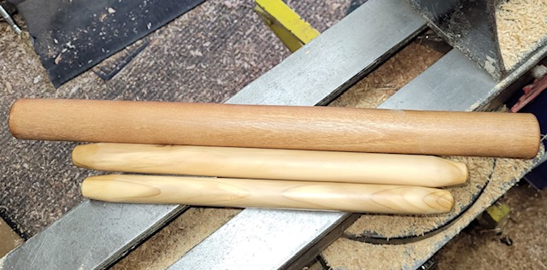 Put turned these rolling pins at home

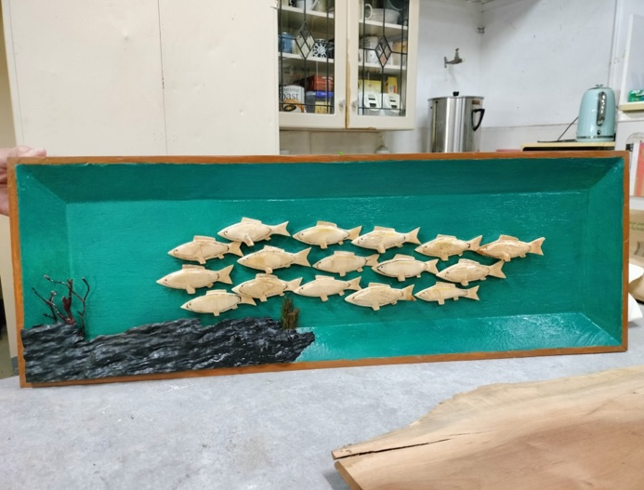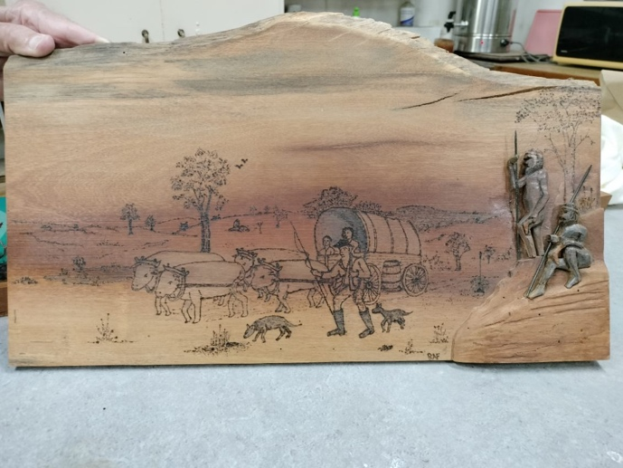
Rick’s School of fish plaque and Early Australia plaque

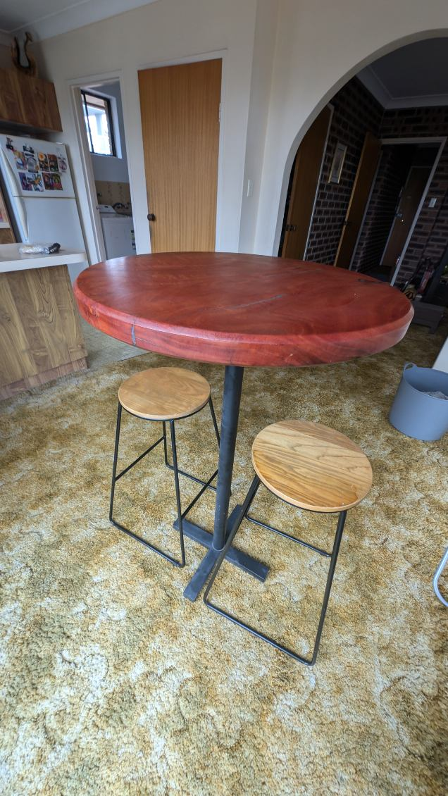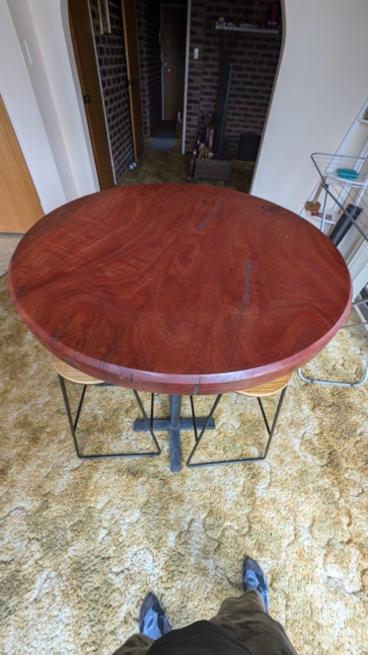
Aron made the bar table which is for sale.
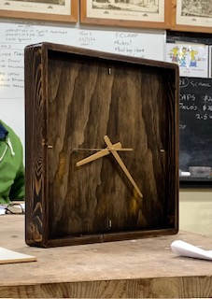 Michael made this clock.
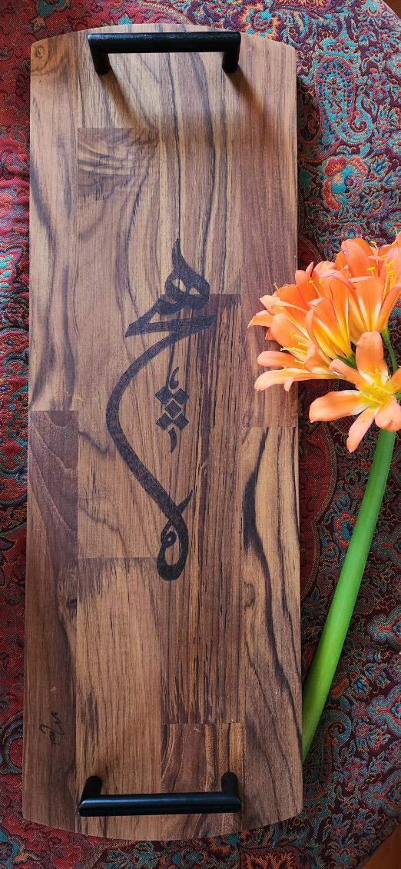
Masi, one of our newest members, made this beautiful (cheese) board and she would like to thank Pete and Horacio for their help and Rick for lending her his pyrography tool.

Stalls and Events
On August 17, 4 of our members helped out at our table at the Illawarra Family History Group’s Fair at the City Diggers (RSL) and a number of items were sold, $104 was raised and new connections were made as well as some great conversations were had.

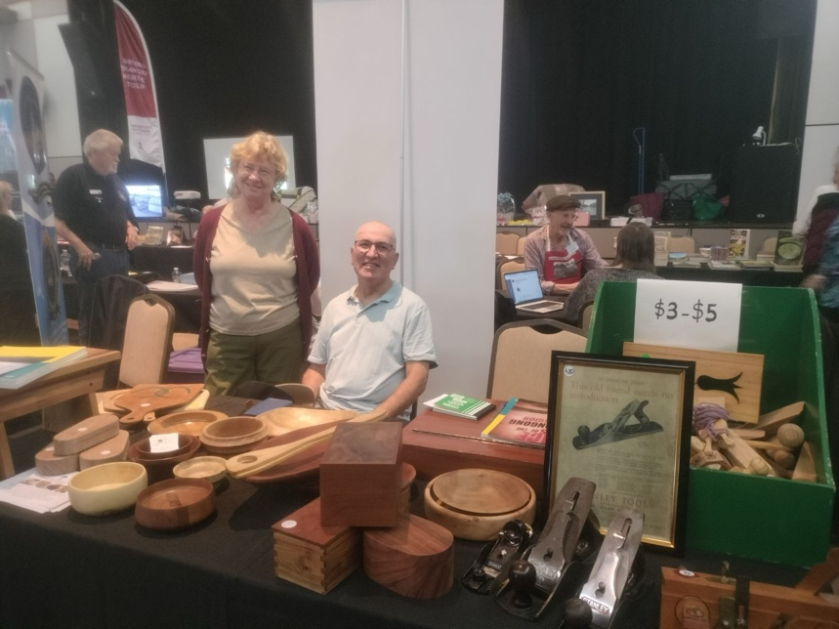
Darinka and Horacio at the stall.
Thank you to all those who volunteered in setting up, giving up their time at the stall, and again taking it all down, and bringing it back to the shed. Thanks for organising, Darinka.

Helensburgh Fair – 26 October This is a very popular, big fair and a great opportunity for our club to sell items. You can sell your own items, as well as sales for the club. We will need quite a few people to help on the day, so please volunteer for this and keep our club viable! It is close to Christmas, so keep that in mind!

Workshop Safety – a message from the Workshop Coordinator
(we cannot be reminded of this often enough!)
- IMPORTANT: Work shop safety must always be at the top of our list of priorities. Wear suitable clothes and enclosed shoes.
- Always ensure the dust collector gates are open when you use the equipment in the shed. ASK someone, if you are not sure what to do.
- Get help with the correct procedure for the sawdust bag.
- Clean up a machine and the floor after use, if significant mess. DO NOT ASSUME SOMEONE ELSE will use it after you. Do it as you go.
- Put the hose in to the vacuum cleaner the right way! If it is not sucking up the mess, empty it!
- The drum sander cannot have painted or varnished timber going through it as it will clog up the sandpaper.
- The table saw is NOT a storage space
    - NOT a work bench
    - Put NOTHING on the extension
- Use eye, ear, head and feet protection too, no loose clothes, and, keep an eye on people around you.
- Sometimes it’s just the simple things we all forget, like if you have medium/long hair, tie it up if working close to moving machinery.
- NEVER be complacent – blades bite!
(the last 3 dot points were copied from “Ingrained” the Knox newsletter)

LIBRARY
Our club library is available to all members with copies of Australian Wood Worker, Fine Woodworking, etc. available to get some ideas on your next project. Just remember to sign out and back in anything that you need.

NEWSLETTER ITEMS

Other Woodworking groups
If you are interested in what other Woodworker Groups are doing, Pat kindly supplies me with the links to the Knox and District Woodworkers Club (Vic) NEWSLETTER
The LATEST KDWC edition of the "Ingrained" newsletter is now at https://www.knoxwoodies.org.au/current

Time for some fun:

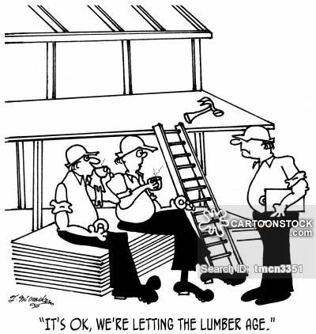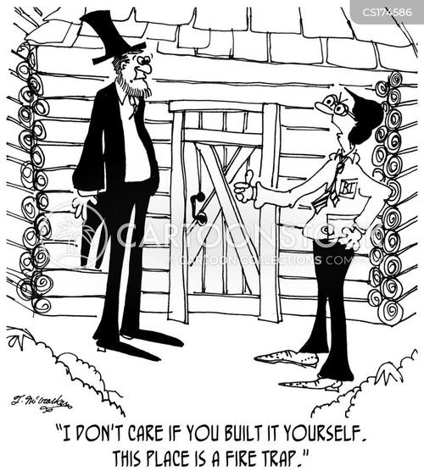

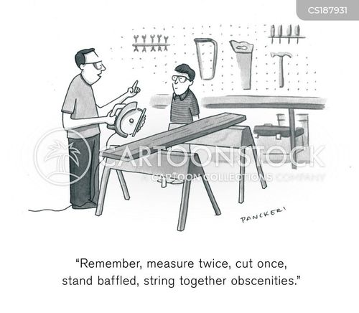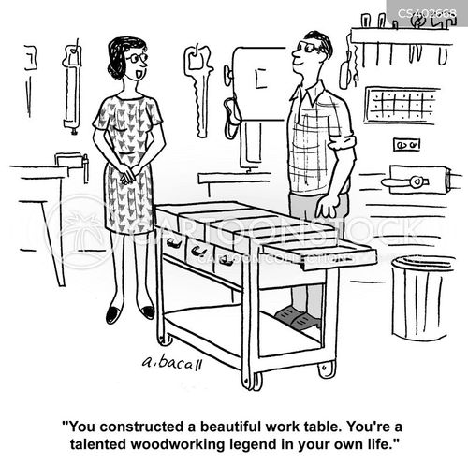

This is your lot for this newsletter. Please send in anything you think may be useful/fun for our members.

Cheers

Virginie Schmelitschek
(Editor)

