ILLAWARRA WOODWORKERS GROUP INCORPORATED

www.illawarrawoodworkers.org.au



Illawarra Woodworkers Group

2024 NEWSLETTER

Committee 2024/25
President | Jason Hedley
Vice - President | Aron Lavings
Secretary | Pat Keefe
Treasurer & Public Officer | Julien Leveugle
Assistant Treasurer | William Perry
Coordinator (Organising) | Horacio Rodrigues
Coordinator (Workshop Maintenance) | Mark Beaver
Club sales Coordinator | Darinka Radinovic
Librarian | Darinka Radinovic
Newsletter Editor | Virginie Schmelitschek / Julien Leveugle

Hello Fellow Woodies
Here is your 5th and last newsletter for 2024. Yes, you have received 5 this year, so no complaints, please! We have had a good (and safe!) year in the shed and look forward to another one next year. Thank you to all members who make it such a nice place to be.

Member news: Annual Workshop Clean Up and Christmas BBQ /Sausage Sizzle
On Saturday 14 December we will be having our Annual Workshop Clean Up and Christmas BBQ /Sausage Sizzle lunch after the work. If you are not used to cleaning up after yourself (in the shed), this is your time to observe and learn from the masters, so next year, you too, can keep your workspaces clean, after EACH use. The shed is a communal space, and we do not employ cleaners, as we cannot afford them. We do not pay weekly rent, so we all need to pitch in!
Please bring something towards the lunch to share and BYO drinks. Usual starting time for the clean up and lunch from about 11.30am.
All welcome, including partners.

Show and Tell October Meeting
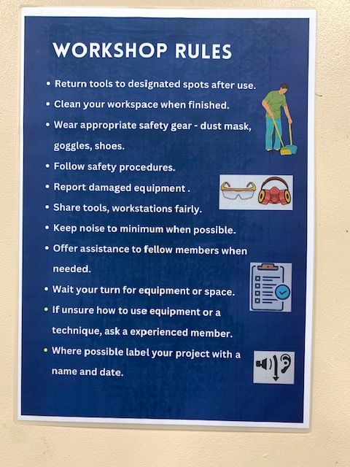
Darinka made this new very important ‘Workshop Rules’ poster for us and it hangs on the big steel cupboard near the sink. Please make yourself familiar with the rules, as they are Important to keep everyone safe and the shed clean.

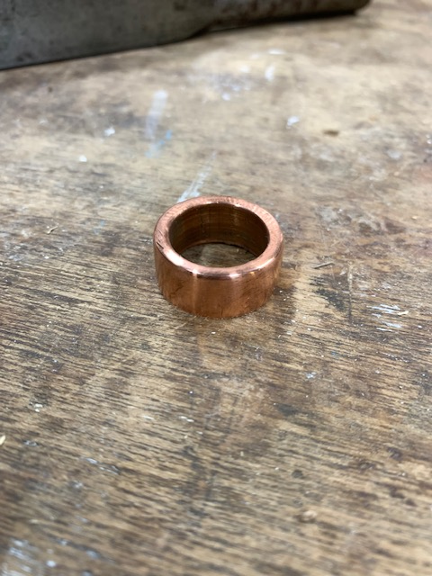 This was meant to be a ferrule, but it failed – Pat’s work.

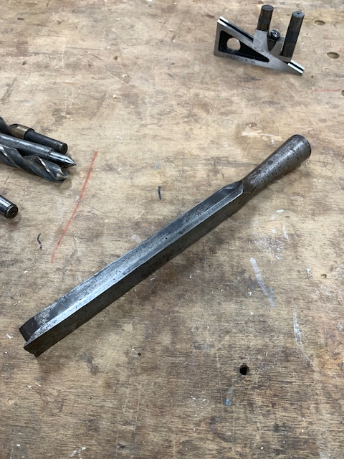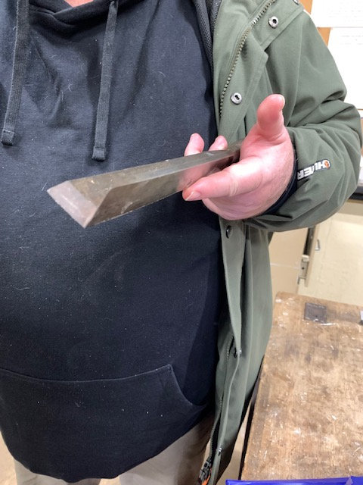
A corner chisel from the 1920’s.

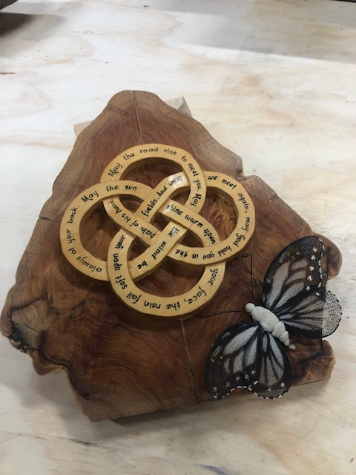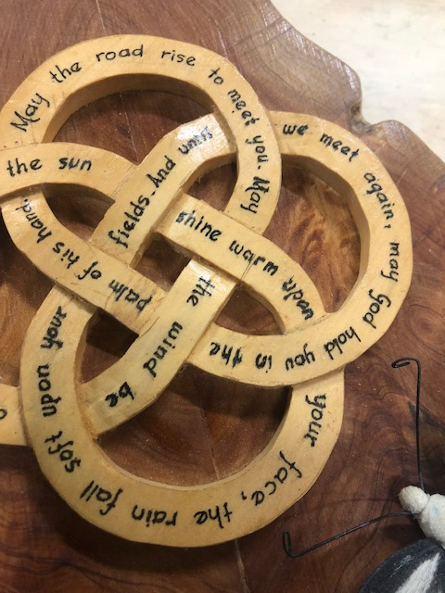

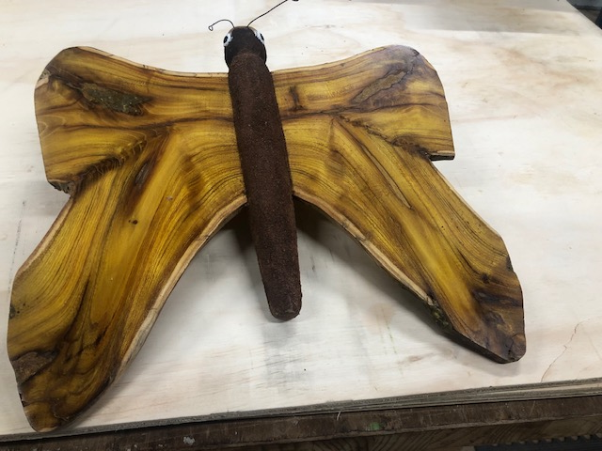 Rick’s beautiful items
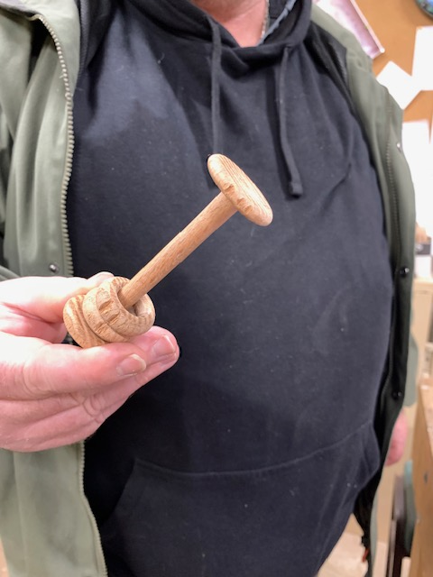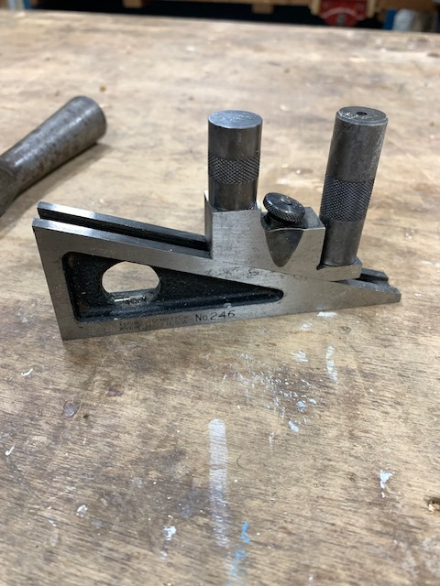
Pat made this baby rattle for his first grandchild. A plane, belonging to Pat (if I am correct)

Stalls and Events
On 26 October some of our members ran our stall at the Helensburgh Country Fair. It was a perfect day. We raised $? (and probably spent just as much again on food and items from other stalls!).
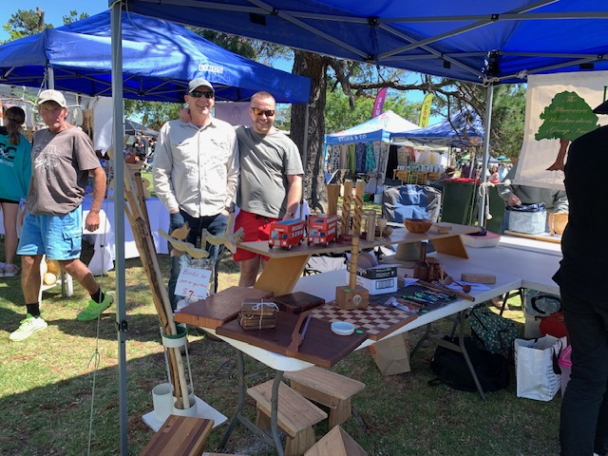 Our President, Jason and Vice-President Aron
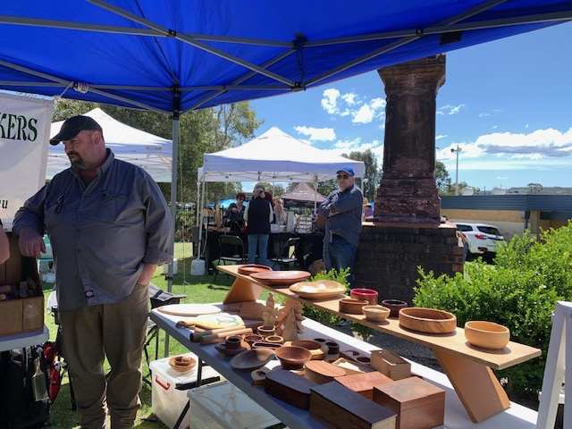 Pat and Michael manning the table

Workshop Safety – a monthly message from the Workshop Coordinator
(we cannot be reminded of this often enough!)
- IMPORTANT: Work shop safety must always be at the top of our list of priorities. Wear suitable clothes and enclosed shoes.
- Always ensure the dust collector gates are open when you use the equipment in the shed. ASK someone, if you are not sure what to do.
- Get help with the correct procedure for the sawdust bag.
- Clean up a machine and the floor after use, if significant mess. DO NOT ASSUME SOMEONE ELSE will use it after you. Do it as you go.
Put the hose in to the vacuum cleaner the right way! If it is not sucking up the mess, empty it!
- The drum sander cannot have painted or varnished timber going through it as it will clog up the sandpaper.
- The table saw is NOT a storage space
    - NOT a work bench
    - Put NOTHING on the extension
- Use eye, ear, head and feet protection too, no loose clothes, and, keep an eye on people around you.
- Sometimes it’s just the simple things we all forget, like if you have medium/long hair, tie it up if working close to moving machinery.
- NEVER be complacent – blades bite!
(the last 3 dot points were copied from “Ingrained” the Knox newsletter)

LIBRARY
Our club library is available to all members with copies of Australian Wood Worker, Fine Woodworking, etc. available to get some ideas on your next project. Just remember to sign out and back in anything that you need.

A photo and poem (created by AI) sent in by Darinka, who saw this clock in Bungendore
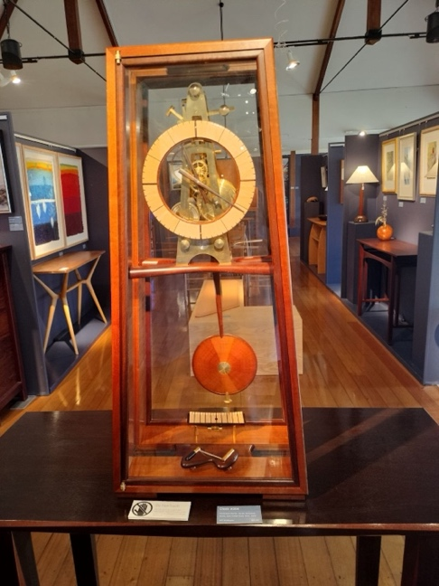
"The Woodworker and the Clockmaker"
In the woodworker’s hands, the timber yields,
Crafted from forests, drawn from fields.
Each plank he shapes, each joint aligned,
A quiet dance of hand and mind.
The clockmaker waits with tools of steel,
His world of gears, precise and real.
He studies the case, its polished grain,
A home for time, both wild and tame.
The woodworker whispers, “Here, it’s done—
The cradle for your ticking sun.”
The clockmaker nods, his fingers glide,
Setting the heart of time inside.
Together they weave both form and flow,
The wood’s warm touch, the clock’s soft glow.
One gives the frame, the other the beat—
A timeless art where craftsmen meet.
So stands their work, both still and alive,
Where memory and moments forever thrive.
The woodworker shapes; the clockmaker binds,
A harmony of hearts and minds.

Member Profile:
this month I interviewed Pete Hansen (my very first live interview for this newsletter! And I forgot to take a portrait photo, so I had to use this photo! Where was my photographer??!!)
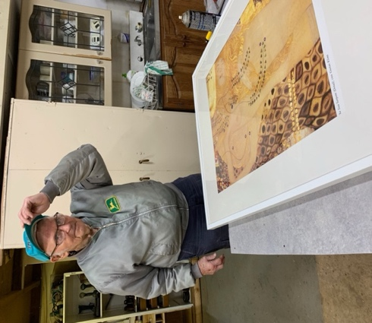
Question 1: how long have you been doing woodwork?
Since a young age, as I was in the building trade, since the 50’s. I have been a carpenter/joiner during my working life, of course first as an apprentice.
Question 2: How long have you been a member of IWG?
Since Illawarra Woodworkers Group became a group, in 1988, first meeting in homes and garages, then at University of Wollongong (Botanical Garden area). We had no money as a group. We were asked to have a stall/show at Craft Alive, to be a drawcard, as we got paid for being there as well. Bill Boddy’s son and daughter were teachers at Fairy Meadow Demonstration School and we were offered this space in 2001, after we were checked out by the Department of Education. It used to be the Boys’ toilet block! No fences, and it was broken into by louts. With a roller shutter on it, it was later used as a shed. We had to do a lot of work before it became the shed it is now: pull it down, it had asbestos in the roof. In return, we tutor a group of 6 kids during school term, on Thursday afternoons.
Question 3: What type of woodwork do you mostly prefer?
I really like wood turning, making bowls, dibbers, door wedges, etc.
Question 4: What item you made are you most proud of?
The letter “Q” I made for the Quota Club (Note: I do not have a photo of Pete’s beautiful “Q”, which he made earlier this year for the Quota Club, but you may well remember seeing it at a previous Show and Tell during a meeting).
Question 5: Do you have a shed at home?
No. I no longer have one at home.
Question 6: Did you ever have an accident while doing woodwork?
As an answer Pete showed me his left hand, where part of his ring finger is missing, due to an accident at work, when he was very young. He is warning us to be careful in the shed, keep clear of saws and other machinery. They bite!!
Question 7: Did you have any disasters at work?
In the 50’s we did work around Sandon Point, where it could get very windy. In those days Dutch people brought in their homes from overseas as pre-fab kits and then put them up. We were busy securing a building and suddenly a woman came running, calling for help, as her husband was putting up a house and the wind kept lifting the shutters so we helped securing and anchoring it, tying down the walls as the house was not braced at all.
Question 8: What do you like about being a member of IWG?
I like the companionship, having a laugh, with all the different characters.
Question 9: Do you have any words of wisdom for members or people who may like to join?
Always be careful; get help when you need it and help others; keep your hands away from the lathe: machines can bite!!
Thanks, Pete, for being my first guest for the Member’s Profile ‘column’.

Other Woodworking groups
If you are interested in what other Woodworker Groups are doing, Pat kindly supplies me with the links to the Knox and District Woodworkers Club (Vic) NEWSLETTER
Edition - Dec 2024 Vol 37.
The LATEST KDWC edition of the "Ingrained" newsletter is now at https://www.knoxwoodies.org.au/current

And I discovered this in their newsletter: there is a Council of Australian Woodwork Clubs! https://www.councilwoodworkclubs.org/events and in there I found that there is an event in March 2025 (8 & 9, 9 – 4pm) in Kiama, by the Kiama woodcraft Annual Woodcraft Expo. Info from David Bywater, Expo Coordinator, Mob: 0425 249 148. We should check it out!!

This is your lot for this newsletter. Please send in anything you think may be useful/fun for our members for 2025.

Cheers for a Happy Christmas and safe New Year.

Virginie Schmelitschek
(Editor)

