ILLAWARRA WOODWORKERS GROUP INCORPORATED

www.illawarrawoodworkers.org.au



Illawarra Woodworkers Group

2025 February NEWSLETTER

Committee 2024/25
President | Jason Hedley
Vice -president | Aron Lavings
Secretary | Pat Keefe
Treasurer & Public Officer | Julien Leveugle
Assistant Treasurer | William Perry
Coordinator (Organising) | Horacio Rodrigues
Coordinator (Workshop Maintenance) | Mark Beaver
Club sales Coordinator | Darinka Radinovic
Librarian | Darinka Radinovic
Newsletter Editor | Virginie Schmelitschek / Julien Leveugle

Hello Fellow Woodies
This is another quick newsletter. There is not much to report, as the new year is only just starting.
At the Committee Meeting on Saturday 8 February our financial situation was discussed and it was decided that our annual membership will rise to $50 per annum, as from April 2025, in order to get closer to covering our insurance and also our electricity bill.
Please pay your membership fees by April 1, into the Bendigo Bank.
BSB: 633 000 and account number 140997834.

Do you remember Rick’s request for helpers with the school kids on Thursday term? It will start this Thursday, so please be there by 1.30pm, if you think you can help. We really need some regular new helpers!

Member news:
At the meeting on Saturday 8 February, Yvonne showed us her very nice bandsaw box.

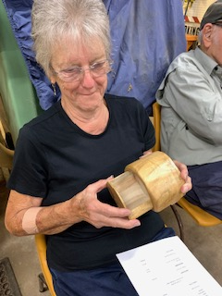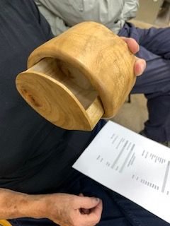

Stalls and Events
- Sydney Traditional Tools Group has their 2025 Sale Day on Sunday 23 February. $10 entry. Please find more details here: https://tttg.org.au/events/tool_sales

- Illawarra Quilters is holding another Quilt and Craft Expo for Seniors Week on 14 & 15 March. I will represent our group with a table and sell our items. Please make some items, aiming at the audience of quilters and other fabric craft, keeping in mind that Easter is not far away at the end of March, followed by Mother’s Day in early May. Bobbin holders, wool holders, bread boards, rolling pins, door wedges, etc. I will pick these up on Thursday 13 March, so please finish your items on time.

- As elections are also looming, the Committee has decided to have a Woodwork sale on the morning of the elections in the shed, so aim to get some items ready for this sale!

Workshop Safety – a monthly message from the Workshop Coordinator
(we cannot be reminded of this often enough!)
- IMPORTANT: Work shop safety must always be at the top of our list of priorities. Wear suitable clothes and enclosed shoes.
- Always ensure the dust collector gates are open when you use the equipment in the shed. ASK someone, if you are not sure what to do.
- Get help with the correct procedure for the sawdust bag.
- Clean up a machine and the floor after use, if significant mess. DO NOT ASSUME SOMEONE ELSE will use it after you. Do it as you go.
- Put the hose in to the vacuum cleaner the right way! If it is not sucking up the mess, empty it!
- The drum sander cannot have painted or varnished timber going through it as it will clog up the sandpaper.
- The table saw is NOT a storage space
    - NOT a work bench
    - Put NOTHING on the extension
- Use eye, ear, head and feet protection too, no loose clothes, and, keep an eye on people around you.
- Sometimes it’s just the simple things we all forget, like if you have medium/long hair, tie it up if working close to moving machinery.
- NEVER be complacent – blades bite!
(the last 3 dot points were copied from “Ingrained” the Knox newsletter)

LIBRARY
Our club library is available to all members with copies of Australian Wood Worker, Fine Woodworking, etc. available to get some ideas on your next project. Just remember to sign out and back in anything that you need.

Other Woodworking groups
If you are interested in what other Woodworker Groups are doing, here is the link to the Knox & District Woodworkers Club Inc. newsletter “Ingrained”:
Edition – FEB 2025 Vol 37. Edition: (04)
The LATEST KDWC edition of the "Ingrained" newsletter is now at https://drive.google.com/file/d/1efLgshAw-tH9HEC8NFb18WIEebMvJIIr/view

This is your lot for this newsletter. Please send in anything you think may be useful/fun for our members.

Cheers

Virginie Schmelitschek
(Editor)

