ILLAWARRA WOODWORKERS GROUP INCORPORATED

www.illawarrawoodworkers.org.au



Illawarra Woodworkers Group

2025 April NEWSLETTER

Committee 2024/25
President | Jason Hedley
Vice -president | Aron Lavings
Secretary | Pat Keefe
Treasurer & Public Officer | Julien Leveugle
Assistant Treasurer | William Perry
Coordinator (Organising) | Horacio Rodrigues
Coordinator (Workshop Maintenance) | Mark Beaver
Club sales Coordinator | Darinka Radinovic
Librarian | Darinka Radinovic
Newsletter Editor | Virginie Schmelitschek / Julien Leveugle

Hello Fellow Woodies
This newsletter is bursting with good news and photos of our activities, so enjoy this issue!
The 6 school children who are attending our woodwork class are thoroughly enjoying them, and so is their teacher. Check out the photo of his socks last week, as it was Crazy Sock Day for Down Syndrome Awareness Day.
We have had 2 very successful fundraising events: our (partial) table at the Illawarra Quilters Expo, which raised $326 for our Club and the BBQ we managed for the school for their Cross Country Event, which raised a massive $760!! Better than a Bunnings BBQ, as it was much easier! The school set up their marquees, chairs and BBQs for us, and cleared it all away again afterwards!
Thank you to the members who put their time in for these events, as we cannot do these without participation by members.
Please see the photos further on in this issue.

AGM
Our AGM is fast approaching, at the April Meeting, I need to remind you to pay your annual fees ($50) before this meeting, as this entitles you to attend and participate.
Please pay your $ 50 membership fee by April 1, into the Bendigo Bank.
BSB: 633 000 and account number 140997834.
There will an election and our very faithful Secretary Pat is standing down after at least 11 years in this role. Thank you, Pat, for all those years of holding this position! Our President Jason may also need to step down, due to work commitments on Saturdays.
Please consider volunteering for a position, to keep the Club legal. Without a Committee we cannot operate.
There will be a BBQ afterwards, so see you there! (We have sausages, but bring a plate to share, if you feel like it).
FEES DUE; FEES DUE; FEES DUE; FEES DUE; FEES DUE; FEES DUE; FEES DUE; FEES DUE!!

Member news:
Two members have had operations: David on a hip and Pete on a hand, and both are recovering very well. We look forward to your return to the Shed.

Stalls and Events
At the Quilters Expo, the following items were sold (just to give you an idea what sells at these kind of events):
7 Birds (all kinds); 4 bowls; a small box; a dark wood lidded box; a cutting board; a red double decker bus; 2 clappers (for quilters); coasters; 2 iPad stands; 5 finger pressers (for sewing); 2 Christmas trees; 3 tube squeezers; 4 door wedges; an oval wooden vase on a base.
We also received orders for 2 clappers as well as 2 wool winders.

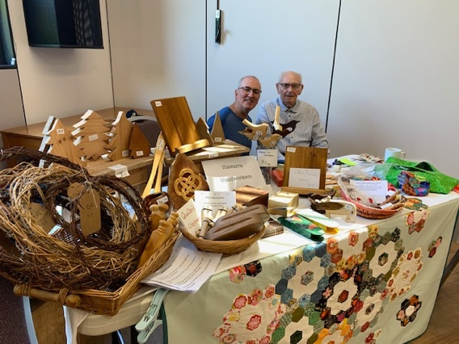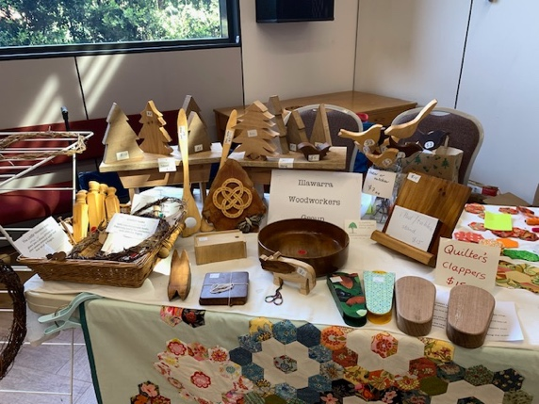
Horacia attended Day 1 and Pete dropped in. Day 2: the table was getting emptier…

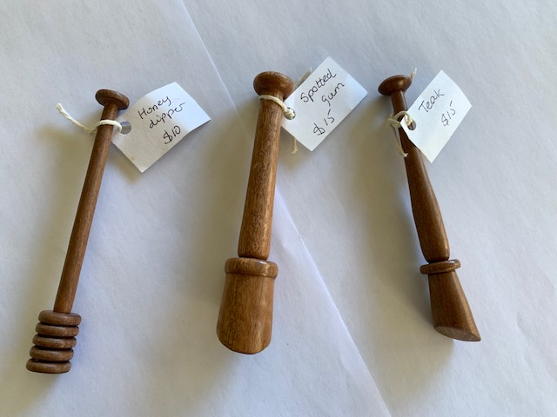
Pat made wood pressers (6) and 5 were sold.

FMDS – Woodwork classes
Here are our pupils for this term and they are all very keen!
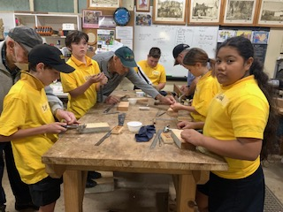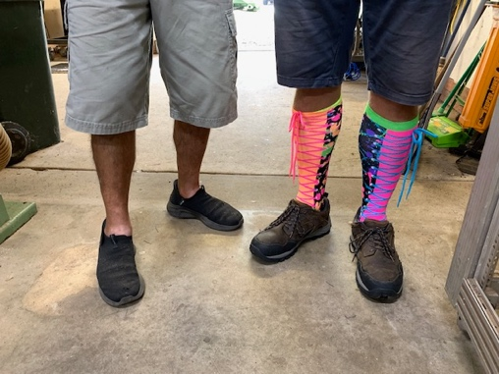
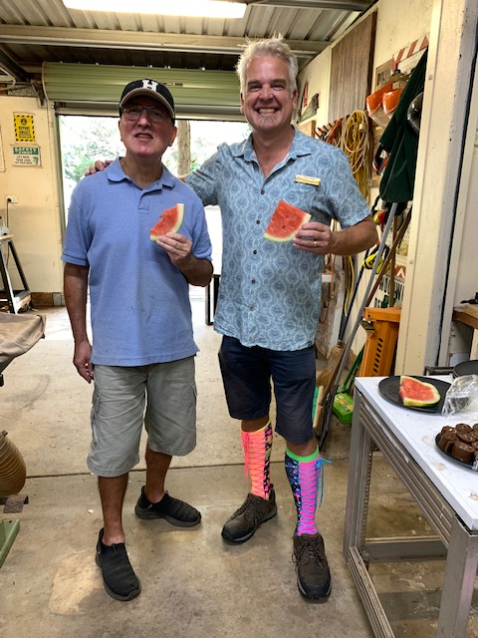
Friday 21 March – BBQ for the school

Show and Tell
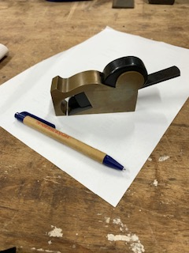 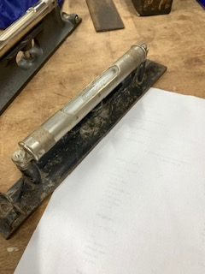 Pat also donated 5 pairs of cut resistant gloves.
Pat’s gunmetal plane. Rayborne – engineering level.

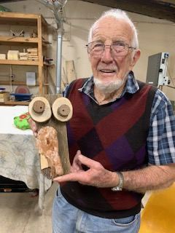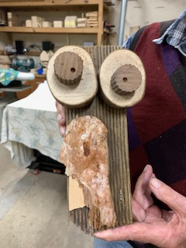
John C showed us his quirky owl

Workshop Safety – a monthly message from the Workshop Coordinator
(we cannot be reminded of this often enough!)
- IMPORTANT: Work shop safety must always be at the top of our list of priorities. Wear suitable clothes and enclosed shoes.
- Always ensure the dust collector gates are open when you use the equipment in the shed. ASK someone, if you are not sure what to do.
- Get help with the correct procedure for the sawdust bag.
- Clean up a machine and the floor after use, if significant mess. DO NOT ASSUME SOMEONE ELSE will use it after you. Do it as you go.
- Put the hose in to the vacuum cleaner the right way! If it is not sucking up the mess, empty it!
- The drum sander cannot have painted or varnished timber going through it as it will clog up the sandpaper.
- The table saw is NOT a storage space
    - NOT a work bench
    - Put NOTHING on the extension
- Use eye, ear, head and feet protection too, no loose clothes, and, keep an eye on people around you.
- Sometimes it’s just the simple things we all forget, like if you have medium/long hair, tie it up if working close to moving machinery.
- NEVER be complacent – blades bite!
(the last 3 dot points were copied from “Ingrained” the Knox newsletter)

LIBRARY
Our club library is available to all members with copies of Australian Wood Worker, Fine Woodworking, etc. available to get some ideas on your next project. Just remember to sign out and back in anything that you need.

Member Profile:
this month I interviewed Rick Funnell

Question 1: how long have you been doing woodwork?
I have always been interested, and I worked with builders. I also built my own home addition.
Question 2: How long have you been a member of IWG?
Since its inception
Question 3: What type of woodwork do you mostly prefer?
Carving
Question 4: What item you made are you most proud of?
I made a motor bike with rockers (like a rocking horse, but a bike). I have still got it and it will go to my 1st great grandchild.
Question 5: Do you have a shed at home?
Yep – and it is neat and tidy.
Question 6: Did you ever have an accident while doing woodwork?
No
Question 7: Did you have any disasters at work/ home?
Plenty of those! Timber flying of the lathe and it missed me – just. Scared the hell out of me!
Question 8: What do you like about being a member of IWG?
Being with other people who are interested in the same things

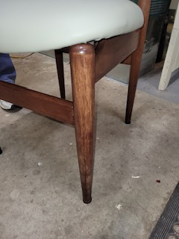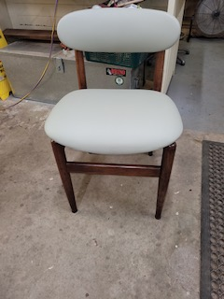
Chair leg repaired in the shed.

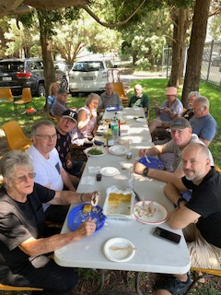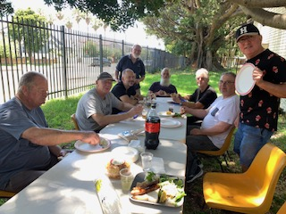
Two belated photos of our Christmas lunch – after the massive clean-up.

Other Woodworking groups
If you are interested in what other Woodworker Groups are doing, here is the link to the Knox and District Woodworkers Club (Vic) NEWSLETTER
The LATEST KDWC edition MAR 2025 Volume 37 Number 05 of the "Ingrained" newsletter is now at https://www.knoxwoodies.org.au/current

Time for some fun:
- My brother slipped with the draw knife once while shaping a chair leg, he's now my half brother!
- Once you start working the piece with an adze, you have to keep going, or it will only be half-adzed.
- Why do woodworkers dislike drilling holes? Because it's the boring part.

This is your lot for this newsletter. Please send in anything you think may be useful/fun for our members.

Cheers

Virginie Schmelitschek
(Editor)

