ILLAWARRA WOODWORKERS GROUP INCORPORATED

www.illawarrawoodworkers.org.au



Illawarra Woodworkers Group

October 2025 NEWSLETTER

Committee 2025/26
President | David Lipscombe
Vice -president | Horacio Rodrigues
Secretary | Michael Cappelin
Treasurer | Darinka Radinovic
Assistant Treasurer | Julien Leveugle
Public Officer | William Perry
Coordinator (Organising) | Rick Funnell
Coordinator (Maintenance) | Pat Keefe
Coordinator (Workshop) | Jason Hedley
Club sales Coordinator | Darinka Radinovic
Librarian | Darinka Radinovic
Newsletter Editor | Virginie Schmelitschek / Julien Leveugle
Website Coordinator | Julien Leveugle

Hello Fellow Woodies
As you can see by the Committee names above, we have a new President, David Lipscomb. President Jason Hedley resigned in early August, citing irreconcilable differences with some club executive members.
At the Committee meeting in September, David Lipscombe accepted a nomination to be Interim President until next year’s AGM.
Thank you, David, for stepping in this role, which you have held for many years previously.
Also discussed was that a policy will be worked out for the supply of consumables and also the Constitution will get an overhaul.

SHOW AND TELL:

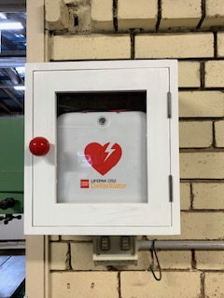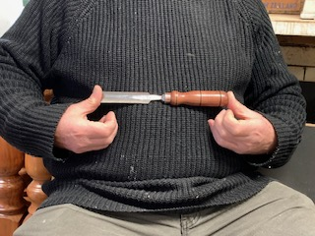
Bill made this cabinet to keep our very new, I have no idea who the person in this photo is, with the shiny
(donated by Bendigo Bank) defibrillator dust-free. chisel.

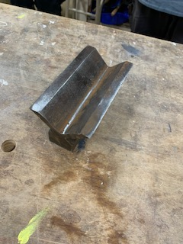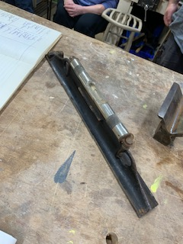
Pat showed us this V-block and machinist level which he bought.

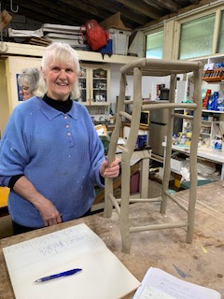
Our newest member Jenny made this beautiful driftwood stool and is justifiably very proud.

At the request of the Vice-Principal of FMDS, Danny, a collection box for “bees” was made by a few members. Danny was very pleasantly surprised to see her design finished, even having wheels for easy moving.
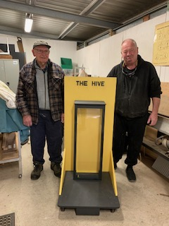
Here are just a few of the members who worked on it during many hours.
David also made a cross for a grave, which was a request for a job. For privacy reasons it was not photographed.

Workshop Safety
a monthly message from the Workshop Coordinator
(we cannot be reminded of this often enough!)

- IMPORTANT: Work shop safety must always be at the top of our list of priorities. Wear suitable clothes and enclosed shoes.
- Always ensure the dust collector gates are open when you use the equipment in the shed. ASK someone, if you are not sure what to do.
- Use the push sticks to keep your fingers away from blades.
- Know what thickness you can cut on the machine you are using.
- Get help with the correct procedure for the sawdust bag.
- Clean up a machine and the floor after use, if significant mess. DO NOT ASSUME SOMEONE ELSE will use it after you. Do it as you go.
- Put the hose in to the vacuum cleaner the right way! If it is not sucking up the mess, empty it!
- The drum sander cannot have painted or varnished timber going through it as it will clog up the sandpaper.
- The table saw is
    - NOT a work bench
    - NOT a storage space
    - Put NOTHING on the extension
    - The safety guard must be mounted AT ALL TIMES
- Use eye, ear, head and feet protection too, no loose clothes, and, keep an eye on people around you.
- Sometimes it’s just the simple things we all forget, like if you have medium/long hair, tie it up if working close to moving machinery.
- NEVER be complacent – blades bite!
(the last 3 dot points were copied from “Ingrained” the Knox newsletter)

LIBRARY
Our club library is available to all members with copies of Australian Wood Worker, Fine Woodworking, etc. available to get some ideas on your next project. Just remember to sign out and back in anything that you need.

Stalls and Events

12 October 2025 Dunstone Design Workshop Open Day and Handtool Event
From 10:00 am - 1:00 pm 3/5 Aurora Place, Queanbeyan
This year’s Dunstone Design Workshop Open Day is going to include a pop-up handtool event. American hand tool expert and educator Curtis Turner will be visiting our workshop and demonstrating with Lie-Nielsen tools. Anthony Powell from Lie-Nielsen Toolworks Australia will be in attendance with a healthy stock of tools for sale. Brisbane maker Damion Fauser will be showing a selection of his favourite hand tools and techniques, including his pink ivory HNT Gordon moving fillister plane. Terry Gordon will be sending down a selection of HNT Gordon planes and vices for sale. Master Carver Hape Kiddle will be discussing and demonstrating the range of knives, gouges, files, rasps and other hand tools that he uses every day in his practice. He will also have a selection of his carvings on exhibition in the Dunstone Design gallery. Dunstone Design will also demonstrate how we make our famous resawn veneers on our band resaw “Goliath”.
See: https://www.dunstonedesign.com.au/event/2025-workshop-open-day-and-handtool-event/ for all details


And more events: https://www.woodfest.com.au

25th Oct 2025 Helensburgh LIONS Club Country Fair (Saturday)
This is a very popular, big fair and a great opportunity for our club to sell items. You can sell your own items, as well as sales for the club. We will need quite a few people to help on the day, so please volunteer for this and keep our club viable! It is close to Christmas, so keep that in mind!

This Year's Proposed Entertainment schedule
- 10:00 Opening & Helensburgh Public School Choir

10:30 Zumba Dance Demonstration

11:00 Chimera - Local Music

11:40 ADA Dance Group

2:15 George Mann (USA)

01:15 Live music with Aubrey Purton Duo

02:00 Irish Dancers

02:30 Sam Vukelic - Local Solo Music

03:00 Official Close

School Classes:
Last term’s school kids had a great time attending the weekly classes. Sadly some had other activities clashing with the woodwork class, which is regrettable.
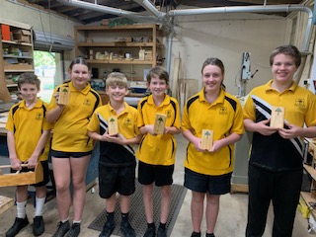
A few weeks ago this group proudly received their trophies, after learning to hammer, measure, fill holes with putty, and sand to make a toolbox, a birdhouse, a pencil case and plane. These classes are made possible with great dedication, preparation (of the 6 kits for each item they make) and attendance of just a few our club members. The kids thoroughly enjoy their classes and some show great promise.
Please consider attending, as this needs to continue and some of our members would like to step down. We cannot let this class fold, as it is our guarantee to a rent-free shed.

Woodworking groups
If you are interested in what other Woodworker Groups are doing, the Knox and District Woodworkers Club (Vic) NEWSLETTER is an interesting read:
OCT 2025 Volume 37 Number 12 ­
The LATEST KDWC edition of the "Ingrained" newsletter is now at
https://drive.google.com/file/d/1TUi7Mmynyv4io8DcmyTRESMpX86Dgpx_/view


This is an Open Garden event in our area. Yours truly’s garden is open to visitors on Sunday 23 November

MEMBER PROFILE: Bill Perry

Question 1: how long have you been doing woodwork?
I started as a teenager about 50 years ago doing simple projects and mostly teaching myself from there on. I started my formal training in fine woodcraft with part time classes at Sturt Craft College in Mittagong in 1995 and continued there for many years. I also did a few of years with the original Illawarra Woodwork School from 2010 to learn how to make solid timber dining chairs.
Question 2: How long have you been a member of IWG?
I have been a member since May 1998, joined the committee in 1999 and have held the positions of newsletter editor (2 years), treasurer (24 years) and public officer (16 years & current). I also started the woodies website in 2009 and managed it until a couple of years ago.
Question 3: What type of woodwork do you mostly prefer?
Furniture, small boxes and anything that requires lots of problem solving to complete.
Question 4: What item you made are you most proud of?
A set of 6 Tasmanian blackwood solid timber dining chairs with carved/shaped slab seats that I designed and made.
Question 5: Do you have a shed at home?
I have taken over the double garage as my workshop.
Question 6: Did you ever have an accident while doing woodwork?
Nothing significant where I have hurt myself, and I hope that continues. However, some timber, jigs and clamps have been sacrificed in my learning journey.
Question 7: Did you have any disasters at work or the shed?
Only minor issues that have been changed into a design change for the item I am making.
Question 8: What do you like about being a member of IWG?
I enjoy the comradery with the other members and the opportunity to help with other members journeys in woodwork.

REMINDER:
The school has asked us to sign in (and out) on weekdays for our own safety. A sheet with a QR code is now attached to the steel cabinet left of the sink. This is IMPORANT, as the school needs to do a head count of everyone on their premises, in case of an emergency. Please comply.

Time for some fun:
8 Things You Don’t Want to Hear During Surgery!
1. Oops!
2. Has anyone seen my watch?
3. That was some party last night. I can’t remember when I’ve been that drunk.
4. Damn! Page 47 of the manual is missing!
5. Well, this book doesn’t say that... What edition is your manual?
6. Ok, now take a picture from this angle. This is truly a freak of nature.
7. Damn, there go the lights again...
8. Everybody stand back! I lost my contact lens!



This is your lot for this newsletter.

Please send in anything you think may be useful/fun for our members.

Cheers

Virginie Schmelitschek
(Editor)

