www.illawarrawoodworkers.org.au



Illawarra Woodworkers Group Inc.

January 2026 NEWSLETTER

Committee 2025/26
President | David Lipscombe
Vice -president | Horacio Rodrigues
Secretary | Michael Cappelin
Treasurer | Darinka Radinovic
Assistant Treasurer | Julien Leveugle
Public Officer | William Perry
Coordinator (Organising) | Rick Funnell
Coordinator (Maintenance) | Pat Keefe
Coordinator (Workshop) | Jason Hedley
Club sales Coordinator | Darinka Radinovic
Librarian | Darinka Radinovic
Newsletter Editor | Virginie Schmelitschek / Julien Leveugle
Website Coordinator | Julien Leveugle

Hello Fellow Woodies
A new year and my attempt sat a new style newsletter for our group was frustrating and time consuming, so back to the same format.
However, it is imperative that I receive items for the newsletter, to keep us all up to date with all things IWG. So if you have an idea, an article, knowledge of an event, a remark, a photo, ANYTHING AT ALL WOOD RELATED, send me an email: virginiesch@icloud.com.
Just leaving it to me, it could become very stale!
(Especially as I am not there every time the Shed opens!)
As it is now also open on Tuesdays, it would be good to receive more items for YOUR newsletter.

NEXT MEETING : (first one for this year) will be on 14 February. Please come and attend at 8.30am (Committee Members) and 9am (all other members).
URGENT CLUB SALE items needed for 13 & 14 March – Quilters Expo. Please make saleable items appropriate for this demographic. See suggestions further in this newsletter.

So sit back, and enjoy the little bit that I have for this newsletter.

Yours in wood

Virginie Schmelitschek
Editor

Member Show & Tell:
A 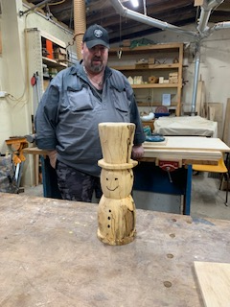 B 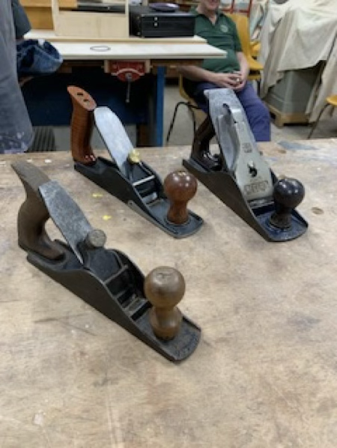
A In October, Pat showed us his snowman whose wood was hard and soft as the timber had gone rotten over the years. While it was hard to work with, it is still a very nice snowman!
B He also showed us his new English planes at the November meeting. L to R they are: 1) a modern version of a scrub plane. 2) the older version and 3) Record plane (STAY SET). This can be sharpened without upsetting the setting – his words).
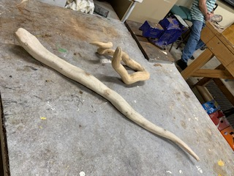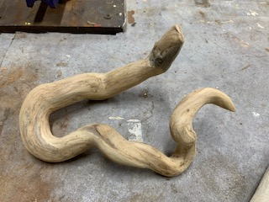
In November Rick showed us the great snakes he had carved out of branches. They are very life-like!

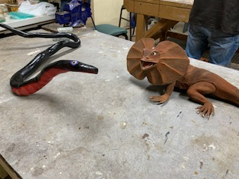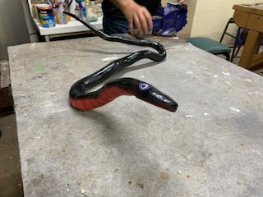
Rick had some garden ornaments to deter Indian Mynahs and which had faded over the years.
My artist daughter repainted them for fun, to make them look more ferocious! Only time (and Rick) will tell us whether they work, with the lick of paint.

Member Profile: Pat Keefe

Question 1: how long have you been doing woodwork? 20+
Question 2: How long have you been a member of IWG? 15?
Question 3: What type of woodwork do you mostly prefer? Turning
Question 4: What item you made are you most proud of?
The Hobbit Door - a turner platter/wall hanging I did a few years ago, between 800 & 900 diameter.
Question 5: Do you have a shed at home? Yep
Question 6: Did you ever have an accident while doing woodwork? Yep
Question 7: Did you have any disasters at work or the shed? Yep ++
Question 8: What do you like about being a member of IWG? Sense of community.
I received Pat’s photo of his “Hobbit door”!!

The Hobbit Door - a turner platter/wall hanging he did a few years ago, between 800 & 900 mm in diameter.
finished on a 900 wide bench
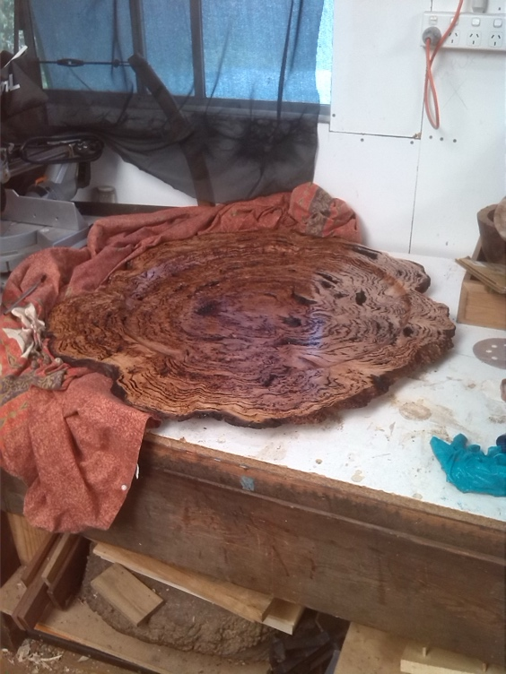

with a 1meter rule

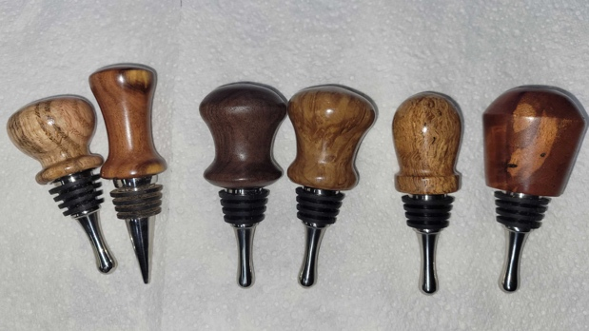
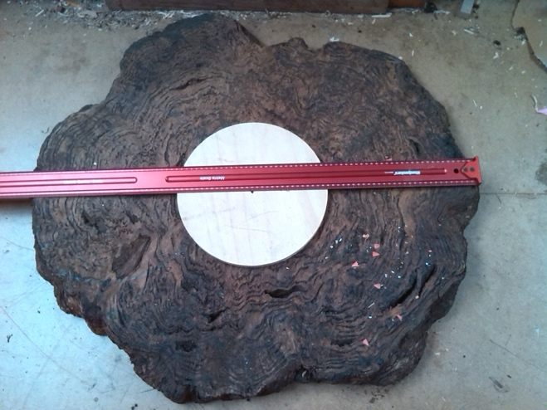
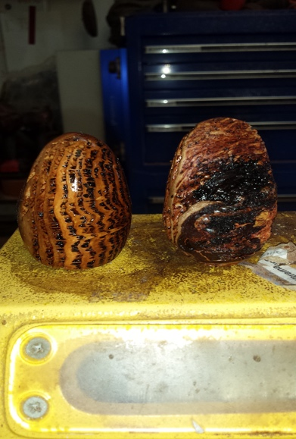 Some more of Pat’s turnings

URGENT - Stalls and Events - URGENT
URGENT CLUB SALES ITEMS REQUIRED for the Quilters Expo on 13 & 14 March.
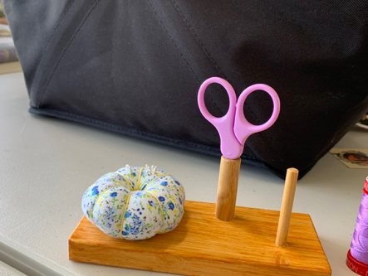
This our opportunity to raise some cash – last year we raised $320 at this event, which is also advertised as a Seniors Week event and as such attracts a lot of visitors (over 500 last year!). So get turning, shaving, hammering, cutting and sanding and making sawdust for the Club!
Remember that Mother’s Day will not be far away!
Some items that are particularly needed:

Quilters Ruler Stand: I have included a few photos here below with the measurements. These can sell for at least $15 and more in the shops and look simple to make.

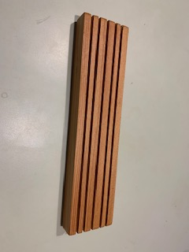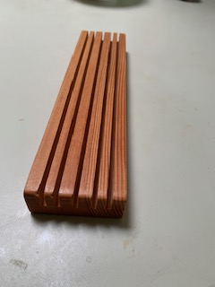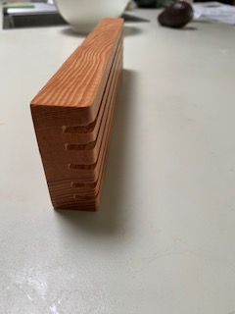

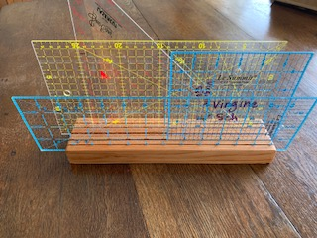
Sizes for the ruler block: 5 slots. H 30 mm, L 300 mm, W 70 mm. Slot depth: 15 mm. 10mm from sides.
Below is the stand in use – to give you an idea.

Another item I need to sell: small turned wooden bowls of < than 100 mm in diameter to sell for pincushions.
I will be demonstrating how to make pincushions during the 2 Expo days, so a good opportunity to sell small bowls.
So please make me about 10. Also door wedges and dibbers.

FMDS Kids class – Term 4 2025
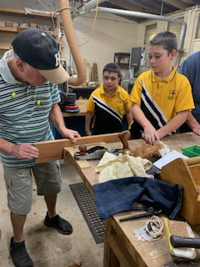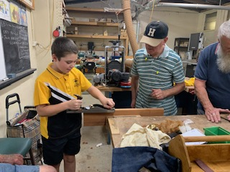
During the last term of 2025 the school group had a ball. These kids were very very keen, especially this small boy in the middle of the photo on the left. He would keep working, when it was time to eat lamingtons and watermelon!! He was only in Year 5 and showing great promise. They all loved their lesson in planing with Horacio, creating beautiful curls!

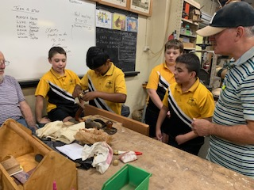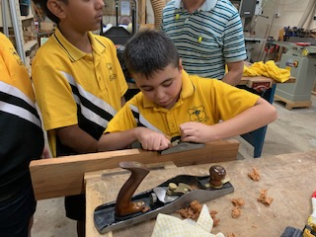

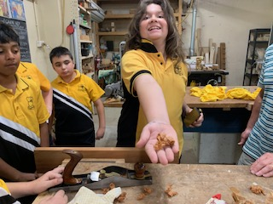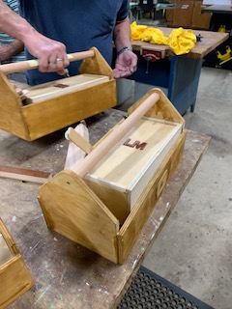

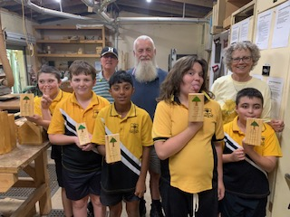
They were stoked with their “certificate’, made by Rick.
On Tuesday 2 December, the Horicultural Group of the school received their fixed outdoor sink – new larger castors, more appropriate for the terrain - as our members David, Horatio, Pete and Rick were there to hand it over. 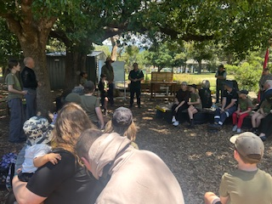 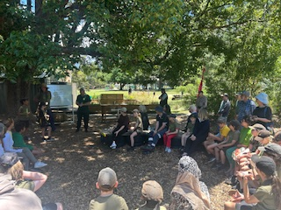 Photos: courtesy of David Lipscombe.
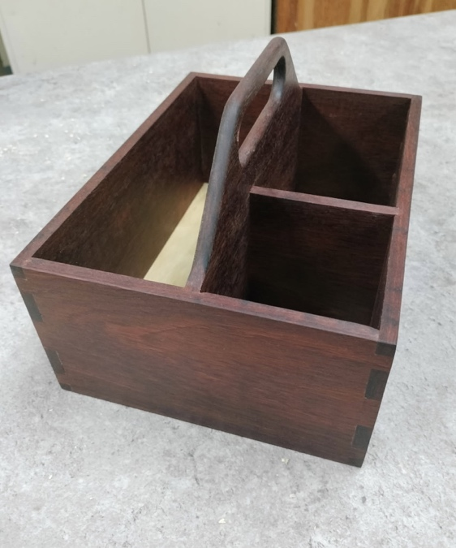
Bill Perry made this caddy from, jarrah timber kitchen doors. He finished with kitchen oil.

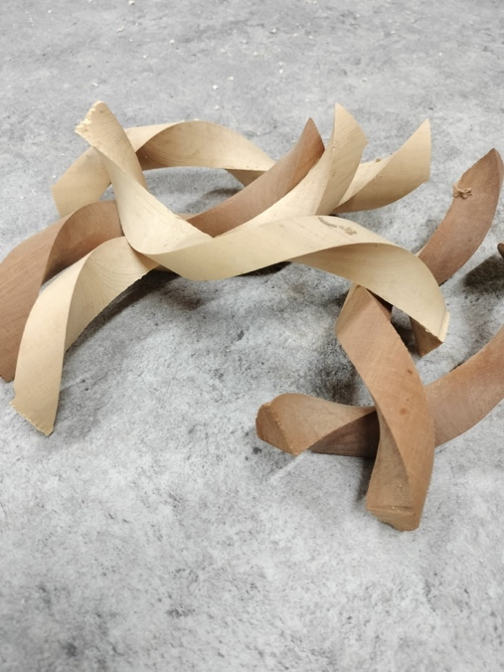 DAVID’S CHALLENGE!!

All members were given 2 spiral-cut timber pieces by our President David and challenged to transform it into something remarkable.
Carve, sculpt, or shape into an object that shows off your creativity, skill and imagination.
The only rule: let the natural wood twist of the wood inspire you!

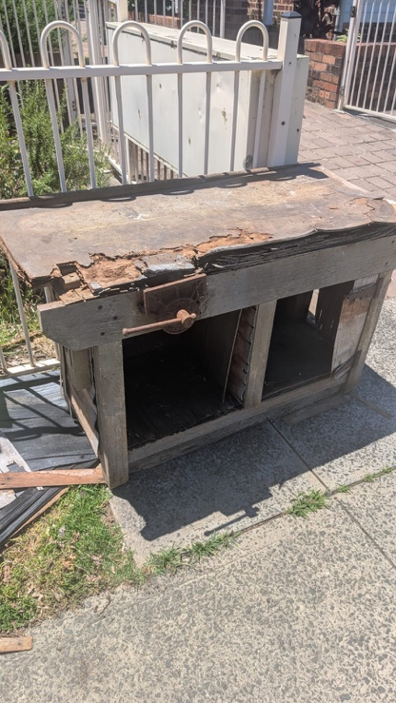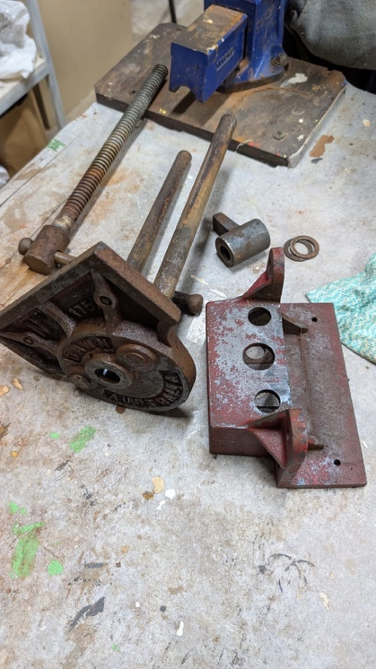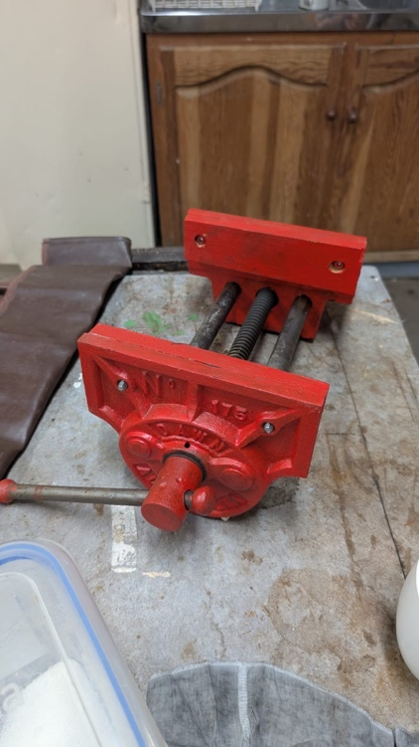

Before and after photos of the vice Aron found and restored for the club. He has since left for Queensland. Thank you, Aron and all the best in sunny and wet Queensland.

Workshop Safety– a monthly message from the Workshop Coordinator
(we cannot be reminded of this often enough!)
- IMPORTANT: Work shop safety must always be at the top of our list of priorities. Wear suitable clothes and enclosed shoes.
- Always ensure the dust collector gates are open when you use the equipment in the shed. ASK someone, if you are not sure what to do.
- Get help with the correct procedure for the sawdust bag.
- Clean up a machine and the floor after use, if significant mess. DO NOT ASSUME SOMEONE ELSE will use it after you. Do it as you go.
- Put the hose in to the vacuum cleaner the right way! If it is not sucking up the mess, empty it!
- The drum sander cannot have painted or varnished timber going through it as it will clog up the sandpaper.
- The table saw is NOT a storage space
    - NOT a work bench
    - Put NOTHING on the extension
- Use eye, ear, head and feet protection too, no loose clothes, and, keep an eye on people around you.
- Sometimes it’s just the simple things we all forget, like if you have medium/long hair, tie it up if working close to moving machinery.
- NEVER be complacent – blades bite!
(the last 3 dot points were copied from “Ingrained” the Knox newsletter)

LIBRARY
Our club library is available to all members with copies of Australian Wood Worker, Fine Woodworking, etc. available to get some ideas on your next project. Just remember to sign out and back in anything that you need

Other Woodworking groups
If you are interested in what other Woodworker Groups are doing, here the Knox and District Woodworkers Club (Vic) NEWSLETTER
The LATEST KDWC edition of the "Ingrained" newsletter is now at https://www.knoxwoodies.org.au/current

Members Welfare
Hey Woodies: Give a couple of fellow members a ring, to check up on them if you haven’t seen them about normally! They would really appreciate a chat. Or consider a
Shed session at the normal 'cuppa' time, online and keep in touch with one
another. Always be prepared to ask RUOK?

This is your lot for this newsletter. Please send in anything you think may be useful/fun for our members and see you in the Shed!

Cheers

Virginie Schmelitschek
(Editor)

