class05

julien

20190124

#Class 05 R graphics intro  
  
#My frirst boxplot  
  
#?rnorm or help(rnorm) to learn about normal distribution  
x <- rnorm(1000,0)  
boxplot(x)

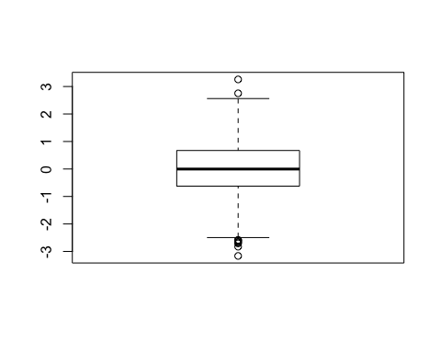

# summary(x)  
# hist(x)  
# ?boxplot  
# boxplot(x, horizontal = TRUE)  
# ?read.table  
  
weight <- read.table("bimm143_05_rstats/weight_chart.txt", header=TRUE)  
plot(weight, type="o", pch=15, cex=1.5, lwd=2, ylim=c(2,10), xlab="Age (months)", ylab="Weight (kg)", main="Weight Chart from Text File")

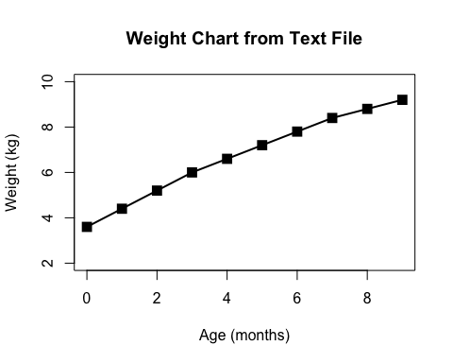

features <- read.table("bimm143_05_rstats/feature_counts.txt", sep = "\t", header = TRUE)  
features

## Feature Count  
## 1 Messenger RNA 79049  
## 2 Coding Sequences 50770  
## 3 Genes 32029  
## 4 Transfer RNAs 26248  
## 5 CpG islands 13840  
## 6 Pseudogenes 5195  
## 7 Micro-RNAs 1638  
## 8 Small nucleolar RNAs 1602  
## 9 Small nuclear RNAs 1431  
## 10 Miscellaneous RNA 491  
## 11 Immunoglobulin Segments 474  
## 12 Ribosomal RNAs 341

barplot(features$Count, names.arg = features$Feature, xlab = "Feature", horiz = TRUE, las=1, mar=c(1,1,1,1), main = "Feature Counts from Text File")

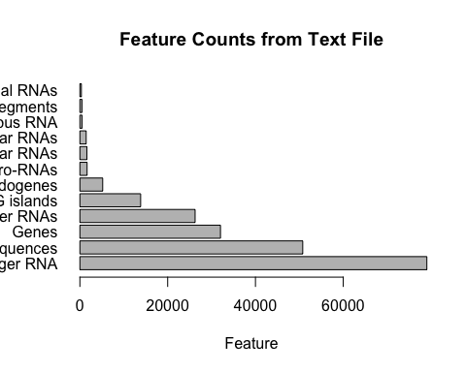

#margin parameters need to be done by guess and check  
par(mar=c(3.1, 12.1, 4.1, 2.1))  
barplot(features$Count, names.arg = features$Feature, xlab = "Feature", horiz = TRUE, las=1, main = "Feature Counts from Text File", xlim = c(0,80000))

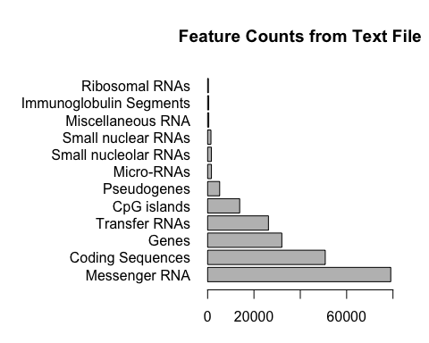

#2C: Histograms  
hist_values <- c(rnorm(1000), rnorm(1000)+4)  
par(mar=c(5,4,4,2)+0.1)  
hist(hist_values, breaks=50, col = rainbow(50))

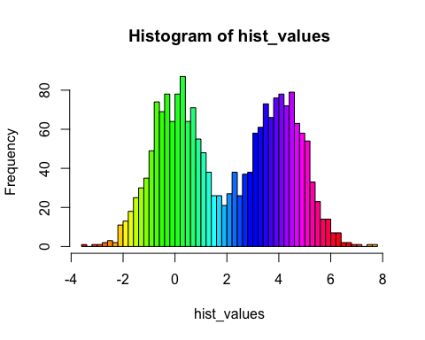

#3B Coloring by Value  
updown <- read.table("bimm143_05_rstats/up_down_expression.txt", sep = "\t", header = TRUE)  
# updown  
table(updown$State)

##   
## down unchanging up   
## 72 4997 127

par(mar=c(5,4,4,2)+0.1)  
plot(updown$Condition1, updown$Condition2, col = updown$State, xlab = "Expression Condition 1", ylab = "Expression Condition 2", main = "R day eRRYday")

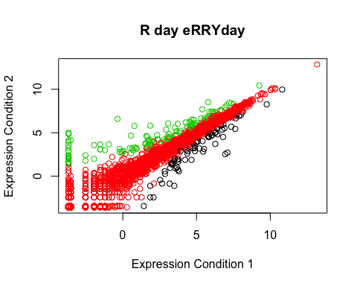

levels(updown$State)

## [1] "down" "unchanging" "up"

palette(c("blue", "gray", "red"))