

Monitoring Procedure

Digiplug UMGI Supply Chain Program
STATUS INFORMATION

Security classification: | Confidential |  | State: | Final
Current version number: | 1.0 | Date of first issue: |  | 26/02/2008
Prepared by: | Samuel Leucart, Moussa Bagayoko |  | Date: | 07/04/2008
Verified by: | Moulay Younes Alaoui-Rizq |  | Date: | 15/04/2008
Approved by: | Julien Andrieux |  | Date: | 17/04/2008
Copyright notice
This document may not be reproduced (even partially) or communicated to third parties without the written authorization of the company’s General Management.
DISTRIBUTION LIST
Name | Address | I/A/V
Julien Simon | julien.simon@digiplug.com | V/A
Julien Andrieux | julien.andrieux@digiplug.com | V/A
Digiplug Managers |  | I/A
IT Operations team |  | A
Nicolas Tavier | nicolas.tavier@accenture.com | I
Morgan Le Du | morgan.ledu@accenture.com | I
Moussa Bagayoko | moussa.bagayoko@accenture.com | I
Moulay Younes Alaoui Rizq | moulay.y.alaoui-rizq@accenture.com | I
Nourou Dine Issaka | nourou.dine.issaka@accenture.com | I
Nicolas Macaire | nicolas.macaire@accenture.com | I
(I = for information, A = for action, V=for validation)
DOCUMENT CHANGE RECORD
Version | Date | Description | Affected sections
2.0D | 26/02/2008 | Obsoletes first release 1.0 (called « Monitoring/Propositions diverses ») | All
2.0 | 03/03/2008 | Proofreading | All
0.1 | 07/04/2008 | Re start of the document | All
1.0 | 23/04/2008 | Validated version | All
IT Contact PEople
Function
IT Lead | Julien Andrieux
IT Consultant | Moulay Younes Alaoui Rizq
IT Consultant | Nourou Dine Issaka

Table of content

1 Purpose 5
2 Monitoring solution and technology 6
2.1 Solution overview 6
2.2 Polling technology: Active and passive checking 7
2.3 Monitored Indicators 7
2.4 High-Availability 7
2.4.1 Minimal dependencies 7
2.4.2 Failover 7
2.5 Related Procedures and Documents 7
3 System monitoring team 8
3.1 Team Organization 8
3.2 Related Procedures and Documents 8
4 Monitoring elements classification 9
4.1 Classification Policy 9
4.2 Related Procedures and Documents 9
5 Monitoring outputs 10
5.1 End user view 10
5.2 Notifications 14
5.2.1 Triggers 14
5.2.2 Notification classification 14
5.2.3 Notification methods 15
5.2.4 Notification audience 15
5.2.5 Acknowledgement 16
5.3 Related Procedures and Documents 17
6 Sample scenario 18

- Purpose
The purpose of this document is to present the technology, tools, indicators, procedures and actors associated with the Monitoring Procedure.

A system monitoring Team has been set up to monitor the UMGI Supply Chain Program production platform with the help of supporting tools and technology resources.

The role of the monitoring process is to identify the needs for performance tuning, or for hardware /software / network upgrades or replacements. Monitoring also enables the supervision of the platform and the detection of errors, in order to anticipate and resolve any bugs which could impact service levels. Thus, it facilitates Incident Management.

This documentation assumes that the reader:

- Has a working knowledge of data center concepts and troubleshooting approaches;
- Is familiar with monitoring management strategies, concepts, tools and technologies.

- Monitoring solution and technology

Solution overview
The aim of the monitoring solution is to gather up to date, near real-time information needed to anticipate and correct errors, which could have an impact on the SLAs agreed between Digiplug and its clients.

To achieve this, Digiplug dedicates technical and human resources to monitor all aspects of its platform on a 24/7 basis: networks, hardware, systems, software and business services.

Digiplug has set up an infrastructure and a human organization that enables to monitor in a 24/7 basis networks, hardware, systems, software and business services.
The aim is to be permanently informed in order to correct and anticipate errors to meet the SLAs agreed on with its clients.

This means that the monitoring solution must track meaningful indicators such as:
- System status;
- Performance indicators;
- Technical flaw indicators;
- Applications health;
- System load;
- Hardware status;
- Network availability.

The tools used to perform the monitoring are:
- Nagios (www.nagios.org)
Nagios is an open source basis solution widely deployed in data centers. It delivers efficient, adaptive and high performance monitoring services.
Using external "plugins" which return status information to Nagios, the monitoring daemon runs periodic checks on hosts and services. When problems are encountered, the daemon sends notifications to administrative contacts through different ways (email, instant message, SMS, etc.). Current status information, historical logs and reports can all be accessed via a web browser.

- Cacti (www.cacti.net)
Cacti is a complete graphing solution. Out of the box, Cacti provides a fast polling system, an advanced graph templates, multiple data acquisition methods, and user management features. Cacti will help generating up to date reporting, and besides pure monitoring, the system will collect data, and make it available for performance analysis or capacity planning. For example, this data will be used to:
  - Study and increase the system performance by adding hardware resources where really needed (CPU, RAM...);
  - Locate bottlenecks;
  - Improve overall application performance;
  - Plan storage evolutions.

- SmokePing (oss.oetiker.ch/smokeping/)
SmokePing is a complete network latency graphing and monitoring solution, based on RRDTool.

- Syslog (www.syslog.org)
Syslog is not really a monitoring tool but it helps Monitoring Team to analyze incident root causes and to audit the platform security.
A centralized Syslog server will be installed. Syslog is supported by a wide variety of devices and receivers across multiple platforms. Thanks to this, Syslog will be used to integrate log data from many different types of systems into a central repository.

Polling technology: Active and passive checking
Two checking modes are available in monitoring:
- Active checking consists in regularly sending requests to the monitored system or application to obtain its status.
- Passive checking consists in catching notifications sent by the system or application itself. Passive checking alone is less reliable than active checking, because it relies on the monitored system to get its status.

The checking mode used in the platform is the active mode. The polling frequency is function of the type and criticality of the monitored element or service (See Operations Excel Spreadsheet).

The checking protocols are:
- SNMP (Simple Network Management Protocol): SNMP is used in network management systems to monitor devices for conditions that warrant administrative attention.
- ICMP (pings).
- HTTP POST, XML POST, etc., for application-level monitoring

Each monitoring system handles plug-in technologies, enabling IT Operations to develop specific scripts (using either the Perl or C programming languages) in order to perform complex tasks, such as deep application monitoring.

Nagios can also check application logs, but this kind of procedure is heavy to perform and maintain. This kind of monitoring should consequently be rarely used, with a mandatory approval from IT Operations.

Monitored Indicators
The complete monitored indicators list is detailed in the Operations Excel Spreadsheet.

High-Availability

Minimal dependencies
The monitoring systems must be as standalone as possible. In other words, no dependencies between the monitoring systems and the elements monitored can exist. Monitored systems must be able to continue working even if monitoring elements are down, and vice versa.

Failover
The reliability of the monitoring systems is enhanced by a failover/recovery mechanism. The monitoring system servers are redundant.

Related Procedures and Documents
- Technical Infrastructure Design
- Capacity & scalability Management (database, file storage, etc.) - Monitoring

- System monitoring team

Team Organization
People in charge of monitoring are organized to enable a 24/7 basis supervision.
- 5 administrators are in charge of monitoring. There are always 2 administrators on duty: one primary, one backup.
- During business hours, they can all be notified and be assigned to an incident.
- Outside business hours, a procedure is in place to enable administrators on call to log into the monitoring system through a VPN, wherever they are. They can then perform a deeper diagnosis (for more information, see the Incident Management Procedure).
- Administrators report to the IT Lead for incident escalations.

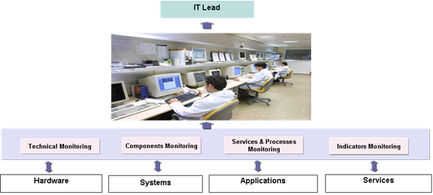

Illustration 1: Team organization

Related Procedures and Documents
- Incident Management Procedure

- Monitoring elements classification

Classification Policy
Once the platform is set up and each time a new device/service is planned to be put in production, the System monitoring team has to identify the Users Request and give a Criticality classification to the element.

Devices/Services are divided into three Criticality categories:
- Critical
A device/service which must always be available, i.e. no downtime is acceptable; the failure of this device will affect entire business and application processes.
Examples: Core Routers

- Major
A device/service which must be available most of the time; the failure of this device will affect a certain part of a business or application process.
Examples: WAM! Net connection

- Minor
A device/service which must be available during business hours, the failure of which will not affect the critical business and application processes during the business hours
Examples: Router degradation in performance or outages that have no impact on users.

The systems monitoring team has to:
- Identify the list of parameters or services to be monitored and assign them a criticality level.

- Add the device and its related service to the list of monitored parameters.

- Coordinate with the Requester to configure a new device/service, so that it is appropriately monitored, with the right thresholds.

- Monitor devices and prepare monitoring reports.

- Provide and maintain a dashboard.

Related Procedures and Documents
- Operations Excel Spreadsheet
- Data Classification
- Monitoring outputs
Monitoring data is accessible in two ways:
- Front-end user views to present real-time status of the platform,
- Alerts and notifications from the systems to the Operations Team.

End user view
Nagios and Cacti provide different screens to administrators, which display real-time status of the platform. A few illustrations of these views are shown below.

Note: When needed, administrators can browse more specific screens for a deeper investigation.

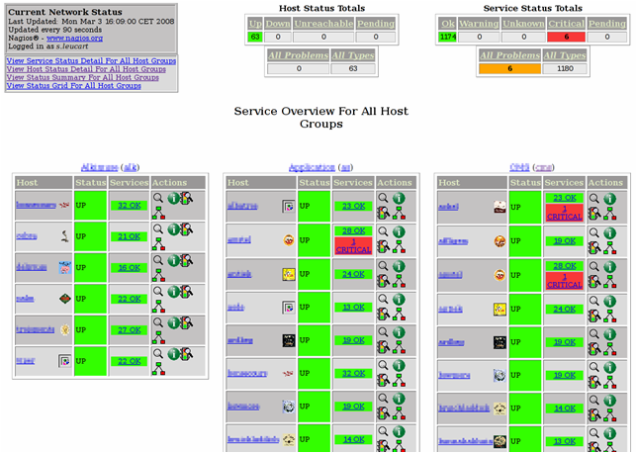

Illustration 2: End user front view in Nagios

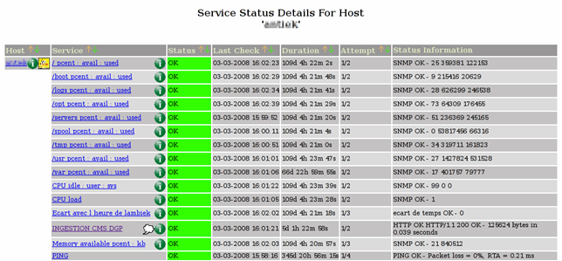

Illustration 3: Service Status for a host in Nagios

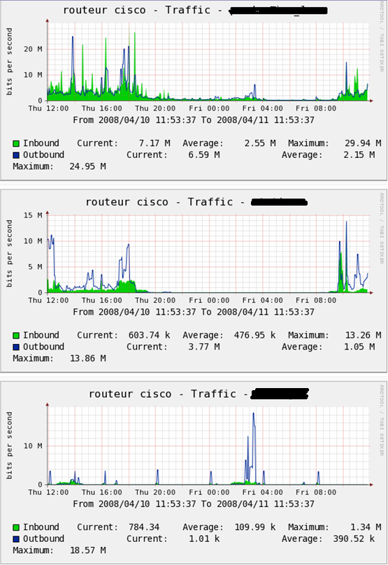

Illustration 4: Graphic view of a host in Cacti

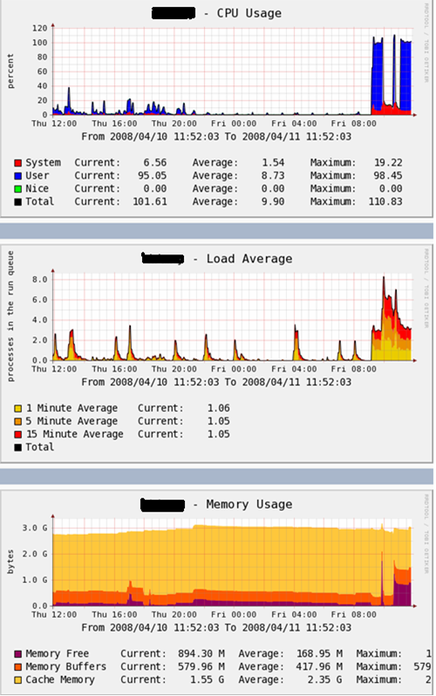

Illustration 5: Graphic view of services in Cacti

Notifications
The systems can send notifications to the Operations Team when necessary, on a 24/7 basis.

Triggers
Different events can trigger an alert when:
- A threshold is reached (for warning, critical states...);
- An application process is working;
- A system is down;
- Some hardware fails.

Alerts are used to perform an impact analysis and to quickly find out the root cause of the incident.

Notification classification
During its regular polling of monitored elements, the monitoring system collects the status of monitored elements and sends alerts if needed. These notifications contain the state of the monitored element, including:
- Failure state;
- Recovery state;
- Unknown state;
- Warning state.

According to the state, the monitoring system computes the impact of the error and automatically selects the notification methods and audience. The alert can be:
- A critical error with an important impact on business.
- A warning for errors with a limited impact on business which still need to be corrected before they get worse.

(See Operations Excel Spreadsheet for more details).
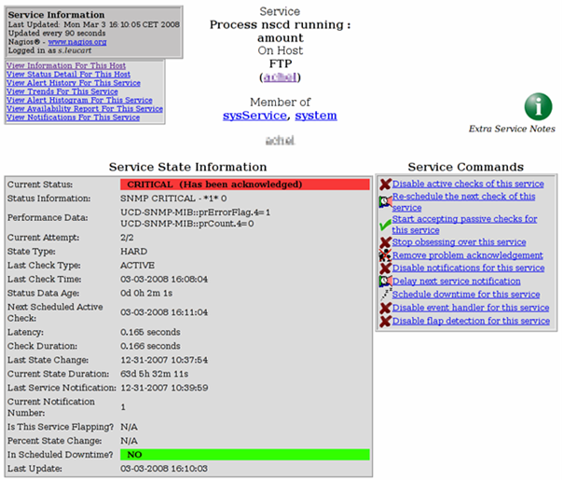

Illustration 6: Service detailed status

Notification methods
The notification methods are:
- E-mail
- SMS
E-mails and SMS are automatically sent by the monitoring system to a predefined list of people. The frequency is each time an error is detected.
Several group lists can be configured.

Notification audience
Based on the notification classification, an e-mail or SMS is automatically sent to:
- The monitoring team
- The administrator who is on call
- Other(s) administrator(s) if the first one has not acknowledged the notification

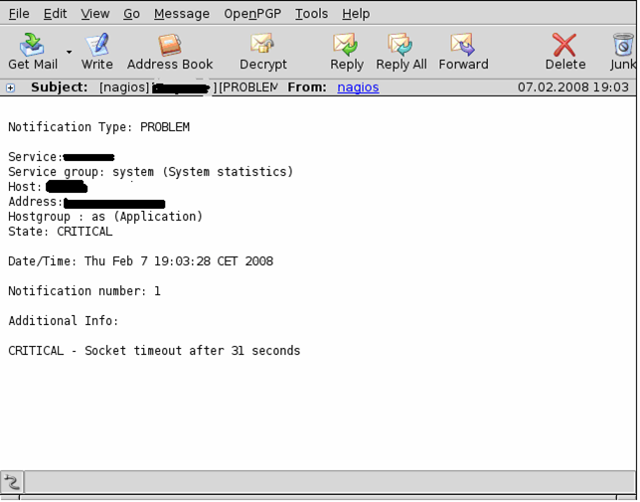

Illustration 7: Mail Notification

Acknowledgement
Once an alert notification has been received, the administrator acknowledges the alert and logs the incident into the incident tracking system.
This guarantees that the incident has been taken into account.
At the end of the intervention, the administrator updates the resolution information.

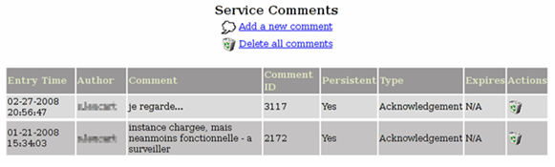
Illustration 8: Acknowledgement HMI

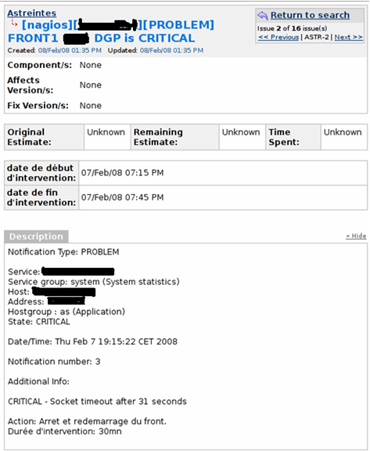
Illustration 9: Intervention report

Related Procedures and Documents
- Incident Management Procedure

- Sample scenario

The example below illustrates a possible scenario:
- An error (hardware, network, service, etc.) is monitored on a server
- The monitoring system analyzes the error, applies predefined rules based on its source and the services impacted, and notifies the appropriate people.
- An alert is displayed on the monitoring screens, an SMS and an e-mail are also sent to the monitoring administrators (during business hours).
- An alert is displayed on the monitoring screens, an SMS and an e-mail are sent to the administrator on call (outside business hours).
- If the monitoring system categorizes the error as critical, an escalation process is followed by the administrator on call to alert Digiplug management, who can then take additional measures (customer communication, etc).

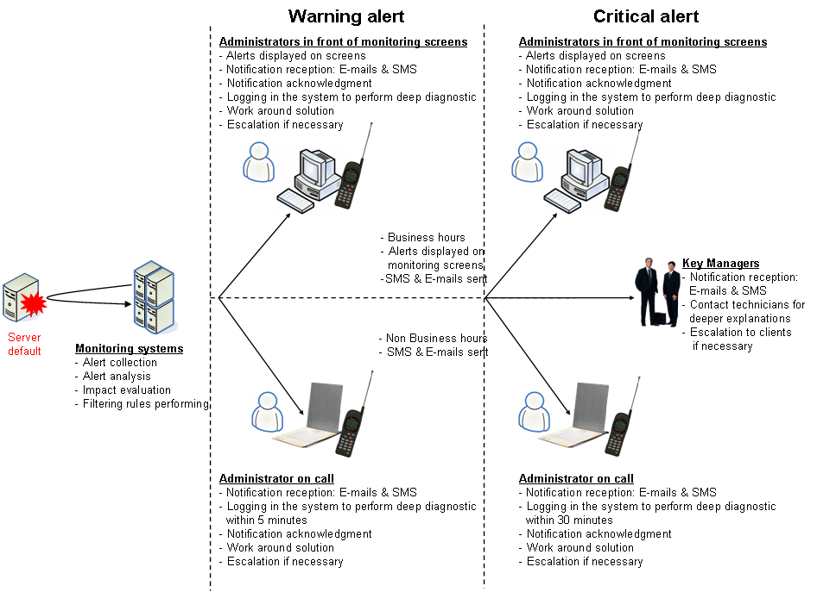

Illustration 10: Notification procedure

