Requirements Specification

for

*“Groupal”*

**February 2015**

**Team ZNC**

**Julie Quiroz**

**Duy Tran**

**David Inguanzo**

**Reggie Randolph**

**Table of Contents**

1 Introduction

1.1 Purpose

1.2 Project Scope

1.3 References

2 System Description

3 Functional Requirements

3.1 System Features

3.2 Use Cases

3.3 Entity Relationship Diagrams

3.4 Data Dictionary

4 External Interface Requirements

5 Technical Requirements (Non functional)

5.1 Performance

5.2 Scalability

5.3 Security

5.4 Maintainability

5.5 Usability

5.6 Multi lingual Support

5.7 Auditing and Logging

5.8 Availability

# **Introduction**

## **Purpose**

*This app will provide a friendly user interface for groups to plan future events with each other. Social interaction is encouraged within large groups to easier provide everyone with available dates and times for scheduling.*

## **Project Scope**

*The benefits of this app will improve overall planning of groups and will better how multiple people communicate and explore options during their free times. The overall goal is to share times with others and explore options of what activities can be done. Date picking and block-out dates will be shown by individuals in order to find a medium for the group.*

## **References**

[*http://developer.android.com/index.html*](http://developer.android.com/index.html)

[*https://www.gliffy.co*](https://www.gliffy.com/)*m*

# **System Description**

*The interface will be as followed in figure 1 and will flow in a way that the user will easily understand and be able to follow along to create their events with members of their friends. The Location settings will use GPS features, and the Friend settings will implement Facebook to add individuals.*

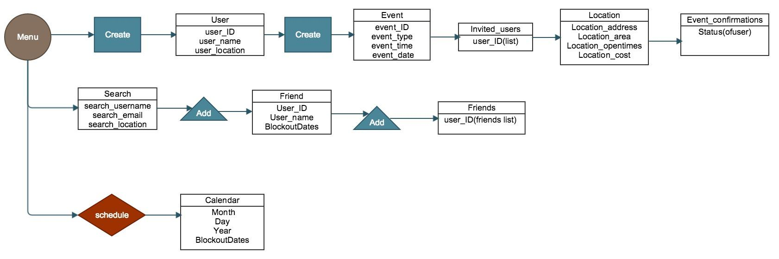

*Figure 1*

# **Functional Requirements**

## **System Features**

*Integration of google calendar to create social events with other users for free. [Name of app] will use multiple social network api’s such as but not limited to Facebook, Google+, Twitter, etc. Events are scheduled by taking user input and GPS. Then the app determines a location best suited for the user.*

## **Use Cases**

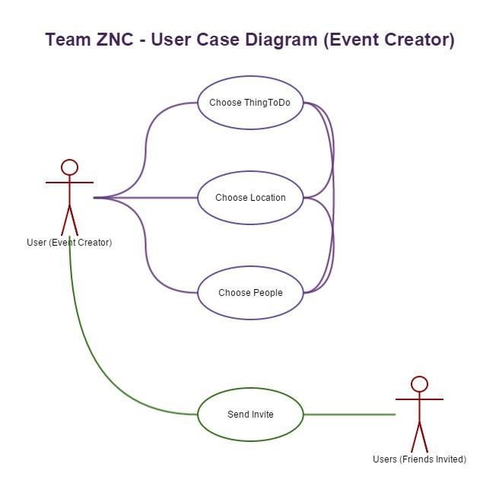

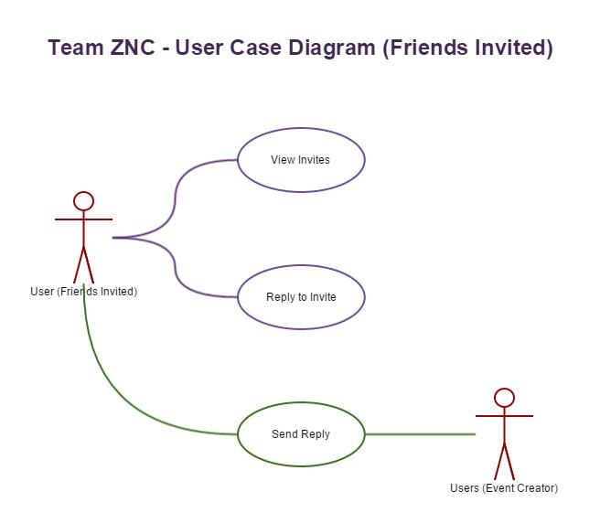

## **Entity Relationship Diagrams**

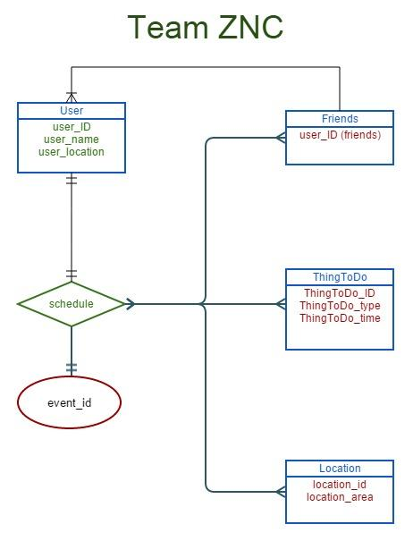

## **Data Dictionary**

|  |  |  |  |
| --- | --- | --- | --- |
| **Attribute** | **Type** | **Optional** | **Describtion** |
| *User* | *Entity* | *No* | *Someone using the app and who has access to all other entities* |
| Friends | Entity | Yes | People with connections to user |
| Thingstodo | Entity | Yes | Event created by user |
| Location | Entity | Yes | Event location |
| schedule | Relationship | No | Makes an event which can include location, Thing to do, or friends |
| Event_Id | Entity | No | Social event created by user |

# **External Interface Requirements**

*Location Settings*

*Google for locations with attributes*

# **Technical Requirements (Non functional)**

*Android Studio*

*GitHub*

*Google Hangout*

## **Performance**

*Response time will be under 1 second for every user touch interface, under 5 second for every loading website.*

## **Scalability**

*After two years, 10 thousand members should be support if the system continue to dramatically increase*.

## **Security**

*Data encryption is require for the database. MySQL provided the users with basic protection such as passwords protection and data encryption.*

## **Maintainability**

*Every months, a maintenance crew will make sure the development and the stability of the of the application.*

## **Usability**

*This application will be used on Android phone for 4.0 - 5.2 inches screen size.*

## **Multi lingual Support**

*Initially, the application will support English. Depend on the popularity of the application, we will improve the support language staring with Spanish.*

## **Auditing and Logging**

*User will be able to create a personal profile and membership with Shedule. Each user will have own user ID.*

## **Availability**

*The application will be available on 24 hours , seven day a week except for maintenance time. Through android application market, Shedule will be provided for world wide user who own an android device.*