Test Header

Data last refreshed on August 15, 2026
This is some sample text below the heading. You can add as many paragraphs as you want. This is just a placeholder for demonstration purposes.
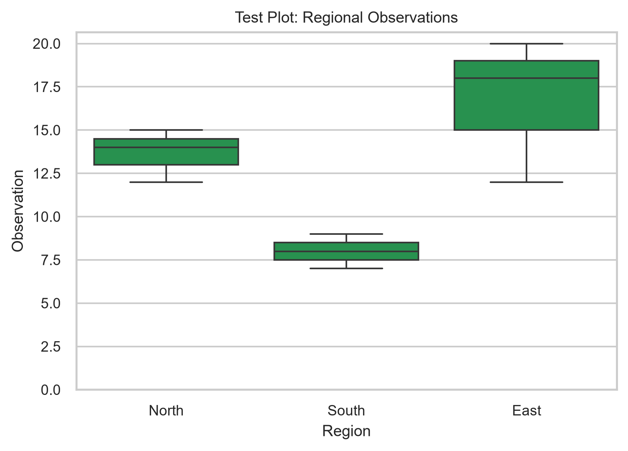
Here is some default explanatory text below the image. You can add as many paragraphs as you want.

Note: this paragraph is formatted manually rather than by style.

