***Caesars Entertainment in New Jersey - Software fail.***

Caesars Entertainment in New Jersey emailed promotions to 250 people who self-identify as compulsive online gamblers and are trying to avoid exactly this type of temptation by adding themselves to a do-not-send list.

Caesars Entertainment says a "back-end software issue" caused it to wrongly e-mail promotional gambling material to more than 250 "compulsive" online gamblers.

"The issue that caused our system to inadvertently target their patrons has been fixed and we have had no incidents since," Palansky said in a statement Wednesday. "We can assure the public that this lapse on our part was not an intentional targeting of their patrons, but simply a back-end software issue that failed to properly scrub our database before certain mailings."

The promotional materials were emailed to more than 250 internet self-excluded gamblers between Feb. 16 and May 28 as well as 19 individuals on the self-exclusion list during that same time frame.

Even though online gambling is legal, caesars entertainment corp has been hit with a $10,000 civil penalty.

It's not the first time Caesars has been dinged in connection to compulsive gambling. In May, it was penalized $3,000 because it did not include in a legible manner the compulsive gambling "1-800-GAMBLER" phone hotline on billboards hawking online gambling.

**References:**

<https://arstechnica.com/tech-policy/2014/11/software-issue-caused-casino-to-e-mail-promotions-to-compulsive-gamblers/?comments=1&post=27940201>

<https://www.law360.com/articles/593831/caesars-fined-in-nj-for-marketing-to-excluded-gamblers>

<http://www.slate.com/blogs/future_tense/2014/11/10/caesars_entertainment_in_new_jersey_accidentally_advertised_to_people_with.html>

***Software Glitch Accidentally Releases Prisoners***

**More than 3,200 US prisoners have been released early** because of a software glitch. **The bug miscalculated the sentence reductions prisoners in Washington state had received for good behaviour**. It was introduced in 2002 as part of an update that followed a court ruling about applying good behaviour credits. State officials say the early releases **have been happening by accident for more than 13 years**.

"Approximately 3 percent of all released inmates since 2002 were released earlier than allowed by law," said Nick Brown, the governor's general counsel. He said the problem was first flagged when a crime victim's family was notified the perpetrator was about to get out — early. "The family did its own calculation, determined that the offender was getting out earlier than the court had ordered, and contacted the department to ask why this was happening," Brown said.

Washington state officials are now in full [damage-control mode](http://www.doc.wa.gov/news/pressreleases/2015/12222015-sentencing-error-information.asp). Until the software is fixed, they say no one will be released without a "hand-calculation" of the release date. State officials said that many early-release prisoners would have to return to jail to finish their sentences. Analysis of the errors showed that, on average, **prisoners whose sentences were wrongly calculated got out 49 days early. One prisoner had his sentence cut by 600 days.** In a conference cal, Dan Pacholke, the state's secretary of corrections, said the state is still digging into what crimes may have been committed by ex-cons in the period of time they should have still been in prison. Prematurely released prisoners are charged with causing two deaths, one a DUI vehicular homicide. Local police are now helping to round up those who still need to spend time in jail. So far, 31 of the early released inmates have been taken back into custody. Most of those who've been taken back into custody have not been accused of committing new crimes while they were on the outside.

**References:**

<http://www.bbc.com/news/technology-35167191>

<http://wacoalitionforparole.org/early-release-of-wa-prisoners-due-to-doc-computer-glitch/>

<http://www.npr.org/2016/01/01/461700642/computer-glitch-leads-to-mistaken-early-release-of-prisoners-in-washington>

***AT&T Lines Go Dead (1990)***

At 2:25pm on Monday, January 15th, network managers at AT&T's Network Operations Center in Bedminster, N.J. began noticing an alarming number of red warning signals from various parts of their world-wide network. **Within seconds, the giant 72 screen video array that graphically represented the network was crisscrossed with a tangle of red lines as a rapidly spreading malfunction leapfrogged from one computer-operated switching center to another.** The standard procedures the managers tried first **failed** to bring the network back up to speed and **for nine hours**, while engineers raced to stabilize the network, almost 50% of the calls placed through AT&T failed to go through. Until 11:30pm, when network loads were low enough to allow the system to stabilize, AT&T alone **lost more than $60 million in unconnected calls**. Still unknown is the amount of business lost by airline reservations systems, hotels, rental car agencies and other businesses that relied on the telephone network. This wasn't supposed to happen. AT&T had built a reputation and a huge advertising campaign base on its reliability and security.

It is known that **75 million phone calls were missed and 200 thousand airline reservations were lost**. Working backwards through the data, a team of 100 frantically searching telephone technicians identified the problem, which **began in New York City**. The New York switch had performed a routine self-test that indicated it was nearing its load limits.

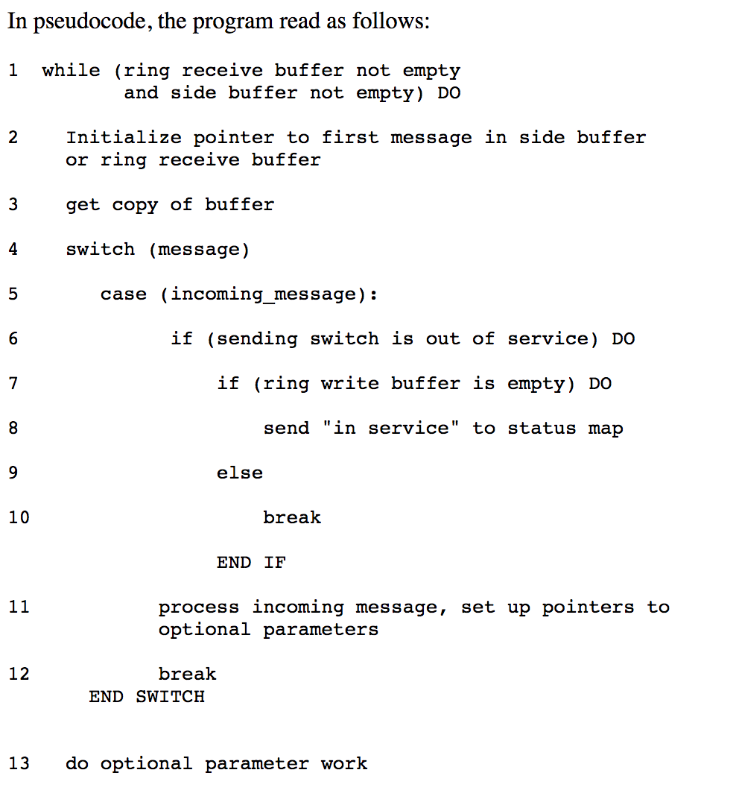As standard procedure, the switch performed a 4 second maintenance reset and sent a message over the signalling network that it would take no more calls until further notice. After reset, the New York switch began to distribute the signals that had backed up during the time it was off-line. Across the country, another switch received a message that a call from New York was on its way, and began to update its records to show the New York switch back on line. A second message from the New York switch then arrived, less than ten milliseconds after the first. **Because the first message had not yet been handled, the second message should have been saved until later. A software defect then caused the second message to be written over crucial communications information.** Software in the receiving switch detected the overwrite and immediately activated a backup link while it reset itself, **but another pair of closely timed messages triggered the same response in the backup processor, causing it to shut down also.** When the second switch recovered, it began to route its backlogged calls, and propagated the cycle of close-timed messages and shut-downs throughout the network. The problem repeated iteratively throughout the 114 switches in the network, blocking over 50 million calls in the nine hours it took to stabilize the system.

The cause of the problem had come months before. In early December, technicians had upgraded the software to speed processing of certain types of messages. Although the upgraded code had been rigorously tested, **a one-line bug was inadvertently added to the recovery software of each of the 114 switches in the network**. The defect was a **C program** that featured a break statement located within an if clause, that was nested within a switch clause.

**References:**

<http://users.csc.calpoly.edu/~jdalbey/SWE/Papers/att_collapse.html>

<http://www.phworld.org/history/attcrash.htm>

<https://www.slideshare.net/ItrisAutomationSquare/risk-management-and-business-protection-with-coding-standardization-static-analyzer>