Bar Exam

Descrição. -> Ventura

London Airspace

Descrição. -> Ventura

Casino

Descrição. -> Ventura

***Software Glitch Accidentally Releases Prisoners***

**More than 3,200 US prisoners have been released early** because of a software glitch. **The bug miscalculated the sentence reductions prisoners in Washington state had received for good behaviour**. It was introduced in 2002 as part of an update that followed a court ruling about applying good behaviour credits. State officials say the early releases **have been happening by accident for more than 13 years**.

"Approximately 3 percent of all released inmates since 2002 were released earlier than allowed by law," said Nick Brown, the governor's general counsel. He said the problem was first flagged when a crime victim's family was notified the perpetrator was about to get out — early. "The family did its own calculation, determined that the offender was getting out earlier than the court had ordered, and contacted the department to ask why this was happening," Brown said.

Washington state officials are now in full [damage-control mode](http://www.doc.wa.gov/news/pressreleases/2015/12222015-sentencing-error-information.asp). Until the software is fixed, they say no one will be released without a "hand-calculation" of the release date. State officials said that many early-release prisoners would have to return to jail to finish their sentences. Analysis of the errors showed that, on average, **prisoners whose sentences were wrongly calculated got out 49 days early. One prisoner had his sentence cut by 600 days.** In a conference cal, Dan Pacholke, the state's secretary of corrections, said the state is still digging into what crimes may have been committed by ex-cons in the period of time they should have still been in prison. Prematurely released prisoners are charged with causing two deaths, one a DUI vehicular homicide. Local police are now helping to round up those who still need to spend time in jail. So far, 31 of the early released inmates have been taken back into custody. Most of those who've been taken back into custody have not been accused of committing new crimes while they were on the outside.

<http://www.bbc.com/news/technology-35167191>

<http://wacoalitionforparole.org/early-release-of-wa-prisoners-due-to-doc-computer-glitch/>

<http://www.npr.org/2016/01/01/461700642/computer-glitch-leads-to-mistaken-early-release-of-prisoners-in-washington>

***Apple Maps gives us directions to nowhere***

The major new feature of the company's iOS 6 mobile operating system was a new mapping module developed by Apple itself — a replacement for the Google-supplied maps that have been standard on the iPhone since it debuted in 2007. The app has been faulted for misidentifying cities, using incorrect icons, and even failing to display certain locations.

Many of the complaints so far seem to be coming from Europe. For instance, Irish Minister for Justice Alan Shatter has asked Apple to remove the airline icon for [Airfield House](http://www.airfield.ie/). The problem? **Airfield House is**[**not an airport but a farm**](http://www.breakingnews.ie/ireland/shatter-to-contact-apple-over-misleading-airfield-map-app-567605.html), according to Ireland's Breaking News. Shatter may be worried that pilots relying on Maps may think the spot is an airport and end up landing on a bunch of cows and pigs.

Several [locations in the U.K. have been moved or are missing](http://www.bbc.co.uk/news/technology-19659736)from the app, reports the BBC News. **Stratford-upon-Avon and Solihull are both nowhere to be found.** **The town of**[**Uckfield**](http://www.uckfield.co.uk/)**in East Sussex is in the wrong location. Certain schools are missing, while the app apparently placed a furniture museum in a river.** Satellite images of different locations, including ones in Scotland, are covered by clouds.

Users in Asia aren't happy either. Some have complained of[**poor quality in the level of details**](http://www.japanmobiletech.com/2012/09/ios-6-maps-fail-in-japan.html), while others say the **app doesn't show train station exits**, according to Japanese blog site Japan Mobile Tech. One Twitter user pointed out that the app has also created [**two instances of the Senkaku, or Diaoyu, Islands**](https://twitter.com/samuel_wade/status/248710189820280832). Japan and China have been fighting over ownership of that territory, leading the tweeter to quip that Apple may be trying to broker a deal by creating two versions of the islands.

An **entire city is in the ocean**, **highways end in the middle of nowhere** and **a hospital now covers the entire centre of British city Stratford-upon-Avon**, Shakespeare's home.

Map detail might be lacking in some American cities, but **London, Beijing, and Tokyo are virtually blank**, and several major landmarks are labeled inaccurately or wildly misplaced.

Even Apple's highly-touted 3D "flyover" feature is somewhat broken: it frequently displays comically distorted images that **look like major landmarks and structures have been destroyed**. **The Statue of Liberty? Gone. The Brooklyn Bridge? Obliterated.**

Apple licenses mapping data from vehicle navigation systems maker TomTom. TomTom said it stands behind the quality of its maps but didn't develop the app. "During the process of turning mapping data into an app, every manufacturer does it their own way," said TomTom spokesperson Cem Cohen. "We are not part of that process. Apple uses exactly the same maps as our other customers." Cohen said TomTom hasn't talked to Apple about the issues.

<https://www.theverge.com/2012/9/20/3363914/wrong-turn-apple-ios-6-maps-phone-5-buggy-complaints>

<https://www.cnet.com/news/apples-maps-app-slammed-over-missing-cities-and-other-mistakes/>

<http://www.smh.com.au/technology/technology-news/apples-homegrown-maps-leaves-users-lost-20120920-26a9b.html>

***When the laptops exploded (2006) (provavelmente inútil porque é erro nas baterias)***

***Wall Street Crash: The Crash of 1987***

On “Black Monday” (October 19, 1987) **<** long bull market was halted by a rash of SEC investigations of insider trading and by other market forces.  As investors fled stocks in a mass exodus, computer trading programs generated a flood of sell orders, overwhelming the market, crashing systems and leaving investors effectively blind. **The largest one-day percentage drop in history.**

The SEC - which was established for the prevention of further crashes and fraudulent practices that had infected the stock market - was doing a fine job after the war and finally coaxed tentative investors back into the market in the sixties. The SEC, however, could take investors to the proper information but couldn't make them think. In the early '60s and '70s, investors looked not at the value of the company but at the appeal of its public image and the vernacular used to describe it Even though these illustrations were vague, investors were infatuated with these companies, which somehow represented some higher idea. The SEC required companies to state explicitly that they had no assets or even a fighting chance at getting any, but investors continued to believe that the potential for these companies was limitless. This [bullish](http://www.investopedia.com/terms/b/bull.asp) attitude, despite frequent bumps and [insolvencies](http://www.investopedia.com/terms/s/solvency.asp), continued into the eighties when [conglomerates](http://www.investopedia.com/terms/c/conglomerate.asp) and [hostile takeovers](http://www.investopedia.com/terms/h/hostiletakeover.asp) were the golden children of a finance-hungry media. Under the math of the "[new economy](http://www.investopedia.com/terms/n/neweconomy.asp),"firms would grow exponentially rather than incrementally simply by picking up other companies, The SEC was unable to halt the shady [IPOs](http://www.investopedia.com/terms/i/ipo.asp) and conglomerations, so the market continued to rise unabated throughout the '80s.

Then, in early 1987, there was a rash of SEC investigations into [insider trading](http://www.investopedia.com/terms/i/insidertrading.asp). For the most part, people were aware of the tendency of Wall Street to look out for itself, but the barrage of SEC investigations, rattled investors. **By October, investors decided to move out of the crooked game and into the more stable environment offered by**[**bonds**](http://www.investopedia.com/terms/b/bond.asp)**or, in some cases,**[**junk bonds**](http://www.investopedia.com/terms/j/junkbond.asp)**.** As people began the mass exodus out of the market, the computer programs began to kick in. The programs put a [stop loss](http://www.investopedia.com/terms/s/stop-lossorder.asp) on stocks and sent a sell order to [DOT](http://www.investopedia.com/terms/d/DOT.asp) (designated order turnaround), the NYSE computer system. **The instantaneous transmission of so many sell orders overwhelmed the printers for DOT and caused the whole market system to lag, leaving investors on every level (institutional to individual) effectively blind**.

**Herd-like panic set in and people started dumping stock in the dark without knowing what their losses were or whether their orders would execute fast enough to keep up with plummeting prices.** The Dow plummeted 508.32 points (22.6%) and **500 billion dollars vaporized**.

<http://www.investopedia.com/features/crashes/crashes6.asp>

<http://www.devtopics.com/20-famous-software-disasters-part-2/>

***AT&T Lines Go Dead (1990)***

At 2:25pm on Monday, January 15th, network managers at AT&T's Network Operations Center in Bedminster, N.J. began noticing an alarming number of red warning signals from various parts of their world-wide network. **Within seconds, the giant 72 screen video array that graphically represented the network was crisscrossed with a tangle of red lines as a rapidly spreading malfunction leapfrogged from one computer-operated switching center to another.** The standard procedures the managers tried first **failed** to bring the network back up to speed and **for nine hours**, while engineers raced to stabilize the network, almost 50% of the calls placed through AT&T failed to go through. Until 11:30pm, when network loads were low enough to allow the system to stabilize, AT&T alone **lost more than $60 million in unconnected calls**. Still unknown is the amount of business lost by airline reservations systems, hotels, rental car agencies and other businesses that relied on the telephone network. This wasn't supposed to happen. AT&T had built a reputation and a huge advertising campaign base on its reliability and security.

It is known that **75 million phone calls were missed and 200 thousand airline reservations were lost**. Working backwards through the data, a team of 100 frantically searching telephone technicians identified the problem, which **began in New York City**. The New York switch had performed a routine self-test that indicated it was nearing its load limits.

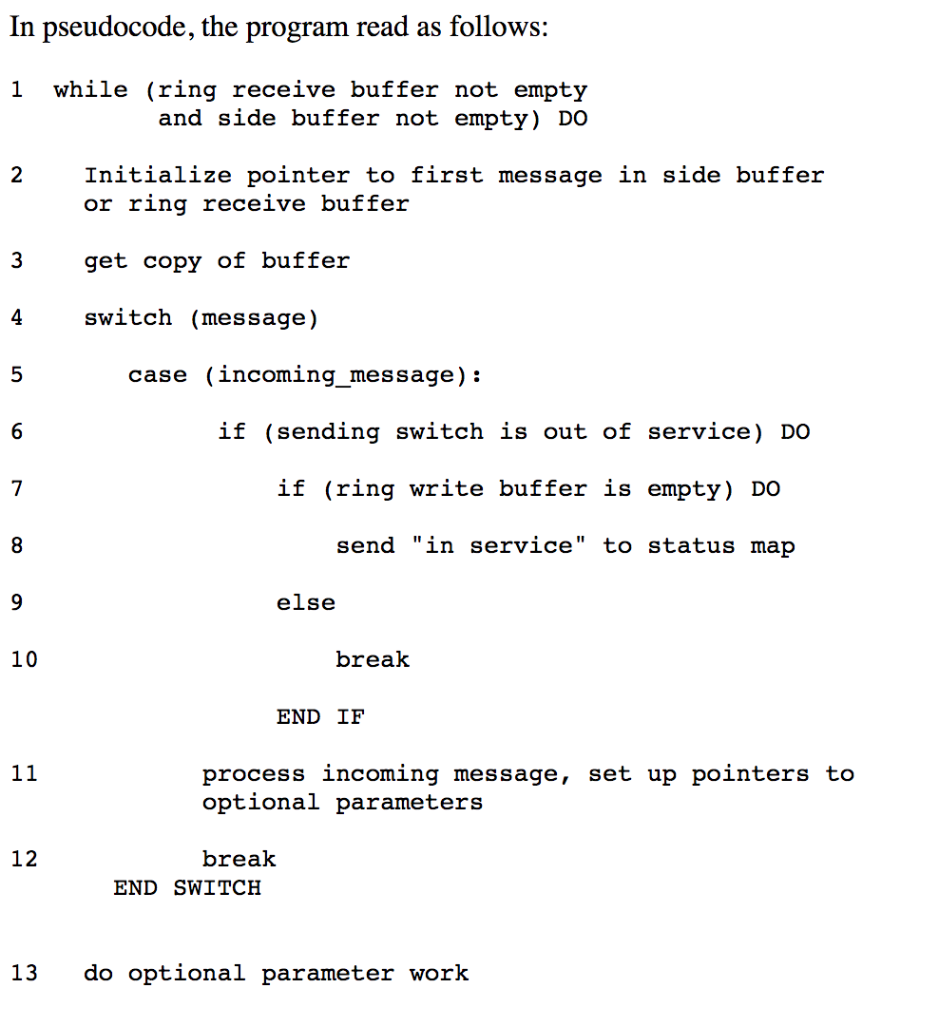As standard procedure, the switch performed a 4 second maintenance reset and sent a message over the signalling network that it would take no more calls until further notice. After reset, the New York switch began to distribute the signals that had backed up during the time it was off-line. Across the country, another switch received a message that a call from New York was on its way, and began to update its records to show the New York switch back on line. A second message from the New York switch then arrived, less than ten milliseconds after the first. **Because the first message had not yet been handled, the second message should have been saved until later. A software defect then caused the second message to be written over crucial communications information.** Software in the receiving switch detected the overwrite and immediately activated a backup link while it reset itself, **but another pair of closely timed messages triggered the same response in the backup processor, causing it to shut down also.** When the second switch recovered, it began to route its backlogged calls, and propagated the cycle of close-timed messages and shut-downs throughout the network. The problem repeated iteratively throughout the 114 switches in the network, blocking over 50 million calls in the nine hours it took to stabilize the system.

The cause of the problem had come months before. In early December, technicians had upgraded the software to speed processing of certain types of messages. Although the upgraded code had been rigorously tested, **a one-line bug was inadvertently added to the recovery software of each of the 114 switches in the network**. The defect was a **C program** that featured a break statement located within an if clause, that was nested within a switch clause.

<http://users.csc.calpoly.edu/~jdalbey/SWE/Papers/att_collapse.html>

<http://www.phworld.org/history/attcrash.htm>

<https://www.slideshare.net/ItrisAutomationSquare/risk-management-and-business-protection-with-coding-standardization-static-analyzer>