The **Unified Software Development Process** or Unified Process is a popular iterative and incremental software development process framework. The best-known and extensively documented refinement of the Unified Process is the Rational Unified Process (RUP). Other examples are OpenUP and Agile Unified Process. Unified process can be applied to different software systems with different levels of technical and managerial complexity across various domains and organizational cultures.

The first book to describe the process was titled The Unified Software Development Process and published in **1999** by **Ivar Jacobson, Grady Booch and James Rumbaugh.**

**The Four Phases**

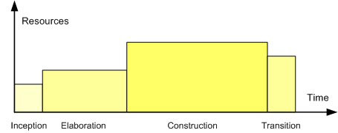The life of a software system can be represented as a series of cycles. A cycle ends with the release of a version of the system to customers.

Within the Unified Process, each cycle contains four phases. **A phase is simply the span of time between two major milestones, points at which managers make important decisions** about whether to proceed with development and, if so, what's required concerning project scope, budget, and schedule

***1. Inception***

**Primary goal:** establish the case for the viability of the proposed system.

**Tasks:**

* Defining the scope of the system (that is, what's in and what's out)
* Outlining a candidate architecture, which is made up of initial versions of six different models
* Identifying critical risks and determining when and how the project will address them
* Starting to make the business case that the project is worth doing, based on initial estimates of cost, effort, schedule, and product quality

**Major milestone**: Life-Cycle Objectives.

**The indications that the project has reached this milestone:**

* The major stakeholders agree on the scope of the proposed system.
* The candidate architecture clearly addresses a set of critical high-level requirements.
* The business case for the project is strong enough to justify a green light for continued development.

***2. Elaboration***

**Primary goal:** establish the ability to build the new system given the financial constraints, schedule constraints, and other kinds of constraints that the development project faces.

**Tasks:**

* Capturing a healthy majority of the remaining functional requirements
* Expanding the candidate architecture into a full architectural baseline, which is an internal release of the system focused on describing the architecture
* Addressing significant risks on an ongoing basis
* Finalizing the business case for the project and preparing a project plan that contains sufficient detail to guide the next phase of the project (Construction)

**Major milestone**: Life-Cycle Architecture

**The indications that the project has reached this milestone:**

* Most of the functional requirements for the new system have been captured in the use case model.
* The architectural baseline is a small, skinny system that will serve as a solid foundation for ongoing development.
* The business case has received a green light, and the project team has an initial project plan that describes how the Construction phase will proceed.

***3. Conception***

**Primary goal:** build a system capable of operating successfully in beta customer environments.

**Tasks**: involve building the system iteratively and incrementally, making sure that the viability of the system is always evident in executable form.

**Major milestone:** Initial Operational Capability.

**The indications that the project has reached this milestone:** if a set of beta customers has a more or less fully operational system in their hands.

***4. Transition***

**Primary goal:** roll out the fully functional system to customers.

**Tasks:** correcting defects and modifying the system to correct previously unidentified problems.

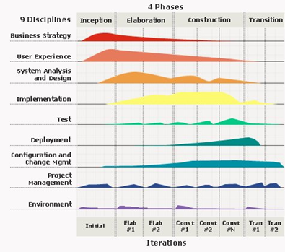**The major milestone:** Product Release.

**Characteristics**

***Iterative and incremental***

The Elaboration, Construction and Transition phases are divided into a series of timeboxed iterations. **Each iteration results in an increment, which is a release of the system that contains added or improved functionality compared with the previous release**.

***Use-case driven***

In the Unified Process, use-cases are **used to capture functional requirements and refine the content of the iterations**. Each iteration has a set of use cases or requirements scenarios throughout the implementation, testing, and development time.

***Architecture-centric***

Since no single model is sufficient to cover all aspects of a system, **the Unified Process supports multiple architectural models and views**. One of the most important deliverables of the process is the executable architecture baseline which is created during the Elaboration phase. This partial implementation of the system serves to validate the architecture and act as a foundation for remaining development.

***Risk-focused***

The Unified Process requires **the project team to focus on addressing the most critical risks early in the project life cycle**. The deliverables of each iteration, especially in the Elaboration phase, must be selected in order to ensure that the greatest risks are addressed first.

**Sources:**

<https://pt.slideshare.net/guy_davis/unified-process>

<http://www.methodsandtools.com/archive/archive.php?id=32>

<https://www.techopedia.com/definition/3885/unified-process-up>

<https://pt.wikipedia.org/wiki/Processo_unificado>

<http://www.informit.com/articles/article.aspx?p=24671&seqNum=7>