**ISSUE**

(identify the issue, using the issue system of the project (GitHub, Bitbucket, Track, etc.), study it, and describe it very shortly, compiling the most relevant information you found about it.)

Issue #11800: The shortcuts key (Ctrl++, Ctrl+-) would not work if input a large number as the font size on Themes Settings dialog (<https://github.com/adobe/brackets/issues/11800>)

Steps:

* launch the Brackets
* Click View > Themes...
* Input a large number as the font size, such as "100px, 1000px..."
* Click Done
* Try to Press Ctrl++ and Ctrl+- to increase or decrease the font size

Result: The shortcuts key doesn't work

Expect: The shortcuts key could work normally

The problem was that when you try to increase or decrease the font size, brackets doesn't let you if the new font size is more than the maxium font size (72px) or less than the minium font size (1px). Therefore, if the the font size in themes settings is 100px and you try to drecrease it pressing Ctrl+- nothing happens because the new font size will be 99px which is still more than 72px.

Because I think it makes sense to be able to decrease the font size even though it is still more than the allowed I tried to solve the problem. So now if the font size is more than the maxium and you try to decrease it, it will decrese to the maxium font size, and if the font size is less than the minium and you increase it, it will increase to the minium font size.

**REQUIREMENTS**

(if applicable, describe the requirements of the application (web, mobile, desktop) underlying the issue, in its context. You can describe it in the form of feature descriptions, user stories, use cases, and if applicable add screenshots.)

**SOURCE CODE FILES**

(list the names of the files and code fragments directly and indirectly involved with the issue.)

/src/view/ViewCommandHandlers.js

lines 91: Declares the minimiun font size in pixels

line 17: Declares the maxium font size in pixels

line 326: Function that decides wether or not to update the font size

line 338-342: Defining variables to the calculate fsNew and fsStr

line 346: If clause that doesnt let update the font size if it’s too big

**DESIGN OF THE FIX**

(do a very simple UML diagram that helps on illustrating how you plan to fix the issue. You may use one or all of the UML diagrams you learned already: classes, sequence, states, etc.)

**FIX SOURCE CODE**

(describe the code you wrote to fix the issue, packaging as a patch-file.)

Change this if:

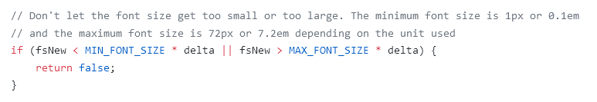

To

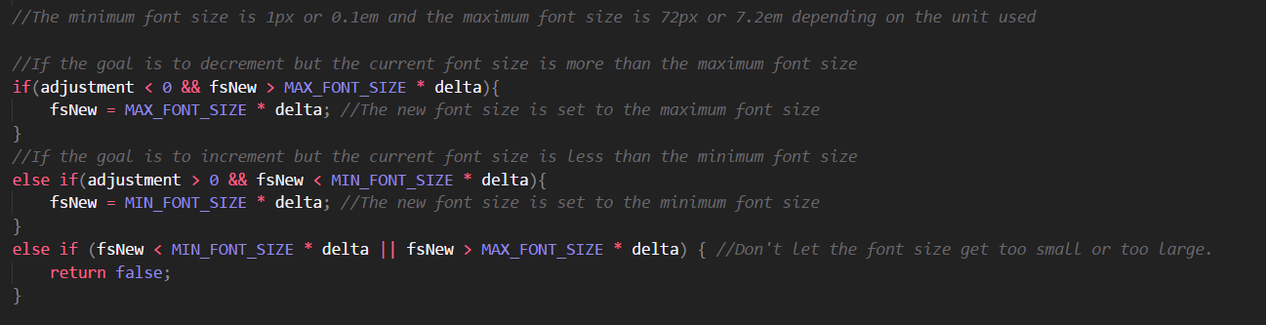

And because we are changing the value of fsNew, we have to define fsStr after that:



**SUBMIT THE FIX**

(after approval by your teacher, submit the fix to the project, as a pull-request, or a patch, depending on how it is supposed to submit fixes in your project.)