**P1**. Suppose the information content of a packet is the bit pattern 1110 0110 1001 0101 and an even parity scheme is being used. What would the value of the field containing the parity bits be for the case of a two-dimensional parity scheme?

Your answer should be such that a minimum-length checksum field is used.

**Answer:**

1 1 1 0 1

0 1 1 0 0

1 0 0 1 0

1 1 0 1 1

1 1 0 0 0

Even parit scheme is used -; “In an even parity scheme, the sender includes one additional bit and chooses its value such that the total number of 1s in the d+` bits( the original information) plus a parity bit) is even”.

1-D 1110 0110 1001 1101 0← <-parity bit

2-D:

1110 |1

0110|0

1001|0

1101|1

**P5.** Consider the 5-bit generator, G = 10011, and suppose that D has the value

1010101010. What is the value of R?

**Answer:**

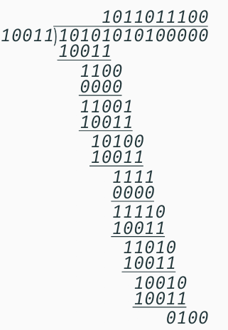

If we divide 10011 into 1010101010 0000, we get 1011011100, with a remainder of R=0100.

**P17.** Recall that with the CSMA/CD protocol, the adapter waits K * 512 bit times after a collision, where K is drawn randomly.

For K = 100, how long does the adapter wait until returning to Step 2 for a 100 Mbps broadcast channel?

For a 1 Gbps broadcast channel?

**Answer:**

- The one bit time for 10Mbps is 1/10000000 s = 0.0001 ms

- The one bit time for 100Mbps is 1/100000000 s = 0.00001 ms

- Waiting time for a 10Mbps broadcast channel is K*512*0.0001= 5.12 ms

- Waiting time for a 100Mbps broadcast channel is K*512*0.00001= 0.512ms

**P19.** Suppose nodes A and B are on the same 10 Mbps broadcast channel, and the propagation delay between the two nodes is 245 bit times. Suppose A and B send Ethernet frames at the same time, the frames collide, and then A and B choose different values of K in the CSMA/CD algorithm. Assuming no other nodes are active, can the retransmissions from A and B collide? For our purposes, it suffices to work out the following example. Suppose A and B begin transmission at t = 0 bit times. They both detect collisions at t = 245 t bit times. Suppose KA = 0 and KB = 1. At what time does B schedule its retransmission? At what time does A begin transmission? (Note: The nodes must wait for an idle channel after returning to Step 2—see protocol.) At what time does A’s signal reach B? Does B refrain from transmitting at its scheduled time?

**Answer:**

**Initial Conditions**

-Both nodes A and B are on a 10 Mbps broadcast channel.

-Propagation delay between nodes A and B is 245 bit times.

-Both nodes begin transmission at t=0t = 0t=0 bit times.

-Both nodes detect the collision at t=245t = 245t=245 bit times.

**After Collision Detection**

When a collision is detected, both nodes will perform the backoff algorithm using the CSMA/CD protocol. The backoff time is determined by K×512 bit times, where K is chosen randomly.

**Given Values**

-KA=0

-KB=1

**Calculations for Node A (K_A = 0)**

-Since KA=0, node A will have a backoff time of 0×512=0 bit times.

-A will attempt to retransmit immediately after detecting the collision and the channel becoming idle.

-Node A detects the collision at t=245 bit times.

-Node A waits for the channel to become idle after the collision detection. Given no additional propagation delay needs to be considered in this idealized scenario for the retransmission:

-Node A begins retransmission at t=245+0=245 bit times.

**Calculations for Node B (K_B = 1)**

-Since KB=1, node B will have a backoff time of 1×512=512 bit times.

-B will attempt to retransmit after waiting for 512 bit times.

-Node B detects the collision at t=245 bit times.

-Node B waits for 512 bit times after detecting the collision:

-Node B begins retransmission at t=245+512=757 bit times.

**Signal Propagation and Channel Idleness**

-When node A begins retransmission at t=245 bit times, its signal will take 245 bit times to reach node B.

-Therefore, node A's signal reaches node B at t=245+245=490 bit times.

-Node B is scheduled to start its retransmission at t=757 bit times.

**Does B Refrain from Transmitting?**

-At t=757 bit times, node B checks if the channel is idle before starting its transmission.

Since node A’s signal has already been transmitted at t=245 bit times and reached node B by t=490 bit times, node B will sense that the channel is not idle (it detects node A's transmission).

**Conclusion**

Node B will detect the channel is busy at t=757t = 757t=757 bit times and will defer its transmission until the channel becomes idle.

Therefore, the retransmissions from nodes A and B will not collide in this scenario.