# 

# FUNCTIONAL SPECIFICATION DOCUMENT

## Grand Central Partnership

Admin Desktop Asset Management Interface

**Client:** Grand Central Partnership

**Project:** Admin Desktop Asset Management Interface

Devin Cox

Devin@TrueVGD.com

212.736.0770 x 209

Project Owner Cell 646-75-4515

## 

## Document Change History

|  |  |  |  |
| --- | --- | --- | --- |
| Version # | Date | Description | Initials |
| 1dc | 09/14/2016 | Initial Document Creation | DC |
| 2dc | 09/19/2016 | GCP\_Wires\_Admin\_18 updates | js |
| 3dc | 09/20/2016 | GCP\_Wires\_Admin\_18 updates | js |
| 4js | 09/21/2016 | GCP\_Wires\_Admin\_18.txt | js |
| 5js | 09/23/2016 | Review and update | js |
| 6js | 09/26/2016 | Updated document GCP\_Wires\_19.PDF | Js |
| 7js | 09/27/2016 | Updated “Asset ID” instead of “Item Number”. | Js |
| 8js | 10/06/2016 | Updated screenshots GCP\_Wires\_Admin\_20-2.ai | Js |
| 9js | 10/06/2016 | Updated with feedback. | Js |

## Current Document Summary

|  |  |  |  |
| --- | --- | --- | --- |
| Organization v | Date | Task Assigned | Stakeholder Name |
| VGD | 07/07/2016 | Initiate Admin FSD Draft | Devin Cox |
| VGD | 09/19/2016 | Update Admin FSD Draft | Devin Cox |
|  |  |  |  |

# Project Overview – Admin Desktop Asset Management Interface

**1. Inventory Management Interface**

Based on a final design, VGD will implement two similar inventory management interfaces —one on the application, the other on the Admin site. The purpose of this document is to describe the Admin Desktop Asset Management Interface.

For each we will:

1. Code an Inventory Management Landing page (scan QR/ search item/ add item).
2. Implement the “Add an item” flow.
3. Configure support of a QR Code scan feature.
4. Implement geo-location tagging.
5. Specify and implement an “update existing item” workflow.
6. Make changes to these aspects of the Admin site: upload configure list, history and audit logging, user, and asset upload, download a report.
7. VGD ensure images, captured, saved and displayed are of the same quality as compared to images taken by a device native camera.
8. Images saved in the DB are compressed to better utilize memory, an average decompression will be used to ensure image quality is maintained.
9. Images available on the Admin site are of the same quality as images saved by the device.

**2. Usage Switchboard**

VGD will implement a usage switchboard, based on Spring Security, to restrict access to each of the app’s three modules – File a Report, Archive, and Inventory Management – on a USER ID level.

The admin will be able to define flags during the user upload process to set each user’s access level. Only two permissions will be defined on the User Account Management excel upload:

* TMS – User can edit/add/closed tickets.
* AMS – User can add/edit/delete assets.

**3. Application Upgrades and Feedback**

VGD will upgrade the current libraries on the application to support sharper images and add support for Android Lollipop and Marshmallow – this may involve updating the libraries and extensive regression testing to achieve the desired rich experience.

**4. Ticketing System and Integration with the Application**

Based on the team’s research, Bugzilla seems the best open-source tracking tool with which to integrate. VGD will make custom adjustments as well as architect and implement the integration of the ticketing system with the application.

**5. Richer User Experience**

After the launch of Phase 1, the team had discussed areas where the app could be modified to enrich or enrich the user experience. This budget bucket would be for UX enhancements, to be drawn from, if needed, for the scope of this project.

# Project Deliverables

1. Updated Application interfaces to accommodate some inventory management functionality.
2. Updated Application interfaces to accommodate some ticket management functionality.
3. A web based desktop dashboard interface to manage the asset inventory.
4. A web based platform to administer the ticket management workflow process.

# Project Team

### Grand Central Partnership

**VP for Administration & Operations:** Rochelle Patricof

**VP Capital Projects, Maintenance & Procurement:** Peter Lempin

**Sr. Project Manager:** Ryan Pukos

### VGD

**Project Director:** Preeti Sharma

**Project Manager:** Devin Cox

**Project Manager:** Prashant Shah

**Technical Project Manager:** Anupam Dutta

**IA / UI / UX Design:** Shane Lessa

**Technical Delivery Manager:** Jose Lugo

### Specific Platform/ Environment

### Mobile Operating Systems (App)

|  |  |
| --- | --- |
| Deliverable | Description |
| Android 6.0 | Google Android Marshmallow |
|  |  |
|  |  |

### Browser Version Support (Dashboard)

|  |  |
| --- | --- |
| Deliverable | Description |
| Internet Explorer 9 | Microsoft Internet Explorer version 9.0 internet browser compatibility |
| Safari | 6.0.4 Apple Safari compatibility |
| Chrome | 51.0 Google Chrome browser on Windows OS compatibility |
|  |  |

### Device Compatibility

|  |  |
| --- | --- |
| Deliverable | Description |
| Tablet | LG G Pad F 8.0 |
|  |  |

Drop-Downs

|  |  |  |
| --- | --- | --- |
| Ticket Menu Name | Offered to Non-GCP Asset | Editable from Admin Panel |
| Discovered by | Yes | Yes |
| Reported Via | Yes | Yes |
| Reason for Ticket | Yes | Yes |
| Component | No | No |
| Priority | Yes | No |
| Photo | Yes | N/A |
| Refer To | Yes | Yes |
| Notes | Yes | N/A |
| Primary Street | Yes (not Offered in GCP Asset) | Yes |
| Intersecting Street | Yes (not Offered in GCP Asset) | Yes |
| Between Street | Yes (not Offered in GCP Asset) | Yes |
| Relative Location | Yes (not Offered in GCP Asset) | Yes |
| Sector | Yes | Yes |

|  |  |
| --- | --- |
| Asset Attribute | Editable from Admin Panel |
| Category | No |
| QR Code | N/A |
| Condition Description | Yes |
| Status | Yes |

Categories Offered (Related components file:[**http://teamwork.truevgd.com/files/1441714**](http://teamwork.truevgd.com/files/1441714)**)**

|  |  |
| --- | --- |
| **GCP Asset** | **Non-GCP Asset** |
| Bench | Banner |
| Bike Rack | Bollard |
| Bike Sleeve | Citi Bike Station |
| Emergency Box | Fire Hydrant |
| Flag | Link NYC |
| Granite Corner | Mail Box |
| Hanging Basket | Muni Meter |
| Hoop Fence | Newsstand |
| Illuminated Street Sign | NYPD Camera |
| Information Cart | Other |
| Light Pole | Park Avenue Mall |
| News Box | Pedestrian Signal Box |
| NYPD Camera Sign | Phone Booth |
| Planter | Relay Box |
| Shoe Shine Stand | Sewer Catch Basin |
| Sign - Parking | Sidewalk |
| Sidewalk Plaques | Sidewalk Grate |
| Trash Can | Sign - Bus |
| Tree Pit Stone Border | Sign - Traffic |
|  | Taxi Stand |
|  | Traffic Control Box |
|  | Tree |
|  | Tree Pit |
|  | Wayfinding Sign |

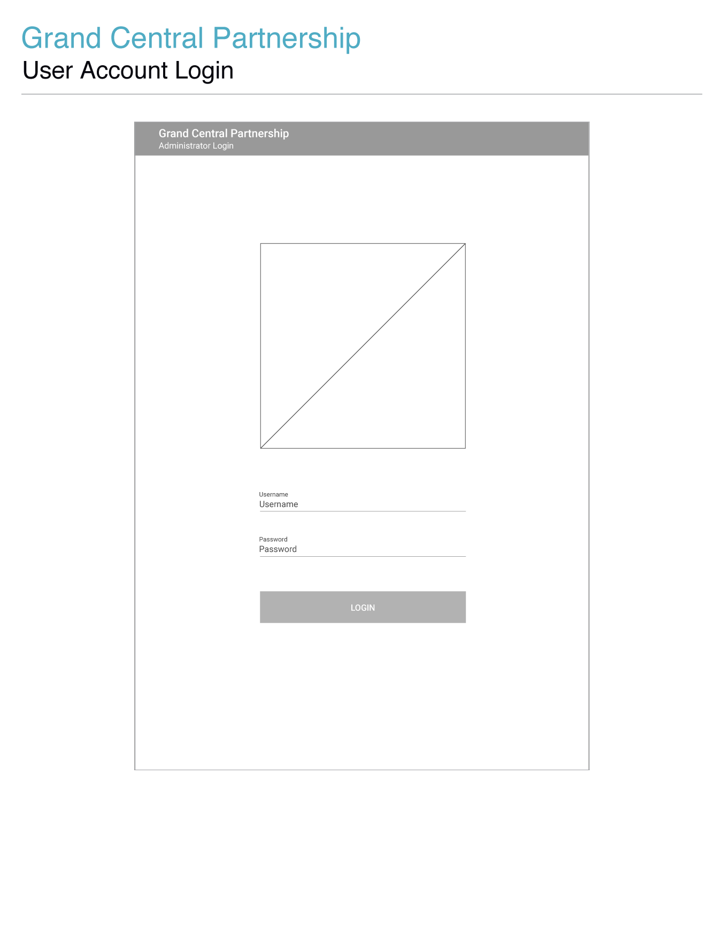

|  |  |  |
| --- | --- | --- |
| Item | Type | Function |
| Location Header | Text | * Text displaying the user's current location within the GCP Asset Management database. |
| GCP Logo | Image | * For display. |
| Login Text Fields | Text Field | * Upon opening the GCP Asset Management Dashboard, users will be required to provide their login credentials (username / password) in order to access the application. |
| Username | Text Field | * Will allow for the entry of alpha characters, numeric characters, and some special characters. * Upon users exiting the username text field, the provided username will be validated, to ensure both the user and the system, that it has been properly formatted (alias@domain.tld). If the entered username isn't properly formatted, the entered text will highlight in red to draw attention to the error, and the characters entered will remain to allow users to correct their error(s). * When clicked, targeted input fields will transition from an inactive state to a focused state. The aesthetics of these states will be dictated by the provided visual design files. This effect is to be applied to all input fields within the GCP Asset Management Dashboard. * The username field will continue to contain the username submitted with an invalid password. |
| Password | Text Field | * Text entered in this field will be masked. * The password field will clear if an invalid username is submitted for login. |
| Login | Button | * Login button will remain disabled until the user has entered text in both the username text field and the password text field. * Once a username and a password are entered the login button will transition to an active state and will be enabled for the submission of the provided login credentials. |

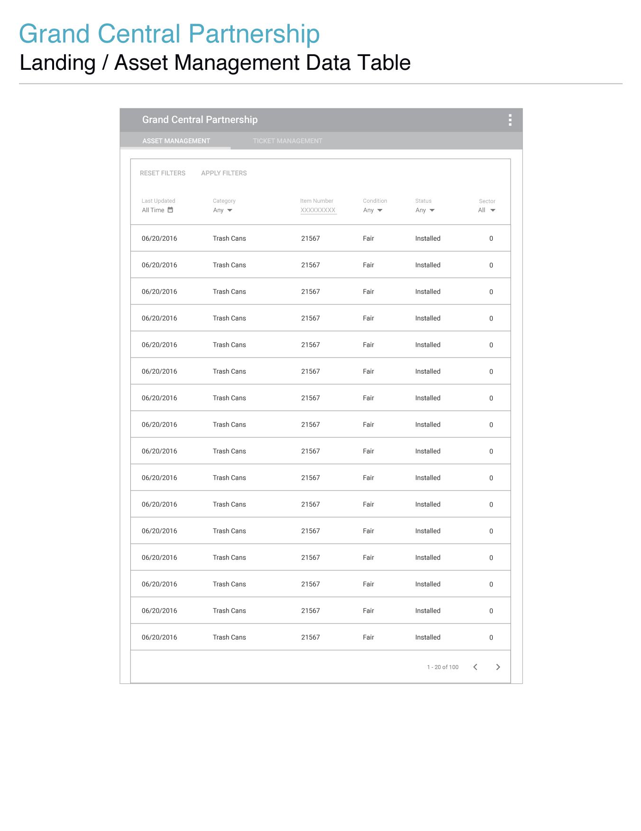

| Item | Type | Function |
| --- | --- | --- |
| Asset Management | Button | * This section will be active and in view after a successful login. * When clicked users will be directed to the asset management section of the admin dashboard. |
| Column Headers | Buttons | * By default the asset data table is sorted starting with the asset whose details were most recently modified to the least recently modified asset in the set. * Clicking a column label will toggle between sorting the data table in ascending/descending alphabetical/numerical/chronological order depending on the data type stored within the column label’s column. * Deleted assets will not be displayed within the asset management data table |
| Apply Filters | Button | * If filter options are entered or selected users must click the apply filters button to apply the filters to the asset data table. * This button will only be enabled if the user has either entered or selected a filter or if filter that was previously set is modified. * This is to assure users that the selected options will be applied as they intended. It allows for users to view and compare the information displayed before the filters are applied. Updating the results in real-time can cause increased load times/extra unnecessary stress on the server. Also by not updating the results in real-time without page refresh, users can undo filter changes and/or return to previous filter selections by clicking their browser's back button.   **When clicked:**   * The entered/selected filter settings will be applied to the asset data table. * The asset data table will return to its original visibility state. * Pagination buttons will be enabled. * Filters will be replaced with column headers and text for applied filter options. |
| Reset Filters | Button | * When clicked any filter options that were entered or selected will be reset to placeholder text. Resetting filters is not applied to the asset data table, only to the filter options that are currently in view. If users wish to apply the reset to the asset data table they must click the apply filters button. * Only becomes enabled once a filter setting has been entered or selected. |
| Date Created | Text | * Text displaying the last time the asset's information was created. |
| Category | Text | * Assets require a category to be associated with them. When clicked a dropdown menu will transition into view and will contain all the options for the asset categories defined by GCP. Once a category is selected the menu will transition out of view and the selected category will display as the activated option for this input. * Upon opening the inactive category dropdown menu, the category that was active from the map view will be positioned/displayed above the category dropdown button placeholder text. |
| Asset ID | Text | * Asset ID assigned to ticket. |
| Condition | Text | * A display of the asset's condition. |
| Status | Text | * A display of the asset's status. |
| Sector | Text | * GCP's territory will be split among several designated sectors. The sector that correlates with an asset’s location will display here. |

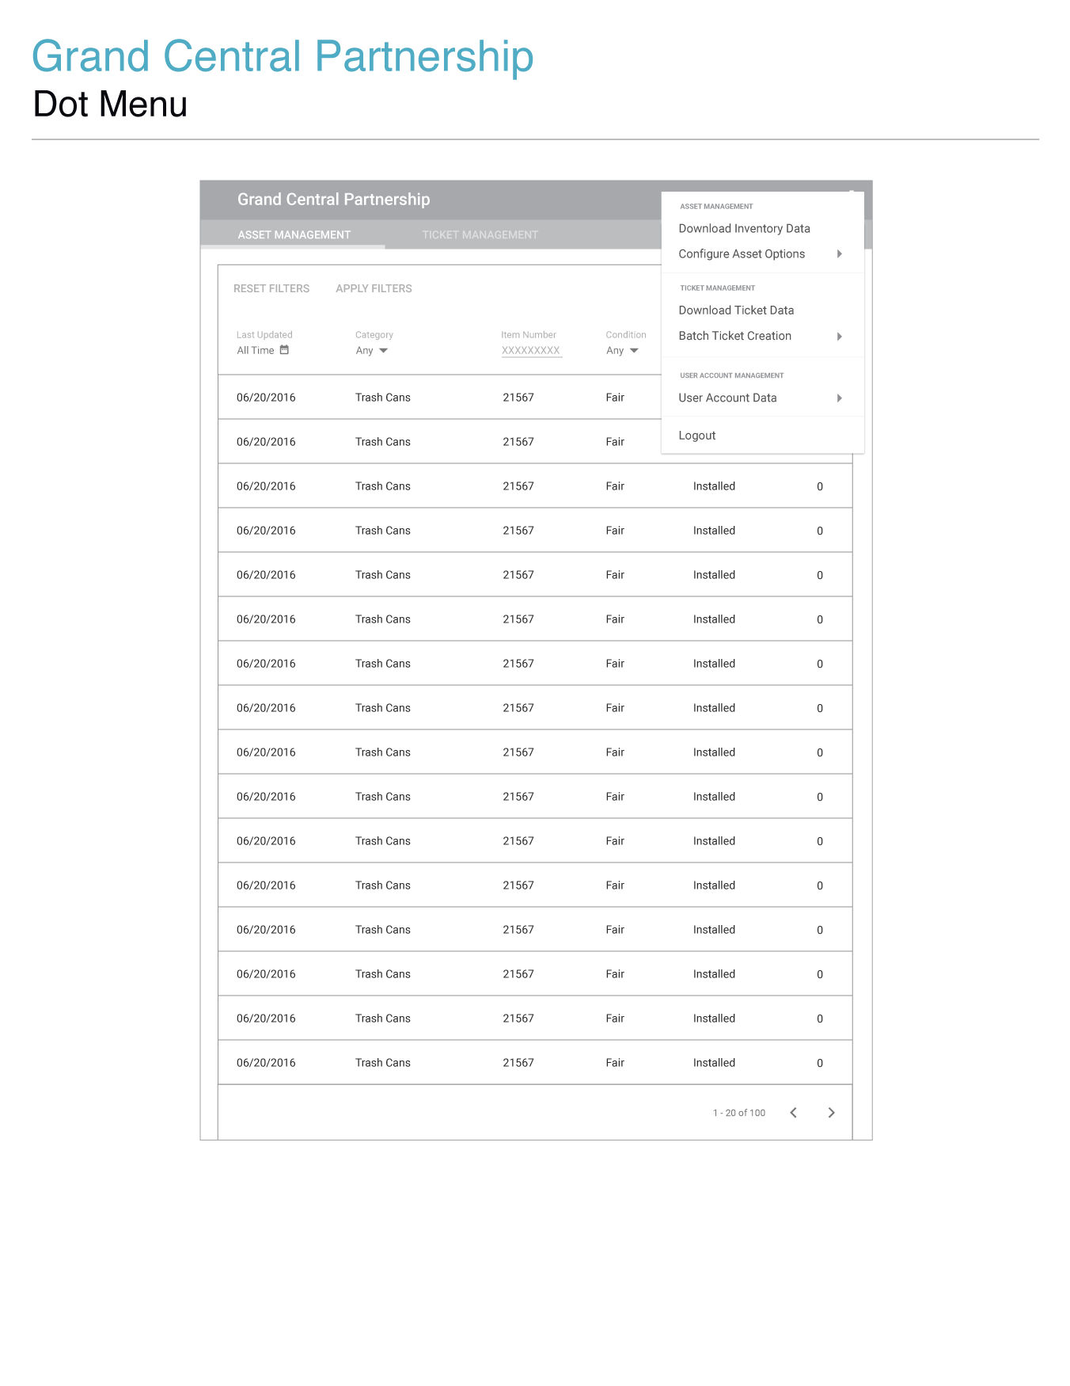

### 

| Item | Type | Function |
| --- | --- | --- |
| Dot Menu | Buttons/Dropdown Menu | * When clicked a dropdown menu will transition into view containing options for downloading inventory data, uploading/downloading of asset menu configurations, downloading of the ticket database, downloading of batch ticket template files, uploading of batch ticket files, and the uploading/downloading of user account data. * If users wish to logout out of the GCP Admin dashboard they can do so by clicking the logout button. |

### _imgs/_04_asset_dot_00.png

| Item | Type | Function |
| --- | --- | --- |
| • User Account Data  • Asset Attribute Configuration  • Batch Ticket Creation | Menu Options/Buttons | * The User Account Data/Asset Attribute Configuration/Batch Ticket Creation menu options will transition to active states when hovered over and will open submenus containing options to either upload or download a data file relative to which ever menu option the user hovered over. * When an upload or download data button is clicked, that button will briefly transition to an active state before and the dot menu will transition out of view. * If an upload option is selected, a dialog will transition into view containing a header identifying the purpose of the file upload dialog, a browse button for opening a default system specific file selection dialog, a cancel button for closing the file upload dialog, and an upload button to initiate the file upload function. * Batch Ticket Data’s submenu will contain options to download the batch ticket data template or to upload a batch ticket data file. * When the file upload process initiates an “uploading file” status will display as the server loops through the file making sure the data entered is correct. If the data file is not properly formatted an error message will be returned within the dialog. If the data is formatted properly a file upload success message will display within the dialog. * If a download option is selected, the clicked download button will briefly transition to an active state, the dot menu will collapse, and the user’s browser will start downloading a file containing the data file that is relative to the selected download option. * For bulk uploads any images associated with the items in the data file will not be a part of the upload. If users wish to modify the images associated with an asset or a ticket they can do so by editing that individual ticket or asset. |

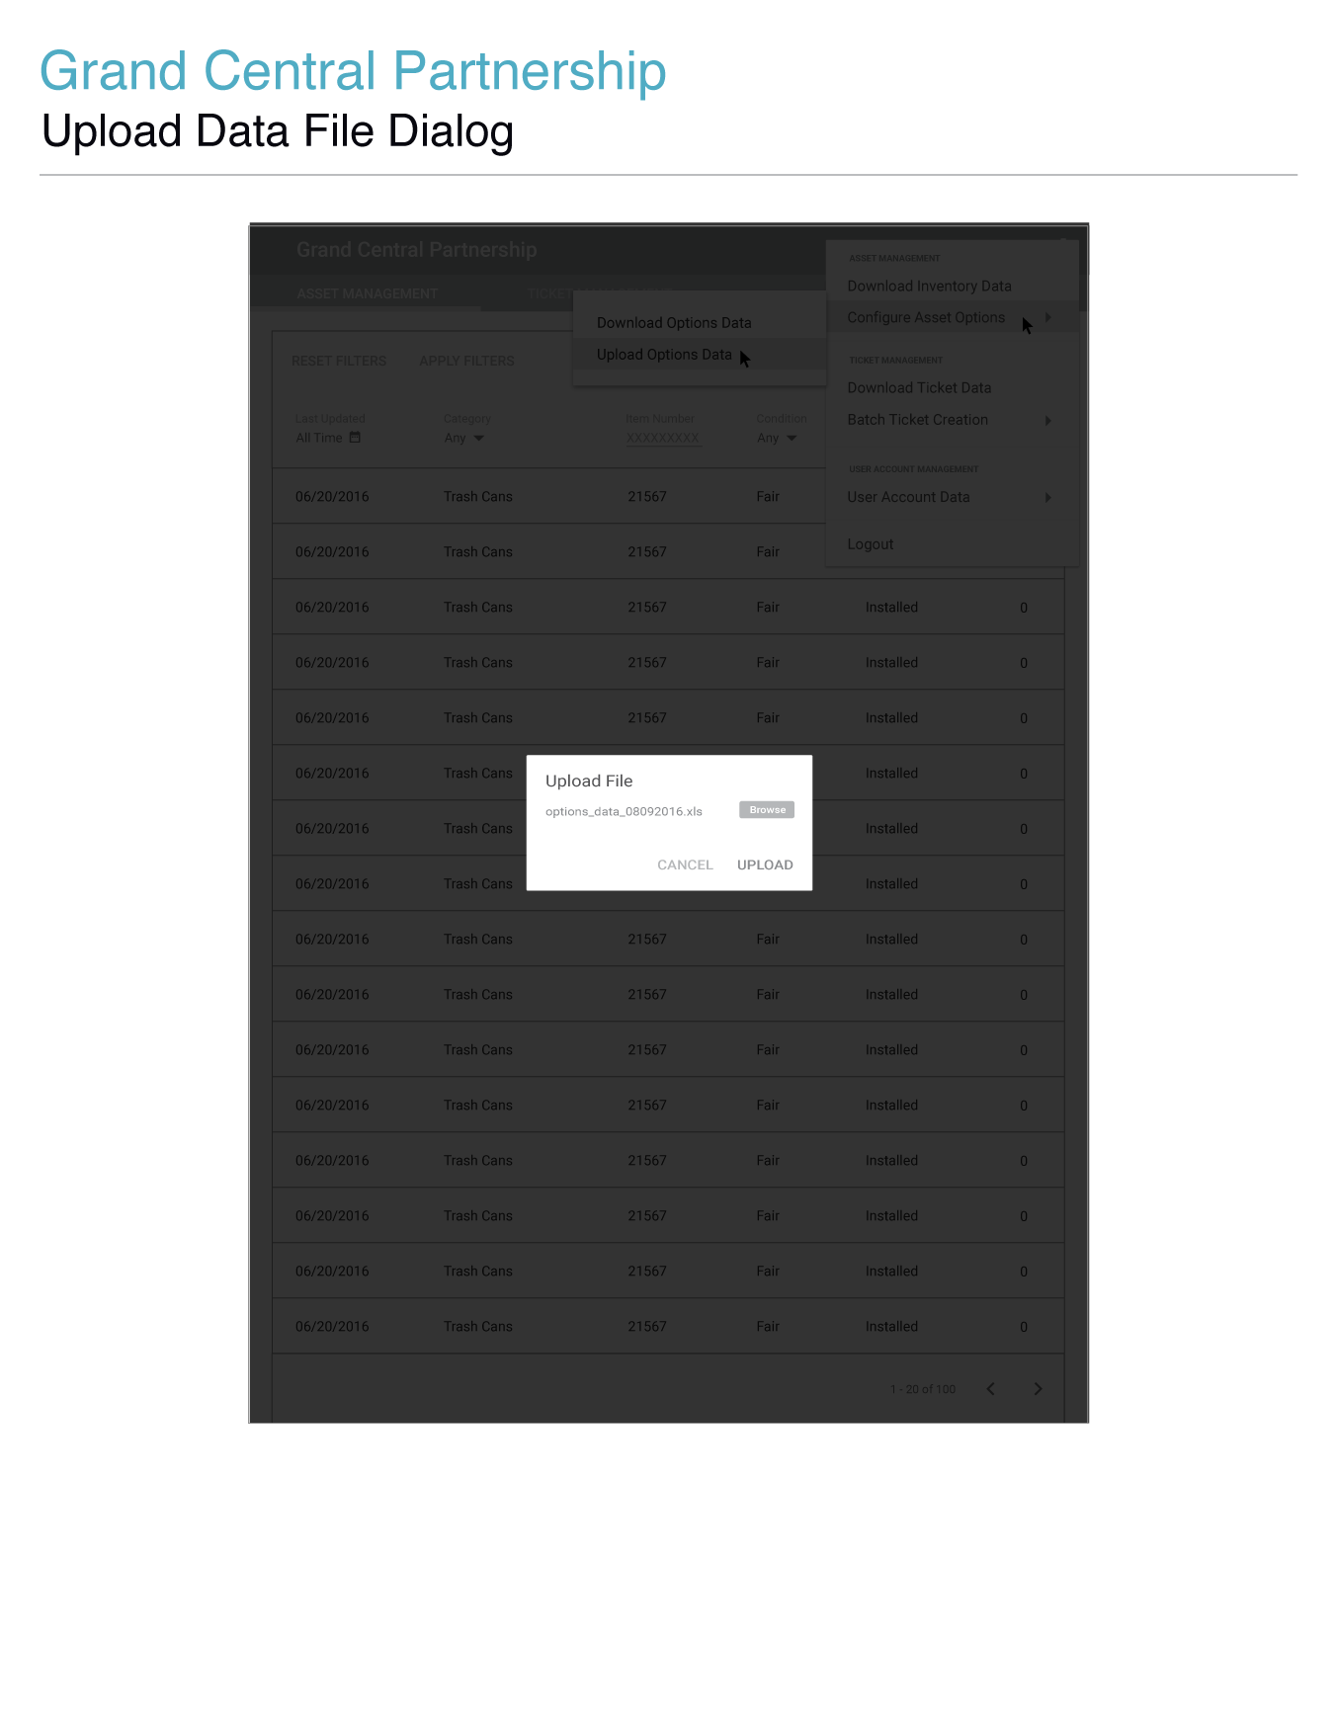

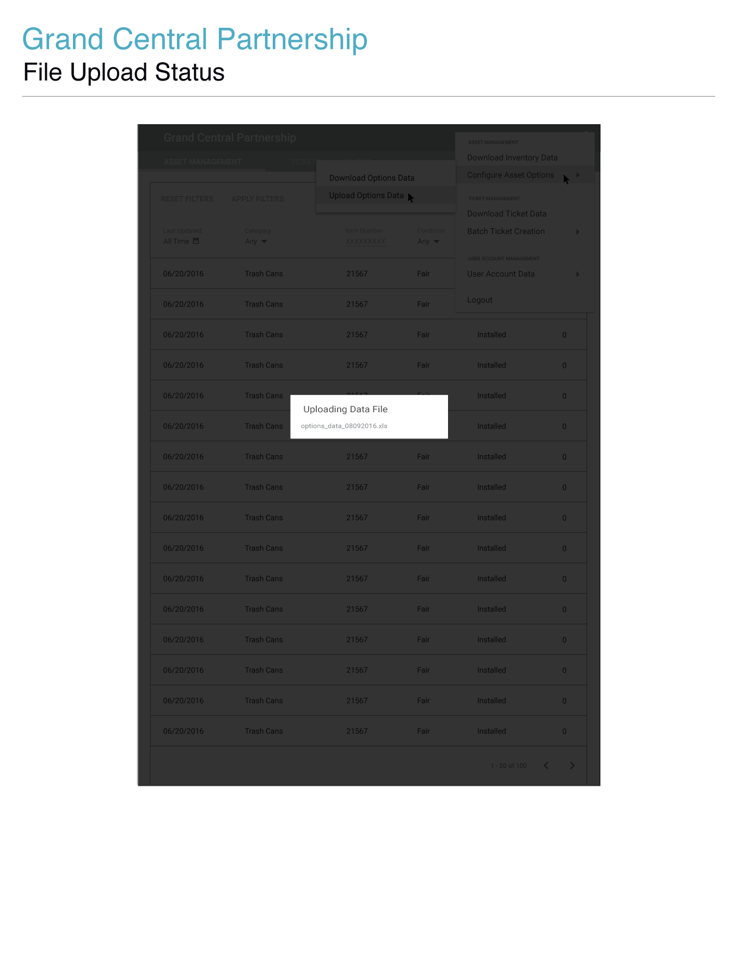

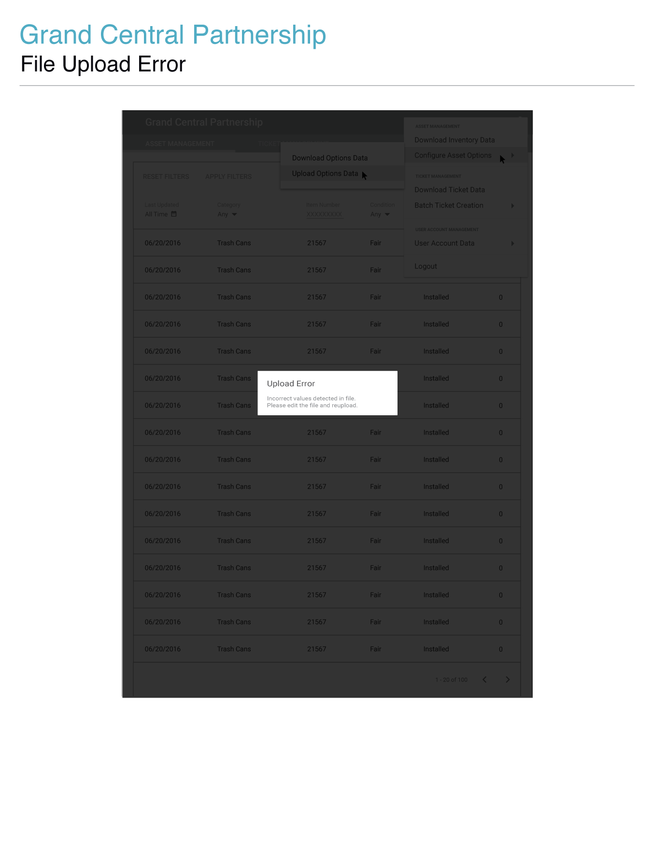

| Item | Type | Function |
| --- | --- | --- |
|  |  |  |
| Data Upload Dialog | Dialog | * The data upload dialog will transition to view after the user’s click any of the data upload menu options. The upload button will be disabled upon opening the data upload dialog. To enable the upload button, users must select a data file. * To select a data file, users must click the browse button. When the browse button is clicked a default system specific file selection dialog will come into view allowing users to select the data file they wish to upload. Users will be limited to selecting data files associated with the file types defined by GCP. * If users select a file to upload, but do not upload the data file and close the data upload dialog, the next time the data upload dialog is opened the data file will be cleared from selection and display. Users will have to click the browse button once again to select a data file to upload. * After a data file has been selected, the upload button will become enabled allowing users to upload the selected data file. The file’s name will display next to the browse button. * The uploading of the data file will initiate once the upload button is clicked. Once the file has uploaded successfully, the data file upload dialog will transition out of view and a confirmation message will transition into view at the bottom of the browser window. After a few moments of being in view, the confirmation message will transition out of view. * If the user clicks cancel or the area outside of the dialog content container, the dialog will transition out of view. But while a file is in the process of uploading, the overlay will be locked in place. |

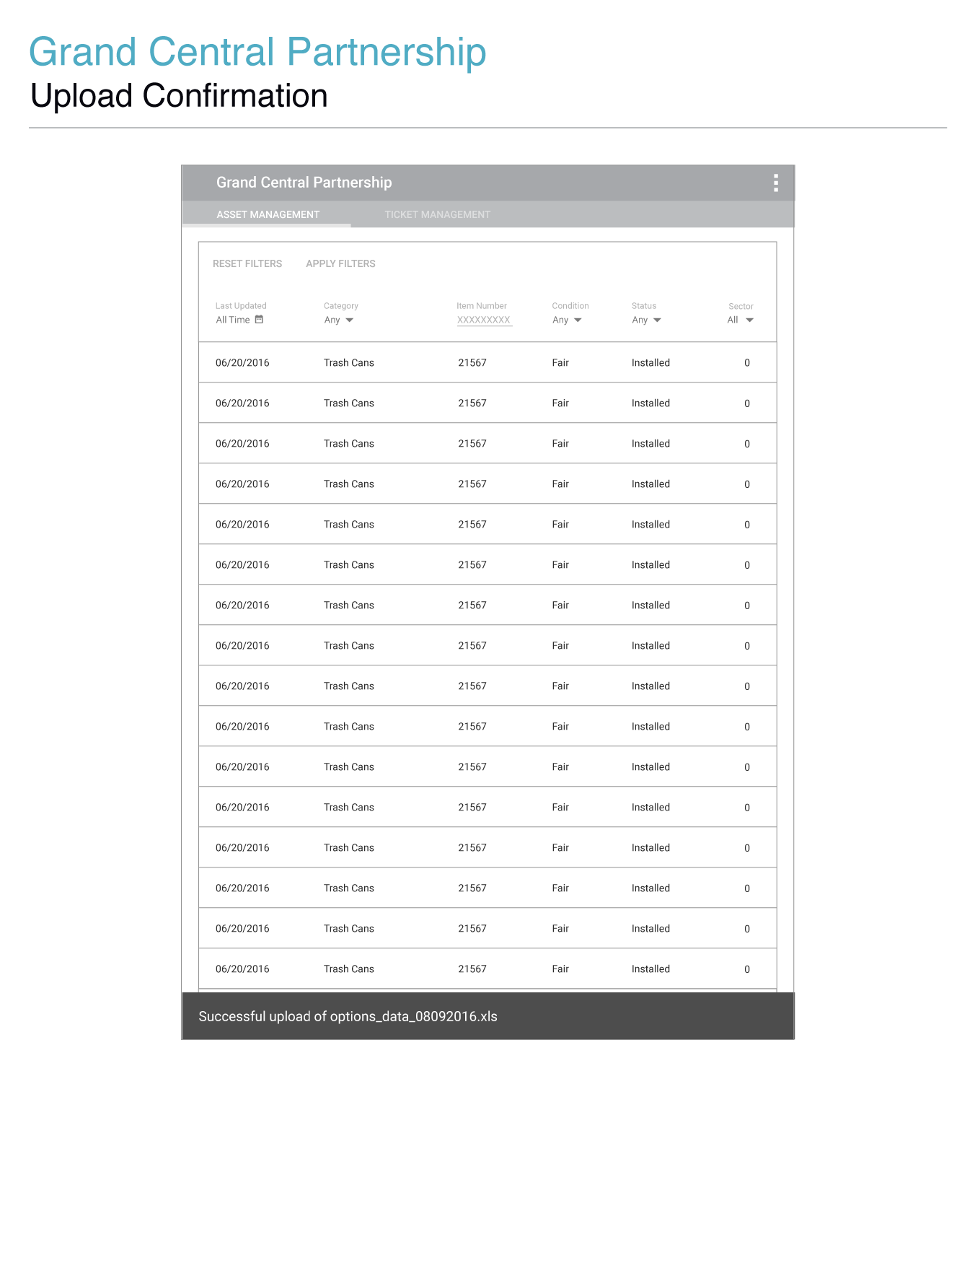

| Item | Type | Function |
| --- | --- | --- |

|  |  |  |
| --- | --- | --- |
| Data Upload Confirmation | Text | .   * Once the file has uploaded successfully, the data file upload dialog will transition out of view and a confirmation message will transition into view at the bottom of the browser window. After a few moments of being in view, the confirmation message will transition out of view. |

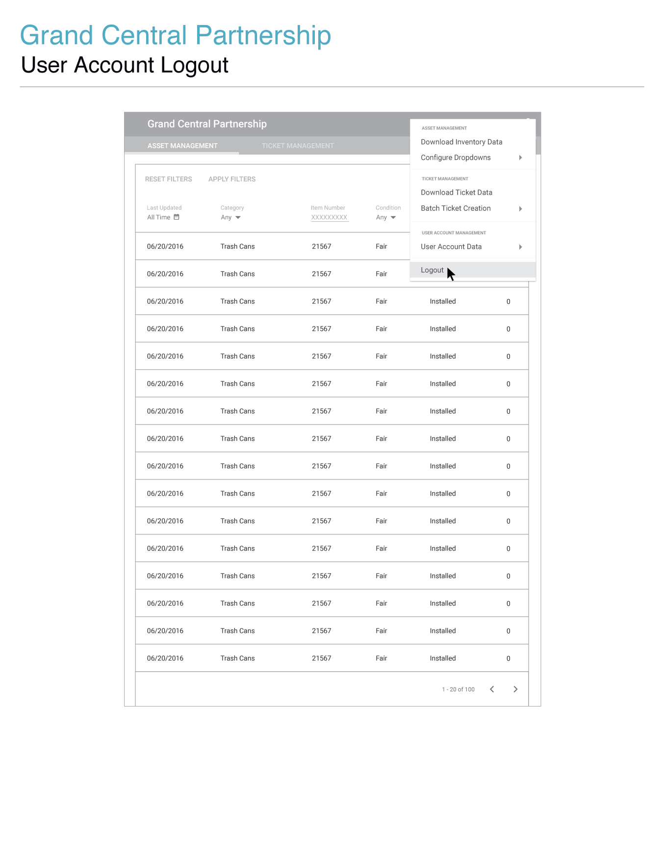

### _imgs/_09_logout_confirm_00.png

| Item | Type | Function |
| --- | --- | --- |
| Logout | Button | **When clicked a dialog will transition into view containing:**     * A header identifying the purpose of the logout dialog. * Text prompting users to confirm whether or not they wish to logout of the GCP Asset Management Dashboard. * A cancel button for closing the logout confirmation dialog. * A second logout button for users to finalize their logging out of the GCP Desktop Admin Dashboard. |

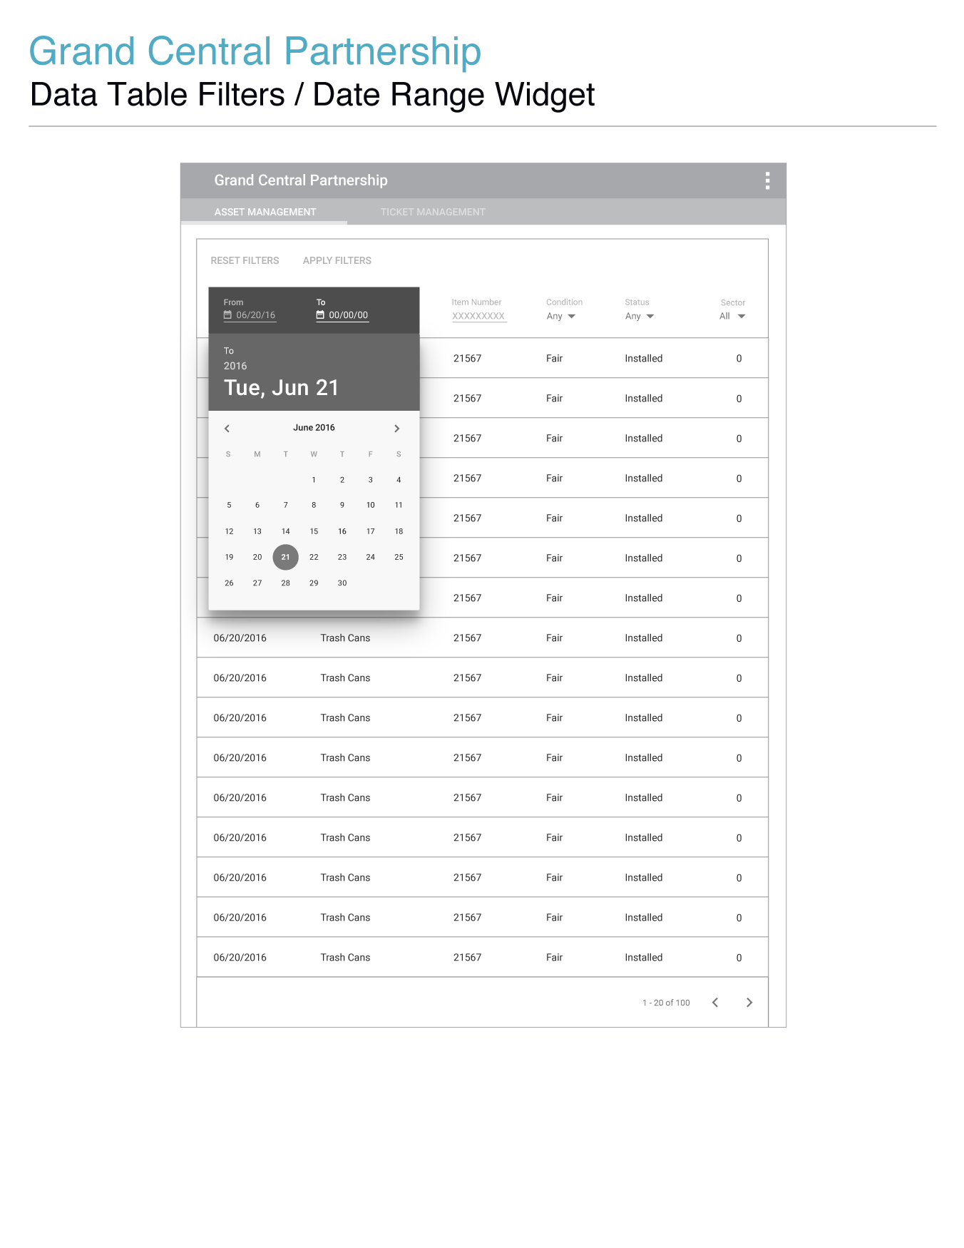

| Item | Type | Function |
| --- | --- | --- |
| Column Headers | Buttons | * By default, the ticket management data table is sorted by the most recently updated ticket, in descending chronological order. * Clicking a column label will toggle between sorting a data table in ascending/descending alphabetical/numerical/chronological order depending on the data type stored within the column label’s column. * Closed tickets will remain at the bottom of the ticket list, unless the closed filter is selected and applied to the ticket management data table. |
| Apply Filters | Button | * This is to assure users that the selected options will be applied as they intended. It allows for users to view and compare the information displayed before the filters are applied. Updating the results in real-time can cause increased load times/extra unnecessary stress on the server. Also by not updating the results in real-time without page refresh, users can undo filter changes and/or return to previous filter selections by clicking their browser's back button.   **When clicked:**   * The entered/selected filter setting(s) will be applied to the data table. * The data table will return to its original visibility state. * Pagination buttons will be enabled. * Column labels will return to static states, displaying both the column label and text for any filters applied for that column. |
|  |  |  |
| Reset Filters | Button | * When clicked all filters will reset to their default placeholder text and the data table will reset to its default state. * Only becomes enabled once a filter setting has been entered or selected. |
| Date Created | Date Range Picker/Button | * When clicked a date range picker will display allowing users to select from a date and to a date. * The date range picker will open to the **From** date enabled and the current day highlighted. The date range picker will not collapse or activate the **To** date once a **From** date is selected. * To select a **To** date users must click on the **To** date button at the top of the widget. * Users can select a date by clicking on a date in view. To change the month users can click the left and right arrows to cycle through the months of the year. To change the year users can click the year button displayed above the date/day header text in a lowered opacity.   **When the year is clicked:**   * The dates will transition from view * A scrollable list of years will transition into view * The year will transition to full opacity * The date/day combination will transition to a lowered opacity * To display dates again users must click the date/day button below the year at the top of the widget.   **When the date/day button is clicked:**   * The scrollable list of years will transition out of view * The dates/days will transition into view * The date/day button at the top of the widget will transition to full opacity * The year will transition to a lowered opacity * Users must click outside of the date range picker in order to close it. |

## 

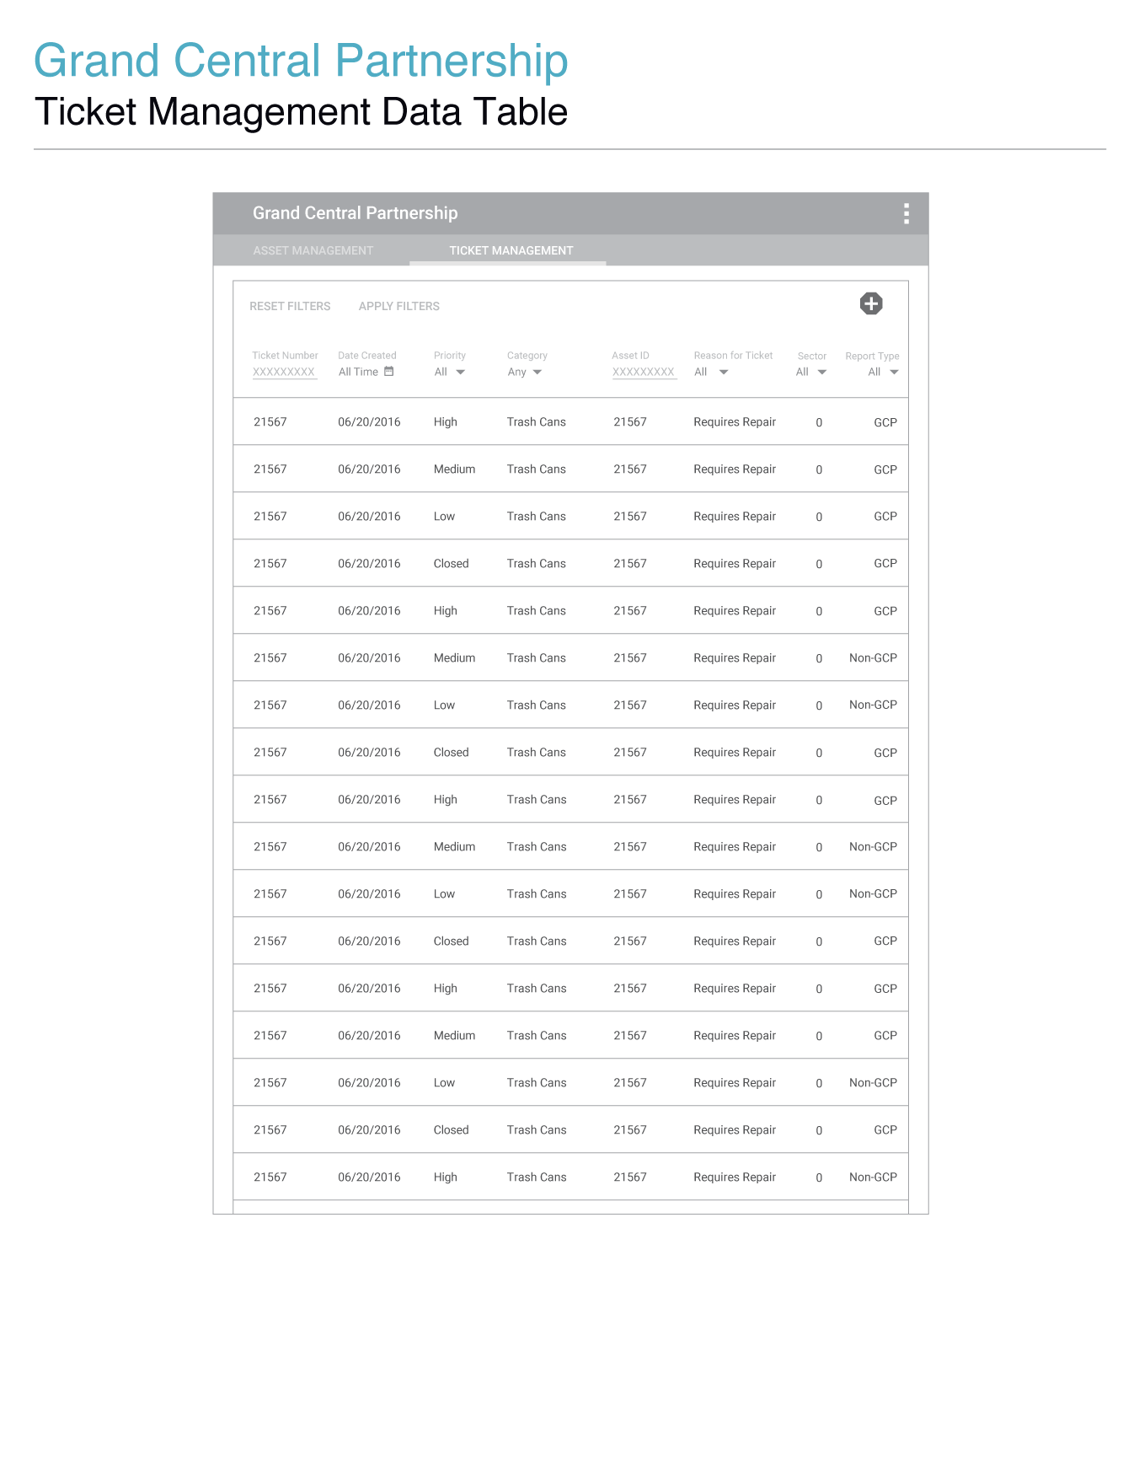

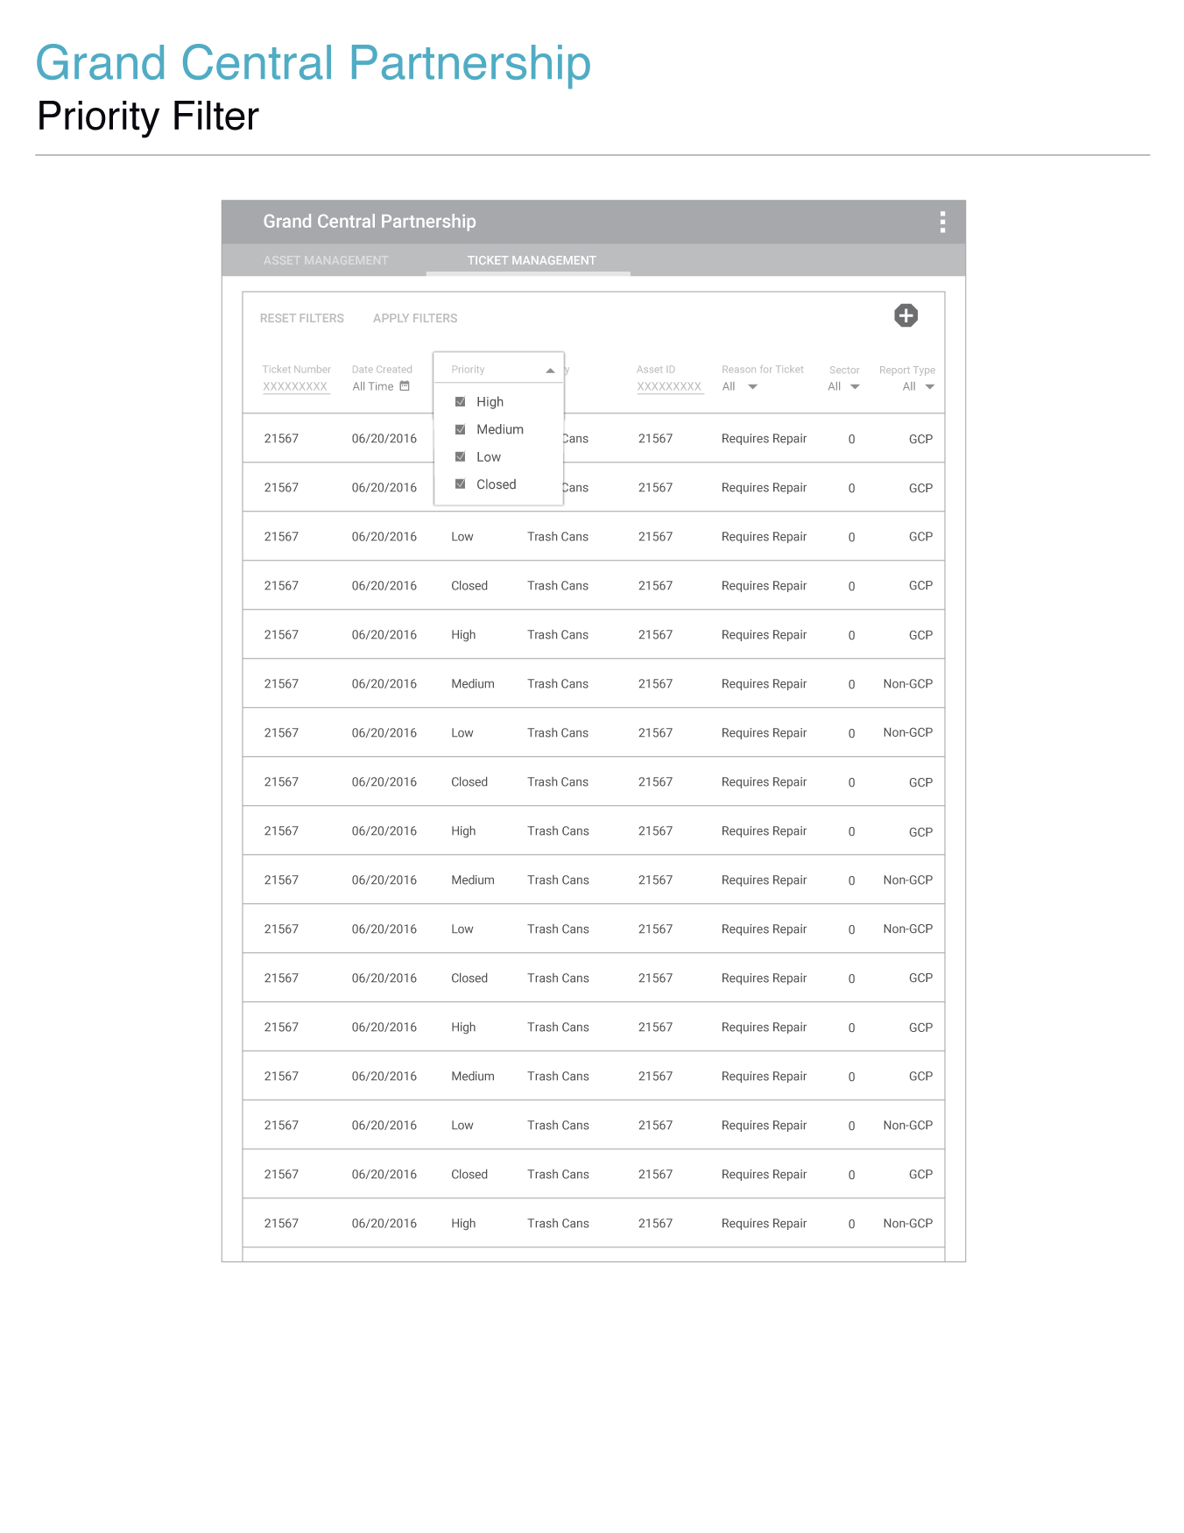

|  |  |  |
| --- | --- | --- |
| Item | Type | Function |
| Ticket Number | Text | * When clicked the input field will transition to an active state. A partial or full ticket ID may be entered to limit the scope of results displayed in the ticket management data table. * The ticket number filter can only be applied once a minimum of 4 characters have been entered in the text field, and after clicking the ‘Apply Filter’ button. |
| Date Created | Date Range Picker/Button | * When clicked a date range picker will display allowing users to select a **From** date and a **To** date. |
| Priority | Dropdown Menu/Checkbox Inputs | * When clicked, a vertically listed menu will transition into view containing checkboxes for filtering tickets based on their set priority. |
| Category Menu | Dropdown Menu | * When clicked, a vertically listed menu will transition into view containing menu options for the asset categories defined by GCP. |
| Asset ID | Text | * Asset ID will be assigned to a ticket. |
| Reason for Ticket | Dropdown Menu | * When clicked, a vertically listed menu will transition into view containing menu options for reasons of submitting a ticket. |
| Sector | Dropdown Menu | * Dropdown menu containing options for sectors set by GCP. |
| Report Type | Dropdown Menu | * Menu for filtering GCP and non-GCP assets. |
|  |  |  |

|  |  |  |
| --- | --- | --- |
|  |  |  |
|  |  |  |

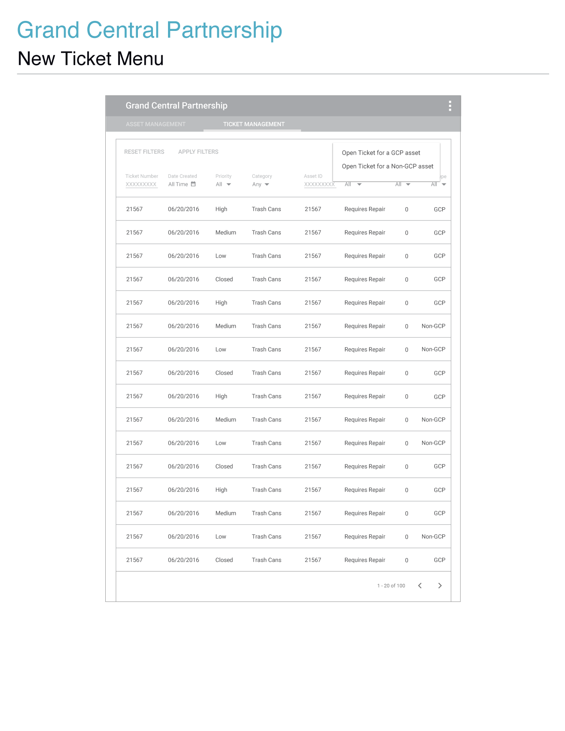

|  |  |  |
| --- | --- | --- |
| Item | Type | Function |
| Open a Ticket for a GCP Asset | Button | * Click to open a ticket for a GCP owned asset ticket. |
| Open a Ticket for a Non-GCP Asset | Button | * Click to open a ticket for a non-GCP owned asset ticket. |

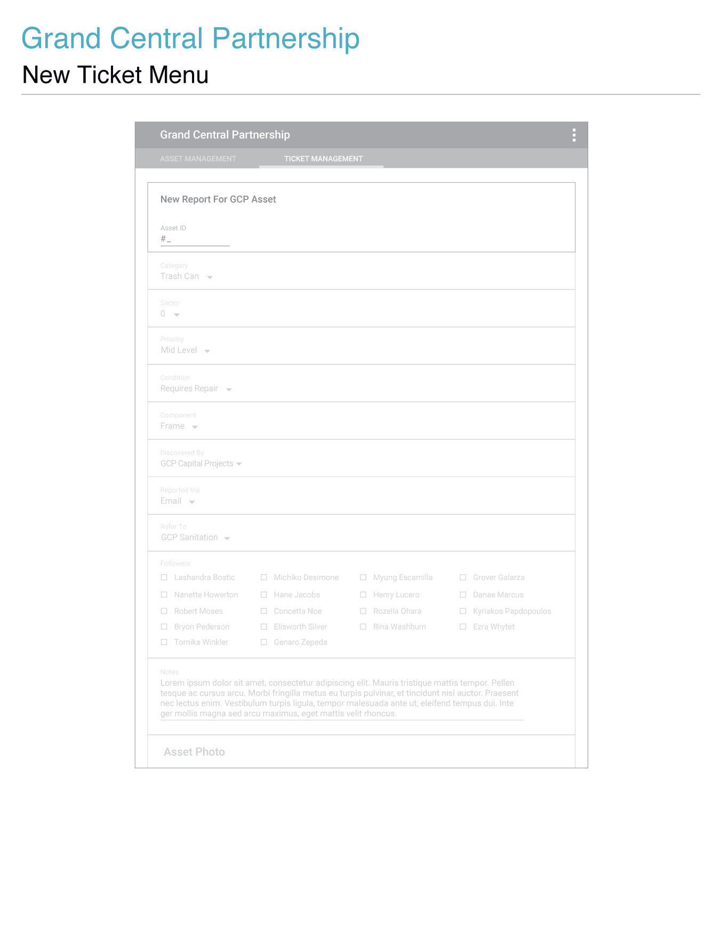

## _imgs/_15_new_ticket_error_00.png

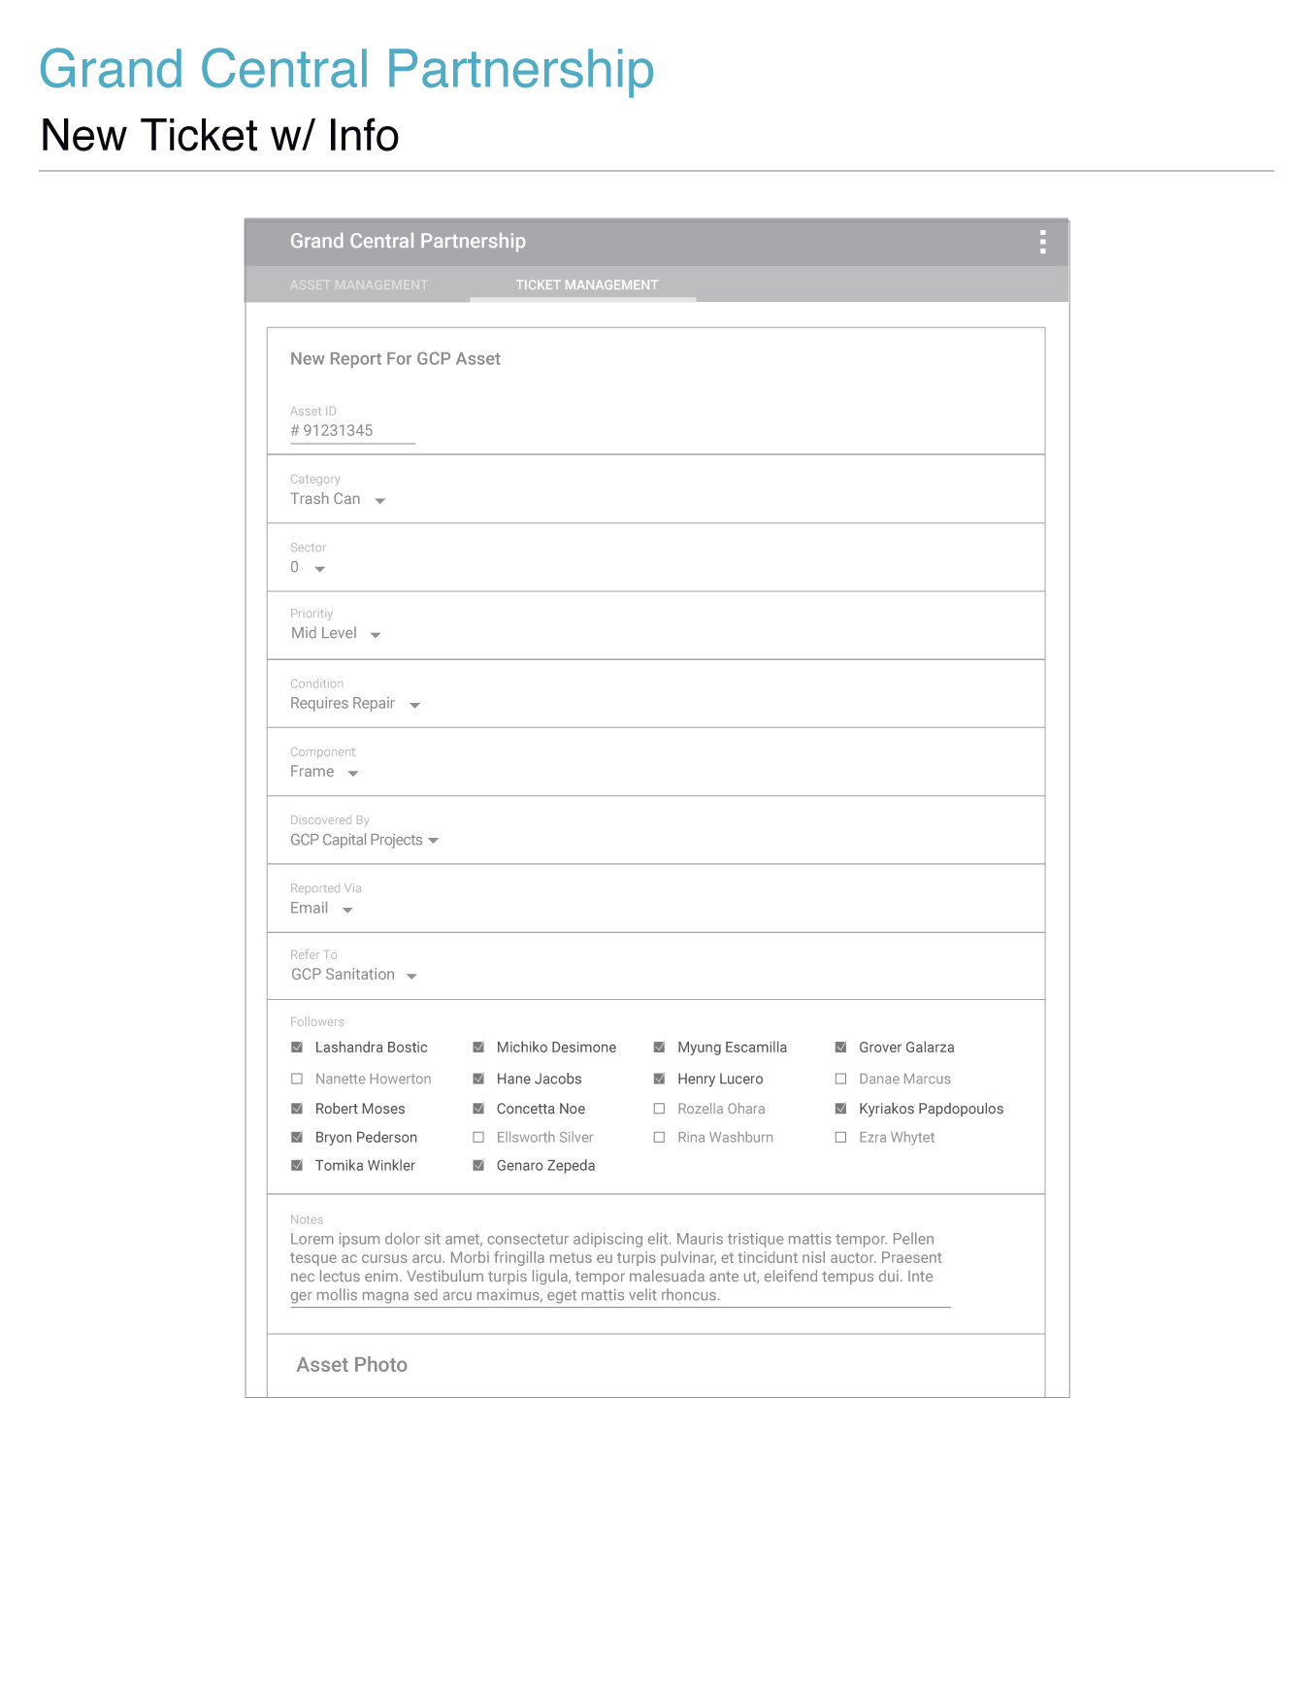

**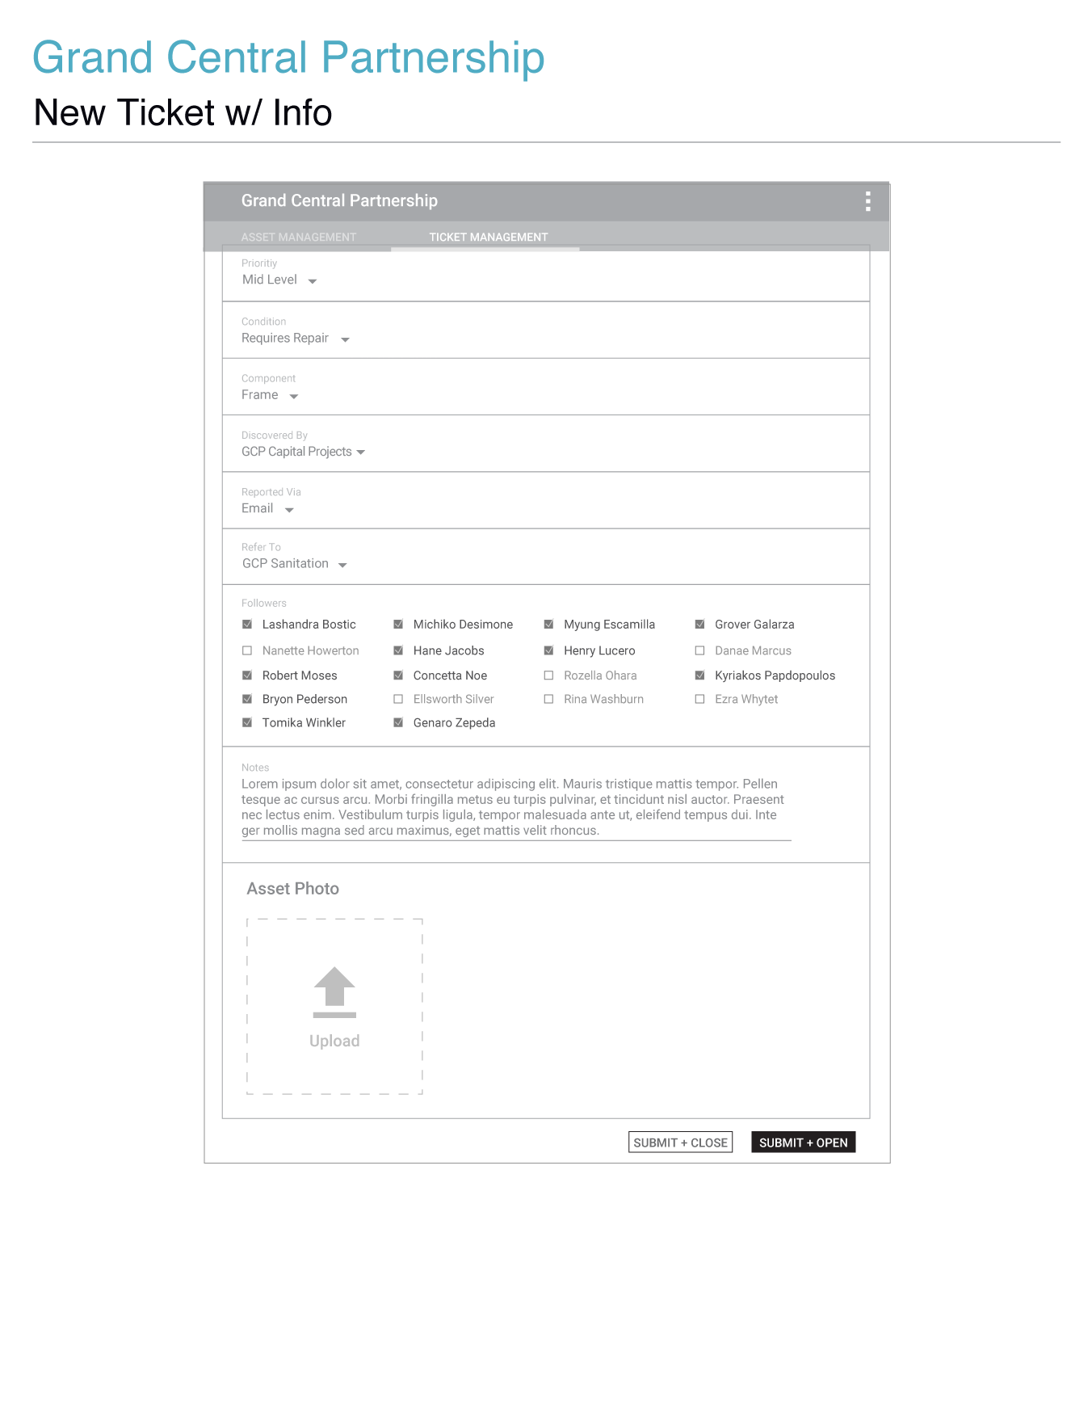**

**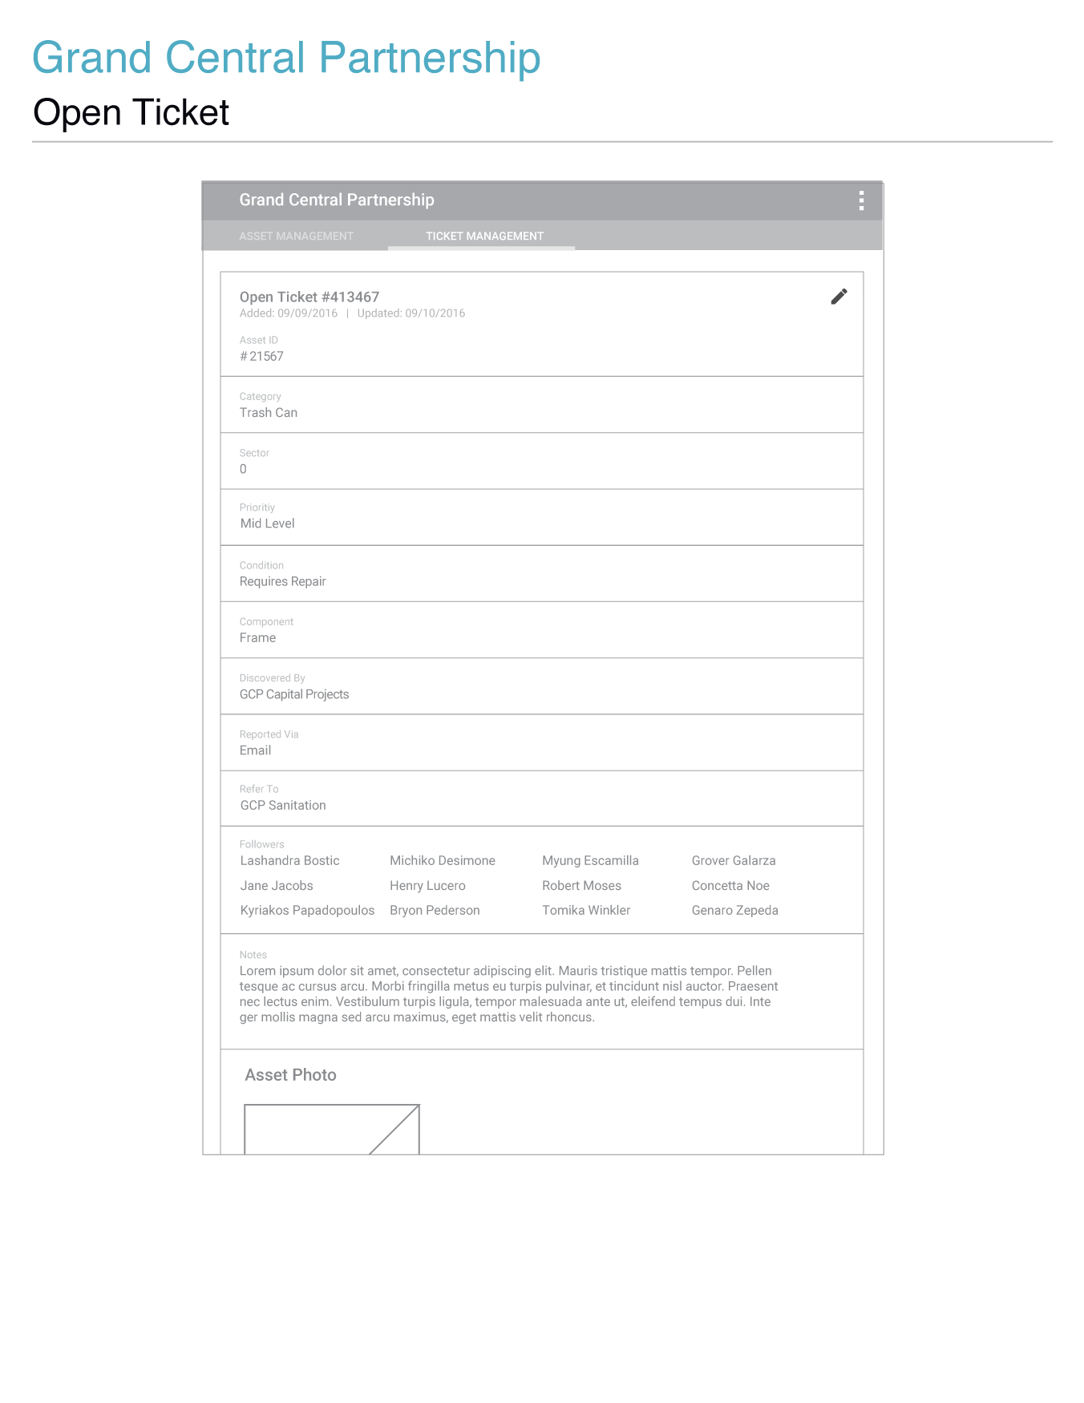**

**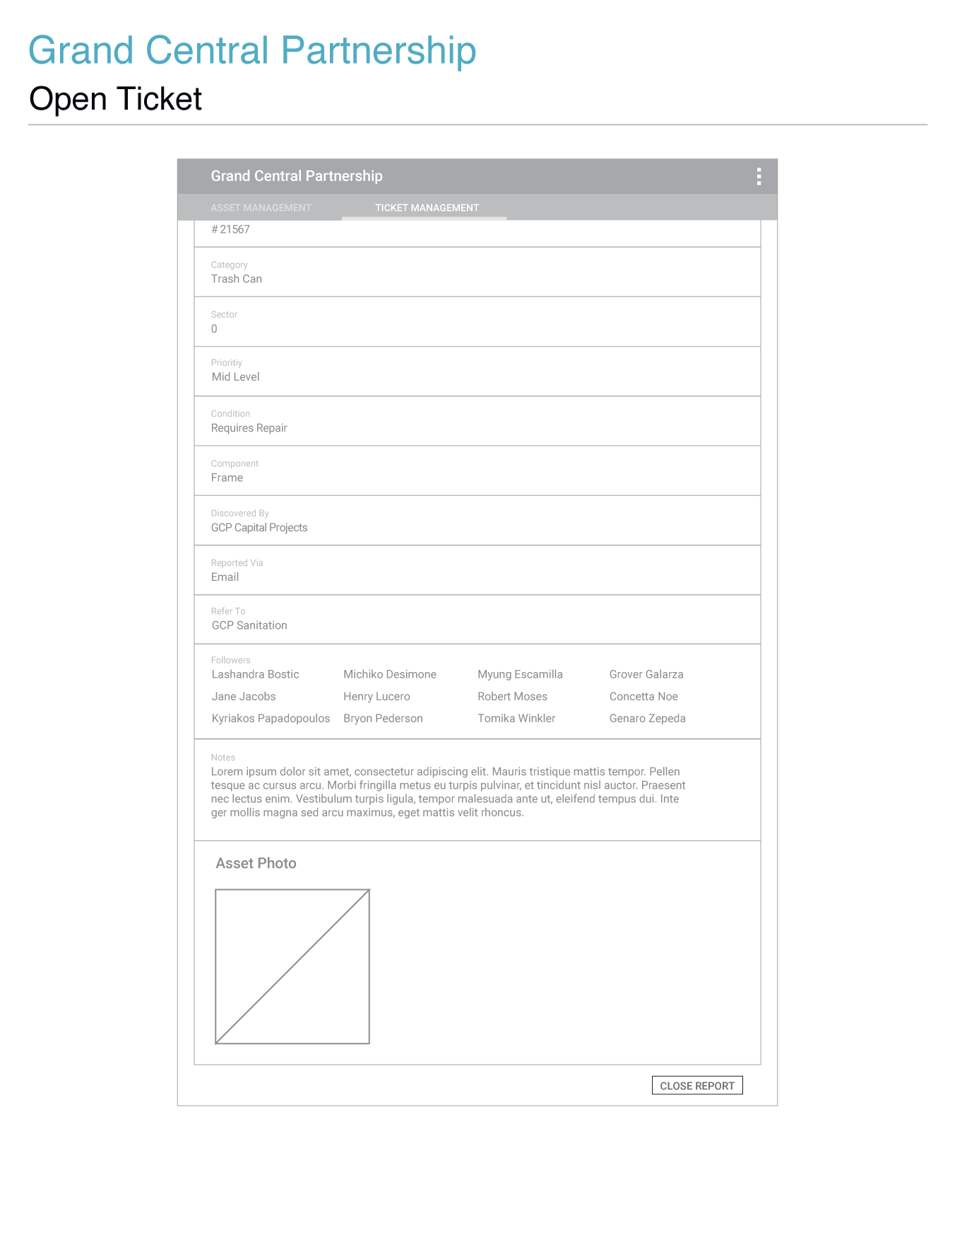**

**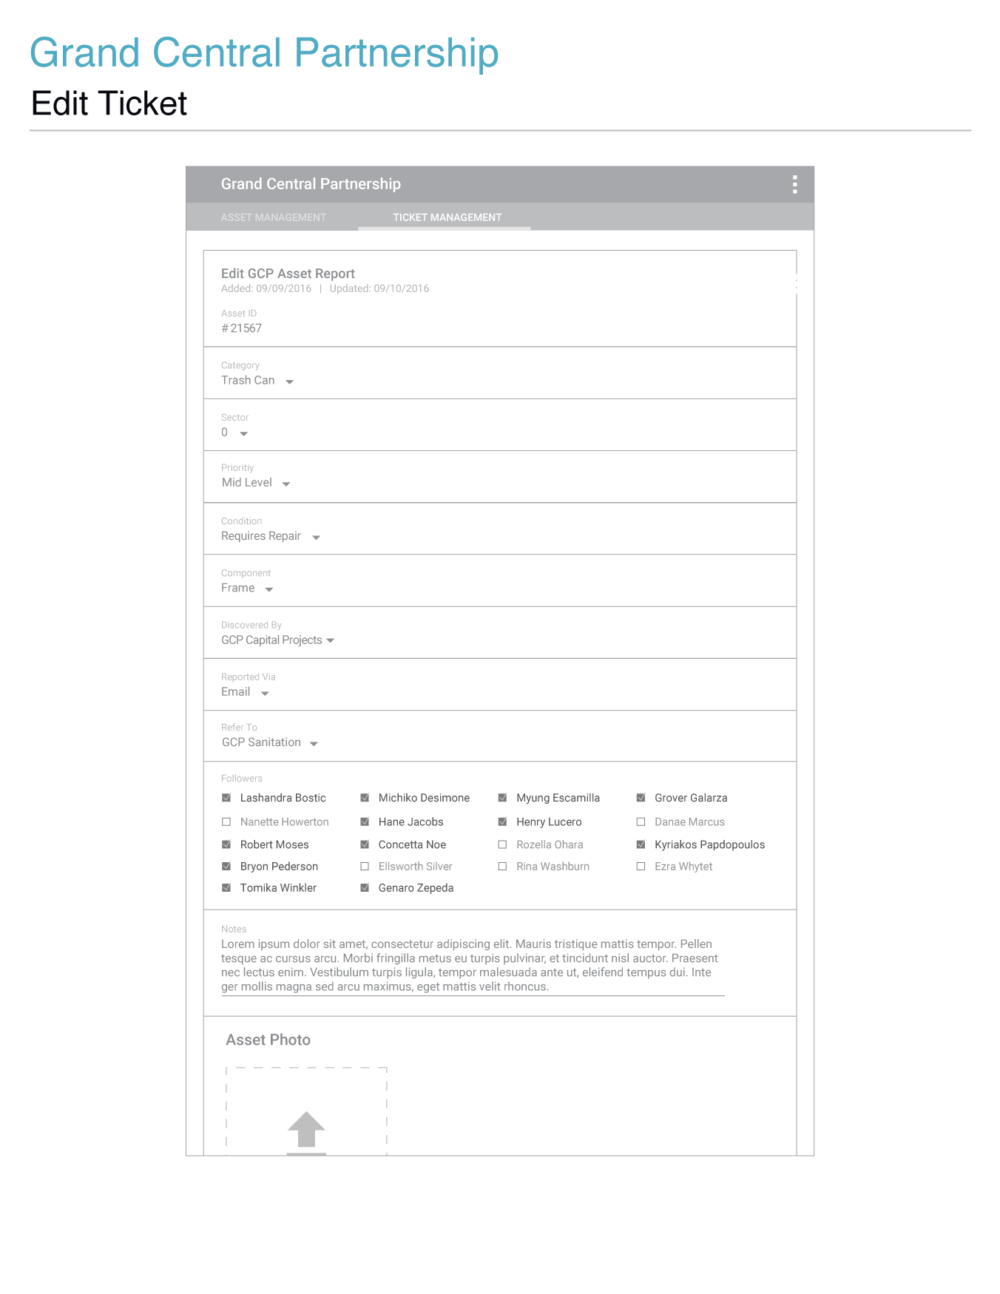**

**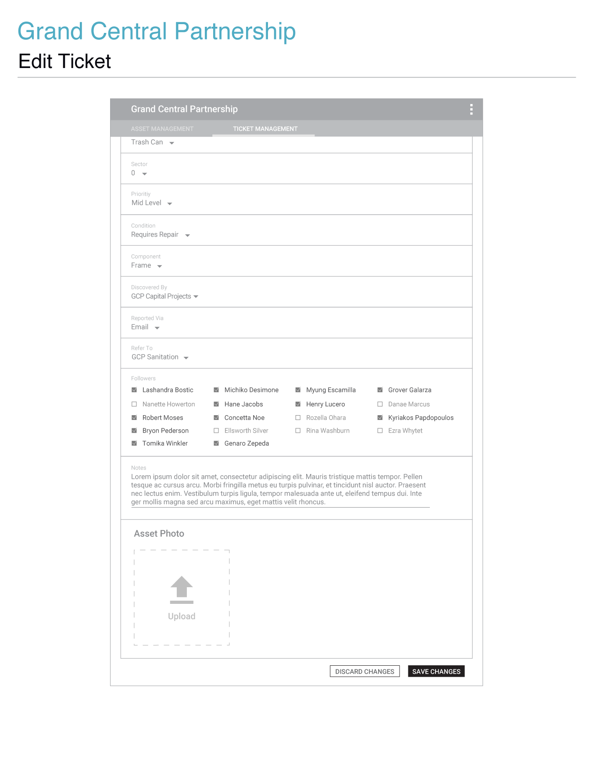**

**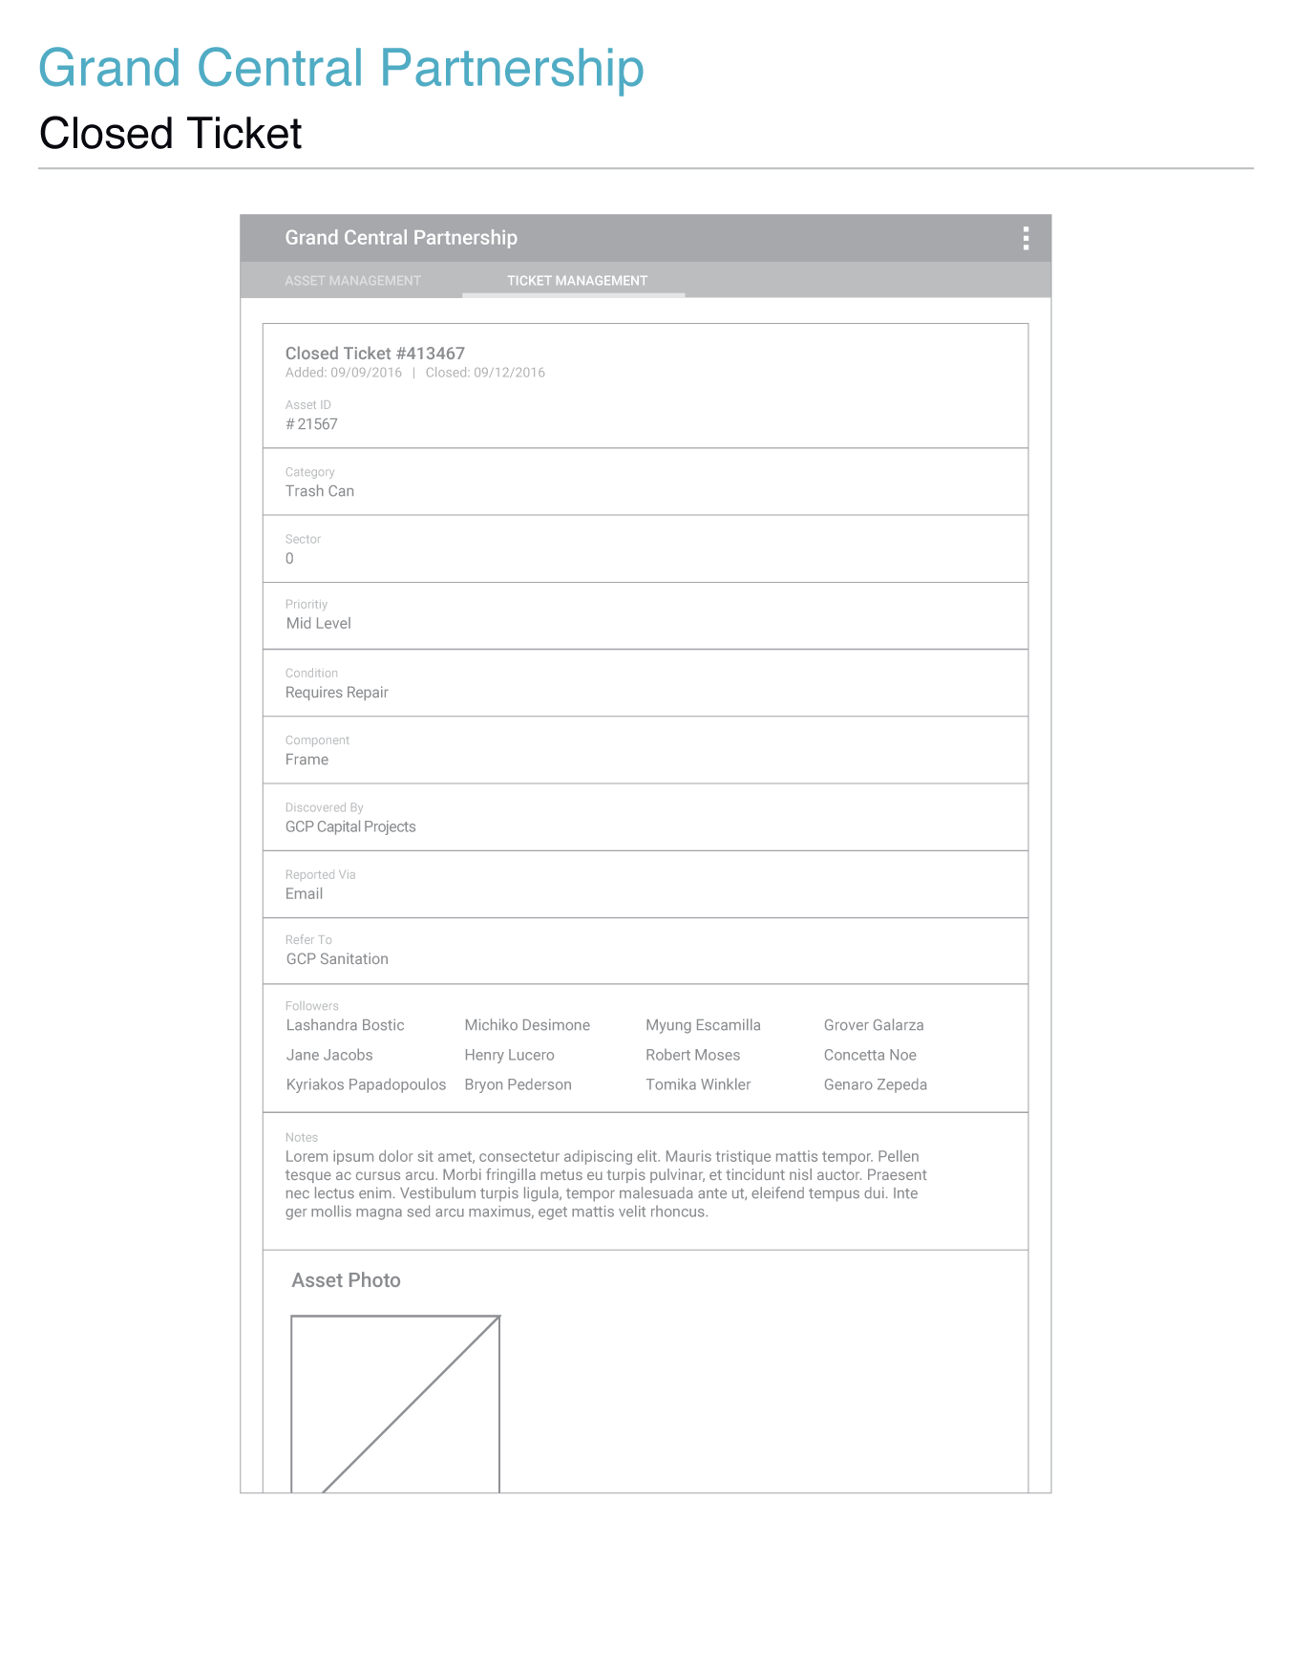**

**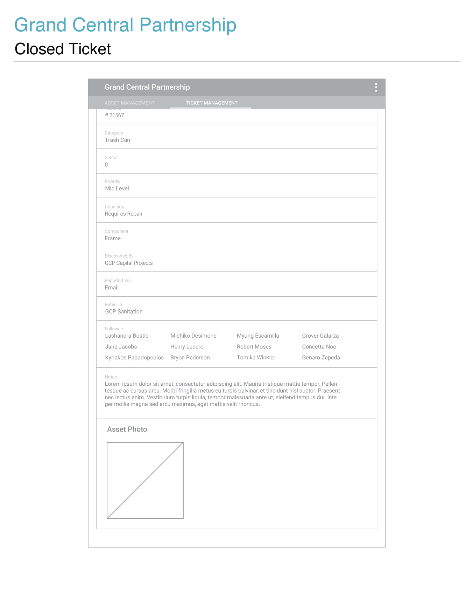**

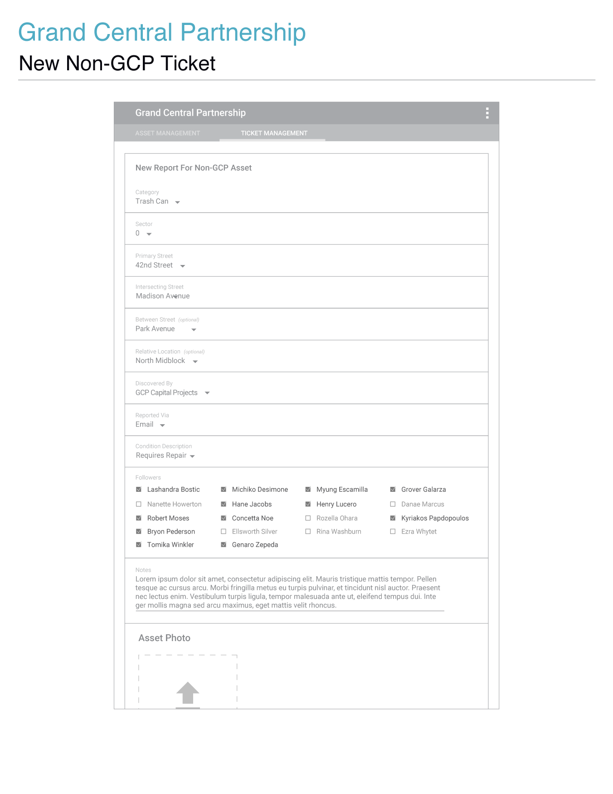

## _imgs/_25_new_non_gcp_00.png

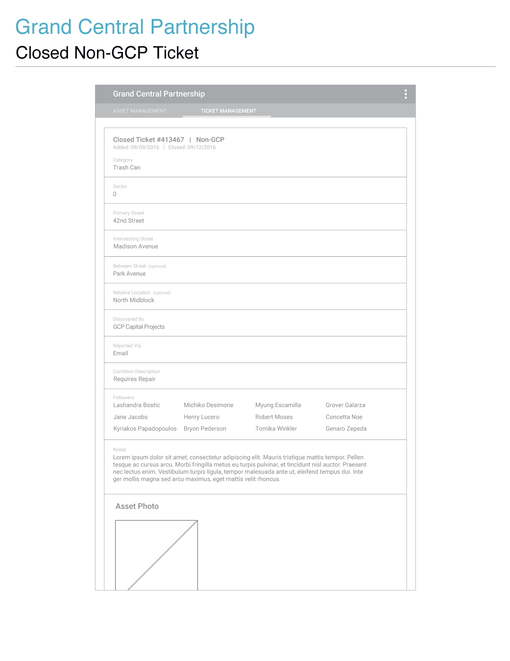

| Item | Type | Function |
| --- | --- | --- |
| GCP Header | Button | * When clicked users will be redirected to the asset data table page. Provides users with domain level location status. |
| Asset Report Header | Text | * Text providing context to the information within the displayed section. |
| Asset ID Input Field  *\*required* | Text Input Field | * An asset ID must be entered in the asset ID field for validation. When a valid asset ID is entered, the fields below will become enabled. As users enter an asset ID, asset IDs matching the first three entered characters will display below this field as suggested results.  If the entered asset ID does not have a match in GCP’s asset database, then an error will display and the entered ID and field label will highlight in red to visually communicate the error.Only once all the fields are filled will the buttons at the bottom of the form become enabled.Non-GCP asset reports/tickets will be an exception to asset ID validation and geo-location data. |
| Category  *\*required* | Dropdown Menu | * All tickets require users to select an asset category for the asset they are reporting on. When tapped a dropdown menu will transition into view and will contain options for the asset categories defined by GCP. Once a category is selected the menu will transition out of view and the selected category will display as the active option for the input. |
| Sector  *\*required* | Dropdown Menu | GCP's territory will be split among several designated sectors. This dropdown menu allows users to select the sector of the asset that is being reported on. |
| Priority  *\*required* | Dropdown Menu | When tapped a dropdown menu will transition into view containing options for choosing the priority level of the report.Once an option is selected the menu will transition out of view and the selected option will display as the activated option for this input. |
| Condition  *\*required* | Dropdown Menu | Ticket reports require users to document the condition of the asset that is being reported on. When tapped a dropdown menu will transition into view and containing options for an asset’s condition. Once a condition is selected the menu will transition out of view and the selected condition will display as the activated option for this input. |
| Component  *\*required* | Dropdown Menu | Ticket reports require users to document the component of the asset that’s being reported on. Contains options for selecting a component that is relative to the asset that is being reported on. |
| Discovered By  *\*required* | Dropdown Menu | Menu option for selecting who/which organization originally filed the ticket report. |
| Reported Via  *\*required* | Dropdown Menu | Ticket reports require users to document the method used for creating and submitting a report. |
| Refer To  *\*required* | Dropdown Menu | Menu option for selection which organization will be responsible for resolving the ticket. |
| Followers | Checkboxes | Checkboxes paired with fullnames as labels. Anyone who is checked off will receive updates and notifications regarding the ticket. |
| Notes | Text Field | If users have any notes they wish to include in their ticket report they may do so here. |
| Asset Photo | Photo Attachment Module | If users wish to attach photos with their ticket report they may do so.Photos can either be uploaded via local storage or by capturing a photo with a device’s native camera utility. |
|  |  |  |

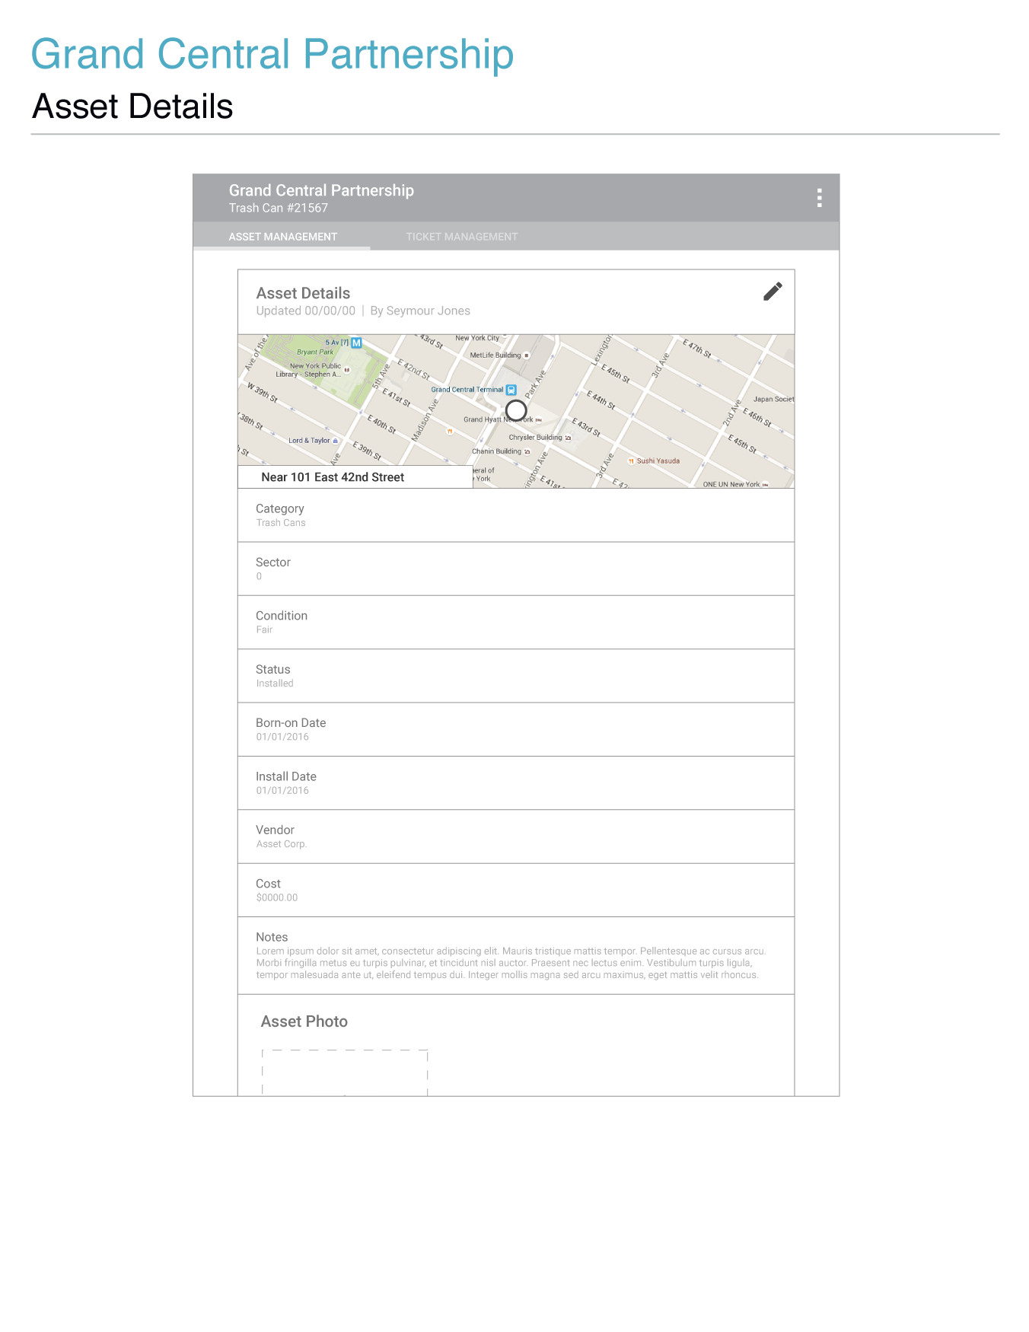

## _imgs/_27_asset_edit_00.png

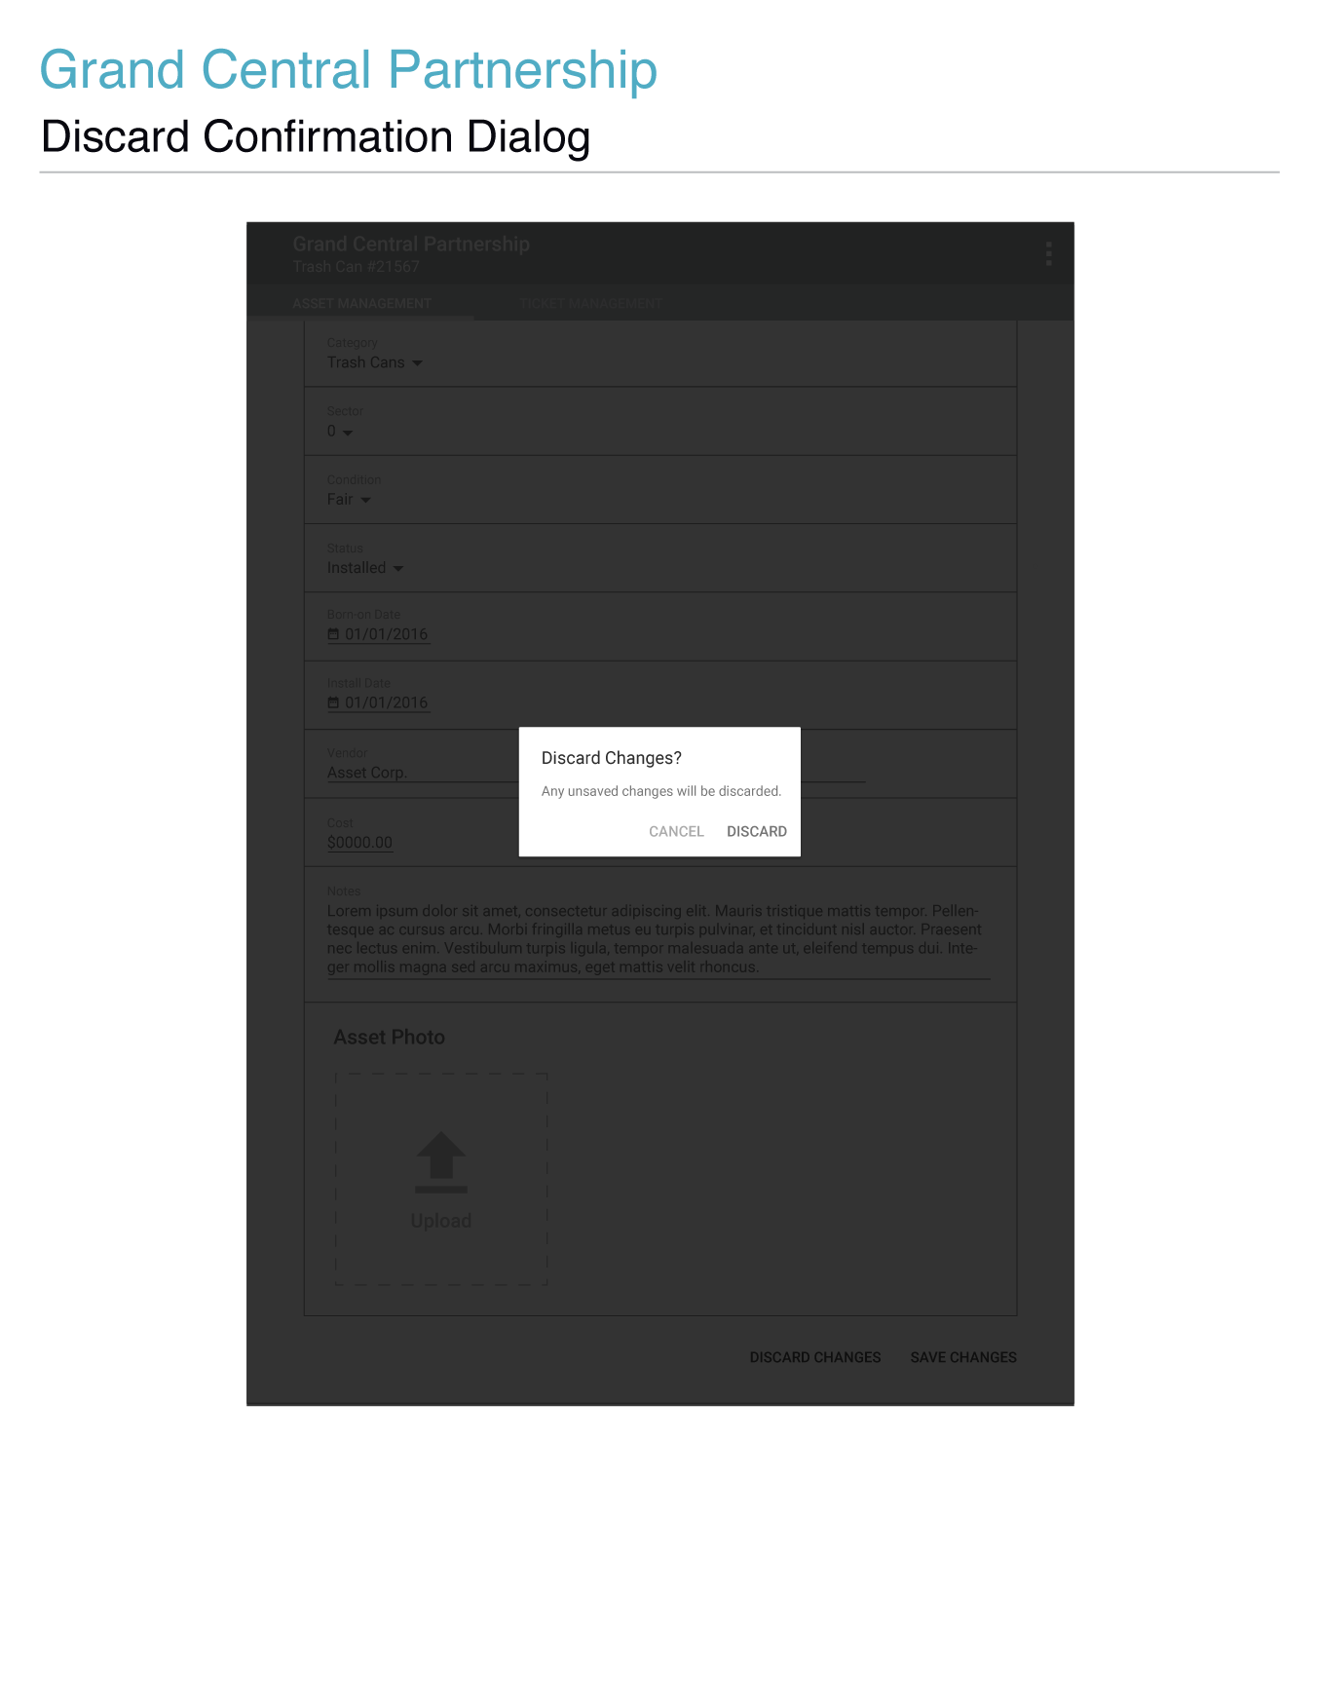

## _imgs/_29_save_dialog_00.png _imgs/_30_save_confirm_00.png

| Item | Type | Function |
| --- | --- | --- |
| GCP Header | Button | * When clicked users will be redirected to the asset data table page. Provides users with domain level location status. |
| Asset Details Header | Text | * Text providing context to the information within the displayed section. |
| Date Updated | Text | * Text displaying the last time the asset's information was updated. |
| Updated by | Text | * Text displaying the name of the user who updated the asset’s information last. |
| Edit Icon | Button | * When clicked the current screen will transition out of view and a screen will transition into view displaying input fields containing active selections/information previously entered, relative to the information displayed on the static asset details screen. * Not displayed while in edit mode. |
| Asset Location | Image (not editable) | * Image of the asset's location, and approximate address of the asset. |
| Category | Text | * A display of the asset's category. |
| Category (edit mode) | Dropdown | * Assets require a category to be associated with them. When clicked a dropdown menu will transition into view and will contain all the options for the asset categories defined by GCP. Once a category is selected the menu will transition out of view and the selected category will display as the activated option for this input. |
| Condition | Text | * A display of the asset's condition. |
| Condition (edit mode) | Dropdown | * When clicked a dropdown menu will transition into view and will contain all the options for the asset conditions defined by GCP. Once a condition is selected the menu will transition out of view and the selected condition will display as the activated option for this input. |
| Status | Dropdown | * A display of the asset's status. |
| Status (edit mode) | Dropdown | * When clicked a dropdown menu will transition into view and will contain all the options for the asset statuses defined by GCP. Once a status is selected the menu will transition out of view and the selected status will display as the activated option for this input. |
| Born-on Date | Text | * A display of the asset's born-on date. |
| Born-on Date (edit mode) | Date Picker | * When clicked a date range picker will display. Functions the same way as the date range picker filter, but only allows a single date selection. |
| Install Date | Text | * Display of the asset's install date. |
| Install Date (edit mode) |  | * When clicked a date range picker will display. Functions the same way as the date range picker filter, but only allows a single date selection. |
| Vendor | Text | * A display of the asset's vendor. |
| Vendor (edit mode) | Text Field | * Text field for entering the name of an asset’s vendor. |
| Cost | Text | * A display of the asset's cost. |
| Cost (edit mode) | Text Field | * Text field for entering the cost of an asset. Only allows numerical characters. |
| Notes | Text | * A display of notes regarding the asset. * Character limit for notes section in Report Detail screen will be 1024. |
| Notes (edit mode) | Text Field | * Text field for entering notes about an asset. |
| Asset Photo | Image | * If an image of an asset was submitted it will display as a thumbnail image. * If users click the thumbnail a dialog containing the full image will come into view. * If the user clicks the area outside of the overlay image container, or clicks the Android back button, the dialog will transition out of view and leave users where they left off prior to clicking the body of the thumbnail. |
| Asset Photo (edit mode) | Widget | * If upload is clicked the device's default file selection dialog will come into view allowing users to choose an identifying image for the asset. One photo can be added for one asset. Five photos can be added for one ticket. * After uploading an image of an asset, a thumbnail of that image will display with its file name and an 'x' button overlaying the bottom of the image. When the 'x' button is clicked a dialog will transition into display prompting users to confirm whether or not they wish to remove the photo they had just uploaded or captured. * If users click the remove button in the dialog, the dialog will transition out of view, the thumbnail will be removed from the add asset form, and the upload button will replace the thumbnail of the deleted image. If the user clicks cancel or the area outside of the dialog content container, the dialog will transition out of view and leave users where they left off prior to clicking the 'x' button. * If users click the body of a thumbnail, a dialog containing the full image will come into view. * If the user clicks the area outside of the overlay image container, the dialog will transition out of view and leave users where they left off prior to clicking the body of the thumbnail. |
| Discard Changes (edit mode) | Button | * Becomes enabled once changes are made. * When clicked a dialog will transition into view prompting users to confirm whether or not they wish to discard changes that were made to the asset in view. If users click cancel or the area outside of the dialog content container, the dialog will transition out of view. * If users click discard changes, then the changes will be discarded, users will be redirected to the asset details page, and a message confirming the discarding of changes to the asset will transition into view at the bottom of the browser window and display for a few moments before transitioning out of view. |
| Save Changes (edit mode) | Button | * Becomes enabled once changes are made. * When clicked a dialog will transition into view prompting users to confirm whether or not they wish to save changes to the asset in view. If users click cancel or the area outside of the dialog content container, the dialog will transition out of view. * If users click save changes, then the will be saved to the asset in the GCP Asset Management database, users will be redirected to the asset details page, and a message confirming that the changes were saved will transition into view at the bottom of the browser window and display for a few moments before transitioning out of view. |

## _imgs/_31_delete_option_00.png

## _imgs/_32_delete_dialog_00.png

### _imgs/_33_delete_confirm_00.png

|  |  |  |
| --- | --- | --- |
| Item | Type | Function |
| Delete Asset | Button | * This option is specific to the asset details and asset edit pages. * When clicked a dialog will transition into view prompting users to confirm whether or not they wish to delete the asset in view. If users click cancel or the area outside of the dialog content container, the dialog will transition out of view. * If users click delete, then the asset will be removed from the GCP Asset Management database, users will be redirected to the asset data table, and a message confirming the removal of the asset will transition into view at the bottom of the browser window and display for a few moments before transitioning out of view. Any filters that were active prior to the user navigating to the asset details/edit asset pages should be set and active when the asset data table loads on redirect. * Character limit for notes section in delete asset popup box will be 1024. |

## _imgs/_34_asset_labels_00.png