**Exercise 8**

*Get started with Cassandra and import data via Spark*

**Prior Knowledge**

Unix Command Line Shell

HDFS

Simple Python

Spark Python  
Simple SQL syntax

**Learning Objectives**

Understand Cassandra’s CQL shell

Integrate Python, Cassandra and Spark

Load data from CSV into Cassandra using Spark Python

**Software Requirements**

* Apache Spark 2.3.0
* Python 3.7
* Apache Cassandra 3.11.1
* Nano text editor or other text editor

**Part A**

1. Install Cassandra
   1. mkdir -p ~/opt/packages/cassandra/
   2. Change into that directory and download the latest release of cassandra from Apache:
      1. <https://downloads.apache.org/cassandra/3.11.6/>
   3. tar xzvf apache-cassandra-3.5-bin.tar.gz
   4. ln -s ~/opt/packages/cassandra/apache-cassandra-3.11.6 ~/opt/cassandra
   5. Update your .bash_profile:
      1. # Cassandra  
         if [ -d "$HOME/opt/cassandra" ]; then  
         export PATH="$PATH:$HOME/opt/cassandra/bin"  
         fi
   6. source your .bash_profile
   7. verify your cassandra installation by typing: cassandra -v. It should give you the version number 3.11.6
2. Start cassandra: cassandra -f. You should see a lot of logging:

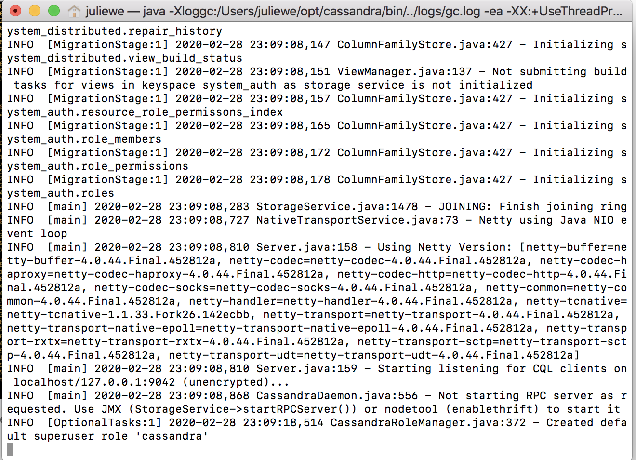

1. Now you can ask Cassandra about its own situation. In a separate terminal window type:  
   nodetool status  
     
   You should see something like:  
   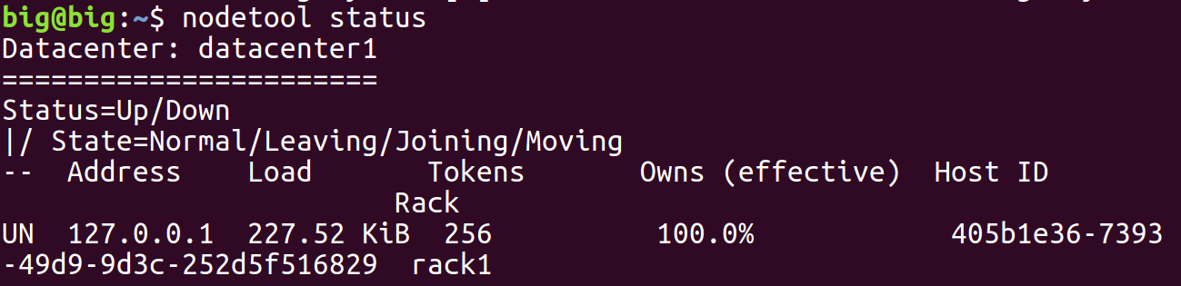

1. You can also try:  
   nodetool info  
   You should see something like:  
   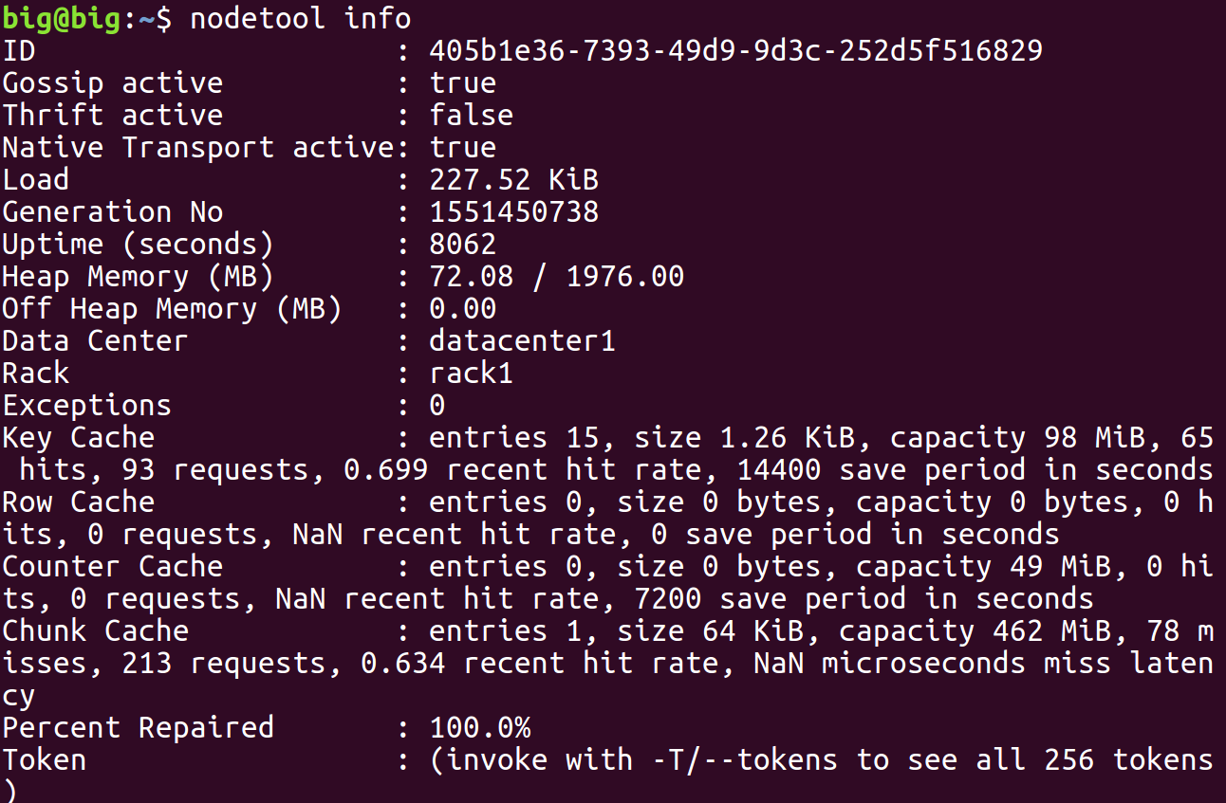
2. Now you can start the Cassandra Shell:  
   Type:

cqlsh  
  
You should see:  
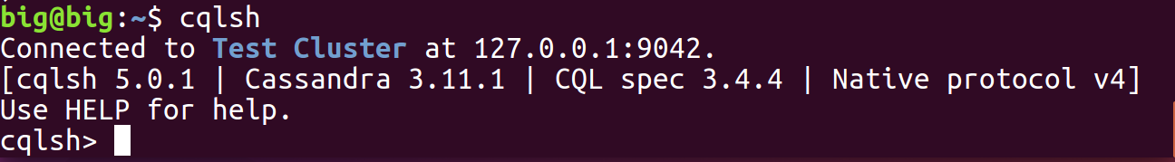  
Let’s create a new database (Keyspace):

* 1. Type (all on a single line)  
       
     CREATE KEYSPACE TEST WITH REPLICATION = { 'class' : 'SimpleStrategy', 'replication_factor' : 1 };
  2. Check it worked:  
     Type:  
       
     desc keyspace test;
  3. You should see:  
       
     CREATE KEYSPACE test WITH replication = {'class': 'SimpleStrategy', 'replication_factor': '1'} AND durable_writes = true;

1. Now we need to select to use that keyspace:  
   use test;
2. The command prompt will change to:  
   cqlsh:test>
3. Let’s create a simple (key, value) table
   1. Type:  
      create table kv ( key text, value text, primary key (key));
   2. Now type  
      desc kv;
   3. You should see:

cqlsh:test> desc kv;

CREATE TABLE test.kv (

key text PRIMARY KEY,

value text

) WITH bloom_filter_fp_chance = 0.01

AND caching = '{"keys":"ALL", "rows_per_partition":"NONE"}'

AND comment = ''

AND compaction = {'class': 'org.apache.cassandra.db.compaction.SizeTieredCompactionStrategy'}

AND compression = {'sstable_compression': 'org.apache.cassandra.io.compress.LZ4Compressor'}

AND dclocal_read_repair_chance = 0.1

AND default_time_to_live = 0

AND gc_grace_seconds = 864000

AND max_index_interval = 2048

AND memtable_flush_period_in_ms = 0

AND min_index_interval = 128

AND read_repair_chance = 0.0

AND speculative_retry = '99.0PERCENTILE';

* 1. Add some simple values:  
     insert into kv (key, value) values ('a','1');

insert into kv (key, value) values ('b','2');

insert into kv (key, value) values ('c','3');

* 1. Now type:  
     select * from kv;  
       
     You should see:  
     key | value

-----+-------

a | 1

c | 3

b | 2

(3 rows)

1. You can also do other simple SQL of course

cqlsh:test> select * from kv where key='a' ;

key | value

-----+-------

a | 1

(1 rows)

1. Type **exit** to leave the cqlsh command line.

**PART B – Loading data from CSV files into Cassandra**

1. Firstly, we need to create a database and a table in which to store our data. Start up the **cqlsh** again and type the following commands

CREATE KEYSPACE wind   
WITH replication = {'class': 'SimpleStrategy', 'replication_factor': '1'};  
  
USE wind;  
  
CREATE TABLE winddata (

stationid text,

time timestamp,

direction float,

temp float,

velocity float,

PRIMARY KEY (stationid, time)

);

1. In order to load the CSV files into Cassandra, we are going to use a Spark package to help us: the Cassandra plugin for Spark.   
     
   *Please note, there are lots of ways of loading CSV data into Cassandra, including a built-in Cassandra utility, which might be easier to use for small datasets.  
     
   This exercise is designed to demonstrate how to integrate Cassandra with Spark. For a really large dataset, if this was loaded from HDFS into Cassandra, this Spark-based approach would have the major benefit of parallelizing the operation.*
2. Start Jupyter as before. Create a new Python3 notebook. Add this code to configure Pyspark to connect to our Cassandra node cluster.

# Configuration related to Cassandra connector & Cluster

import os

os.environ['PYSPARK_SUBMIT_ARGS'] = '--packages com.datastax.spark:spark-cassandra-connector_2.11:2.3.0 --conf spark.cassandra.connection.host=127.0.0.1 pyspark-shell'

The first time when you run this it will take a while because it needs to download a jar file and connect to our Cassandra cluster. You will get output like this

1. Now copy code from

~/BigData/code_jw/starters/big-import.py  
to the notebook.

Let’s look at it line by line.

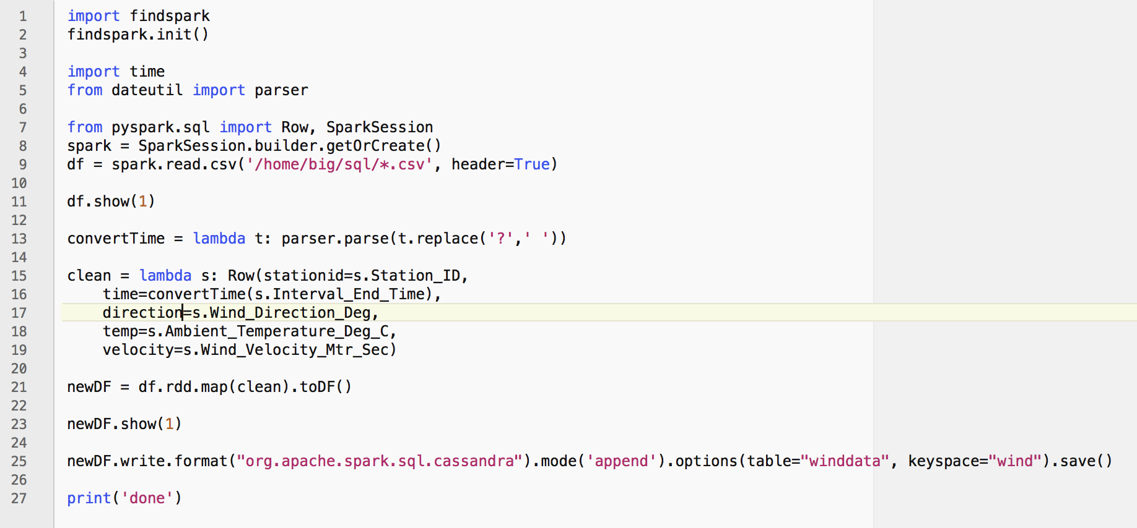

You should recognize lines 1 and 2.  
Line 4-5: dateutil.parser is a useful utility that can read most common date formats.

Lines 7-9: these are just as in the SQL exercise.  
  
Line 11: This will print out one line of the data we’ve read in so we can see the format.  
  
Line 13. This is a function that will parse the date time string into a Python datetime object. Unfortunately the input format is not one recognized by dateutil.parser, but we can easily fix that by removing the ‘?’.

Line 15: this function replaces one Row with another. In the new Row, the names are simpler (and match those we used to create the keyspace). Also the date is formatted using our **convertTime** function.

Line 21: This converts from a dataframe to an RDD, uses map to apply our clean function, and then converts back to a dataframe.  
  
Line 23: This shows our more beautiful dataframe layout.  
  
Line 25: This exports the dataframe to Cassandra, specifying the database and table to use.

1. Run the cell. This will take a bit of time.
2. You should see the following:  
   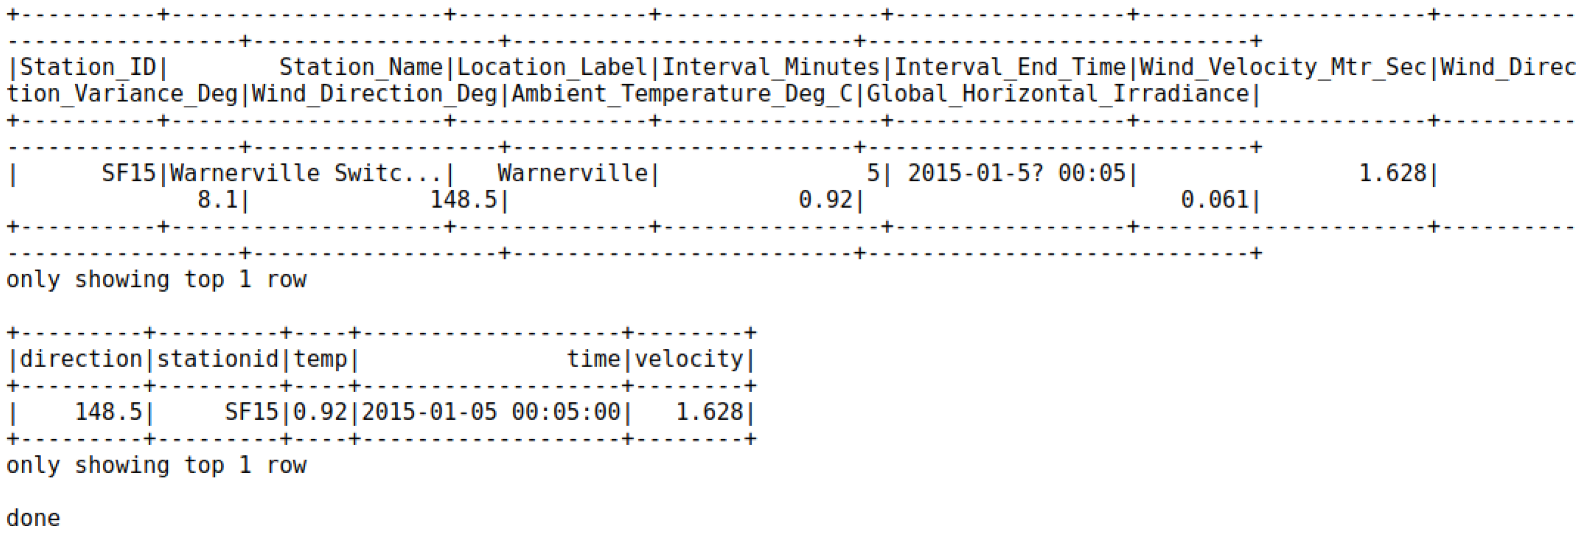
3. Browse to <http://localhost:4040>   
   It will look similar to:  
   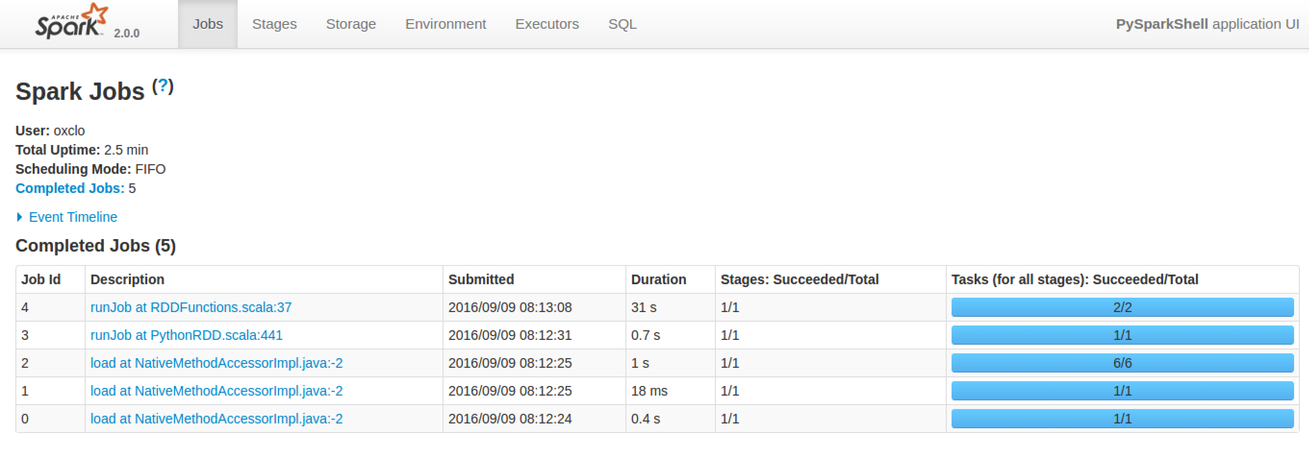
4. Click on the most recent job:   
   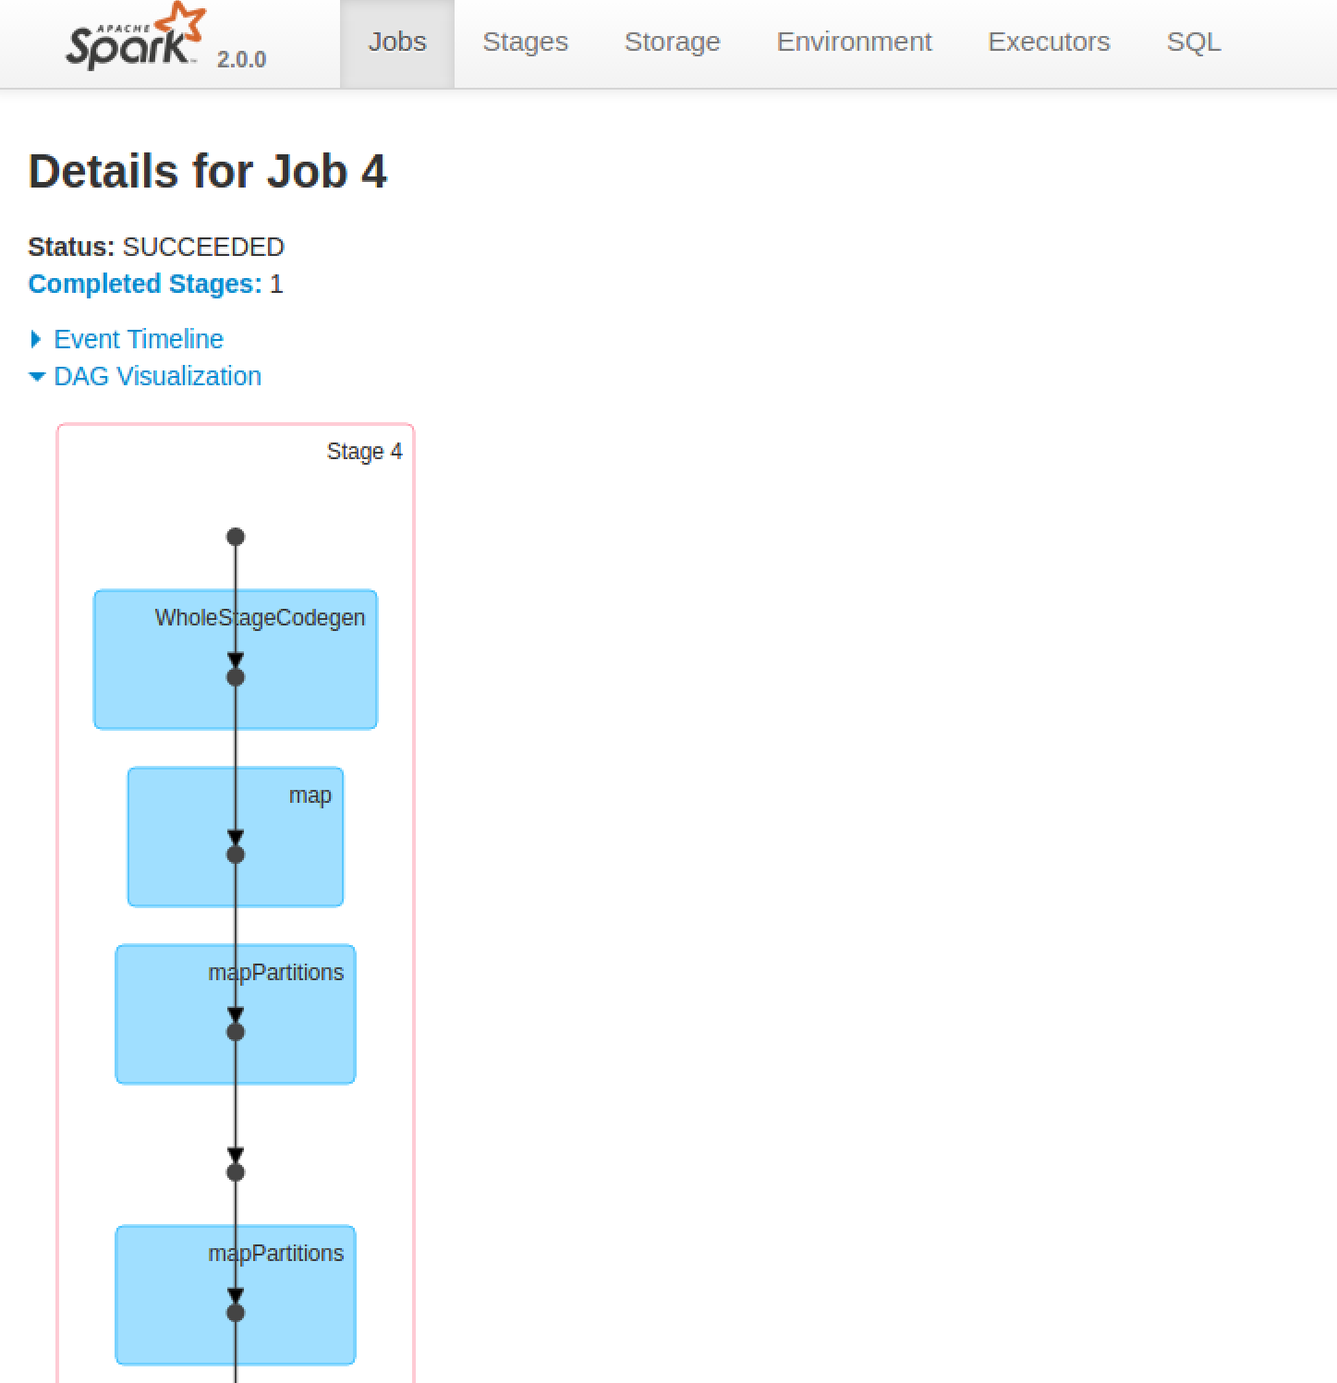
5. You can also get more details by clicking on a stage in the DAG (Directed Acyclic Graph) picture:  
   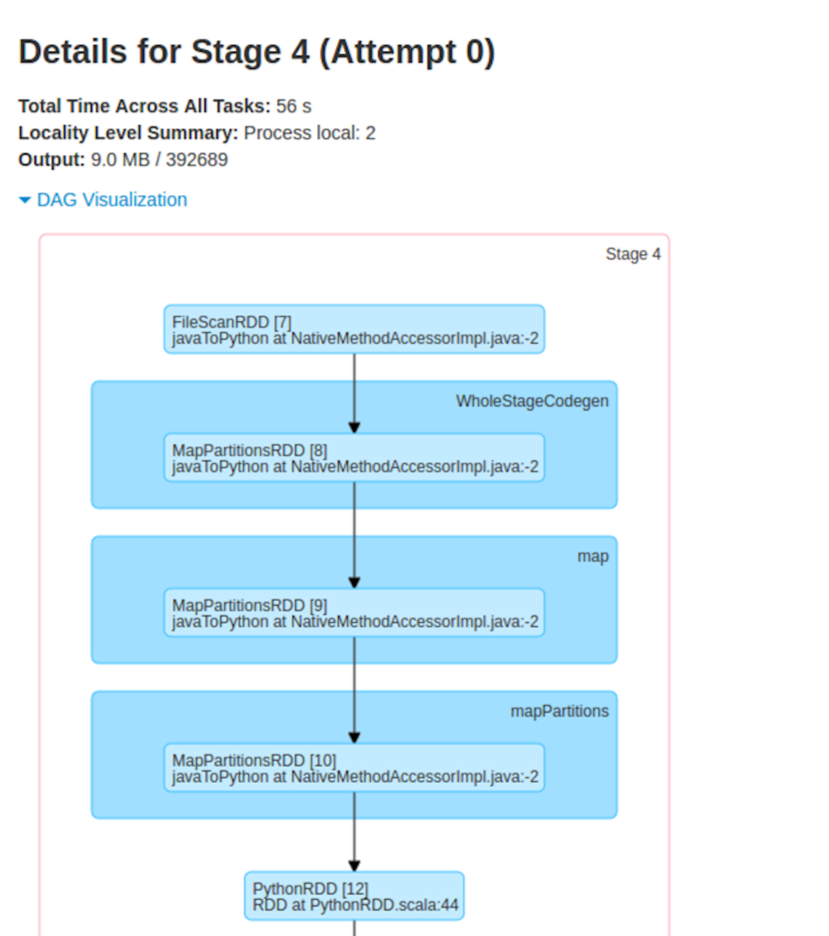
6. Check that the data has loaded. Start another terminal window and restart **cqlsh**.
7. In your **cqlsh** window type:  
     
   select * from wind.winddata limit 15;
8. You should see something like:

stationid | time | direction | temp | velocity

-----------+--------------------------+-----------+-------+----------

SF36 | 2015-01-01 00:00:00+0000 | 116.9 | 11.33 | 2.727

SF36 | 2015-01-01 00:05:00+0000 | 108.5 | 11.25 | 1.814

SF36 | 2015-01-01 00:10:00+0000 | 113.7 | 11.2 | 2.621

SF36 | 2015-01-01 00:15:00+0000 | 117.8 | 11.11 | 3.678

SF36 | 2015-01-01 00:20:00+0000 | 117.3 | 11.07 | 2.842

SF36 | 2015-01-01 00:25:00+0000 | 117.3 | 11.07 | 2.629

SF36 | 2015-01-01 00:30:00+0000 | 117.3 | 11.09 | 2.235

SF36 | 2015-01-01 00:35:00+0000 | 117.2 | 11.09 | 2.043

SF36 | 2015-01-01 00:40:00+0000 | 117.2 | 11.05 | 1.635

SF36 | 2015-01-01 00:45:00+0000 | 117.3 | 10.93 | 2.224

SF36 | 2015-01-01 00:50:00+0000 | 112.5 | 10.86 | 1.822

SF36 | 2015-01-01 00:55:00+0000 | 108.7 | 10.8 | 0.866

SF36 | 2015-01-01 01:00:00+0000 | 108.7 | 10.67 | 1.068

SF36 | 2015-01-01 01:05:00+0000 | 108.6 | 10.54 | 1.393

SF36 | 2015-01-01 01:10:00+0000 | 108.7 | 10.44 | 1.468

(15 rows)

1. We can do some more queries on the data.

use wind;  
select * from winddata where time = '2015-01-01' and stationid = 'SF36';  
  
You should see:  
  
Now try  
select * from winddata where time <= '2015-01-02' and stationid = 'SF36' limit 20;  
  
All normal:

stationid | time | direction | temp | velocity

-----------+--------------------------+-----------+-------+----------

SF36 | 2015-01-01 00:00:00+0000 | 116.9 | 11.33 | 2.727

SF36 | 2015-01-01 00:05:00+0000 | 108.5 | 11.25 | 1.814

SF36 | 2015-01-01 00:10:00+0000 | 113.7 | 11.2 | 2.621

SF36 | 2015-01-01 00:15:00+0000 | 117.8 | 11.11 | 3.678

SF36 | 2015-01-01 00:20:00+0000 | 117.3 | 11.07 | 2.842

SF36 | 2015-01-01 00:25:00+0000 | 117.3 | 11.07 | 2.629

SF36 | 2015-01-01 00:30:00+0000 | 117.3 | 11.09 | 2.235

SF36 | 2015-01-01 00:35:00+0000 | 117.2 | 11.09 | 2.043

SF36 | 2015-01-01 00:40:00+0000 | 117.2 | 11.05 | 1.635

SF36 | 2015-01-01 00:45:00+0000 | 117.3 | 10.93 | 2.224

SF36 | 2015-01-01 00:50:00+0000 | 112.5 | 10.86 | 1.822

SF36 | 2015-01-01 00:55:00+0000 | 108.7 | 10.8 | 0.866

SF36 | 2015-01-01 01:00:00+0000 | 108.7 | 10.67 | 1.068

SF36 | 2015-01-01 01:05:00+0000 | 108.6 | 10.54 | 1.393

SF36 | 2015-01-01 01:10:00+0000 | 108.7 | 10.44 | 1.468

SF36 | 2015-01-01 01:15:00+0000 | 108.9 | 10.37 | 1.859

SF36 | 2015-01-01 01:20:00+0000 | 108.6 | 10.29 | 1.67

SF36 | 2015-01-01 01:25:00+0000 | 108.6 | 10.25 | 1.241

SF36 | 2015-01-01 01:30:00+0000 | 108.5 | 10.21 | 0.675

SF36 | 2015-01-01 01:35:00+0000 | 108.4 | 10.26 | 0.623

(20 rows)

1. Now another:   
   select * from winddata where time <= '2015-01-01 01:00:00' and stationid in ('SF37', 'SF36');

stationid | time | direction | temp | velocity

-----------+--------------------------+-----------+-------+----------

SF36 | 2015-01-01 00:00:00+0000 | 116.9 | 11.33 | 2.727

SF36 | 2015-01-01 00:05:00+0000 | 108.5 | 11.25 | 1.814

SF36 | 2015-01-01 00:10:00+0000 | 113.7 | 11.2 | 2.621

SF36 | 2015-01-01 00:15:00+0000 | 117.8 | 11.11 | 3.678

SF36 | 2015-01-01 00:20:00+0000 | 117.3 | 11.07 | 2.842

SF36 | 2015-01-01 00:25:00+0000 | 117.3 | 11.07 | 2.629

SF36 | 2015-01-01 00:30:00+0000 | 117.3 | 11.09 | 2.235

SF36 | 2015-01-01 00:35:00+0000 | 117.2 | 11.09 | 2.043

SF36 | 2015-01-01 00:40:00+0000 | 117.2 | 11.05 | 1.635

SF36 | 2015-01-01 00:45:00+0000 | 117.3 | 10.93 | 2.224

SF36 | 2015-01-01 00:50:00+0000 | 112.5 | 10.86 | 1.822

SF36 | 2015-01-01 00:55:00+0000 | 108.7 | 10.8 | 0.866

SF36 | 2015-01-01 01:00:00+0000 | 108.7 | 10.67 | 1.068

SF37 | 2015-01-01 00:00:00+0000 | 252.3 | 11.11 | 3.774

SF37 | 2015-01-01 00:05:00+0000 | 273.89999 | 10.75 | 2.69

SF37 | 2015-01-01 00:10:00+0000 | 299.79999 | 11.1 | 1.747

SF37 | 2015-01-01 00:15:00+0000 | 303.5 | 11.65 | 1.534

SF37 | 2015-01-01 00:20:00+0000 | 282.79999 | 10.27 | 2.269

SF37 | 2015-01-01 00:25:00+0000 | 281.70001 | 9.72 | 2.141

SF37 | 2015-01-01 00:30:00+0000 | 292.70001 | 9.78 | 1.054

SF37 | 2015-01-01 00:35:00+0000 | 280.39999 | 9.53 | 2.36

SF37 | 2015-01-01 00:40:00+0000 | 280.29999 | 9.3 | 2.155

SF37 | 2015-01-01 00:45:00+0000 | 266.10001 | 9.37 | 3.1

SF37 | 2015-01-01 00:50:00+0000 | 272 | 9.46 | 2.703

SF37 | 2015-01-01 00:55:00+0000 | 265.39999 | 9.54 | 3.026

SF37 | 2015-01-01 01:00:00+0000 | 291.60001 | 9.7 | 1.508

(26 rows)

1. So we can query normally can we? Let’s try something else:

select * from winddata where time <= '2015-01-01 01:00:00';  
  
Uh oh!  
  
InvalidRequest: code=2200 [Invalid query] message="Cannot execute this query as it might involve data filtering and thus may have unpredictable performance. If you want to execute this query despite the performance unpredictability, use ALLOW FILTERING"  
  
Basically, Cassandra will not do unbounded time queries, unless you force it to!

1. Try again, but this time explicitly enabling this query.   
   select * from winddata where time <= '2015-01-01 01:00:00' allow filtering;
2. Now let’s try another query:  
     
   select * from winddata where time <= '2015-01-01 01:00:00' and temp < 10 ;  
     
   Again this fails. Unlike a normal SQL database, you cannot do arbitrary queries on Cassandra. You must limit your queries to those that can be done based on the primary key. There are ways of creating secondary indices, but these basically create a whole new table under the covers to allow efficient searching.  
     
   That is all, unless you want to explore some advanced features of Cassandra.  
     
   If not, close down your cqlsh window (exit) and your Jupyter notebook and session as before.  
     
   **Extension**  
   First let’s try some JSON support. Try the following:

CREATE KEYSPACE jsontest WITH REPLICATION =   
 { 'class' : 'SimpleStrategy', 'replication_factor' : 1 };

use jsontest;  
create table users (id text primary key, name text, age int , job text);  
insert into users (id, name, age, job) values ('1', 'Paul', 46, 'Student');

select json * from users;

You should see:

[json]

----------------------------------------------------------

{"id": "1", "age": 46, "job": "Student", "name": "Paul"}

(1 rows)

1. Now let’s insert data using JSON.  
   Notice how we can use either JSON or not.

insert into users json   
' {"id": "2", "age": 43, "job": "Teacher", "name": "Henry"} ';

select * from users;

id | age | job | name

----+-----+---------+-------

2 | 43 | Teacher | Henry

1 | 46 | Student | Paul

(2 rows)

1. Of course, JSON supports complex types including lists, maps, sets and other data. Luckily Cassandra does too. Try out the map type with the following commands:

create table demomap ( id int primary key, mapdata map<text,text>);

insert into demomap json   
'{"id":1, "mapdata":{ "key1": "value1","key2":"value2"}}';

select * from demomap;

select json * from demomap;

1. Now let’s try out the **set** type.

create table demoset (id int primary key, myset set<text>);

-- insert as json

insert into demoset json ' { "id":1, "myset":["a","b","c"]}';

-- insert in traditional sql style   
insert into demoset (id, myset) values (2, {'hello','paul'});

select * from demoset;  
select json * from demoset;

1. CQL also supports a list type. See if you can figure it out. If not, there is an example over the page.List example:

Congratulations - you’ve completed this lab and extensions.

create table demolist (id int primary key, list list<text>);

insert into demolist (id, list) values (1,['a1','b2','c3']);

select * from demolist;

id | list

----+--------------------

1 | ['a1', 'b2', 'c3']

(1 rows)

update demolist set list = ['z1'] + list where id = 1;  
select * from demolist;

-- what do you expect here?