**Learning simple functional programming in Python**

*This exercise is a prequel for anyone planning to do map/reduce programming in Spark, using Python.*

The specific aim of this exercise is to make you familiar with *lambda* expressions,

and thence onto the map, reduce, filter and flatMap concepts. It also validates that the VirtualBox VM is working and that you can run *Jupyter*.

**Exercise setup**

This exercise assumes that you have successfully downloaded and installed Anaconda (Python 3.7 version)

1. Launch Jupyter notebook. This can be done from Anaconda Navigator or from a terminal window (it may require you to add the path to the Anaconda distribution in your .bash_profile file if this wasn’t done automatically during installation):

> jupyter notebook

A brower window should pop open and show files/folders in the current directory (if opened from the terminal) or in your home directory (if opened from Ananconda Navigator) :

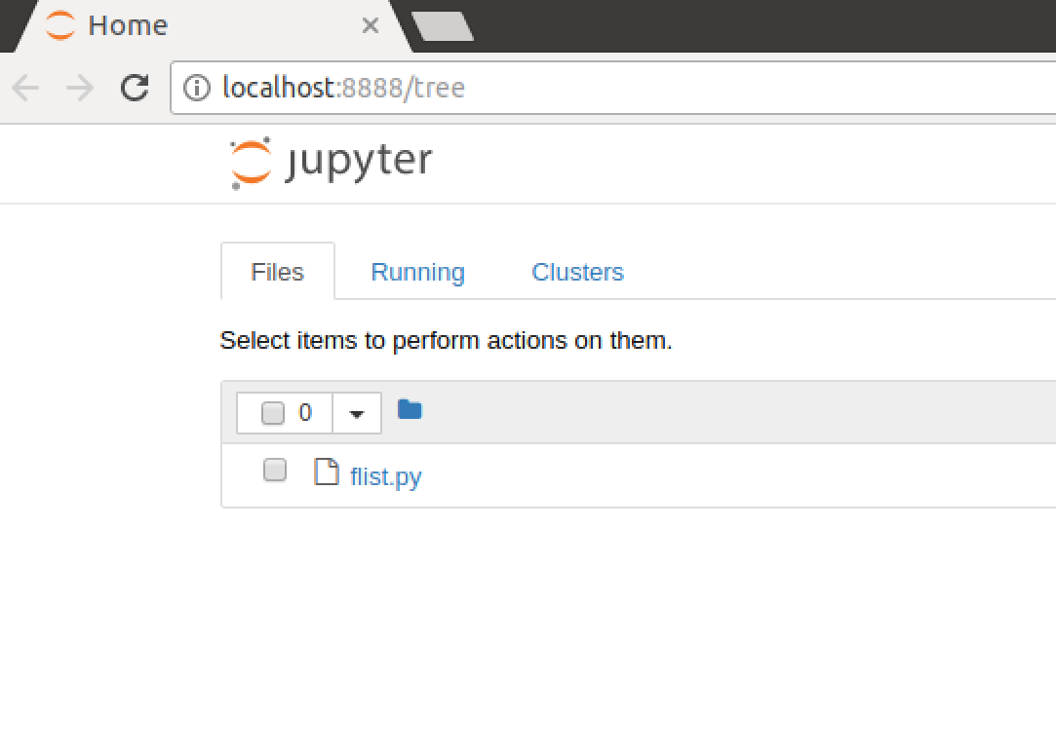

2. Navigate to a directory where you want to store files associated with this course.

3. In the top right corner, click on New->Python 3

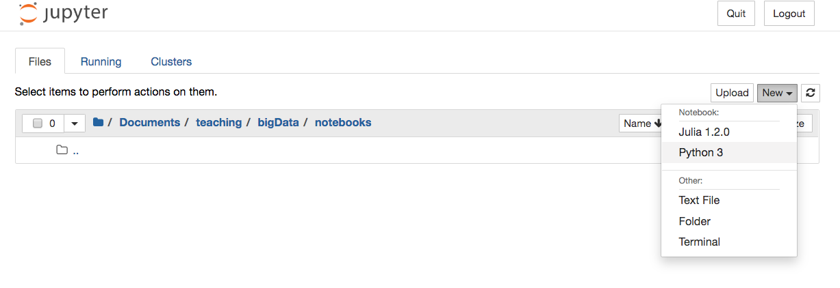

This will open a new tab, with a Python Notebook (this is a way of editing and running Python in a browser window that will be used extensively during the course). You should see:

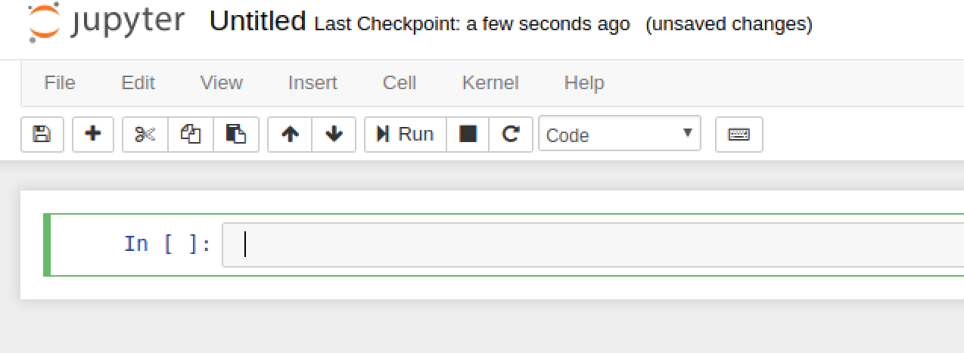

Click on the word **Untitled,** and change the name of the notebook to **precourse.** You should be able to hit Ctrl-S at any time to save. You can find further keyboard mappings here:

<https://www.cheatography.com/weidadeyue/cheat-sheets/jupyter-notebook/>

**Exercise Steps**

For this exercise, we will be using a simple Python class **FList.**

This file is some simple Python *syntactic sugar*. Basically it makes the syntax of our exercises look more like the Apache Spark syntax and less like the default Python syntax. *You need this file in the same directory as your notebook*

In the cell type:

from flist import FList

nums = FList([1,2,3,4,5])

def double(x): return x*2

print(nums)

print(nums.map(double))

It should look like this:

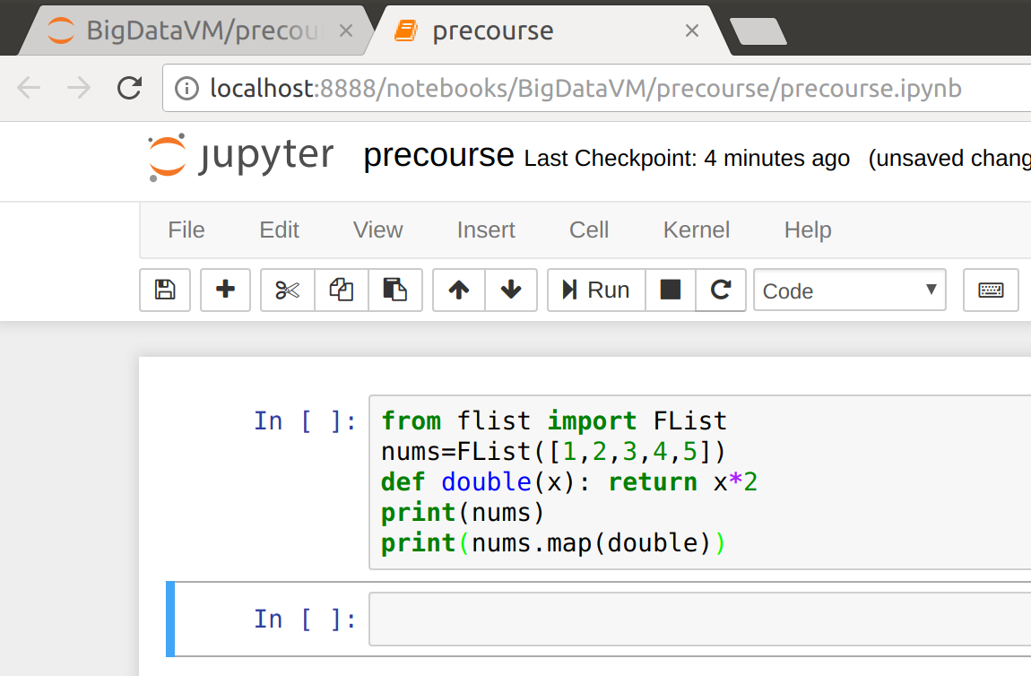

Now click the Run icon (or press Shift-Enter)

You should see output like this:

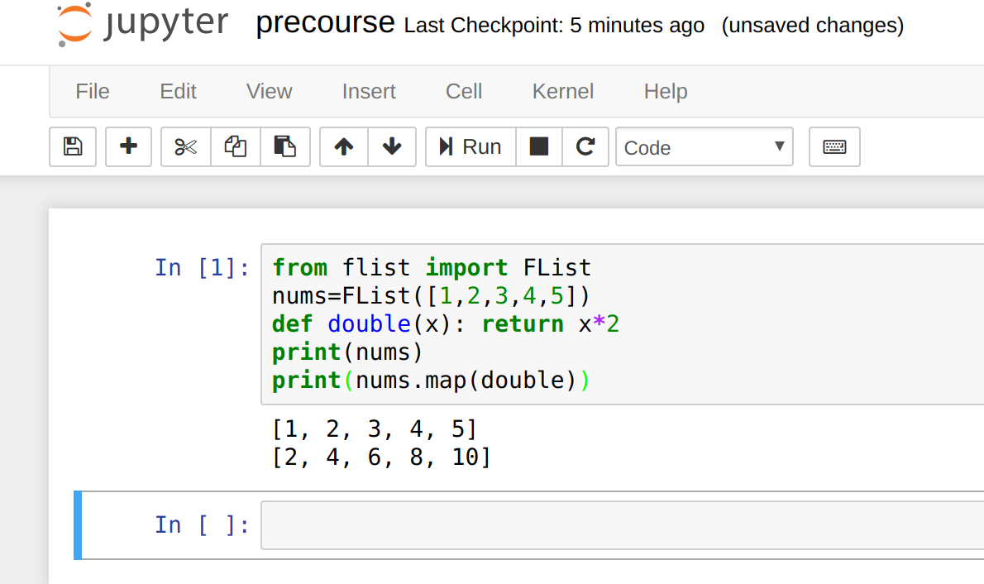

Let’s review what is happening there.

FList is just a list, very similar to a normal Python list, but with slightly different behaviour for map, filter, flatMap and reduce.

Double is just a function that returns twice its input.

def double(x): return x*2;

The **map** function is a *meta-function*: it takes a function as an argument, and applies it to the list.

**print** nums.map(double)

[2, 4, 6, 8, 10]

In pseudo-code we can say that:

*[n1,n2,n3].map(double) == [double(n1), double(n2), double(n3)]*

The **filter** function is another meta-function. **filter** decides whether to include an element in the list based on the result of calling the function that you pass in. If the function evaluates to **True,** then it keeps the element. Otherwise it removes it. Let’s see filter in action.

In the next cell, type

def even(x): return x%2==0

print(nums.filter(even))

When you run this cell you should see:

**[2, 4]**

As you can see this approach leads to very expressive code.

However, we can make this code even more expressive if we understand the concept of a lambda. Lambdas are a concept that pre-dates physical computers and goes back to the thinking of a brilliant mathematician called Alonzo Church who formulated the *lambda calculus* in the 1930s.

A lambda is simply an *unnamed* function. Suppose we want a function that returns the double its input.

lambda x: x*2

If you run this, Python will tell you it’s a function:

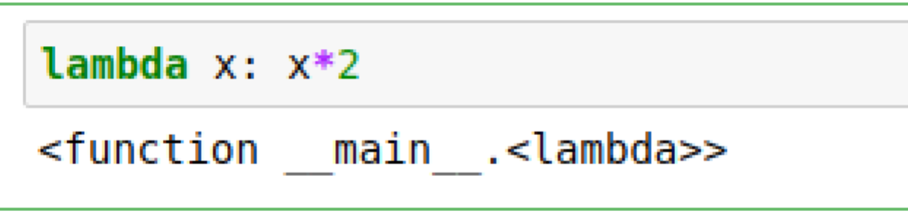

As you can see Python believes this to be a function. We can apply that function. Type

(lambda x: x*2)(2)  
  
And run it

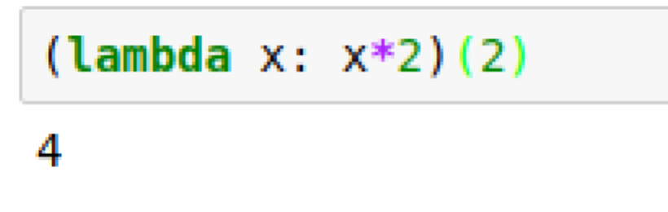

Guess what? This lambda is equivalent to our previous function **double**

Now we can redo our “double every number in the list”

Run the following:

nums.map(lambda x: x*2)

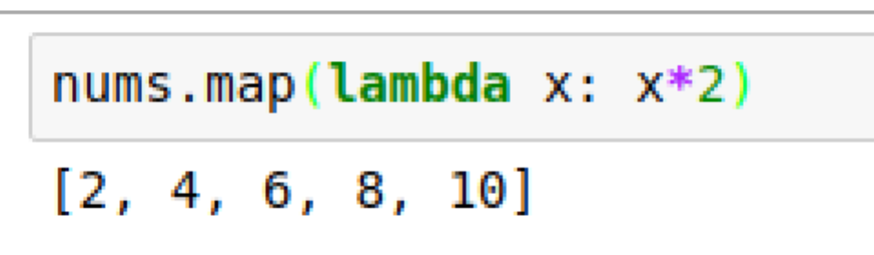

Why would we use this instead of defining double as a named function?

The main reasons are that it is more compact, and the code is more self-expressive. When you start using lambdas you might not appreciate this, because initially it can be confusing, and therefore less readable. But once lambdas become ingrained and hence you can understand them easily, this syntax becomes more readable, because everything is captured right there.

We can also chain these:

nums.map(lambda x: x*2).filter(lambda x: x%2==0)

[2, 4, 6, 8, 10]

(Surprisingly if you double a number, the result is always even!)

Or we can chain them the other way round:

nums.filter(lambda x: x%2==0).map(lambda x: x*2).

[4, 8]

We can quickly create new functions. For example, imagine we wanted all the *even squares*. We can try this:

nums.map(lambda x: x**2).filter(lambda x: x%2==0)

[4, 16]

*Now suppose we wanted to add up all the squares from 1 to 5.*

First we need the list of squares. Try this:

squares = nums.map(lambda x: x**2)

**print(**squares)

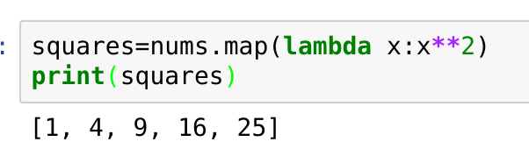

In a procedural language, the normal approach is to use a loop: create a variable **total** and then add each to the total. That isn’t very *functional,* because functions don’t have variables. More importantly, it has state (the loop counter and the total). **State is the enemy of scalability** (as we will find out in the course)**.**

Instead, we can have a function that is applied to elements in the list, but instead of returning an element, it returns an accumulator, and then applies this to the next element. In general this technique is called **folding**. Specifically, we call this the **reduce** function. Another way of thinking of reduce is to imagine putting an associative operator *between* the elements of the list. So for example if we wanted to add up the list:

[1, 4, 9, 16, 25]   
we simply need to put the + operator between each entry:

[1 + 4 + 9 + 16 + 25]

The plus operation can be defined simply using a lamba:

lambda x, y: x+y

Let’s try that. In a new cell type:

print(squares.reduce(lambda x,y: x+y))

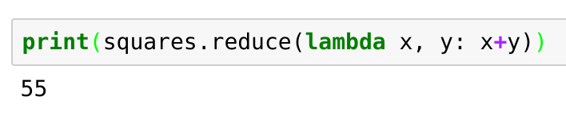

We don’t just have to use numbers with these meta-functions. Suppose we have two sentences and we want the individual words:

sentences = FList(['The moon is made of cheese.', 'Badgers love jam.'])

print(sentences.map(lambda x: x.split()))

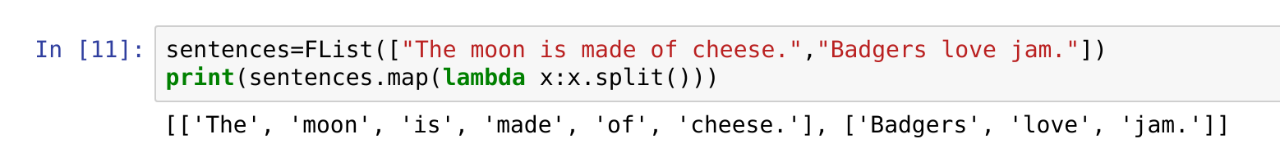

This is cool, but you might see an issue here. We have a list of lists. We might just want a single list. There is a functional pattern called **flattening** that does this.

**print**(sentences.map(lambda x: x.split()).flatten())

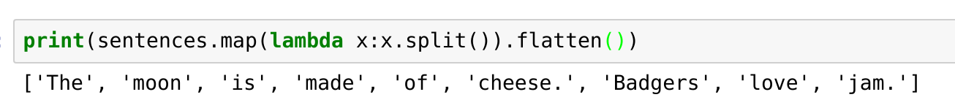

Usually the flattening is needed because of a map. Hence flatMap, which lets us do it all in one go:

**print(**sentences.flatMap(lambda x: x.split()))

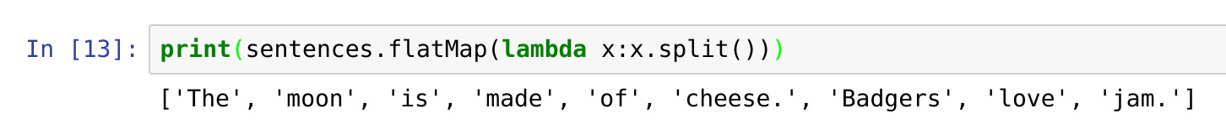

That should be enough lambdas and meta-functions to get us started.   
To recap, we have covered a little bit of *map, filter, flatten, flatMap, reduce* and *lambda.*

You can close the browser window. Then click back on the terminal window and hit Ctrl-C. You should see:

Shutdown this notebook server (y/[n])?

Type **y** and hit Enter. You can now type **exit**  to close the Terminal window.

*Congratulations on completing the first exercise.*