**Pre-Course Exercise 2**

*Start up an instance on Amazon EC2 and get Apache web server running*

**Prior Knowledge**

Unix Command Line Shell

**Learning Objectives**

Understand about EC2 instances

Start an instance using the web interface

Configure the AWS command line

Manage instances from a command line

Understand Security Groups

**Software Requirements**

(see separate document for installation of these)

* AWS CLI

**Part A: Starting an Instance from the Web Console.**

1. You have been provided with an Ubuntu VM. Start that up (in VirtualBox).
2. Open up a browser window and navigate to   
   <https://aws.amazon.com/>
3. Click on the menu item My Account-> AWS Management Console  
   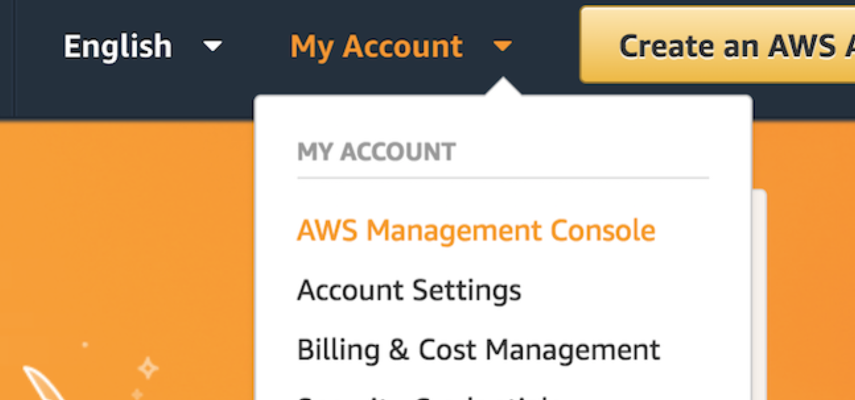
4. Log in with your credentials
5. You should see a screen like this:  
   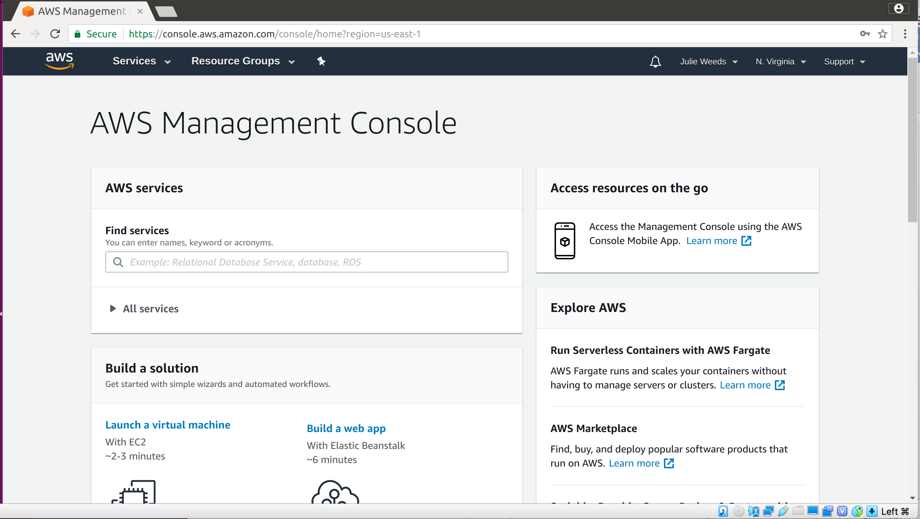
6. In the top right corner click on N. Virginia and change to **EU (London) (unless it is already on London!)**
7. Expand **All Services** andclick on the link **EC2**  
     
   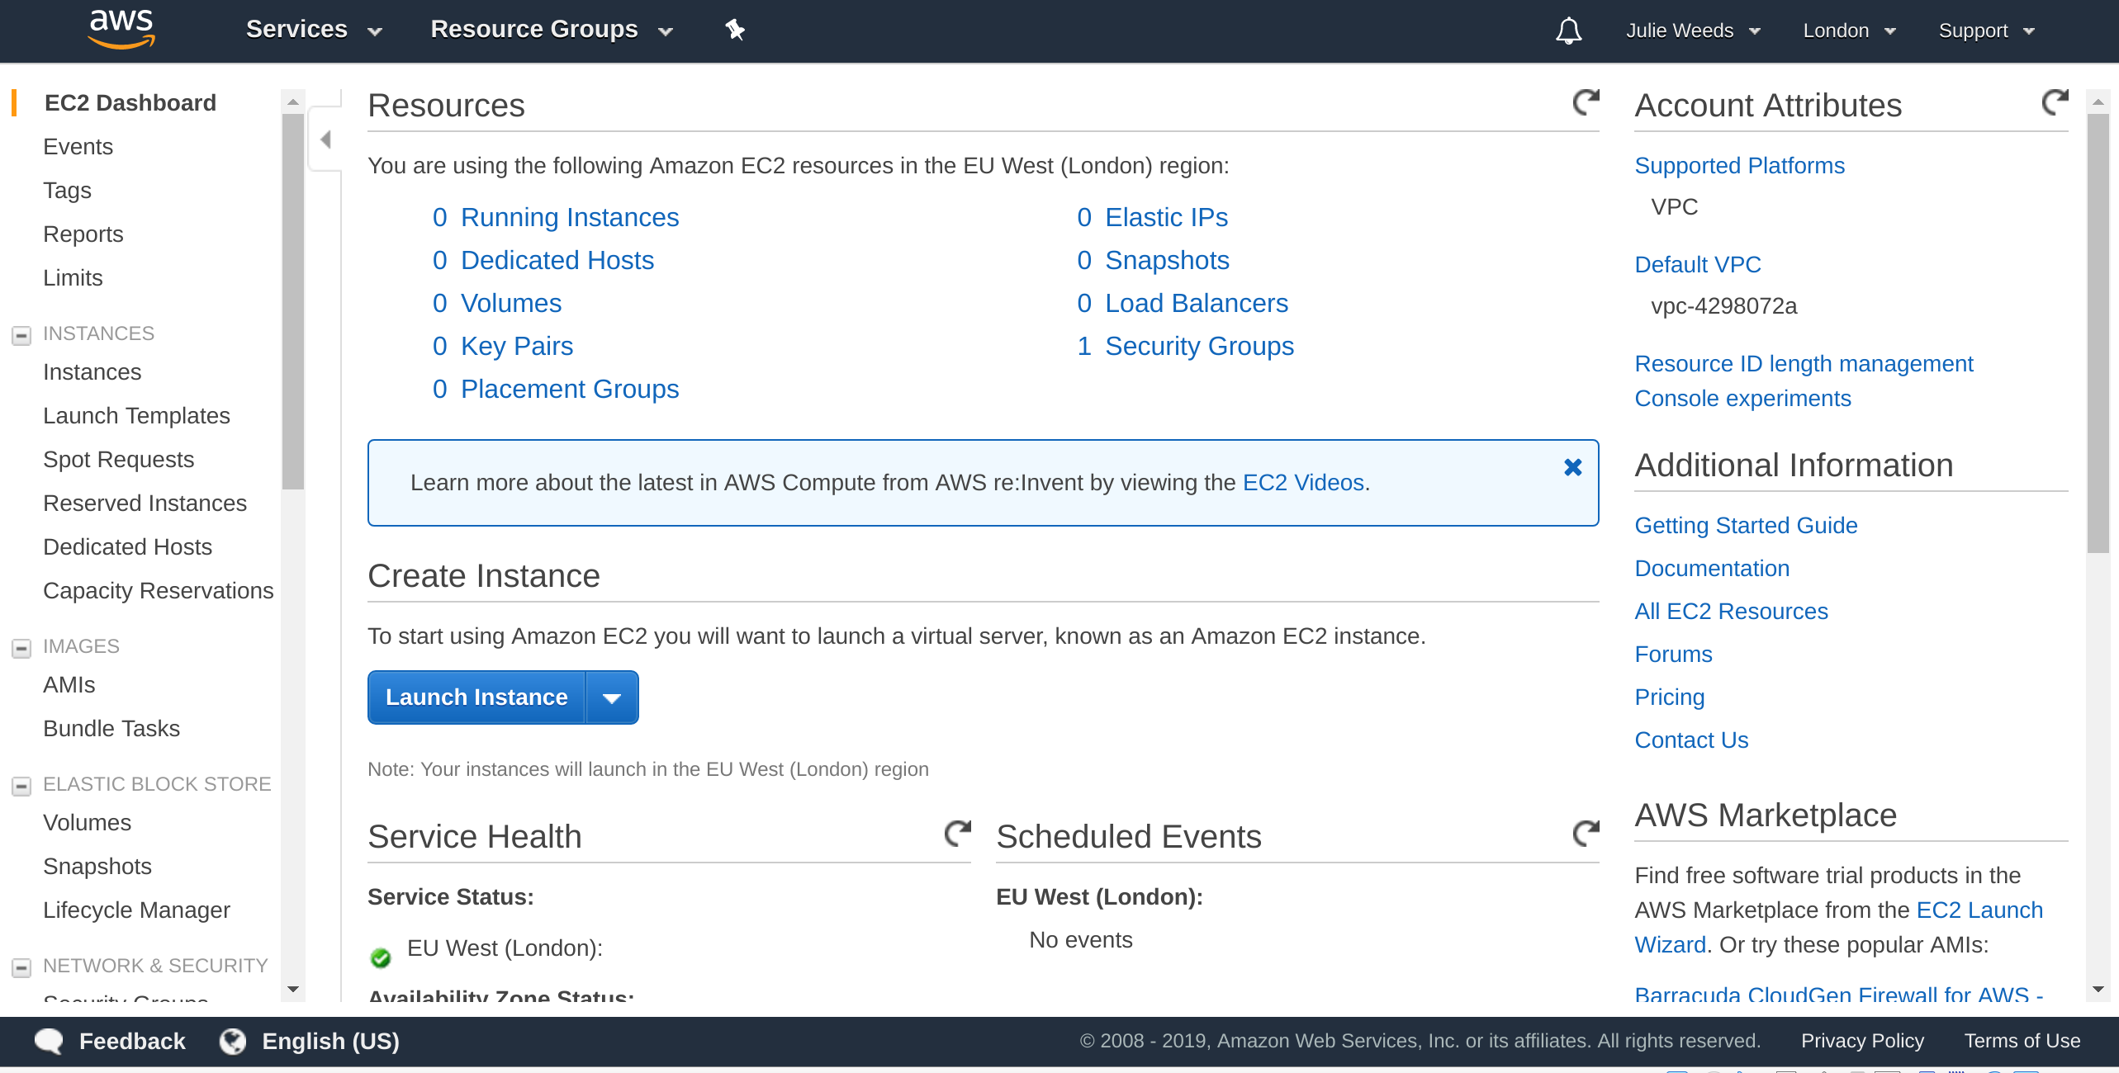
8. Click on the blue button: Launch Instance
9. Choose “**Ubuntu Server 18.04 LTS (HVM), SSD Volume Type**”

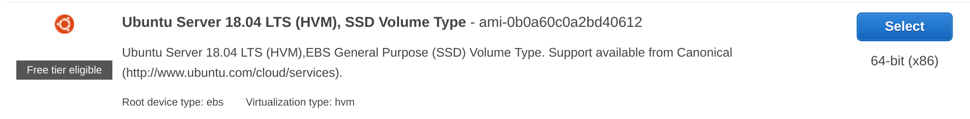

1. Choose the instance type **t2.micro**.
2. Click **Next: Configure Instance Details**
3. Click **Next: Add Storage**
4. Click **Next: Add Tags**
5. Now click: **Next: Configure Security Group**
6. Change the name of the security group to **simple**  
   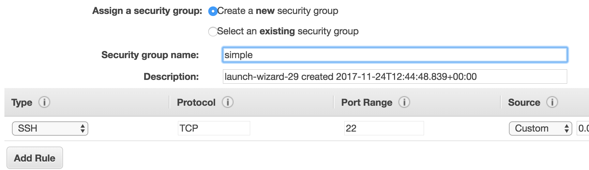

*Hint: There is a security warning about the security rule. The default rule allows Secure Shell (SSH) access from any IP address. If you know your company or personal internet connection comes from a specific IP address you can improve security by restricting to that.*

*Note this is NOT the IP address you get by looking at the local machine’s configuration, but the publicly visible IP address that the Amazon cloud sees from you. You can see what your IP is by typing “what’s my IP” into Google.*

***However, I am not sure if the current network sends messages from different IPs or the same and therefore we will leave this as-is despite the warning.***

1. Click **Review and Launch**You should see something very like this:  
   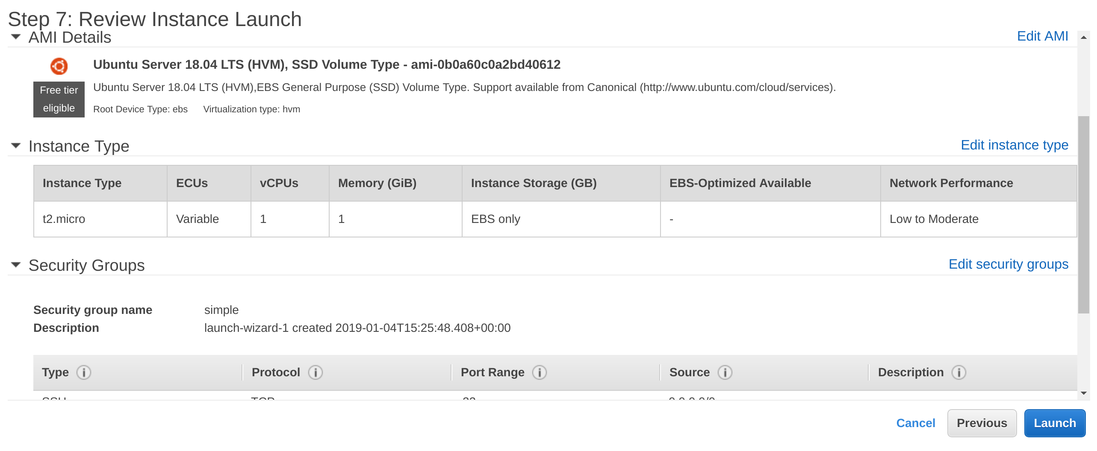
2. Click **Launch**
3. You will be prompted with a new window to decide on the correct key pair to secure this instance with. Since this is the first time you are using EC2, you need to create a key pair. Change the dropdown box to **Create a new key pair.**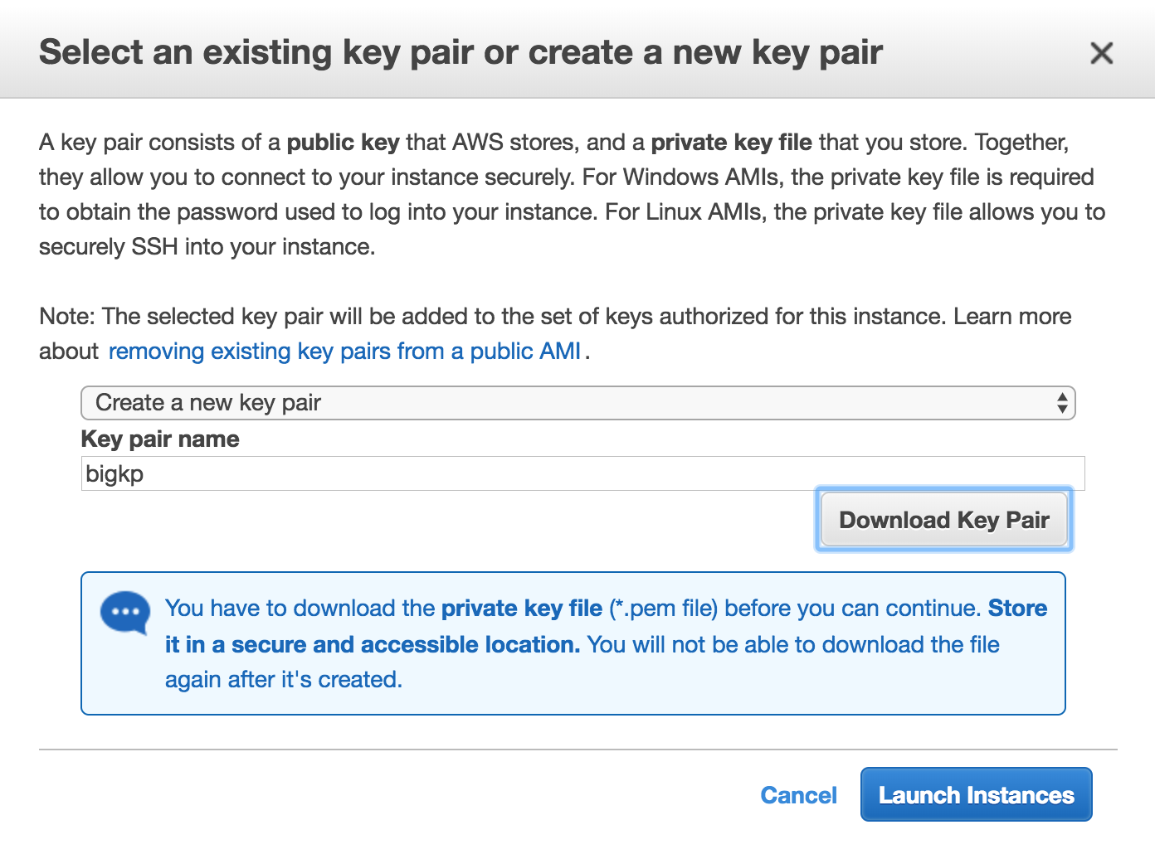
4. Use **bigkp** as the name of the keypair.
5. Click **Download Key Pair**. This will save a file to your ~/Downloads directory.
6. Click **Launch Instances**You should see something like:  
   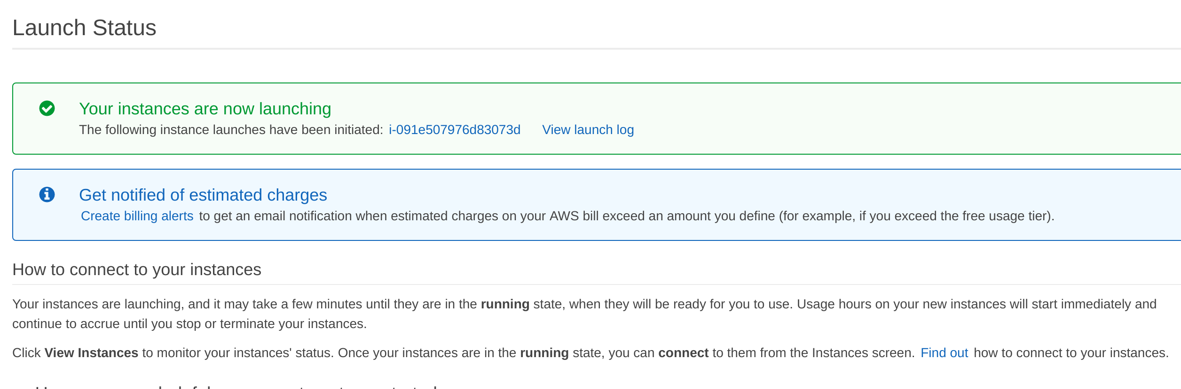
7. Click on the blue instance ID link (e.g. **i-091e507976d8307d**in the screenshot above)  
   You will see a dashboard like:  
   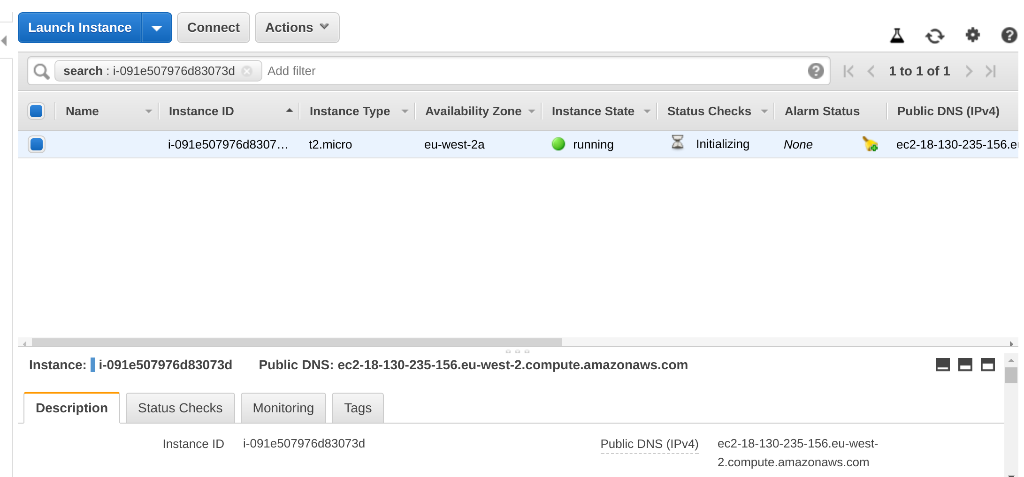
8. Make sure you are running the Ubuntu VM, and start a fresh terminal window (Ctrl-Alt-T, or find Terminal graphically)
9. Check is there is already a ~/keys directory.  
     
   **If not,** then make a directory to store your private key:  
   mkdir ~/keys
10. Copy your private key to the new directory:  
    cp ~/Downloads/bigkp**.**pem ~/keys/
11. Before you can use the key you need to change the permissions on it. Type:  
    chmod 400 ~/keys/bigkp.pem
12. Check to see if the status checks on your instance are now complete. Refresh the browser window:  
    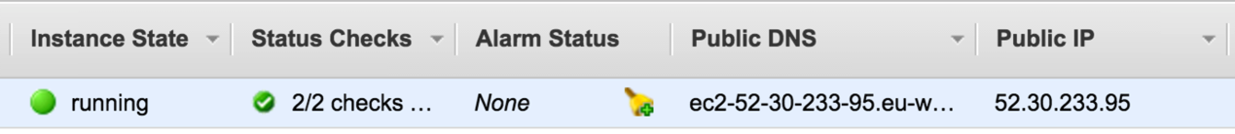
13. Copy the DNS server Address from the browser window (e.g. **ubuntu@ec2-18-130-235-156.eu-west-2.compute.amazonaws.com** in my case)
14. Try to SSH into the machine. Replace your key file name and the server address below!  
      
    **﻿ssh -i "bigkp.pem" ubuntu@ec2-18-130-235-156.eu-west-2.compute.amazonaws.com**
15. As this is the first time you are accessing this host, the key on the server side is not known. You should see something like:  
      
    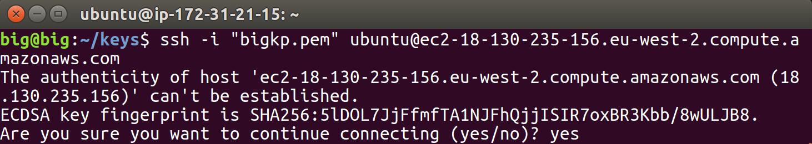
16. Type **yes** and hit Enter.

You will see something like:

1. *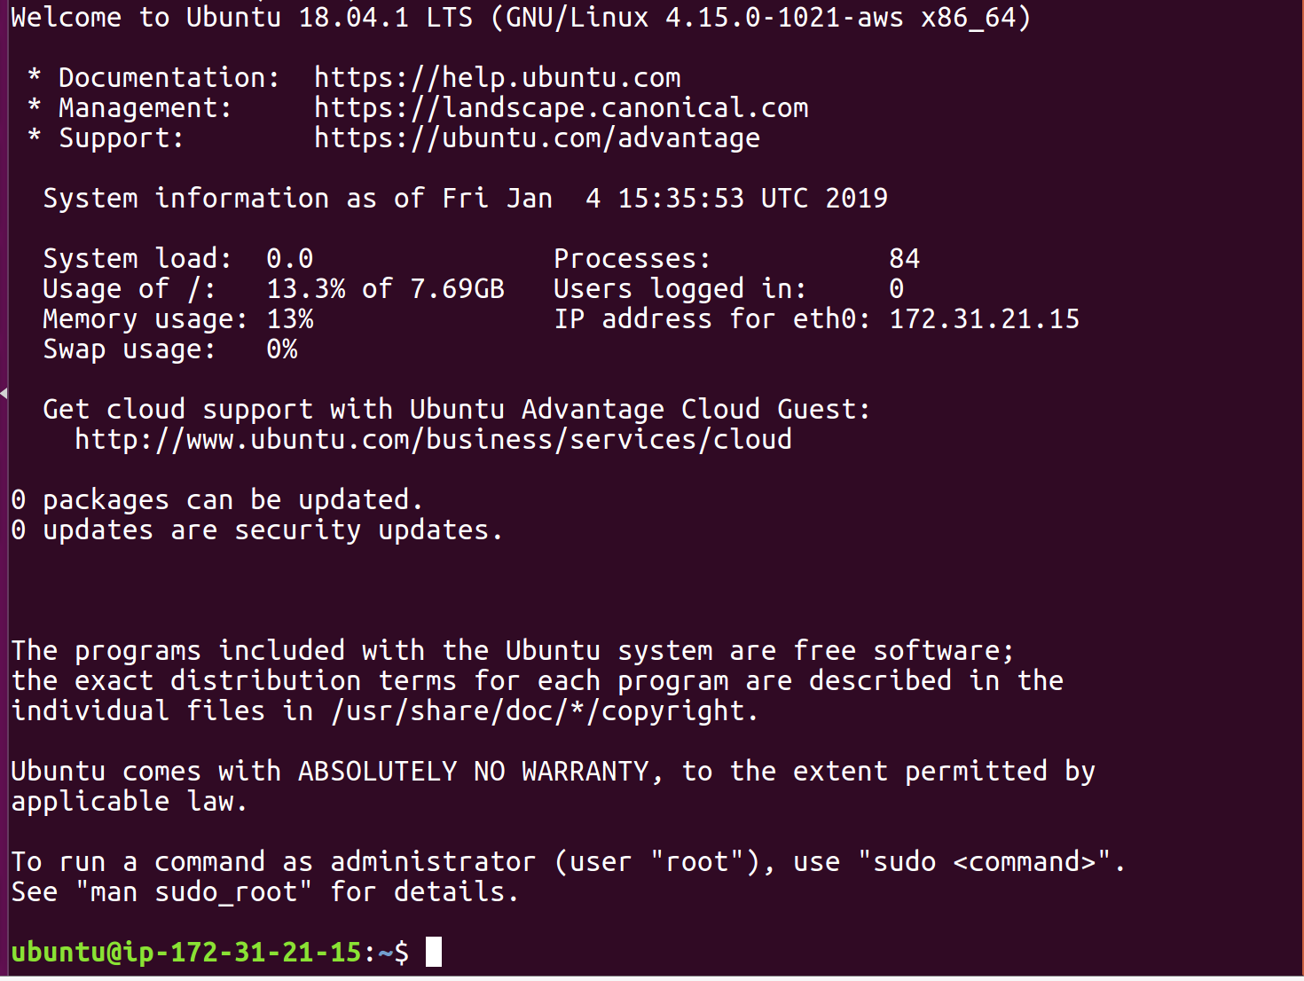Congratulations – you have a cloud instance running.*

**PART B – Using the AWS Command Line to terminate the instance**

1. The AWS Command Line (AWS CLI) is available as part of the Python PIP installed code. PIP is a package manager for Python.
2. In a fresh Ubuntu Terminal Window (*make sure you are not doing this on your cloud server by mistake!)*
3. Now you can configure the AWS command line with your credentials
4. First you need to create an Access Key and Secret Key.
5. Go to the AWS Console
6. In the top right corner, click on your username, then choose **My Security Credentials**:   
   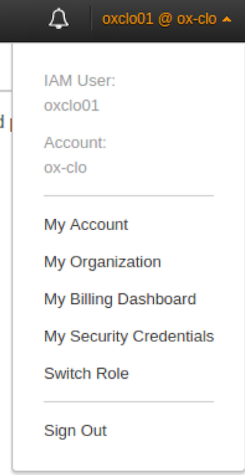
7. You will be warned as follows.  
   Choose **Continue to Security Credentials.**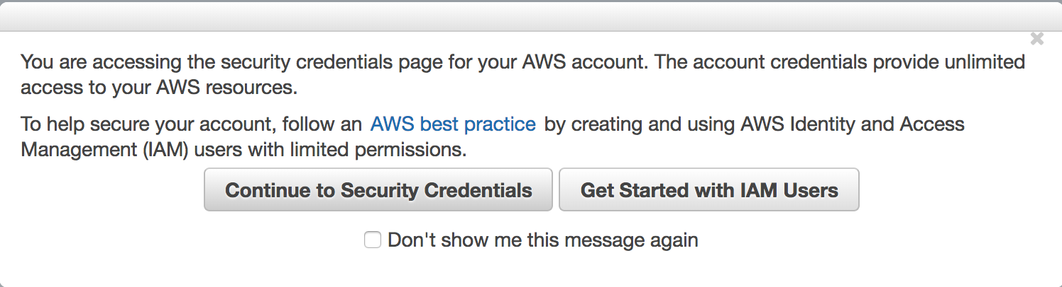
8. You should see: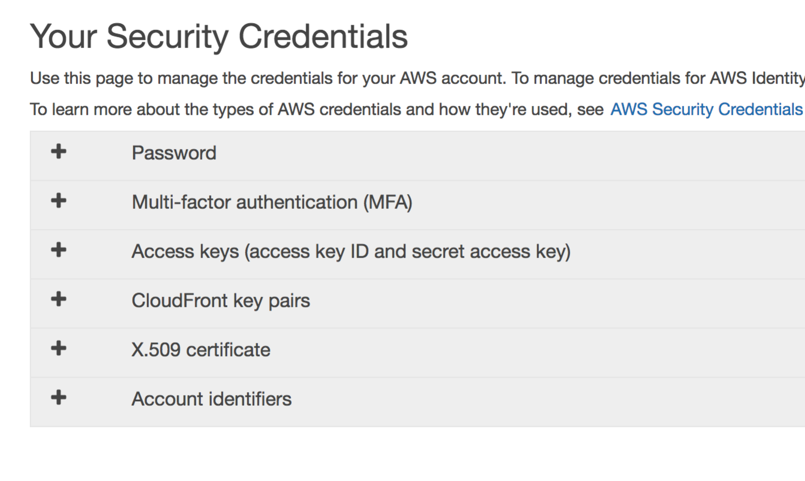
9. Expand **AccessKeys**
10. Click **Create New Access Key.** You will see:  
    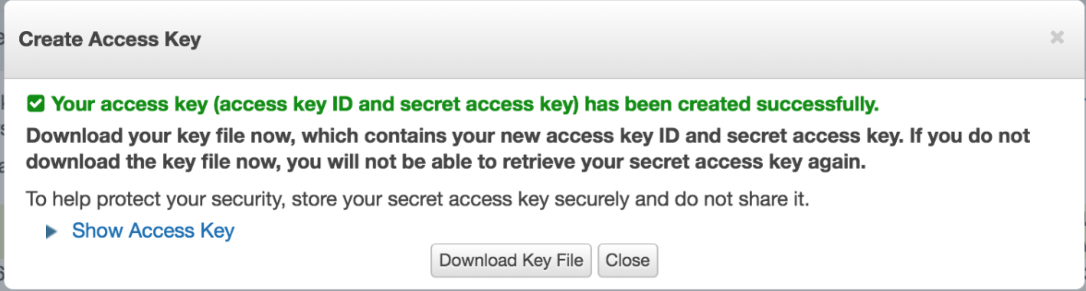
11. Click **Download Key File**It should download a file called **rootkey.csv**
12. ***You need to make a note of these credentials or download them, because the secret key will not be available again.***
13. Now we can use these keys to configure the AWS CLI. In a terminal window type:  
      
    aws configure  
    1. When prompted  
       AWS Access Key ID [None]:  
         
       Type the Access Key ID from the text file or CSV (cut and paste)
    2. Do the same for the Secret Access Key.
    3. For the region choose London: **eu-west-2a**

*Hint: You now have three credentials for AWS:*

* *Your userid/password*
* *An Access Key/Secret Key for controlling EC2/AWS through command line, third-party tools and apps, and any Web Service APIs*
* *An SSH Private Key pair for accessing the actual instances that you startup.*
  1. For the output format, type **json**

1. Now let’s use the CLI to terminate your instance.
2. From the AWS Web-based console, go back to the EC2 page, and then choose Running Instances. Find your running EC2 instance and find the id of your running instance:

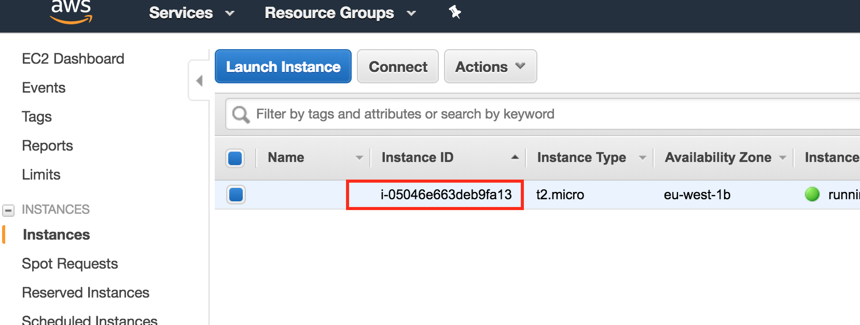

1. Now use the AWS CLI to terminate:  
   Replacing the instance ID with your own, type:  
     
   aws ec2 terminate-instances --instance-ids **i-05046e663deb9fa13**
2. You should see a log like:

aws ec2 terminate-instances --instance-ids i-0fa3d4032833ea933

{

"TerminatingInstances": [

{

"InstanceId": "i-0fa3d4032833ea933",

"CurrentState": {

"Code": 32,

"Name": "shutting-down"

},

"PreviousState": {

"Code": 16,

"Name": "running"

}

}

]

}

1. Your SSH session to the server will die, and the server will no longer be running.
2. It is really important to check on the AWS console that this instance has actually been terminated (or stopped). If it does not shut down in a reasonable amount of time form giving the command to the AWS CLI, you can terminate it in the console. Click on Instance state and select terminate or stop. **YOU WILL BE CHARGED BY AWS FOR ANY INSTANCES THAT ARE LEFT RUNNING SO THIS IS REALLY IMPORTANT.**

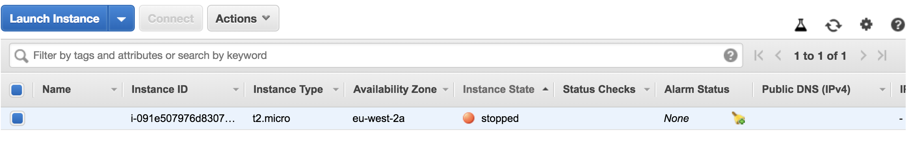

1. **Congratulations**! You have completed both of these exercises.