Automation Suit Run:

**Recommendation before run it:** Best use Windows 10, Chrome Version 83.0.4103.97.

1) Download AutomationSuit-ContactForm-Exercise2.zip file

2) Unzip and paste all the folder into “ *c://* “

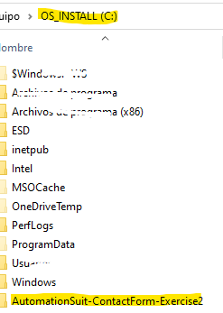

3) Install the following tools and library:

-**python 3.8.3** --> Go to https://www.python.org/ftp/python/3.8.3/python-3.8.3.exe. Run it and make sure to click on Add Python to PATH, then select Install Now

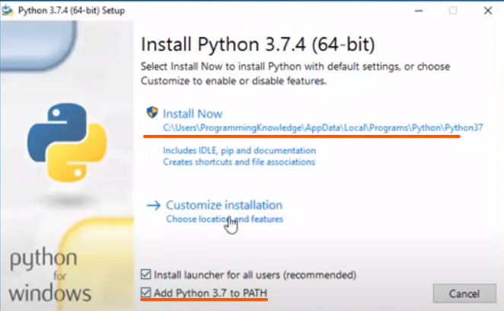

-**Selenium** --> Open CMD console and type <*pip install selenium*> update if necessary

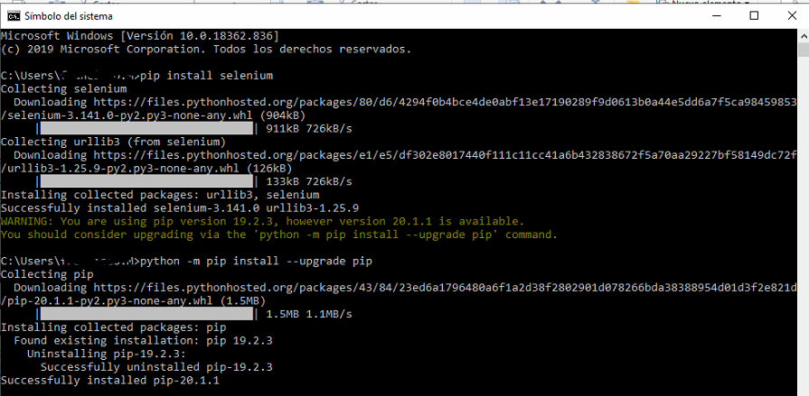

*Note: To open CMD Press Windows+R to open the “Run” box. Type “cmd” into the box and then press Enter.*

-**HTMLTestRunner** --> Open CMD console and type *<pip install html-testRunner>*

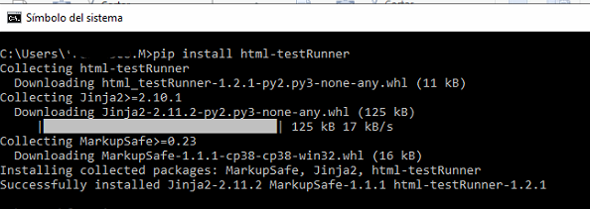

-**Chrome WebDriver** --> https://chromedriver.chromium.org/downloads .**You must download the indicated according to your version of Chrome. I recommend having the Chrome version updated (current Version 83.0.4103.97) so you should download the ChromeDriver 83.0.4103.39.** Then chooise *chromedriver_win32.zip* archive

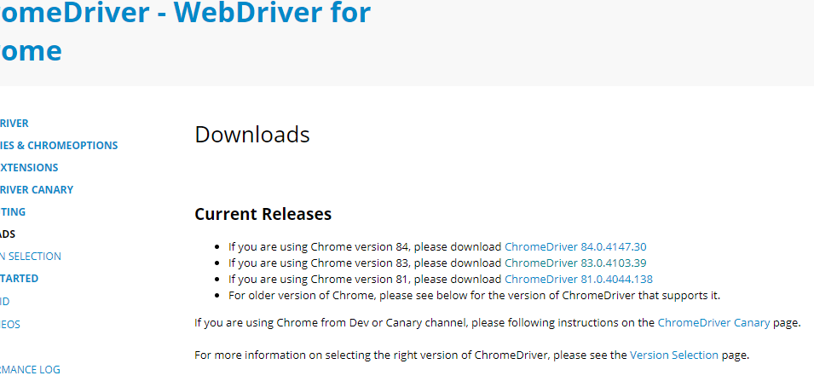

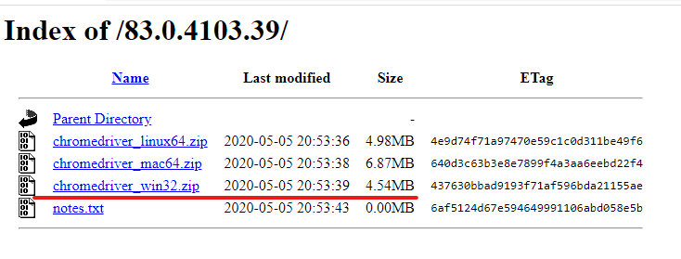

-Unzip Chrome WebDriver downloaded into the folder C://AutomationSuit-ContactForm-Exercise2

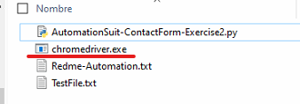

4) Run the automation suit --> double click to **AutomationSuit-ContactForm-Exercise2.py** file. Automation will start

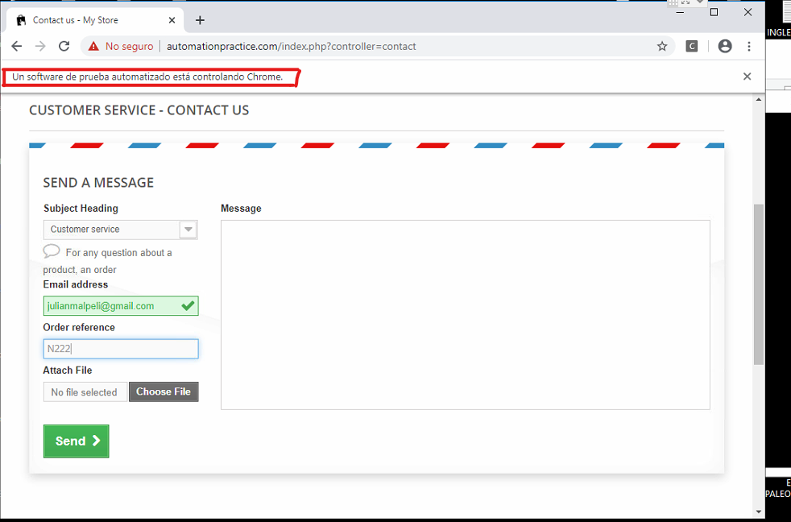

5) Once the execution is finish, you can view the report in html format in the following folder:

