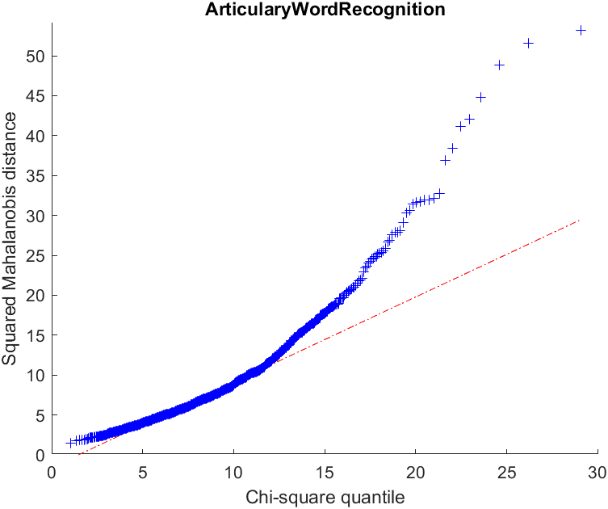













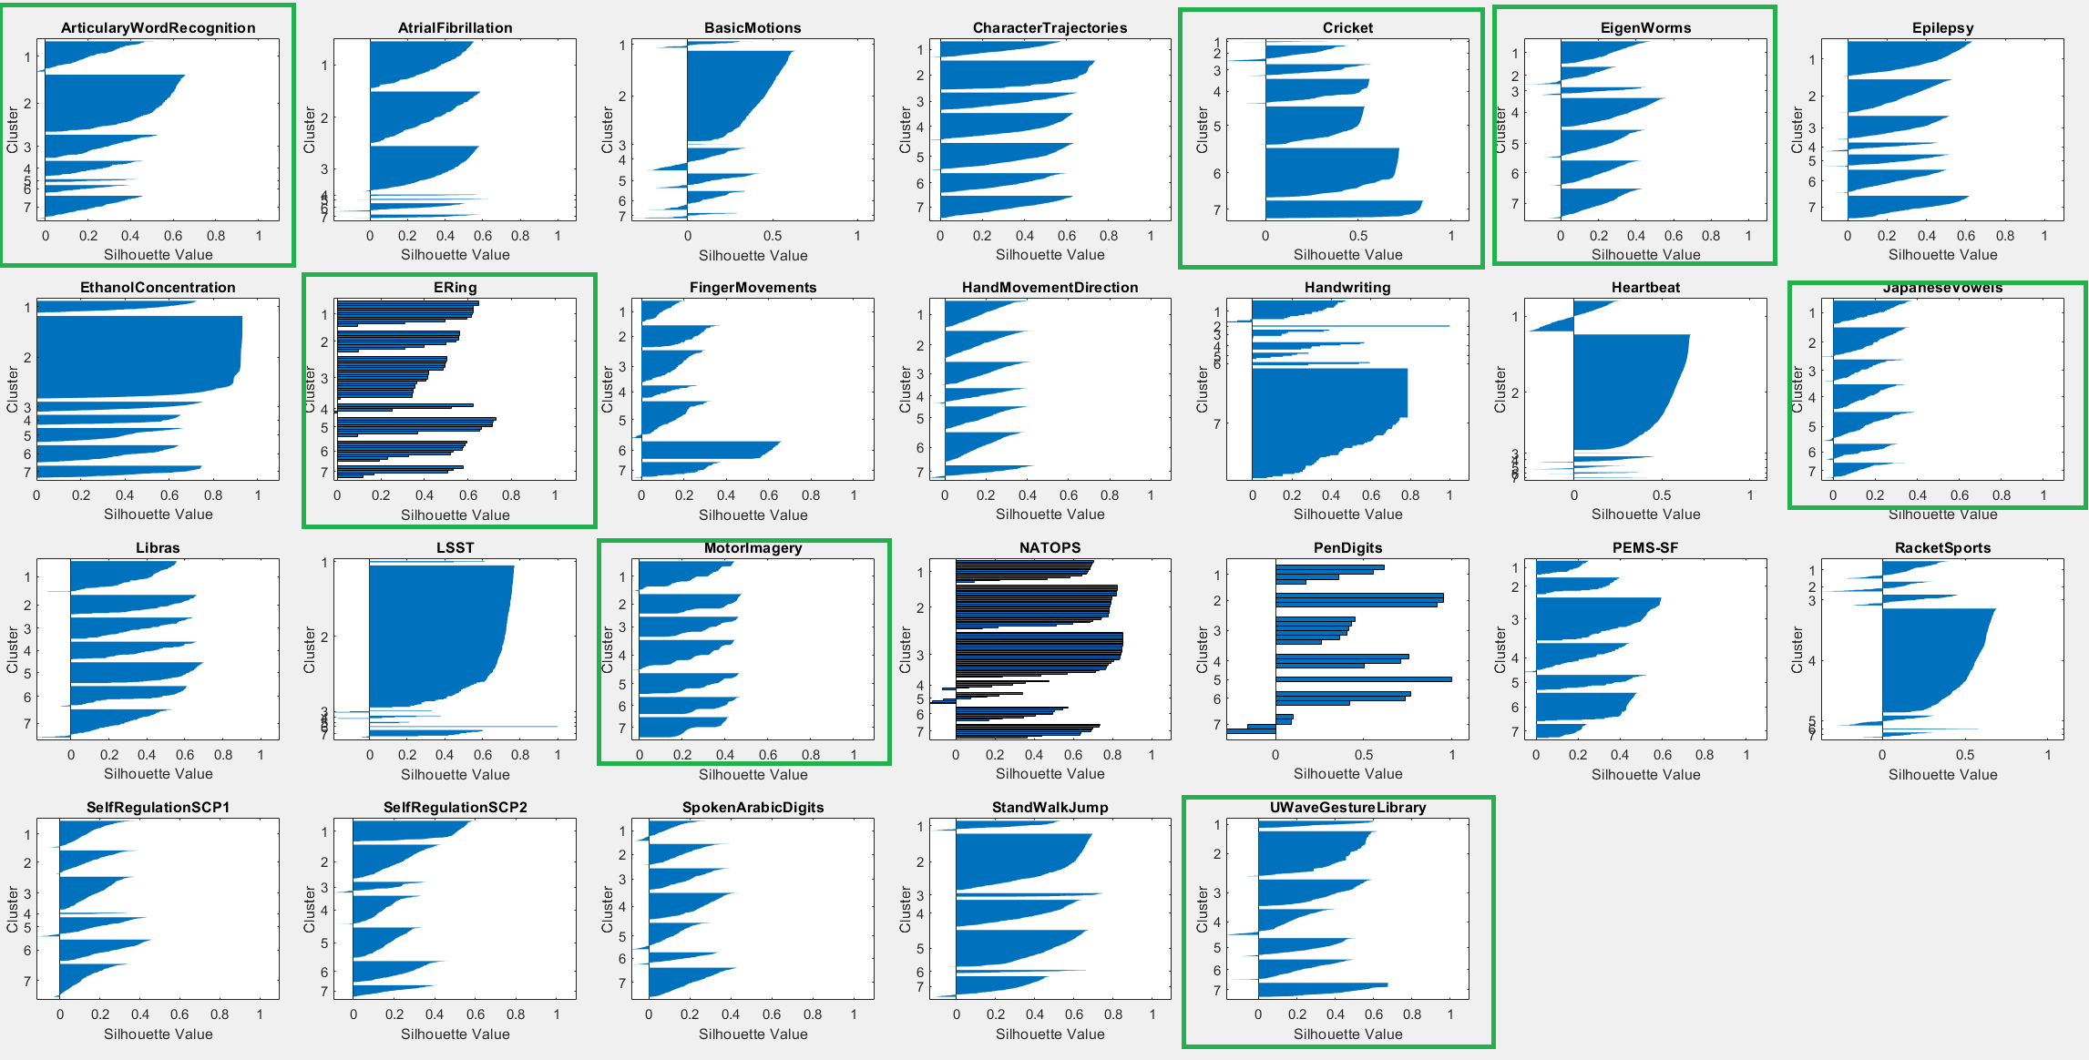

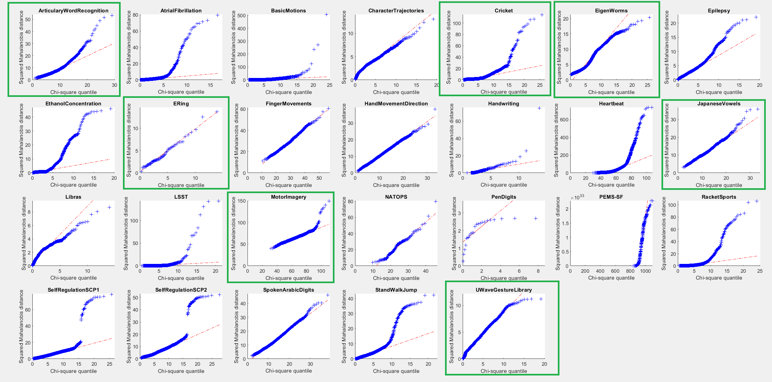

--------------ArticularyWordRecognition

Analysis of the Mardia's multivariate asymmetry skewness and kurtosis.

[No. of data = 1584, Variables = 9]

----------------------------------------------------------------------------

Multivariate Coefficient Statistic df P

----------------------------------------------------------------------------

Skewness 18.1819 4800.0339 165 0.0000

Skewness

corrected for small sample 18.1819 4810.9461 165 0.0000

Kurtosis 127.9398 40.9271 0.0000

----------------------------------------------------------------------------

With a given significance level of: 0.05

The multivariate skewness results significative.

The multivariate skewness corrected for small sample results significative.

The multivariate kurtosis results significative.

--------------AtrialFibrillation

Analysis of the Mardia's multivariate asymmetry skewness and kurtosis.

[No. of data = 2000, Variables = 2]

----------------------------------------------------------------------------

Multivariate Coefficient Statistic df P

----------------------------------------------------------------------------

Skewness 21.5473 7182.4206 4 0.0000

Skewness

corrected for small sample 21.5473 7200.3911 4 0.0000

Kurtosis 51.2940 242.0207 0.0000

----------------------------------------------------------------------------

With a given significance level of: 0.05

The multivariate skewness results significative.

The multivariate skewness corrected for small sample results significative.

The multivariate kurtosis results significative.

--------------BasicMotions

Analysis of the Mardia's multivariate asymmetry skewness and kurtosis.

[No. of data = 1000, Variables = 6]

----------------------------------------------------------------------------

Multivariate Coefficient Statistic df P

----------------------------------------------------------------------------

Skewness 232.6883 38781.3906 56 0.0000

Skewness

corrected for small sample 232.6883 38931.0709 56 0.0000

Kurtosis 488.1518 710.2919 0.0000

----------------------------------------------------------------------------

With a given significance level of: 0.05

The multivariate skewness results significative.

The multivariate skewness corrected for small sample results significative.

The multivariate kurtosis results significative.

--------------CharacterTrajectories

Analysis of the Mardia's multivariate asymmetry skewness and kurtosis.

[No. of data = 2000, Variables = 3]

----------------------------------------------------------------------------

Multivariate Coefficient Statistic df P

----------------------------------------------------------------------------

Skewness 2.8160 938.6561 10 0.0000

Skewness

corrected for small sample 2.8160 940.7693 10 0.0000

Kurtosis 11.7528 -13.2565 0.0000

----------------------------------------------------------------------------

With a given significance level of: 0.05

The multivariate skewness results significative.

The multivariate skewness corrected for small sample results significative.

The multivariate kurtosis results significative.

--------------Cricket

Analysis of the Mardia's multivariate asymmetry skewness and kurtosis.

[No. of data = 2000, Variables = 6]

----------------------------------------------------------------------------

Multivariate Coefficient Statistic df P

----------------------------------------------------------------------------

Skewness 39.1953 13065.1059 56 0.0000

Skewness

corrected for small sample 39.1953 13090.3109 56 0.0000

Kurtosis 140.7941 211.7725 0.0000

----------------------------------------------------------------------------

With a given significance level of: 0.05

The multivariate skewness results significative.

The multivariate skewness corrected for small sample results significative.

The multivariate kurtosis results significative.

--------------EigenWorms

Analysis of the Mardia's multivariate asymmetry skewness and kurtosis.

[No. of data = 2000, Variables = 6]

----------------------------------------------------------------------------

Multivariate Coefficient Statistic df P

----------------------------------------------------------------------------

Skewness 2.9365 978.8202 56 0.0000

Skewness

corrected for small sample 2.9365 980.7085 56 0.0000

Kurtosis 48.6348 1.4486 0.1474

----------------------------------------------------------------------------

With a given significance level of: 0.05

The multivariate skewness results significative.

The multivariate skewness corrected for small sample results significative.

The multivariate kurtosis results not significative.

--------------Epilepsy

Analysis of the Mardia's multivariate asymmetry skewness and kurtosis.

[No. of data = 2000, Variables = 3]

----------------------------------------------------------------------------

Multivariate Coefficient Statistic df P

----------------------------------------------------------------------------

Skewness 1.3906 463.5339 10 0.0000

Skewness

corrected for small sample 1.3906 464.5775 10 0.0000

Kurtosis 16.6515 6.7424 0.0000

----------------------------------------------------------------------------

With a given significance level of: 0.05

The multivariate skewness results significative.

The multivariate skewness corrected for small sample results significative.

The multivariate kurtosis results significative.

--------------EthanolConcentration

Analysis of the Mardia's multivariate asymmetry skewness and kurtosis.

[No. of data = 2000, Variables = 3]

----------------------------------------------------------------------------

Multivariate Coefficient Statistic df P

----------------------------------------------------------------------------

Skewness 16.4160 5472.0023 10 0.0000

Skewness

corrected for small sample 16.4160 5484.3215 10 0.0000

Kurtosis 45.0061 122.4994 0.0000

----------------------------------------------------------------------------

With a given significance level of: 0.05

The multivariate skewness results significative.

The multivariate skewness corrected for small sample results significative.

The multivariate kurtosis results significative.

--------------ERing

Analysis of the Mardia's multivariate asymmetry skewness and kurtosis.

[No. of data = 65, Variables = 4]

----------------------------------------------------------------------------

Multivariate Coefficient Statistic df P

----------------------------------------------------------------------------

Skewness 7.8043 84.5465 20 0.0000

Skewness

corrected for small sample 7.8043 90.0866 20 0.0000

Kurtosis 23.0282 -0.5654 0.5718

----------------------------------------------------------------------------

With a given significance level of: 0.05

The multivariate skewness results significative.

The multivariate skewness corrected for small sample results significative.

The multivariate kurtosis results not significative.

--------------FingerMovements

Analysis of the Mardia's multivariate asymmetry skewness and kurtosis.

[No. of data = 450, Variables = 28]

----------------------------------------------------------------------------

Multivariate Coefficient Statistic df P

----------------------------------------------------------------------------

Skewness 155.3419 11650.6413 4060 0.0000

Skewness

corrected for small sample 155.3419 11733.6951 4060 0.0000

Kurtosis 852.6460 3.2725 0.0011

----------------------------------------------------------------------------

With a given significance level of: 0.05

The multivariate skewness results significative.

The multivariate skewness corrected for small sample results significative.

The multivariate kurtosis results significative.

--------------HandMovementDirection

Analysis of the Mardia's multivariate asymmetry skewness and kurtosis.

[No. of data = 2000, Variables = 10]

----------------------------------------------------------------------------

Multivariate Coefficient Statistic df P

----------------------------------------------------------------------------

Skewness 2.4750 825.0125 220 0.0000

Skewness

corrected for small sample 2.4750 826.4753 220 0.0000

Kurtosis 120.9484 1.3689 0.1710

----------------------------------------------------------------------------

With a given significance level of: 0.05

The multivariate skewness results significative.

The multivariate skewness corrected for small sample results significative.

The multivariate kurtosis results not significative.

--------------Handwriting

Analysis of the Mardia's multivariate asymmetry skewness and kurtosis.

[No. of data = 152, Variables = 3]

----------------------------------------------------------------------------

Multivariate Coefficient Statistic df P

----------------------------------------------------------------------------

Skewness 16.4831 417.5724 10 0.0000

Skewness

corrected for small sample 16.4831 430.0299 10 0.0000

Kurtosis 58.7038 49.1870 0.0000

----------------------------------------------------------------------------

With a given significance level of: 0.05

The multivariate skewness results significative.

The multivariate skewness corrected for small sample results significative.

The multivariate kurtosis results significative.

--------------Heartbeat

Analysis of the Mardia's multivariate asymmetry skewness and kurtosis.

[No. of data = 2000, Variables = 61]

----------------------------------------------------------------------------

Multivariate Coefficient Statistic df P

----------------------------------------------------------------------------

Skewness 3657.2990 1219099.6608 39711 0.0000

Skewness

corrected for small sample 3657.2990 1220987.3608 39711 0.0000

Kurtosis 12324.5022 2163.2544 0.0000

----------------------------------------------------------------------------

With a given significance level of: 0.05

The multivariate skewness results significative.

The multivariate skewness corrected for small sample results significative.

The multivariate kurtosis results significative.

--------------JapaneseVowels

Analysis of the Mardia's multivariate asymmetry skewness and kurtosis.

[No. of data = 542, Variables = 12]

----------------------------------------------------------------------------

Multivariate Coefficient Statistic df P

----------------------------------------------------------------------------

Skewness 23.5485 2127.2179 364 0.0000

Skewness

corrected for small sample 23.5485 2140.8118 364 0.0000

Kurtosis 168.5137 0.3262 0.7443

----------------------------------------------------------------------------

With a given significance level of: 0.05

The multivariate skewness results significative.

The multivariate skewness corrected for small sample results significative.

The multivariate kurtosis results not significative.

--------------Libras

Analysis of the Mardia's multivariate asymmetry skewness and kurtosis.

[No. of data = 540, Variables = 2]

----------------------------------------------------------------------------

Multivariate Coefficient Statistic df P

----------------------------------------------------------------------------

Skewness 0.1211 10.8996 4 0.0277

Skewness

corrected for small sample 0.1211 11.0008 4 0.0266

Kurtosis 5.8791 -6.1606 0.0000

----------------------------------------------------------------------------

With a given significance level of: 0.05

The multivariate skewness results significative.

The multivariate skewness corrected for small sample results significative.

The multivariate kurtosis results significative.

--------------LSST

Analysis of the Mardia's multivariate asymmetry skewness and kurtosis.

[No. of data = 252, Variables = 6]

----------------------------------------------------------------------------

Multivariate Coefficient Statistic df P

----------------------------------------------------------------------------

Skewness 280.5439 11782.8435 56 0.0000

Skewness

corrected for small sample 280.5439 11963.6472 56 0.0000

Kurtosis 422.4566 303.3445 0.0000

----------------------------------------------------------------------------

With a given significance level of: 0.05

The multivariate skewness results significative.

The multivariate skewness corrected for small sample results significative.

The multivariate kurtosis results significative.

--------------MotorImagery

Analysis of the Mardia's multivariate asymmetry skewness and kurtosis.

[No. of data = 2000, Variables = 64]

----------------------------------------------------------------------------

Multivariate Coefficient Statistic df P

----------------------------------------------------------------------------

Skewness 1195.5036 398501.2094 45760 0.0000

Skewness

corrected for small sample 1195.5036 399117.3728 45760 0.0000

Kurtosis 4178.3383 -11.1086 0.0000

----------------------------------------------------------------------------

With a given significance level of: 0.05

The multivariate skewness results significative.

The multivariate skewness corrected for small sample results significative.

The multivariate kurtosis results significative.

--------------NATOPS

Analysis of the Mardia's multivariate asymmetry skewness and kurtosis.

[No. of data = 102, Variables = 24]

----------------------------------------------------------------------------

Multivariate Coefficient Statistic df P

----------------------------------------------------------------------------

Skewness 366.2439 6226.1460 2600 0.0000

Skewness

corrected for small sample 366.2439 6424.2370 2600 0.0000

Kurtosis 759.5717 19.3790 0.0000

----------------------------------------------------------------------------

With a given significance level of: 0.05

The multivariate skewness results significative.

The multivariate skewness corrected for small sample results significative.

The multivariate kurtosis results significative.

--------------PenDigits

Analysis of the Mardia's multivariate asymmetry skewness and kurtosis.

[No. of data = 24, Variables = 2]

----------------------------------------------------------------------------

Multivariate Coefficient Statistic df P

----------------------------------------------------------------------------

Skewness 0.1506 0.6023 4 0.9628

Skewness

corrected for small sample 0.1506 0.7365 4 0.9467

Kurtosis 4.4657 -2.1643 0.0304

----------------------------------------------------------------------------

With a given significance level of: 0.05

The multivariate skewness results not significative.

The multivariate skewness corrected for small sample results not significative.

The multivariate kurtosis results significative.

--------------PEMS-SFWarning: Matrix is close to singular or badly scaled. Results may be inaccurate. RCOND = 4.956476e-52.

> In Mskekur (line 123)

In testCompareData (line 75)

Analysis of the Mardia's multivariate asymmetry skewness and kurtosis.

[No. of data = 288, Variables = 963]

----------------------------------------------------------------------------

Multivariate Coefficient Statistic df P

----------------------------------------------------------------------------

Skewness 2551186418521948946191213593371185756740630191492578444360677891933969687454805095996244342341632.0000122456948089053541828627892225062733044402175662273036257410823765410540107938419065224864349552640.0000149306730 0.0000

Skewness

corrected for small sample 2551186418521948946191213593371185756740630191492578444360677891933969687454805095996244342341632.0000123735206129240952473515126908841623558918207194737446149114567817049020795047836845464072287682560.0000149306730 0.0000

Kurtosis 1446305517979677278907667248600056360322143735546110236245801041920.00009001906407591194967553090130370413188950594505001479329116323840.0000 0.0000

----------------------------------------------------------------------------

With a given significance level of: 0.05

The multivariate skewness results significative.

The multivariate skewness corrected for small sample results significative.

The multivariate kurtosis results significative.

--------------RacketSports

Analysis of the Mardia's multivariate asymmetry skewness and kurtosis.

[No. of data = 1020, Variables = 6]

----------------------------------------------------------------------------

Multivariate Coefficient Statistic df P

----------------------------------------------------------------------------

Skewness 35.1374 5973.3610 56 0.0000

Skewness

corrected for small sample 35.1374 5995.9634 56 0.0000

Kurtosis 224.4562 287.5884 0.0000

----------------------------------------------------------------------------

With a given significance level of: 0.05

The multivariate skewness results significative.

The multivariate skewness corrected for small sample results significative.

The multivariate kurtosis results significative.

--------------SelfRegulationSCP1

Analysis of the Mardia's multivariate asymmetry skewness and kurtosis.

[No. of data = 2000, Variables = 6]

----------------------------------------------------------------------------

Multivariate Coefficient Statistic df P

----------------------------------------------------------------------------

Skewness 11.5612 3853.7289 56 0.0000

Skewness

corrected for small sample 11.5612 3861.1634 56 0.0000

Kurtosis 100.9646 120.8745 0.0000

----------------------------------------------------------------------------

With a given significance level of: 0.05

The multivariate skewness results significative.

The multivariate skewness corrected for small sample results significative.

The multivariate kurtosis results significative.

--------------SelfRegulationSCP2

Analysis of the Mardia's multivariate asymmetry skewness and kurtosis.

[No. of data = 2000, Variables = 7]

----------------------------------------------------------------------------

Multivariate Coefficient Statistic df P

----------------------------------------------------------------------------

Skewness 8.5948 2864.9374 84 0.0000

Skewness

corrected for small sample 8.5948 2870.3106 84 0.0000

Kurtosis 93.9748 61.7034 0.0000

----------------------------------------------------------------------------

With a given significance level of: 0.05

The multivariate skewness results significative.

The multivariate skewness corrected for small sample results significative.

The multivariate kurtosis results significative.

--------------SpokenArabicDigits

Analysis of the Mardia's multivariate asymmetry skewness and kurtosis.

[No. of data = 2000, Variables = 13]

----------------------------------------------------------------------------

Multivariate Coefficient Statistic df P

----------------------------------------------------------------------------

Skewness 19.5339 6511.3017 455 0.0000

Skewness

corrected for small sample 19.5339 6522.4657 455 0.0000

Kurtosis 205.5749 11.9737 0.0000

----------------------------------------------------------------------------

With a given significance level of: 0.05

The multivariate skewness results significative.

The multivariate skewness corrected for small sample results significative.

The multivariate kurtosis results significative.

--------------StandWalkJump

Analysis of the Mardia's multivariate asymmetry skewness and kurtosis.

[No. of data = 2000, Variables = 4]

----------------------------------------------------------------------------

Multivariate Coefficient Statistic df P

----------------------------------------------------------------------------

Skewness 17.1793 5726.4266 20 0.0000

Skewness

corrected for small sample 17.1793 5738.4576 20 0.0000

Kurtosis 44.8422 67.2678 0.0000

----------------------------------------------------------------------------

With a given significance level of: 0.05

The multivariate skewness results significative.

The multivariate skewness corrected for small sample results significative.

The multivariate kurtosis results significative.

--------------UWaveGestureLibrary

Analysis of the Mardia's multivariate asymmetry skewness and kurtosis.

[No. of data = 2000, Variables = 3]

----------------------------------------------------------------------------

Multivariate Coefficient Statistic df P

----------------------------------------------------------------------------

Skewness 1.5103 503.4396 10 0.0000

Skewness

corrected for small sample 1.5103 504.5730 10 0.0000

Kurtosis 13.2571 -7.1153 0.0000

----------------------------------------------------------------------------

With a given significance level of: 0.05

The multivariate skewness results significative.

The multivariate skewness corrected for small sample results significative.

The multivariate kurtosis results significative.

>>