**Wavelet Packets Applied on Image Processing**

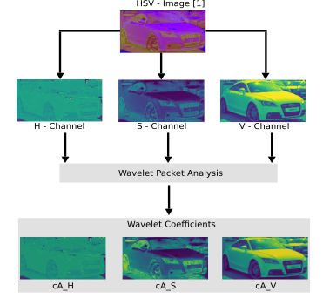

* Multiresolution Analysis

* Time-Frequency Localization

* Orthogonal or Biorthogonal Wavelet Mothers

[1] **3D Object Representations for Fine-Grained Categorization.** Jonathan Krause, Michael Stark, Jia Deng, Li Fei-Fei. *4th IEEE Workshop on 3D Representation and Recognition, at ICCV, 2013* **(3dRR-13)**. Sydney, Australia. Dec. 8, 2013.