**Tutorial – Criando Sistema Multicamada com JSF, EJB e JPA**

1. Inicie o NetBeans.

2. Inicie o servidor Glassfish local.

3. Crie um novo projeto através do menu “Arquivo > Novo projeto”. Selecione a categoria “Maven” e, na lista de projetos disponíveis, selecione “Aplicação Web”. Clique “Próximo”. Dê o nome “CriandoJPA” para o projeto. Clique “Próximo”. Selecione o servidor “Glassfish” e “JavaEE 7 para Web”. Clique “Finalizar”.

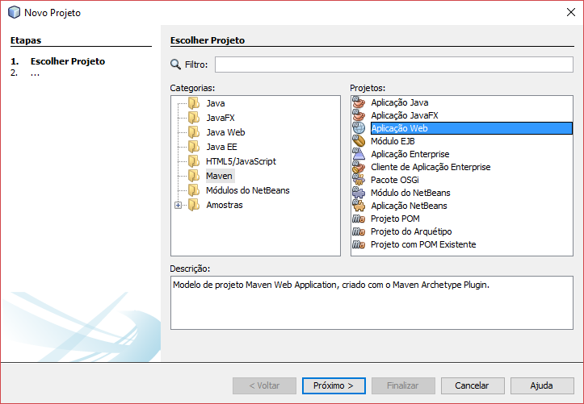

4. Antes de prosseguir, verifique se o banco de dados Derby local possui a base de dados “sample” do Glassfish.

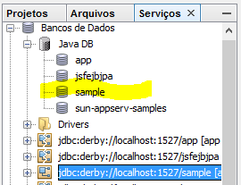

Caso não exista, utilize o script de criação da base de dados (disponível ao final deste documento).

Esta base de dados possui o seguinte esquema relacional:

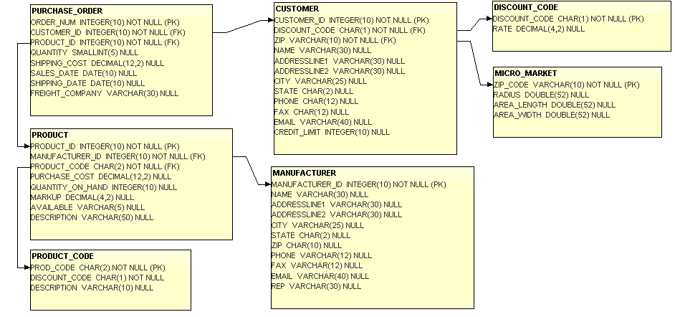

5. Crie uma nova unidade de persistência clicando com o botão direito sobre o projeto e selecione o menu “Novo > Outros...”. Selecione a categoria “Persistência” e “Unidade de Persistência” e clique “Próximo”.

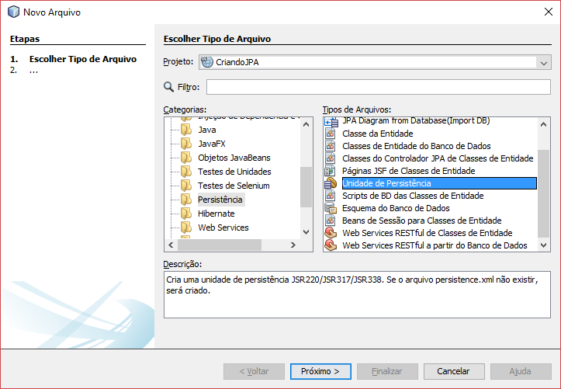

Na janela de configuração, coloque “criandojpaPU” para o “Nome da Unidade de Persistência”, clique em “Origem dos Dados:” e selecione “jdbc/sample”. Como estratégia de geração de tabela marque “Nenhum”. Clique “Finish”.

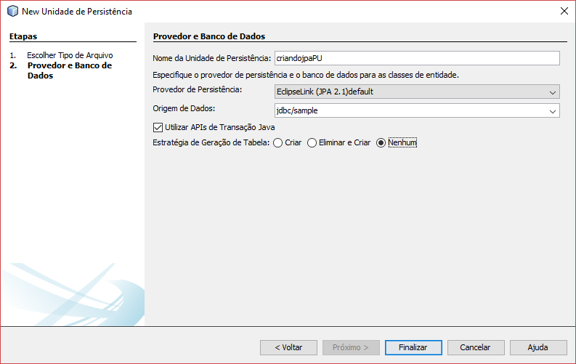

Abra o arquivo “persistence.xml” no modo “Código-fonte” e adicione as propriedades para habilitar o logging dos comandos SQL enviados via JDBC para a fonte de dados:

<properties>

<property name="eclipselink.logging.level" value="FINE"/>

<property name="eclipselink.logging.level.sql" value="FINE"/>

<property name="eclipselink.logging.parameters" value="true"/>

</properties>

6. Crie uma entidade persistente clicando com o botão direito sobre o projeto e selecione o menu “Novo > Outros...”. Selecione a categoria “Persistência” e “Classes de entidade do banco de dados” e clique “Próximo”.

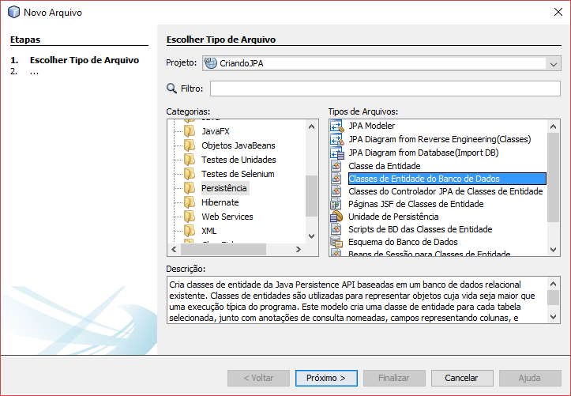

Na janela de configuração, selecione a fonte de dados “jdbc/sample”. Desmarque a opção “Incluir tabelas relacionadas”. Após, selecione as tabelas “Customer” e “DiscountCode”. Clique em “Adicionar”. Clique “Próximo”.

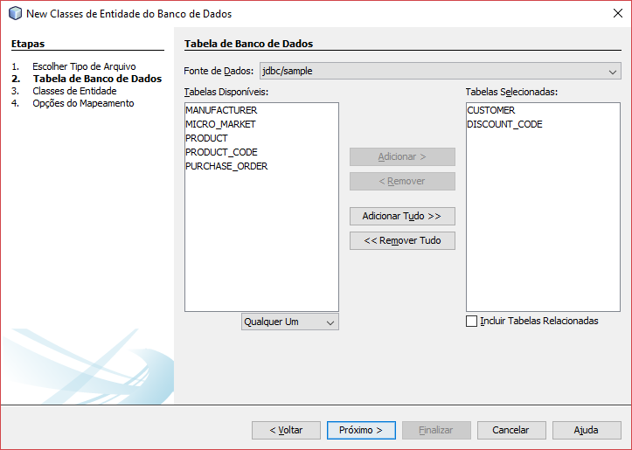

Configure o nome do pacote como “facin.extensao.criandojpa.entidades”. Clique “Próximo”. Clique “Finalizar”.

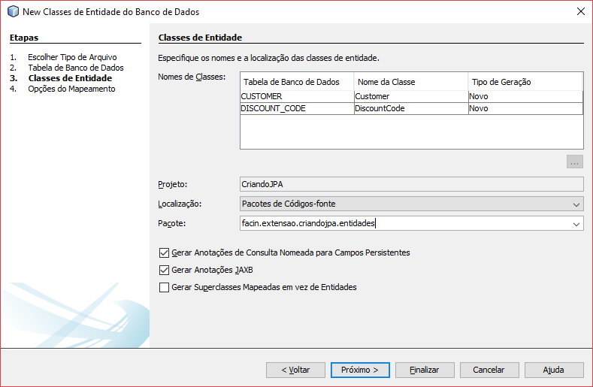

7. Observe e analise o código da classe gerada através da importação do esquema do banco de dados. Transforme o relacionamento bidirecional (criado automaticamente) em unidirecional de “Customer” para “DiscountCode”. Para tal, abra o arquivo “DiscountCode.java” e remove o atributo indicado a seguir (junto com seus métodos get e set):

@OneToMany(cascade = CascadeType.ALL, mappedBy = "discountCode")

private Collection<Customer> customerCollection;

8. Crie um EJB Session Stateless clicando com o botão direito sobre o projeto e selecionando o menu “Novo > Outros...”. Selecione a categoria “Persistência” e “Beans de sessão para classes de entidade” e clique “Próximo”.

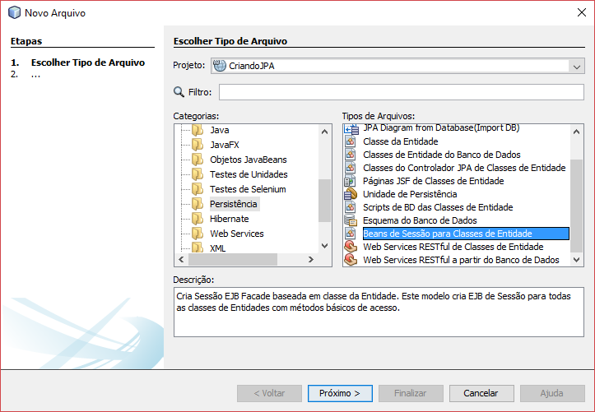

Selecione as classes criadas no passo anterior. Clique “Adicionar”. Clique “Próximo”.

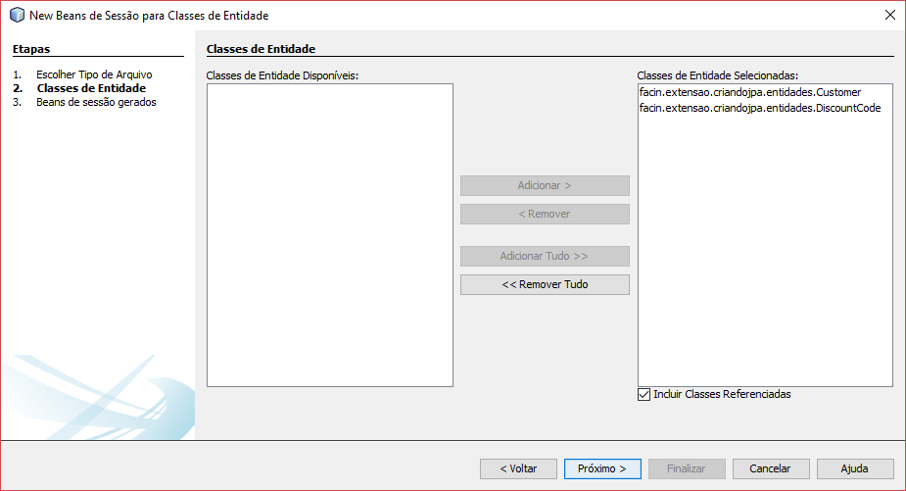

Adicione as novas classes para o pacote “facin.extensao.criandojpa.negocio”. Marque a opção de interface “Local”. Clique “Finalizar”.

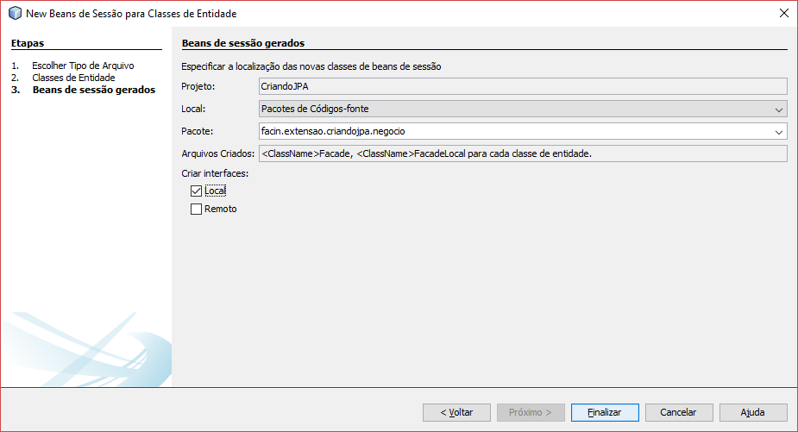

9. Observe e analise o código das classes e das interfaces geradas. A estrutura de código consiste em um DAO (*Data Access Object*) para operações CRUD genéricas.

10. Adicione uma classe que funcionará como DTO (*Data Transfer Object*) para permitir a passagem de dados entre as camadas de Interface com Usuário e Negócio. Nomeie essa classe “CustomerDTO” dentro do pacote “facin.extensao.criandojpa.negocio” no projeto e adicione o seguinte código:

public class CustomerDTO implements Serializable{

private Integer customerId;

private String name;

private String fullAddress;

private String phone;

private String fax;

private String email;

private Integer creditLimit;

private BigDecimal discount;

public Integer getCustomerId() {

return customerId;

}

public void setCustomerId(Integer customerId) {

this.customerId = customerId;

}

public String getName() {

return name;

}

public void setName(String name) {

this.name = name;

}

public String getFullAddress() {

return fullAddress;

}

public void setFullAddress(String fullAddress) {

this.fullAddress = fullAddress;

}

public String getPhone() {

return phone;

}

public void setPhone(String phone) {

this.phone = phone;

}

public String getFax() {

return fax;

}

public void setFax(String fax) {

this.fax = fax;

}

public String getEmail() {

return email;

}

public void setEmail(String email) {

this.email = email;

}

public Integer getCreditLimit() {

return creditLimit;

}

public void setCreditLimit(Integer creditLimit) {

this.creditLimit = creditLimit;

}

public BigDecimal getDiscount() {

return discount;

}

public void setDiscount(BigDecimal discount) {

this.discount = discount;

}

public CustomerDTO(Integer customerId, String name, String fullAddress, String phone, String fax, String email, Integer creditLimit, BigDecimal discount) {

this.customerId = customerId;

this.name = name;

this.fullAddress = fullAddress;

this.phone = phone;

this.fax = fax;

this.email = email;

this.creditLimit = creditLimit;

this.discount = discount;

}

}

11. Adicione um EJB de sessão stateless com interface local no pacote “facin.extensao.criandojpa.negocio” que funcionará como fachada para acessar a base de dados através dos EJBs criados nos passos anteriores. Crie a interface “FachadaLocal” e a classe concreta “Fachada” de acordo com o código a seguir:

@Local

public interface FachadaLocal {

List<CustomerDTO> getCustomers() throws FachadaException;

}

@Stateless

public class Fachada implements FachadaLocal {

@EJB

private DiscountCodeFacadeLocal discountEjb;

@EJB

private CustomerFacadeLocal cutomerEjb;

@Override

public List<CustomerDTO> getCustomers() throws FachadaException{

try {

List<Customer> customers = cutomerEjb.findAll();

return copiarParaDTO(customers);

} catch(Exception e) {

throw new FachadaException("Erro ao buscar", e);

}

}

private List<CustomerDTO> copiarParaDTO(List<Customer> todos) {

List<CustomerDTO> dtos = new ArrayList<>(todos.size());

for (Customer c : todos) {

Integer id = c.getCustomerId();

String name = c.getName();

String address = c.getAddressline1() + " " + c.getAddressline2() + " " + c.getCity() + " " + c.getState();

String phone = c.getPhone();

String fax = c.getFax();

String email = c.getEmail();

Integer limit = c.getCreditLimit();

BigDecimal discount = new BigDecimal(c.getDiscountCode().getRate());

CustomerDTO dto = new CustomerDTO(id, name, address, phone, fax, email, limit, discount);

dtos.add(dto);

}

return dtos;

}

}

12. Adicione uma classe de exceção no pacote “facin.extensao.criandojpa.negocio”:

public class FachadaException extends EJBException {

public FachadaException() {

}

public FachadaException(String message) {

super(message);

}

public FachadaException(String message, Exception ex) {

super(message, ex);

}

}

13. Acrescente um novo descritor de configuração do GlassFish para configurar o uso de Unicode UTF-8 como codificação de caracteres. Clique com o botão direito sobre o projeto e selecione o menu “Novo>Outros”. Localize a categoria “GlassFish” e selecione “Descritor do GlassFish”. Clique “Próximo”. Clique “Finalizar”. Edite o arquivo “glassfish-web.xml” para que ele se pareça com o seguinte (mude para a visão adequada clicando no botão “XML” da janela de edição):

<?xml version="1.0" encoding="UTF-8"?>

<!DOCTYPE glassfish-web-app PUBLIC "-//GlassFish.org//DTD GlassFish Application Server 3.1 Servlet 3.0//EN" "http://glassfish.org/dtds/glassfish-web-app_3_0-1.dtd">

<glassfish-web-app error-url="">

<parameter-encoding default-charset="UTF-8"/>

</glassfish-web-app>

14. Adicione um novo arquivo *facelet* para a *view*. Clique com o botão direito sobre o projeto e selecione o menu “Novo>Outros”. Localize a categoria “JavaServer Faces” e selecione “Página JSF”. Clique “Próximo”. Utilize “index” para o nome do arquivo. Clique “Finalizar”.

15. Abra a página JSF “index.xhtml”. Edite seus componentes para que apresente uma tabela que irá conter o resultado da consulta à base de dados. Não esqueça de atualizar as referências para as bibliotecas de marcações necessárias. Adicione o seguinte código dentro do corpo da página:

<h1>Customers:</h1>

<h:dataTable id="tabCustomers">

<h:column>

<f:facet name="header">

<h:outputText value="Id"/>

</f:facet>

<h:outputText />

</h:column>

<h:column>

<f:facet name="header">

<h:outputText value="Name"/>

</f:facet>

<h:outputText />

</h:column>

<h:column>

<f:facet name="header">

<h:outputText value="Discount"/>

</f:facet>

<h:outputText />

</h:column>

</h:dataTable>

16. Adicione um bean que funcionará como intermediário entre a view JSF e o EJB de acesso à persistência de dados. Clique com o botão direito sobre o projeto WEB e selecione o menu “Novo > Classe Java...”. Utilize o nome “IndexBean” no pacote “facin.extensao.criandojpa.web”. Clique “Finalizar”.

17. Abra e edite o código da classe “IndexBean” com as seguintes anotações:

import javax.enterprise.context.RequestScoped;

import javax.inject.Named;

@Named

@RequestScoped

public class IndexBean {

}

18. Adicione um atributo privado para a injeção dos recursos necessários para acessar o EJB:

@EJB

private FachadaLocal fachadaEjb;

19. Adicione propriedades para os dados a serem utilizadas pelas páginas JSF:

public List<CustomerDTO> getCustomers() {

return fachadaEjb.getCustomers();

}

20. Abra o código fonte da página “index.xhtml” e adicione a vinculação dos componentes gráficos às propriedades dos beans:

<h:dataTable id="tabCustomers" value="#{indexBean.customers}" var="c">

<h:column>

<f:facet name="header">

<h:outputText value="Id"/>

</f:facet>

<h:outputText value="#{c.customerId}"/>

</h:column>

<h:column>

<f:facet name="header">

<h:outputText value="Name"/>

</f:facet>

<h:outputText value="#{c.name}"/>

</h:column>

<h:column>

<f:facet name="header">

<h:outputText value="Discount"/>

</f:facet>

<h:outputText value="#{c.discount}"/>

</h:column>

</h:dataTable>

21. Execute a aplicação.

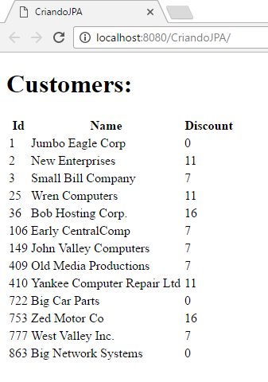

CREATE TABLE "APP"."CUSTOMER"

(

CUSTOMER_ID int PRIMARY KEY NOT NULL,

DISCOUNT_CODE char(1) NOT NULL,

ZIP varchar(10) NOT NULL,

NAME varchar(30),

ADDRESSLINE1 varchar(30),

ADDRESSLINE2 varchar(30),

CITY varchar(25),

STATE char(2),

PHONE char(12),

FAX char(12),

EMAIL varchar(40),

CREDIT_LIMIT int

)

;

CREATE TABLE "APP"."DISCOUNT_CODE"

(

DISCOUNT_CODE char(1) PRIMARY KEY NOT NULL,

RATE decimal(4)

)

;

CREATE TABLE "APP"."MANUFACTURER"

(

MANUFACTURER_ID int PRIMARY KEY NOT NULL,

NAME varchar(30),

ADDRESSLINE1 varchar(30),

ADDRESSLINE2 varchar(30),

CITY varchar(25),

STATE char(2),

ZIP char(10),

PHONE varchar(12),

FAX varchar(12),

EMAIL varchar(40),

REP varchar(30)

)

;

CREATE TABLE "APP"."MICRO_MARKET"

(

ZIP_CODE varchar(10) PRIMARY KEY NOT NULL,

RADIUS float(52),

AREA_LENGTH float(52),

AREA_WIDTH float(52)

)

;

CREATE TABLE "APP"."PRODUCT"

(

PRODUCT_ID int PRIMARY KEY NOT NULL,

MANUFACTURER_ID int NOT NULL,

PRODUCT_CODE char(2) NOT NULL,

PURCHASE_COST decimal(12),

QUANTITY_ON_HAND int,

MARKUP decimal(4),

AVAILABLE varchar(5),

DESCRIPTION varchar(50)

)

;

CREATE TABLE "APP"."PRODUCT_CODE"

(

PROD_CODE char(2) PRIMARY KEY NOT NULL,

DISCOUNT_CODE char(1) NOT NULL,

DESCRIPTION varchar(10)

)

;

CREATE TABLE "APP"."PURCHASE_ORDER"

(

ORDER_NUM int PRIMARY KEY NOT NULL,

CUSTOMER_ID int NOT NULL,

PRODUCT_ID int NOT NULL,

QUANTITY smallint,

SHIPPING_COST decimal(12),

SALES_DATE date,

SHIPPING_DATE date,

FREIGHT_COMPANY varchar(30)

)

;

INSERT INTO "APP"."DISCOUNT_CODE" (DISCOUNT_CODE,RATE) VALUES ('H',16.00);

INSERT INTO "APP"."DISCOUNT_CODE" (DISCOUNT_CODE,RATE) VALUES ('L',7.00);

INSERT INTO "APP"."DISCOUNT_CODE" (DISCOUNT_CODE,RATE) VALUES ('M',11.00);

INSERT INTO "APP"."DISCOUNT_CODE" (DISCOUNT_CODE,RATE) VALUES ('N',0.00);

INSERT INTO "APP"."CUSTOMER" (CUSTOMER_ID,DISCOUNT_CODE,ZIP,NAME,ADDRESSLINE1,ADDRESSLINE2,CITY,STATE,PHONE,FAX,EMAIL,CREDIT_LIMIT) VALUES (1,'N','95117','Jumbo Eagle Corp','111 E. Las Olivas Blvd','Suite 51','Fort Lauderdale','FL','305-555-0188','305-555-0189','jumboeagle@example.com',100000);

INSERT INTO "APP"."CUSTOMER" (CUSTOMER_ID,DISCOUNT_CODE,ZIP,NAME,ADDRESSLINE1,ADDRESSLINE2,CITY,STATE,PHONE,FAX,EMAIL,CREDIT_LIMIT) VALUES (2,'M','95035','New Enterprises','9754 Main Street','P.O. Box 567','Miami','FL','305-555-0148','305-555-0149','www.new.example.com',50000);

INSERT INTO "APP"."CUSTOMER" (CUSTOMER_ID,DISCOUNT_CODE,ZIP,NAME,ADDRESSLINE1,ADDRESSLINE2,CITY,STATE,PHONE,FAX,EMAIL,CREDIT_LIMIT) VALUES (3,'L','12347','Small Bill Company','8585 South Upper Murray Drive','P.O. Box 456','Alanta','GA','555-555-0175','555-555-0176','www.smallbill.example.com',90000);

INSERT INTO "APP"."CUSTOMER" (CUSTOMER_ID,DISCOUNT_CODE,ZIP,NAME,ADDRESSLINE1,ADDRESSLINE2,CITY,STATE,PHONE,FAX,EMAIL,CREDIT_LIMIT) VALUES (25,'M','85638','Wren Computers','8989 Red Albatross Drive','Suite 9897','Houston','TX','214-555-0133','214-555-0134','www.wrencomp.example.com',25000);

INSERT INTO "APP"."CUSTOMER" (CUSTOMER_ID,DISCOUNT_CODE,ZIP,NAME,ADDRESSLINE1,ADDRESSLINE2,CITY,STATE,PHONE,FAX,EMAIL,CREDIT_LIMIT) VALUES (36,'H','94401','Bob Hosting Corp.','65653 Lake Road','Suite 2323','San Mateo','CA','650-555-0160','650-555-0161','www.bobhostcorp.example.com',65000);

INSERT INTO "APP"."CUSTOMER" (CUSTOMER_ID,DISCOUNT_CODE,ZIP,NAME,ADDRESSLINE1,ADDRESSLINE2,CITY,STATE,PHONE,FAX,EMAIL,CREDIT_LIMIT) VALUES (106,'L','95035','Early CentralComp','829 E Flex Drive','Suite 853','San Jose','CA','408-555-0157','408-555-0150','www.centralcomp.example.com',26500);

INSERT INTO "APP"."CUSTOMER" (CUSTOMER_ID,DISCOUNT_CODE,ZIP,NAME,ADDRESSLINE1,ADDRESSLINE2,CITY,STATE,PHONE,FAX,EMAIL,CREDIT_LIMIT) VALUES (149,'L','95117','John Valley Computers','4381 Kelly Valley Ave','Suite 77','Santa Clara','CA','408-555-0169','408-555-0167','www.johnvalley.example.com',70000);

INSERT INTO "APP"."CUSTOMER" (CUSTOMER_ID,DISCOUNT_CODE,ZIP,NAME,ADDRESSLINE1,ADDRESSLINE2,CITY,STATE,PHONE,FAX,EMAIL,CREDIT_LIMIT) VALUES (409,'L','10095','Old Media Productions','4400 527th Street','Suite 562','New York','NY','212-555-0110','212-555-0111','www.oldmedia.example.com',10000);

INSERT INTO "APP"."CUSTOMER" (CUSTOMER_ID,DISCOUNT_CODE,ZIP,NAME,ADDRESSLINE1,ADDRESSLINE2,CITY,STATE,PHONE,FAX,EMAIL,CREDIT_LIMIT) VALUES (410,'M','10096','Yankee Computer Repair Ltd','9653 211th Ave','Floor 4','New York','NY','212-555-0191','212-555-0197','www.nycompltd@repair.example.com',25000);

INSERT INTO "APP"."CUSTOMER" (CUSTOMER_ID,DISCOUNT_CODE,ZIP,NAME,ADDRESSLINE1,ADDRESSLINE2,CITY,STATE,PHONE,FAX,EMAIL,CREDIT_LIMIT) VALUES (722,'N','48124','Big Car Parts','52963 Notouter Dr','Suite 35','Detroit','MI','313-555-0144','313-555-0145','www.bparts.example.com',50000);

INSERT INTO "APP"."CUSTOMER" (CUSTOMER_ID,DISCOUNT_CODE,ZIP,NAME,ADDRESSLINE1,ADDRESSLINE2,CITY,STATE,PHONE,FAX,EMAIL,CREDIT_LIMIT) VALUES (753,'H','48128','Zed Motor Co','2267 NE Michigan Ave','Building 21','Dearborn','MI','313-555-0151','313-555-0152','www.parts@ford.example.com',5000000);

INSERT INTO "APP"."CUSTOMER" (CUSTOMER_ID,DISCOUNT_CODE,ZIP,NAME,ADDRESSLINE1,ADDRESSLINE2,CITY,STATE,PHONE,FAX,EMAIL,CREDIT_LIMIT) VALUES (777,'L','48128','West Valley Inc.','88 Northsouth Drive','Building C','Dearborn','MI','313-555-0172','313-555-0171','www.westv.example.com',100000);

INSERT INTO "APP"."CUSTOMER" (CUSTOMER_ID,DISCOUNT_CODE,ZIP,NAME,ADDRESSLINE1,ADDRESSLINE2,CITY,STATE,PHONE,FAX,EMAIL,CREDIT_LIMIT) VALUES (863,'N','94401','Big Network Systems','456 444th Street','Suite 45','Redwood City','CA','650-555-0181','650-555-0180','www.bignet.example.com',25000);

INSERT INTO "APP"."MANUFACTURER" (MANUFACTURER_ID,NAME,ADDRESSLINE1,ADDRESSLINE2,CITY,STATE,ZIP,PHONE,FAX,EMAIL,REP) VALUES (19941212,'Birders United','4000 Cormorant Circle','Building 19','Burlington','OR','95051 ','206-555-0183','206-555-0179','bill@example.com','Bill Snider');

INSERT INTO "APP"."MANUFACTURER" (MANUFACTURER_ID,NAME,ADDRESSLINE1,ADDRESSLINE2,CITY,STATE,ZIP,PHONE,FAX,EMAIL,REP) VALUES (19948494,'Computer Support Center','5632 Michigam Ave',' ','Dearborn','RI','48127 ','313-555-0181','313-555-0182','www.comsup.example.net','Sam Wright');

INSERT INTO "APP"."MANUFACTURER" (MANUFACTURER_ID,NAME,ADDRESSLINE1,ADDRESSLINE2,CITY,STATE,ZIP,PHONE,FAX,EMAIL,REP) VALUES (19955564,'Birders United','4000 Cormorant Circle','Building 15','Burlington','OR','95051 ','206-555-0179','206-555-0179','phil@example.com','Phil Waters');

INSERT INTO "APP"."MANUFACTURER" (MANUFACTURER_ID,NAME,ADDRESSLINE1,ADDRESSLINE2,CITY,STATE,ZIP,PHONE,FAX,EMAIL,REP) VALUES (19955565,'Birders United','4000 Cormorant Circle','Building 16','Burlington','OR','95051 ','206-555-0180','206-555-0179','birders@example.com','Birders');

INSERT INTO "APP"."MANUFACTURER" (MANUFACTURER_ID,NAME,ADDRESSLINE1,ADDRESSLINE2,CITY,STATE,ZIP,PHONE,FAX,EMAIL,REP) VALUES (19955656,'Soft Circle Opticians','95 Eastway Clearview Drive','Building 1','Boston','MA','02100 ','617-555-0171','617-555-0172','www.softcircle@example.com','Alfred Nelson');

INSERT INTO "APP"."MANUFACTURER" (MANUFACTURER_ID,NAME,ADDRESSLINE1,ADDRESSLINE2,CITY,STATE,ZIP,PHONE,FAX,EMAIL,REP) VALUES (19960022,'Super Computer Products','63 Garcia Rock Way','Floor 22','Albuqerque','NM','87119 ','505-555-0193','505-555-0193','www.supercomputer@example.com','Tom Cross');

INSERT INTO "APP"."MANUFACTURER" (MANUFACTURER_ID,NAME,ADDRESSLINE1,ADDRESSLINE2,CITY,STATE,ZIP,PHONE,FAX,EMAIL,REP) VALUES (19963322,'Pauls Dairy','236 Hill Street Lane','Suite 6','Orlando','CA','94567 ','415-555-0140','415-555-0141','paulsdairy.example.com','John White');

INSERT INTO "APP"."MANUFACTURER" (MANUFACTURER_ID,NAME,ADDRESSLINE1,ADDRESSLINE2,CITY,STATE,ZIP,PHONE,FAX,EMAIL,REP) VALUES (19963323,'Joseph Ironworks','7655 382nd Street','Suite 200','Mountainside','TX','94043 ','408-555-0122','408-555-0128','joseph.ironworks@example.com','John Green');

INSERT INTO "APP"."MANUFACTURER" (MANUFACTURER_ID,NAME,ADDRESSLINE1,ADDRESSLINE2,CITY,STATE,ZIP,PHONE,FAX,EMAIL,REP) VALUES (19963324,'Nails and Screws','7654 First Avenue','Suite 1005','Ypsilanti','MI','94043 ','302-555-0191','302-555-0193','nails.screws@example.com','Fred Stanford');

INSERT INTO "APP"."MANUFACTURER" (MANUFACTURER_ID,NAME,ADDRESSLINE1,ADDRESSLINE2,CITY,STATE,ZIP,PHONE,FAX,EMAIL,REP) VALUES (19963325,'Main Beauty Hair Salon','44 Overload Street','Building 150','Chicago','WA','94043 ','211-555-0182','211-555-0183','mainbeauty@example.com','7 of 9');

INSERT INTO "APP"."MANUFACTURER" (MANUFACTURER_ID,NAME,ADDRESSLINE1,ADDRESSLINE2,CITY,STATE,ZIP,PHONE,FAX,EMAIL,REP) VALUES (19965794,'Easy Reach Telephones','975 El Camino Circle','Suite 4055','Santa Clara','VA','95051 ','408-555-0167','408-555-0168','www.easyreach@example.com','Walter James');

INSERT INTO "APP"."MANUFACTURER" (MANUFACTURER_ID,NAME,ADDRESSLINE1,ADDRESSLINE2,CITY,STATE,ZIP,PHONE,FAX,EMAIL,REP) VALUES (19971233,'Bills Bank and Sons','5960 Inglewood Pkwy','Building C5','Pleasantville','WI','94588 ','408-555-0183','408-555-0184','www.billbank@example.com','Frank Smith');

INSERT INTO "APP"."MANUFACTURER" (MANUFACTURER_ID,NAME,ADDRESSLINE1,ADDRESSLINE2,CITY,STATE,ZIP,PHONE,FAX,EMAIL,REP) VALUES (19974892,'Wilson Fish Co','20959 Whalers Ave','Building 3','San Jose','OH','95128 ','650-555-0133','408-555-0133','www.wilsonfish@example.com','Matthew Williams');

INSERT INTO "APP"."MANUFACTURER" (MANUFACTURER_ID,NAME,ADDRESSLINE1,ADDRESSLINE2,CITY,STATE,ZIP,PHONE,FAX,EMAIL,REP) VALUES (19977346,'Upper Cargo Lift Services','2845 Smith Under Road','Suite 7','San Mateo','GA','94403 ','650-555-0171','650-555-0172','uppercargo.example.com','Frank Peters');

INSERT INTO "APP"."MANUFACTURER" (MANUFACTURER_ID,NAME,ADDRESSLINE1,ADDRESSLINE2,CITY,STATE,ZIP,PHONE,FAX,EMAIL,REP) VALUES (19977347,'Super Savings Pharmacy','56 Broadway Lane','Floor 123','Oakland','NH','98123 ','510-555-0173','510-555-0173','superpharmace.example.com','Tom Brown');

INSERT INTO "APP"."MANUFACTURER" (MANUFACTURER_ID,NAME,ADDRESSLINE1,ADDRESSLINE2,CITY,STATE,ZIP,PHONE,FAX,EMAIL,REP) VALUES (19977348,'Early Posting Corp','235 E Market St.','Suite 1','San David','CA','94567 ','415-555-0138','415-555-0139','superposting.example.com','John Adams');

INSERT INTO "APP"."MANUFACTURER" (MANUFACTURER_ID,NAME,ADDRESSLINE1,ADDRESSLINE2,CITY,STATE,ZIP,PHONE,FAX,EMAIL,REP) VALUES (19977775,'Sams Photo Center','9447 West 13th Street','Suite 25','Reading','MN','01867 ','617-555-0177','617-555-0178','www.photctr@example.com','Laurie Brown');

INSERT INTO "APP"."MANUFACTURER" (MANUFACTURER_ID,NAME,ADDRESSLINE1,ADDRESSLINE2,CITY,STATE,ZIP,PHONE,FAX,EMAIL,REP) VALUES (19978451,'All Sushi','399 San Pablo Ave','Building 600','Cleveland','CA','94530 ','650-555-0140','408-555-0143','www.allsushi@example.com','Teresa Ho');

INSERT INTO "APP"."MANUFACTURER" (MANUFACTURER_ID,NAME,ADDRESSLINE1,ADDRESSLINE2,CITY,STATE,ZIP,PHONE,FAX,EMAIL,REP) VALUES (19980198,'Pleasant Enterprises','76342 865th Ave','Suite 450','New York','NY','10044 ','212-555-0184','212-555-0185','www.pleasant@example.com','Louis Lewis');

INSERT INTO "APP"."MANUFACTURER" (MANUFACTURER_ID,NAME,ADDRESSLINE1,ADDRESSLINE2,CITY,STATE,ZIP,PHONE,FAX,EMAIL,REP) VALUES (19982461,'Soft Cables','9988 Main Upper Street','Suite 100','Indianapolis','IA','46290 ','650-555-0151','408-555-0152','www.cbales@example.com','Henry Adams');

INSERT INTO "APP"."MANUFACTURER" (MANUFACTURER_ID,NAME,ADDRESSLINE1,ADDRESSLINE2,CITY,STATE,ZIP,PHONE,FAX,EMAIL,REP) VALUES (19984681,'Birders United','4000 Cormorant Circle','Building 17','Burlington','OR','95051 ','206-555-0181','206-555-0179','returnpalace@example.com','Nick Phillips');

INSERT INTO "APP"."MANUFACTURER" (MANUFACTURER_ID,NAME,ADDRESSLINE1,ADDRESSLINE2,CITY,STATE,ZIP,PHONE,FAX,EMAIL,REP) VALUES (19984682,'Birders United','4000 Cormorant Circle','Building 18','Burlington','OR','95051 ','206-555-0182','206-555-0179','brian@example.com','Brian Brown');

INSERT INTO "APP"."MANUFACTURER" (MANUFACTURER_ID,NAME,ADDRESSLINE1,ADDRESSLINE2,CITY,STATE,ZIP,PHONE,FAX,EMAIL,REP) VALUES (19984899,'Mike Recording Industries','5109 Union Street Road','Building 8A','San Alfred','CA','94123 ','415-555-0166','415-555-0165','www.mikerecording@example.com','Mike Black');

INSERT INTO "APP"."MANUFACTURER" (MANUFACTURER_ID,NAME,ADDRESSLINE1,ADDRESSLINE2,CITY,STATE,ZIP,PHONE,FAX,EMAIL,REP) VALUES (19985590,'Birders United','4000 Cormorant Circle','Building 14','Burlington','OR','95051 ','206-555-0178','206-555-0179','ann.jones@example.com','Ann Jones');

INSERT INTO "APP"."MANUFACTURER" (MANUFACTURER_ID,NAME,ADDRESSLINE1,ADDRESSLINE2,CITY,STATE,ZIP,PHONE,FAX,EMAIL,REP) VALUES (19985678,'Happy End Searching','5 81st Street','Suite 100','Mountain View','CA','94043 ','650-555-0102','408-555-0103','happysearching@example.com','John Snow');

INSERT INTO "APP"."MANUFACTURER" (MANUFACTURER_ID,NAME,ADDRESSLINE1,ADDRESSLINE2,CITY,STATE,ZIP,PHONE,FAX,EMAIL,REP) VALUES (19986196,'James Deli','250 Marinade Blvd','Suite C','Novato','IL','94949 ','650-555-0144','408-555-0145','www.jdeli@example.net','Phil Jones');

INSERT INTO "APP"."MANUFACTURER" (MANUFACTURER_ID,NAME,ADDRESSLINE1,ADDRESSLINE2,CITY,STATE,ZIP,PHONE,FAX,EMAIL,REP) VALUES (19986542,'Florenc Bakery','795 Stone Flour Road','Suite 4','Tombstone','DE','85638 ','602-555-0182','602-555-0188','florenc.example.com','Jeff Green');

INSERT INTO "APP"."MANUFACTURER" (MANUFACTURER_ID,NAME,ADDRESSLINE1,ADDRESSLINE2,CITY,STATE,ZIP,PHONE,FAX,EMAIL,REP) VALUES (19986982,'Smith Bird Watching','4000 Finch Circle','Building 14','Santa Clara','CA','95051 ','650-555-0111','408-555-0112','www.sbw@example.com','Brian Washington');

INSERT INTO "APP"."MANUFACTURER" (MANUFACTURER_ID,NAME,ADDRESSLINE1,ADDRESSLINE2,CITY,STATE,ZIP,PHONE,FAX,EMAIL,REP) VALUES (19987296,'Birders United','4000 Cormorant Circle','Building 20','Burlington','OR','95051 ','206-555-0184','206-555-0179','gerard@example.com','Jerry Young');

INSERT INTO "APP"."MANUFACTURER" (MANUFACTURER_ID,NAME,ADDRESSLINE1,ADDRESSLINE2,CITY,STATE,ZIP,PHONE,FAX,EMAIL,REP) VALUES (19989719,'Fast Boards','1000 Van Nuys Lane','Suite 904537','Van Nuys','VT','91405 ','800-555-0173','800-555-0174','www.fboards@example.com','Julie Board');

INSERT INTO "APP"."MICRO_MARKET" (ZIP_CODE,RADIUS,AREA_LENGTH,AREA_WIDTH) VALUES ('10095',1987.854,975.875,865.681);

INSERT INTO "APP"."MICRO_MARKET" (ZIP_CODE,RADIUS,AREA_LENGTH,AREA_WIDTH) VALUES ('10096',1876.766,955.666,923.556);

INSERT INTO "APP"."MICRO_MARKET" (ZIP_CODE,RADIUS,AREA_LENGTH,AREA_WIDTH) VALUES ('12347',475.965,385.849,146.937);

INSERT INTO "APP"."MICRO_MARKET" (ZIP_CODE,RADIUS,AREA_LENGTH,AREA_WIDTH) VALUES ('48124',753.765,487.664,456.632);

INSERT INTO "APP"."MICRO_MARKET" (ZIP_CODE,RADIUS,AREA_LENGTH,AREA_WIDTH) VALUES ('48128',684.675,475.854,408.074);

INSERT INTO "APP"."MICRO_MARKET" (ZIP_CODE,RADIUS,AREA_LENGTH,AREA_WIDTH) VALUES ('85638',758.648,328.963,482.164);

INSERT INTO "APP"."MICRO_MARKET" (ZIP_CODE,RADIUS,AREA_LENGTH,AREA_WIDTH) VALUES ('94043',157.869,385.821,147.538);

INSERT INTO "APP"."MICRO_MARKET" (ZIP_CODE,RADIUS,AREA_LENGTH,AREA_WIDTH) VALUES ('94401',368.386,285.848,173.794);

INSERT INTO "APP"."MICRO_MARKET" (ZIP_CODE,RADIUS,AREA_LENGTH,AREA_WIDTH) VALUES ('95035',683.396,472.859,379.757);

INSERT INTO "APP"."MICRO_MARKET" (ZIP_CODE,RADIUS,AREA_LENGTH,AREA_WIDTH) VALUES ('95051',255.59,689.856,478.479);

INSERT INTO "APP"."MICRO_MARKET" (ZIP_CODE,RADIUS,AREA_LENGTH,AREA_WIDTH) VALUES ('95117',755.778,547.967,468.858);

INSERT INTO "APP"."PRODUCT_CODE" (PROD_CODE,DISCOUNT_CODE,DESCRIPTION) VALUES ('BK','L','Books');

INSERT INTO "APP"."PRODUCT_CODE" (PROD_CODE,DISCOUNT_CODE,DESCRIPTION) VALUES ('CB','N','Cables');

INSERT INTO "APP"."PRODUCT_CODE" (PROD_CODE,DISCOUNT_CODE,DESCRIPTION) VALUES ('FW','L','Firmware');

INSERT INTO "APP"."PRODUCT_CODE" (PROD_CODE,DISCOUNT_CODE,DESCRIPTION) VALUES ('HW','H','Hardware');

INSERT INTO "APP"."PRODUCT_CODE" (PROD_CODE,DISCOUNT_CODE,DESCRIPTION) VALUES ('MS','N','Misc');

INSERT INTO "APP"."PRODUCT_CODE" (PROD_CODE,DISCOUNT_CODE,DESCRIPTION) VALUES ('SW','M','Software');

INSERT INTO "APP"."PRODUCT" (PRODUCT_ID,MANUFACTURER_ID,PRODUCT_CODE,PURCHASE_COST,QUANTITY_ON_HAND,MARKUP,AVAILABLE,DESCRIPTION) VALUES (948933,19941212,'MS',36.95,50,75.00,'TRUE','Computer Tool Kit');

INSERT INTO "APP"."PRODUCT" (PRODUCT_ID,MANUFACTURER_ID,PRODUCT_CODE,PURCHASE_COST,QUANTITY_ON_HAND,MARKUP,AVAILABLE,DESCRIPTION) VALUES (958888,19955564,'HW',799.99,0,1.50,'FALSE','Ultra Spacr 999Mhz Computer');

INSERT INTO "APP"."PRODUCT" (PRODUCT_ID,MANUFACTURER_ID,PRODUCT_CODE,PURCHASE_COST,QUANTITY_ON_HAND,MARKUP,AVAILABLE,DESCRIPTION) VALUES (958889,19955565,'HW',595.95,0,1.25,'FALSE','686 7Ghz Computer');

INSERT INTO "APP"."PRODUCT" (PRODUCT_ID,MANUFACTURER_ID,PRODUCT_CODE,PURCHASE_COST,QUANTITY_ON_HAND,MARKUP,AVAILABLE,DESCRIPTION) VALUES (964025,19963322,'SW',209.95,300,41.00,'TRUE','Jax WS Application Development Environment');

INSERT INTO "APP"."PRODUCT" (PRODUCT_ID,MANUFACTURER_ID,PRODUCT_CODE,PURCHASE_COST,QUANTITY_ON_HAND,MARKUP,AVAILABLE,DESCRIPTION) VALUES (964026,19963323,'SW',259.95,220,51.00,'TRUE','Java EE 6 Application Development Environment');

INSERT INTO "APP"."PRODUCT" (PRODUCT_ID,MANUFACTURER_ID,PRODUCT_CODE,PURCHASE_COST,QUANTITY_ON_HAND,MARKUP,AVAILABLE,DESCRIPTION) VALUES (964027,19963324,'SW',269.95,700,61.00,'TRUE','Java Application Development Environment');

INSERT INTO "APP"."PRODUCT" (PRODUCT_ID,MANUFACTURER_ID,PRODUCT_CODE,PURCHASE_COST,QUANTITY_ON_HAND,MARKUP,AVAILABLE,DESCRIPTION) VALUES (964028,19963325,'SW',219.95,300,32.00,'TRUE','NetBeans Development Environment');

INSERT INTO "APP"."PRODUCT" (PRODUCT_ID,MANUFACTURER_ID,PRODUCT_CODE,PURCHASE_COST,QUANTITY_ON_HAND,MARKUP,AVAILABLE,DESCRIPTION) VALUES (971266,19948494,'CB',25.95,500,30.00,'TRUE','Network Cable');

INSERT INTO "APP"."PRODUCT" (PRODUCT_ID,MANUFACTURER_ID,PRODUCT_CODE,PURCHASE_COST,QUANTITY_ON_HAND,MARKUP,AVAILABLE,DESCRIPTION) VALUES (975789,19977775,'BK',29.98,25,5.00,'TRUE','Learn Solaris 10');

INSERT INTO "APP"."PRODUCT" (PRODUCT_ID,MANUFACTURER_ID,PRODUCT_CODE,PURCHASE_COST,QUANTITY_ON_HAND,MARKUP,AVAILABLE,DESCRIPTION) VALUES (978493,19977346,'BK',19.95,100,5.00,'TRUE','Client Server Testing');

INSERT INTO "APP"."PRODUCT" (PRODUCT_ID,MANUFACTURER_ID,PRODUCT_CODE,PURCHASE_COST,QUANTITY_ON_HAND,MARKUP,AVAILABLE,DESCRIPTION) VALUES (978494,19977347,'BK',18.95,43,4.00,'TRUE','Learn Java in 1/2 hour');

INSERT INTO "APP"."PRODUCT" (PRODUCT_ID,MANUFACTURER_ID,PRODUCT_CODE,PURCHASE_COST,QUANTITY_ON_HAND,MARKUP,AVAILABLE,DESCRIPTION) VALUES (978495,19977348,'BK',24.99,0,1.00,'FALSE','Writing Web Service Applications');

INSERT INTO "APP"."PRODUCT" (PRODUCT_ID,MANUFACTURER_ID,PRODUCT_CODE,PURCHASE_COST,QUANTITY_ON_HAND,MARKUP,AVAILABLE,DESCRIPTION) VALUES (980001,19985678,'SW',1095.00,800000,8.25,'TRUE','Identity Server');

INSERT INTO "APP"."PRODUCT" (PRODUCT_ID,MANUFACTURER_ID,PRODUCT_CODE,PURCHASE_COST,QUANTITY_ON_HAND,MARKUP,AVAILABLE,DESCRIPTION) VALUES (980002,19960022,'MS',75.00,0,12.00,'FALSE','Corporate Expense Survey');

INSERT INTO "APP"."PRODUCT" (PRODUCT_ID,MANUFACTURER_ID,PRODUCT_CODE,PURCHASE_COST,QUANTITY_ON_HAND,MARKUP,AVAILABLE,DESCRIPTION) VALUES (980005,19986982,'SW',11500.99,500,55.25,'TRUE','Accounting Application');

INSERT INTO "APP"."PRODUCT" (PRODUCT_ID,MANUFACTURER_ID,PRODUCT_CODE,PURCHASE_COST,QUANTITY_ON_HAND,MARKUP,AVAILABLE,DESCRIPTION) VALUES (980025,19974892,'HW',2095.99,3000,15.75,'TRUE','1Ghz Sun Blade Computer');

INSERT INTO "APP"."PRODUCT" (PRODUCT_ID,MANUFACTURER_ID,PRODUCT_CODE,PURCHASE_COST,QUANTITY_ON_HAND,MARKUP,AVAILABLE,DESCRIPTION) VALUES (980030,19986196,'FW',59.95,250,40.00,'TRUE','10Gb Ram');

INSERT INTO "APP"."PRODUCT" (PRODUCT_ID,MANUFACTURER_ID,PRODUCT_CODE,PURCHASE_COST,QUANTITY_ON_HAND,MARKUP,AVAILABLE,DESCRIPTION) VALUES (980031,19986542,'SW',595.95,75,14.00,'TRUE','Sun Studio C++');

INSERT INTO "APP"."PRODUCT" (PRODUCT_ID,MANUFACTURER_ID,PRODUCT_CODE,PURCHASE_COST,QUANTITY_ON_HAND,MARKUP,AVAILABLE,DESCRIPTION) VALUES (980032,19978451,'FW',39.95,50,25.50,'TRUE','Sound Card');

INSERT INTO "APP"."PRODUCT" (PRODUCT_ID,MANUFACTURER_ID,PRODUCT_CODE,PURCHASE_COST,QUANTITY_ON_HAND,MARKUP,AVAILABLE,DESCRIPTION) VALUES (980122,19985590,'HW',1400.95,100,25.00,'TRUE','Solaris x86 Computer');

INSERT INTO "APP"."PRODUCT" (PRODUCT_ID,MANUFACTURER_ID,PRODUCT_CODE,PURCHASE_COST,QUANTITY_ON_HAND,MARKUP,AVAILABLE,DESCRIPTION) VALUES (980500,19980198,'BK',29.95,1000,33.00,'TRUE','Learn NetBeans');

INSERT INTO "APP"."PRODUCT" (PRODUCT_ID,MANUFACTURER_ID,PRODUCT_CODE,PURCHASE_COST,QUANTITY_ON_HAND,MARKUP,AVAILABLE,DESCRIPTION) VALUES (980601,19971233,'HW',2000.95,2000,25.00,'TRUE','300Mhz Pentium Computer');

INSERT INTO "APP"."PRODUCT" (PRODUCT_ID,MANUFACTURER_ID,PRODUCT_CODE,PURCHASE_COST,QUANTITY_ON_HAND,MARKUP,AVAILABLE,DESCRIPTION) VALUES (984666,19987296,'HW',199.95,25,45.00,'TRUE','Flat screen Monitor');

INSERT INTO "APP"."PRODUCT" (PRODUCT_ID,MANUFACTURER_ID,PRODUCT_CODE,PURCHASE_COST,QUANTITY_ON_HAND,MARKUP,AVAILABLE,DESCRIPTION) VALUES (985510,19984899,'HW',595.00,800,5.75,'TRUE','24 inch Digital Monitor');

INSERT INTO "APP"."PRODUCT" (PRODUCT_ID,MANUFACTURER_ID,PRODUCT_CODE,PURCHASE_COST,QUANTITY_ON_HAND,MARKUP,AVAILABLE,DESCRIPTION) VALUES (986420,19955656,'SW',49.95,0,5.25,'FALSE','Directory Server');

INSERT INTO "APP"."PRODUCT" (PRODUCT_ID,MANUFACTURER_ID,PRODUCT_CODE,PURCHASE_COST,QUANTITY_ON_HAND,MARKUP,AVAILABLE,DESCRIPTION) VALUES (986710,19982461,'CB',15.98,400,30.00,'TRUE','Printer Cable');

INSERT INTO "APP"."PRODUCT" (PRODUCT_ID,MANUFACTURER_ID,PRODUCT_CODE,PURCHASE_COST,QUANTITY_ON_HAND,MARKUP,AVAILABLE,DESCRIPTION) VALUES (986712,19989719,'HW',69.95,1000,10.50,'TRUE','512X IDE DVD-ROM');

INSERT INTO "APP"."PRODUCT" (PRODUCT_ID,MANUFACTURER_ID,PRODUCT_CODE,PURCHASE_COST,QUANTITY_ON_HAND,MARKUP,AVAILABLE,DESCRIPTION) VALUES (986733,19984681,'HW',69.98,400,55.00,'TRUE','A1 900 watts Speakers');

INSERT INTO "APP"."PRODUCT" (PRODUCT_ID,MANUFACTURER_ID,PRODUCT_CODE,PURCHASE_COST,QUANTITY_ON_HAND,MARKUP,AVAILABLE,DESCRIPTION) VALUES (986734,19984682,'HW',49.95,200,65.00,'TRUE','Mini Computer Speakers');

INSERT INTO "APP"."PRODUCT" (PRODUCT_ID,MANUFACTURER_ID,PRODUCT_CODE,PURCHASE_COST,QUANTITY_ON_HAND,MARKUP,AVAILABLE,DESCRIPTION) VALUES (988765,19965794,'HW',10.95,25,9.75,'TRUE','104-Key Keyboard');

INSERT INTO "APP"."PURCHASE_ORDER" (ORDER_NUM,CUSTOMER_ID,PRODUCT_ID,QUANTITY,SHIPPING_COST,SALES_DATE,SHIPPING_DATE,FREIGHT_COMPANY) VALUES (10398001,1,980001,10,449.00,{d '2011-05-24'},{d '2011-05-24'},'Poney Express');

INSERT INTO "APP"."PURCHASE_ORDER" (ORDER_NUM,CUSTOMER_ID,PRODUCT_ID,QUANTITY,SHIPPING_COST,SALES_DATE,SHIPPING_DATE,FREIGHT_COMPANY) VALUES (10398002,2,980005,8,359.99,{d '2011-05-24'},{d '2011-05-24'},'Poney Express');

INSERT INTO "APP"."PURCHASE_ORDER" (ORDER_NUM,CUSTOMER_ID,PRODUCT_ID,QUANTITY,SHIPPING_COST,SALES_DATE,SHIPPING_DATE,FREIGHT_COMPANY) VALUES (10398003,2,980025,25,275.00,{d '2011-05-24'},{d '2011-05-24'},'Poney Express');

INSERT INTO "APP"."PURCHASE_ORDER" (ORDER_NUM,CUSTOMER_ID,PRODUCT_ID,QUANTITY,SHIPPING_COST,SALES_DATE,SHIPPING_DATE,FREIGHT_COMPANY) VALUES (10398004,3,980030,10,275.00,{d '2011-05-24'},{d '2011-05-24'},'Poney Express');

INSERT INTO "APP"."PURCHASE_ORDER" (ORDER_NUM,CUSTOMER_ID,PRODUCT_ID,QUANTITY,SHIPPING_COST,SALES_DATE,SHIPPING_DATE,FREIGHT_COMPANY) VALUES (10398005,1,980032,100,459.00,{d '2011-05-24'},{d '2011-05-24'},'Poney Express');

INSERT INTO "APP"."PURCHASE_ORDER" (ORDER_NUM,CUSTOMER_ID,PRODUCT_ID,QUANTITY,SHIPPING_COST,SALES_DATE,SHIPPING_DATE,FREIGHT_COMPANY) VALUES (10398006,36,986710,60,55.00,{d '2011-05-24'},{d '2011-05-24'},'Slow Snail');

INSERT INTO "APP"."PURCHASE_ORDER" (ORDER_NUM,CUSTOMER_ID,PRODUCT_ID,QUANTITY,SHIPPING_COST,SALES_DATE,SHIPPING_DATE,FREIGHT_COMPANY) VALUES (10398007,36,985510,120,65.00,{d '2011-05-24'},{d '2011-05-24'},'Slow Snail');

INSERT INTO "APP"."PURCHASE_ORDER" (ORDER_NUM,CUSTOMER_ID,PRODUCT_ID,QUANTITY,SHIPPING_COST,SALES_DATE,SHIPPING_DATE,FREIGHT_COMPANY) VALUES (10398008,106,988765,500,265.00,{d '2011-05-24'},{d '2011-05-24'},'Slow Snail');

INSERT INTO "APP"."PURCHASE_ORDER" (ORDER_NUM,CUSTOMER_ID,PRODUCT_ID,QUANTITY,SHIPPING_COST,SALES_DATE,SHIPPING_DATE,FREIGHT_COMPANY) VALUES (10398009,149,986420,1000,700.00,{d '2011-05-24'},{d '2011-05-24'},'Western Fast');

INSERT INTO "APP"."PURCHASE_ORDER" (ORDER_NUM,CUSTOMER_ID,PRODUCT_ID,QUANTITY,SHIPPING_COST,SALES_DATE,SHIPPING_DATE,FREIGHT_COMPANY) VALUES (10398010,863,986712,100,25.00,{d '2011-05-24'},{d '2011-05-24'},'Slow Snail');

INSERT INTO "APP"."PURCHASE_ORDER" (ORDER_NUM,CUSTOMER_ID,PRODUCT_ID,QUANTITY,SHIPPING_COST,SALES_DATE,SHIPPING_DATE,FREIGHT_COMPANY) VALUES (20198001,777,971266,75,105.00,{d '2011-05-24'},{d '2011-05-24'},'We deliver');

INSERT INTO "APP"."PURCHASE_ORDER" (ORDER_NUM,CUSTOMER_ID,PRODUCT_ID,QUANTITY,SHIPPING_COST,SALES_DATE,SHIPPING_DATE,FREIGHT_COMPANY) VALUES (20598100,753,980601,100,200.99,{d '2011-05-24'},{d '2011-05-24'},'We deliver');

INSERT INTO "APP"."PURCHASE_ORDER" (ORDER_NUM,CUSTOMER_ID,PRODUCT_ID,QUANTITY,SHIPPING_COST,SALES_DATE,SHIPPING_DATE,FREIGHT_COMPANY) VALUES (20598101,722,980500,250,2500.00,{d '2011-05-24'},{d '2011-05-24'},'Coastal Freight');

INSERT INTO "APP"."PURCHASE_ORDER" (ORDER_NUM,CUSTOMER_ID,PRODUCT_ID,QUANTITY,SHIPPING_COST,SALES_DATE,SHIPPING_DATE,FREIGHT_COMPANY) VALUES (30198001,409,980001,50,2000.99,{d '2011-05-24'},{d '2011-05-24'},'Southern Delivery Service');

INSERT INTO "APP"."PURCHASE_ORDER" (ORDER_NUM,CUSTOMER_ID,PRODUCT_ID,QUANTITY,SHIPPING_COST,SALES_DATE,SHIPPING_DATE,FREIGHT_COMPANY) VALUES (30298004,410,980031,100,700.00,{d '2011-05-24'},{d '2011-05-24'},'FR Express');

ALTER TABLE "APP"."CUSTOMER"

ADD CONSTRAINT FOREIGNKEY_ZIP

FOREIGN KEY (ZIP)

REFERENCES "APP"."MICRO_MARKET"(ZIP_CODE)

;

ALTER TABLE "APP"."CUSTOMER"

ADD CONSTRAINT FOREIGNKEY_DISCOUNT_CODE

FOREIGN KEY (DISCOUNT_CODE)

REFERENCES "APP"."DISCOUNT_CODE"(DISCOUNT_CODE)

;

ALTER TABLE "APP"."PRODUCT"

ADD CONSTRAINT FOREIGNKEY_PRODUCT_CODE

FOREIGN KEY (PRODUCT_CODE)

REFERENCES "APP"."PRODUCT_CODE"(PROD_CODE)

;

ALTER TABLE "APP"."PRODUCT"

ADD CONSTRAINT FOREIGNKEY_MANUFACTURER_ID

FOREIGN KEY (MANUFACTURER_ID)

REFERENCES "APP"."MANUFACTURER"(MANUFACTURER_ID)

;

ALTER TABLE "APP"."PURCHASE_ORDER"

ADD CONSTRAINT FOREIGNKEY_PRODUCT_ID

FOREIGN KEY (PRODUCT_ID)

REFERENCES "APP"."PRODUCT"(PRODUCT_ID)

;

ALTER TABLE "APP"."PURCHASE_ORDER"

ADD CONSTRAINT FOREIGNKEY_CUSTOMER_ID

FOREIGN KEY (CUSTOMER_ID)

REFERENCES "APP"."CUSTOMER"(CUSTOMER_ID)

;