Application Activity: Managing Finances
Name: Julio César Celón Altamirano

Part 1: Self-Reliance
- Give at least two reasons why the self-reliant approach to finances can lead to greater peace and stability for you. Use at least one specific example from the course reading or your own life to support each reason in your response.
- Reason 1: For me, keeping the commandment of tithing is a fundamental part of my life. It allows me to know and feel that the Lord is pleased with me and that I can be sure that the windows of heaven are open and blessings will come into my life until they overflow.
- Example from the course or your life to support this reason: Since I have lived by the law of tithing, I have never lacked anything. My family has been blessed and protected with health and love.
- Reason 2: Making the effort to create a budget for my income and expenses helps me avoid overspending, prioritize my spending, save money, and stay out of debt.
- Example from the course or your life to support this reason: Maintaining a budget with a record of my income and expenses allows me to have better control over allocating resources to what is most important, and it allows me to be prepared for future times that may be difficult. Two years ago, I was unemployed, and thanks to the savings I had, I was able to provide for my family during those times of need.
- Give one reason why interest can hurt your finances. Use at least one specific example from the course reading or your own life to support your response.
- Reason: Debt interest grows exponentially over time, hindering your ability to save or invest.
- Example from the course or your life to support this reason: Owning a credit card requires discipline in your spending and payment deadlines. If you are unable to control these two aspects, you may incur interest charges. I know that because I have 4 credit cards, and I see that I need always keep track of the expenditures and the dates to pay these credit cards

Part 2: Open and Download Needed Files for the Budget
- Open your Expense Tracker Excel file. You were instructed to track all expenses and income for two weeks.
  - If you had access to a bank, you didn’t need to track expenses on the Expense Tracker file. It is now time to obtain a bank report of your recent account activity.
- Download the Budget Template Excel file. You will not turn in your actual budget but use it to honestly answer the questions at the end of this document.
  - If you do not have an income and you spend no money, you should still complete Parts 3, 4, and 5 of this assignment. Imagine an income and expenses. Use this as an opportunity to practice using a budget.

Part 3: Enter Income Sources and Budget Categories
- On the budget template, enter the start and end dates for your budget. This is typically the first of the month to the last day of the month or payday to payday. The budget needs to span one month.
- In column A, starting in row 10, list all your income sources for the coming month.
- Then in column B, give your best estimate of the amount of money you expect to earn from each source.
- Consider the list of expense categories in column D, and the categories you used in your Expense Tracker. Modify the categories to best fit your situation.
- Once you have listed your expense categories in column D, use column E to indicate whether each is a fixed or a variable expense. Your responses may differ from those in the example.
- Now, look at the expenses you tracked for the last two weeks to help you create a budget for the coming month. Even though you have only tracked for two weeks, you can multiply some of these items by 2 to fill a month. Enter the amount you plan to spend in each category in the appropriate cells in column F.

Part 4. Balance Your Budget
- Review that the total income you expect to earn is given in cell B8 and the total expenses in cell F8. If the number in cell F8 is more than the number in B8, it means that your planned expenses exceed your total income. Your budget is not balanced.
- Though there is likely not much you can do to adjust your fixed expenses, look over your variable expenses and make necessary adjustments until your Total Income expected (cell B8) is equal to or only slightly greater than the Total Expenses budgeted (cell F8).
  - If you can’t balance your budget by adjusting the variable expenses, you will need to consider what fixed expenses you can adjust (i.e. – reducing or canceling services, subscriptions, etc.) or what other income you could acquire.
- When you finish, your budget should look something like the following.
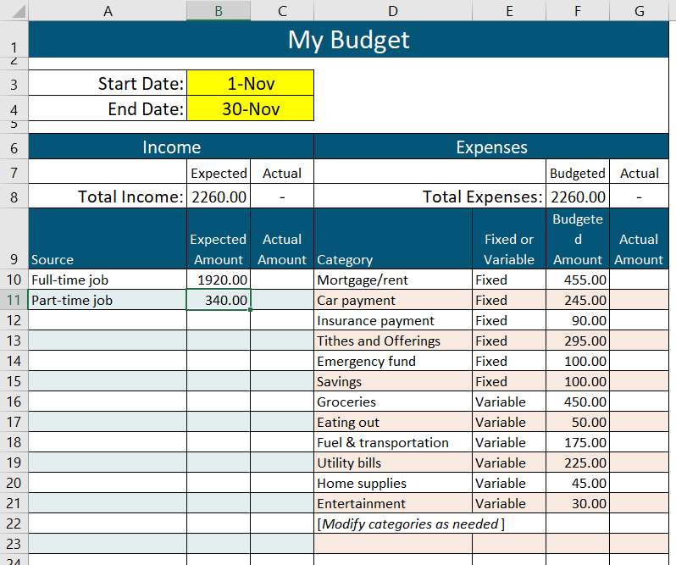

- Notice this assignment did not ask you to put in any information into columns C and G. Those columns are for you to fill in later. The course will not ask about this, but if you stick to this budget, the actual amounts should generally be equal to or less than the budgeted or expected amounts. It is up to you to manage your finances!

Part 5: Reflect
Answer the following questions.*

- Did you download and complete a budget?
_X_Yes
___No

- Did you classify each of your expenses as fixed or variable?
_X_Yes
___No

- Did you adjust the budget so your expenses did not exceed your income?
_Y_Yes
___I didn’t need to
__No

- Describe at least one challenge to keeping a budget where your expenses do not exceed your income.
The challenge is to adjust to the budget and convey it to my wife, to work as a team. Sometimes we spend more money on gifts for the kids.

- Describe at least one way to overcome this challenge.
I need to talk to my wife and convince her to adjust our expenditures to the budget. If we want a gift for the kids, we need to talk about it and plan this expenditure.

Submission Instructions
Just submit this document to the course for grading and feedback. You do not need to submit the budget that you completed.

*For questions 15-17, if you already have a budget that tracks expenses as fixed or variable, you may use that for reporting responses.

