VIETNAM GENERAL CONFEDERATION OF LABOR

**TON DUC THANG UNIVERSITY**

**FACULTY OF INFORMATION TECHNOLOGY**



**REPORT OF SOFTWARE ENGINEERING**

**…FINAL PROJECT…**

*Instructor*: **MR. PHAM THAI KY TRUNG**

*Performer*: **HUYNH TUAN ANH – 521H0003**

**NGUYEN CANH TUNG - 519H0360**

**HO CHI MINH CITY, 2023**

VIETNAM GENERAL CONFEDERATION OF LABOR

**TON DUC THANG UNIVERSITY**

**FACULTY OF INFORMATION TECHNOLOGY**



**REPORT OF SOFTWARE ENGINEERING**

**…FINAL PROJECT…**

Instructor: **MR. PHAM THAI KY TRUNG**

Performer: **HUYNH TUAN ANH**

**NGUYEN CANH TUNG**

**HO CHI MINH CITY, 2023**

THANK YOU

We would like to express our sincere thanks to the Faculty of Information Technology for allowing us to write this thesis. At the same time, we would like to express my deep gratitude to Mr. Pham Thai Ky Trung for guiding us during the time of studying Software Engineering and providing enough knowledge for us to make this report.

**PROJECT COMPLETED AT**

**TON DUC THANG UNIVERSITY**

We hereby declare that this is the product of our own project and under the guidance of Mr. Pham Thai Ky Trung; The research contents and results in this topic are honest and have not been published in any form before. The data in the tables for analysis, comments and evaluation are collected by the author himself from different sources, clearly stated in the reference section.

In addition, the project also uses a number of comments, assessments as well as data from other authors, other agencies and organizations, with citations and source annotations.

**If it is discovered that there is any fraud, We would like to take full responsibility for the content of our project.** Ton Duc Thang University is not related to copyright and copyright violations caused by me during the implementation process (if any).

*Ho Chi Minh City, 2023 April 13*

*Author*

*(Sign and write your full name)*

*Huynh Tuan Anh*

*Nguyen Canh Tung*

TEACHER'S CONFIRMATION AND ASSESSMENT SECTION

**The confirmation part of the instructor**

_______________________________________________________________________________________________________________________________________________________________________________________________________________________________________________________________________________________________________________________________________________________________________________________________________________

Ho Chi Minh City, year month day

(Sign and write your full name)

**The evaluation part of the teacher who marks the test**

_______________________________________________________________________________________________________________________________________________________________________________________________________________________________________________________________________________________________________________________________________________________________________________________________________________

Ho Chi Minh City, year month day

(Sign and write your full name)

SUMMARY

In this essay, we divide it into seven parts:

CHAPTER 1: INTRODUCTION

CHAPTER 2: PROJECT MANAGEMENT PLAN

CHAPTER 3: REQUIREMENT SPECIFICATIONS

CHAPTER 4: ARCHITECTURE

CHAPTER 5: DESIGN

CHAPTER 6: TEST PLAN

CHAPTER 7: DEMO

TABLE OF CONTENTS

THANK YOU i

TEACHER'S CONFIRMATION AND ASSESSMENT SECTION iii

SUMMARY iv

TABLE OF CONTENTS 1

LIST OF SYMBOLS AND ABBREVIATIONS 3

LIST OF TABLES, PICTURES, GRAPHS 4

CHAPTER 1 – INTRODUCTION 5

1.1 Purpose and Scope 5

1.2 Product Overview 5

1.3 Test the implemented program using sample data and verify the results. 5

1.4 Terms, Acronyms, and Abbreviations 5

CHAPTER 2 – PROJECT MANAGEMENT PLAN 6

2.1 Project Organization 6

2.2 Lifecycle Model Used 6

2.3 Risk Analysis 6

2.4 Hardware and Software Resource Requirements 6

2.5 Deliverables and Schedule 6

2.6. Monitoring, Reporting, and Controlling Mechanisms 6

2.7. Professional Standards 6

2.8. Evidence all the artifacts have been placed under configuration management 7

2.9. Impact of the project on individuals and organizations 7

CHAPTER 3 - REQUIREMENT SPECIFICATIONS 8

3.1. Stakeholders for the system 8

3.2. Use case model 8

3.2.1. Graphical use case model 8

3.2.2. Textual Description for each use case 8

3.3. Functional requirements 11

3.4. Non-functional requirements 12

CHAPTER 4 - ARCHITECTURE 13

4.1. Architectural style used 13

4.2. Architectural model 13

4.3. Technology, software, and hardware used 13

4.4. Rationale for your architectural style and model 13

CHAPTER 5 - DESIGN 14

5.1. Database design 14

5.2. Static model – class diagrams 14

5.3. Dynamic model – sequence diagrams 16

5.4. Rationale for your detailed design model 19

5.5. Traceability from requirements to detailed design model 19

CHAPTER 6 - TEST PLAN 20

CHAPTER 7 - DEMO 20

7.1. Database 20

7.2. Source code 23

7.3. Testing 26

**LIST OF SYMBOLS AND ABBREVIATIONS**

LIST OF TABLES, PICTURES, GRAPHS

CHAPTER 1 – INTRODUCTION

* 1. Purpose and Scope

To manage interactions with authorized resellers and agents, a software solution is being developed for a mobile phone distributor as the purpose of this project. Including inventory management, order processing, payment processing, reporting, and a B2C e-commerce platform, the software will cover various aspects of the distributor's operations.

* 1. Product Overview

Both the distributor's staff and authorized resellers/agents will have their needs catered to by the software. Functionalities will be provided through Windows Forms, Web Forms, and a B2C e-commerce website or mobile app. For agent payments, the software will integrate with VNPay and for order confirmations, it will use either Zalo or Email. Additionally, it will support multiple payment methods.

* 1. Test the implemented program using sample data and verify the results.

This document is organized into the following sections: Introduction, Project Management Plan, Requirement Specifications, Architecture, Design, Test Plan, and Demo. Each section provides detailed information on

the specific aspect of the project it covers.

* 1. Terms, Acronyms, and Abbreviations

B2C: Business-to-Consumer

API: Application Programming Interface

MSSQL: Microsoft SQL Server

VNPay: Vietnam Payment Solution

Zalo: Vietnamese messaging app

Win Form: Windows Form

Web Form: Web-based Form

CHAPTER 2 – PROJECT MANAGEMENT PLAN

2.1 Project Organization

My team will divide the work for 2 people including: analyzing project requirements, drawing diagrams, designing databases, creating main functional code interfaces, testing errors and finally running product demos.

2.2 Lifecycle Model Used

The project will follow an Agile development methodology, with iterative and incremental development cycles.

2.3 Risk Analysis

Potential risks include insufficient hardware or software resources, lack of familiarity with technology, and challenges in integration with third-party services.

2.4 Hardware and Software Resource Requirements

The project will require a development environment with C#, Windows Forms, Web Forms, and MSSQL.

2.5 Deliverables and Schedule

2.6. Monitoring, Reporting, and Controlling Mechanisms

Project progress will be monitored through regular team meetings, progress reports, and status updates on GitHub.

2.7. Professional Standards

The project will adhere to best practices in software development, including proper documentation, code reviews, and testing.

2.8. Evidence all the artifacts have been placed under configuration management

The project artifacts, including source code and documentation, will be stored and managed using a GitHub repository.

2.9. Impact of the project on individuals and organizations

The software will streamline the distributor's operations and improve the efficiency of interactions between the distributor, resellers, and agents. This will lead to improved customer satisfaction, increased sales, and enhanced profitability.

CHAPTER 3 - REQUIREMENT SPECIFICATIONS

3.1. Stakeholders for the system

Distributor

Accountant

Reseller/Agent

B2C Customer

3.2. Use case model

3.2.1. Graphical use case model

3.2.2. Textual Description for each use case

|  |  |  |
| --- | --- | --- |
| Use case ID | UC - 1 |  |
| Use case name | Create import form |  |
| Description | Tạo phiếu nhập kho cho hàng hóa |  |
| Actor | Accountant (kế toán) |  |
| Priority | Must have |  |
| Trigger | Có hàng hóa được chuyển đến |  |
| Pre – condition(s) | * Kho còn trống * Hàng hóa nằm trong danh sách kinh doanh |  |
| Post – condition(s) | * Hàng hóa nhập kho thành công * Các mặt hàng mới nhập sẽ có thông tin |  |
| Basic flow | 1. Kiểm tra hàng hóa 2. Xác thực hàng đúng tiêu chuẩn 3. Thống kê thông tin sản phẩm 4. Nhập vào phiếu xác nhận 5. Hệ thống ghi nhận đơn hàng | 1 → 2 → 3 → 4 → 5 |
| Alternative flow |  |  |
| Exception flow | 2a. Hàng không đúng tiêu chuẩn  2a1. Trả về  2a2. Không nhập phiếu | 1 → 2 → 3 → 4 → 5  2a → 2a1 → 2a2 |

|  |  |  |
| --- | --- | --- |
| Use case ID | UC - 3.1 |  |
| Use case name | Create export form |  |
| Description | Tạo phiếu xuất kho cho hàng hóa |  |
| Actor | Accountant (kế toán) |  |
| Priority | Must have |  |
| Trigger | Có hàng hóa được chuyển đi |  |
| Pre – condition(s) | * Có yêu cầu đặt/mua hàng * Hàng hóa còn đủ số lượng |  |
| Post – condition(s) | * Hàng hóa xuất kho thành công * Hệ thống cập nhật |  |
| Basic flow | 1. Kiểm chứng hàng trong kho 2. Xác thực hàng đúng tiêu chuẩn 3. Chuyển cho giao hàng 4. Nhập vào phiếu xác nhận 5. Hệ thống ghi nhận đơn hàng | 1 → 2 → 3 → 4 → 5 |
| Alternative flow | 2a. Hàng không đúng tiêu chuẩn  2a1. Chọn cái khác | 1 → 2 → 3 → 4 → 5  2a → 2a1 |
| Exception flow | 2b. Không còn hàng  2b1. Báo hết hàng  2b2. Không xuất phiếu | 1 → 2 → 3 → 4 → 5  2a → 2a1  2b → 2b1 → 2b2 |

|  |  |  |
| --- | --- | --- |
| Use case ID | UC - 2.1 |  |
| Use case name | Order |  |
| Description | Đặt mua hàng |  |
| Actor | Branch (các đại lí, nhà bán lẻ, cá nhân) |  |
| Priority | Must have |  |
| Trigger | Có nhu cầu buôn bán sử dụng |  |
| Pre – condition(s) | * Có đủ kinh tế * Có nguồn tiêu thụ |  |
| Post – condition(s) | * Nhận được hàng * Đánh giá sản phẩm |  |
| Basic flow | 1. Đăng nhập vào web công ty bán 2. Lựa chọn sản phẩm phù hợp 3. Bỏ vào giỏ hàng 4. Lựa chọn phương thức thanh toán 5. Xác nhận thanh toán | 1 → 2 → 3 → 4 → 5 |
| Alternative flow | 1a. Quên mật khẩu  1a1. Tạo mật khẩu mới  1a2. Đăng nhập lại  1b. Chưa có tài khoản  1b1. Tạo tài khoản  1b2. Đăng nhập | 1 → 2 → 3 → 4 → 5  1a → 1a1 → 1a2  1b → 1b1 → 1b2 |
| Exception flow | 2a. Không còn hàng  2a1. Đăng xuất  2a2. Không đặt nữa | 1 → 2 → 3 → 4 → 5  2a → 2a1 → 2a2 |

3.3. Functional requirements

FR1: Goods received note creation

FR2: Viewing incoming/outgoing stock report

FR3: Viewing best-selling products report

FR4: Viewing monthly revenue report

FR5: Goods delivery note creation

FR6: Placing orders

FR7: Choosing payment method

FR8: Making online payments

FR9: Viewing order status

FR10: Browsing products

FR11: Adding products to cart

FR12: Checkout process

FR13: Making payments

3.4. Non-functional requirements

NFR1: Performance

The system should be able to handle a high volume of transactions.

The system should provide quick response times for user actions.

NFR2: Scalability

The system should be able to handle an increasing number of users and transactions as the business grows.

NFR3: Security

The system should protect sensitive user and transaction data.

The system should provide role-based access control for staff members.

NFR4: Usability

The system should have an intuitive user interface for all user types (accountants, resellers/agents, and B2C customers).

NFR5: Availability

The system should be available 24/7 with minimal downtime.

NFR6: Integration

The system should integrate with VNPay for payment processing.

The system should integrate with Zalo or email for order confirmation notifications.

CHAPTER 4 - ARCHITECTURE

4.1. Architectural style used

The project will use a layered architectural style, with separate presentation, business logic, and data access layers. This style provides separation of concerns, allowing for easier maintenance and scalability of the system.

4.2. Architectural model

Experiment with some basic test cases

4.3. Technology, software, and hardware used

User Interface: C#, Windows Forms, and Web Forms for the distributor staff's applications; responsive HTML, CSS, and JavaScript for the reseller/agent web app.

Business Logic Layer: C# for implementing business rules and processing.

Data Access Layer: C# with ADO.NET or Entity Framework for database connectivity and data manipulation.

Database: MSSQL Server for data storage and retrieval.

4.4. Rationale for your architectural style and model

The layered architecture is chosen for its separation of concerns, modularity, and maintainability. This approach allows for easy updates and extensions, as well as improved testing capabilities.

CHAPTER 5 - DESIGN

5.1. Database design

5.2. Static model – class diagrams

5.3. Dynamic model – sequence diagrams

5.4. Rationale for your detailed design model

The detailed design model is based on the requirements and architecture, ensuring that the system meets stakeholder needs and follows best practices for maintainability and scalability. The model is designed to be flexible and extensible, allowing for future enhancements and updates.

5.5. Traceability from requirements to detailed design model

Experiment with some basic test cases

CHAPTER 6 - TEST PLAN

Experiment with some basic test cases

CHAPTER 7 - DEMO

7.1. Database

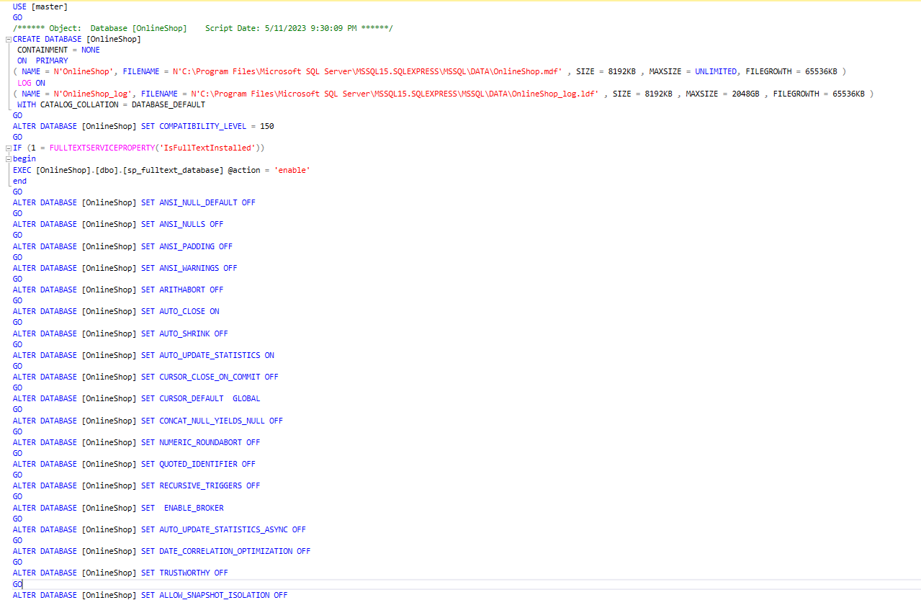

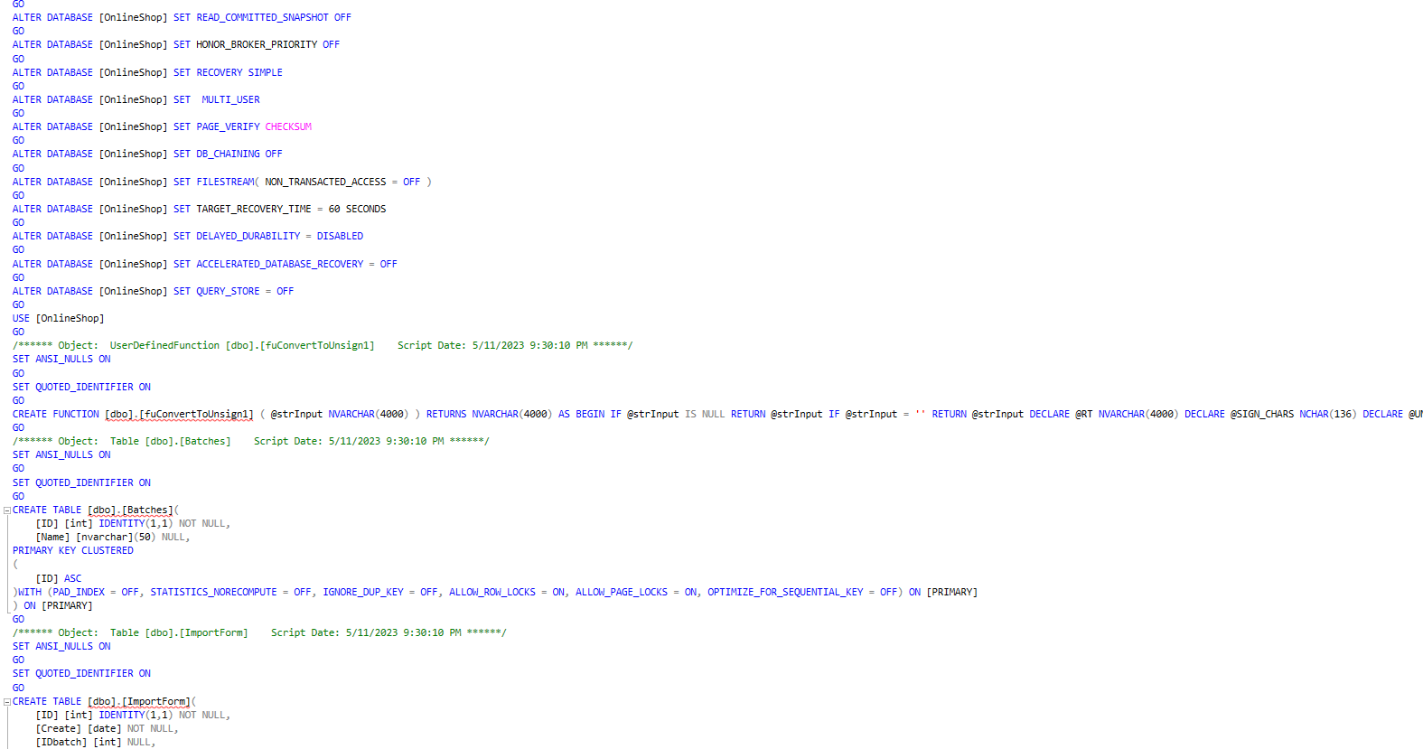

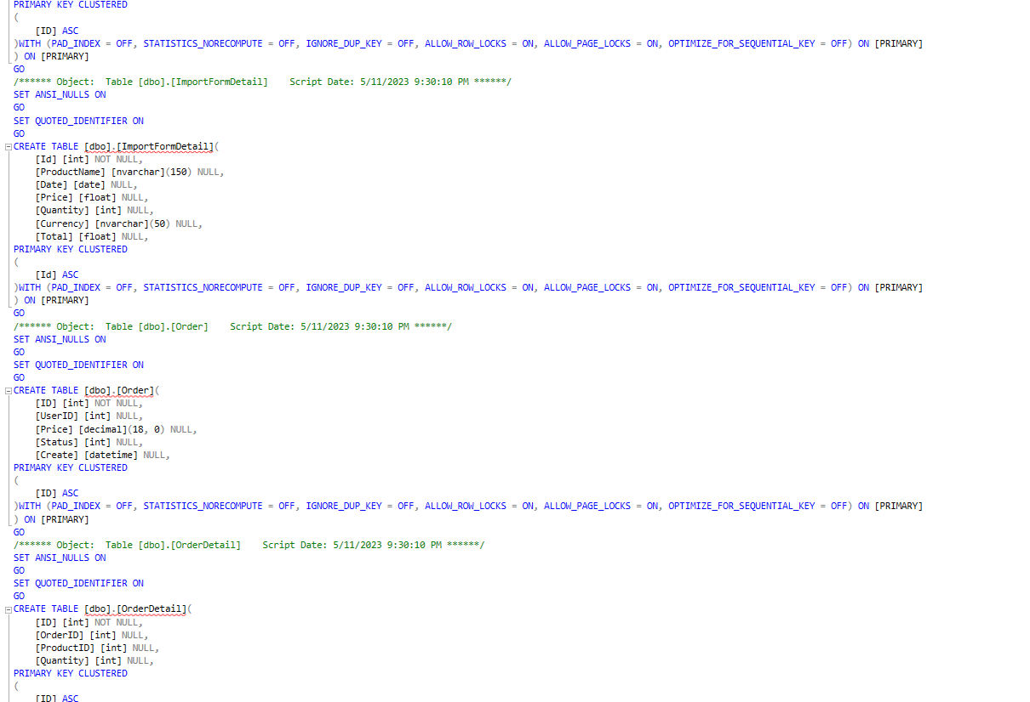

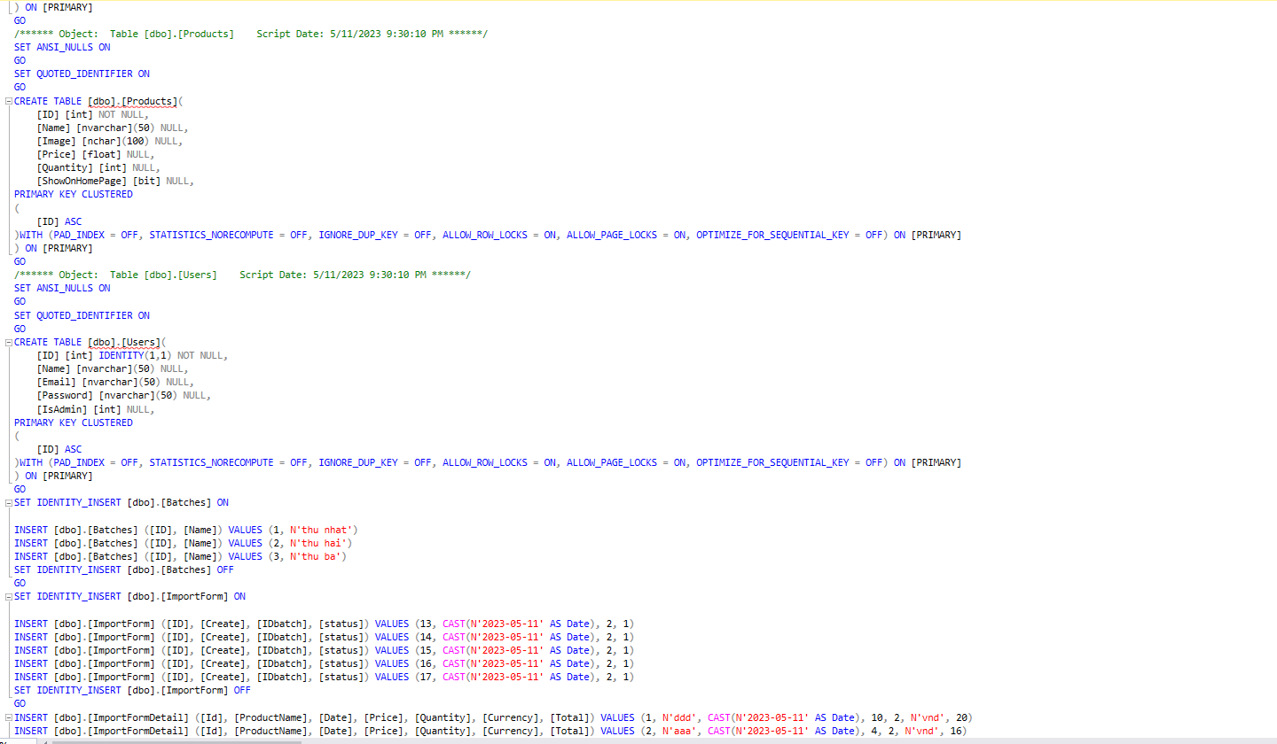

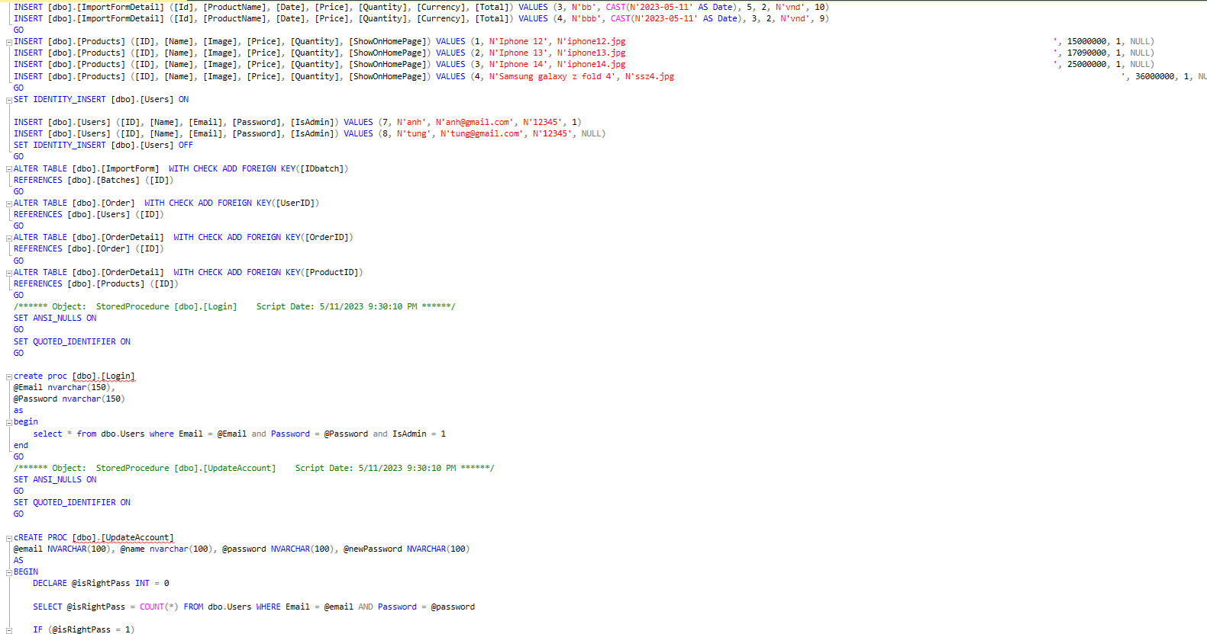

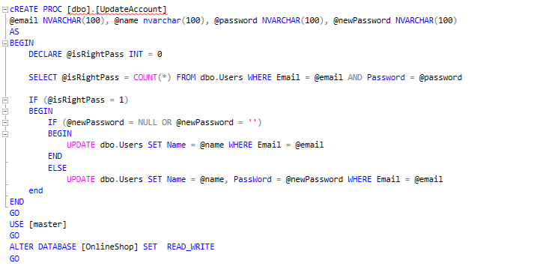

7.2. Source code

7.3. Testing

Video demo: <https://drive.google.com/file/d/1HrXhMJoE8qsV0tObPbvcV_jrTF8thDut/view?usp=share_link>

**REFERENCE MATERIAL**

**APPENDIX**