Etelegate Payment Integration Guide

Integrate Your Order page with
Our Payment page

Version: 06.16.05

Table of Contents
I ) Introduction To Payment Integration………………………………….. (3)
1.1 ) Company Overview...................................……................................….... (3)
1.2 ) Payment Integration Overview........................…….........................…..... (3)

II ) Payment Process Overview…………………………………………….. (4)
2.1 ) Diagrammatic Representation...................………........................…........ (4)
2.2 ) Process Explanation ……….....................……..............................…...... (5)

III ) Data Format……………………………………………………………. (5)
3.1 ) Data sent to the payment page by the Merchant…………………………(5)
3.2 ) Data sent to the Merchant from our bank…..…………………………... (6)

IV ) Transaction Process…..….……………………………………………. (7)
4.1 ) Test transaction techniques…………...………………………………… (7)
4.2 ) Live transaction techniques…………...………………………………… (7)

V ) How to Integrate…...…..….…………………………………………….. (8)
5.1) Integration Example.…………………………………………………….. (8)

VI ) Appendix –A……………………………………………………………. (9)

Introduction To Payment Integration

  - Company Overview

As truly one of the most unique international payment processors, Etelegate.com is a worldwide leader in Online Payment Processing. We specialize in issuing merchant accounts and processing online transactions for both Internet and traditional businesses around the globe. We offer banks, processors, re-sellers, payment gateways, call centers, and investors a turnkey, state-of-the-art gateway interface to manage their business with minimal time and effort while providing an arsenal of fraud detection and prevention technologies. When you decide to process with us, you are taking the first step to a successful processing relationship. Unlike any other payment processor, we understand the bottom line, and what it takes to successfully process payment transactions.

  - Payment Integration Overview

The Payment Integration Guide provides information about the payment process, and instructions for using these features to meet your online payment needs.

Use the Integration Guide to:

- Quickly and easily setup eCommerce sites with our payment process. For example, learn how to integrate our payment system with your sites shopping cart.

- Learn more advanced and simple techniques to get most out of Our product. For example, how to set up an Instant payment notifications to integrate Order page.

- Understand what process your customers see when they pay with Our payment system.

- View various product flows to better visualize your end product.

Payment Process Overview
2.1 ) Diagrammatic Representation

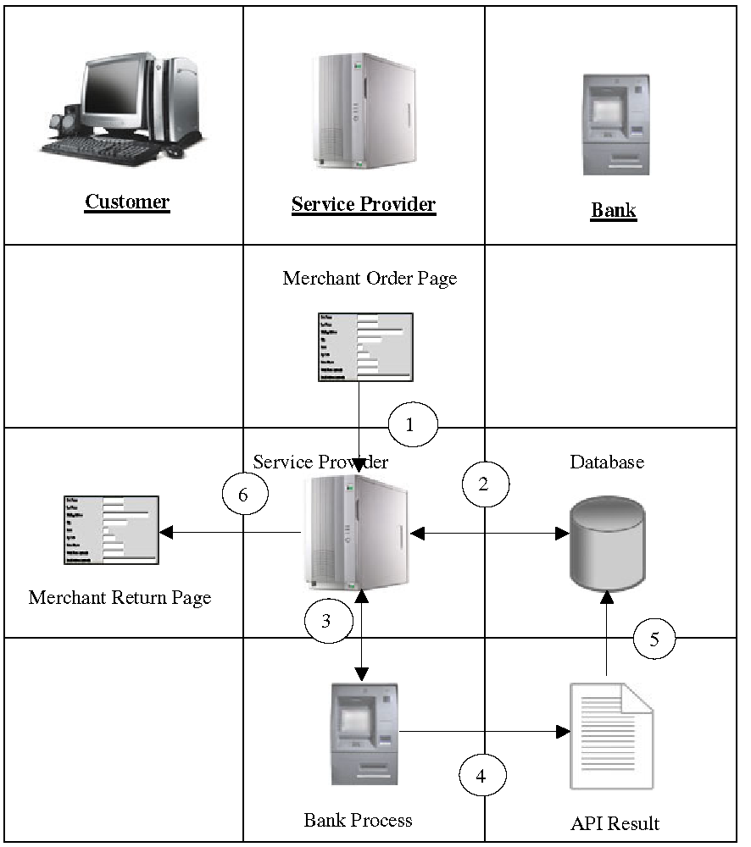

2.2 ) Process Explanation

- The end-user submits the form.

- The Merchant sends the data to our Order Page.

3. We check the Card Number and Check transaction
parameters with Anti-fraud System and sends the payment to Bank.

4. The bank response will be updated with the Our Database.

5. We send the response to the Merchant on the return url you assign for that website in your backend.

6. The return URL of the Merchant updates the Merchant database.

Data Format

3.1 ) Data sent to us by the Merchant
You have to post these data to the our order page.

1. mt_reference_id
- Description – Reference number given by Our administrator
- Content - Unique alphanumeric string

2. mt_transaction_type
- Description – Type of transaction.
- Content – Check or Credit

3. mt_subAccount
- Description – Merchant charge subAccount
- Content – Unique account number to identify purchase amount/purchase schedule.

4. mt_prod_desc
- Description – Description about the product
- Content – Alphanumeric string which describes about the
product purchased.

5. mt_product_id
- Description – Description about the product
- Content – Alphanumeric string which describes about the
product purchased.

6. mt_amount
- Description – Optional Charge Amount
- Content – This option is only available when your processor gives you permission to do so. If Independent Pricing is enabled for your company, you may enter any value you wish to charge here without prior defining of a Price Point.

7. Any extra parameters: ex. param_1, param_2, param_3
- Description – Optional Parameters
- Content – You may pass whatever data you like with any number of extra parameters. This data will be returned to your website on the final post form along with the above data. This can be used to keep track of orders/IDs.
8. mt_checksum
- Description – Optional Charge Amount Verification Checksum
- Content – This option is only used when Independent Pricing is used. This option verifys the charge amount on our end so that the price you intend to charge is not bypassed or changed by a hacker.

NOTE: IF YOU USE INDEPENDENT PRICING, THIS VERIFICATION SYSTEM IS HIGHLY RECOMMENDED. This is the only way for you to verify the information sent to you from our server.

To Achive this value, you can use this formula:
MD5( Secret Key + Website Reference ID + Amount to Charge + Product ID )

3.1.8 ) Integration Example
Use this method on your order page to calculate the checksum on the fly.

<?php
$amountToCharge = 24.99;
$secretKey='ZQ3dku3QM6EwSxkw';
$mt_reference_id='40EEEF366DC2';
$mt_product_id='Prod_02';
$mt_checksum=
md5($secretKey.$mt_reference_id.$amountToCharge.$mt_product_id);
?>

<input type='hidden' name='mt_checksum'
value='<?=$mt_checksum?>'>

<input type='hidden' name='mt_reference_id' value='<?=$mt_reference_id?>'>

<input type='hidden' name='mt_amount' value='<?=$amountToCharge?>'>

<input type='hidden' name='mt_product_id' value='<?=$mt_product_id?>'>

3.2) Data sent to the Merchant from our server
The response file will post these details to the Merchant URL.

1. mt_transaction_result
- Description – Transaction Status
- Content – Return code given below in Appendix-A.

2. mt_total_amount
- Description – Total transaction Amount
- Content – Numeric string up to 10 maximum, the amount paid
through Our order page.

3. mt_reference_number
- Description – Transaction Reference Number.
- Content – Unique transaction number used to identify the order.

4. mt_useremail
- Description – Email user registered with
- Content – This value represents the email the user registered the transaction with.

5. Extra parameters: ex. param_1, param_2, param_3
- Description – Optional Parameters
- Content – Any Data you passed through these parameters initially in the last section will be returned here. This is useful for keeping track of orders or user accounts.
6. mt_username, mt_password
- Description – Circumstantial Parameters
- Content – If a website is enabled with the password management system, the customer will be asked to assign a username and password. They will appear here.

7. verify_checksum
- Description – Circumstantial Parameters
- Content – Use this value to verify the Independent Price that we charged your customer. You can check it against the md5 checksum you generated on your order page.

Transaction Process

The transaction should be made live only after completing the entire process. The
Transactions should be tested using the TEST URL before getting live.

4.1 ) Testing Transaction:

For testing the transaction POST the transaction messages to the URL:

https://secure.etelegate.com/testintegration.php

4.2 ) Live Transaction:

For Live transaction POST the transaction messages to the URL:

https://secure.etelegate.com/integration.php

How to Integrate using Price Points:
5.1 ) Integration Example
The following details have to be sent to Our order page:

<html>
<head>
<title>Payment Gateway</title>
</head>
<body>
<form name='FrmPayment' action='https://secure.etelegate.com/integration.php' method='POST'>
<input type='hidden' name='mt_reference_id' value='0A137B375CC3'>
<select name="mt_transaction_type" size="3">
<option value="Credit" selected>Credit Card</option>
<option value="Check">Check</option>
<option value="WEB900">WEB900</option>
</select>
<input type='hidden' name='mt_subAccount' value='240-00102'>
<input type='hidden' name='mt_prod_desc' value='Car Rental'>
<input type='hidden' name='param_1' value='Extra Parameter'>
<input name="" type="submit">
</form>
</body>
</html>
This example allows for charging an the customer with a Price Point Sub Account. Sub Accounts must be set up in the Web Setup page before they can be used. In this example, the subAccount '00102' specifies a product trial price, trial period, and optional recurring billing information for that product. This method is far more secure than Independent billing.

How to Integrate using independent Pricing:
5.1 ) Integration Example
The following details have to be sent to Our order page:

<html>
<head>
<title>Payment Gateway</title>
</head>
<body>
<form name='FrmPayment' action='https://safe.ecommerceglobal.com/secure/integration.php' method='POST'>
<input type='hidden' name='mt_reference_id' value='01234ABCDE'>
<select name="mt_transaction_type" size="3">
<option value="Credit" selected>Credit Card</option>
<option value="Check">Check</option>
<option value="WEB900">WEB900</option>
</select>
<input type='hidden' name='mt_amount' value='24.99'>
<input type='hidden' name='mt_subAccount' value='-1'>
<input type='hidden' name='mt_prod_desc' value='Sun Glasses'>
<input type='hidden' name='mt_checksum' value='5a51cf045196bf68f9af9225f5212ce6'>
<input name="" type="submit">
</form>
</body>
</html>

This example allows for charging an arbitrary value to the customer. No Price points have to be created beforehand.
Note: in this example, an Independent Price Point Verification Checksum is used. This checksum was created by:
MD5( Secret Key + Reference ID + Amount to Charge + Product ID )
You may also use our checksum generator provided to you on your Pricing Setup Page to generate a valid checksum.
DON”T LET YOUR CUSTOMERS KNOW YOUR SECRET KEY!
Appendix - A
Return code for the transaction:
Type Description
INT Internal Error Occurred.
UIN Invalid User.
SUP Suspended User by the administrator.
VID Invalid Voice Authorization Id.
SUC Transaction Success.
DEC Declined Transaction.
INV Invalid Price Point SubAccount
DIS Disabled Transaction Type
REF Invalid Reference Website

Examples for posting the values from the Integration page using Price Points:
Field Name Value
mt_reference_id MF724431KW
mt_transaction_type Check(For Check Transactions)
mt_transaction_type Credit(For Credit transactions)
mt_subAccount 240-00101
mt_product_desc Products Purchased
mt_product_id Prod_01

This will charge the customer with the one time or recurring payment plan defined by the Sub Account. Note: Price Points will not work unless you set up Price Points in your Web Setup beforehand.

Examples for posting the values from the Integration page using Independent Pricing:
Field Name Value
mt_reference_id MF724431KW
mt_transaction_type Check(For Check Transactions)
mt_transaction_type Credit(For Credit transactions)
mt_checksum 5a51cf045196bf68f9af9225f5212ce6
mt_subAccount -1 (This should be -1 or blank if you are using Independent Pricing
mt_product_desc Products Purchased
mt_product_id Prod_01
mt_amount 24.99

This will charge the customer with the one time payment of 24.99.

