Password Management Integration Guide

Overview:

Etelegate provides payment processing for a variety of internet businesses. Our merchants sell members access to material online or to products which they may purchase. We provide scripts ( in php and perl) to facilitate automatic membership creation/revocation on these websites, if they are hosted on an apache server. If you do not use apache we will support your site via a “post back system” to pass you any variables you might need. If you sell tangible goods we support the Zen and OS Commerce shopping cart systems. This document provides an overview of how most merchant will integrate their web sites with us.

Prerequisites:

- You have registered an account with Etelegate.
- You have registered one or more Price Points (Under Pricing Setup)
- You have an ftp client.
- You have FTP or Control Panel access to your website.
Website Setup:

Most merchants will use our password management system for controlling membership access, anyone that is computer literate can setup.

You will need 3 different files for this system to work:

- A file that holds your usernames and password. (.htpasswd)

- A file that tells the apache web server to require users to give their username and password before they will be allowed access. (.htaccess)

- A file that will add and remove usernames and passwords from the .htpasswd file.(etelegate.pl or etelegate.php)

To begin the process please login, then click tools on the left:

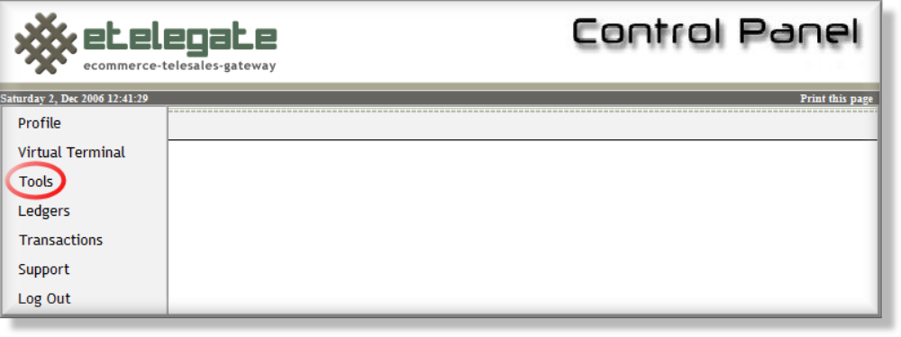

Then click websites on the top:

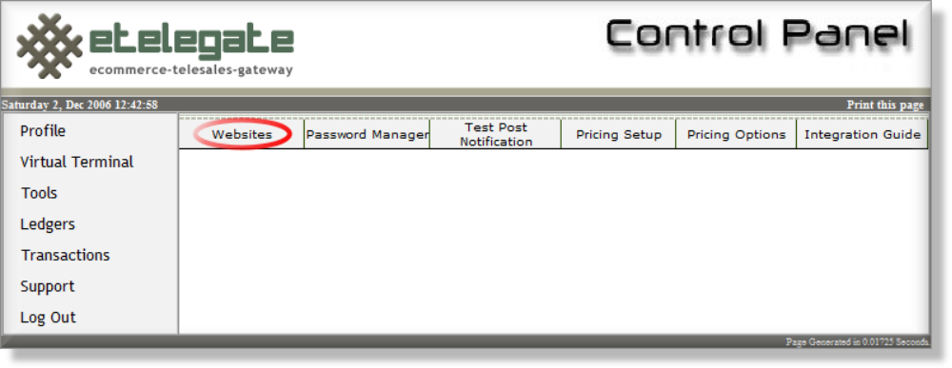
Website Setup (cont.):
Click "Add a Website", if you have not already added your site. If you have already added the website please click edit to the right of the site.

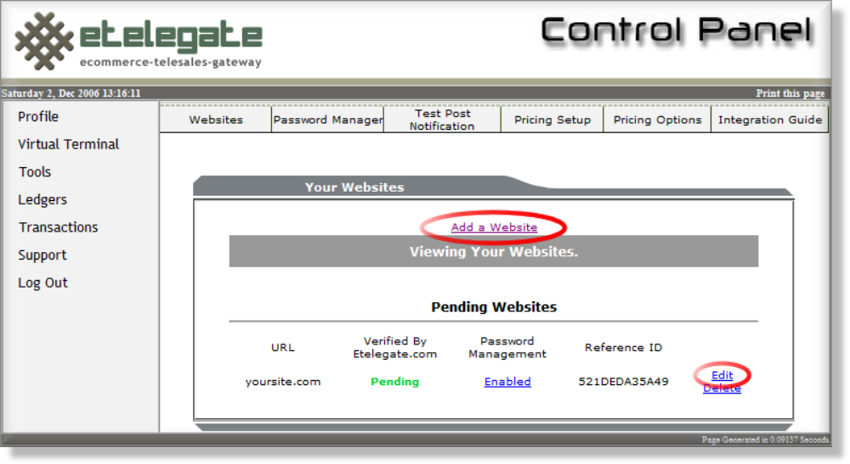

You should now see this screen

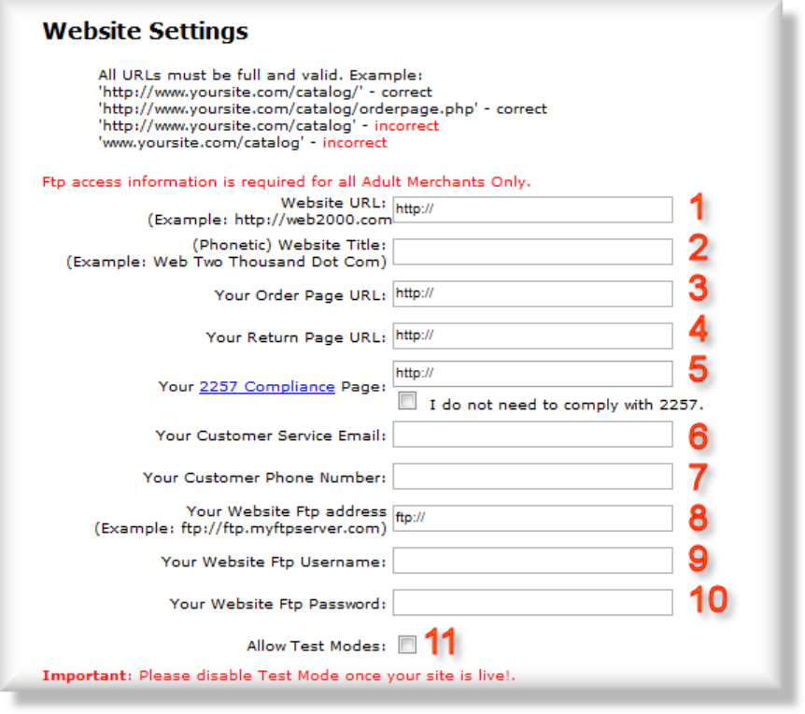
Enter the following in each of the boxes:
Website Setup (cont.):

- Your Website URL. For example "http://www.somesite.com”.

- Your Website Title is how your website name would be spoken in English. This may be used by our automated customer service phone number. For example "www.myno1website.com would be ‘My Number One Web Site’".

- Your Order Page URL. This is the last page on your domain that a user would see before being sent to our site. For example "http://www.somesite.com/join.html”.

- The Return Page URL is where your customers should be redirected after a successful order. For example "http://www.somesite.com/memberslogin.html”.

- If your site hosts adult content then you are required by law to keep various records and have a page with instruction for how to gain access to those records. This is the 2257 Compliance Page, for example "http://www.somesite.com/2257.html”.

- Your Customer Service Email. For example; “customerservice@somesite.com”.

- Your Customer Service Phone Number. For example; “(213)-555-1212”.

In order to provide the highest level of quality, we will need the following information to verify the content of your website and maintain your password management files:

- Your Website FTP Address. For example; “ftp://ftp.somesite.com”.

- Your Website FTP User Name. For example; “johndoe”.

- Your Website FTP Password. For Example; “12345”

- If Allow Test Modes is enabled then we will allow test transactions to take place. These test transactions will allow you insure everything is working properly.
Important – Disable this feature, once your site is live. Test Transactions are NOT Processed and will result in absolutely no debiting of the customer’s funds.
Website Setup (cont.):

Scroll down to the next section:

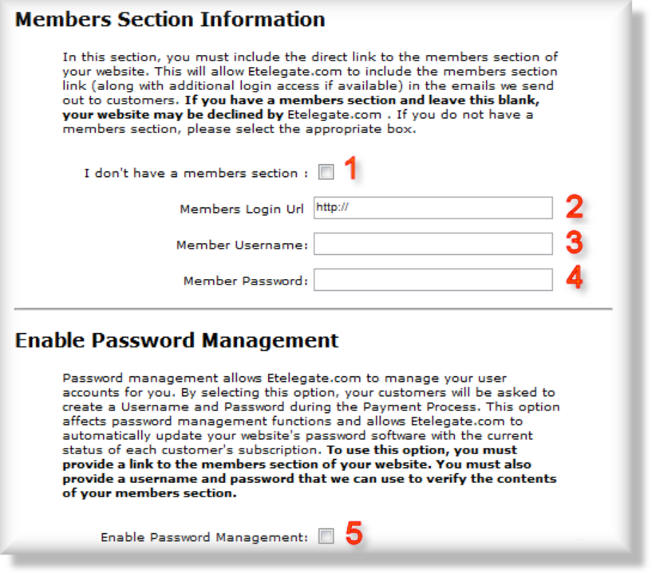

Enter the following in each of the boxes:

- If you are not providing membership access, check ‘I don’t have a members section’ (1).

If you are providing membership access, we require the ability to inspect your content:

- Enter your Members Login URL. For Example “http//www.somesite.com/members”.

- Enter a working Member User Name. For Example, “Etelegate”

- Enter a working Member Password. For Example, “testp4ss”

- Enable Password Management. If you would like us to prompt your customers for a username and password check this button.
Important – This must be enabled in order for password management to work.

Password Management Setup:

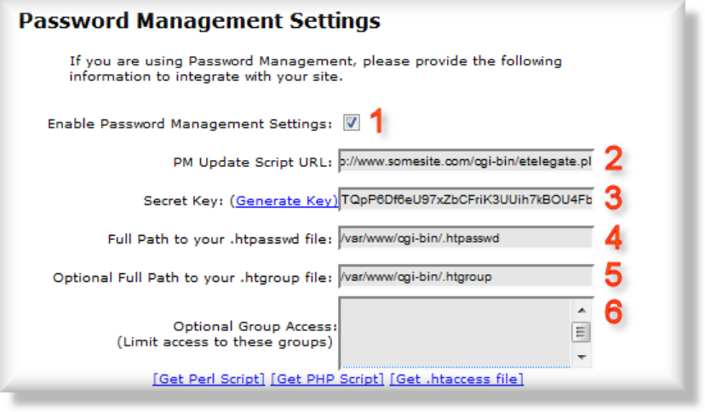
Enter the following in each of the boxes:

- Check the “Enable Password Management Settings" (1) box if you are using our password management.

- The "PM Update Script URL" box is the web address where the Etelegate server can communicate with the Etelegate script. Password Management script on your server. For example; "http://www.somesite.com/cgi-bin/etelegate.pl”.

- Click "(Generate Key)" if you do not already have a Secret Key. This key secures communication between our server and yours.

- The "Full Path to your .htpasswd File:" is the path to the file holding the usernames and passwords for your users. This likely will not be the same as your ftp path. There are several methods to find this information:
Password Management Setup (cont.):

- If you have previously integrated with a different processor, you will likely be able to use the same .htpasswd and .htaccess file as before. There will likely be a .htaccess file in your members directory. If you open this file, you should find a line that starts with “AuthUserFile", following this will be full path to your .htpasswd file.
(OR)
- You can find the path by uploading the included "where.php" or "where.cgi" (permission on this file must be set to "755" which is equivalent to the user having read, write and execute permission, the group having read and execute permission, and other having read and execute permission ) to the same directory as the .htpasswd (permission set to "666", which is equivalent to all users having read and write permission) file. If you view the file with a browser (for example is you went to http://www. Somesite.com/cgi-bin/where.php you might see “/var/www/cgi-bin/”) it will tell you the full path to your .htpasswd file. Once you have this path, add .htpasswd to that path. For example; if the script states you are at "/var/www/cgi-bin", you will type "/var/www/cgi-bin/.htpasswd" in the box.

If you are using groups, fill in these fields (Optional).

- The "Full Path to your .htgroup file:" is the path to the file holding the usernames and passwords for your users, and which group they belong to, if you are using this feature. This is an optional field that most merchants will not use.

- Optional Group Access. If you are using groups they will be named with the descriptions of your sub accounts. If you would like to use the same price point for multiple member’s areas please refer to the advanced integration section.

Installing your Script:

Click either “[Get PHP Script]” or “[Get Perl Script]” to download a password management script. If you do not have a .htaccess file in your member directory please click “Get .htaccess file”.

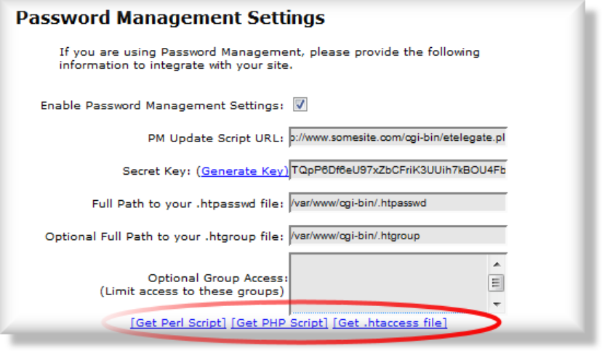

The perl script is more universal and would need to have permissions set to "755". Upload this file to a location on your server, so it may be accessed from the url in "PM Update Script URL:". If the perl script does not work, then usually the php script will, depending on your server configuration.

Important: Your script must be accessible from the public internet (ex: http://www.yoursite.com/etelegate.php). The Secret Key will ensure no one else may access your script file.

If you do not have the .htaccess located in your member directory, please upload the file. If you do not have a .htpasswd file you may upload the version that comes with this manual. The .htpasswd file may be stored anywhere on your server. It is best to store this file in a NON-PUBLIC directory.

If you are using the Group Access option, you’ll need to ensure that a .htgroup file is uploaded also.

Important: .htpasswd and .htgroup files must be readable and writable! (Permission: 666)

Once your script is installed, and .htaccess, .htpasswd, and optionally .htgroup are uploaded to the proper directories, you may begin testing your script.

Testing your Script:

First, scroll down and hit Submit to ensure that your Settings are saved:
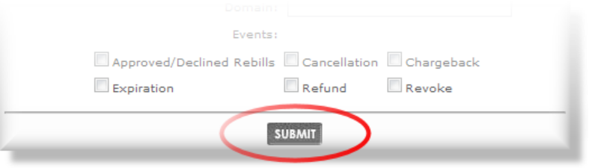

Then click Password Manager on the top:
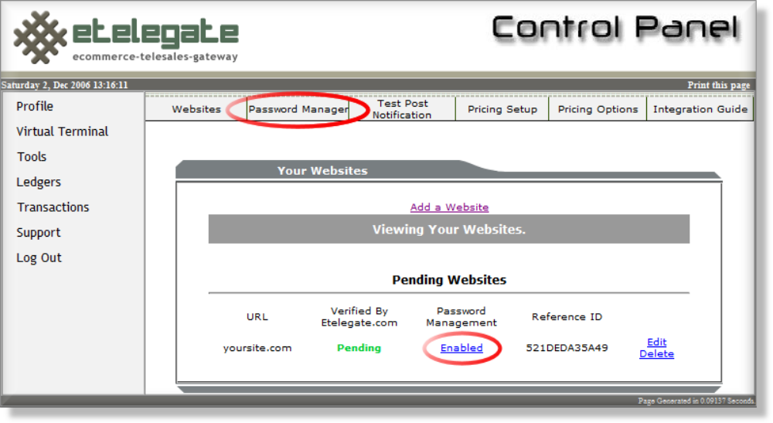

Now Select the Website you would like to manage:
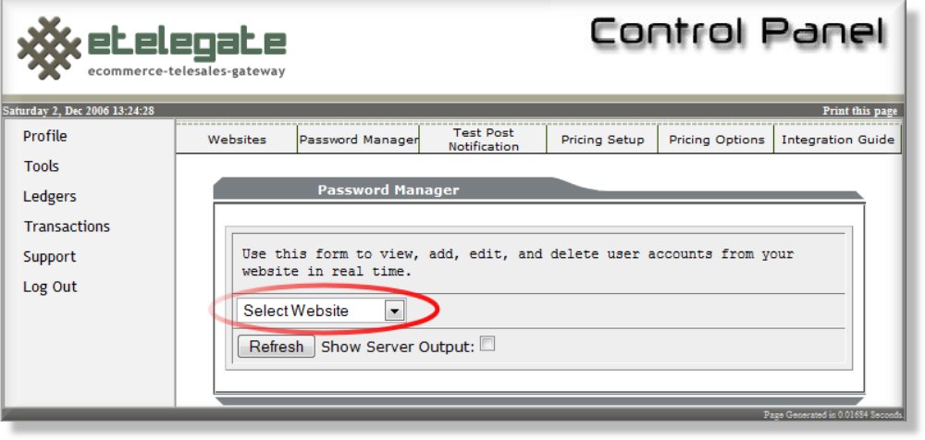
Management:

If you have successfully integrated your site you should see a success message.

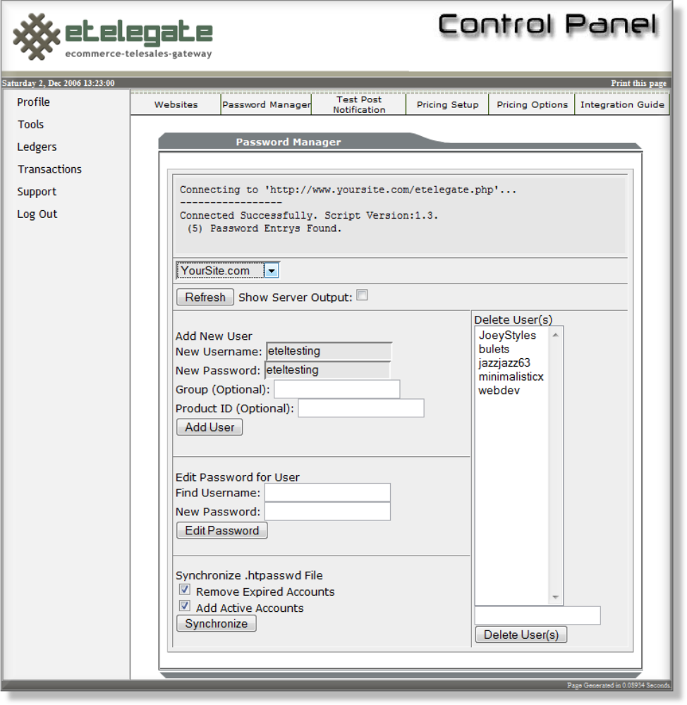

Congratulations, you have now integrated your Password Management.

As a Final Step, please enter a test username and password in this manager and select ‘Add User’ and then browse to your website’s membership section and test the username and password.

