Quick Payment Button
Integration Guide

Overview:

Etelegate provides payment processing for a variety of internet businesses. Our merchants sell members access to material online or to products which they may purchase. This guide will walk you through the steps required to integrate your website withour Payment Page.

Prerequisites:

- You have registered an account with Etelegate.
- You have an ftp client.
- You have FTP or Control Panel access to your website.

Pricing Setup

First, Select Tools
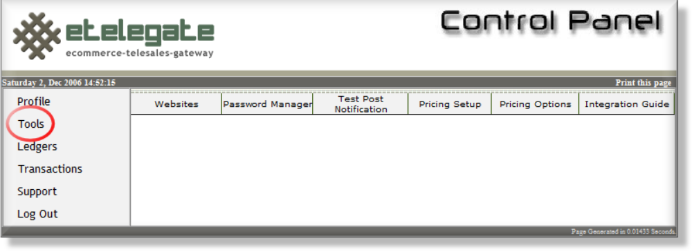

Then, Select Pricing Setup
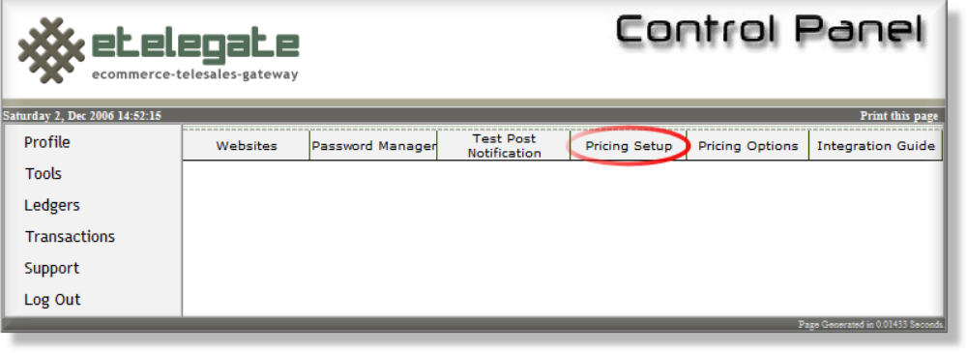

To Create a new Price Point, please select ‘Add a Sub Account’
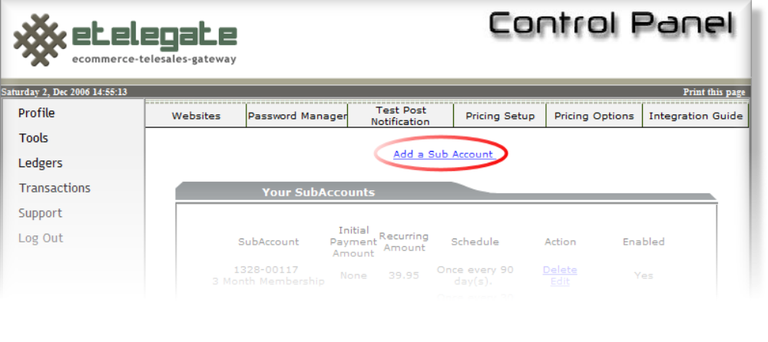

Pricing Setup (cont.)

To Create a Price Point, please enter the following information:
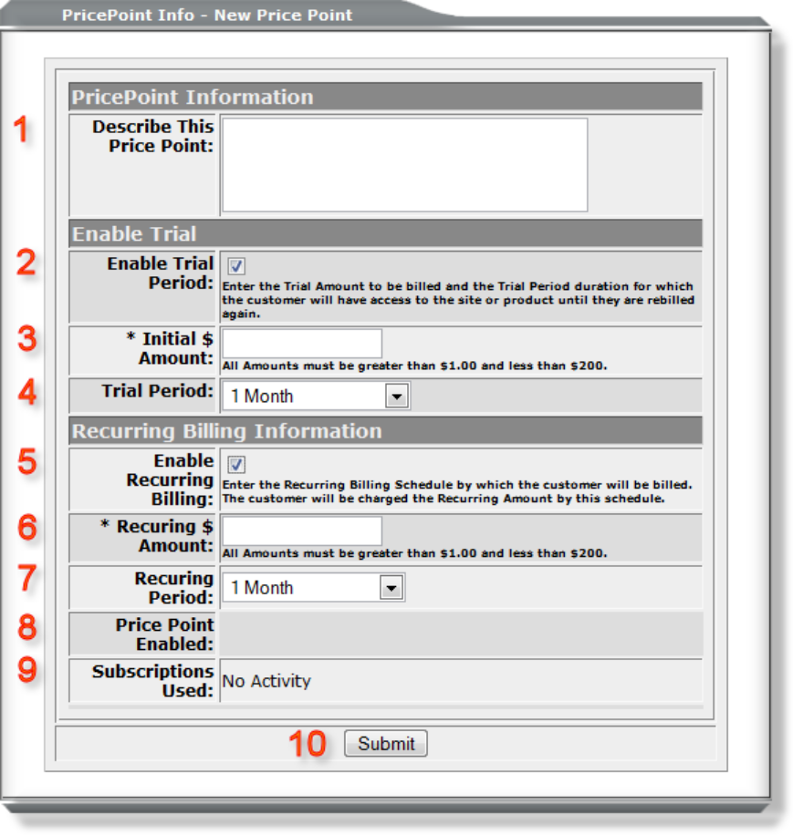
- A Description of this price point, for example “30 Day subscription to Somesite.com”. If you are using Optional Group Access, then this will be the name of the group.

- If you would like this price point to have a Trial Period or non recurring billing, please check this box.

- Enter the Initial Amount (in USD) that you would like your customer to be charged for their first transaction.

- The Trial Period is the length of time that between the initial transaction and either rebilling or expiration.

- If you would like this price point to be a Recurring please check this box.

- Enter the Recurring Amount (in USD) that you would like your customer to be charged for transaction after the first transaction.

- The Recurring Period is the length of time between recurring transactions.
Pricing Setup (cont.)

- Price Point Enabled will allow you to disable the price point later. Ignore it for now.

- Subscriptions Used will show you how many active subscriptions you have with this Price Point.

- Once you are satisfied with your input please click Submit. You price point will be created and you will be shown the price you have just created. If you would like to create another price point you must exit this page and navigate back.

Generate Purchase Busttons (cont.)

Once you are finished, Scroll down to the ‘Generate HTML/Purchase Buttons’ section
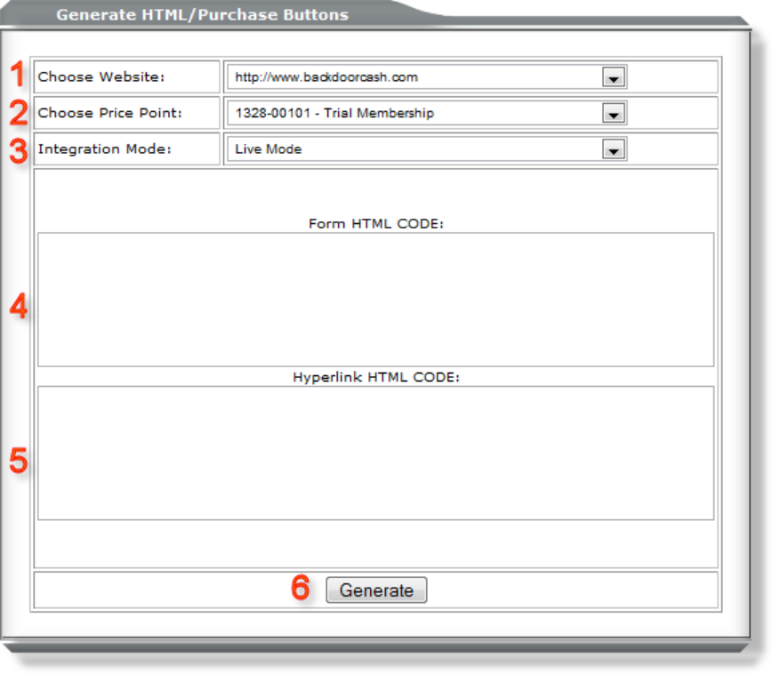

1. Please select which one of your Websites for which to generate buttons codes.

2. Please select which one of your Price Points for which to generate buttons codes.

3. Integration Mode: Please select if you would to generate a button for to use for testing or for actual customer use.

4. Form HTML Code: If you would like a box for your customers to click on to direct your customers to Etelegate, please copy the html generated in this box.

5. Hyperlink HTML Code: If you would like a hyperlink for your customers to click on to direct your customers to Etelegate, please copy the html generated in this box.

6. Once you have selected the website, price point, and integration mode you like to generate buttons for, please click Generate and html will appear in boxes 4 and 5. Copy all the generated html in the box and place this html code on your Website’s Payment Section.

