TITLE PAGE
Title
Comparative Performance of Linear and Non-Linear Algorithms for Identifying Prevalent Radiographic Knee Osteoarthritis: Analysis of the ELSA-Brasil Musculoskeletal Study
Running Head
Linear vs. Complex Models for Radiographic KOA
Authors
Júlio Guerra Domingues [1]
Adriano Alonso Veloso [2]
Rosa Weiss Telles [3]
Sandhi Maria Barreto [4]
Affiliations:
- Department of Anatomy and Medical Imaging, UFMG, Belo Horizonte, Brazil
- Department of Computer Science, UFMG, Belo Horizonte, Brazil
- Department of Internal Medicine, UFMG, Belo Horizonte, Brazil
- Department of Preventive and Social Medicine, UFMG, Belo Horizonte, Brazil
Corresponding Author:
Júlio Guerra Domingues
Email: juliogdomingues@gmail.com

ABSTRACT

Objective
To develop a parsimonious clinical model for identifying prevalent radiographic knee osteoarthritis (rKOA) and to compare its discriminative performance against complex machine learning algorithms, including XGBoost, Random Forest, and Neural Networks.

Design
A cross-sectional analysis was conducted using data from the ELSA-Brasil Musculoskeletal Study (2012–2014), a cohort of civil servants aged 38–79 unselected for any medical conditions. The primary outcome was prevalent rKOA (Kellgren–Lawrence grade ≥ 2). We evaluated candidate variables across demographic, anthropometric, clinical history, metabolic, and bioimpedance domains. Two modeling frameworks were implemented: a "Constitutional Model" (using only demographic/history variables) and a "Symptom-Augmented Model." Performance was assessed using 5-fold nested cross-validation with participant-level clustering, comparing a Stepwise Logistic Regression against Random Forest, Extreme Gradient Boosting (XGBoost), and Multilayer Perceptron (MLP).

Results
The study included 5,652 knee radiographs from 2,830 participants (ages 38-74, mean 56.0 years). The prevalence of radiographic KOA was 13.2%. A stepwise logistic regression model based on six constitutional variables (age, body mass index, race, occupation, history of trauma, and history of surgery) achieved an Area Under the Curve (AUC) of 0.810 (95% CI 0.795–0.825). Increasing algorithmic complexity did not improve discrimination: XGBoost (AUC 0.803), Random Forest (AUC 0.789), and MLP (AUC 0.742) failed to outperform the linear model. The inclusion of clinical symptoms modestly improved the logistic regression AUC to 0.824.

Conclusions
A parsimonious clinical-epidemiological model is highly effective for identifying prevalent radiographic knee osteoarthritis and performs equivalently to "black box" machine learning architectures. These findings suggest that for population-level stratification, the relationship between clinical characteristics and structural disease is adequately captured by linear associations driven primarily by age and BMI.
Keywords
Knee Osteoarthritis; Screening; Machine Learning; Epidemiology; ELSA-Brasil.

Introduction
Osteoarthritis (OA) is one of the most prevalent musculoskeletal diseases worldwide, with a major impact on quality of life, especially in the elderly [1,2]. Knee involvement (KOA) is notable for its high frequency and associated morbidity, being one of the leading causes of physical disability globally [1]. Symptoms such as pain, stiffness, and loss of mobility lead to significant economic and social repercussions, including treatment costs and loss of productivity [3–5].
Current clinical guidance emphasizes that knee osteoarthritis (KOA) can often be identified based on characteristic clinical features, such as activity-related pain and short-duration morning stiffness, without the routine use of imaging [6]. In many settings, radiography does not alter initial management and may add unnecessary cost and logistical burden.
Nevertheless, radiographic assessment remains a cornerstone of osteoarthritis research and epidemiological surveillance, serving as a widely accepted and standardized criterion for defining the structural presence of the disease [7]. Radiographic evaluation provides a morphological baseline that correlates with long-term joint degradation and subsequent functional decline, even when symptoms are currently intermittent or absent [7,8]. Thus, while not essential for every clinical encounter, identifying structural disease is vital for population-level monitoring and for characterizing the burden of disease in large-scale health studies.
Technological advances have spurred interest in using complex machine learning (ML) algorithms and novel biomarkers (e.g., bioimpedance, advanced anthropometry) to improve predictive accuracy [9,10]. These "black box" models often promise superior performance by capturing non-linear interactions but come at the cost of interpretability and computational complexity [11,12]. A critical question is whether these complex approaches actually offer meaningful advantages over traditional, transparent statistical methods when applied to standard clinical-epidemiological data.
In this context, population-based cohorts such as Brazilian Longitudinal Study of Adult Health (ELSA-Brasil) - Musculoskeletal (ELSA-Brasil MSK) provide a valuable opportunity to develop models that prioritize feasibility, interpretability, and broader applicability. The ELSA-Brasil is a large, multicenter cohort originally established to investigate chronic non-communicable diseases in Brazilian adults. Building upon this infrastructure, the ancillary ELSA-Brasil MSK incorporated standardized musculoskeletal evaluations, including knee radiography, in a well-characterized sample [13].
The primary objectives of this study were: 1) to develop and validate a parsimonious model to identify prevalent radiographic KOA using routinely available clinical variables; and 2) to compare the performance of traditional stepwise logistic regression against complex ML algorithms—specifically XGBoost, Random Forest, and Neural Networks—while evaluating whether the inclusion of symptom data and objective bioimpedance measures provides incremental value in identifying structural joint disease.

Methods

Study Design and Sample
The present analysis had a cross-sectional design and used clinical-epidemiological data and knee radiographs obtained during the first visit of ELSA-Brasil MSK (2012–2014) . The baseline ELSA-Brasil MSK sample comprised 2,901 active and retired civil servants (53% women), aged 38–79 years (mean 56.0 years, SD 8.9), unselected for any medical conditions. Of the 2830 participants, there were 5,652 knee radiographs available for analysis (8 excluded due to arthroplasty or technical artifacts) [13].

Ethical Aspects
The ethical principles of respect for persons, beneficence, and justice were considered in the planning of both ELSA-Brasil and ELSA-Brasil MSK. The study was conducted in accordance with the Declaration of Helsinki. ELSA-Brasil was approved by the Research Ethics Committees of the six participating teaching and research institutions. The baseline of the ELSA-Brasil MSK ancillary study and its first follow-up were approved through an amendment submitted to the Research Ethics Committee (REC) of UFMG (amendment CAAE 0186.1.203.000-06 of proposal ETIC 186/06, dated 09/03/2012, and CAAE 47125015.4.1001.5149, opinion 1.897.023 of 01/24/2017).

Outcome Definition
The primary outcome was prevalent radiographic knee osteoarthritis (KOA), defined at the knee level as Kellgren–Lawrence (KL) grade ≥ 2 for the tibiofemoral compartment and/or patellofemoral (PF) OA (defined as a definitive osteophyte in the PF joint or definitive PF joint space narrowing accompanied by any bone abnormality) [13]. This outcome reflects the presence of radiographic disease at the time of imaging rather than incident or progressive osteoarthritis, irrespective of symptom status. Knees with total knee arthroplasty were excluded from the analysis.

Candidate Predictors
To ensure the construction of a robust model, we performed a comprehensive literature review to identify potential candidate variables (features).
Demographic and Anthropometric Factors: Established risk factors such as older age, female sex, and higher body mass index (BMI) are consistently associated with KOA incidence [14,15]. According to a recent comprehensive systematic review and meta-analysis, high BMI and older age remain primary drivers of risk [16]. Sex-specific differences have also been noted, with high BMI and atherosclerosis showing stronger associations in women, while abdominal obesity is more predictive in men [17].
Mechanical and History Factors: Previous knee injury is a potent risk factor for the development of OA [14,15]. Mechanical factors, including joint malalignment (varus/valgus) and occupational exposures like frequent squatting or heavy lifting, also contribute to disease risk, albeit with varying magnitudes of effect compared to constitutional factors [20]. Regarding physical activity, the evidence is nuanced; while recreational activity does not appear to increase risk [18,19], high-impact sports and professional athletics are linked to higher KOA prevalence, largely mediated by increased exposure to traumatic joint injuries [20,21].
Metabolic Factors: Beyond mechanical loading, a "metabolic" phenotype of OA has been proposed. The accumulation of metabolic syndrome components—hypertension, dyslipidemia, and impaired glucose tolerance—is associated with both incidence and MRI-detected progression of KOA [22–24].
Genetics: While genetic variations contribute to OA susceptibility, their effect is less pronounced in typical late-onset KOA compared to environmental and lifestyle factors [25]. We included a family history of knee replacement as a proxy for high genetic and environmental shared risk within nuclear families, even though this information is subject to period and access biases
Bioimpedance and BMI: To explore whether refined measures of adiposity and muscle mass outperform BMI, we incorporated bioimpedance-derived metrics, including bone mineral content, mineral mass and skeletal muscle mass.
Based on this evidence, we curated a broad initial dataset from ELSA-Brasil MSK spanning demographic, anthropometric, clinical, metabolic, and lifestyle domains for feature selection. Candidate variables and model comparisons are provided in the Supplementary Material.
Clinical Symptoms: Joint symptoms are often the primary manifestation of established structural disease. We characterized knee-related complaints using the Western Ontario and McMaster Universities Osteoarthritis Index (WOMAC). Variables included the presence of pain, stiffness, and physical dysfunction in different timeframes.
Detailed operational definitions and questionnaire wording for all variables are provided in the Supplementary Methods.

Radiographic Assessment
Bilateral knee radiographs were obtained using a standardized non-fluoroscopic digital protocol, comprising a weight-bearing posteroanterior (PA) fixed-flexion view and lateral views. To ensure reproducibility of the joint space width measurement, the fixed-flexion view employed a novel positioning device developed specifically for the study [26]. Images were interpreted following a validated two-step protocol: initially, two trained technologists independently screened all images for "possible OA"; subsequently, an experienced musculoskeletal radiologist reviewed all images flagged by at least one technologist to establish the final diagnosis and grading. This process was calibrated against an external expert reader, yielding substantial inter-observer agreement (κ = 0.755; 95% CI 0.663–0.847) [13].

Statistical Analysis
Continuous variables were standardized; missing clinical data were imputed using the median within each training fold and applied to the corresponding test fold; missing WOMAC scores were imputed to 0 assuming asymptomatic knees in the absence of pain reports. Categorical predictors were treated as dummy variables.
We implemented four distinct modeling frameworks to evaluate the trade-off between interpretability and complexity. The baseline linear model was a Stepwise Logistic Regression developed through a two-stage hybrid selection procedure. First, to act as a strict filter to reduce dimensionality and mitigate collinearity, we applied an L1-penalized Logistic Regression (LASSO) with 3-fold cross-validation to identify an initial subset of non-zero coefficients. From this subset, we performed an iterative forward stepwise selection, where variables were added one by one based on the maximization of the 5-fold cross-validated Area Under the Receiver Operating Characteristic Curve (AUC). The final model utilized standard L2-penalized Logistic Regression (with the default inverse regularization strength, C=1.0) with the optimal parsimonious subset of predictors. The primary advantage of this traditional approach is its high transparency, producing a simple model where the individual contribution of each clinical factor is quantifiable via Odds Ratios, though it inherently assumes that risk factors interact in a strictly linear, additive manner.
To capture potential non-linear interactions—such as a specific variable only becoming a major determinant after a certain age threshold—and complex data structures, we employed three advanced machine learning algorithms. While these approaches can theoretically achieve higher accuracy by learning intricate patterns, their major disadvantage is their "black box" nature, which complicates the extraction of straightforward clinical rules. The first complex model, Random Forest (RF), was implemented as a bagging-based ensemble of 200 decision trees with a maximum depth of 10. Conceptually, this algorithm builds a "forest" of independent decision trees based on random subsets of data and averages their predictions, making it highly robust against overfitting. The second model, Extreme Gradient Boosting (XGBoost), was configured as a gradient boosting framework utilizing 100 estimators, a learning rate of 0.1, and a maximum tree depth of 3. Unlike RF, which builds trees independently, XGBoost builds trees sequentially, with each new tree specifically designed to correct the errors of the previous ones. Its objective function was binary logistic loss, with L2 regularization to prevent overfitting. Finally, we deployed a Multilayer Perceptron (MLP), a feed-forward artificial neural network consisting of two hidden layers with 64 and 32 neurons, respectively. This model simulates layers of interconnected artificial "neurons" to learn highly abstract representations of the data. The network utilized Rectified Linear Unit (ReLU) activation functions and was trained using the Adam optimizer (initial learning rate 0.001) with L2 regularization (alpha=0.0001) and early stopping (patience=10) to optimize convergence.
These approaches were applied across two primary analytical frameworks: the Constitutional Model, which relied exclusively on stable demographic, anthropometric, and history variables, and the Symptom-Augmented Model, which incorporated self-reported joint symptoms. Model performance was assessed using 5-fold nested cross-validation with GroupKFold to prevent data leakage from bilateral knees of the same participant. Cluster-robust standard errors were calculated to account for within-participant correlation between bilateral knees.
Discrimination was quantified using the AUC, with 95% confidence intervals estimated using 2,000 bootstrap resamples of the out-of-fold predictions. Calibration was assessed using the Brier score and calibration plots. For the final inferential analysis, we reported Raw Odds Ratios (OR) and Standardized ORs, with cluster-robust standard errors calculated at the participant level to account for within-individual correlation between knees. All analyses were performed in Python 3.12.1 using scikit-learn (v1.8.0) and statsmodels (v0.14.6). The source code and scripts used for model development and evaluation are hosted in a public GitHub repository. To maintain the integrity of the double-blind peer review process, the direct link has been temporarily redacted and will be made available upon publication.

Results
Of the 5,652 knee radiographs available for analysis from 2,830 participants, 18.1% met the criteria for radiographic KOA. When stratified by clinical status, 26.8% (n=1,514) of the evaluated knees were symptomatic, among which the prevalence of radiographic KOA was 26.1%. Table 1 details key baseline clinical and demographic characteristics of the study participants, stratified by the presence of prevalent rKOA. Detailed statistics for all analyzed variables are provided in Supplementary Table S1.

Table 1. Characteristics of the ELSA-Brasil MSK Study Population Stratified by Prevalent Radiographic Knee Osteoarthritis (rKOA).
Characteristic | Total (N=2,830) | No rKOA (N=2,318) | With rKOA (N=512) | P-value
Age (years), mean ± SD | 56.1 ± 8.9 | 55.0 ± 8.8 | 60.8 ± 8.2 | <0.001
Sex (Female), n (%) | 1493 (52.8%) | 1213 (52.3%) | 280 (54.7%) | 0.358
Race/Skin Color, n (%) |  |  |  | 0.033
Black | 360 (12.7%) | 278 (12.0%) | 82 (16.0%)
Brown/Mixed | 976 (34.5%) | 796 (34.3%) | 180 (35.2%)
White | 1378 (48.7%) | 1147 (49.5%) | 231 (45.1%)
Asian | 63 (2.2%) | 56 (2.4%) | 7 (1.4%)
Indigenous | 15 (0.5%) | 14 (0.6%) | 1 (0.2%)
Occupation, n (%) |  |  |  | 0.003
Routine Manual | 339 (12.0%) | 259 (11.2%) | 80 (15.6%)
Non-routine Manual | 23 (0.8%) | 17 (0.7%) | 6 (1.2%)
Routine Non-manual | 734 (25.9%) | 589 (25.4%) | 145 (28.3%)
Non-routine Non-manual | 1710 (60.4%) | 1436 (61.9%) | 274 (53.5%)
BMI (kg/m²), mean ± SD | 27.0 ± 4.7 | 26.5 ± 4.5 | 29.2 ± 5.2 | <0.001
Frequent Knee Symptoms, n (%) | 663 (23.4%) | 433 (18.7%) | 230 (44.9%) | <0.001
History of Knee Trauma, n (%) | 684 (24.2%) | 462 (19.9%) | 222 (43.4%) | <0.001
History of Knee Surgery, n (%) | 183 (6.5%) | 71 (3.1%) | 112 (21.9%) | <0.001
Note: P-values derived from Student's t-test for continuous variables and Chi-square test for categorical variables. Participants were classified as "With rKOA" if at least one knee exhibited radiographic osteoarthritis. Similarly, for knee-specific clinical variables (Symptoms, Trauma, Surgery), participants were classified as "Yes" if at least one knee was affected.

Determinants of Prevalent Radiographic KOA
Prior to the final stepwise selection, the LASSO regression acted as a robust filter to reduce the dimensionality of the data. From the initial pool of candidate predictors, the LASSO model identified 27 variables with non-zero coefficients, highlighting a broad range of potential determinants including demographic factors, clinical history, and metabolic markers (Supplementary Table S2).
To address the primary objective of developing a parsimonious model, the stepwise selection process identified a core set of six independent clinical variables associated with prevalent radiographic disease (Table 2). To compare the relative importance of variables measured on different scales, we analyzed Standardized Odds Ratios (sOR). Age (sOR 2.34; 95% CI 2.09–2.61) and BMI (sOR 1.89; 95% CI 1.71–2.09) emerged as the dominant determinants of identification (Figure 3). Regarding absolute effect size, a History of Knee Surgery exhibited the strongest individual association (OR 8.10; 95% CI 5.46–12.03), serving as a proxy for established severe disease. History of Knee Trauma was also strongly associated with prevalent KOA (OR 2.47; 95% CI 1.95–3.13). Conversely, protective associations were observed for non-manual/non-routine occupations (OR 0.66; 95% CI 0.53–0.83) and self-reported White race (OR 0.69; 95% CI 0.55–0.87).

Table 2. Association of Clinical Factors with Prevalent Radiographic Knee Osteoarthritis (for the Constitutional Model).
Feature | Raw OR (95% CI) | Standardized OR (95% CI)* | P-value
Age (per year) | 1.10 (1.09–1.11) | 2.34 (2.09–2.61) | < 0.001
Race (White vs Others) | 0.69 (0.55–0.87) | 0.83 (0.74–0.93) | 0.001
Occupation (Non-routine vs Ref) | 0.66 (0.53–0.83) | 0.82 (0.73–0.91) | < 0.001
BMI (per kg/m²) | 1.14 (1.12–1.17) | 1.89 (1.71–2.09) | < 0.001
History of Knee Trauma (Yes vs No) | 2.47 (1.95–3.13) | 1.38 (1.27–1.50) | < 0.001
History of Knee Surgery (Yes vs No) | 8.10 (5.46–12.03) | 1.48 (1.37–1.59) | < 0.001
*Standardized OR reflects the change in odds per 1 Standard Deviation increase for continuous variables. Analysis performed at the knee level (N=5,652); confidence intervals were estimated using cluster bootstrap to account for within-participant correlation.

Figure 1. Incremental Gain in Model Discrimination (Stepwise Selection)
The plot displays the cumulative Area Under the Curve (AUC) for the Constitutional Model (without symptoms) as variables are sequentially added via forward stepwise selection. The process begins with Age (AUC 0.690) and reaches a plateau of 0.810 with the inclusion of six variables (Age, BMI, History of Surgery, History of Trauma, Occupation, and Race).
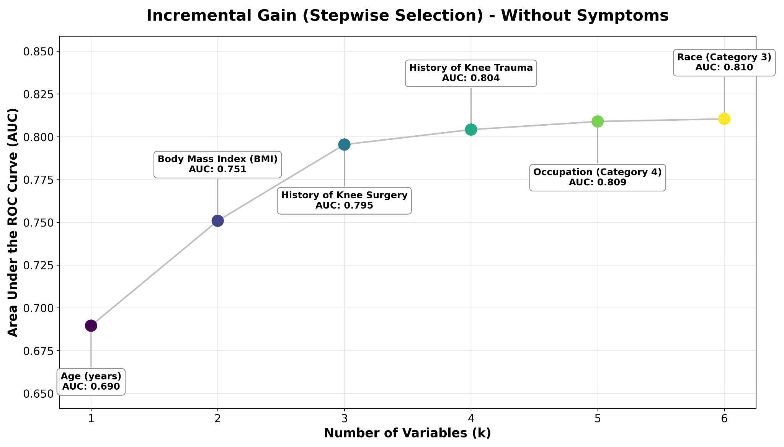

In the Symptom-Augmented Model, the inclusion of Frequent Symptoms (OR 1.58; 95% CI 1.15–2.17) did not displace the constitutional factors. Age (sOR 2.33) and BMI (sOR 1.74) retained their magnitude, reinforcing that symptoms represent a distinct layer of information that complements, rather than nullifies, the structural risk profile.

Model Performance and Comparison
The comparative analysis of discrimination metrics revealed that increasing algorithmic complexity did not translate into superior performance for the identification of prevalent radiographic knee osteoarthritis (KOA). The parsimonious Logistic Regression consistently demonstrated discriminative ability equivalent or superior to the complex ML architectures across all analytical scenarios.
In the Constitutional Model, the Logistic Regression achieved an AUC of 0.810 (95% CI: 0.795–0.825) and a Brier score of 0.091. In contrast, the complex algorithms failed to provide a performance advantage; The XGBoost model achieved a comparable AUC of 0.803, followed by the RF (AUC 0.789) and the MLP, which demonstrated the lowest discrimination (AUC 0.742). This hierarchy likely reflects the predominantly linear nature of the risk associations in this population (Figure 2).

Figure 2. ROC Curves for the Constitutional Model (Without Symptoms)
Receiver Operating Characteristic (ROC) curves comparing the discriminative performance of four modeling approaches in identifying radiographic knee osteoarthritis using only clinical and demographic variables. The Stepwise Logistic Regression (blue line, AUC=0.810) demonstrates performance equivalent or superior to XGBoost (orange, AUC=0.803), RF (green, AUC=0.789), and MLP (red, AUC=0.742).
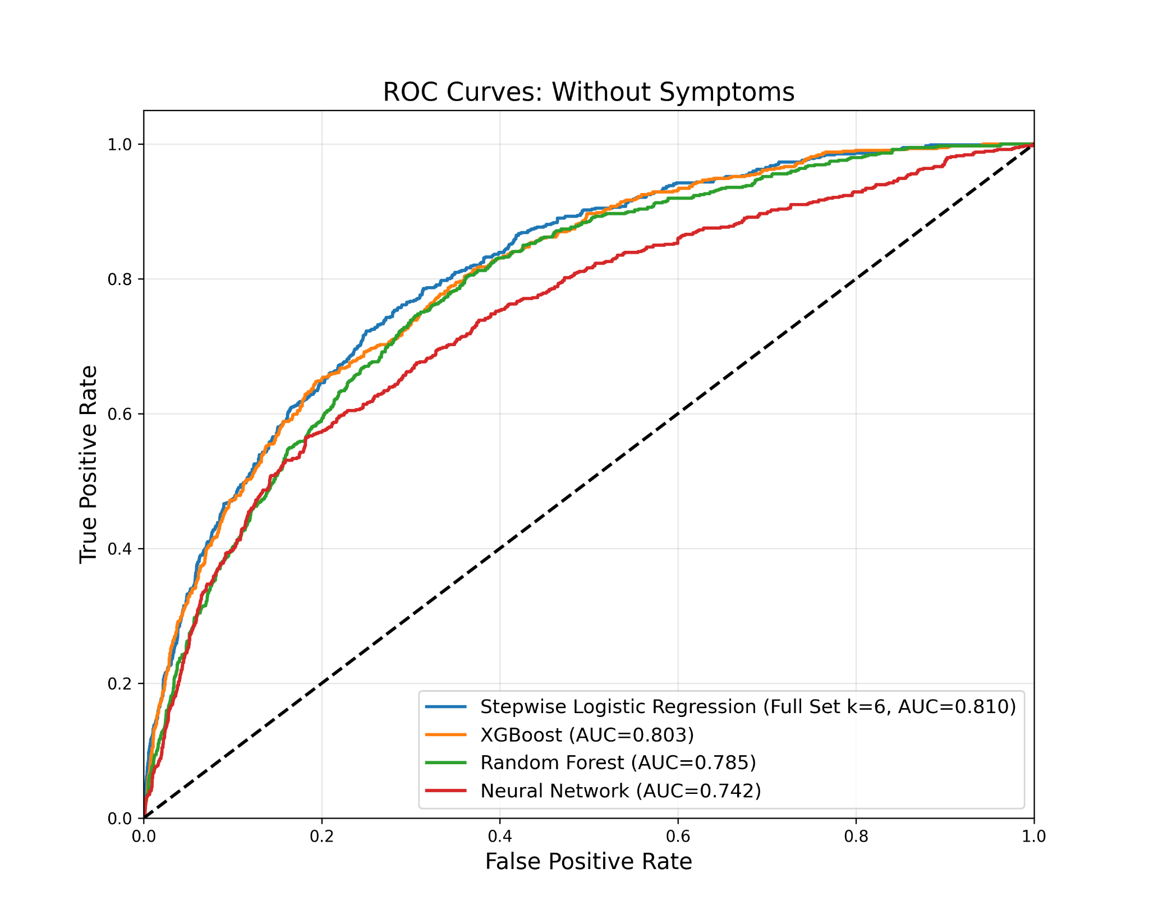

The Symptom-Augmented Model, which incorporated self-reported clinical symptoms, yielded a modest improvement in discrimination, raising the Logistic Regression AUC to 0.824 while maintaining calibration (Brier score 0.090). However, this incremental gain did not alter the hierarchy of model efficacy; the linear model remained superior to more complex ML alternatives (Figure 3).

Figure 3. ROC Curves for the Symptom-Augmented Model
ROC curves illustrating model performance when self-reported symptom data are included. While the Stepwise Logistic Regression (blue line) AUC improves to 0.824, it retains its advantage over the complex ML algorithms (XGBoost AUC=0.809; RF AUC=0.789; MLP AUC=0.765).
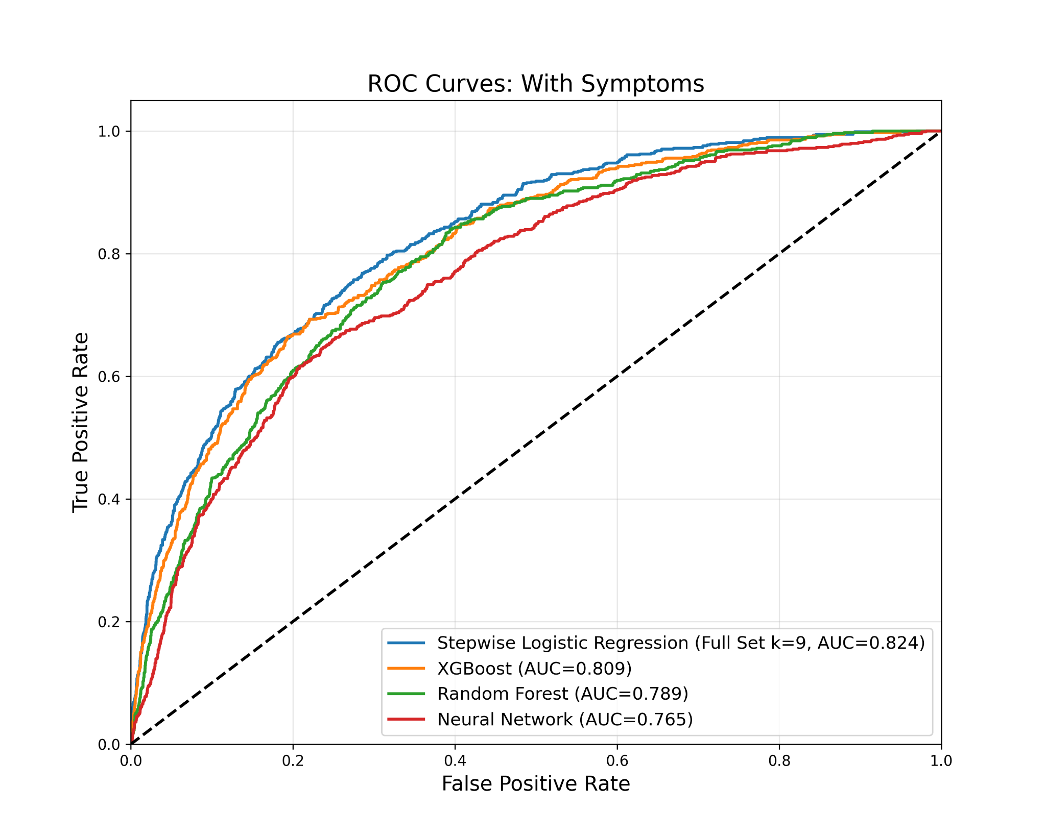

Discussion
The present study demonstrates that a simple clinical-epidemiological model is highly effective for identifying prevalent radiographic knee osteoarthritis in a general adult population. By rigorously comparing traditional statistical methods against complex ML architectures, our analysis revealed that increasing algorithmic complexity did not translate into superior discriminative performance. The stepwise logistic regression model achieved discriminative accuracy comparable or superior to tree models and neural network approaches. These findings suggest that for the specific purpose of population-level identification of structural disease, the relationship between clinical characteristics and radiographic outcomes is adequately captured by linear associations. This challenges the assumption that opaque computational algorithms are inherently necessary for high-fidelity medical classification.
The robustness of the constitutional model has significant implications for resource allocation and identification strategies. The ability to identify individuals with a high pre-test probability of radiographic disease using only age, BMI, and medical history supports the feasibility of opportunistic identification within primary care settings. Since these variables are ubiquitous in electronic health records, health systems could automate the stratification of the population without requiring additional clinical appointments or specialized diagnostic inputs. Such a system would facilitate the targeted delivery of preventive interventions, such as weight management programs and neuromuscular training, to high-probability individuals before the onset of disabling symptoms or the utilization of high-cost imaging modalities.
The dominance of age and BMI as the primary drivers of identification reinforces the established understanding of osteoarthritis as a condition fundamentally driven by the cumulative effects of biological aging and mechanical loading. These findings are consistent with extensive epidemiological evidence identifying aging and excess body weight as the strongest determinants of knee osteoarthritis prevalence [14–17].
In contrast to the strong signal from mechanical and historical factors, the inclusion of metabolic and advanced body composition variables provided negligible returns. Although metabolic and cardiometabolic factors were considered during feature selection due to the growing interest in the metabolic phenotype of osteoarthritis [22–24], they did not meaningfully improve discrimination beyond the core predictors. Furthermore, the analysis demonstrated that detailed bioimpedance metrics, including skeletal muscle mass and bone mineral content, offered no incremental discriminative value over simple BMI. This plateau of information suggests that while metabolic factors may play a role in disease etiology, their utility for identifying prevalent radiographic disease is limited once age and BMI are accounted for.
These findings must be interpreted in light of the study design and its inherent limitations. The cross-sectional nature of the analysis precludes the inference of causal directionality or the estimation of future incident disease, limiting the model to the identification of current status rather than prognostic estimation. Additionally, the well-documented discordance between radiographic findings and clinical pain means that individuals identified as high probability by the model may not currently require symptomatic treatment, although they remain prime candidates for structural preservation strategies. Regarding external validity, while the ELSA-Brasil cohort comprises civil servants and excludes the extremes of the socioeconomic spectrum, previous analyses have shown that the distribution of major chronic disease risk factors is comparable to that of the general Brazilian adult population [27], and representativeness is not a prerequisite for valid etiological inference [28]. Despite these limitations, the use of a large, multicenter cohort constitutes a major strength, providing a realistic representation of disease prevalence in the community that avoids the selection biases common to clinical or hospital-based datasets.

Conclusions
A parsimonious clinical-epidemiological model is highly effective for identifying prevalent radiographic knee osteoarthritis in the general adult population. The systematic comparison of modeling strategies revealed that complex ML algorithms and advanced metabolic biomarkers offer no discriminative advantage over simple linear models based on age, BMI, and clinical history. These findings challenge the prevailing trend toward algorithmic complexity in medical diagnostics, suggesting that for population-level stratification, the most powerful tools are often the most accessible. By validating a transparent and feasible approach to identifying structural disease using routinely available data, this study supports the implementation of opportunistic identification strategies in primary care. Such an approach allows for the efficient triage of high-probability individuals and the optimization of healthcare resources without reliance on opaque computational systems or expensive diagnostic technologies.

References
1. GBD 2021 Osteoarthritis Collaborators. Global, regional, and national burden of osteoarthritis, 1990-2020 and projections to 2050: a systematic analysis for the Global Burden of Disease Study 2021. Lancet Rheumatol. 2023;5(9):e508-e522. doi:10.1016/S2665-9913(23)00163-7
2. Tang S, Zhang C, Oo WM, et al. Osteoarthritis. Nat Rev Dis Primer. 2025;11(1):10. doi:10.1038/s41572-025-00594-6
3. Sharma L. Osteoarthritis of the Knee. N Engl J Med. 2021;384(1):51-59. doi:10.1056/NEJMcp1903768
4. Jin X, Liang W, Zhang L, Cao S, Yang L, Xie F. Economic and Humanistic Burden of Osteoarthritis: An Updated Systematic Review of Large Sample Studies. PharmacoEconomics. 2023;41(11):1453-1467. doi:10.1007/s40273-023-01296-1
5. Li E, Tan J, Xu K, Pan Y, Xu P. Global burden and socioeconomic impact of knee osteoarthritis: a comprehensive analysis. Front Med. 2024;11. doi:10.3389/fmed.2024.1323091
6. Kloppenburg M, Namane M, Cicuttini F. Osteoarthritis. Lancet Lond Engl. 2025;405(10472):71-85. doi:10.1016/S0140-6736(24)02322-5
7. Yoshikawa R, Segal NA, Tolstykh I, et al. Usefulness of 3D joint space width on weight-bearing CT in comparison with 2D joint space width on radiographs for predicting 24-month worsening of knee osteoarthritis pain and function in the MOST study. Osteoarthritis Cartilage. 2026;34(2):290-296. doi:10.1016/j.joca.2025.11.001
8. Miguel R de CC, Machado LA, Costa-Silva L, Telles RW, Barreto SM. Performance of distinct knee osteoarthritis classification criteria in the ELSA-Brasil musculoskeletal study. Clin Rheumatol. 2019;38(3):793-802. doi:10.1007/s10067-018-4347-0
9. Ramazanian T, Fu S, Sohn S, Taunton MJ, Kremers HM. Prediction Models for Knee Osteoarthritis: Review of Current Models and Future Directions. Arch Bone Jt Surg. 2023;11(1):1-11. doi:10.22038/ABJS.2022.58485.2897
10. Joseph GB, McCulloch CE, Nevitt MC, Lane NE, Majumdar S, Link TM. Machine learning models for clinical and structural knee osteoarthritis prediction: Recent advancements and future directions. Osteoarthr Cartil Open. 2025;7(3):100654. doi:10.1016/j.ocarto.2025.100654
11. Jamshidi A, Pelletier JP, Martel-Pelletier J. Machine-learning-based patient-specific prediction models for knee osteoarthritis. Nat Rev Rheumatol. 2019;15(1):49-60. doi:10.1038/s41584-018-0130-5
12. Binvignat M, Pedoia V, Butte AJ, et al. Use of machine learning in osteoarthritis research: a systematic literature review. RMD Open. 2022;8(1):e001998. doi:10.1136/rmdopen-2021-001998
13. Telles RW, Machado LAC, Costa-Silva L, Barreto SM. Cohort Profile Update: The Brazilian Longitudinal Study of Adult Health Musculoskeletal (ELSA-Brasil MSK) cohort. Int J Epidemiol. 2022;51(6):e391-e400. doi:10.1093/ije/dyac084
14. Zhang Y, Jordan JM. Epidemiology of osteoarthritis. Clin Geriatr Med. 2010;26(3):355-369. doi:10.1016/j.cger.2010.03.001
15. Silverwood V, Blagojevic-Bucknall M, Jinks C, Jordan JL, Protheroe J, Jordan KP. Current evidence on risk factors for knee osteoarthritis in older adults: a systematic review and meta-analysis. Osteoarthritis Cartilage. 2015;23(4):507-515. doi:10.1016/j.joca.2014.11.019
16. Duong V, Abdel Shaheed C, Ferreira ML, et al. Risk factors for the development of knee osteoarthritis across the lifespan: A systematic review and meta-analysis. Osteoarthritis Cartilage. 2025;33(10):1162-1179. doi:10.1016/j.joca.2025.03.003
17. Szilagyi IA, Waarsing JH, van Meurs JBJ, Bierma-Zeinstra SMA, Schiphof D. A systematic review of the sex differences in risk factors for knee osteoarthritis. Rheumatol Oxf Engl. 2023;62(6):2037-2047. doi:10.1093/rheumatology/keac688
18. Barbour KE, Hootman JM, Helmick CG, et al. Meeting physical activity guidelines and the risk of incident knee osteoarthritis: a population-based prospective cohort study. Arthritis Care Res. 2014;66(1):139-146. doi:10.1002/acr.22120
19. Felson DT, Niu J, Clancy M, Sack B, Aliabadi P, Zhang Y. Effect of recreational physical activities on the development of knee osteoarthritis in older adults of different weights: the Framingham Study. Arthritis Rheum. 2007;57(1):6-12. doi:10.1002/art.22464
20. Driban JB, Hootman JM, Sitler MR, Harris KP, Cattano NM. Is Participation in Certain Sports Associated With Knee Osteoarthritis? A Systematic Review. J Athl Train. 2017;52(6):497-506. doi:10.4085/1062-6050-50.2.08
21. Freiberg A, Bolm-Audorff U, Seidler A. The Risk of Knee Osteoarthritis in Professional Soccer Players—a Systematic Review With Meta-Analyses. Dtsch Arzteblatt Int. 2021;118(4):49-55. doi:10.3238/arztebl.m2021.0007
22. Yoshimura N, Muraki S, Oka H, Kawaguchi H, Nakamura K, Akune T. Association of knee osteoarthritis with the accumulation of metabolic risk factors such as overweight, hypertension, dyslipidemia, and impaired glucose tolerance in Japanese men and women: the ROAD study. J Rheumatol. 2011;38(5):921-930. doi:10.3899/jrheum.100569
23. Jansen NEJ, Molendijk E, Schiphof D, et al. Metabolic syndrome and the progression of knee osteoarthritis on MRI. Osteoarthritis Cartilage. 2023;31(5):647-655. doi:10.1016/j.joca.2023.02.003
24. Sowers M, Karvonen-Gutierrez CA, Palmieri-Smith R, Jacobson JA, Jiang Y, Ashton-Miller JA. Knee osteoarthritis in obese women with cardiometabolic clustering. Arthritis Rheum. 2009;61(10):1328-1336. doi:10.1002/art.24739
25. van Meurs JBJ. Osteoarthritis year in review 2016: genetics, genomics and epigenetics. Osteoarthritis Cartilage. 2017;25(2):181-189. doi:10.1016/j.joca.2016.11.011
26. Telles RW, Costa-Silva L, Machado LAC, Reis RCPD, Barreto SM. Fixed-flexion knee radiography using a new positioning device produced highly repeatable measurements of joint space width: ELSA-Brasil Musculoskeletal Study (ELSA-Brasil MSK). Rev Bras Reumatol. 2017;57(2):154-161. doi:10.1016/j.rbre.2016.11.010
27. Schmidt MI, Duncan BB, Mill JG, et al. Cohort Profile: Longitudinal Study of Adult Health (ELSA-Brasil). Int J Epidemiol. 2015;44(1):68-75. doi:10.1093/ije/dyu027
28. Rothman KJ, Greenland S, Lash TL. Modern Epidemiology. 3rd ed. Lippincott Williams & Wilkins; 2008.

Supplementary Material

Supplementary Table S1. Baseline Characteristics of All Candidate Predictors

Category | Variable | Distribution (N=2,830 Participants or N=5,652 Knees)
Demographic | Age (years) | 56.1 ± 8.9
Demographic | Sex (Female) | 1493 (52.8%)
Demographic | Race/Skin Color | Missing/Other: 38 (1.3%)  Black: 360 (12.7%)  Brown/Mixed: 976 (34.5%)  White: 1378 (48.7%)  Asian: 63 (2.2%)  Indigenous: 15 (0.5%)
Demographic | Occupation | Missing: 24 (0.8%)  Routine Manual: 339 (12.0%)  Non-routine Manual: 23 (0.8%)  Routine Non-manual: 734 (25.9%)  Non-routine Non-manual: 1710 (60.4%)
Demographic | Family Hx Knee Replacement (Yes) | 154 (5.5%)
Anthropometric | BMI (kg/m²) | 27.0 ± 4.7
Anthropometric | Abdominal Obesity (Yes) | 1162 (41.1%)
Anthropometric | Waist-Hip Ratio | 0.9 ± 0.1
Bioimpedance | Skeletal Muscle Mass (kg) | 27.1 ± 6.3
Bioimpedance | Bone Mineral Content (kg) | 2.8 ± 0.6
Bioimpedance | Mineral Mass (kg) | 3.4 ± 0.7
Lifestyle | Smoking Status | Missing: 1 (0.0%)  Never: 1703 (60.2%)  Former: 856 (30.2%)  Current: 270 (9.5%)
Lifestyle | Alcohol Use | Missing: 1 (0.0%)  Never: 341 (12.0%)  Former: 501 (17.7%)  Current: 1987 (70.2%)
Lifestyle | Binge Drinking (Yes) | 477 (16.9%)
Lifestyle | Excessive Alcohol (Derived) | 295 (10.4%)
Lifestyle | Physical Activity (IPAQ) | Missing: 1 (0.0%)  Low: 1999 (70.6%)  Moderate: 593 (21.0%)  High: 237 (8.4%)
Occupational Exposures | Stairs at Work (Yes) | 1794 (63.7%)
Occupational Exposures | Kneeling at Work (Yes) | 294 (10.4%)
Occupational Exposures | Squatting at Work (Yes) | 476 (16.9%)
Metabolic | Hypertension | 1152 (40.7%)
Metabolic | Diabetes | 477 (16.9%)
Metabolic | Metabolic Syndrome (JIS) | 1200 (42.6%)
Metabolic | Metabolic Syndrome (IDF) | 1145 (40.6%)
Metabolic | Metabolic Syndrome (NCEP) | 941 (33.4%)
Metabolic | Hypertriglyceridemia | 715 (25.3%)
Metabolic | Hypertriglyceridemia Meds | 740 (26.3%)
Metabolic | Low HDL | 670 (23.7%)
Metabolic | Low HDL Meds | 700 (24.8%)
Metabolic | Framingham CVD Risk (Model 1) | 11.7 ± 11.0
Metabolic | Framingham CVD Risk (Model 2) | 14.8 ± 13.6
Metabolic | Framingham CHD Risk (Chol) | 7.3 ± 6.1
Metabolic | Framingham CHD Risk (LDL) | 7.2 ± 5.7
Knee-Specific Factors | N=5,652 Knees
Knee-Specific Factors | History of Trauma (Yes) | 833 (14.7%)
Knee-Specific Factors | History of Surgery (Yes) | 203 (3.6%)
Knee-Specific Factors | Frequent Symptoms (Yes) | 941 (16.6%)
Knee-Specific Factors | Recent Pain (7d) (Yes) | 982 (17.4%)
Function & Performance | Participant Level
Function & Performance | Knee Disability (Yes) | 314 (11.1%)
Function & Performance | Sit-to-Stand Test (s) | 7.9 ± 2.3
WOMAC Scores (0-100) | Knee Level
WOMAC Scores (0-100) | Total Score | 28.6 ± 48.3
WOMAC Scores (0-100) | Pain Subscale | 6.0 ± 10.2
WOMAC Scores (0-100) | Stiffness Subscale | 2.2 ± 4.2
WOMAC Scores (0-100) | Function Subscale | 20.4 ± 35.3

Supplementary Table S2. Variables Selected by the LASSO Model
Variable | LASSO Coefficient
Age | 0.741
BMI | 0.502
History of Surgery | 0.352
History of Trauma | 0.222
Frequent Symptoms | 0.165
Recent Pain (7d) | 0.148
Occupation: Non-routine Non-manual | -0.141
Race: Black | -0.115
Knee Disability | 0.11
Squatting at Work | -0.106
Waist-Hip Ratio | -0.075
Low HDL Meds | -0.065
Smoking: Never | 0.063
Race: Missing/Other | 0.054
Race: Asian | -0.053
Diabetes | 0.048
Sit-to-Stand Test | 0.043
Kneeling at Work | 0.042
Abdominal Obesity | 0.03
Occupation: Routine Manual | 0.028
Physical Activity: High | 0.017
Smoking: Former | -0.013
Race: Indigenous | -0.013
Occupation: Missing | 0.009
Hypertriglyceridemia Meds | -0.004
Metabolic Syndrome (JIS) | -0.004
Alcohol Use: Former | 0.001
Variables are listed in order of absolute coefficient magnitude. Coefficients represent the change in log-odds of having radiographic knee osteoarthritis for a one-unit change in the predictor, holding other variables constant. The model included 27 non-zero predictors out of the initial candidate set.

Supplementary Methods: Operational Definitions of Key Variables
All clinical history, symptom, and occupational exposure variables were obtained by structured interviewer-administered questionnaires as part of the ELSA-Brasil Musculoskeletal Study. All variables were assessed separately for the left and right knees and coded at the knee level.
Sociodemographic Variables
- Race/skin color: Race/skin color was self-reported using the standard Brazilian census (IBGE) categories. Participants were asked to classify themselves as Black, Brown/Mixed, White, Yellow/Asian, or Indigenous. Additional response options included "Does not know" or "Does not wish to answer". For modeling purposes, race/skin color was treated as a categorical variable.
- Occupation: Occupational nature was classified into four categories based on the distinct tasks performed: Routine manual, Non-routine manual, Routine non-manual, Non-routine non-manual.
Symptom-related Variables
- Frequent knee symptoms: Assessed by the question: "In the last 12 months, have you had pain, discomfort, or stiffness in your knee that lasted for most days for at least one month?" Participants indicated the affected knee(s). Knees were classified as positive if the participant reported symptoms for the corresponding side. This variable was coded as binary (yes/no).
- Recent knee symptoms: Assessed by the question: "In the last 7 days... did you have pain, discomfort, or stiffness in your knee?" Responses were recorded separately for each knee. Knees were coded as binary (yes/no).
- Knee disability: Knee-related functional limitation was assessed by the question: "In the last 12 months, have you had knee pain, discomfort, or stiffness that prevented you from performing normal activities (such as work, household, or leisure activities)?" Knees were classified as positive if disability was reported for the corresponding side. This variable was coded as binary.
Clinical History Variables
- History of knee trauma or injury: Assessed by asking: "Have you ever sustained a knee injury or trauma that resulted in difficulty walking for at least one week?" Knees were coded as positive if the participant reported such an event for the corresponding side, regardless of timing. This variable was coded as binary.
- History of knee surgery: Assessed by the question: "Have you ever undergone any type of knee surgery, including arthroscopy, meniscus or ligament repair, or a total joint replacement?" Knees were coded as positive if any prior surgical intervention was reported for that side. This variable was coded as binary.

